

**Update _2_0_229A**

Clinical Reminders

MST SCREENING UPDATE

Install Guide

**February 2024**

Product Development

Office of Information Technology

Department of Veterans Affairs

Table of Contents

Introduction 1

Pre-Install 4

Install Details 5

Install Example 5

Post Installation 8

# Introduction

Changes are being made to the CPRS Military Sexual Trauma (MST) Screening Clinical Reminder that is used to screen patients for experiences of MST. The associated template/dialog was updated. No changes to the definition or logic were made.

Providers in the field requested an optional text box be added to the MST Screening Clinical Reminder to allow the option to provide details of the plan for follow-up care after a positive MST screen, for example, when a warm handoff to PCMHI was provided.

Additional edits were made to the reminder text to help clarify when to choose which follow-up option as well as to correct some text errors from the previous version.

These minor text changes should improve the documentation of care transfers and assist in following up on referral requests.

The version number is now 3.1

Before:

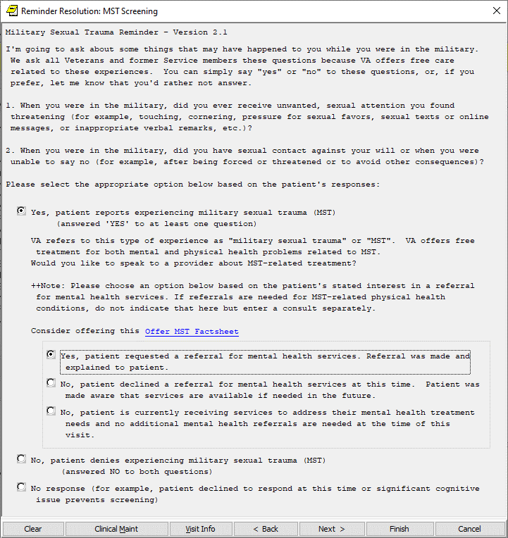

After:

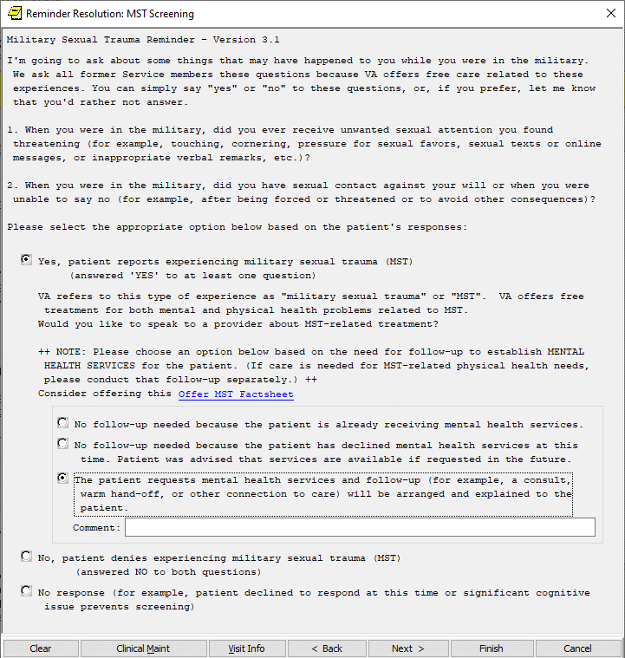

UPDATE_2_0_229A contains 1 Reminder Exchange entry:

UPDATE_2_0_229A VA-MST SCREENING UPDATE

**The exchange file contains the following components:**

**TIU TEMPLATE FIELD**

VA-MST FACTSHEET

**HEALTH FACTORS**

VA-REMINDER UPDATES [C]

VA-UPDATE_2_0_229A

MST CATEGORY [C]

MST DECLINES TO ANSWER

VA-MST DECLINES MH REFERRAL

VA-MST CURRENTLY ENROLLED IN MH

VA-MST REQUESTS MH REFERRAL

MST YES REPORTS

MST NO DOES NOT REPORT

**REMINDER SPONSOR**

MENTAL HEALTH SERVICES

**REMINDER TERM**

VA-REMINDER UPDATE_2_0_229A

**REMINDER DIALOG**

VA-MST SCREENING

# Pre-Install

1. **Find MST Referral order currently in use.**

* Using the Vista Menu, Reminder Dialog Manager, DI- Reminder Dialog, change view to Group view and Inq/Print the reminder dialog group VA-MST REQUESTS MH REFERRAL. You will need to identify the local order used as an additional finding and add this order back post install.

# Install Details

This update is being distributed as a web host file. The address for the host file is: https://REDACTED /UPDATE_2_0_229A.PRD

The file will be installed using Reminder Exchange, programmer access is not required.

Installation:

=============

This update can be loaded with users on the system. Installation will take less than 30 minutes.

# Install Example

**Installation of the updated reminder should be coordinated with your MST coordinator.**

To Load the exchange file, use LWH. The URL is

https://REDACTED/UPDATE_2_0_229A.PRD

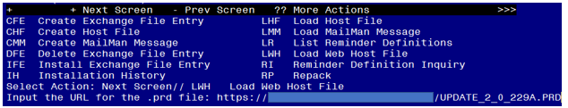

If you use LWH and it works, you will see something like this message. Make sure the file was loaded successfully.

Search and locate an entry titled UPDATE_2_0_229A VA-MST SCREENING UPDATE in reminder exchange.

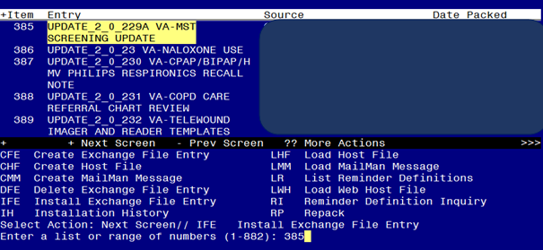

At the **Select Action** prompt, enter **IFE** for Install Exchange File Entry

Enter the number that corresponds with your entry titled UPDATE_2_0_229A VA-MST SCREENING UPDATE *(in this example it is entry 385, it will vary by site)* that is dated 02/13/2024.

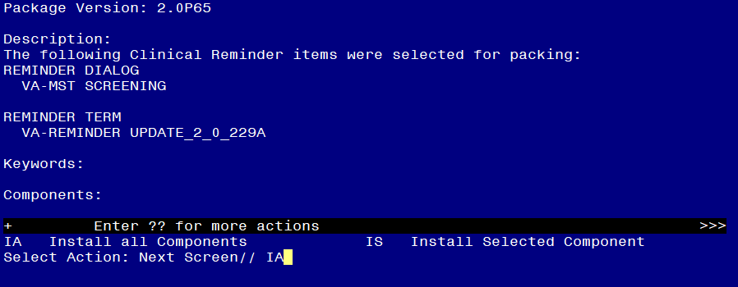

At the **Select Action** prompt, type **IA** for Install all Components and hit enter.

**For all new entries in any category you will choose I to Install**

**Skip any items you are prompted to overwrite.**

You will then be prompted to install the first dialog component. You will choose IA to install all even though some items will already have an X to indicate they exist.

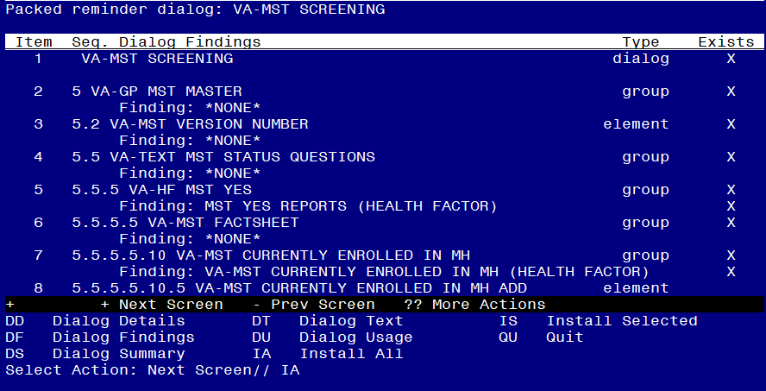

At the **Select Action** prompt, type **IA** to install the dialog – **VA-MST SCREENING**

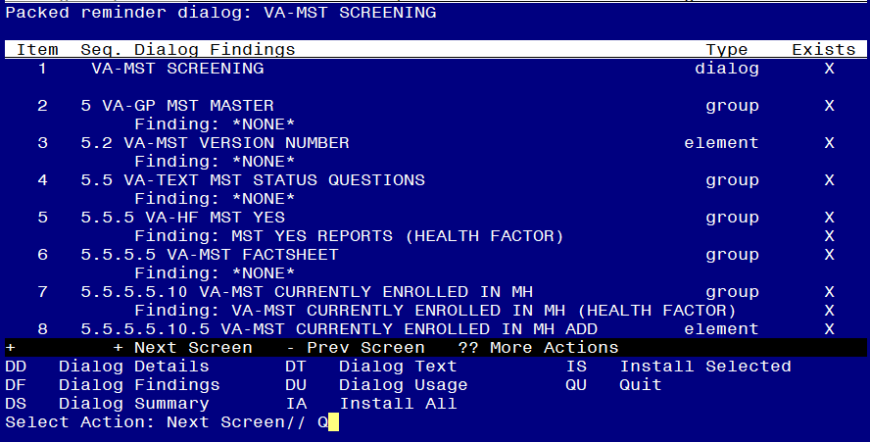

When the dialog has completed installation, you will then be returned to this screen. At the **Select Action** prompt, type **Q.**

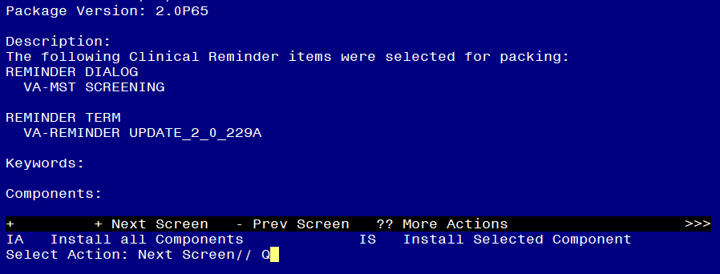

You will then be returned to this screen. At the **Select Action** prompt, type **Q.**

Install complete.

# Post Installation

1. **Add MST Referral identified in pre-install to reminder dialog.** Using the Vista Menu, Reminder Dialog Manager, DI- Reminder Dialog, change view to Group view edit the reminder dialog group VA-MST REQUESTS MH REFERRAL, add the quick order identified in the pre-install as an additional finding.
2. **Using CPRS, Open the MST Screening reminder** on a test patient and confirm the version number displayed at the top of the screen is 3.1.