

**Update _2_0_229**

Clinical Reminders

MST SCREENING UPDATE

Install Guide

**August 2021**

Product Development

Office of Information Technology

Department of Veterans Affairs

Table of Contents

Introduction 1

Pre-Install 1

Install Details 2

Install Example 3

Post Installation 6

# Introduction

This installation guide is for changes being made to the CPRS Military Sexual Trauma (MST) clinical reminder that is used to screen patients for experiences of MST. These changes are being made to align the clinical reminder with the definition of MST and MST eligibility requirements in recently passed legislation, to streamline the screening process, and to promote consistency across CPRS and the Cerner Electronic Health Record (EHR). Most of the revisions in this update are minor text changes to update language in the screening or changes to the logic of when and for whom the clinical reminder will be activated. The core aspects of the MST screening and referral process as included in the prior version of the MST clinical reminder largely remain the same.

The specific changes that have been made in this version of the MST Clinical Reminder are:

* The clinical reminder will be automatically set as due for certain other former Service members (FSMs), along with continuing to be set as due for Veterans.
* Patients with a current positive screen will no longer have the clinical reminder automatically set as due after a new period of military service.
* The text of the screen has been modified to include a revised screening question 1 (updating the definition of MST per new legislation), to be inclusive of both Veterans and FSMs, and to include additional information about the availability of care for MST-related physical health conditions.
* The text that is automatically pasted into the CPRS progress note stating the results of the screen has been simplified and shortened.

UPDATE_2_0_229 contains 1 Reminder Exchange entry:

UPDATE_2_0_229 VA-MST SCREENING UPDATE

**The exchange file contains the following components:**

**TIU TEMPLATE FIELD**

VA-MST FACTSHEET

**HEALTH FACTORS**

VA-REMINDER UPDATES [C]

VA-UPDATE_2_0_229

MST CATEGORY [C]

MST DECLINES TO ANSWER

VA-MST DECLINES MH REFERRAL

VA-MST CURRENTLY ENROLLED IN MH

VA-MST REQUESTS MH REFERRAL

MST YES REPORTS

MST NO DOES NOT REPORT

**REMINDER SPONSOR**

MENTAL HEALTH SERVICES

OFFICE OF QUALITY & PERFORMANCE

MENTAL HEALTH SERVICES AND WOMEN VETERANS HEALTH PROGRAM

**REMINDER TERM**

VA-REMINDER UPDATE_2_0_229

VA-MST OTH ELIGIBILITY

VA-IRAQ/AFGHAN PERIOD OF SERVICE

VA-MST DECLINES REPORT

VA-MST NEGATIVE REPORT

VA-MST POSITIVE REPORT

**REMINDER DEFINITION**

VA-MST SCREENING

**REMINDER DIALOG**

VA-MST SCREENING

# Pre-Install

1. **Find MST Referral order currently in use.**

* Using the Vista Menu, Reminder Dialog Manager, DI- Reminder Dialog, change view to Group view and Inq/Print the reminder dialog group VA-MST REQUESTS MH REFERRAL. You will need to identify the local order used as an additional finding and add this order back post install.

# Install Details

This update is being distributed as a web host file. The address for the host file is: https://Redacted/UPDATE_2_0_229.PRD

The file will be installed using Reminder Exchange, programmer access is not required.

Installation:

=============

This update can be loaded with users on the system. Installation will take less than 30 minutes.

# Install Example

To Load the exchange file, use LWH. The URL is https://Redacted/UPDATE_2_0_229.PRD

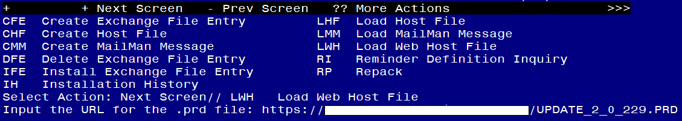

If you use LWH and it works, you will see something like this message. Make sure the file was loaded successfully.

Terminal window screen shot of the message displaying the URL of the file that was successfully loaded.  Part of the URL has been redacted as it is a VA only internal web site URL.

Search and locate an entry titled UPDATE_2_0_229 VA-MST SCREENING UPDATE in reminder exchange.

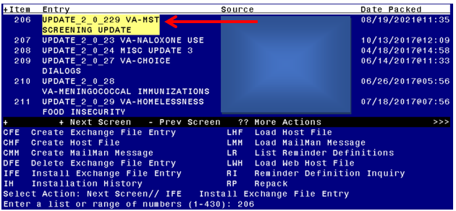

At the **Select Action** prompt, enter **IFE** for Install Exchange File Entry

Enter the number that corresponds with your entry titled UPDATE_2_0_229 VA-MST SCREENING UPDATE *(in this example it is entry 206, it will vary by site)* that is dated 08/19/2021.

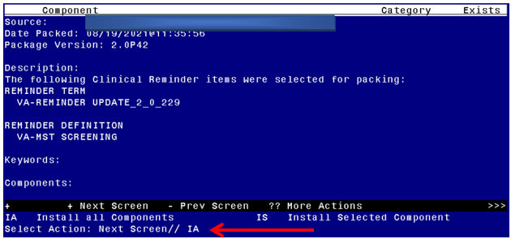

At the **Select Action** prompt, type **IA** for Install all Components and hit enter.

**For all new entries in any category you will choose I to Install**

**Skip any Health Factors that you are prompted to Overwrite.**

**Merge any Reminder Terms that exist but are different**

**OVERWRITE the reminder definition**

You will then be prompted to install the first dialog component. You will choose IA to install all even though some items will already have an X to indicate they exist.

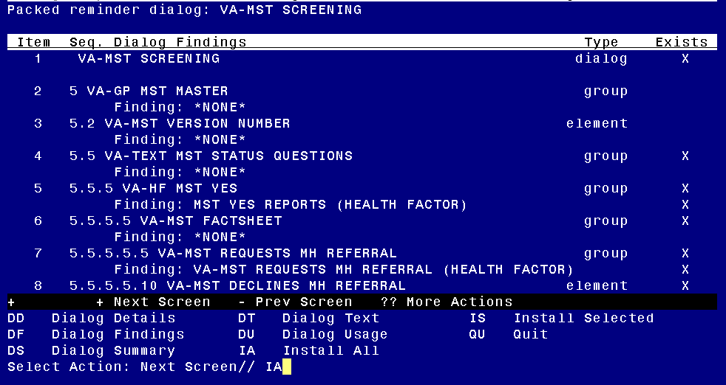

At the **Select Action** prompt, type **IA** to install the dialog – **VA-MST SCREENING**

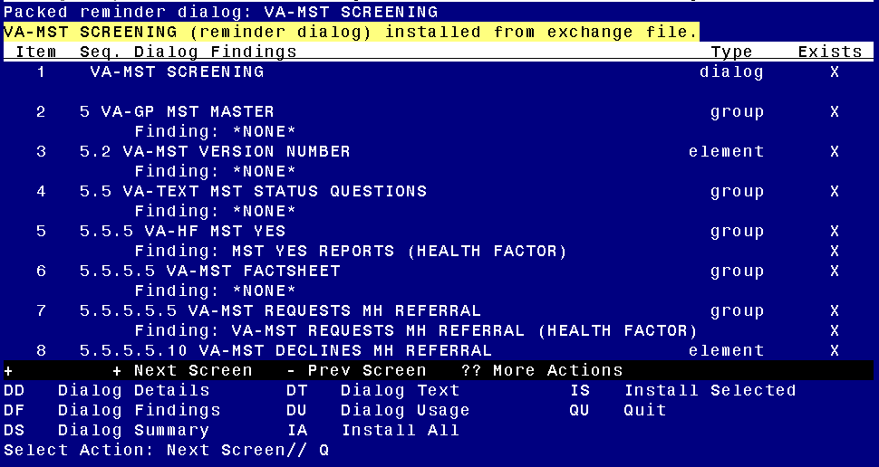

When the dialog has completed installation, you will then be returned to this screen. At the **Select Action** prompt, type **Q.**

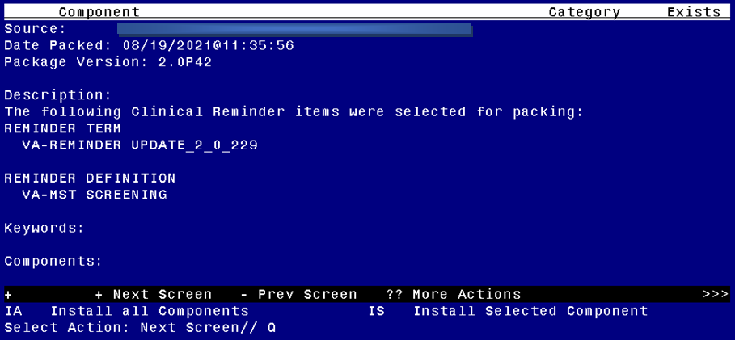

You will then be returned to this screen. At the **Select Action** prompt, type **Q.**

Install complete.

# Post Installation

1. **Add MST Referral identified in pre-install to reminder dialog.** Using the Vista Menu, Reminder Dialog Manager, DI- Reminder Dialog, change view to Group view edit the reminder dialog group VA-MST REQUESTS MH REFERRAL, add the quick order identified in the pre-install as an additional finding.
2. **Open the MST reminder** on a test patient and confirm the version number displayed at the top of the screen is 2.1.
3. **Inquire into the reminder definition VA-MST SCREENING** and confirm the cohort logic matches what is shown below:

Customized PATIENT COHORT LOGIC to see if the Reminder applies to patient:

(FI(4)!FI(9))!((FI(4)!FI(9))&FF(2))