

**Update _2_0_231**

Clinical Reminders

VA-COPD CARE REFERRAL CHART REVIEW

Install Guide

**October 2021**

Product Development

Office of Information Technology

Department of Veterans Affairs

Table of Contents

Introduction 1

Install Details 1

Install Example 2

Post Installation 6

# Introduction

This template will be used to support the referral process for Veterans that recently experienced a COPD exacerbation and were hospitalized in the Hospital or Emergency Department within VA and community care. The template is often used by telehealth nurses, pharmacists, and nurses within PACT. Health factors within this template will be critical for sites to track their referrals and ensure a seamless care transition for Veterans.

UPDATE_2_0_231 contains 1 Reminder Exchange entry:

**UPDATE_2_0_231 VA-COPD CARE REFERRAL CHART REVIEW**

**The exchange file contains the following components:**

**TIU TEMPLATE FIELD**

WORD PROCESS (REQUIRED)

TEXT (1-3)

DATE

**REMINDER TERM**

VA-REMINDER UPDATE_2_0_231

**REMINDER DIALOG**

VA-COPD CARE REFERRAL CHART REVIEW

**HEALTH FACTORS**

|  |
| --- |
| VA-REMINDER UPDATES [C] |
| VA-UPDATE_2_0_231 |
| VA-COPD CARE MANAGEMENT [C] |
| VA-COPD NO REFERRAL OTHER |
| VA-COPD PT DECLINED |
| VA-COPD NO COPD EXACERBATION |
| VA-COPD NONVA CARE |
| VA-COPD NURSING HOME ADMISSION |
| VA-COPD NO COPD DX |
| VA-COPD SPECIALTY CARE |
| VA-COPD NOT REFERRED TO COPD CARE PROG |
| VA-COPD REFER COPD CARE PROG SCHEDULING |
| VA-COPD PHARM REFER FOR COPD CARE PROG |
| VA-COPD RECENT OTHER ADMISSION |
| VA-COPD RECENT COMMUNITY INPATIENT ADMISSION |
| VA-COPD RECENT COMMUNITY ED VISIT |
| VA-COPD RECENT VA INPATIENT ADMISSION |
| VA-COPD RECENT ED VISIT |
| VA-COPD OTHER REFERRAL TO COPD CARE PROG |
| VA-COPD SPEC CARE REFERRAL TO COPD CARE PROG |
| VA-COPD INPAT REFERRAL TO COPD CARE PROG |
| VA-COPD ED REFERRAL TO COPD CARE PROG |
| VA-COPD REFERRAL DASHBOARD  VA-COPD ENROLLED TH NO  VA-COPD ENROLLED TH YES  VA-COPD TELEHEALTH DO NOT REFER  VA-COPD TELEHEALTH REFERRAL RECOMMENDED  VA-COPD TELEHEALTH REFERRAL PLACED |

# Install Details

This update is being distributed as a web host file. The address for the host file is: **https://Redacted/UPDATE_2_0_231.PRD**

The file will be installed using Reminder Exchange, programmer access is not required.

Installation:

=============

This update can be loaded with users on the system. Installation will take less than 5 minutes.

# Install Example

To Load the Web Host File. Navigate to Reminder exchange in Vista

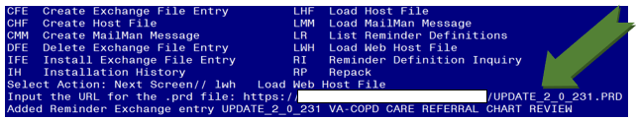

At the **Select Action:** prompt, enter **LWH** for Load Web Host File

At the **Input the url for the .prd file:** prompt, type the following web address:

[**https://vaww.va.gov/reminders/docs/UPDATE_2_0_231.PRD**](https://vaww.va.gov/reminders/docs/UPDATE_2_0_231.PRD)

You should see a message at the top of your screen that the file successfully loaded.

Search and locate an entry titled **UPDATE_2_0_231** VA-COPD CARE REFERRAL CHART REVIEW in reminder exchange.

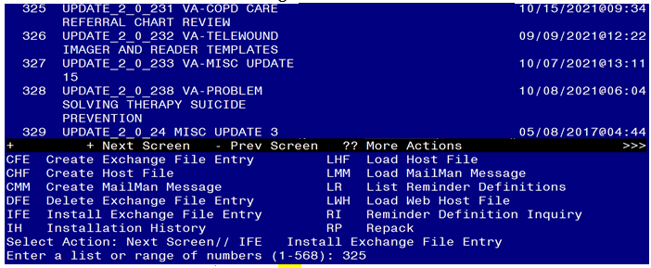

At the **Select Action** prompt, enter **IFE** for Install Exchange File Entry

Enter the number that corresponds with your entry UPDATE_2_0_231 VA-COPD CARE REFERRAL CHART REVIEW *(in this example it is entry 325. It will vary by site).* The date of the exchange file should be 10/15/2021.

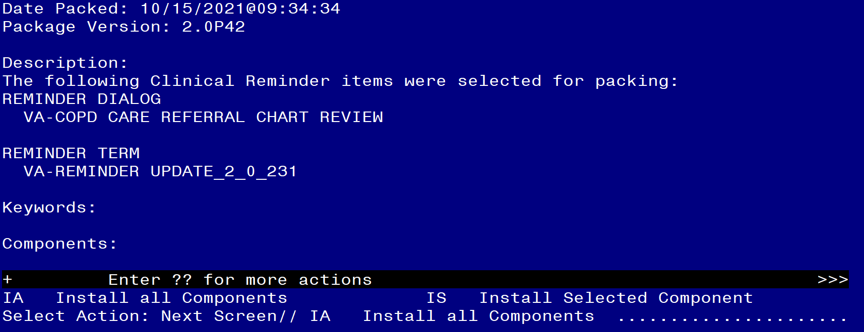

At the **Select Action** prompt, type **IA** for Install all Components and hit enter.

Select Action: Next Screen// IA Install all Components

You will see several prompts, for all new entries you will choose **I to Install**

**Install** all new items.

**You will be promped to install the reminder dialog component (VA-COPD CARE REFERRAL CHART REVIEW).** You will choose to install all even though some components may have an X to indicate that they exist.

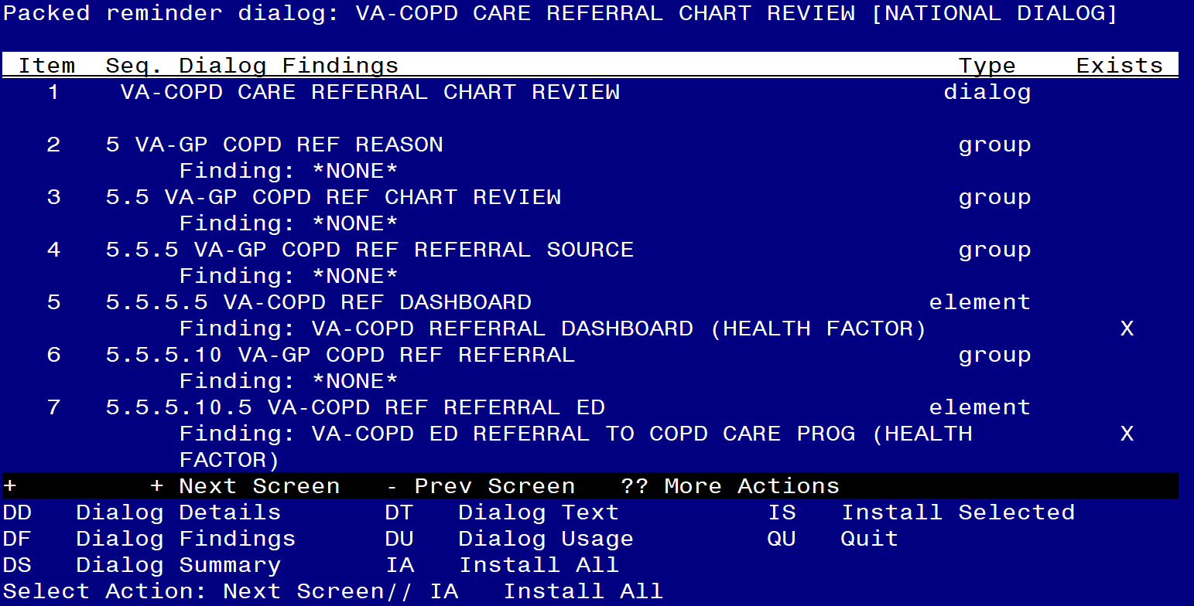

At **Select Action**, type **IA** to install **VA-COPD CARE REFERRAL CHART REVIEW**

Select Action: Next Screen// IA Install All

Install reminder dialog and all components with no further changes: Y// Yes

After completing this dialog install, you will type Q.

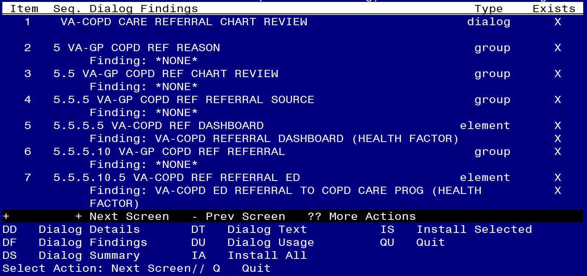

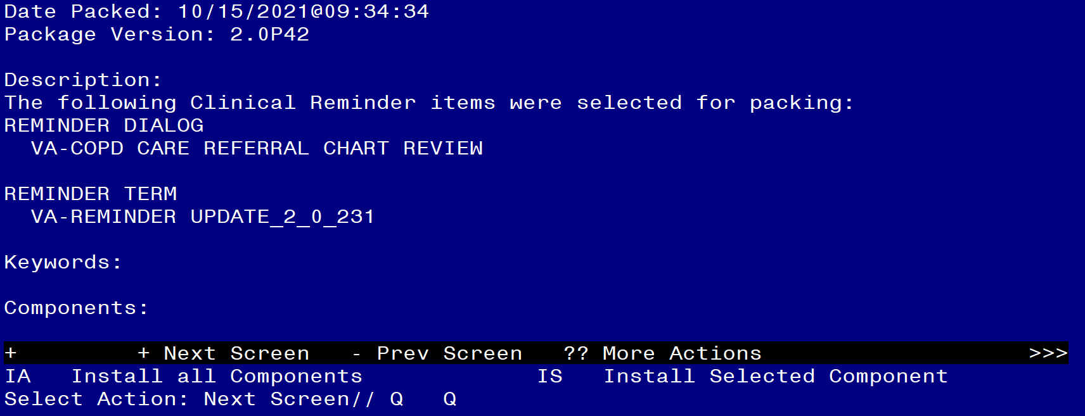

You will then be returned to this screen. At the **Select Action** prompt, type **Q.**

Install complete.

# Post Installation

1. **Map local order dialog or menu for a telehealth consult to the VAL-COPD REF HT PLACED element.**

This element is local. Coordinate with the COPD program staff to determine if this option to order a home telehealth consult should be disabled.

NAME: VAL-COPD REF HT PLACED

DISABLE: Enter “2” if this option should be disabled.

CLASS: LOCAL//

SPONSOR:

REVIEW DATE:

RESOLUTION TYPE:

ORDERABLE ITEM:

Finding item: HF VA-COPD TELEHEALTH REFERRAL PLACED

FINDING ITEM: VA-COPD TELEHEALTH REFERRAL PLACED// Do not change.

Additional findings: none

Select ADDITIONAL FINDING: Enter “Q.” then name of local quick order or menu.

1. **Make the Dialog template available to be attached to a Personal or Shared template or to be able to attach the dialog to a progress note title.**

Select Reminder Managers Menu <TEST ACCOUNT> Option: **CP** CPRS Reminder Configuration

CA Add/Edit Reminder Categories

CL CPRS Lookup Categories

CS CPRS Cover Sheet Reminder List

MH Mental Health Dialogs Active

PN Progress Note Headers

RA Reminder GUI Resolution Active

TIU TIU Template Reminder Dialog Parameter

DEVL Evaluate Coversheet List on Dialog Finish

DL Default Outside Location

PT Position Reminder Text at Cursor

LINK Link Reminder Dialog to Template

TEST CPRS Coversheet Time Test

NP New Reminder Parameters

GEC GEC Status Check Active

WH WH Print Now Active

Select CPRS Reminder Configuration <TEST ACCOUNT> Option: **TIU** TIU Template Reminder Dialog Parameter

Reminder Dialogs allowed as Templates may be set for the following:

1 User USR [choose from NEW PERSON]

3 Service SRV [choose from SERVICE/SECTION]

4 Division DIV [SALT LAKE CITY]

5 System SYS [NATREM.FO-SLC.MED.VA.GOV]

Enter selection: **5** Choose the appropriate number for your site. Your site may do this by System or other levels. The example below uses SYSTEM level.

Select Display Sequence: **?**

388 VA-COVID-19 TELEPHONE FOLLOW-UP

389 VA-SRA-CONSULT RESPONSE (D)

When you type a question mark above, you will see the list of #’s (with dialogs) that are already taken. Choose a number **NOT** on this list. For this example, 390 is not present so I will use 390.

Select Display Sequence: **390**

Are you adding 390 as a new Display Sequence? Yes// **YES**

Display Sequence: 390// **<Enter>**

Clinical Reminder Dialog: **VA-COPD CARE REFERRAL CHART REVIEW**

reminder dialog NATIONAL

...OK? Yes// **<Enter>** (Yes)

1. **Setup of Note Title.**

The note title to create to associate with this template is: **COPD WELLNESS VISIT REFERRAL**

VHA Enterprise Standard Title: **NURSING NOTE**

You can add this to your document class where surgery progress notes are located.

***Note:*** *Comprehensive information on Creating new Document Classes and Titles can be found beginning on page 54 of the TIU/ASU Implementation Guide at the following link:* [*http://www.va.gov/vdl/documents/Clinical/CPRS-Text_Integration_Utility_(TIU)/tiuim.pdf*](http://www.va.gov/vdl/documents/Clinical/CPRS-Text_Integration_Utility_(TIU)/tiuim.pdf)

1. **Associate the reminder dialog with the note title in CPRS**

In CPRS, open the Template Editor, expand Document Titles, select the appropriate folder (if applicable), then click New Template (top right-hand corner).

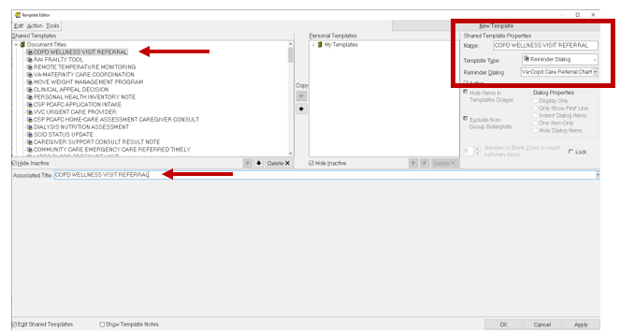

Type in the following information:

Name: **COPD WELLNESS VISIT REFERRAL**

Template Type: **Reminder Dialog**

Reminder Dialog: **VA-COPD CARE REFERRAL CHART REVIEW**

Next, type in the Associated Title name – **COPD WELLNESS VISIT REFERRAL**

– then click Apply.

1. **Link the dialog to a shared template in CPRS if desired.**