

**Update_2_0_232**

Clinical Reminders

VA-TELEWOUND IMAGER AND READER TEMPLATES

Install Guide

**December 2021**

Product Development

Office of Information Technology

Department of Veterans Affairs

**Table of Contents**

Introduction 1

Install Details 2

Install Example 2

Post Installation 6

# Introduction

The imaging templates will be used by Nurses/telehealth care technicians when they image a Veterans wound in the field following a consult placed by Primary care providers/wound care specialist. The settings will vary based on the need. Imaging can take place in outpatient setting, inpatient setting, or into the home. The imaging will also occur in an intra/inter facility capacity. The reader template will be used by wound care specialists following the imaging to assess image quality and provide guidance on wound treatment and management.

**UPDATE_2_0_232 contains 1 Reminder Exchange entry:**

UPDATE_2_0_232 VA-TELEWOUND IMAGER AND READER TEMPLATES

**The exchange file contains the following components:**

**TIU TEMPLATE FIELD**

TEXT (1-50 CHAR) REQ

WP FREE TEXT REQ(74X4)

VA*WP 65/6 INDENT2

TEXT (1-70) REQUIRED

PAIN SCALE 0-10

EDIT 20 (REQ)

EDIT 45(REQUIRED)

WOUND DRESSSINGS

EDIT 20

YES NO NA

VA-TELEWOUND BETTER/WORSE/SAME

YES/NO (R/VERT)

YES/NO/NA (R/VERT)

**HEALTH FACTORS**

VA-REMINDER UPDATES [C]

VA-UPDATE_2_0_232

VA-TELEWOUND IMAGE QUALITY [C]

VA-TWR IMAGE QUALITY NEEDS IMPROVEMENT

VA-TWR IMAGE QUALITY INADEQUATE

VA-TWR IMAGE QUALITY ADEQUATE

VA-TELEWOUND IMAGER TECHNOLOGY [C]

VA-TWI TECHNOLOGY-OTHER

VA-TWI TECHNOLOGY-TE3

VA-TWI TECHNOLOGY-3D IMAGE

VA-TWI TECHNOLOGY-POINT AND SHOOT

**REMINDER SPONSOR**

OFFICE OF TELEHEALTH SERVICES STORE AND FORWARD TELEHEALTH

**REMINDER TERM**

VA-REMINDER UPDATE_2_0_232

**REMINDER DIALOG**

VA-TELEWOUND READER NOTE

VA-TELEWOUND IMAGER NOTE

# Install Details

This update is being distributed as a web host file. The address for the host file is: **https://REDACTED/UPDATE_2_0_232.PRD**

The file will be installed using Reminder Exchange, programmer access is not required.

Installation:

=============

This update can be loaded with users on the system. Installation will take less than 20 minutes.

# Install Example

To Load the Web Host File. Navigate to Reminder exchange in Vista

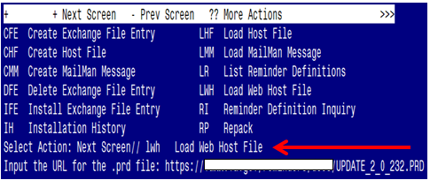

At the **Select Action:** prompt, enter **LWH** for Load Web Host File

At the **Input the url for the .prd file:** prompt, type the following web address:

**https://REDACTED/UPDATE_2_0_232.PRD**

You should see a message at the top of your screen that the file successfully loaded.

Terminal window screen shot of the message displaying the URL of the file that was successfully loaded.  Part of the URL has been redacted as it is a VA only internal web site URL.

Search for and locate the reminder exchange entry titled UPDATE_2_0_232 VA-TELEWOUND IMAGER AND READER TEMPLATES.

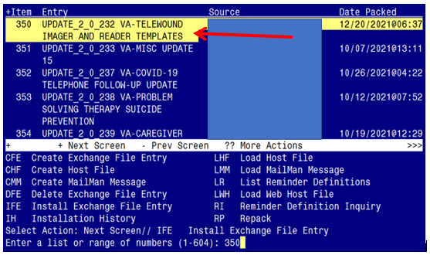

At the **Select Action** prompt, enter **IFE** for Install Exchange File Entry

Enter the number that corresponds with your entry titled **UPDATE_2_0_232 VA-TELEWOUND IMAGER AND READER TEMPLATES** *(in this example it is entry 350, it will vary by site).* The exchange file date should be 12/20/2021@06:37.

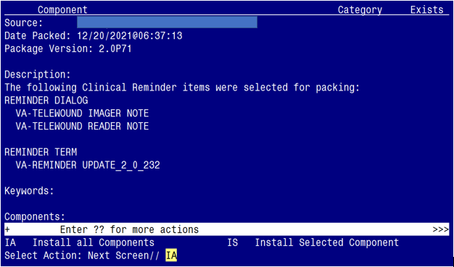

At the **Select Action** prompt, type **IA** for Install all Components and hit enter.

Select Action: Next Screen// IA Install all Components

For any new components choose – I to INSTALL

For any existing components choose - S to SKIP

**You will be promped to install the 1st dialog component:**

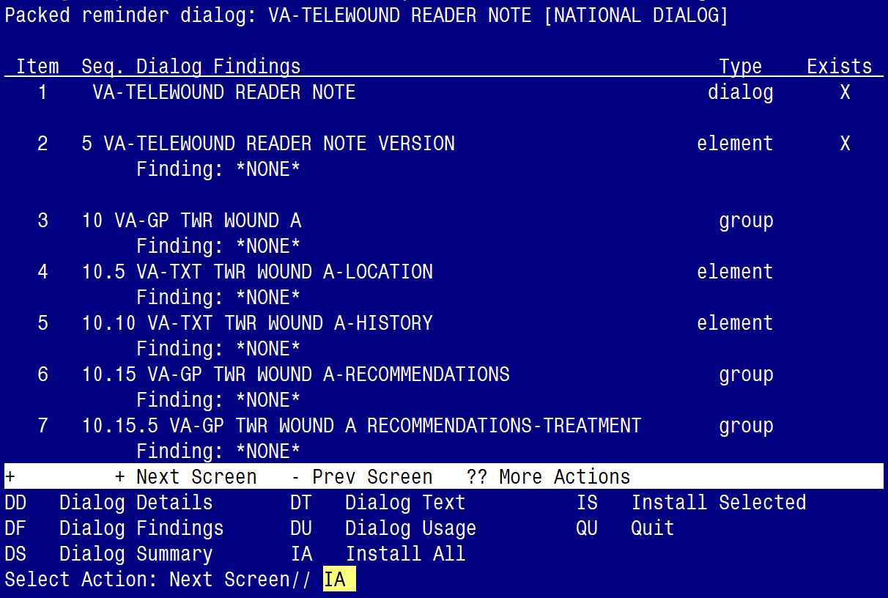

At the **Select Action** prompt, type **IA** to install the dialog – **VA-TELEWOUND READER NOTE**

Select Action: Next Screen// IA Install All

Install reminder dialog and all components with no further changes: Y// ES

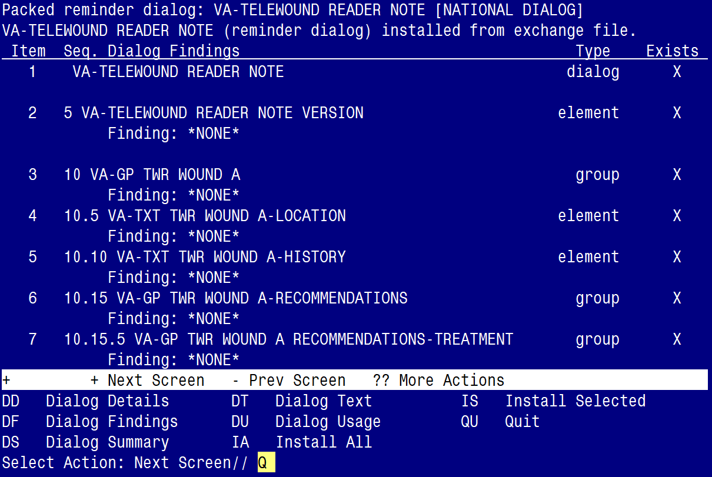

When the dialog has completed installation, you will then be returned to this screen. At the **Select Action** prompt, type **Q.**

**You will be promped to install the 2nd dialog component:**

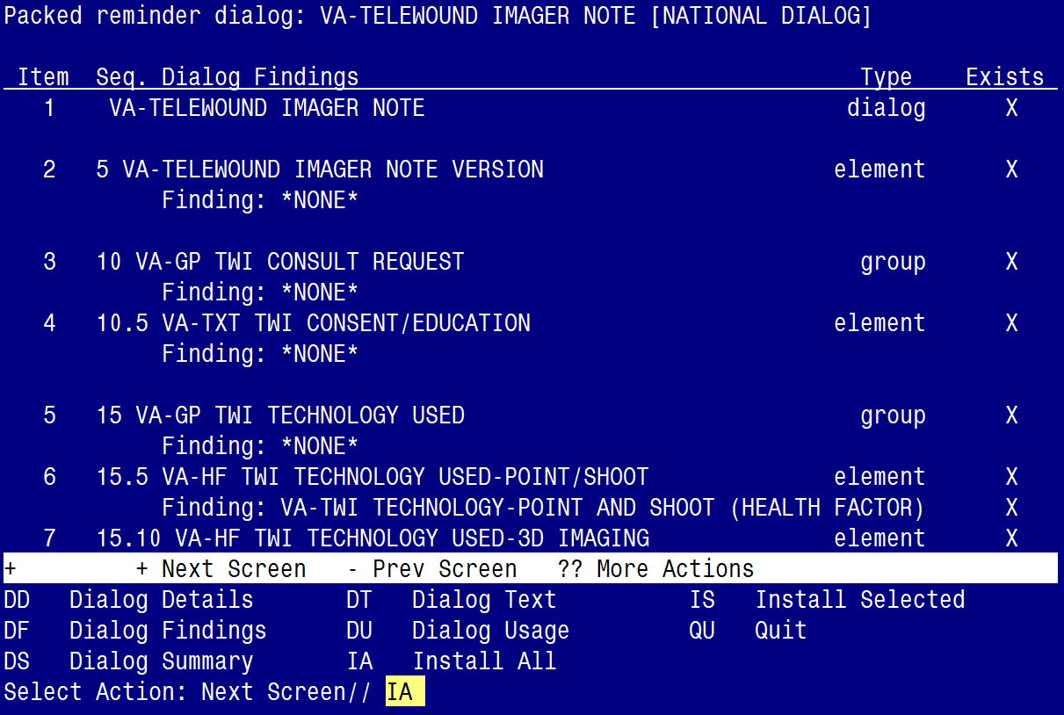

At the **Select Action** prompt, type **IA** to install the dialog – **VA-TELEWOUND IMAGER NOTE**

Select Action: Next Screen// IA Install All

Install reminder dialog and all components with no further changes: Y// ES

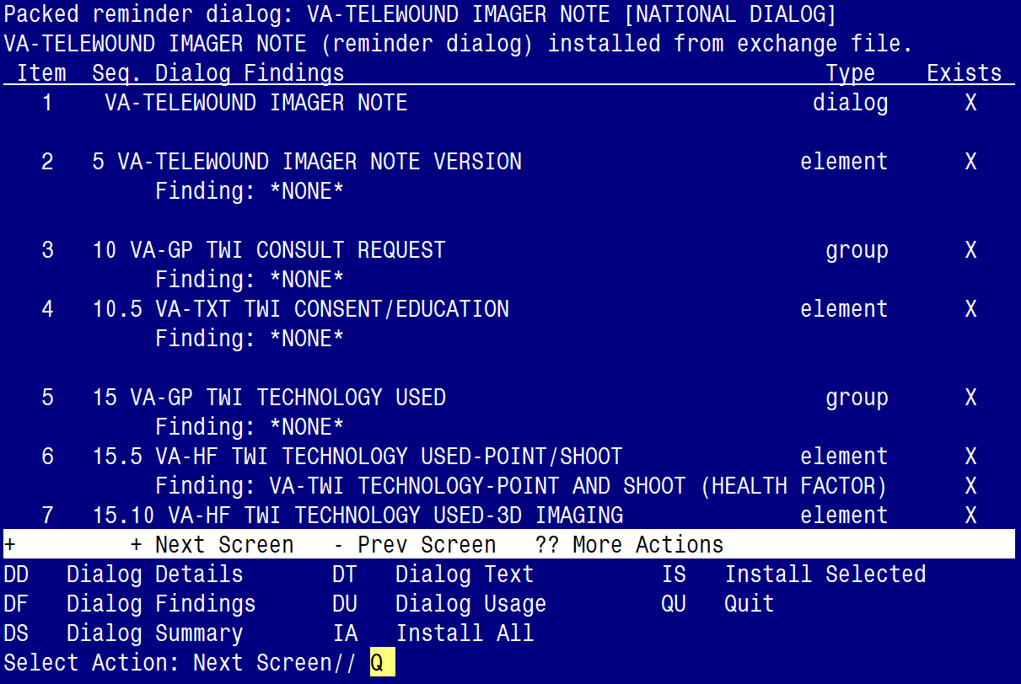

When the dialog has completed installation, you will then be returned to this screen. At the **Select Action** prompt, type **Q.**

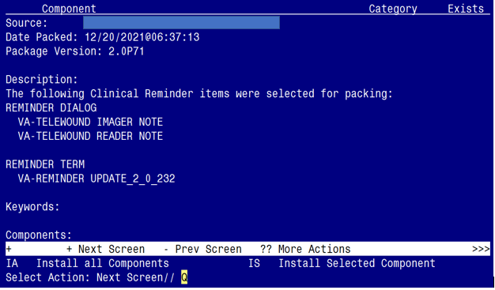

You will be returned to this screen. Type Q to quit.

Install Completed

# Post Installation

1. **Make the Dialog templates available to be attached to a Personal or Shared templates or to be able to attach the dialog to a progress note title.**

Select Reminder Managers Menu <TEST ACCOUNT> Option: **CP** CPRS Reminder Configuration

CA Add/Edit Reminder Categories

CL CPRS Lookup Categories

CS CPRS Cover Sheet Reminder List

MH Mental Health Dialogs Active

PN Progress Note Headers

RA Reminder GUI Resolution Active

TIU TIU Template Reminder Dialog Parameter

DEVL Evaluate Coversheet List on Dialog Finish

DL Default Outside Location

PT Position Reminder Text at Cursor

LINK Link Reminder Dialog to Template

TEST CPRS Coversheet Time Test

NP New Reminder Parameters

GEC GEC Status Check Active

WH WH Print Now Active

Select CPRS Reminder Configuration <TEST ACCOUNT> Option: **TIU** TIU Template Reminder Dialog Parameter

Reminder Dialogs allowed as Templates may be set for the following:

1 User USR [choose from NEW PERSON]

3 Service SRV [choose from SERVICE/SECTION]

4 Division DIV [SALT LAKE CITY]

5 System SYS [NATREM.FO-SLC.MED.VA.GOV]

Enter selection: **5** *Choose the appropriate number for your site. Your site may do this by System or other levels. The example below uses SYSTEM level.*

Setting Reminder Dialogs allowed as Templates for System: NATREM.FO-SLC.MED.VA.GOV

Select Display Sequence: **?**

388 VA-COVID-19 TELEPHONE FOLLOW-UP

389 VA-SRA-CONSULT RESPONSE (D)

*When you type a question mark above, you will see the list of #’s (with dialogs) that are already taken. Choose a number* ***NOT*** *on this list. For this example, 390 is not present so I will use 390.*

Select Display Sequence: **390**

Are you adding 390 as a new Display Sequence? Yes// **YES**

Display Sequence: 390// <Enter> 390

Clinical Reminder Dialog: **VA-TELEWOUND IMAGER NOTE** reminder dialog NATIONAL

...OK? Yes// <Enter> (Yes)

**REPEAT THIS STEP TO ADD THE 2ND DIALOG AS A SEQUENCE**

Display Sequence: 391// <Enter> 391

Clinical Reminder Dialog: **VA-TELEWOUND READER NOTE** reminder dialog NATIONAL

...OK? Yes// <Enter> (Yes)

1. **Setup of Note Titles.**

The note titles to create to associate with these templates are:

**TELEWOUND IMAGER CONSULT NOTE**

**TELEWOUND READER CONSULT NOTE**

VHA Enterprise Standard Title: **TELEHEALTH CONSULT**

**You can add these to your document class where CONSULTS are located.**

***Note:*** *Comprehensive information on Creating new Document Classes and Titles can be found beginning on page 54 of the TIU/ASU Implementation Guide at the following link:* [*http://www.va.gov/vdl/documents/Clinical/CPRS-Text_Integration_Utility_(TIU)/tiuim.pdf*](http://www.va.gov/vdl/documents/Clinical/CPRS-Text_Integration_Utility_(TIU)/tiuim.pdf)

1. **Associate the reminder dialogs with the note titles in CPRS**

In CPRS, open the Template Editor, expand Document Titles, select the appropriate folder (if applicable), then click New Template (top right-hand corner).

Screen shot showing the Template Editor in CPRS.  Under Shared Templates, Document Titles is expanded and TELE-WOUND IMAGER CONSULT NOTE is hightlighted, the same title is entered in Associate Title.
Under New Template, Shared Template Properties, the name TELE-WOUND IMAGER CONSULT NOTE is entered, template type is Reminder Dialog and Reminder Dialog has Va-Telemedicine Imager Note is entered.  Active is checked.

Type in the following information:

Name: **TELE-WOUND IMAGER CONSULT NOTE**

Template Type: **Reminder Dialog**

Reminder Dialog: **VA-TELEWOUND IMAGER NOTE**

Next, type in the Associated Title name – **TELE-WOUND IMAGER CONSULT NOTE** – then click Apply.

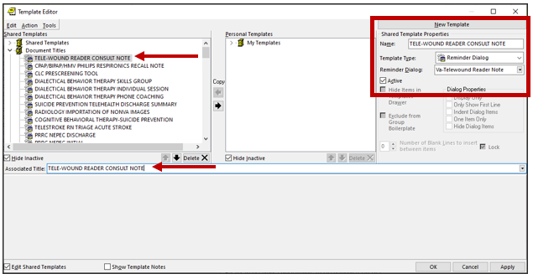

Type in the following information:

Name: **TELE-WOUND READER CONSULT NOTE**

Template Type: **Reminder Dialog**

Reminder Dialog: **VA-TELEWOUND READER NOTE**

Next, type in the Associated Title name – **TELE-WOUND READER CONSULT NOTE** – then click Apply.