

**Update \_2\_0\_235**

Clinical Reminders

VA-DEMENTIA WARNING SIGNS

**March 2022**

Product Development

Office of Information Technology

Department of Veterans Affairs

Table of Contents

[Introduction 1](#_Toc86040273)

[Pre-Install 2](#_Toc86040274)

[Install Details 2](#_Toc86040275)

[Install Example 3](#_Toc86040276)

[Post-Installation 8](#_Toc86040277)

# Introduction

DESCRIPTION:

The VHA Dementia Warning Signs Template should be used at any site for documenting observed or reported dementia warning signs and documenting the initiation of, or referral for, a dementia workup.

The template is intended for use by VA clinical staff primarily in primary care settings, i.e., Patient-Aligned Care Teams (PACT), Community-Based Outpatient Clinics (CBOC), Home-Based Primary Care (HBPC), and Geriatric Patient Aligned Care Teams (Geri-PACT).

When primary care team members observe dementia warning signs or have dementia warning signs reported to them for one of their patients, they should open the national VHA Dementia Warning Signs Template to document the observed or reported dementia warning signs and to document their initiation of a dementia workup, including referral(s) to specialty care providers as needed.

This template is to be used ONLY when warning signs have been identified.

Please note: The presence of dementia warning signs does not mean the patient has dementia. However, an evaluation is recommended.

Thank you to the following test sites who installed and tested this reminder update:

East Orange

Cleveland

San Diego

Black Hills

UPDATE\_2\_0\_235 contains 1 Reminder Exchange entry: UPDATE\_2\_0\_235 VA-DEMENTIA WARNING SIGNS with the following components:

**TIU TEMPLATE FIELD**

1 VA-BLANK IN PN TEXT

2 VA-DWS FIREARM SAFETY CLINICIAN LINK

3 VA-DWS FIREARM SAFETY LINK

4 VA-WORD PROCESS

5 VA-BLANK SP

6 VA-CLINICIAN FACT SHEET DCI

7 VA-NCP PREVENTATIVE SERVICES GUIDANCE LINK

8 VA-DEMENTIA STEERING COMMITTEE LINK

**HEALTH FACTORS**

9 VA-REMINDER UPDATES [C]

10 VA-UPDATE\_2\_0\_235

11 VA-DEMENTIA REPORTED BY [C]

12 VA-DEMENTIA REPORTED BY

13 VA-DEMENTIA OTHER CONCERNS [C]

14 VA-DWS GUN UTD

15 VA-DWS GUN NO

16 VA-DWS GUN

17 VA-DWS DRIVE UTD

18 VA-DWS DRIVE NO

19 VA-DWS DRIVE

20 VA-DEMENTIA WARNING SIGNS [C]

21 VA-DWS OTHER WARNING SIGNS

22 VA-DWS SELF CARE

23 VA-DWS CONFUSED

24 VA-DWS DIRECTIONS

25 VA-DWS LOST

26 VA-DWS ASK SAME QUESTIONS

27 VA-DWS FAILS TO FOLLOW

28 VA-DWS FORGETFUL

29 VA-DWS UNKEMPT

30 VA-DWS APPOINTMENT

31 VA-DWS REPORT [C]

32 VA-DWS COMPLETED

33 VA-DWS FOLLOW-UP COMPLETED

**REMINDER TERM**

34 VA-REMINDER UPDATE\_2\_0\_235

**HEALTH SUMMARY COMPONENT**

PCE HEALTH FACTORS SELECTED

**HEALTH SUMMARY TYPE**

35 VA-DWS REPORTED

**HEALTH SUMMARY OBJECTS**

36 VA-DWS REPORTED (TIU)

**TIU DOCUMENT DEFINITION**

37 VA-DWS REPORTED

**REMINDER DIALOG**

38 VA-DEMENTIA WARNING SIGNS

# Pre-Install

None

# Install Details

This update is being distributed as a web host file. The address for the host file is: **https://vaww.va.gov/reminders/docs/UPDATE\_2\_0\_235.PRD**

The file will be installed using Reminder Exchange, programmer access is not required.

This update can be loaded with users on the system. Installation will take less than 5 minutes

# Install Example

To Load the Web Host File. Navigate to Reminder exchange in Vista

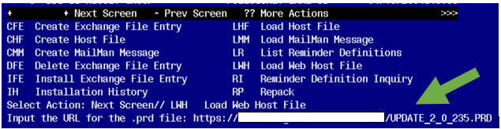

At the **Select Action:** prompt, enter **LWH** for Load Web Host File

At the **Input the url for the .prd file:** prompt, type the following web address:

**https://Redacted/UPDATE\_2\_0\_235.PRD**

**You should see a message that the file was successfully loaded.**

**Terminal window screen shot of the message displaying the URL of the file that was successfully loaded.  Part of the URL has been redacted as it is a VA only internal web site URL.**

**This will install one exchange entries in your exchange file**

Added Reminder Exchange entry UPDATE\_2\_0\_235 VA-DEMENTIA WARNING SIGNS

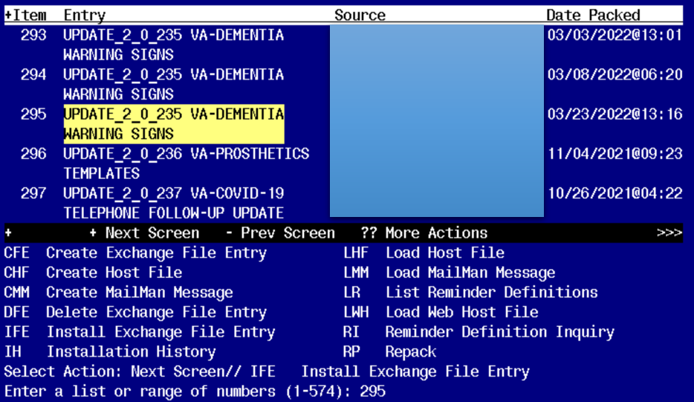

Search and locate an entry titled **UPDATE\_2\_0\_235 VA-DEMENTIA WARNING SIGNS**

At the **Select Action** prompt, enter **IFE** for Install Exchange File Entry

Enter the number that corresponds with your entry **UPDATE\_2\_0\_235 VA-DEMENTIA WARNING SIGNS.**  *(in this example it is entry 295 it will vary by site).* The date of the exchange file should be 03/23/2022. .

**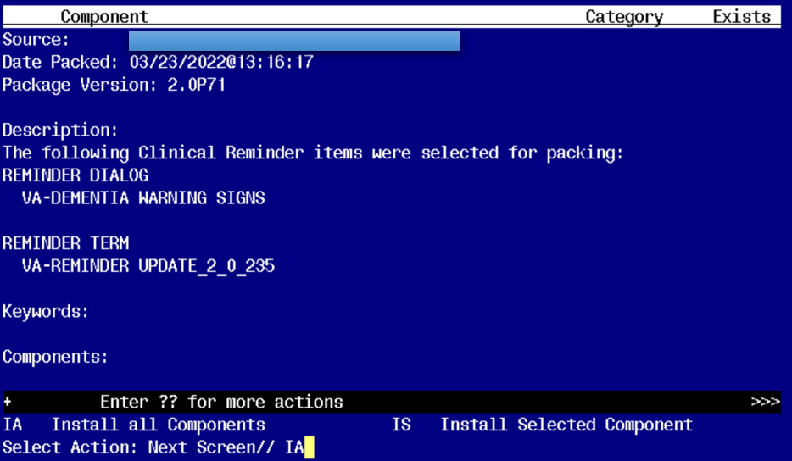**

At the **Select Action** prompt, type **IA** for **Install all Components** and hit enter.

Any items that are NEW in any categories, you should INSTALL

There should not be any items that are pre-existing.

You will then be prompted to install the reminder dialog component, you will choose IA to install even though most items will have an X to indicate they already exist.

For the Reminder Dialog VA_DEMENTIA WARNING SIGNS [NATIONAL DIALOG]:
Screen shot of the terminal window showing a list of elements, groups and dialogs with the text with IA for "Install All" entered at the "Select Action:" Prompt.  The correct entry is described in the text.


At the **Select Action** prompt, type **IA** to install the dialog – **VA-DEMENTIA WARNING SIGNS**

**For the Reminder Dialog VA_DEMENTIA WARNING SIGNS [NATIONAL DIALOG]:
After all of the installation is done, Q is entered for Quit.**

You will then be returned to this screen. At the **Select Action** prompt, type **Q.**

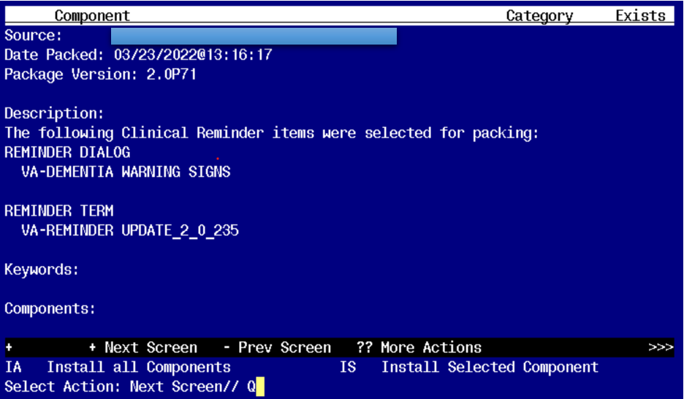

You will then be returned to this screen. At the **Select Action** prompt, type **Q.**

Install complete.

# Post-Installation

1. **Make the Dialog template available to be attached to a Personal or Shared template or to be able to attach the dialog to a progress note title.**

Select Reminder Managers Menu <TEST ACCOUNT> Option: **CP** CPRS Reminder Configuration

CA Add/Edit Reminder Categories

CL CPRS Lookup Categories

CS CPRS Cover Sheet Reminder List

MH Mental Health Dialogs Active

PN Progress Note Headers

RA Reminder GUI Resolution Active

TIU TIU Template Reminder Dialog Parameter

DEVL Evaluate Coversheet List on Dialog Finish

DL Default Outside Location

PT Position Reminder Text at Cursor

LINK Link Reminder Dialog to Template

TEST CPRS Coversheet Time Test

NP New Reminder Parameters

GEC GEC Status Check Active

WH WH Print Now Active

Select CPRS Reminder Configuration <TEST ACCOUNT> Option: **TIU** TIU Template Reminder Dialog Parameter

Reminder Dialogs allowed as Templates may be set for the following:

1 User USR [choose from NEW PERSON]

3 Service SRV [choose from SERVICE/SECTION]

4 Division DIV [SALT LAKE CITY]

5 System SYS [NATREM.FO-SLC.MED.VA.GOV]

Enter selection: **5** *Choose the appropriate number for your site. Your site may do this by System or other levels. The example below uses SYSTEM level.*

Setting Reminder Dialogs allowed as Templates for System: NATREM.FO-SLC.MED.VA.GOV

Select Display Sequence: **?**

388 VA-COVID-19 TELEPHONE FOLLOW-UP

389 VA-SRA-CONSULT RESPONSE (D)

*When you type a question mark above, you will see the list of #’s (with dialogs) that are already taken. Choose a number* ***NOT*** *on this list. For this example, 390 is not present so I will use 390.*

Select Display Sequence: **390**

Are you adding 390 as a new Display Sequence? Yes// **YES**

Display Sequence: 390// <Enter> 390

Clinical Reminder Dialog: **VA-DEMENTIA WARNING SIGNS** reminder dialog NATIONAL

...OK? Yes// <Enter> (Yes)

1. **Add local consult orders if there are any. This group and all elements are local so if a site has more services that would be appropriate, more can be added. Any of the services listed above can be modified to match what is available at the local site. If you change the template display text make sure to also change the alternate text to match. If your site has no orders to add or decides not to add orders this group should be disabled.**

26 4.25 Group: VAL-GP DEMENTIA WS REFERRAL  
 Text: Optional Referrals:  
 [BOX, SUPPRESS, SHOW, NO SELECTION]  
  
 27 4.25.5 Element: VAL-DEMENTIA WS REFERRAL GERIATRIC  
 Text: A referral was made for a geriatric evaluation.  
  
 28 4.25.10 Element: VAL-DEMENTIA WS REFERRAL SOCIAL WORK  
 Text: A referral was made for social work.  
  
 29 4.25.15 Element: VAL-DEMENTIA WS REFERRAL DEMENTIA CLINIC  
 Text: A referral was made for the dementia clinic.  
  
 30 4.25.20 Element: VAL-DEMENTIA WS REFERRAL PCMHI

  78   65.20.10  Group: VA-GP DWS PLAN - REFERRED

                  Text: [BOX, SUPPRESS, SHOW, NO SELECTION]

  79   65.20.10.10  Element: VAL-DWS REFERRED INSTRUCTIONAL TEXT

                       Text: Consider referral to

                              (the following options will enter a consult to the

                             corresponding service)

  80   65.20.10.20  Element: VAL-DWS REFERRAL TO SOCIAL WORK

                       Text: Social Work consult entered.

  81   65.20.10.30  Element: VAL-DWS GERIATRIC CONSULT

                       Text: Geriatric Clinic consult entered.

  82   65.20.10.50  Element: VAL-DWS GERIATRIC PSYCH

                       Text: Geriatric Psychiatric consult entered.

  83   65.20.10.60  Element: VAL-DWS NEUROLOGY CONSULT

                       Text: Neurology consult entered.

  84   65.20.10.65  Element: VAL-DWS PCMHI

                       Text: Referred to PCMHI.

  85   65.20.10.70  Element: VAL-DWS DEMENTIA CLINIC

                       Text: Dementia clinic consult entered.

1. **An order set or individual quick orders can be added as finding items to this group. Make sure to change the text so the user will know what they are getting when they click this option. Local elements can also be added to this group if sites decide to have orders placed** individually rather than all with one click. If your site decides not to add orders this group should be disabled.

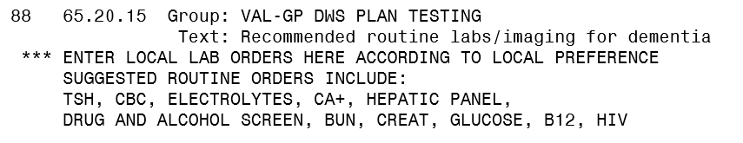

Other diagnostic testing:

1. **An order set or individual quick orders can be added as finding items to this group. Make sure to change the text so the user will know what they are getting when they click this option. Local elements can also be added to this group if sites decide to have orders placed individually rather than all with one click. If your site has no orders to add or decides not to add orders this group should be disabled**

**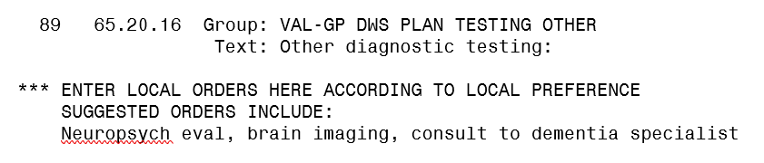**

Local elements can be added to this group to include any quick orders for the recommended testing for the items listed above. Work with your local specialists to determine what orders to include.

1. **Elements can be added to this group to allow for finding items for some of these less common tests if your site has them available.**

**