

**Update _2_0_237**

Clinical Reminders

VA-COVID-19 TELEPHONE FOLLOW-UP UPDATE

Install Guide

**October 2021**

Product Development

Office of Information Technology

Department of Veterans Affairs

Table of Contents

Introduction 1

Pre-Install 3

Install Details 4

Install Example 4

Post Installation 8

# Introduction

This update contains several updates to the VA-COVID-19 TELEPHONE FOLLOW-UP Reminder Dialog.

Description:

1. For patients that are being followed up on or being notified of positive results, if patients have mild to moderate illness, there is an additional option in the care disposition section to document if the patient is a candidate for monoclonal antibodies
2. For asymptomatic patients being notified of positive results, there is a message about monoclonal antibody treatment if they become symptomatic.
3. In the plan section, there was an additional item added for referral to Infection Control and also an addition added regarding vaccination
4. Additional spacing between sections was added to the dialog and also the progress note.

UPDATE_2_0_237 contains 1 Reminder Exchange entry:

UPDATE_2_0_237 VA-COVID-19 TELEPHONE FOLLOW-UP UPDATE

**The exchange file contains the following components:**

**REMINDER GENERAL FINDINGS**

VA-NALOXONE RX OTHER

**TIU TEMPLATE FIELD**

VA-TIME SPENT

DATE

WORD PROC 70X5

VA-CDC DISPOSITION

VA-WORD

ADDITIONAL INFO (DISP ONLY)

HYPERLINK COVID-19 PREVENT SPREAD

HYPERLINK COVID-19 HOW TO PROTECT SELF

**HEALTH FACTORS**

VA-REMINDER UPDATES [C]

VA-UPDATE_2_0_237

VA-COVID-19 [C]

VA-HOME MONITORING BLOOD PRESSURE

VA-HOME MONITORING PULSE OX

VA-HOME MONITORING TEMP

VA-COVID-19 FOLLOW UP PC

VA-COVID-19 PLAN OTHER FOLLOW UP

VA-COVID-19 PLAN SECURE MESSAGE

VA-COVID-19 PLAN ANNIE AP FOLLOW UP

VA-COVID-19 PLAN CONTINUE CALLS

VA-COVID-19 PLAN PROVIDE PREVENTION INFO

VA-COVID-19 PLAN CONTACT VA NURSE LINE

VA-COVID-19 ASYMPTOMATIC RELEASE ISOLAT

VA-COVID-19 ASYMPTOMATIC

VA-COVID-19 PATIENT WORSENING

VA-COVID-19 STABLE RELEASE ISOLATION

VA-COVID-19 PATIENT STABLE

VA-COVID-19 IMPROVE RELEASE ISOLATION

VA-COVID-19 PATIENT IMPROVING

VA-COVID-19 UNABLE TO CARE FOR SELF HOME

VA-COVID-19 CAN CARE FOR SELF AT HOME

VA-COVID-19 NO SYMPTOMS

VA-SYMPTOM VOMITING

VA-SYMPTOM SORE THROAT

VA-SYMPTOM SHORTNESS OF BREATH

VA-SYMPTOM RUNNY NOSE

VA-SYMPTOM NAUSEA

VA-SYMPTOM MUSCLE PAIN

VA-SYMPTOM LOSS OF TASTE OR SMELL

VA-SYMPTOM HEADACHE

VA-SYMPTOM FEVER

VA-SYMPTOM FATIGUE

VA-SYMPTOM DIARRHEA

VA-SYMPTOM COUGH

VA-SYMPTOM CHILLS

VA-TRAVEL SCREEN [C]

VA-EXPOSURE TO COVID NO

VA-EXPOSURE TO COVID YES

VA-EXPOSURE TO FEVER/RESP ILL 14D

VA-COVID-19 DC TEST POSITIVE

VA-COVID-19 DC TEST NEGATIVE

VA-COVID-19 OUTSIDE PCR SPEC COLLECTED

VA-COVID-19 NON PCR AG LAB OUTSIDE NEG

VA-COVID-19 UNK OUTSIDE LAB TEST NEG

VA-COVID-19 PCR LAB OUTSIDE NEGATIVE

VA-COVID-19 NON PCR AG LAB OUTSIDE POS

VA-COVID-19 UNK OUTSIDE LAB TEST POS

VA-COVID-19 PCR LAB OUTSIDE POSITIVE

VA-COVID-19 UNABLE TO LEAVE MESSAGE

VA-COVID-19 UNABLE TO REACH PATIENT

**REMINDER TERM**

VA-REMINDER UPDATE_2_0_237

**HEALTH SUMMARY TYPE**

COVID19 LAB RESULTS

**HEALTH SUMMARY OBJECTS**

COVID19 LAB RESULTS (TIU)

**TIU DOCUMENT DEFINITION**

COVID19 LAB RESULTS

**REMINDER DIALOG**

VA-COVID-19 TELEPHONE FOLLOW-UP

# Pre-Install

Sites had the ability to make local changes of this reminder dialog, they also had the option of disabling some of the components used in the plan section. Using the Vista menu Reminder Dialog Manager, Reminder Dialog, change your view to GROUP and choose inquire/print for the following reminder dialog groups:

VAL-COVID 19 RESULTS NEGATIVE LOCAL INFORMATION

VAL-GP COVID-19 FOLLOW UP CALL

VAL-GP COVID-19 FOLLOW-UP PLAN EDUCATION

The reminder dialog element **VAL-COVID-19 FOLLOW-UP PLAN ED NURSE HOTLINE** contains the VA nurse phone line information, this is a local element and you may have edited the dialog text to add a specific phone number. Using the Vista menu Reminder Dialog Manager, Reminder Dialog, change your view to ELEMENT and choose inquire/print for this element.

There is a reminder dialog element in the plan that indicated that the ANNIE service will be used, if your site does not offer this service, you may have edited this element **VAL-COVID-19 FOLLOW-UP PLAN ANNIE**  and set to DISABLE AND DO NOT SEND MESSAGE. Using the Vista menu Reminder Dialog Manager, Reminder Dialog, change your view to ELEMENT and choose inquire/print for this element.

Save this info for the post install, it will make comparing and adding information back post -install easier if your site has made local edits. Not all sites will have made local edits to these dialog groups and elements.

# Install Details

This update is being distributed as a web host file. The address for the host file is: https://Redacted/UPDATE_2_0_237.PRD

The file will be installed using Reminder Exchange, programmer access is not required.

Installation:

=============

This update can be loaded with users on the system. Installation will take less than 2 minutes.

# Install Example

To Load the exchange file, use LWH. The URL is https://Redacted/UPDATE_2_0_237.PRD

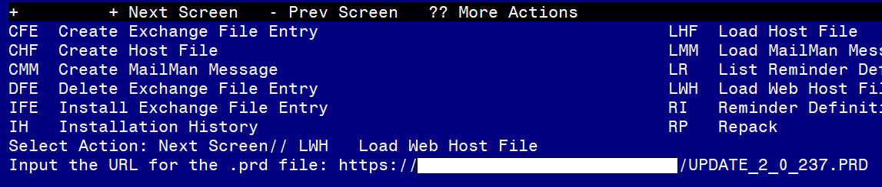

If you use LWH and it works, you will see something like this message. Make sure the file was loaded successfully.

Terminal window screen shot of the message displaying the URL of the file that was successfully loaded.  Part of the URL has been redacted as it is a VA only internal web site URL.

Search and locate an entry titled UPDATE_2_0_237 VA-COVID-19 TELEPHONE FOLLOW-UP UPDATE in reminder exchange.

At the **Select Action** prompt, enter **IFE** for Install Exchange File Entry

Enter the number that corresponds with your entry titled UPDATE_2_0_237 VA-COVID-19 TELEPHONE FOLLOW-UP UPDATE *(in this example it is entry 217, it will vary by site)* that is dated 10/26/2021.

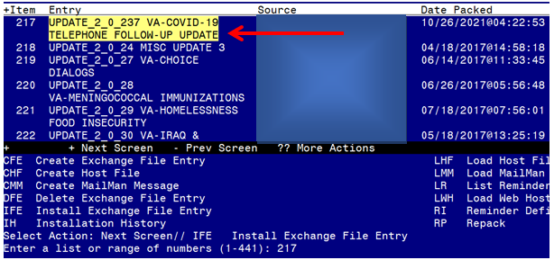

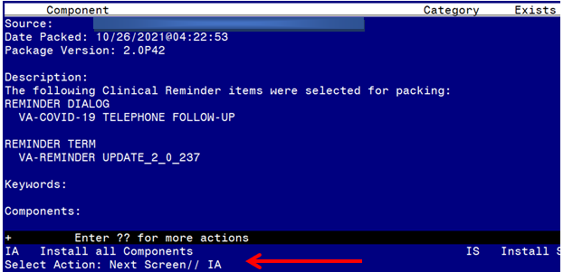

At the **Select Action** prompt, type **IA** for Install all Components and hit enter.

**For all new entries in any category you will choose I to Install**

**Skip any items in any category you are prompted to overwrite**

You will then be prompted to install the dialog component. You will choose IA to install all even though some items will already have an X to indicate they exist.

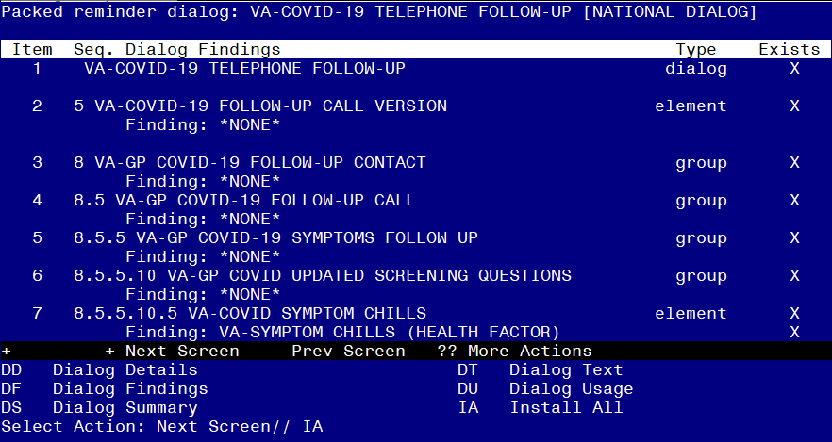

At the **Select Action** prompt, type **IA** to install the dialog – **VA-COVID-19 TELEPHONE FOLLOW-UP**

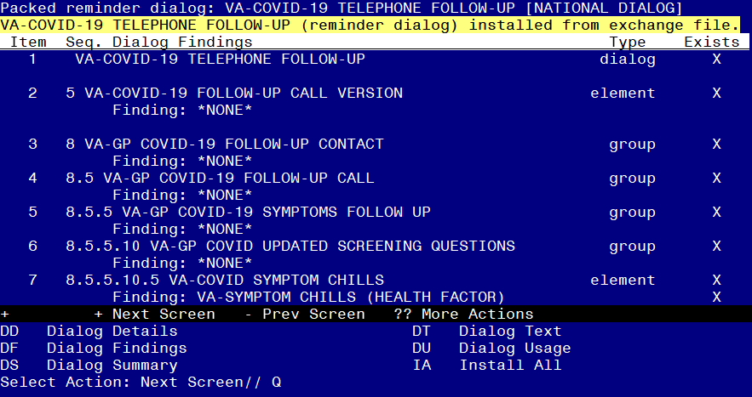

When the dialog has completed installation, you will then be returned to this screen. At the **Select Action** prompt, type **Q.**

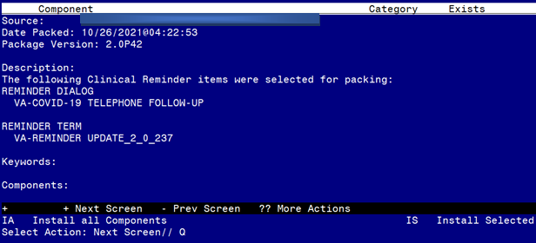

You will then be returned to this screen. At the **Select Action** prompt, type **Q.**

Install complete.

# Post Installation

1. **Review the following items and compare to the pre-install inquiry:** 
   1. **Re-do any local changes or additions to the local section or plan section.** If you made changes to the below items, you will need to re-do any local modifications to the following groups, review and compare the following reminder dialog groups:

VAL-COVID 19 RESULTS NEGATIVE LOCAL INFORMATION

VAL-GP COVID-19 FOLLOW UP CALL

VAL-GP COVID-19 FOLLOW-UP PLAN EDUCATION *

*When you compare this one there are new national options in this group, you will be reviewing and adding back in any additional local items your site had added.

* 1. **Re-do any local changes or additions** to the reminder dialog element VAL-COVID-19 FOLLOW-UP PLAN ED NURSE HOTLINE.
  2. **If you had this item disabled prior to this install,** you will need to add the disable and do not send message to this reminder dialog element VAL-COVID-19 FOLLOW-UP PLAN ANNIE