

**Update_2_0_240**

Clinical Reminders

VA-PAVE REMINDER AND TEMPLATE

Install Guide

**April 2022**

Product Development

Office of Information Technology

Department of Veterans Affairs

**Table of Contents**

Introduction 1

Install Details 4

Install Example 4

Post Installation 8

# Introduction

Veterans’ Health Administration (VHA) directive 1410 communicates the policy and responsibilities for the Prevention of Amputation in Veterans Everywhere (PAVE) Program, which outlines the scope of care and treatment provided to Veterans at risk of primary or secondary limb loss.

This update contains a reminder definition with associated dialog for use in primary care and an additional template for use in podiatry.

1. Clinical reminder

An annual foot evaluation to identify risk factors predictive of ulcers and amputations is required for all patients with a diagnosis of Diabetes, Chronic Kidney Disease, Occlusive Peripheral Artery Disease, or Sensory Neuropathy of any cause.

The foot evaluation includes inspection, assessment of foot pulses, and testing for loss of protective sensation using 10 gram monofilament.

Provide general foot self-care education to all patients needing this evaluation.

1. Template

The Podiatry PAVE template will be added to local facility Podiatry note titles for use in clinic to do a full foot assessment, assign a level of risk and document education provided.

Patients with a confirmed Level 2 or Level 3 risk assessment will continue to be followed in Podiatry and use of the template will inform the national clinical reminder so that the PC team does not need to do a screening of risk on those patients.

**UPDATE_2_0_240 contains 1 Reminder Exchange entry:**

UPDATE_2_0_240 VA-PAVE REMINSL

PROVIDER AND TEMPLATE

**The exchange file contains the following components:**

**TIU TEMPLATE FIELD**

VA-DIABETES NUTRITION AND FOOD

VA-DIABETES:KEEPING FEET HEALTHY

VA-FIELD MANUAL FOR FOOT HEALTH

VA-PAVE LOW RISK DESCRIPTION

VA-DATE

VA-PAVE HIGH RISK DESCRIPTION

**EDUCATION TOPICS**

VA-DIABETIC FOOT CARE COUNSELING

VA-DIABETIC FOOT CARE EDUCATION

**EXAM**

VA-DIABETIC FOOT CHECK

VA-DIABETIC FOOT EXAM, COMPLETE

**HEALTH FACTORS**

VA-REMINDER UPDATES

VA-UPDATE_2_0_240

VA-PAVE INCORRECT DIAGNOSIS [C]

VA-PAVE INCORRECT NEUROPATHY DIAGNOSIS

VA-PAVE INCORRECT VASCULAR DIAGNOSIS

VA-PAVE INCORRECT RENAL DIAGNOSIS

VA-PAVE INCORRECT DIABETES DIAGNOSIS

VA-PAVE PODIATRY FOOT EXAM [C]

VA-PAVE NO DIFFICULTY EXAMING FEET

VA-PAVE DOES NOT KNOW HOW TO EXAMINE FEET

VA-PAVE DIFFICULTY REACHING FEET

VA-PAVE DIFFICULTY SEEING FEET

VA-PAVE PATIENT HAS DIFFICULTY EXAMINING FEET

VA-PAVE NOT ABLE TO CLEAN FEET ONCE DAILY

VA-PAVE PATIENT ABLE TO CLEAN FEET AT LEAST ONCE DAILY

VA-PAVE PATIENT NEVER WALKS BAREFOOT

VA-PAVE PATIENT WALKS BAREFOOT LESS THAN ONCE A MONTH

VA-PAVE PATIENT WALKS BAREFOOT A FEW TIMES PER MONTH

VA-PAVE PATIENT WALKS BAREFOOT A FEW TIMES PER WEEK

VA-PAVE PATIENT WALKS BAREFOOT DAILY

VA-PAVE FOOT LEVEL 3 EDUCATION

VA-PAVE FOOT LEVEL 3

VA-PAVE FOOT LEVEL 2 EDUCATION

VA-PAVE FOOT LEVEL 2

VA-PAVE FOOT LEVEL 1 EDUCATION

VA-PAVE FOOT LEVEL 1

VA-PAVE FOOT LEVEL 0 EDUCATION

VA-PAVE FOOT LEVEL 0

VA-PAVE PODIATRY FOOT EXAM

VA-PAVE PACT FOOT CHECK [C]

VA-PAVE RECEIVES BEHAVIORAL HEALTH AND REFUSE PRIMARY CARE

VA-PAVE BILATERAL FOOT AMPUTATION

REMINDER FACTORS [C]

LIFE EXPECTANCY <6 MONTHS

VA-PAVE PACT PATIENT REFUSED FOOT CHECK

VA-PAVE PACT FOOT CHECK DONE ELSEWHERE

VA-PAVE PACT FOOT LEVEL LOW RISK

VA-PAVE PACT FOOT LEVEL HIGH RISK

VA-PAVE PACT SENSORY FOOT CHECK ABNORMAL

VA-PAVE PACT SENSORY FOOT CHECK NORMAL

VA-PAVE PACT PEDAL PULSES FOOT CHECK ABNORMAL

VA-PAVE PACT PEDAL PULSES FOOT CHECK NORMAL

VA-PAVE PACT VISUAL FOOT CHECK ABNORMAL

VA-PAVE PACT VISUAL FOOT CHECK NORMAL

LIFE EXPECTANCY < 6 MONTHS

**REMINDER SPONSOR**

NATIONAL CENTER FOR HEALTH PROMOTION AND DISEASE PREVENTION (NCP)

**REMINDER TAXONOMY**

VA-PAVE DIABETIC AMPUTEE (BILATERAL)

VA-PAVE AMPUTEE (PARTIAL)

VA-PAVE FOOT HIGH RISK DZ

VA-TERMINAL CANCER PATIENTS

VA-PAVE DIABETIC FOOT CHECK

VA-PAVE CODES

**REMINDER LOCATION LIST**

VA-MH STOP CODES

VA-PODIATRY VISITS (OP)

**REMINDER TERM**

VA-REMINDER UPDATE_2_0_240

VA-PAVE PACT PATIENT REFUSED

VA-MH STOP CODES (BL)

VA-PAVE FOLLOWED BY BEHAVIORAL HEALTH AND REFUSE PRIMARY CARE

VA-PAVE SEEN BY PODIATRY

VA-PAVE FOOT EXAM RESULTS

VA-PAVE FOOT CARE EDUCATION

VA-PAVE DM AMPUTEE/HIGH RISK (BILATERAL)

VA-PAVE DM AMPUTEE (PARTIAL)/HIGH RISK

VA-LIFE EXPECTANCY < 6 MONTHS

VA-PAVE INCORRECT DIAGNOSIS (TRM)

VA-PAVE DIABETIC FOOT CHECK

VA-PAVE CODES

**REMINDER DEFINITION**

VA-PAVE PACT FOOT CHECK

**REMINDER DIALOG**

VA-PODIATRY PAVE FOOT EXAM

VA-PACT PAVE FOOT CHECK

# Install Details

This update is being distributed as a web host file. The address for the host file is: **https://REDACTED/UPDATE_2_0_240.PRD**

The file will be installed using Reminder Exchange, programmer access is not required.

Installation:

=============

This update can be loaded with users on the system. Installation will take less than 5 minutes.

# Install Example

To Load the Web Host File. Navigate to Reminder exchange in Vista

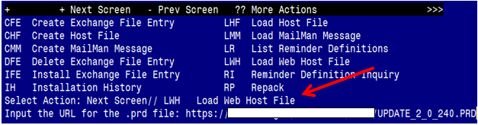

At the **Select Action:** prompt, enter **LWH** for Load Web Host File

At the **Input the url for the .prd file:** prompt, type the following web address:

**https://REDACTED/UPDATE_2_0_240.PRD**

You should see a message at the top of your screen that the file successfully loaded.

Terminal window screen shot of the message displaying the URL of the file that was successfully loaded.  Part of the URL has been redacted as it is a VA only internal web site URL.

Search for and locate the reminder exchange entry titled UPDATE_2_0_240 VA-PAVE REMINDER AND TEMPLATE. 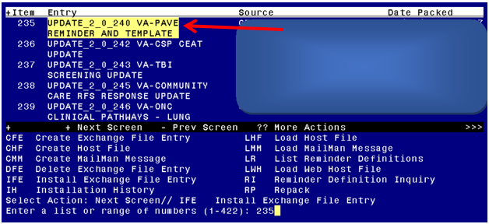

At the **Select Action** prompt, enter **IFE** for Install Exchange File Entry

Enter the number that corresponds with your entry titled **UPDATE_2_0_240 VA-PAVE REMINDER AND TEMPLATE**  *(in this example it is entry 235, it will vary by site)* The date on the exchange file should be 04/05/2022.

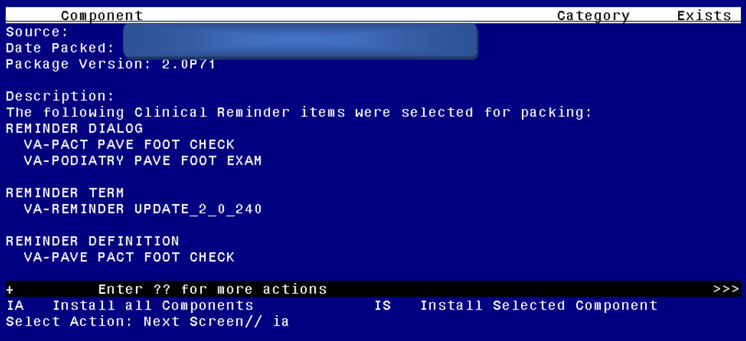

At the **Select Action** prompt, type **IA** for Install all Components and hit enter.

Select Action: Next Screen// IA Install all Components

During the installation, you will see several prompts:

Install all new components

SKIP any existing components that you are prompted to overwrite

**You will be promped to install the first reminder dialog component:**

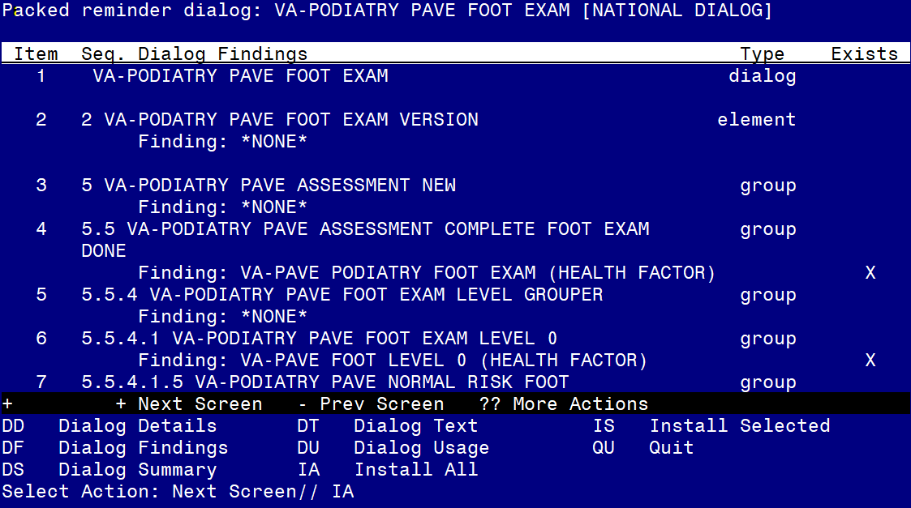At the **Select Action** prompt, type **IA** to install the dialog – **VA-PODIATRY PAVE FOOT EXAM**

Select Action: Next Screen// IA Install All

Install reminder dialog and all components with no further changes: Y// ES

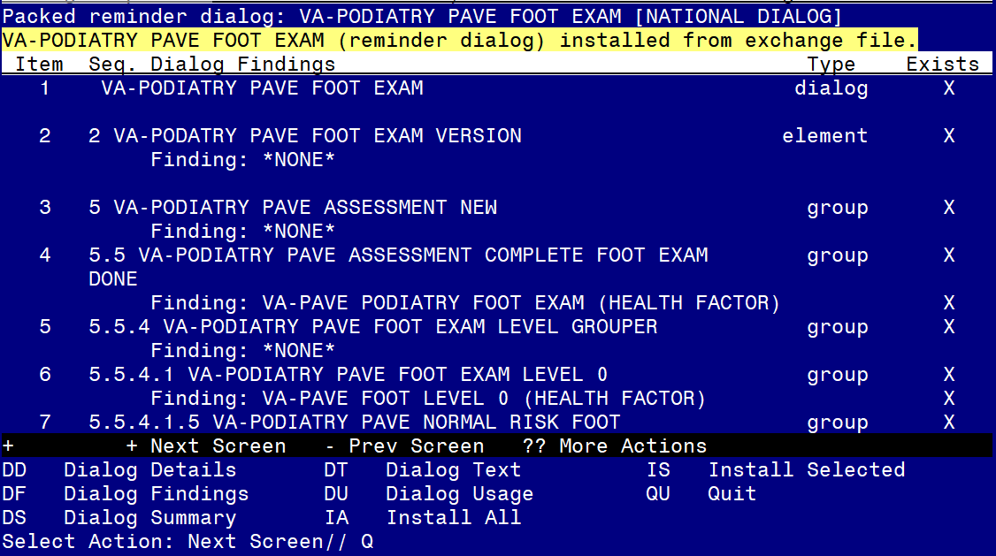

When the dialog has completed installation, you will then be returned to this screen. At the **Select Action** prompt, type **Q.**

**You will be promped to install the next reminder dialog component:**

**For the VA-PODIATRY PAVE FOOT EXAM:
Screen shot of the terminal window showing a list of elements, groups and dialogs with the text with IA for "Install All" entered at the "Select Action:" Prompt.  The correct way to handle each dialog, element and group in the list is described in the text of the document.  In this case, SKIP any existing components that you are prompted to overwrite **

At the **Select Action** prompt, type **IA** to install the dialog – **VA-PACT PAVE FOOT CHECK**

Select Action: Next Screen// IA Install All

Install reminder dialog and all components with no further changes: Y// ES

When you see this prompt, hit enter to link the dialog to the reminder definition:

Reminder Dialog VA-PACT PAVE FOOT CHECK is not linked to a reminder.

Select Reminder to Link: VA-PACT PAVE FOOT CHECK//

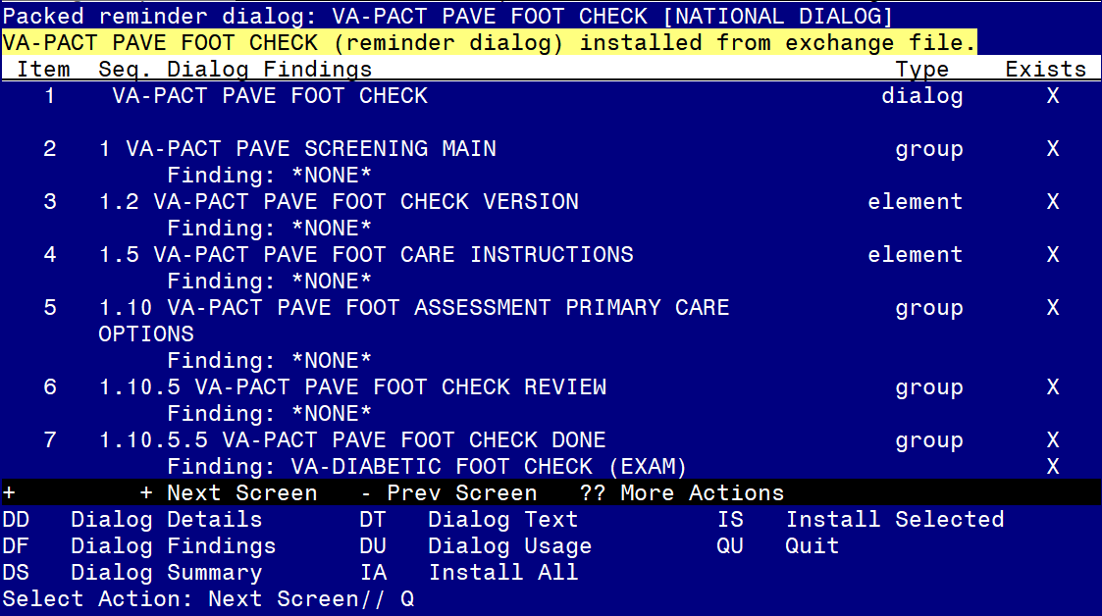

When the dialog has completed installation, you will then be returned to this screen. At the **Select Action** prompt, type **Q.**

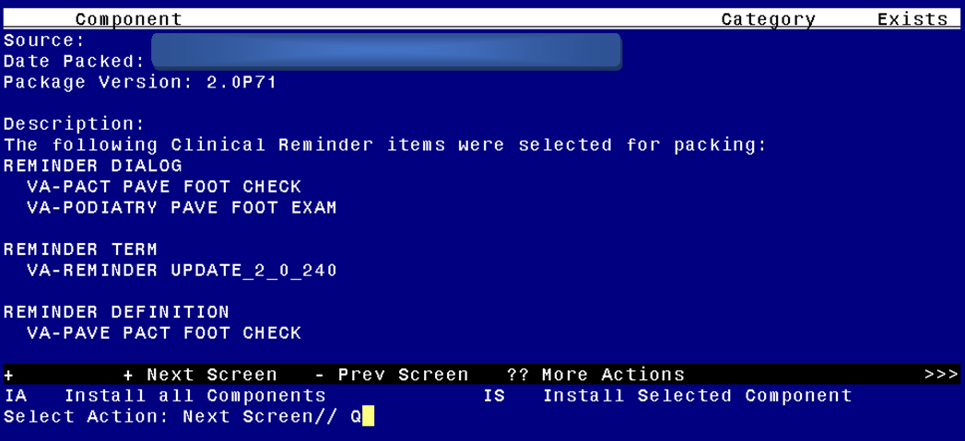

You will be returned to this screen. Type Q to quit.

Install Completed

# Post Installation

1. **Setup of Note Title.**

The note title to create to associate with the new template is:

**PODIATRY PAVE FOOT EXAM**

VHA Enterprise Standard Title: **PODIATRY NOTE**

**You can add these to your document class where progress notes are located.**

***Note:*** *Comprehensive information on Creating new Document Classes and Titles can be found beginning on page 54 of the TIU/ASU Implementation Guide at the following link:* [*http://www.va.gov/vdl/documents/Clinical/CPRS-Text_Integration_Utility_(TIU)/tiuim.pdf*](http://www.va.gov/vdl/documents/Clinical/CPRS-Text_Integration_Utility_(TIU)/tiuim.pdf)

1. Add the new reminder to the cover sheet for the appropriate users. The print name is **PAVE Foot Check.**
2. **Make the Dialog templates available to be attached to a Personal or Shared templates or to be able to attach the dialog to a progress note title.**

Select Reminder Managers Menu <TEST ACCOUNT> Option: **CP** CPRS Reminder Configuration

CA Add/Edit Reminder Categories

CL CPRS Lookup Categories

CS CPRS Cover Sheet Reminder List

MH Mental Health Dialogs Active

PN Progress Note Headers

RA Reminder GUI Resolution Active

TIU TIU Template Reminder Dialog Parameter

DEVL Evaluate Coversheet List on Dialog Finish

DL Default Outside Location

PT Position Reminder Text at Cursor

LINK Link Reminder Dialog to Template

TEST CPRS Coversheet Time Test

NP New Reminder Parameters

GEC GEC Status Check Active

WH WH Print Now Active

Select CPRS Reminder Configuration <TEST ACCOUNT> Option: **TIU** TIU Template Reminder Dialog Parameter

Reminder Dialogs allowed as Templates may be set for the following:

1 User USR [choose from NEW PERSON]

3 Service SRV [choose from SERVICE/SECTION]

4 Division DIV [SALT LAKE CITY]

5 System SYS [NATREM.FO-SLC.MED.VA.GOV]

Enter selection: **5** *Choose the appropriate number for your site. Your site may do this by System or other levels. The example below uses SYSTEM level.*

Setting Reminder Dialogs allowed as Templates for System: NATREM.FO-SLC.MED.VA.GOV

Select Display Sequence: **?**

388 VA-COVID-19 TELEPHONE FOLLOW-UP

389 VA-SRA-CONSULT RESPONSE (D)

*When you type a question mark above, you will see the list of #’s (with dialogs) that are already taken. Choose a number* ***NOT*** *on this list. For this example, 390 is not present so I will use 390.*

Select Display Sequence: **490**

Are you adding 490 as a new Display Sequence? Yes// **YES**

Display Sequence: 490// <Enter> 390

Clinical Reminder Dialog: **VA-PODIATRY PAVE FOOT EXAM**

reminder dialog NATIONAL

...OK? Yes// <Enter> (Yes)

1. **Associate the reminder dialogs with the note title in CPRS**
2. In CPRS, open the Template Editor, expand Document Titles, select the appropriate folder (if applicable), then click New Template (top right-hand corner).

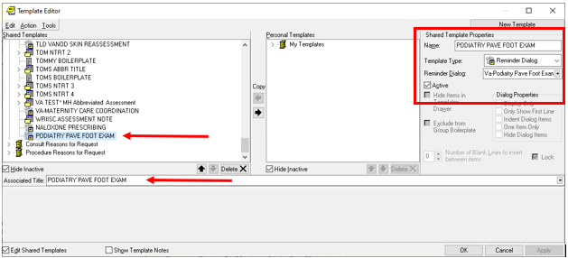

Type in the following information:

Name: **PODIATRY PAVE FOOT EXAM**

Template Type: **Reminder Dialog**

Reminder Dialog: **VA- PODIATRY PAVE FOOT EXAM**

Next, type in the Associated Title name – **PODIATRY PAVE FOOT EXAM**– then click Apply.

1. Add Order to the reminder dialog

Add your local quick order for a referral to Podiatry for a PAVE evaluation as an additional finding to the reminder dialog group: VAL-PACT PAVE FOOT REFERRAL TO PODIATRY LEVEL 1 REVISED

If your site would like to have more than one consult type for PAVE, there are three additional elements under the refer to podiatry section that are installed as disabled. You can enable one or more of these elements and add orders as additional findings if needed, you can also edit the dialog text to provide any additional information if needed. .

VAL-PACT PAVE PODIATRY CONSULT 2

VAL-PACT PAVE PODIATRY CONSULT 3

VAL-PACT PAVE PODIATRY CONSULT 4

1. If your site has a local PAVE reminder, map findings for the below terms. If your site does not have a local PAVE reminder you may skip this step. Note that you may not have a local health factor that aligns with the options listed below.
2. VA-PAVE PACT PATIENT REFUSED – add local health factors that represent a patient refused a PAVE Foot Check
3. VA-PAVE FOLLOWED BY BEHAVIORAL HEALTH AND REFUSE PRIMARY CARE - add local health factors that represent the patient does not receive primary care services and IS followed by Behavioral Health
4. VA-PAVE SEEN BY PODIATRY - add local health factors that represent a is being seen by podiatry
5. VA-PAVE FOOT EXAM RESULTS – add local health factors that represent PAVE foot level.
6. VA-PAVE FOOT CARE EDUCATION – add local health factors that represent foot care education provided
7. VA-PAVE DM AMPUTEE (PARTIAL)/HIGH RISK – add local health factors that represent High Risk patient
8. VA-PAVE DM AMPUTEE/HIGH RISK (BILATERAL) – add local health factors that represent the patient is a bilateral amputee
9. VA-PAVE DIABETIC FOOT CHECK – add local health factors that represent a completed diabetic foot check/exam