

**Update _2_0_242A**

Clinical Reminders

VA-CSP CEAT UPDATE

Install Guide

**May 2022**

Product Development

Office of Information Technology

Department of Veterans Affairs

Table of Contents

Introduction 1

Install Details 2

Install Example 2

# Introduction

Due to a court ruling, the Caregiver Support Program must revert the definition of Supervision, Protection and Instruction to the statute. Centralized Eligibility and Appeals Teams (CEATs) must use the language found in this update in making Veteran eligibility determinations for the Program of Comprehensive Assistance for Family Caregivers (PCAFC).

This update will change the wording in one reminder dialog group, VA-GP CSP CEAT INITIAL APP SUPERVISION.

**BEFORE TEXT:**

2) Veteran has a need for supervision,

protection, or instruction.

*Need for supervision, protection, or instruction

means an individual has a functional impairment

that directly impacts the individual's ability to

maintain his or her personal safety on a daily

basis.

**AFTER TEXT:**

2) Veteran has a need for supervision, protection, or

instruction.

*Need for supervision, protection, or instruction means an

individual is in need of personal care services because of:

-A need for supervision or protection based on symptoms or

residuals of neurological or other impairment or injury; or

-A need for regular or extensive instruction or supervision

without which the ability of the veteran to function in daily

life would be seriously impaired

UPDATE_2_0_242A contains 1 Reminder Exchange entry:

**UPDATE_2_0_242A VA-CSP CEAT UPDATE**

**The exchange file contains the following components:**

**HEALTH FACTORS**

VA-REMINDER UPDATES [C]

VA-UPDATE_2_0_242A

VA-CSP CEAT [C]

VA-CSP CEAT NO SUPERVISION NEED

VA-CSP CEAT SUPERVISON NEED

**REMINDER TERM**

VA-REMINDER UPDATE_2_0_242A

**REMINDER DIALOG**

VA-GP CSP CEAT INITIAL APP SUPERVISION

# Install Details

This update is being distributed as a web host file. The address for the host file is: https://REDACTED/UPDATE_2_0_242A.PRD

The file will be installed using Reminder Exchange, programmer access is not required.

Installation:

=============

This update can be loaded with users on the system. Installation will take less than 2 minutes.

# Install Example

To Load the exchange file, use LWH. The URL is

https://REDACTED/UPDATE_2_0_242A.PRD

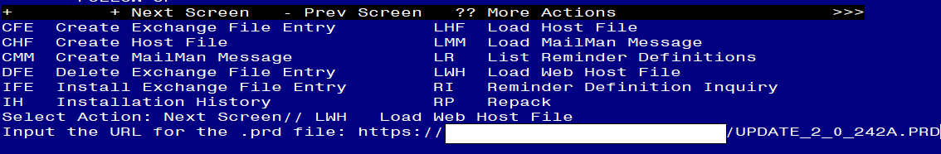

If you use LWH and it works, you will see something like this message. Make sure the file was loaded successfully.

Terminal window screen shot of the message displaying the URL of the file that was successfully loaded.  Part of the URL has been redacted as it is a VA only internal web site URL.

Search and locate an entry titled UPDATE_2_0_242A VA-CSP CEAT UPDATE in reminder exchange.

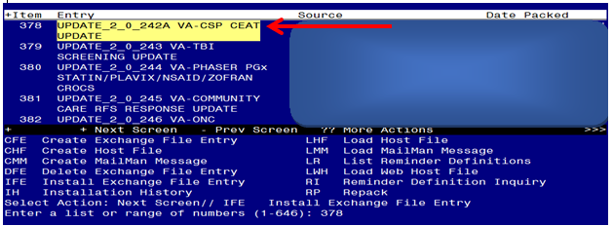

At the **Select Action** prompt, enter **IFE** for Install Exchange File Entry

Enter the number that corresponds with your entry titled UPDATE_2_0_242A VA-CSP CEAT UPDATE *(in this example it is entry 378, it will vary by site)* that is dated 05/04/2022.

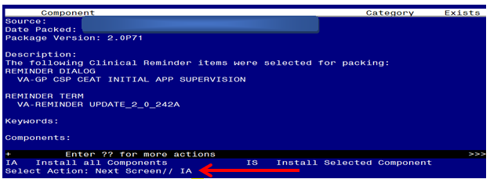

At the **Select Action** prompt, type **IA** for Install all Components and hit enter.

**For all new entries in any category you will choose I to Install**

**Skip any items you are prompted to overwrite.**

You will then be prompted to install the first dialog component. You will choose IA to install all even though ALL items will already have an X to indicate they exist.

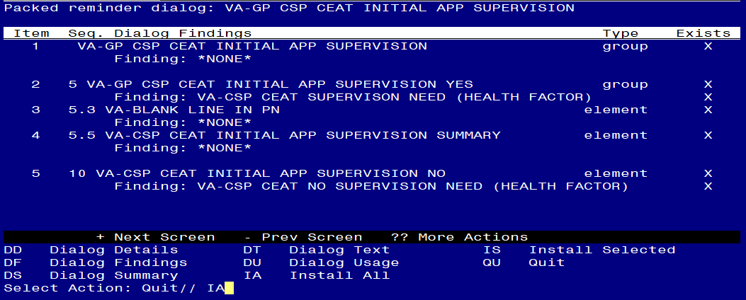

At the **Select Action** prompt, type **IA** to install the dialog – **VA-GP CEAT INITIAL APP SUPERVISION**

Install reminder dialog and all components with no further changes: **Y// ES**

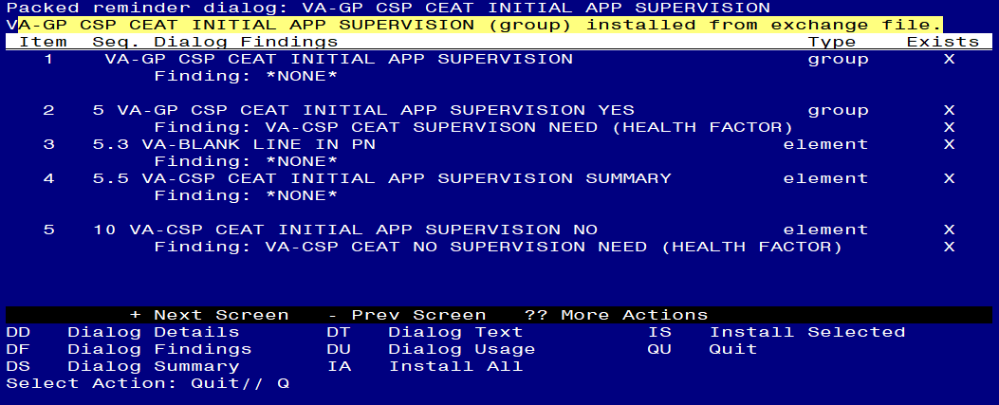

When the dialog has completed installation, you will then be returned to this screen. At the **Select Action** prompt, type **Q.**

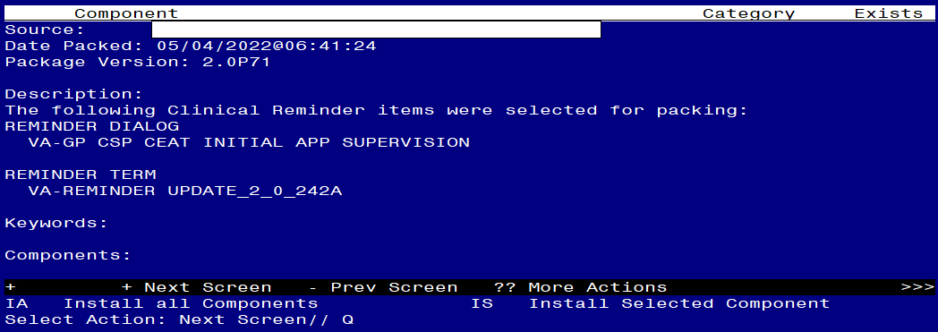

You will then be returned to this screen. At the **Select Action** prompt, type **Q.**

Install complete.