

**Update _2_0_242**

Clinical Reminders

VA-CSP CEAT UPDATE

Install Guide

**October 2021**

Product Development

Office of Information Technology

Department of Veterans Affairs

Table of Contents

Introduction 1

Install Details 3

Install Example 3

Post Installation 6

# Introduction

Last year, Caregiver Support expanded services that were required by the MISSION Act. Due to the overwhelming number of applications that were received,  there was a delay in the reassessments of those who were previous enrolled.   Beginning October 1, 2021,  those reassessments have started and a few significant issues with one of the sections in the CSP PCAFC CEAT REVIEW NOTE were identified.

For the **Status Change Reassessment Review** section of that template, the following changes have been made:

1. Added: ,   ‘Veteran not eligible due to reassessment’ and a sub-reason were added under the Discharge option
2. Added Not Reviewed to options in all required sections except determination section so that those items do not have to be reviewed every time

This update will update the version number to 3.1 and update only the STATUS CHANGE RE-ASSESSMENT REVIEW section of the reminder dialog template VA-CSP CEAT REVIEW RESPONSE NOTE.

UPDATE_2_0_242 contains 1 Reminder Exchange entry:

**UPDATE_2_0_242 VA-CSP CEAT UPDATE**

**The exchange file contains the following components:**

**TIU TEMPLATE FIELD**

VA-WORDR

TEXT (1-70) REQUIRED

WORD 1 LINE1 PC

TEXT (1-60 CHAR)R

WORD 2 LINES1 REQ

**HEALTH FACTORS**

VA-REMINDER UPDATES [C]

VA-UPDATE_2_0_242

VA-CSP CEAT [C]

VA-CSP CEAT 2ND FAM CG-APPLIC FAM NO

VA-CSP CEAT 2ND FAM CG-APPLIC FAM YES

VA-CSP CEAT 2ND FAM CG-APPLIC ABUSE NO

VA-CSP CEAT 2ND FAM CG-APPLIC ABUSE YES

VA-CSP CEAT 2ND FAM CG-APPLIC 18YO NO

VA-CSP CEAT 2ND FAM CG-APPLIC 18YO YES

VA-CSP CEAT SEC FAM CG-APPLIC FAM YES

VA-CSP CEAT SEC FAM CG-APPLIC FAM NO

VA-CSP CEAT SEC FAM CG-APPLIC ABUSE YES

VA-CSP CEAT SEC FAM CG-APPLIC ABUSE NO

VA-CSP CEAT SEC FAM CG-APPLIC 18YO YES

VA-CSP CEAT SEC FAM CG-APPLIC 18YO NO

VA-CSP CEAT PRIM FAM CG-APPLIC ABUSE NO

VA-CSP CEAT PRIM FAM CG-APPLIC ABUSE YES

VA-CSP CEAT PRIM FAM CG-APPLIC FAM NO

VA-CSP CEAT PRIM FAM CG-APPLIC FAM YES

VA-CSP CEAT PRIM FAM CG-APPLIC 18YO NO

VA-CSP CEAT PRIM FAM CG-APPLIC 18YO YES

VA-CSP CEAT COMMITTED FRAUD YES

VA-CSP CEAT COMMITTED FRAUD NO

VA-CSP CEAT COMPLIANT W SERVICES NO

VA-CSP CEAT COMPLIANT W SERVICES YES

VA-CSP CEAT REASSESSMENT NO

VA-CSP CEAT REASSESSMENT YES

VA-CSP CEAT WELLNESS CONTACTS NO

VA-CSP CEAT WELLNESS CONTACTS YES

VA-CSP CEAT RESIDES IN STATE NO

VA-CSP CEAT RESIDES IN STATE YES

VA-CSP CEAT REVOKE VA ERROR

VA-CSP CEAT REVOKE CG NOT CAPABLE

VA-CSP CEAT REVOKE NOT LIVING IN US

VA-CSP CEAT REVOKE NOT FAMILY

VA-CSP CEAT REVOKE NO PC TEAM

VA-CSP CEAT REVOKE NOT RECEIVING CARE

VA-CSP CEAT REVOKE OTHERS PROVIDING

VA-CSP CEAT REVOKE NO REASSESSMENT

VA-CSP CEAT REVOKE NO WELLNESS CONTACTS

VA-CSP CEAT REVOKE CG UNWILLING

VA-CSP CEAT REVOKE PERSONAL SAFETY

VA-CSP CEAT REVOKE NEGLECT OR ABUSE

VA-CSP CEAT REVOKE FRAUD

VA-CSP CEAT CONT ENROLLMENT

VA-CSP CAREGIVER DISCHARGE [C]

VA-CSP DISCHARGE NO SC DISABILITY

VA-CSP DISCHARGE BASED ON CG ASSESS

VA-CSP CEAT DC CAREGIVER REQUEST D/T IPV

VA-CSP CEAT DC CAREGIVER REQUEST

VA-CSP CEAT DC VETERAN REQUEST

VA-CSP CEAT DC CAREGIVER DECEASED

VA-CSP CEAT DC VETERAN DECEASED

VA-CSP CEAT DC CG INSTITUTIONALIZED

VA-CSP CEAT DC VET INSTITUTIONALIZED

VA-CSP CEAT PCP ONGOING NO

VA-CSP CEAT PCP ONGOING YES

VA-CSP CEAT CARE AT HOME YES

VA-CSP CEAT CARE AT HOME NO

VA-CSP CEAT PCS NO OTHER PROGRAM NO

VA-CSP CEAT PCS NO OTHER PROGRAM YES

VA-CSP CEAT SERIOUS INJURY 70% SC YES

VA-CSP CEAT SERIOUS INJURY 70% SC NO

VA-CSP CEAT VET OR MED DC NO

VA-CSP CEAT VET OR MED DC YES

VA-CSP CEAT STAT CHANGE REASSESS REVIEW

**REMINDER TERM**

VA-REMINDER UPDATE_2_0_242

**REMINDER DIALOG**

VA-GP CEAT REVIEW UPDATE 1021

# Install Details

This update is being distributed as a web host file. The address for the host file is: https://REDACTED /UPDATE_2_0_242.PRD

The file will be installed using Reminder Exchange, programmer access is not required.

Installation:

=============

This update can be loaded with users on the system. Installation will take less than 2 minutes.

# Install Example

To Load the exchange file, use LWH. The URL is

https://REDACTED/ UPDATE_2_0_242.PRD

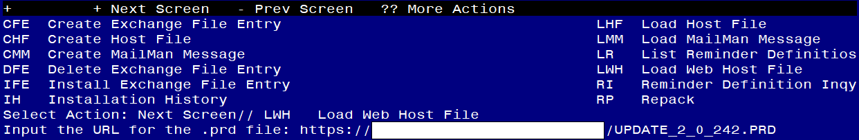

If you use LWH and it works, you will see something like this message. Make sure the file was loaded successfully.

Terminal window screen shot of the message displaying the URL of the file that was successfully loaded.  Part of the URL has been redacted as it is a VA only internal web site URL.

Search and locate an entry titled UPDATE_2_0_242 VA-CSP CEAT UPDATE in reminder exchange.

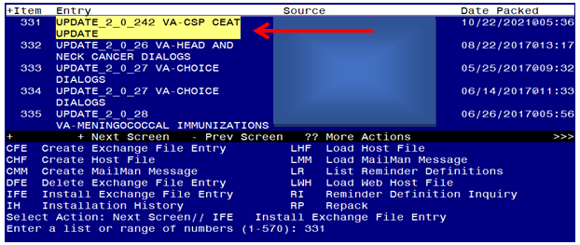

At the **Select Action** prompt, enter **IFE** for Install Exchange File Entry

Enter the number that corresponds with your entry titled UPDATE_2_0_242 VA-CSP CEAT UPDATE *(in this example it is entry 331, it will vary by site)* that is dated 10/22/2021.

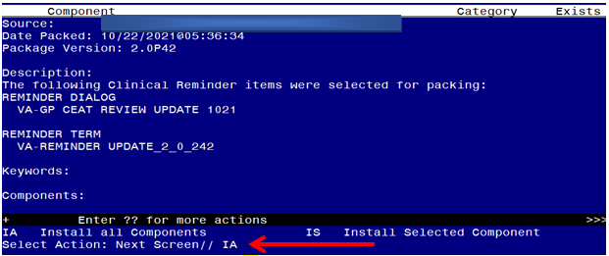

At the **Select Action** prompt, type **IA** for Install all Components and hit enter.

**For all new entries in any category you will choose I to Install**

**Skip any items you are prompted to overwrite.**

You will then be prompted to install the first dialog component. You will choose IA to install all even though some items will already have an X to indicate they exist.

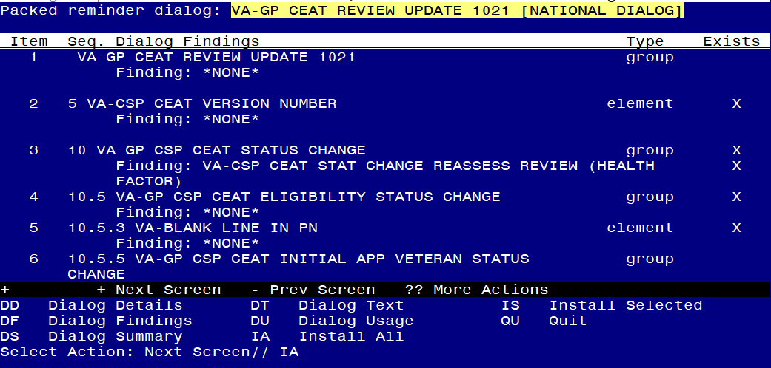

At the **Select Action** prompt, type **IA** to install the dialog – **VA-GP CEAT REVIEW UPDATE 1021**

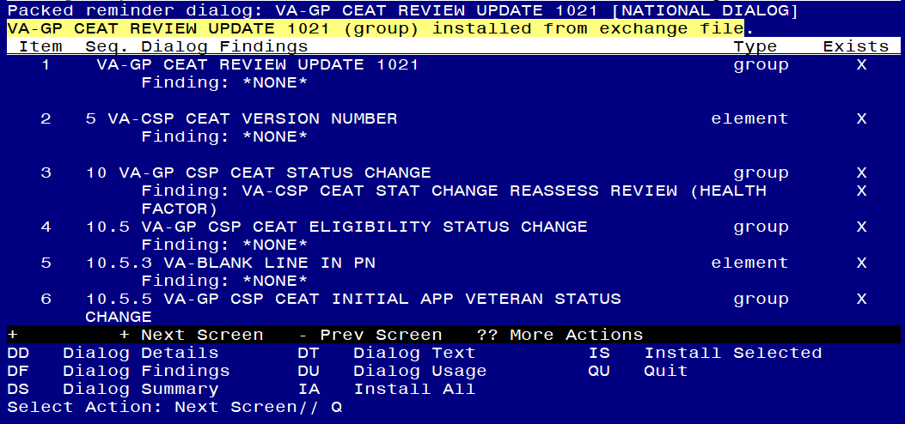

When the dialog has completed installation, you will then be returned to this screen. At the **Select Action** prompt, type **Q.**

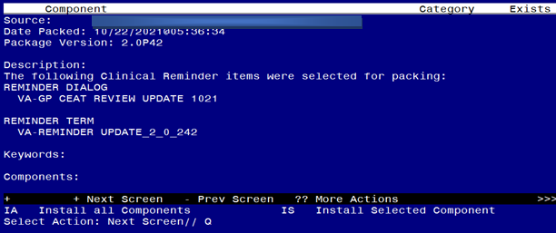

You will then be returned to this screen. At the **Select Action** prompt, type **Q.**

Install complete.

# Post Installation

1. **Confirm the template version displays as 3.1 at the top of the template one of two ways:**
   1. **In CPRS, open the note titled CSP PCAFC CEAT REVIEW CONSULT**
   2. **In Vista, using the menu Reminder Dialog Manager, Reminder Dialog, change view to Dialog view, review the reminder dialog text for the reminder dialog VA-CSP CEAT REVIEW RESPONSE NOTE**