

**Update_2_0_252**

Clinical Reminders

VA-RELATIONSHIP HEALTH AND SAFETY SCREEN

Install Guide

**July 2023**

Product Development

Office of Information Technology

Department of Veterans Affairs

**Table of Contents**

Introduction 1

Install Details 3

Install Example 4

Post Installation 8

# Introduction

The Relationship Health and Safety (RHS) Screen clinical reminder is the only approved method for screening individuals to identify intimate partner relationship concerns across a spectrum of behaviors by type and frequency to enhance prevention, offer intervention and promote safety. In accordance with policy (VHA 1198), this clinical reminder is to be activated to prompt annual screening of all women 47 and under. Your site may choose to expand the RHS screen patient cohort; either by expanding the age range and/or expanding for all Veteran patients versus by female-only birth sex. Please consult with the facility IPVAP Coordinator.

This Update includes a national **Relationship Health and Safety Screen** cover sheet clinical reminder definition and dialog. This national clinical reminder version will replace all previous versions of the same clinical reminder definition and dialog and should also be used in place of any locally developed relationship health and safety, domestic violence or intimate partner violence screening templates. Refer to your Intimate Partner Violence Assistance Program (IPVAP) coordinator for additional information on local processes.

Take Note: The instructions request this clinical reminder be assigned to the CPRS cover sheet at the SYSTEM level. If your facility would prefer to assign the CPRS cover sheet reminder to specific users/user groups vs. assigning it at the recommended SYSTEM-level, please contact the national IPVAP for guidance (redacted) contact your local IPVAP Coordinator for any additional questions related to the installation of this clinical reminder.

**UPDATE_2_0_252 contains 1 Reminder Exchange entry:**

UPDATE_2_0_252 VA-RELATIONSHIP HEALTH AND SAFETY SCREEN

**The exchange file contains the following components:**

**REMINDER GENERAL FINDINGS**

VIEW PROGRESS NOTE TEXT

**TIU TEMPLATE FIELD**

VA-WORD

OTHER NON-VA

OTHER TEXT

GEN WORD PROCESSING LARGE

VA-RHS SCREEN RESOURCES

VA-RHS SCREEN THE HOTLINE

VA-RHS SCREENING LINK

**HEALTH FACTORS**

VA-REMINDER UPDATES [C]

VA-UPDATE_2_0_252

DOMESTIC/INTERPERSONAL VIOLENCE SCREEN [C]

VA-IPVAP/S-CONSENT TO SCREEN – NO

VA-IPVAP/S – SECONDARY POSITIVE

VA-IPVAP/S – SECONDARY NEGATIVE

VA-IPVAP/S-RES/EDUCATION OTHER

VA-IPVAP/S-RES/EDUCATION READINESS TO LEARN

VA-IPVAP/S-SAFETY PLAN COMPLETED - DECLINED

VA-IPVAP/S-SAFETY PLAN COMPLETED - NO

VA-IPVAP/S-SAFETY PLAN COMPLETED - YES

VA-IPVAP/S-RES/RESOURCES - OTHER

VA-IPVAP/S-RES/RESOURCES - NO

VA-IPVAP/S-RES/RESOURCES YES/OTHER

VA-IPVAP/S-RES/RESOURCES YES/CONTACT INFO

VA-IPVAP/S-RES/RESOURCES YES/FLYER INFO

VA-IPVAP/S-RES/RESOURCES YES/VERBAL EDU

VA-IPVAP/S-RES/RESOURCES – YES

VA-IPVAP/S-RES/RESOURCES DECLINES CONSULT

VA-IPVAP/S-RES/RESOURCES ACCEPTS WARM HANDOFF/CONSULT

VA-IPVAP/S-RES/SAME DAY CONSULT BY CHAMPION

VA-IPVAP/S-RES/RESOURCES ACCEPTS FUTURE CONSULT

VA-IPVAP/S-SECONDARY SCREEN/KILL - NO

VA-IPVAP/S-SECONDARY SCREEN/KILL - YES

VA-IPVAP/S-SECONDARY SCREEN/CHOKE - NO

VA-IPVAP/S-SECONDARY SCREEN/CHOKE - YES

VA-IPVAP/S-SECONDARY SCREEN/BEHAVIOR - NO

VA-IPVAP/S-SECONDARY SCREEN/BEHAVIOR - YES

VA-IPVAP/S-PRIMARY SCREEN RESULT - POSITIVE

VA-IPVAP/S-PRIMARY SCREEN RESULT - NEGATIVE

VA-IPVAP/S-PRIMARY SCREEN/PRESSURE - FREQ

VA-IPVAP/S-PRIMARY SCREEN/PRESSURE - OFTEN

VA-IPVAP/S-PRIMARY SCREEN/PRESSURE -SOMETIMES

VA-IPVAP/S-PRIMARY SCREEN/PRESSURE - RARELY

VA-IPVAP/S-PRIMARY SCREEN/PRESSURE - NEVER

VA-IPVAP/S-PRIMARY SCREEN/HURT - FREQ

VA-IPVAP/S-PRIMARY SCREEN/HURT - OFTEN

VA-IPVAP/S-PRIMARY SCREEN/HURT -SOMETIMES

VA-IPVAP/S-PRIMARY SCREEN/HURT - RARELY

VA-IPVAP/S-PRIMARY SCREEN/HURT - NEVER

VA-IPVAP/S-PRIMARY SCREEN/THREATEN - FREQ

VA-IPVAP/S-PRIMARY SCREEN/THREATEN - OFTEN

VA-IPVAP/S-PRIMARY SCREEN/THREATEN -SOMETIMES

VA-IPVAP/S-PRIMARY SCREEN/THREATEN - RARELY

VA-IPVAP/S-PRIMARY SCREEN/THREATEN - NEVER

VA-IPVAP/S-PRIMARY SCREEN/INSULT - FREQ

VA-IPVAP/S-PRIMARY SCREEN/INSULT - OFTEN

VA-IPVAP/S-PRIMARY SCREEN/INSULT -SOMETIMES

VA-IPVAP/S-PRIMARY SCREEN/INSULT - RARELY

VA-IPVAP/S-PRIMARY SCREEN/INSULT - NEVER

VA-IPVAP/S-PRIMARY SCREEN/SCREAM - FREQ

VA-IPVAP/S-PRIMARY SCREEN/SCREAM - OFTEN

VA-IPVAP/S-PRIMARY SCREEN/SCREAM -SOMETIMES

VA-IPVAP/S-PRIMARY SCREEN/SCREAM - RARELY

VA-IPVAP/S-PRIMARY SCREEN/SCREAM - NEVER

VA-IPVAP/S-SAFETY CONCERNS ABOUT DOC - NO

VA-IPVAP/S-SAFETY CONCERNS ABOUT DOC - YES

VA-IPVAP/S-CONSENT TO SCREEN - YES

VA-IPVAP/S-SCREEN SAFE TO PROCEED

VA-IPVAP/S-SCREEN NOT COMPLETED/OTHER

VA-IPVAP/S-SCREEN NOT COMPLETED/ADULT

VA-IPVAP/S-SCREEN NOT COMPLETED/2YO

VA-IPVAP/S-SCREEN NOT COMPLETED

**REMINDER SPONSOR**

SOCIAL WORK/CASE MANAGEMENT – INTIMATE PARTNER VIOLENCE ASSISTANCE PROGRAM

**REMINDER COMPUTED FINDINGS**

VA-AGE

**REMINDER TERM**

VA-REMINDER UPDATE_2_0_252

VA-RHS SCREEN AGE

VA-IPVAP/S-PRIMARY RESCREEN – 6 MO

VA-IPVAP/S DOES NOT CONSENT

VA-IPVAP/S SCREEN NOT COMPLETED

VA-IPVAP/S CONSENT/SCREENING COMPLETED

**REMINDER DEFINITION**

VA-RELATIONSHIP HEALTH AND SAFETY SCREEN

**REMINDER DIALOG**

VA-IPVAP RELATIONSHIP HEALTH AND SAFETY SCREEN

# Install Details

This update is being distributed as a web host file. The address for the host file is: REDACTED

The file will be installed using Reminder Exchange, programmer access is not required.

Installation:

=============

This update can be loaded with users on the system. Installation will take less than 30 minutes.

# Install Example

To Load the Web Host File. Navigate to Reminder exchange in Vista

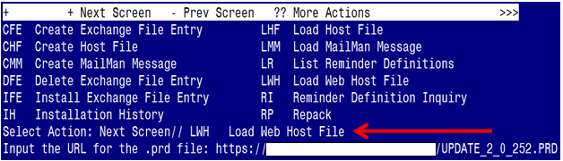

At the **Select Action:** prompt, enter **LWH** for Load Web Host File

At the **Input the url for the .prd file:** prompt, type the following web address.

REDACTED

You should see a message at the top of your screen that the file successfully loaded.

Terminal window screen shot of the message displaying the URL of the file that was successfully loaded.  Part of the URL has been redacted as it is a VA only internal web site URL.

Search for and locate the reminder exchange entry titled:

**UPDATE_2_0_252 VA-RELATIONSHIP HEALTH AND SAFETY SCREEN**

(see screenshot on the next page)

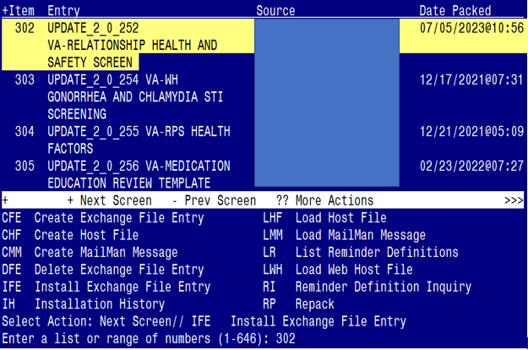

At the **Select Action** prompt, enter **IFE** for Install Exchange File Entry

Enter the number that corresponds with your entry titled:

**UPDATE_2_0_252 VA-RELATIONSHIP HEALTH AND SAFETY SCREEN**

*(In this example it is entry 302, it will vary by site).* The exchange file date should be 07/05/2023@10:56.

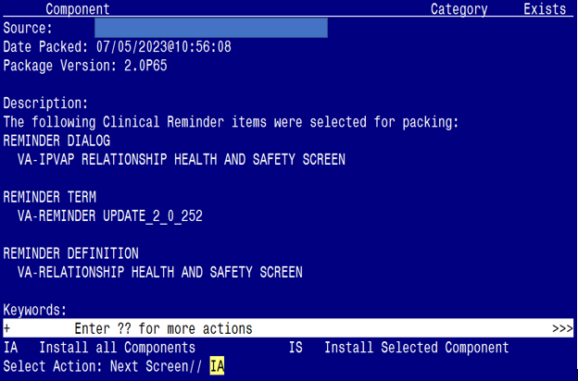

At the **Select Action** prompt, type **IA** for Install all Components and hit enter.

Select Action: Next Screen// IA Install all Components

You will see several prompts:

* For all new components, you will choose **I to Install**
* For any existing components, you will choose **O to Overwrite**

**You will be promped to install the dialog component:**

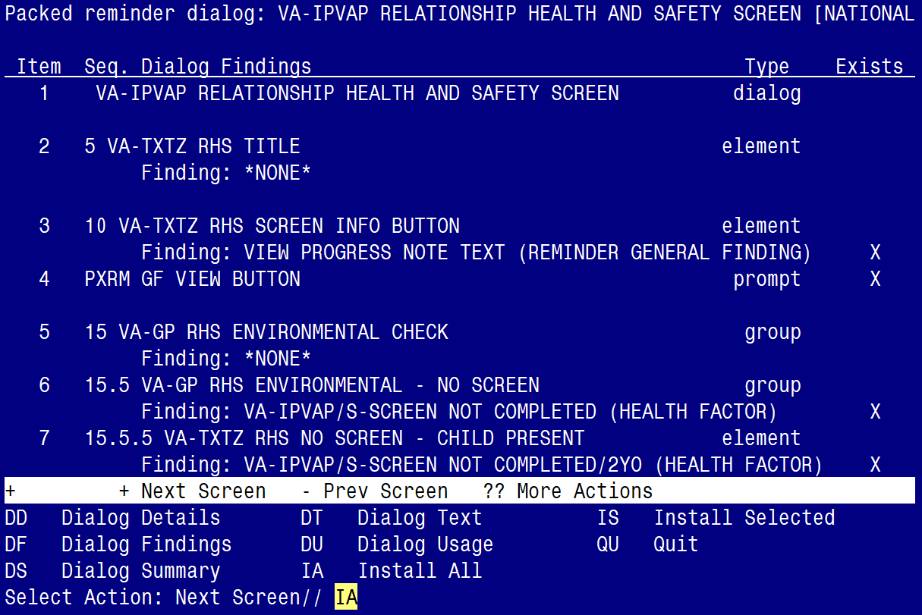

At the **Select Action** prompt, type **IA** to install the dialog:

**VA-IPVAP RELATIONSHIP HEALTH AND SAFETY SCREEN**

Select Action: Next Screen// IA Install All

Install reminder dialog and all components with no further changes: Y// ES

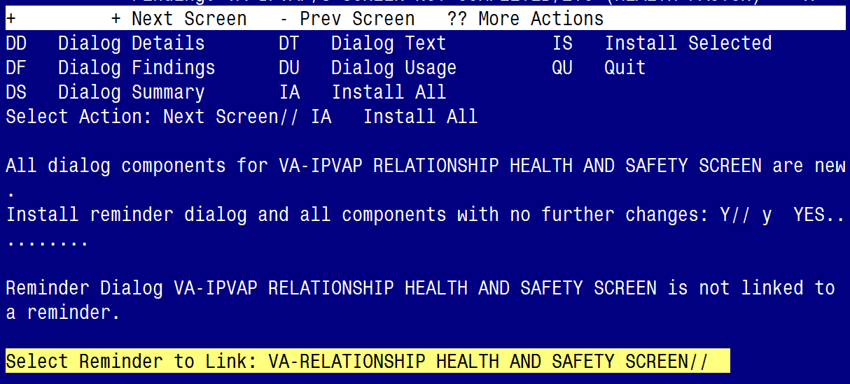

**Press ENTER to link the Reminder**:

Reminder Dialog VA-IPVAP RELATIONSHIP HEALTH AND SAFETY SCREEN is not linked to a reminder.

Select Reminder to Link: VA-RELATIONSHIP HEALTH AND SAFETY SCREEN//

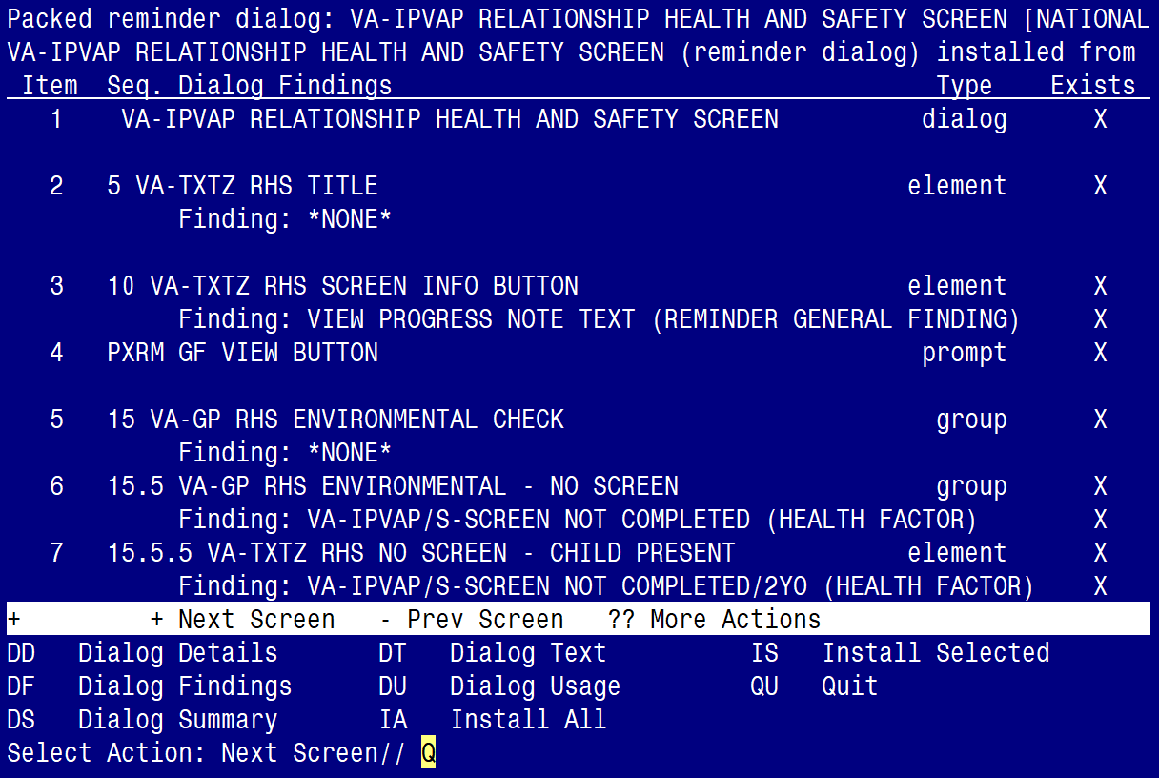

When the dialog has completed installation, you will then be returned to this screen. At the **Select Action** prompt, type **Q.**

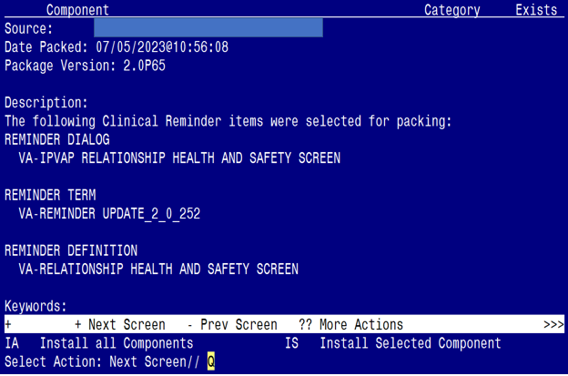

You will be returned to this screen. Type Q to quit.

Install Completed

# Post Installation

1. **Make the Dialog able to be attached to a Personal/Shared template or to a progress note title.**

From the Reminders Manager Menu:

Select Reminder Managers Menu Option: **CP** CPRS Reminder Configuration

CA Add/Edit Reminder Categories

CL CPRS Lookup Categories

CS CPRS Cover Sheet Reminder List

MH Mental Health Dialogs Active

PN Progress Note Headers

RA Reminder GUI Resolution Active

TIU TIU Template Reminder Dialog Parameter

DL Default Outside Location

PT Position Reminder Text at Cursor

Select CPRS Reminder Configuration Option: **TIU** TIU Template Reminder Dialog Parameter

Reminder Dialogs allowed as Templates may be set for the following:

1 User USR [choose from NEW PERSON]

3 Service SRV [choose from SERVICE/SECTION]

4 Division DIV [choose from INSTITUTION]

5 System SYS [NATREM.FO-SLC.MED.VA.GOV]

Enter selection*:* 5  *Choose the appropriate number for your site. Your site may do this by System or other levels. The example below uses SYSTEM level*

Setting Reminder Dialogs allowed as Templates for System:

Select Display Sequence: **?**

148 VA-VETERANS CHOICE NOTE

149 VA-TBI SCREENING

*When you type a question mark above, you will see the list of #’s (with dialogs) that are already taken. Choose a number* ***NOT*** *on this list. For this example, looking above I see the number 150 is not present, so I will use 150.*

Select Display Sequence: **150**

Are you adding 150 as a new Display Sequence? Yes// **Y** YES

Display Sequence: 150// <Enter> 150

Clinical Reminder Dialog**: type in the name of the dialog**

**VA-IPVAP RELATIONSHIP HEALTH AND SAFETY SCREEN**

then **<enter>**

reminder dialog NATIONAL

OK? Yes// <Enter> (Yes)

1. **Setup of specific Note title.**

You will need to create a new note title for the template, as follows:

**RHS SCREEN**

*Map the note title to the VHA Enterprise Standard Title:*

**RISK ASSESSMENT SCREENING NOTE**

Note: Comprehensive information on Creating Document Definitions can be found beginning on page 47 of the [TIU/ASU Implementation Guide](http://www.va.gov/vdl/documents/Clinical/CPRS-Text_Integration_Utility_(TIU)/tiuim.pdf)

1. **Associate the new reminder dialog with the note title in CPRS.**

To do this, go to Template Editor, then Document Titles, select the appropriate folder (if applicable), and choose New Template (top right-hand corner).

Type in the following information:

Name: **RHS SCREEN**

Template Type: Reminder Dialog

Reminder Dialog:

**VA-IPVAP RELATIONSHIP HEALTH AND SAFETY SCREEN**

Next, type in the Associated Title, which in this case is **RHS SCREEN** and hit Apply.

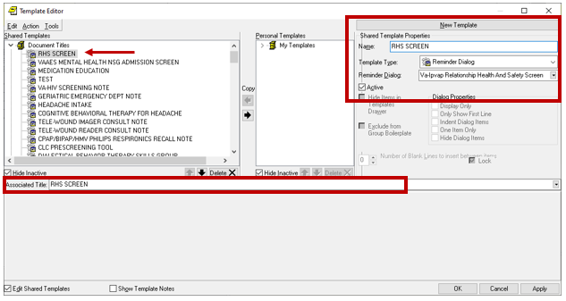

**TAKE NOTE**: You **ONLY** need to complete **post-installation steps 4 - 5** if your facility is using an existing Relationship Health & Safety Screen (RHS-Screen) clinical reminder definition and dialog. One was distributed from the IPVAP office in 2019.

If your facility does not have a ‘LOCAL’ or ‘VISN’ RHS-Screen clinical reminder definition and dialog, you may skip steps 4-5 and proceed to step 6. If you are unsure, contact your local Intimate Partner Violence (IPVAP) coordinator to confirm.

1. **Disable/Inactivate** yourLOCAL or VISN **Relationship Health & Safety Screen** Clinical Reminder Definition and Dialog (skip this step if your facility does not have one)**.**
2. **Definition** - Relationship Health and Safety Screen clinical reminder **definition**

* In 2019, the IPVAP program office developed and distributed a Relationship Health and Safety Screen clinical reminder definition.
* If your facility received and installed that clinical reminder definition or has created a ‘local’ Relationship Health and Safety Screen clinical reminder definition, you will need to **INACTIVATE** it.
* ZZ-out the name of your ‘local’ clinical reminder definition if that is your site’s current practice when inactivating a clinical reminder definition.

Reminder Definition name to search for:

* Reminder Definition Name: Relationship Health and Safety Screen
  + Print Name: Relationship Health & Safety Screen

1. **Dialog** - Relationship Health & Safety Screen clinical reminder **dialog**

* In 2019, the IPVAP program office developed and distributed a Relationship Health & Safety Screen clinical reminder dialog.
* If your facility received and installed that clinical reminder dialog or has created a ‘local’ Relationship Health & Safety Screen clinical reminder dialog, you will need to **DISABLE** it.

Reminder Dialog name to search for:

* Reminder Dialog Name: Relationship Health & Safety Screen

1. Map **local Health Factors** to three National Reminder Term Finding Items.

If your facility has been using a local or VISN Relationship Health and Safety Screen clinical reminder definition, you will need to map local Health Factors to three Reminder Terms (see below).

Refer to your ‘local’ Relationship Health and Safety Screen clinical reminder definition to confirm the name(s) of the health factors to map.

* 1. **Reminder Term:** **VA-IPVAP/S CONSENT/SCREENING COMPLETED**

NAME: VA-IPVAP/S CONSENT/SCREENING COMPLETED

DESCRIPTION: Veteran consents to RHS screen and screening was completed.

HF VA-IPVAP/S-CONSENT TO SCREEN - YES Finding # 1

Select Finding: << Add local Health Factor finding item here

* Type “HF.” and then enter the name of your local health factor.
* Refer to your ‘local’ definition to see if you have a Reminder Term titled:

*IPV CONSENTS/SCREENING DONE*

* 1. **Reminder Term***:* **VA-IPVAP/S SCREEN NOT COMPLETED**

NAME: VA-IPVAP/S SCREEN NOT COMPLETED

DESCRIPTION: RHS screen was not completed.

HF VA-IPVAP/S-SCREEN NOT COMPLETED Finding # 1

Select Finding: << Add local Health Factor finding item here

* Type “HF.” and then enter the name of your local health factor.
* Refer to your ‘local’ definition to see if you have a Reminder Term titled:

*IPV SCREENING NOT DONE*

* 1. **Reminder Term: VA-IPVAP/S DOES NOT CONSENT**

NAME: VA-IPVAP/S DOES NOT CONSENT

DESCRIPTION: Veteran does not consent to an IPV screen.

HF VA-IPVAP/S-CONSENT TO SCREEN - NO Finding # 1

Select Finding: << Add local Health Factor finding item here

* Type “HF.” and then enter the name of your local health factor.
* Refer to your ‘local’ definition to see if you have a Reminder Term titled:

*RELATIONSHIP H&S SCREEN – DOES NOT CONSENT*

1. **Add the new reminder definition to your CPRS cover sheet.**

Steps a, b and c below request this clinical reminder be assigned to the CPRS cover sheet at the **SYSTEM** level. If your facility would prefer to assign the CPRS cover sheet reminder to specific users/user groups vs. assigning it at the recommended SYSTEM-level, please contact the national IPVAP for guidance (redacted). Consult your local IPVAP Coordinator for any additional questions related to the installation of this clinical reminder.

* 1. On the CPRS cover sheet, select the clock icon

Screen shot showing the portion of the CPRS cover sheet with VistAWeb, Remote Data, the clock icon and Postings 

* 1. Select ACTION > EDIT COVER SHEET REMINDER LIST

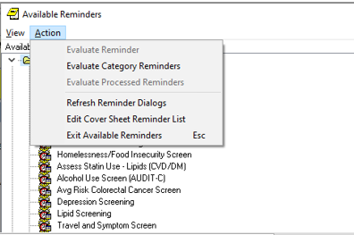

* 1. Add the Relationship Health & Safety Screen defintion at the SYSTEM level for your Cover Sheet

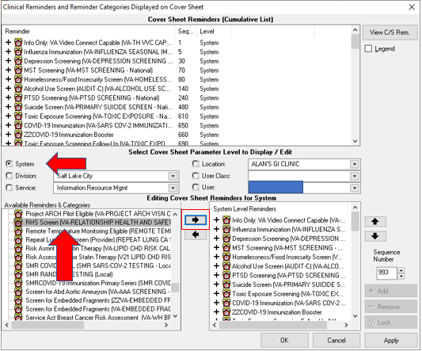

* 1. Item completed.

1. Add your sites Patient Telephone and Patient Address object the following ELEMENTS:

Element: VAL-TH VVC TELEPHONE TRIAGE CONTACT PHONE OBJECT

Text: *PHONE OBJECT HERE*

Element: VAL-TH VVC TELEPHONE TRIAGE PATIENT LOCATION HOME

Text: Home *PATIENT ADDRESS OBJECT HERE*

1. A template field titled “VA-RHS SCREEN RESOURCES” is available for sites that have a hyperlink to state/local information related to Relationship Health and Safety (see screenshot below). You can replace the ‘placeholder’ text in this template field with your site’s hyperlink. Ask your local Intimate Partner Violence (IPVAP) coordinator to confirm.

Screen shot showing a check box followed by - Provided IPV information to include state domestic violence hotline, local shelters and name of Intimate Partner Violence Assistance Program Coordinator (IPVAP-C), Champions or trained Licensed Independent Practitioners (LIPs). and then in blue print a place to enter a local link to the information.

1. The National Social Work Program Office and Intimate Partner Violence Assistance Program (IPVAP) have requested sites create the following business rules for the RHS SCREEN note title.

This request is made to limit who can view completed RHS Screen notes.

* A COMPLETED (TITLE) RHS SCREEN may BE VIEWED by a PROVIDER
* A COMPLETED (TITLE) RHS SCREEN may BE VIEWED by a PHYSICIAN
* A COMPLETED (TITLE) RHS SCREEN may BE VIEWED by a PHYSICIAN ASSISTANT
* A COMPLETED (TITLE) RHS SCREEN may BE VIEWED by a NURSE PRACTITIONER
* A COMPLETED (TITLE) RHS SCREEN may BE VIEWED by a NURSE
* A COMPLETED (TITLE) RHS SCREEN may BE VIEWED by a SOCIAL WORKER
* A COMPLETED (TITLE) RHS SCREEN may BE VIEWED by a PSYCHOLOGIST
* A COMPLETED (TITLE) RHS SCREEN may BE VIEWED by a MEDICAL RECORDS TECHNICIAN

**Three Items of Note**:

1 - These business rules were previously implemented at one VAMC and were successful in limiting completed-note viewership of their RHS notes.

2 – The MEDICAL RECORDS TECHNICIAN user class is needed for medical records staff to access the RHS-Screen notes when requested. Your site may or may not have this user class created in your system; if not it is requested you create it and add medical records staff members to that user class.

3 – These business rules are specific to the note title RHS SCREEN and will not impact / limit viewership if providers utilize a different note title to complete the RHS Screen clinical reminder definition/dialog.

1. (Optional) Your IPVAP coordinator may choose to have consult orders linked to the RHS Screen dialog. If so, add consult orders to the additional findings in following ELEMENTS.
   1. ADD THE SAME LOCAL CONSULT TO THESE TWO ELEMENTS: Red arrow pointing at ADD THE SAME LOCAL CONSULT TO THESE TWO ELEMENTS and that red arrow is also pointing at a screen shot below of the reminder dialog template saying Individual accepts future consult.

Element: VAL-TXTZ RHS FUTURE CONSULT PLACED PRIM NEG

ADDITIONAL FINDINGS: *ADD LOCAL CONSULT HERE*

Element: VAL-TXTZ RHS FUTURE CONSULT PLACED PRIM NEG 2

ADDITIONAL FINDINGS: *ADD LOCAL CONSULT HERE*

* 1. ADD THE SAME LOCAL CONSULT TO THESE TWO ELEMENTS: Blue arrow pointin at ADD THE SAME LOCAL CONSULT TO THESE TWO ELEMENTS.  The same blue arrow is pointing to "Individual accepts warm hand-off/consult to be placed " in the screen shot of the reminder dialog template below.

Element: VAL-TXTZ RHS WARM HANDOFF CONSULT

ADDITIONAL FINDINGS: *ADD LOCAL CONSULT HERE*

Element: VAL-TXTZ RHS WARM HANDOFF CONSULT 2

ADDITIONAL FINDINGS: *ADD LOCAL CONSULT HERE*

Screen shot of a reminder dialog template listing 4 radio buttons:  The first one has a red arrow pointing at it and the second has a blue arrow pointing at it.  The third and fourth don't have arrows.
Individual accepts future consult
Individual accepts warm hand-off/consult to be placed.
Clinical Provider trained by IPVAP who conducted the scree will complete RHS Assessment and related needs.
Individual declines consult.

1. (Optional) Your site may choose to expand the RHS SCREEN patient cohort; either by expanding the age range and/or expanding for ALL Veteran patients versus by female-only birth sex. To do so, you will need to edit the ‘Condition’ in the VA-AGE mapped finding within Finding Item 5. The AGE can be edited (just change 48 to the age of choice) and the portion &PXRMSEX=”F” can be removed (should your site choose to screen ALL Veteran patients versus female-only).

VA-RHS SCREEN AGE (FI(5)=RT(2701))

Finding Type: REMINDER TERM

Condition Case Sensitive: NO

Not Found Text: Veteran patient does not meet the birth sex

and/or age criteria.

Mapped Findings: CF.VA-AGE

Condition: I (V<48)&(PXRMSEX="F")

Condition Case Sensitive: NO