

**Update _2_0_262**

Clinical Reminders

VA-HERPES Zoster Update

Install Guide

**February 2022**

Product Development

Office of Information Technology

Department of Veterans Affairs

Table of Contents

Introduction 1

Pre-install 3

Install Details 4

Install Example 4

Post Installation 9

# Introduction

UPDATE JAN 2022

1. Change the immunocompromised taxonomy to a new one for inclusion. This taxonomy also now includes patients with autoimmune diseases per CDC. These patients are highly likely to undergo immunosuppressive treatment and vaccination prior to immunosuppression is preferable

Taxonomy: VA-IMMUNOCOMPROMISED FOR ZOSTER

1. Change logic to include those patients if 19 or older.

Findings 7, 9 are immunocompromised patients. FI(11) is age >18

((SEX)&(AGE))!FI(1)!((FI(7)!FI(9))&FI(11))&'FI(4)&'FI(5)

FI(7) uses a reminder to evaluate for any drugs that are immunocompromising including high dose steroids, chemotherapy, biologics. (similar to how the COVID-19 reminder uses a separate reminder to evaluate drug findings and high dose steroids).

New reminder: VAL-IMMUNOCOMPROMISING DRUGS FOR ZOSTER

FI(9) is a the taxonomy that includes cancers, HIV, immunodeficiency and also

include autoimmune disease per CDC.

1. Remove Zostavax from the logic as a temporary exclusion since this vaccine has not been available recently. Informational only.
2. Update FF(2) to remove the resolution when only one dose is present and it is marked as series 2. If prior Zostavax was entered as series 1 and the first dose of Shingrix was erroneously entered as series 2, the reminder would resolve when it should not have. Both doses now are required to be entered.
3. Update the dialog and template fields to match the new guidance.  
   Remove the message about IC from the dialog from this TF: NCP HERPES ZOSTER DETAILED GUIDANCE

UPDATE_2_0_262 contains 1 Reminder Exchange entry:

**UPDATE_2_0_262 VA-HERPES ZOSTER IMMUNIZATION UPDATE**

**The exchange file contains the following components:**

**TIU TEMPLATE FIELD**

IM ZOSTER PRIOR REACTION

BLANK TEXT FIELD FOR DIALOGS

VA-LOCATIONS

IM ZOSTER SHINGRIX INFO URL

IM COMMENT COMPLICATONS

IM ZOSTER LOT# EXP DATE

IM ZOSTER SHINGRIX MANUF

NCP HERPES ZOSTER DETAILED GUIDANCE

CDC ZOSTER VACCINE RECOMMENDATIONS

NCP HERPES ZOSTER GUIDANCE

**HEALTH FACTORS**

VA-REMINDER UPDATES [C]

VA-UPDATE_2_0_262

IMMUNIZATION [C]

VA-ZOSTER EDUCATION VVC/TELEHEALTH VST

ZOSTER IMMUNIZATION [C]

HERPES ZOSTER VACCINE UNAVAILABLE

HERPES ZOSTER IMMUN PRECAUTION

HERPES ZOSTER IMMUN CONTRAINDICATION

DECLINES HERPES ZOSTER IMMUNIZATION

REMINDER FACTORS [C]

LIFE EXPECTANCY < 6 MONTHS

**REMINDER SPONSOR**

VA National Center for Health Promotion and Disease Prevention (NCP)

National Center for Health Promotion and Disease Prevention (NCP)

**REMINDER TAXONOMY**

VA-IMMUNIZATION INJECTION 90471

VA-IMMUNOCOMPROMISED FOR ZOSTER VACCINE

LONG TERM SYSTEMIC STEROID

VA-PNEUMOC DZ RISK - CHEMOTHERAPY

VA-TERMINAL CANCER PATIENTS

**REMINDER TERM**

VA-REMINDER UPDATE_2_0_262

VA-HERPES ZOSTER PRIOR ADR

VA-FEMALE

VA-ZOSTER ADMINISTRATION SUPPRESSION

VA-ZOSTER ORDER SUPPRESSION

VA-AGE >18

VA-IMMUNOCOMPROMISED FOR ZOSTER VACCINE - DX

VA-STEROID PREDN EQUIV 5-6.6MG

VA-STEROID PREDN EQUIV 6.6-9MG

VA-STEROID PREDN EQUIV 10-19MG

VA-STEROID PREDN EQUIV >=20MG

VA-CHEMO/IMMUNOSUPPRESSIVE DRUGS

VA-IMMUNOCOMPROMISED FOR ZOSTER VACCINE - RX

VA-ZOSTER IMMUNIZATION LIVE VIRUS

VA-LIFE EXPECTANCY < 6 MONTHS

VA-ZOSTER CONTRAINDICATIONS

VA-ZOSTER ORDERS

VA-ZOSTER DEFERRALS

VA-ZOSTER IMMUNIZATION RECOMBINANT VACCINE

**REMINDER DEFINITION**

VAL-IMMUNOCOMPROMISING DRUGS FOR ZOSTER

VA-HERPES ZOSTER (SHINGLES) IMMUNIZATION

**HEALTH SUMMARY TYPE**

RZV IMMUNIZATIONS

**HEALTH SUMMARY OBJECTS**

RECOMBINANT ZOSTER IMM (TIU)

**TIU DOCUMENT DEFINITION**

RECOMBINANT ZOSTER IMM

**REMINDER DIALOG**

VA-HERPES ZOSTER IMMUNIZATION

# Pre-install

1. Check the dialog group for quick orders for the Herpes Zoster immunization and record those entries so they can be re-entered after installation if needed: VA-HERPES ZOSTER ORDER
2. There is a template field used for Lot #s and expiration dates. Screen cap how you have this field set up for reference post install. IM ZOSTER LOT# EXP DATE
3. There is a template field used for Lot #s and expiration dates. Screen cap how you have this field set up for reference post install. IM ZOSTER MANUF .
4. Print and save the reminder term **VA-ZOSTER ORDER SUPPRESSION** for reference post install.
5. Print and save the reminder term **VA-ZOSTER ADMINISTRATION SUPPRESSION** for reference post install.
6. Print and save the reminder term **VA-STEROID PREDN EQUIV 6.6-9MG** for reference post install
7. Print and save the reminder term **VA-STEROID PREDN EQUIV 5-6.6M**

for reference post install

1. Print and save the reminder term **VA-STEROID PREDN EQUIV 10-19MG**

for reference post install

1. Print and save the reminder term **VA-STEROID PREDN EQUIV >=20MG**

for reference post install

1. Print and save the reminder term **VA-ZOSTER ORDERS** for reference post install

# Install Details

This update is being distributed as a web host file. The address for the host file is: **https://REDACTED/UPDATE_2_0_262.PRD**

The file will be installed using Reminder Exchange, programmer access is not required.

Installation:

=============

This update can be loaded with users on the system. Installation will take less than 5 minutes.

# Install Example

To Load the Web Host File. Navigate to Reminder exchange in Vista

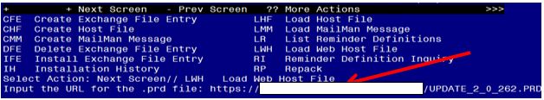

At the **Select Action:** prompt, enter **LWH** for Load Web Host File

At the **Input the url for the .prd file:** prompt, type the following web address:

Terminal window screen shot of the message displaying the URL of the file that was successfully loaded.  Part of the URL has been redacted as it is a VA only internal web site URL.

You should see a message at the top of your screen that the file successfully loaded.

Search and locate an entry titled UPDATE_2_0_262 VA-HERPES ZOSTER IMMUNIZATION UPDATE in reminder exchange 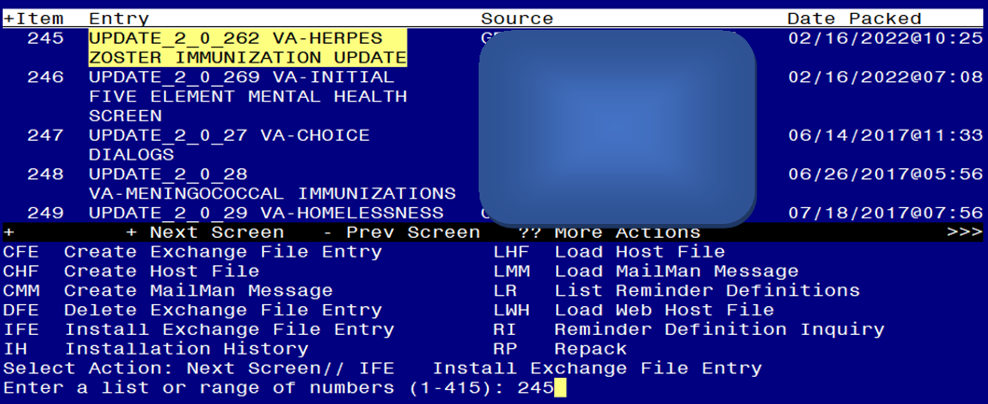

At the **Select Action** prompt, enter **IFE** for Install Exchange File Entry

Enter the number that corresponds with your entry titled UPDATE_2_0_262 VA-HERPES ZOSTER IMMUNIZATION UPDATE *(in this example it is entry 245, it will vary by site, the date should be 02/16/2022)*

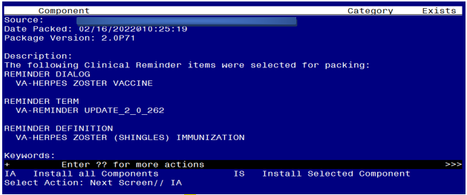

At the **Select Action** prompt, type **IA** for Install all Components and hit enter.

Here is the detail on the installation including the prompts you MAY see during installation and how you should answer them:

You will INSTALL ALL NEW ITEMS in ANY category

You will overwrite any TIU template fields you are prompted to overwrite

You will skip any health factors you are prompted to overwrite

You will overwrite any taxonomies you are prompted to overwrite

You will skip the below terms if you are prompted to overwrite, its is important that you do not overwrite these terms

**VA-STEROID PREDN EQUIV 5-6.6M**

**VA-STEROID PREDN EQUIV 6.6-9MG**

**VA-STEROID PREDN EQUIV 10-19MG**

**VA-STEROID PREDN EQUIV >=20MG**

**VA-ZOSTER ORDERS**

**VA-ZOSTER ADMINISTRATION SUPPRESSION**

**VA-ZOSTER ORDER SUPPRESSION**

**VA-LIFE EXPECTANCY < 6 MONTHS**

You can overwrite any other reminder terms not listed above.

You will overwrite any reminder definition you are prompted to overwrite.

You will overwrite any health summary components you are prompted to overwrite

**You will be promped to install the dialog component,** VA-HERPES ZOSTER IMMUNIZATION**:**

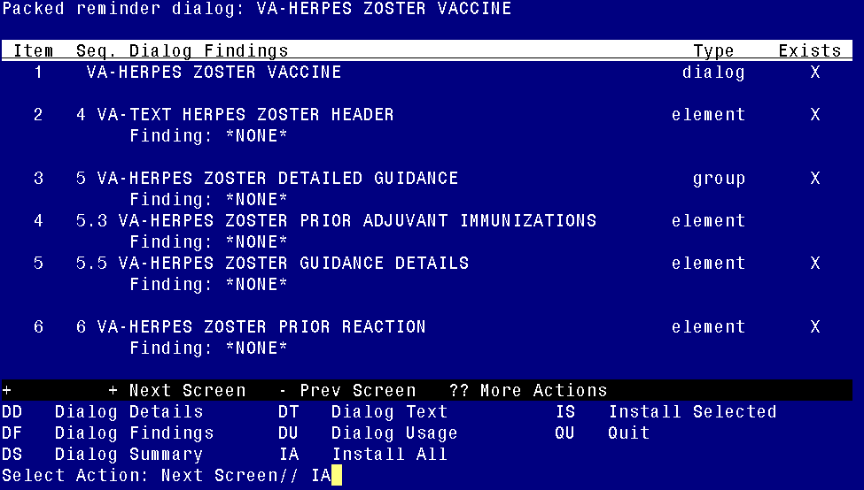

At the **Select Action** prompt, type **IA** to install the dialog – VA-HERPES ZOSTER IMMUNIZATION

Select Action: Next Screen// IA Install All

Install reminder dialog and all components with no further changes: Y// ES

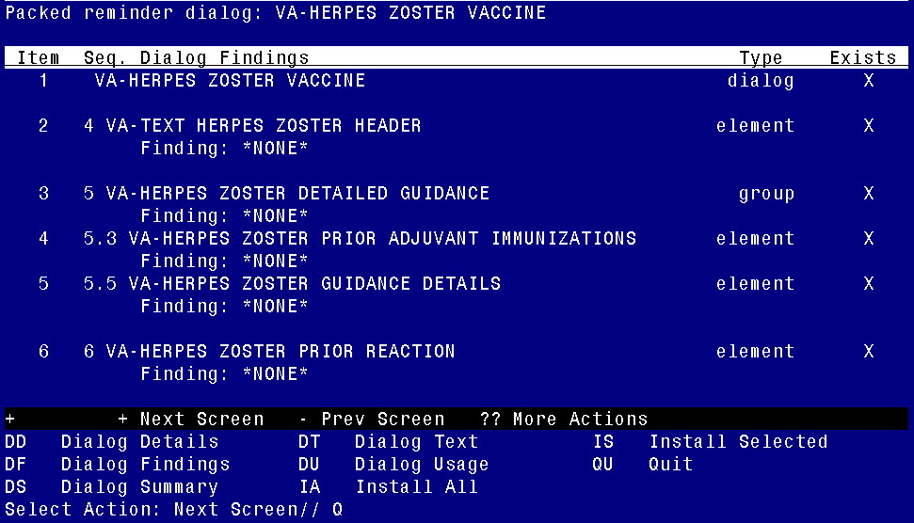

When the dialog has completed installation, you will then be returned to this screen. At the **Select Action** prompt, type **Q.**

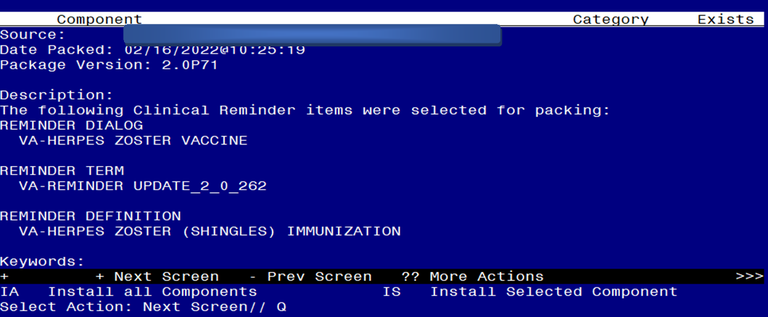

At the Select Action prompt, type Q to quit.

Install Completed

# Post Installation

1. Add the appropriate immunization quick orders as a FINDING ITEM on the following groups using the reminder dialog manager, reminder dialog menu and change view to groups. *If you are not sure what order to map, please work with your pharmacy Ad Pac*.
   1. Group - VA-HERPES ZOSTER ORDER - The finding item should be your local quick order for order for Shingrix; consider using an order set and/or a menu to allow entry of orders for both doses.
2. Verify that you did not overwrite the term VA-ZOSTER ORDERS and add back any local item (if any) you had mapped to this term.

*Limit the finding status to ACTIVE, PENDING, and RENEWED.* . Warning – if you do this and you do not use the start date, an order will suppress the reminder for many months even if the patient does not get the vaccine.

1. Verify that you did not overwrite the terms for high dose steroids and that your settings from pre-install are still there.
   1. **VA-STEROID PREDN EQUIV 5-6.6M**
   2. **VA-STEROID PREDN EQUIV 6.6-9MG**
   3. **VA-STEROID PREDN EQUIV 10-19MG**
   4. **VA-STEROID PREDN EQUIV >=20MG**
2. There has been no change to the options to suppress the order or the administration sections. If you use these, please check that they are still working correctly. If you overwrite these terms, then you will have to reset them.

Compare your pre-install print out of the following reminder terms to the post install and re-map any terms that might be different.

**VA-ZOSTER ORDER SUPPRESSION**

**VA-ZOSTER ADMINISTRATION SUPPRESSION**

To suppress the dialog element for specific user classes: VA-ASU USER CLASS Enter the user class that should NOT see the dialog element. If more than one user class is needed, add additional findings of the CF VA-ASU USER CLASS for each one as needed.

To suppress the dialog element for all users: VA-AGE change the’<’ sign to a ‘>’ sign in the CF for patient age.

To suppress for specific user classes, in the above Terms configure the VA-ASU USER CLASS computed finding and DELETE the VA-AGE finding. **NOTE: If the Age finding is not deleted, the user class settings will not work.**

1. There is a template field used for Lot #s and expiration dates. It is exported as EDIT BOXES, for free text entry. Sites may choose to change the TYPE to a COMBO box and then populate the template fields with local lot #s and expiration dates. Verify that this field is still set up to your site’s preference IM ZOSTER LOT# EXP DATE.
2. There is a template field used for Manufacturer. It is exported as EDIT BOXES, for free text entry. Sites may choose to change the TYPE to a COMBO box and then populate the template fields with local lot #s and expiration dates. Verify that this field is still set up to your site’s preference IM ZOSTER MANUF.