

**Update _2_0_26**

Clinical Reminders

VA-HEAD AND NECK CANCER DIALOGS

Install Guide

**September 2017**

Product Development

Department of Veterans Affairs

Contents

Introduction 3

Install Details 11

Installation 11

Install Example 12

Post-Install Set-up Instructions 17

Introduction

The purpose of this guide is to provide the Clinical Applications Coordinator/Health Informatics Specialist (CAC/HIS) with direction on the installation/implementation of the VA-Oncology reminder dialogs. These reminder dialogs were developed and are supported by the National Oncology Program Office in Specialty Care Services (part of Patient Care Services). Please contact Susan Hamilton-Hill for any questions/concerns at REDACTED.

The National Oncology Program Office seeks to provide tools to VA facilities to enable providers to format essential clinical data so that it is readily available for clinical care and to measure the quality of care in the VA in a prospective, timely, and cost-efficient manner. Using Reminder Dialogs in CPRS is one mechanism to support these goals. Reminder dialogs will include information necessary for quality assessment as defined by the National Quality Forum, ASCO's Quality Oncology Practice Initiative, and other reliable and up-to-date sources. Reminder dialogs will enable the standardization of clinical information necessary for quality indicators into a discrete format and obtain key elements to continuously monitor the quality of cancer care.

There are 4 reminder dialogs to be used to document care for head and neck cancer that need to be installed (MDC, progress note, treatment plan, treatment summary,).

**\*NOTE\***

***If your facility does not provide oncology services, you are not required to install or use these reminder dialog templates.***

There are several dialog elements that can be modified or disabled (if desired) to allow for local content. Please work with oncology-care providers to determine best option. (See POST-INSTALL INSTRUCTIONS # 1).

UPDATE_2_0_26 contains 1 Reminder Exchange entry:

UPDATE_2_0_26 VA-HEAD AND NECK CANCER DIALOGS

**Four reminder dialogs are being distributed with this update:**

VA-ONCOLOGY HEAD NECK

VA-ONCOLOGY MDC HEAD NECK

VA-ONCOLOGY TREATMENT PLAN HEAD NECK

VA-ONCOLOGY TREATMENT SUMMARY HEAD NECK

**The exchange file contains the following components:**

**TIU TEMPLATE FIELD**

WORD PROC 50X2

ONC FUTURE VISITS

00 EDIT BOX 24

ONC LIFESTYLE

TEXT (1-60 CHAR)1

ONCOLOGY TRTMENT SYMPTOM

WORD PROCESSING SHORT

ONCOLOGY SYMPTOM DURING

00 EDIT BOX 12

ONCOLOGY CHEMO ROUTE

ONCOLOGY YES NO

TEXT (1-20 CHAR)

ALLCOMMENT(4LINES)

GEN TEXT BOX 50

ONC MDC CLICK HERE TO INCLUDE

**HEALTH FACTORS**

VA-REMINDER UPDATES

VA-UPDATE_2_0_26

Head & Neck Cancer Diagnosis

ONC Head Neck Tissue Sample Sent:

ONC Head Neck Tissue Sample Sent to POP

ONC Head Neck Testing Other

ONC Head Neck HPV Test-Results Pending

ONC Head Neck HPV Test Not Done

ONC Head Neck HPV Negative

ONC Head Neck HPV +

ONC Head Neck Primary Site Nasal Cavity

ONC Head Neck Primary Site Oropharynx

ONC Head Neck Site Salivary Glands

ONC Head Neck Site Paranasal Sinuses

ONC Head Neck Primary Site Larynx

ONC Head Neck Primary Site Hypopharynx

ONC Head Neck Primary Site:

ONC Head Neck Primary Site Nasopharynx

ONC Head Neck Primary Site Oral Cavity

Head & Neck Cancer Post-Treatment

ONC Head Neck Complications/Treatment

ONC Head Neck-Response Not Determined

ONC Head Neck-Recurrence of Disease

ONC Head Neck-No Recurrence of Disease

ONC Head Neck-Progression of Disease

ONC Head Neck-Stable Disease

ONC Head Neck-Partial Response

ONC Head Neck-Complete Response

Head & Neck Cancer Treatment

ONC Head Neck Surgery Results-Unknown

ONC Head Neck Surgery-Results Pending

ONC Head Neck-Tumor Not Resectable

ONC Head Neck Surgery Outcome-+ Margins

ONC Head Neck Surgery-Clear Margins

ONC Head Neck Surgery:

ONC Head Neck Sublingual Gland Resection

ONC Head Neck Submandibular Gland Resect

ONC Head Neck-Total Parotidectomy

ONC Head Neck Superficial Parotidectomy

ONC Head Neck Radical Maxillectomy

ONC Head Neck Partial Maxillectomy

ONC Head Neck Total Laryngectomy

ONC Head Neck Partial Laryngectomy

ONC Head Neck-Laryngopharyngectomy

ONC Head Neck Surgery-Tonsillectomy

ONC Head Neck Surgery-Palatectomy

ONC Head Neck Surgery-Maxillectomy

ONC Head Neck Surgery-Mandibulectomy

ONC Head Neck Surgery Glossectomy

ONC Head Neck Surgery Not Performed:

ONC Head Neck Surgery-Pt Declined

ONC Head Neck Surgery Not Recommended

ONC Head Neck Clinical Trial Stop Date

ONC Head Neck Clinical Trial Start Date

ONC Head Neck Clinical Trial:

ONC Head Neck RT Dose Fraction

ONC Head Neck RT Total Dose

ONC Head Neck RT Stop Date

ONC Head Neck RT Start Date

ONC Head Neck RT Site:

ONC Head Neck RT Chest Dose Fraction

ONC Head Neck RT Chest Total Dose

ONC Head Neck RT-Chest Stop Date

ONC Head Neck RT-Chest Start Date

ONC Head Neck RT Neck Dose Fraction

ONC Head Neck RT Neck Total Dose

ONC Head Neck RT-Neck Stop Date

ONC Head Neck RT-Neck Start Date

ONC Head Neck RT Brain Dose Fraction

ONC Head Neck RT Brain Total Dose

ONC Head Neck RT-Brain Stop Date

ONC Head Neck RT-Brain Start Date

ONC Head Neck RT Axillary Dose Fraction

ONC Head Neck RT Axillary Total Dose

ONC Head Neck RT-Axillary Stop Date

ONC Head Neck RT-Axillary Start Date

ONC Head Neck RT Pt Declined

ONC Head Neck RT Not Administered

ONC Head Neck RT Stopped:

ONC Head Neck RT Stopped-Pt Request

ONC Head Neck RT Stopped-Progression

ONC Head Neck RT Stopped-Toxicity

ONC Head Neck RT Stopped-Plan Complete

ONC Head Neck Chemo-Plan Complete

ONC Head Neck Chemo Stopped:

ONC Head Neck Chemo Stopped-Pt Request

ONC Head Neck Chemo Stopped-Progression

ONC Head Neck Chemo Stopped-Toxicity

ONC Head Neck Chemo Stop Date

ONC Head Neck Chemo Start Date

ONC Head Neck Chemo:

ONC Head Neck Doxorubicin Stop Date

ONC Head Neck Doxorubicin Start Date

ONC Head Neck Adriamycin Stop Date

ONC Head Neck Adriamycin Start Date

ONC Head Neck Epirubicin Stop Date

ONC Head Neck Epirubicin Start Date

ONC Head Neck Nivolumab Stop Date

ONC Head Neck Nivolumab Start Date

ONC Head Neck Pembrolizumab Stop Date

ONC Head Neck Pembrolizumab Start Date

ONC Head Neck Afatinib Stop Date

ONC Head Neck Afatinib Start Date

ONC Head Neck Gemcitabine Stop Date

ONC Head Neck Gemcitabine Start Date

ONC Head Neck Hydroxyurea Stop Date

ONC Head Neck Hydroxyurea Start Date

ONC Head Neck Methotrexate Stop Date

ONC Head Neck Methotrexate Start Date

ONC Head Neck Vinorelbine Stop Date

ONC Head Neck Vinorelbine Start Date

ONC Head Neck Docetaxel Stop Date

ONC Head Neck Docetaxel Start Date

ONC Head Neck Paclitaxel Stop Date

ONC Head Neck Paclitaxel Start Date

ONC Head Neck Cetuximab Stop Date

ONC Head Neck Cetuximab Start Date

ONC Head Neck Capecitabine Stop Date

ONC Head Neck Capecitabine Start Date

ONC Head Neck Carboplatin Stop Date

ONC Head Neck Carboplatin Start Date

ONC Head Neck Cisplatin High Stop

ONC Head Neck Cisplatin High Start

ONC Head Neck Cisplatin Stop Date

ONC Head Neck Cisplatin Start Date

ONC Head Neck 5-FU Stop Date

ONC Head Neck 5-FU Start Date

ONC Head Neck Chemo Not Admin:

ONC Head Neck Chemo-Pt Declined

ONC Head Neck Chemo Not Recommended

ONC Head Neck ECOG PS-Unknown

ONC Head Neck ECOG PS-5

ONC Head Neck ECOG PS-4

ONC Head Neck ECOG PS-3

ONC Head Neck ECOG PS-2

ONC Head Neck ECOG PS-1

ONC Head Neck ECOG PS-0

ONC Head Neck LN Laterality-Unknown

ONC Head Neck LN Laterality-Midline

ONC Head Neck LN Laterality-Left

ONC Head Neck LN Laterality-Right

ONC Head Neck No. Lymph Nodes Examined

ONC Head Neck No. Lymph Nodes w/Cancer

ONC Head Neck Histology:

ONC Head Neck Histology Adenocarcinoma

ONC Head Neck Histology Squamous Cell

ONC Head Neck Histologic Grade-G4

ONC Head Neck Histologic Grade-G3

ONC Head Neck Histologic Grade-G2

ONC Head Neck Histologic Grade-G1

ONC Head Neck Histologic Grade-GX

ONC Head Neck Histologic Grade-Unknown

ONC Head Neck Path TNM Staging Date:

ONC Head Neck Pathological Stage-M1

ONC Head Neck Pathological Stage-M0

ONC Head Neck Pathological Stage-MX

ONC Head Neck Pathological Stage-N2

ONC Head Neck Pathological Stage-N2c

ONC Head Neck Pathological Stage-N3a

ONC Head Neck Pathological Stage-N3b

ONC Head Neck Pathological Stage-N3

ONC Head Neck Pathological Stage-N2b

ONC Head Neck Pathological Stage-N2a

ONC Head Neck Pathological Stage-N1

ONC Head Neck Pathological Stage-N0

ONC Head Neck Pathological Stage-NX

ONC Head Neck Pathological Stage-T4b

ONC Head Neck Pathological Stage-T4a

ONC Head Neck Pathological Stage-T3

ONC Head Neck Pathological Stage-T2

ONC Head Neck Pathological Stage-T1

ONC Head Neck Pathological Stage-Tis

ONC Head Neck Pathological Stage-T0

ONC Head Neck Pathological Stage-TX

ONC Head Neck Clinical Stage-N2c

ONC Head Neck Clinical Stage-N3b

ONC Head Neck Clinical Stage-N3a

ONC Head Neck Clinical Stage-N2

ONC Head Neck Clinical Stage-N3

ONC Head Neck Clinical Stage-N2b

ONC Head Neck Clinical Stage-N2a

ONC Head Neck Clinical Stage-N1

ONC Head Neck Clinical Stage-N0

ONC Head Neck Clinical Stage-NX

ONC Head Neck Clinical Stage-M1

ONC Head Neck Clinical Stage-M0

ONC Head Neck Clinical Stage-MX

ONC Head Neck Clinical Stage-T4b

ONC Head Neck Clinical Stage-T4a

ONC Head Neck Clinical Stage-T3

ONC Head Neck Clinical Stage-T2

ONC Head Neck Clinical Stage-T1

ONC Head Neck Clinical Stage-Tis

ONC Head Neck Clinical Stage-T0

ONC Head Neck Clinical Stage-TX

ONC Head Neck Clin TNM Staging Date:

ONC Head Neck Path Summary Stage-IVC

ONC Head Neck Path Summary Stage-Unknown

ONC Head Neck Path Summary Stage-IVB

ONC Head Neck Path Summary Stage-IVA

ONC Head Neck Clinical Summary Stage-III

ONC Head Neck Path Summary Stage-II

ONC Head Neck Path Summary Stage-I

ONC Head Neck Path Summary Stage-0

ONC Head Neck Path Summary Staging Date:

ONC Head Neck Clinical Summary Stage-IVC

ONC Head Neck Clin Summary Stage-Unknown

ONC Head Neck Clinical Summary Stage-IVB

ONC Head Neck Clinical Summary Stage-IVA

ONC Head Neck Clinical Summary Stage-II

ONC Head Neck Clinical Summary Stage-I

ONC Head Neck Clinical Summary Stage-0

ONC Head Neck Clin Summary Staging Date:

ONC Head Neck Path Summary Stage-III

ONC Head Neck Date of Diagnosis

ONC Head Neck RT Not Recommended

ONC Head Neck Consent for Chemo-No

ONC Head Neck Consent for Chemo Obtained

ONC Head Neck Treatment Intent-Unknown

ONC Head Neck Treatment Discuss Unknown

ONC Head Neck Intent Not Discussed

ONC Head Neck Intent Treatment Discussed

ONC Head Neck Treatment-Palliative

ONC Head Neck Treatment Intent-Curative

ONC Head Neck Tumor Board-N/A

ONC Head Neck Tumor Board-No

ONC Head Neck Tumor Board-Yes

ONC Head Neck Palliative Referral

ONC Head Neck Hospice Referral

ONC Head Neck Referral:

ONC Head Neck Referral Service Unavail

ONC Head Neck Referral Not Appropriate

ONC Head Neck Pt Declined Referral

**REMINDER SPONSOR**

VHA ONCOLOGY

**REMINDER TERM**

VA-REMINDER UPDATE_2_0_26

VA-ONC HEAD NECK SURGERY RT

VA-ONC HEAD NECK CLINICAL RT

VA-ONC HEAD NECK RT RT

VA-ONC HEAD NECK TREATMENT RT

VA-ONC HEAD NECK TUMOR BOARD RT

VA-ONC HEAD NECK ECOG RT

VA-ONC HEAD NECK STAGING RT

VA-ONC HEAD NECK PATHOLOGY RT

VA-ONC HEAD NECK PRIMARY SITE RT

VA-ONC HEAD NECK DATE DX RT

VA-ONC HEAD NECK LAB RT

VA-ONC HEAD NECK REFERRAL RT

VA-ONC HEAD NECK RESPONSE RT

VA-ONC HEAD NECK CHEMO RT

VA-ONC HEAD NECK TITLE RT

**REMINDER DEFINITION**

VA-BODY SURFACE AREA

**REMINDER DIALOG**

VA-ONCOLOGY TREATMENT SUMMARY HEAD NECK

VA-ONCOLOGY TREATMENT PLAN HEAD NECK

VA-ONCOLOGY MDC HEAD NECK

VA-ONCOLOGY HEAD NECK

**HEALTH SUMMARY TYPE**

VA-ONC HEAD NECK LAB

VA-ONC HEAD NECK PRIMARY SITE

VA-ONC HEAD NECK RESPONSE

VA-ONC HEAD NECK SURGERY

VA-ONC HEAD NECK CLINICAL

VA-ONC HEAD NECK RT

VA-ONC HEAD NECK CHEMO

VA-ONC HEAD NECK ECOG

VA-ONC HEAD NECK PATHOLOGY

VA-ONC HEAD NECK STAGING

VA-ONC HEAD NECK DX DATE

VA-ONC BSA HSO

VA-ONC HEAD NECK HEADER 1

VA-ONC HEAD NECK INTENT

VA-ONC HEAD NECK TUMOR BOARD

VA-ONC MDC PATH

VA-ONC MDC SURGERY

VA-ONC MDC RADIOLOGY

VA-ONC HEAD NECK REFERRAL

VA-ONC HEAD NECK HEADER 3

VA-ONC HEAD NECK HEADER 2

**HEALTH SUMMARY OBJECTS**

VA-ONC HEAD NECK LAB

VA-ONC HEAD NECK PRIMARY SITE

VA-ONC HEAD NECK RESPONSE

VA-ONC HEAD NECK SURGERY

VA-ONC HEAD NECK CLINICAL

VA-ONC HEAD NECK RT

VA-ONC HEAD NECK CHEMO

VA-ONC HEAD NECK ECOG

VA-ONC HEAD NECK PATHOLOGY

VA-ONC HEAD NECK STAGING

VA-ONC HEAD NECK DX DATE

VA-ONC BSA HSO

VA-ONC HEAD NECK HEADER 1

VA-ONC HEAD NECK INTENT

VA-ONC HEAD NECK TUMOR BOARD

VA-ONC MDC THORACIC PATH

VA-ONC MDC THORACIC SURGERY

VA-ONC MDC THORACIC RADIOLOGY

VA-ONC HEAD NECK REFERRAL

VA-ONC HEAD NECK HEADER 3

VA-ONC HEAD NECK HEADER 2

**TIU DOCUMENT DEFINITION**

VA-ONC HEAD NECK LAB

VA-ONC HEAD NECK PRIMARY SITE

VA-ONC HEAD NECK RESPONSE

VA-ONC HEAD NECK SURGERY

VA-ONC HEAD NECK CLINICAL

VA-ONC HEAD NECK RT

VA-ONC HEAD NECK CHEMO

VA-ONC HEAD NECK ECOG

VA-ONC HEAD NECK PATHOLOGY

VA-ONC HEAD NECK STAGING

VA-ONC HEAD NECK DX DATE

VA-ONC BSA HSO

# Install Details

This update is being distributed as a web host file. The address for the host file is: **http://Redacted /UPDATE_2_0_26.PRD**

The file will be installed using Reminder Exchange, programmer access is not required.

# Installation

*This update can be installed with users on the system, but it should be done during non-peak hours.* *Estimated Installation Time is greater than one hour.*

# Install Example

To Load the Web Host File. Navigate to Reminder exchange in Vista

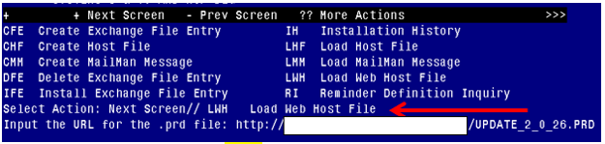

At the **Select Action:** prompt, enter **LWH** for Load Web Host File

At the **Input the url for the .prd file:** prompt, type the following web address:

**http://Redacted /UPDATE_2_0_26.PRD**

Terminal window screen shot of the message displaying the URL of the file that was successfully loaded.  Part of the URL has been redacted as it is a VA only internal web site URL.

You should see a message at the top of your screen that the file successfully loaded.

Search and locate an entry titled UPDATE_2_0_16 VA-HEAD AND NECK CANCER DIALOGS in reminder exchange

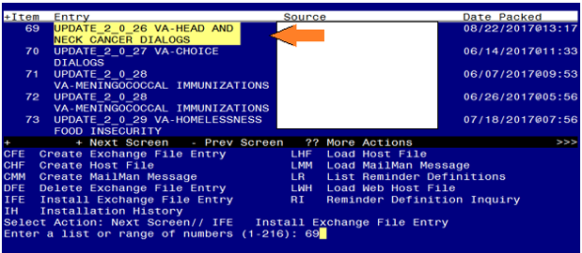

At the **Select Action** prompt, enter **IFE** for Install Exchange File Entry

Enter the number that corresponds with your entry titled UPDATE_2_0_26 VA-HEAD AND NECK CANCER DIALOGS  *(in this example it is entry 69, it will vary by site)*

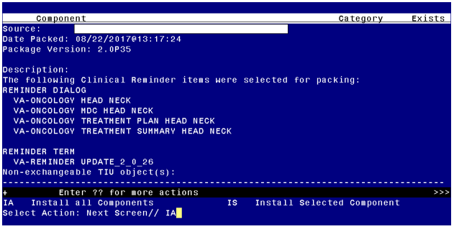

At the **Select Action** prompt, type **IA** for Install all Components and hit enter.

You will see several prompts, for all new entries you will choose I to Install.

After the initial components have installed,

**You will be promped to install the first reminder dialog component:**

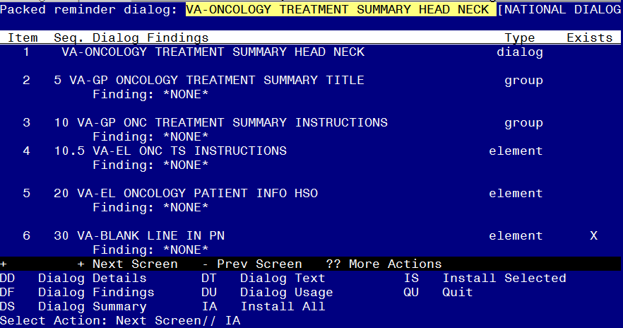

At the **Select Action** prompt, type **IA** to install the dialog **– VA-ONCOLOGY TREATMENT SUMMARY HEAD NECK**

Select Action: Next Screen// IA Install All

Install reminder dialog and all components with no further changes: Y// YES

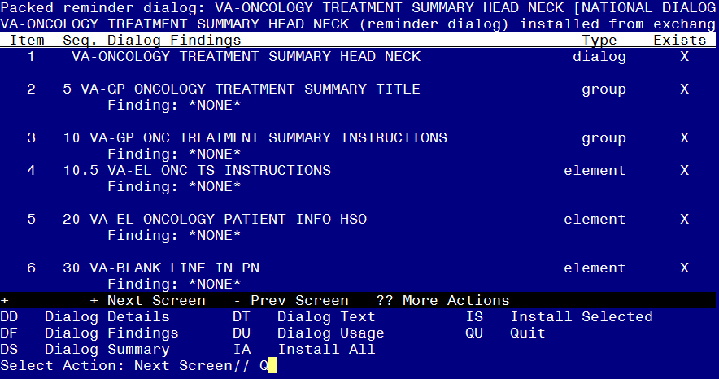

When the dialog has completed installation, you will then be returned to this screen. At the **Select Action** prompt, type **Q.**

**You will then be prompted to install the next Dialog component:**

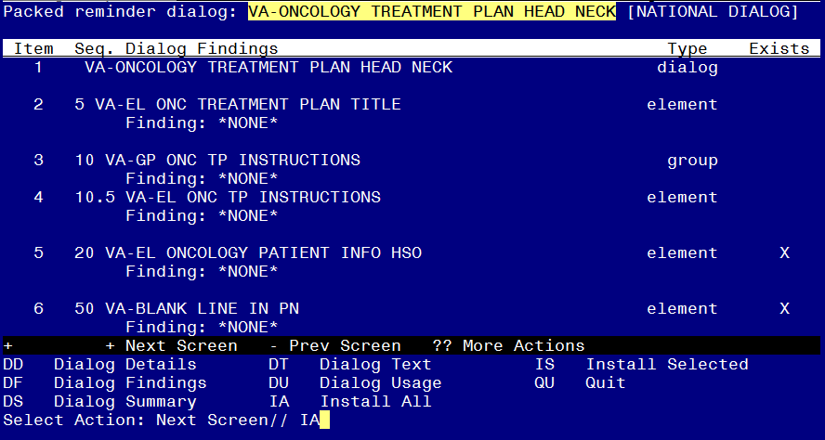

At the **Select Action** prompt, type **IA** to install the dialog **– VA-ONCOLOGY TREATMENT PLAN HEAD NECK**

Select Action: Next Screen// IA Install All

Install reminder dialog and all components with no further changes: Y// YES

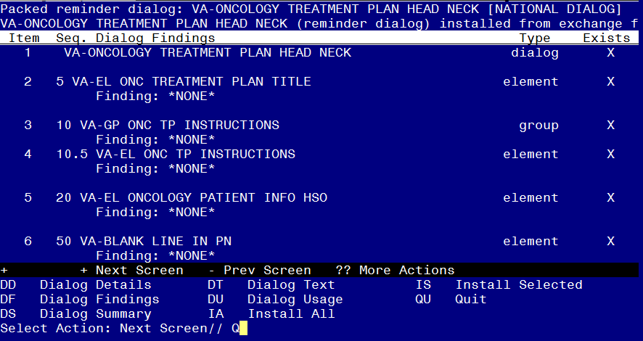

When the dialog has completed installation, you will then be returned to this screen. At the **Select Action** prompt, type **Q.**

**You will then be prompted to install the next Dialog component:**

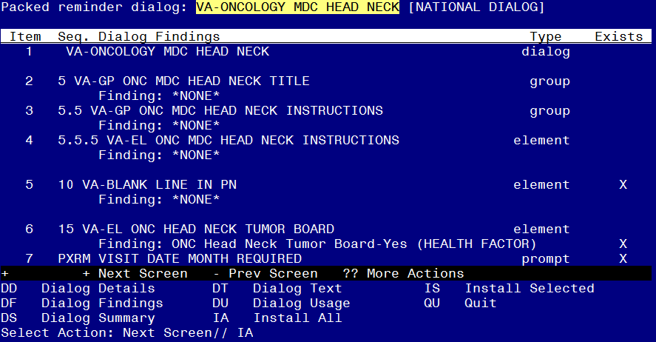

At the **Select Action** prompt, type **IA** to install the dialog **VA-ONCOLOGY MDC HEAD NECK**

Select Action: Next Screen// IA Install All

Install reminder dialog and all components with no further changes: Y// YES

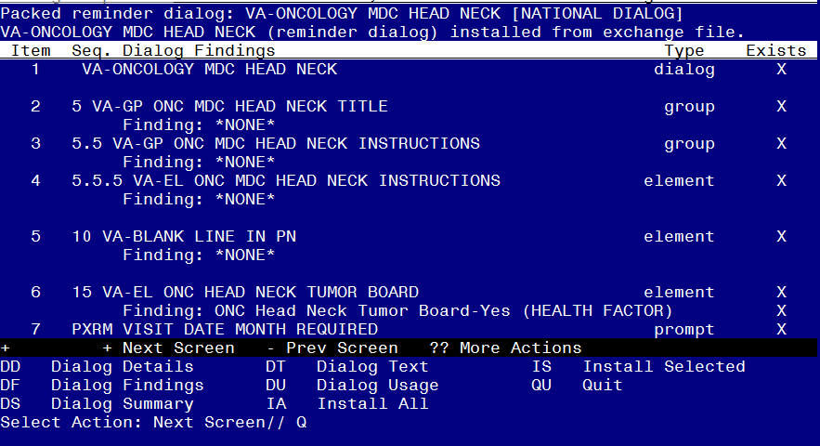

When the dialog has completed installation, you will then be returned to this screen. At the **Select Action** prompt, type **Q.**

**You will then be prompted to install the next Dialog component:**

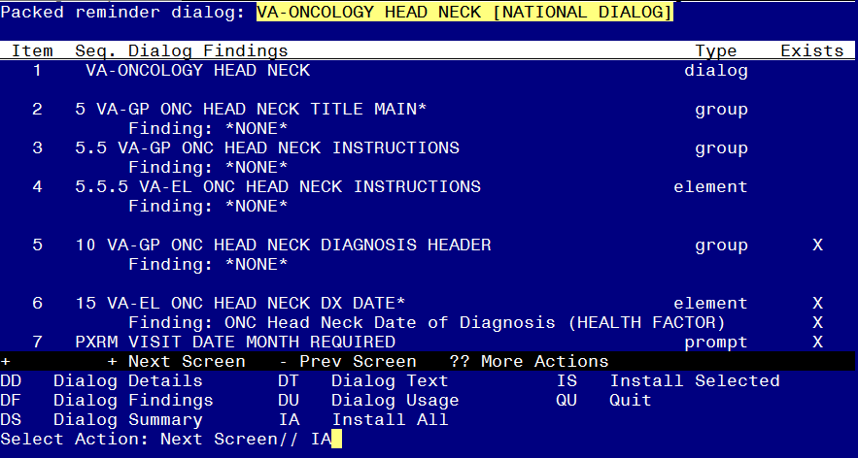

At the **Select Action** prompt, type **IA** to install the dialog **– VA-ONCOLOGY HEAD NECK**  
Select Action: Next Screen// IA Install All

Install reminder dialog and all components with no further changes: Y// YES

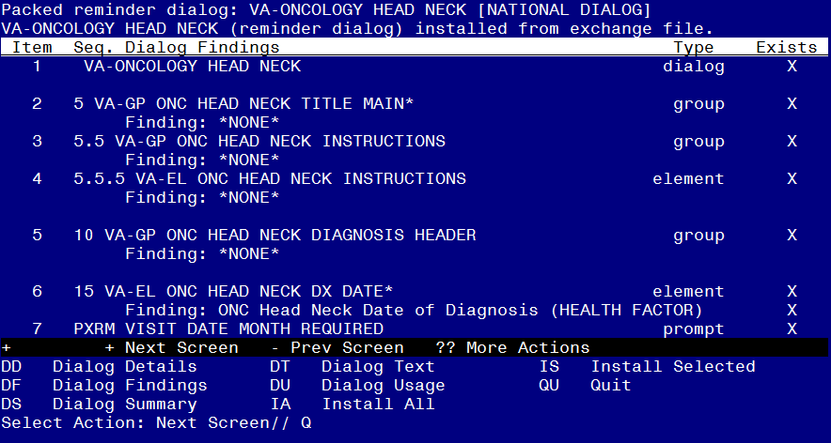

When the dialog has completed installation, you will then be returned to this screen. At the **Select Action** prompt, type **Q.**

You will then see the prompts to install the health summary components, you will choose I to install all new health summary components, you can choose O to Overwrite any components that already exist.

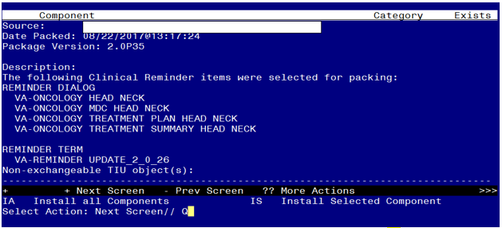

You will then be returned to this screen. At the **Select Action** prompt, type **Q.**

Install Completed

# Post-Install Set-up Instructions

1. **The following dialog elements were created LOCAL so local content can be added. Site may choose to disable these dialog elements if desired.**
2. VAL-GP ONC DASHED LINE SHOW (line shows in dialog and progress note for organization can be disabled, if desired)
3. VAL-GP ONC PT REC IV CHEMO (can edit to suppress check boxes)
4. VAL-GP ONC PT REC PO CHEMO (additional content can be added, if desired)
5. VAL-GP ONC TP EDUCATION (edit to add local oncology clinic info to help reduce typing for providers)
6. VAL-GP ONC TP TEAM MEMBERS (edit to local oncology provider info to help reduce typing for providers)
7. VAL-GP ONC TS FUTURE (edit to add local oncology team members and frequency of return visits)
8. VAL-GP ONC TS GENETIC COUNSELING (can add additional genetic counseling information)
9. VAL-GP ONC TS IMAGING (edit imaging and follow up tests)
10. VAL-GP ONC TS LAB TEST (edit to add additional lab tests)
11. VAL-GP ONC TS RESOURCES (edit to add any hyperlinks/websites)
12. VAL-GP ONC TS SURVEIL OTHER (edit to add other surveillance type)
13. VAL-GP ONC TS SURVEILLANCE (edit to add additional cancer surveillance)
14. VAL-EL ONC VITAL SIGNS HSO (contains weight, height, BP, and pulse, edit to add/remove additional VS objects. If site wants to disable VS element, will also need to disable VAL-GP ONC VITAL SIGNS dialog element).
15. VAL-GP ONC PHYSICAL EXAM (contains 50 character length, 2 line word processing field, edit if additional/less lines are needed)
16. VAL-GP ONC REVIEW OF SYSTEMS (contains 50 character length, 2 line word processing field, edit if additional/less lines are needed)
17. VAL-GP ONC PRESENT ILLNESS (contains 50 character length, 2 line word processing field, edit if additional/less lines are needed)
18. VAL-GP ONC INTERVAL HX (contains 50 character length, 2 line word processing field, edit if additional/less lines are needed)
19. VAL-GP ONC ASSESSMENT PLAN (contains 50 character length, 2 line word processing field, edit if additional/less lines are needed)
20. VAL-GP ONC MDC HEAD NECK CONSULTS (edit to add local consult/quick order)
21. VAL-GP ONC MDC HEAD NECK MEMBERS (edit to add local providers)

1. **Replace embedded TIU Objects in the following element only if National objects does not exist or work properly.**

**a. Dialog:** VA-EL ONCOLOGY PATIENT INFO HSO

|  |  |
| --- | --- |
| Embedded TIU Objects: | Description |
| |PATIENT NAME| | Displays patient name |
| |PATIENT DATE OF BIRTH| | Displays patient’s date of birth |
| |PATIENT WEIGHT| | Displays patient’s weight |
| |PATIENT HEIGHT| | Displays patient’s height |
| |BLOOD PRESSURE| | Displays patient’s blood pressure |
| |PULSE| | Displays patient’s heart rate |

**b. Dialob:** VAL-EL ONC ACTIVE MED HSO

|  |  |
| --- | --- |
| Embedded TIU Objects: | Description |
| |ACTIVE MEDICATIONS| | Displays patient’s active medications |

1. **Enable the dialogs.**

Adding dialog to the TIU Reminder Dialog Parameter (starting from the Reminder Manager Menu).

The following is an example of enabling a dialog so that it can be attached to a Personal or Shared template or note title. You will need to repeat this step for all of the dialogs contained in this update.

Select Reminder Managers Menu <TEST ACCOUNT> Option: CP CPRS Reminder Configuration

From the Reminders Manager Menu Option:

CA Add/Edit Reminder Categories

CL CPRS Lookup Categories

CS CPRS Cover Sheet Reminder List

MH Mental Health Dialogs Active

PN Progress Note Headers

RA Reminder GUI Resolution Active

TIU TIU Template Reminder Dialog Parameter

DL Default Outside Location

PT Position Reminder Text at Cursor

NP New Reminder Parameters

GEC GEC Status Check Active

WH WH Print Now Active

Select CPRS Reminder Configuration Option: TIU TIU Template Reminder Dialog Parameter

Reminder Dialogs allows as Templates may be set for the following:

1 User USR [choose from NEW PERSON]

3 Service SRV [choose from SERVICE/SECTION]

4 Division DIV [NAME OF YOUR DIVISION]

5 System SYS [YOURSERVER.YOURSITE.MED.VA.GOV]

Enter selection: 5 System [YOURSERVER.YOURSITE.MED.VA.GOV]

Setting Reminder Dialogs allows as Templates for System: YOURSERVER.YOURSITE.MED.VA.GOV

Select Display Sequence: ? 🡨 enter ? to determine last sequence number

Display Sequence Value

---------------- -----

1 DAY COMBINED TOBACCO USER

2 PATIENT EDUCATION ASSESSMENT

3 IMMUNIZATION CLINIC DIALOG

4 RD 580 NEU 562 DYSPHAGIA SCREENING TOOL

….412 NON VA CARE COORDINATION NOTE (D) ***🡸 last sequence number on my list yours will be different Choose a number not on your list***

Select Display Sequence: 413

Are you adding 413 as a new Display Sequence? Yes// YES

Display Sequence: 413// 413

Clinical Reminder Dialog: VA-ONCOLOGY HEAD/NECK reminder dialog NATIONAL

...OK? Yes// (Yes)

Repeat for the additional three dialogs: VA-ONCOLOGY MDC HEAD NECK

VA-ONCOLOGY TREATMENT PLAN HEAD NECK

VA-ONCOLOGY TREATMENT SUMMARY HEAD NECK

1. The National Oncology reminder dialogs can be used as templates and/or standalone notes. It is a local decision. Collaborate with Hematology/Oncology staff to determine how the dialogs will be used. The National Oncology Program Office will be releasing additional reminder dialogs so it is important to establish an appropriate location, such as shared folder with a separate folder for each type of cancer. Please follow Local naming convention guidelines in place at your facility.

**Creating a shared folder**

Open template editor

Click + sign Shared Templates

Click on New Template button

Type Oncology

Select folder in Template Type box

Click Apply lower right corner

EX: Creating Shared Folder

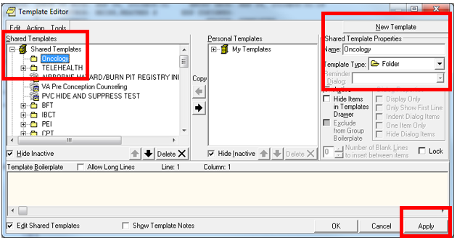

1. **Creating a shared templates**

Open template editor

Click + Shared templates

Locate Oncology folder and click on it

Click New Template button

Type VA-ONCOLOGY

Select Reminder Dialog in template Type box

Type VA-ONCOLOGY in Reminder Dialog box

Click Apply lower right corner

Repeat for all four templates**EX: Creating Shared Template**

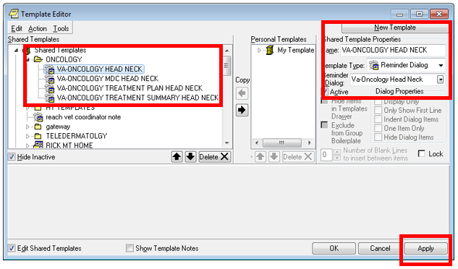

1. **Setup of Note titles**

If your site uses the reminder dialogs as stand-alone notes, you will need to create a new note title for each dialog included in this update.

*All note titles are to be mapped to the following VHA Enterprise Standard Title:***HEMATOLOGY AND ONCOLOGY NOTE.**  
.

Comprehensive information on Creating Document Definitions can be found beginning on page 47 of the [TIU/ASU Implementation Guide](http://www.va.gov/vdl/documents/Clinical/CPRS-Text_Integration_Utility_(TIU)/tiuim.pdf)

1. **Linking progress note to reminder dialog**

The following is an example of attaching a dialog to an associated note so that it can be used as a standalone note. You will need to repeat this step for all of the dialogs contained in this update.

From Template Editor

Edit Shared Template

Click + Document Titles

Click New Template button

Type VA-Oncology Head Neck (OR YOUR LOCAL NOTE TITLE) in Name box

Click down arrow and Click on Reminder Dialog in Template Type Box

Type VA-ONCOLOGY in Reminder Dialog box

Type VA-Oncology Head Neck in Associated Title Box

Click Apply in lower right corner

Repeat for all four templates.

**EX: Linking progress note to dialog**

