

**Update_2_0_271**

Clinical Reminders

VA-Pneumococcal Reminder Update

Install Guide

**March 2022**

Product Development

Office of Information Technology

Department of Veterans Affairs

Table of Contents

Introduction 1

Pre-Install 4

Install Details 5

Install Example 5

Post Installation 11

# Introduction

The CDC and VHA updated the guidance for Pneumococcal vaccine in February 2022

REDACTED

Reminder changes:

All patients at risk of pneumococcal disease should get a dose of conjugate vaccine (PCV). If that conjugate vaccine is PCV15 (or PCV13 done in the past), then PPSV23 should be given at 1 year after conjugate vaccine. PPSV23 is not needed if PCV20 is used.

PCV – pneumococcal conjugate vaccine

1. PCV15 or PCV20 should be given to anyone age 65 and older or anyone ages 18-64 with an underlying condition that increases their risk of pneumococcal disease . If PCV15 is used, then PPSV23 should be administered at one year or later (may be given as early as 8 weeks after PCV15 for patients at very high risk of invasive pneumococcal disease - IPD).
2. If PCV20 is used, no dose of PPSV23 is needed.
3. If the patient already received PCV13, repeat dosing with another conjugate vaccine may be considered but there is inadequate evidence to make it a recommendation and the PCV reminder will not be due.

PPSV23

1. PPSV23 is due after a prior dose of PCV13 or PCV15
   1. Due one year later for patients who are not at very high risk for invasive pneumococcal disease (IPD).
   2. Due 8 weeks later for patients who are at very high risk of IPD (immunocompromised, splenectomy, cochlear implant).
2. If PCV15 is used, then only one dose of PPSV23 is given – no more 2 or 3 doses depending in timing and age.
3. If PPSV23 has been administered in the past and is the only pneumococcal vaccine that the patient has been given, then a dose of conjugate vaccine (PCV) is recommended. No additional dose of PPSV23 is needed.
4. Patients who received PCV13 only or PCV13 + PPSV23 should complete the previously recommended PPSV23 series. ([see schedule](https://www.cdc.gov/vaccines/vpd/pneumo/downloads/pneumo-vaccine-timing.pdf))

Conditions with increased risk of pneumococcal disease include:

Alcoholism; chronic heart, liver, or lung disease; chronic renal failure; cigarette smoking; cochlear implant; congenital or acquired asplenia; cerebrospinal fluid leak; diabetes mellitus; generalized malignancy; HIV; Hodgkin disease; immunodeficiency; iatrogenic immunosuppression; leukemia, lymphoma, or multiple myeloma; nephrotic syndrome; solid organ transplant; sickle cell disease; or other hemoglobinopathies.

**Note:** *The name in Vista of the Pneumococcal Conjugate Reminder Definition and dialog did not change at this time. The name of the definition is still VA-PNEUMOCOCCAL IMMUNIZATION PCV13, the print name that the users will see in CPRS was updated to be Pneumococcal Conjugate Vaccine (PCV15/PCV20). This is to prevent loading a new additional reminder into your system. A future PXRM patch will rename the reminder and dialog.*

**UPDATE_2_0_271 contains 1 Reminder Exchange entry:**

UPDATE_2_0_271 VA-PNEUMOCOCCAL UPDATE

**The exchange file contains the following components:**

**TIU TEMPLATE FIELD**

BLANK TEXT FIELD FOR DIALOGS

VA-LOCATIONS

IM PNEUMO PRECAUT WARNING

IM PNEUMO CONTRA WARNING

IM PNEUMO PPSV23 DIAGNOSES

IM PPSV23 LOT# EXP DATE

IM COMMENT COMPLICATONS

IM VIS PPSV23 URL

IM VIS PPSV23 DT

IM PPSV23 MANUF

IM INJECTION RIGHT/LEFT

IM PNEUMOCOCCAL VACCINE NCP GUIDANCE

IM PNEUMOCOCCAL VACCINE ACIP GUIDANCE

IM PNEUMOC PCV INFO

IM PNEUMO CONJUGATE VACCINE DIAGNOSES

IM VIS PCV URL

IM VIS PCV DT

IM PCV13 MANUF LOT#

IM PCV20 LOT# EXP DATE

IM PCV20 MANUF

IM PCV15 LOT# EXP DATE

IM PCV15 MANUF

**HEALTH FACTORS**

VA-REMINDER UPDATES [C]

VA-UPDATE_2_0_271

IMMUNIZATION [C]

VA-PPSV23 EDUCATION VVC/TELEHEALTH VST

PNEUMOCOCCAL PPSV23 VACCINE PRECAUTION

PNEUMOCOCCAL PPSV23 VACCINE CONTRAIND

PNEUMOCOCCAL PPSV23 DX INCORRECT

REFUSED PNEUMOC VACCINE PPSV23

PNEUMOCOCCAL CONJUGATE VACCINE CONTRAIND

VA-PCV EDUCATION VVC/TELEHEALTH VST

PNEUMOCOCCAL CONJUGATE VACCINE PRECAUTION

PNEUMOCOCCAL CONJUGATE VACCINE DX INCORRECT

REFUSED PNEUMOC CONJUGATE VACCINE PCV

**REMINDER SPONSOR**

VA NATIONAL CENTER FOR HEALTH PROMOTION AND DISEASE PREVENTION (NCP)

NATIONAL CENTER FOR HEALTH PROMOTION AND DISEASE PREVENTION (NCP)

**REMINDER TAXONOMY**

VA-PNEUMOC DZ RISK - CHEMOTHERAPY

VA-PNEUMOC DZ RISK - IMMUNOCOMPROMISED

VA-PNEUMOC DZ RISK - HIGHEST/NOT IMMUNO COMP

VA-PNEUMOC DZ RISK - HIGH

VA-PNEUMOC PPSV23 IMMUNIZATION

LONG TERM SYSTEMIC STEROID

**REMINDER TERM**

VA-REMINDER UPDATE_2_0_271

STEROIDS - PNEUMOCOCCAL DZ RISK

VA-PNEUMOC DZ RISK - LONG TERM STEROIDS

VA-PNEUMOC DZ RISK - CHEMO/IMMUNOSUPP DRUGS

VA-BL PNEUMOC RECENT CHEMO/IMMUNOSUPPRESSION

VA-BL PNEUMOC RECENT CHEMOTHERAPY (ICD ONLY)

VA-PNEUMOC PCV IMMUNIZATION (ALL CONJUGATE)

VA-PNEUMOC PPSV23 IMMUNIZATION

VA-PNEUMOC DZ RISK - IMMUNOCOMPROMISED

VA-PNEUMOC DZ RISK - HIGHEST/NOT IMMUNO COMP

VA-PNEUMOC DZ RISK - HIGH

VA-AGE >64

VA-PNEUMOC PPSV23 ORDER SUPPRESSION

VA-ZOSTER IMMUNIZATION 1Y

VA-PNEUMOC PCV CONTRAINDICATION

VA-PNEUMOC PPSV23 INCORRECT DIAGNOSIS

VA-PNEUMOC PCV20 IMMUNIZATION

VA-PNEUMOC PCV15 IMMUNIZATION

VA-PNEUMOC PCV13 IMMUNIZATION

VA-PNEUMOC PPSV23 CONTRAINDICATIONS

VA-PNEUMOC PPSV23 ORDERS

VA-STEROID PREDN EQUIV 5-6.6MG

VA-STEROID PREDN EQUIV 6.6-9MG

VA-STEROID PREDN EQUIV 10-19MG

VA-STEROID PREDN EQUIV >=20MG

VA-CHEMO/IMMUNOSUPPRESSIVE DRUGS

VA-PNEUMOC DZ RISK - IMMUNOCOMPROMISED RX

VA-PNEUMOC PCV ORDER SUPPRESSION

VA-PNEUMOC PCV DEFERRALS

VA-MENING VACCINES DIPHTHERIA CONJUGATE

VA-PNEUMOC PCV ORDERS

VA-PNEUMOC PCV DX INCORRECT

**REMINDER DEFINITION**

LONG TERM STEROID USE

VA-BL PNEUMOC RECENT CHEMO/IMMUNOSUPPRESSION

VA-OB PNEUMOCOCCAL PRIOR VACCINATIONS

VA-OB PNEUMOCOCCAL PPSV23 INDICATIONS

VAL-IMMUNOCOMPROMISING DRUGS FOR PNEUMOCOCCAL DZ

VA-PNEUMOCOCCAL IMMUNIZATION PPSV23

VA-OB PNEUMOCOCCAL PCV INDICATIONS

VA-PNEUMOCOCCAL IMMUNIZATION PCV13

**HEALTH SUMMARY TYPE**

OB PNEUMOC IMMUNIZATIONS

OB PPSV23 INDICATIONS

OB PCV INDICATIONS

**HEALTH SUMMARY OBJECTS**

PNEUMOCOCCAL IMMUNIZATIONS (TIU)

PPSV23 INDICATIONS (TIU)

PNEUMOCOCCAL CONJUGATE INDICATIONS (TIU)

**TIU DOCUMENT DEFINITION**

PNEUMOCOCCAL IMMUNIZATIONS

PPSV23 INDICATIONS

PNEUMOCOCCAL CONJUGATE INDICATIONS

**REMINDER DIALOG**

VA-PNEUMOCOCCAL IMMUNIZATION PPSV23 PNEUMOVAX

VA-PNEUMOCOCCAL IMMUNIZATION PCV13 PREVNAR

# Pre-Install

1. Confirm with your local Primary care nursing and Pharmacy that your site is ready to administer one or both of the two new conjugate vaccines: PCV 15 and/or PCV 20

DO NOT INSTALL UNTIL YOUR SITE HAS CONFIRMED THEY HAVE THE NEW VACCINES IN STOCK OR HAVE A PLAN TO RAPIDLY SWITCH OVER TO THE NEW FORMULATIONS.  PCV13 IS BEING REMOVED FROM THE FORMULARY AND IS NO LONGER RECOMMENDED

1. Create a Reminder Exchange entry with two reminder definitions:

VA-PNEUMOCOCCAL IMMUNIZATION PCV13

VA-PNEUMOCOCCAL IMMUNIZATION PPSV23

**This will ensure you have a backup if you install before your site is ready to start administering the new vaccine**

1. **Find PPSV23 order currently in use.**

* Using the Vista Menu, Reminder Dialog Manager, DI- Reminder Dialog, change view to group view and Inq/Print the reminder dialog group **OI PNEUMOC PPSV23 OUTPT**. You will need to identify the local order or menu used as a finding item and add this order back post install.

1. **Do a reminder term inquiry for the following reminder terms for reference post install**:

VA-PNEUMOC PPSV23 ORDER SUPPRESSION

VA-STEROID PREDN EQUIV 5-6.6MG

VA-STEROID PREDN EQUIV 6.6-9MG

VA-STEROID PREDN EQUIV 10-19MG

VA-STEROID PREDN EQUIV >=20MG

# Install Details

This update is being distributed as a web host file. The address for the host file is: https://REDACTED /UPDATE_2_0_271.PRD

The file will be installed using Reminder Exchange, programmer access is not required.

Installation:

=============

This update can be loaded with users on the system. Installation will take less than 20 minutes.

# Install Example

To Load the Web Host File. Navigate to Reminder exchange in Vista

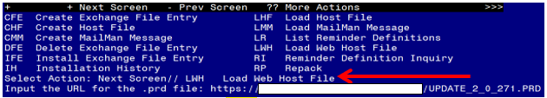

At the **Select Action:** prompt, enter **LWH** for Load Web Host File

At the **Input the url for the .prd file:** prompt, type the following web address:

**https://REDACTED/UPDATE_2_0_271.PRD**

You should see a message at the top of your screen that the file successfully loaded.Terminal window screen shot of the message displaying the URL of the file that was successfully loaded.  Part of the URL has been redacted as it is a VA only internal web site URL.Search and locate an entry titled **UPDATE_2_0_271 VA-PNEUMOCOCCAL UPDATE** in reminder exchange

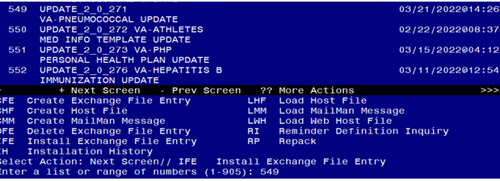

At the **Select Action** prompt, enter **IFE** for Install Exchange File Entry

Enter the number that corresponds with your entry titled **UPDATE_2_0_271 VA-PNEUMOCOCCAL UPDATE** *(in this example it is entry 549, it will vary by site). Make sure the date of the exchange file date is 03/21/2022.*

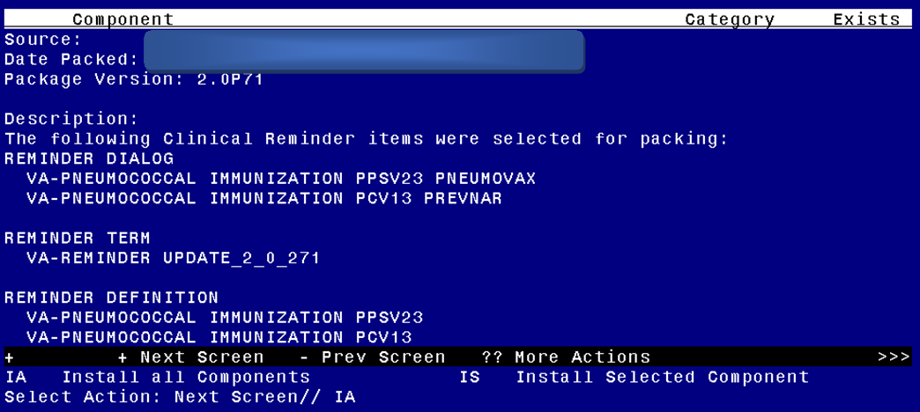

At the **Select Action** prompt, type **IA** for Install all Components and hit enter.

Select Action: Next Screen// IA Install all Components

During the installation, you will see several prompts: *Note that you will Install all new components*

* Any component that is new, use the INSTALL action.
* You can OVERWRITE TXML FIELDS with these exceptions, if you are prompted to overwrite the below TXML FIELDS, choose SKIP

IM PPSV23 LOT# EXP DATE

IM PCV13 MANUF LOT#

* OVERWRITE any REMINDER TAXONOMIES.
* You can OVERWRITE any REMINDER TERMS with these exceptions:

If you are prompted to overwrite any of the 5 reminder terms highlighted below, choose SKIP.

VA-PNEUMOC PPSV23 ORDER SUPPRESSION

VA-STEROID PREDN EQUIV 5-6.6MG

VA-STEROID PREDN EQUIV 6.6-9MG

VA-STEROID PREDN EQUIV 10-19MG

VA-STEROID PREDN EQUIV >=20MG

If you are prompted to overwrite these two terms, you may Merge them

VA-PNEUMOC PPSV23 IMMUNIZATION

VA-PNEUMOC PCV13 IMMUNIZATION

*In your TEST account, you may see prompts that the immunization findings IM.PNEUMOCOCCAL CONJUGATE PCV15, POLYSACCHARIDE CRM197 CONJUGATE, ADJUVANT, PF and IM.PNEUMOCOCCAL CONJUGATE PCV20, POLYSACCHARIDE CRM197 CONJUGATE, ADJUVANT, PF do not exist, you may choose delete at the prompt. The Immunization files in test accounts do not get updated with new vaccine types.*

* OVERWRITE any REMINDER DEFINITIONS if prompted
* OVERWRITE any HEALTH SUMMARY OBJECTS if prompted

**You will be promped to install the dialog component: VA-PNEUMOCOCCAL IMMUNIZATION PCV13 PREVNAR**

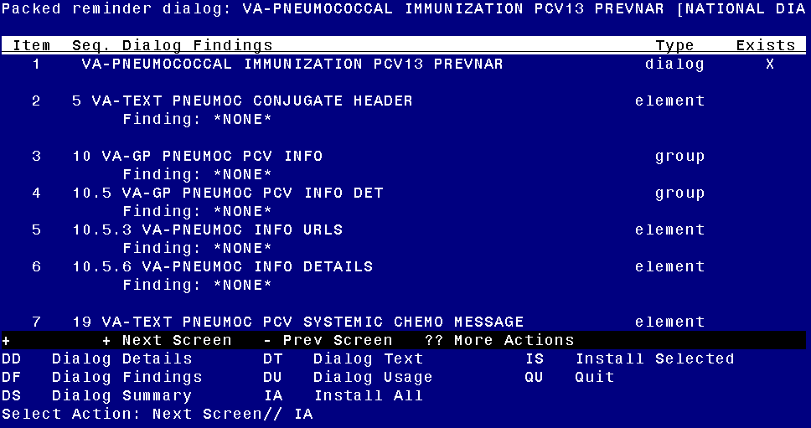

At the **Select Action** prompt, type **IA** to install the dialog – **VA-PNEUMOCOCCAL IMMUNIZATION PCV13 PREVNAR**

Select Action: Next Screen// IA Install All

Install reminder dialog and all components with no further changes: Y// ES

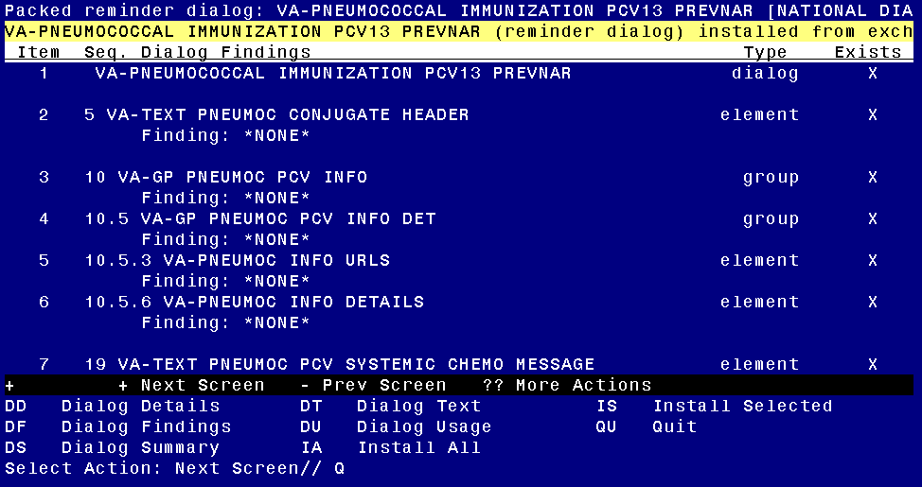

When the dialog has completed installation, you will then be returned to this screen. At the **Select Action** prompt, type **Q.**

**You will be promped to install the dialog component: VA-PNEUMOCOCCAL IMMUNIZATION PPSV23 PNEUMOVAX**

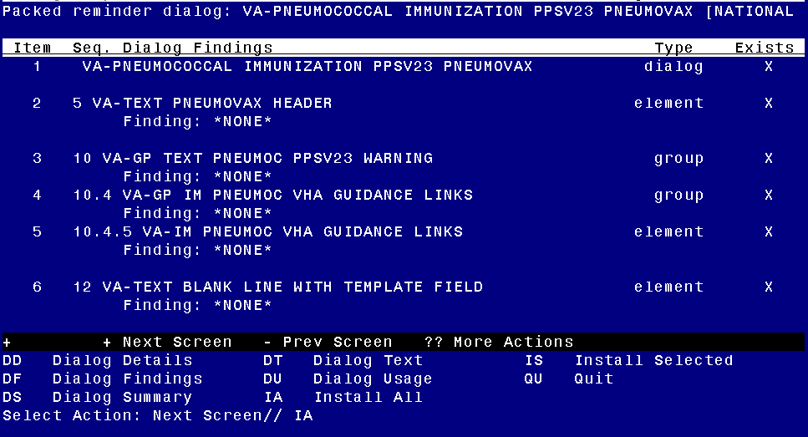

At the **Select Action** prompt, type **IA** to install the dialog – **VA-PNEUMOCOCCAL IMMUNIZATION PPSV23 PNEUMOVAX**

Select Action: Next Screen// IA Install All

Install reminder dialog and all components with no further changes: Y// ES

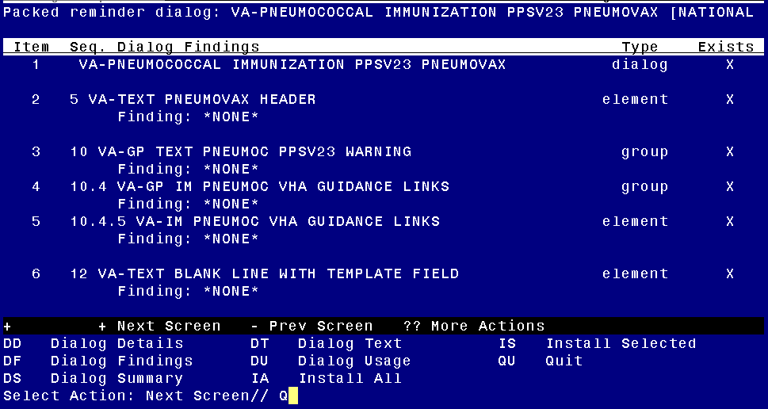

When the dialog has completed installation, you will then be returned to this screen. At the **Select Action** prompt, type **Q.**

You will then use the QUIT action to exit the install

Screen shot of the terminal window showing that after all of the groups, elements and dialogs have been installed, the reminder dialogs and reminder term that were installed with Q entered for quit to finish. The name of the VA employee at the Source line label has been redacted.



# Post Installation

1. **Add order identified in pre-install to reminder dialog.** Using the Vista Menu, Reminder Dialog Manager, DI- Reminder Dialog, change view to GROUP view edit the reminder dialog GROUP OI PNEUMOC PPSV23 OUTPT, add the quick order identified in the pre-install as a finding item.
2. **Add order that represents an order for pneumococcal conjugate vaccine to the reminder dialog group** OI PNEUMOC PCV OUTPT SHORT. You will add your local order for PCV 15, PCV20 or a menu with both as an additional finding item.
3. **Review the following reminder terms from the pre-install and update if needed:**

VA-PNEUMOC PPSV23 ORDER SUPPRESSION

1. **Update reminder term VA-PNEUMOC PCV ORDER SUPPRESSION**

If you want to suppress the ordering option in the dialog then follow the instructions for the reminder term VA-PNEUMOC PCV ORDER SUPPRESSION

To suppress the dialog element for specific user classes: VA-ASU USER CLASS Enter the user class that should NOT see the dialog element. If more than one user class is needed, add additional findings of the CF VA-ASU USER CLASS for each one as needed.

To suppress the dialog element for all users: VA-AGE change the < sign to a > sign in the CF for patient age.

To suppress for specific user classes, in the above Terms configure the VA-ASU USER CLASS computed finding and DELETE the VA-AGE finding. **NOTE: If the Age finding is not deleted, the user class settings will not work.**

1. **Disable the appropriate reminder dialog groups.** This update will install with the dialog groups to document administration of PCV15, and PCV20, you may disable the group(s) for any vaccine type that your site does not have available to administer.

VA-GP IM PNEUMOC CONJUGATE VACCINE PCV15

VA-GP IM PNEUMOC CONJUGATE VACCINE PCV20

The option to document PCV13 has been disabled. PCV13 is no longer recommended to be used, if your site decides to install this and to give some PCV13 even though it is no longer the recommended vaccine, you need to enable the dialog group GP IM PNEUMOC PCV13 PREVNAR.