

**Update _2_0_272A**

Clinical Reminders

VA-ATHLETES MEDICAL INFORMATION TEMPLATE UPDATE

Install Guide

**January 2024**

Product Development

Office of Information Technology

Department of Veterans Affairs

Table of Contents

Introduction 1

Install Details 2

Install Example 3

Post Installation 8

# Introduction

**Description-**

This updated reminder dialog template will be used to address identified needs of the National Veterans Golden Age Games and capture medical data to clear Veterans to participate in the Games at the time of screening.

* The annual National Veterans Golden Age Games (NVGAG) provides Veterans opportunities to engage in rehabilitative sport and recreation opportunities.  It serves Veterans ages 55 years and older who are enrolled in the VA Health Care System.
* Participants learn to use the therapeutic value of sports, fitness and recreation through an active, healthy lifestyle by competing in sporting competitions for example air rifle, horseshoes, pickleball, track and field.
* By participating in NVGAG, Veterans reach their full potential, improve their independence, achieve a healthier lifestyle and enjoy a higher quality of life.
* This reminder template allows the VA provider to electronically capture medical data to determine participation in the National Veterans Golden Age Games.
* This will facilitate communication to health care providers at the Host Site Facility to ensure continuity of care while participation in the National Veterans Golden Age Games away from the Veteran’s primary site of care.

The template has been updated for 2024 and the updates should make it easier for providers to complete.

The version number is now 3.1

Health factors were added.

UPDATE_2_0_272A contains 1 Reminder Exchange entry:

**UPDATE_2_0_272A VA-ATHLETES MED INFO TEMPLATE UPDATE**

**The exchange file contains the following components:**

**REMINDER GENERAL FINDINGS**

VIEW PROGRESS NOTE TEXT

**TIU TEMPLATE FIELD**

GOLDEN GAMES HL

ALLCOMMENT(4LINES)

**HEALTH FACTORS**

VA-REMINDER UPDATES [C]

VA-UPDATE_2_0_272A

VA-NVGAG [C]

VA-NVGAG EKG COMPLETED WITHIN PAST YEAR

VA-NVGAG PARTICIPATION DIV - WHEELCHAIR

VA-NVGAG PARTICIPATION DIV - VISUAL IMPAIR AND LEGAL BLIND

VA-NVGAG PARTICIPATION DIV - VISUAL IMPAIR NOT LEGAL BLIND

VA-NVGAG PARTICIPATION DIV - VISUAL IMPAIR

VA-NVGAG PARTICIPATION DIV - AMBULATORY

VA-NVGAG HX HOSPITALIZATION PAST YEAR - YES

VA-NVGAG HX HOSPITALIZATION PAST YEAR - NO

VA-NVGAG PROVIDER CLEARED VETERAN FOR LOW RISK ACTIVITIES

VA-NVGAG PROVIDER CLEARED VETERAN FOR MOD RISK ACTIVITIES

VA-NVGAG PROVIDER CLEARED VETERAN FOR HIGH RISK ACTIVITIES

VA-NVGAG ADVISED TO BRING MEDS AND DME NO

VA-NVGAG ADVISED TO BRING MEDS AND DME YES

VA-NVGAG MEDICAL HX DERMATOLOGY

VA-NVGAG MEDICAL HX ENDOCRINE

VA-NVGAG MEDICAL HX OPHTHALMOLOGY

VA-NVGAG MEDICAL HX GI GU

VA-NVGAG MEDICAL HX NEUROLOGY

VA-NVGAG MEDICAL HX PULMONOLOGY

VA-NVGAG MEDICAL HX MSK ORTHO RHEUM

VA-NVGAG MEDICAL HX CARDIOLOGY

VA-NVGAG MEDICAL HX OTHER

**REMINDER SPONSOR**

NATIONAL VETERANS SPORTS PROGRAMS AND SPECIAL EVENTS

**REMINDER TERM**

VA-REMINDER UPDATE_2_0_272A

**REMINDER DIALOG**

VA-ATHLETES MEDICAL INFORMATION

# Install Details

This update is being distributed as a web host file. The address for the host file is: **https://Redacted /UPDATE_2_0_272A.PRD**

The file will be installed using Reminder Exchange, programmer access is not required.

Installation:

=============

This update can be loaded with users on the system. Installation will take less than 5 minutes.

# Install Example

To Load the Web Host File. Navigate to Reminder exchange in Vista

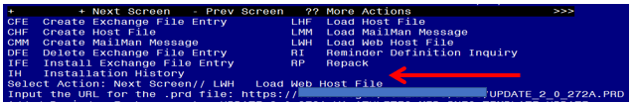

At the **Select Action:** prompt, enter **LWH** for Load Web Host File

At the **Input the url for the .prd file:** prompt, type the following web address:

**https://Redacted /UPDATE_2_0_272A.PRD**

You should see a message at the top of your screen that the file successfully loaded.

Search and locate an entry titled **UPDATE_2_0_****272A VA-ATHLETES MED INFO TEMPLATE UPDATE** in reminder exchange.

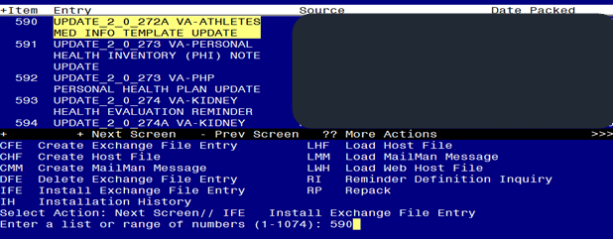

At the **Select Action** prompt, enter **IFE** for Install Exchange File Entry

Enter the number that corresponds with your entry UPDATE_2_0_272A VA-ATHLETES MED INFO TEMPLATE UPDATE *(in this example it is entry 251. It will vary by site).* The date of the exchange file should be 12/01/2023.

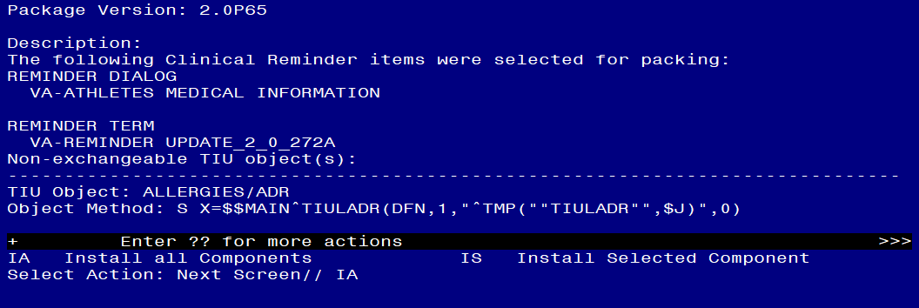

**DO NOT INSTALL ALL COMPONENTS!!!**

**Search for and find the REMINDER SPONSOR entry and you will install selected ONLY that item first (ON MY SCREEN IT IS ITEM 29):**

At the **Select Action** prompt, type **IS** for Install all Components and hit enter, choose the entry that corresponds to the sponsor entry NATIONAL VETERANS SPORTS PROGRAMS AND SPECIAL EVENTS

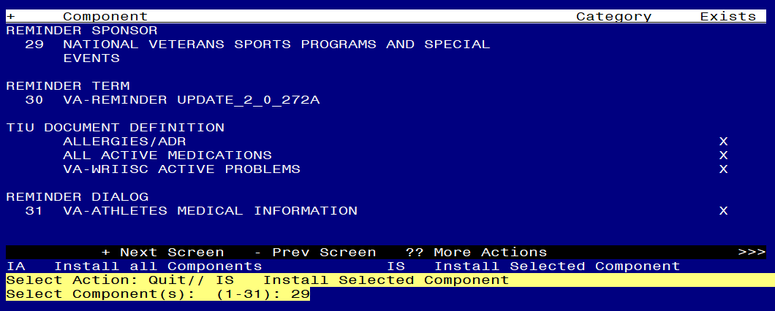

Select Action: Next Screen// **IS Install all Components**

Select Component(s): (1-31): **29**

REMINDER SPONSOR entry NATIONAL VETERANS SPORTS PROGRAMS AND SPECIAL EVENTS is NEW,what do you want to do?

Select one of the following:

C Create a new entry by copying to a new name

I Install

Q Quit the install

S Skip, do not install this entry

Enter response: I// **nstall**

After installing this component, you can install all

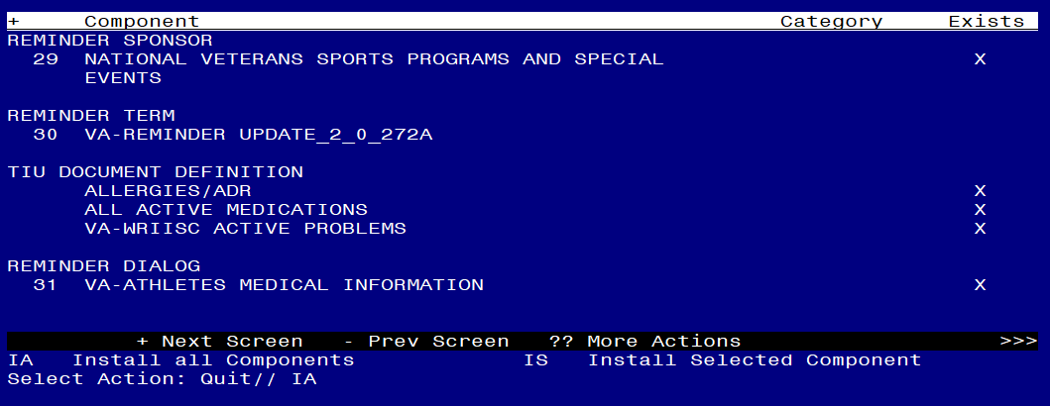

At the **Select Action** prompt, type **IA** for Install all Components and hit enter.

Select Action: Next Screen// IA Install all Components

You will see several prompts:

For all new entries you will choose **I to Install**

If you are prompted to overwrite any components, choose **S to Skip.**

**You will be promped to install the reminder dialog component.** You will choose to install all even though some components may have an X to indicate that they exist.

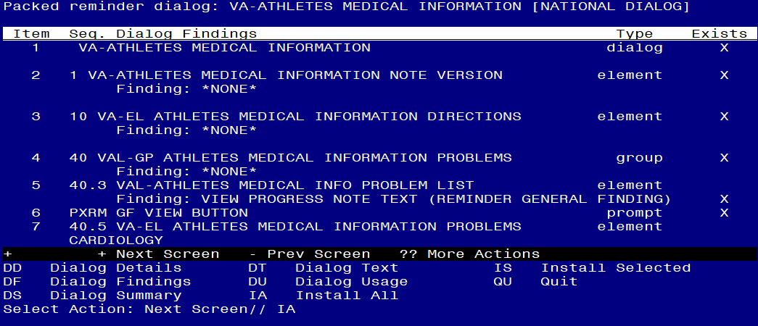

At the **Select Action** prompt, type **IA** to install the dialog: **VA-ATHLETES MEDICAL INFORMATION**

Select Action: Next Screen// IA Install All

Install reminder dialog and all components with no further changes: Y// Yes


Screen shot of the last of the list of elements, groups and dialogs that needed to be installed with a Q for quit entered at the "Select Action:" prompt because they now all exist.  

Select Action: Next Screen// Q

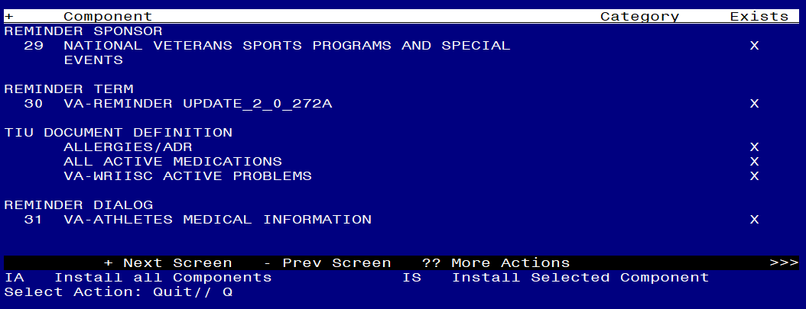

You will then be returned to this screen. At the **Select Action** prompt, type **Q.**

Install complete.

# Post Installation

1. **Update dialog text to replace DATA OBJECTS** (if needed), this reminder dialog contains elements that have data objects for ACTIVE MEDICATIONS and ACTIVE PROBLEM list entries. If you site does not have an object with those names, you can edit the element and replace the object in the dialog text with your local object.

Using the menu Reminder Dialog Management, Reminder Dialogs, change your view to Element. Search for and edit the following elements:

**VAL-ATHLETES MEDICAL INFO PROBLEM LIST** replace the object for problem list with your local object in the alternate progress note text

**VAL ATHLETES MEDICAL INFORMATION MEDICATIONS** replace object with you local object for active medications in the dialog text

1. Open the note titled NATIONAL VETERANS GOLDEN AGE GAMES MEDICAL CLEARANCE FORM and confirm the version that displays is 3.1.