

**Update _2_0_274A**

Clinical Reminders

VA-KIDNEY HEALTH EVALUATION REMINDER UPDATE

Install Guide

**November 2023**

Product Development

Office of Information Technology

Department of Veterans Affairs

Table of Contents

Introduction 1

Pre-Install 3

Install Details 4

Install Example 4

Post Installation 8

# Introduction

Several issues were found after the initial release of reminder update 274. The national kidney health clinical reminder is being updated with the following items:

1. Allow outside labs to have 1 decimal place.
2. Print name of reminder definition (what is viewable in Reminders DUE folder) was changed to Diabetes: Kidney Health Evaluation.
3. Conditions on findings 3,5,7 and 8 were updated to remove the V’=”comment” piece.
4. Added function finding 10 to ensure that a diabetes diagnosis was more recent than an incorrect diagnosis. This function finding was added to the cohort logic string.
5. Selection for incorrect diabetes diagnosis was added to the dialog along with a button to view the diagnoses.
   1. A button that gives clinician information on the diabetes diagnoses was added. This is a local element named VAL-INCORRECT DIABETES DIAGNOSES INFO BUTTON and sites may add their contact information for local HIMS department.
6. Branching logic reminder definitions were updated to include the same condition as the coversheet definitions for the lab tests. The branching logic definitions are:
   1. VA-BL KIDNEY HEALTH NO EGFR UACR DONE
   2. VA-BL KIDNEY HEALTH EGFR DONE
   3. VA-BL KIDNEY HEALTH EGFR AND UACR DONE
   4. VA-BL KIDNEY HEALTH UACR DONE
7. Updated taxonomy VA-ESRD/DIALYSIS
8. Added option for reporting outside results for Urine Albumin, uACR and eGFR when results were outside the limits of the instrument reporting, such as >60. This will be documented using PXRM COMMENT field
9. Added patient data objects for most recent eGFR and uACR

UPDATE_2_0_274A contains 1 Reminder Exchange entry:

UPDATE_2_0_274A VA-KIDNEY HEALTH EVALUATION REMINDER

**The exchange file contains the following components:**

REMINDER GENERAL FINDINGS

1 VIEW PROGRESS NOTE TEXT

TIU TEMPLATE FIELD

2 VA-DOD CKD LINK

HEALTH FACTORS

3 VA-REMINDER UPDATES [C]

4 VA-UPDATE_2_0_274A

5 INCORRECT DIAGNOSES [C]

6 VA-INCORRECT DIABETES DIAGNOSIS

7 VA-INCORRECT DIABETES DIAGNOSIS-PROVIDER

8 VA-KIDNEY HEALTH EVALUATION [C]

9 VA-KIDNEY HEALTH EVALUATION URINE CR COMPLETED

PREVIOUSLY

10 VA-KIDNEY HEALTH EVALUATION URINE ALB PREV NO

RESULTS

11 VA-KIDNEY HEALTH EVALUATION URINE ALB COMPLETED

PREVIOUSLY

12 VA-KIDNEY HEALTH EVALUATION PATIENT DECLINES LABS

13 VA-KIDNEY HEALTH EVALUATION UACR PREV NO RESULTS

14 VA-KIDNEY HEALTH EVALUATION UACR COMPLETED

PREVIOUSLY

15 VA-KIDNEY HEALTH EVALUATION EGFR PREV NO RESULTS

16 VA-KIDNEY HEALTH EVALUATION EGFR COMPLETED

PREVIOUSLY

17 REMINDER FACTORS [C]

18 LIFE EXPECTANCY <6 MONTHS

19 LIFE EXPECTANCY < 6 MONTHS

REMINDER SPONSOR

20 OFFICE OF PATIENT CARE SERVICES

21 OFFICE OF KIDNEY MEDICINE

22 NATIONAL CENTER FOR HEALTH PROMOTION AND DISEASE

PREVENTION (NCP)

23 VHA CARDIOLOGY SERVICES

REMINDER TAXONOMY

24 VA-DIABETES

25 VA-ESRD/DIALYSIS

26 VA-TERMINAL CANCER PATIENTS

REMINDER TERM

27 VA-REMINDER UPDATE_2_0_274A

28 VA-BL DIABETES DX 2Y

29 VA-INCORRECT DIABETES DIAGNOSIS

30 VA-KIDNEY HEALTH EVALUATION URINE CR COMPLETED

PREVIOUSLY

31 VA-KIDNEY HEALTH EVALUATION URINE ALB COMPLETED

PREVIOUSLY

32 VA-KIDNEY HEALTH EVALUATION PATIENT DECLINES

33 VA-KIDNEY HEALTH EVALUATION LAB ORDERED

34 VA-KIDNEY HEALTH EVALUATION URINE CREATININE

35 VA-KIDNEY HEALTH EVALUATION URINE ALBUMIN

36 VA-KIDNEY HEALTH EVALUATION UACR COMPLETED

PREVIOUSLY

37 VA-KIDNEY HEALTH EVALUATION UACR LAB TEST

38 VA-KIDNEY HEALTH EVALUATION EGFR COMPLETED

PREVIOUSLY

39 VA-KIDNEY HEALTH EVALUATION EGFR LAB TEST

40 VA-KIDNEY HEALTH EVALUATION EXCLUSIONS

41 VA-DIABETES DX

REMINDER DEFINITION

42 VA-KIDNEY HEALTH EVALUATION

43 VA-OBJ KIDNEY HEALTH DIABETES DIAGNOSIS

44 VA-BL KIDNEY HEALTH EGFR AND UACR DONE

45 VA-BL KIDNEY HEALTH UACR DONE

46 VA-BL KIDNEY HEALTH NO EGFR UACR DONE

47 VA-BL KIDNEY HEALTH EGFR DONE

HEALTH SUMMARY COMPONENT

CLINICAL REMINDERS FINDINGS

HEALTH SUMMARY TYPE

48 VA-OBJ KID HEALTH DIAB DX

HEALTH SUMMARY OBJECTS

49 VA-OBJ KID HEALTH DIAB DX

TIU DOCUMENT DEFINITION

50 VA-OBJ KID HEALTH DIAB DX

REMINDER DIALOG

51 VA-KIDNEY HEALTH EVALUATION

# Pre-Install

1. With update 274, you should have mapped your local lab tests to reminder terms for uACR, eGFR, orderable items to term that represent Serum or Plasma Creatinine, BMP, CMP and UACR to the reminder term VA-KIDNEY HEALTH EVALUATION LAB ORDERED, and also mapped your quick orders for plasma/serum creatinine, basic metabolic panel (BMP) and comprehensive metabolic panel (CMP) to the associated reminder dialog elements.
2. When doing the install, you should SKIP (so you don’t lose any local mappings to the terms) all terms **except** the ones outlined in the installation example, which you should use MERGE.
3. You should make a note of your quick orders that are mapped in the dialog so that after the dialog you can go back and add those back in as they will be overwritten during the dialog install in the following dialog components

|  |  |
| --- | --- |
| Element name | Quick Order(s) |
| VA-KIDNEY HEALTH EVALUATION EGFR CREATININE | plasma or serum creatinine |
| VA-KIDNEY HEALTH EVALUATION EGFR BMP | basic metabolic panel (BMP) |
| VA-KIDNEY HEALTH EVALUATION EGFR CMP | comprehensive metabolic panel (CMP) |
| VA-KIDNEY HEALTH EVALUATION UACR CREATININE | urine albumin-creatinine ratio (uACR) |
| VA-KIDNEY HEALTH EVALUATION EGFR/UACR CREATININE | plasma or serum creatinine  urine albumin-creatinine ratio (uACR) |
| VA-KIDNEY HEALTH EVALUATION EGFR/UACR BMP | basic metabolic panel (BMP)  urine albumin-creatinine ratio (uACR) |
| VA-KIDNEY HEALTH EVALUATION EGFR/UACR CMP | comprehensive metabolic panel (CMP)  urine albumin-creatinine ratio (uACR) |

# Install Details

This update is being distributed as a web host file. The address for the host file is: https://Redacted /UPDATE_2_0_274A.PRD

The file will be installed using Reminder Exchange, programmer access is not required.

Installation:

=============

This update can be loaded with users on the system. Installation will take less than 10 minutes.

# Install Example

To Load the exchange file, use LWH. The URL is https://REDACTED/ UPDATE_2_0_274A.PRD

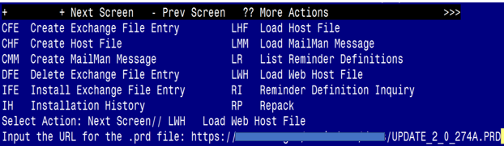

You should see a message that the file was loaded successfully.

Terminal window screen shot of the message displaying the URL of the file that was successfully loaded.  Part of the URL has been redacted as it is a VA only internal web site URL as shown in the text.

Search and locate an entry titled UPDATE_2_0_274A VA-KIDNEY HEALTH EVALUATION UPDATE in reminder exchange.

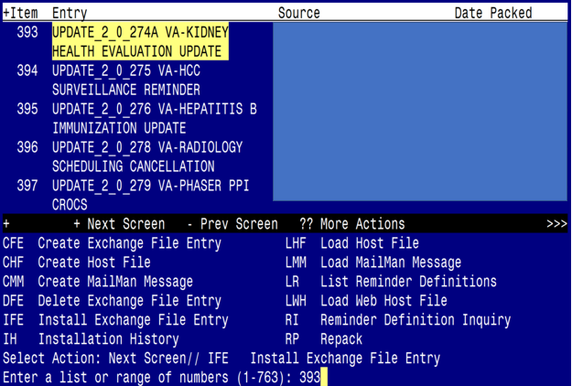

At the **Select Action** prompt, enter **IFE** for Install Exchange File Entry

Enter the number that corresponds with your entry titled UPDATE_2_0_274A VA-KIDNEY HEALTH EVALUATION UPDATE *(in this example it is entry 393, it will vary by site)* that is dated 10/26/2023.

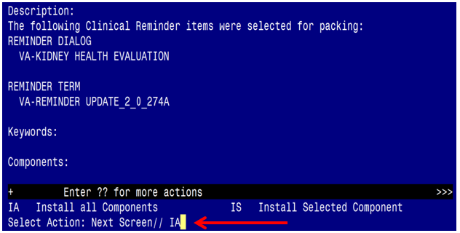 Select IA to install all components and hit enter

**Once this is done, you will be able to use action IA** for Install all Components and hit enter.

**For all new entries in any category you will choose I to Install**

**For Health Factors that exist, but are different you will OVERWRITE**

**For Reminder Taxonomy that exist, but is different, you will OVERWRITE**

**For Reminder Term VA-KIDNEY HEALTH EVALUATION EGFR COMPLETED PREVIOUSLY, you will MERGE.**

**For Reminder Term VA-KIDNEY HEALTH EVALUATION UACR COMPLETED PREVIOUSLY, you will MERGE.**

**For Reminder Term VA-INCORRECT DIABETES DIAGNOSIS, you will MERGE.**

**Any other terms** **that exist, but are different, you will Skip**

**For Reminder Definitions that exist, but are different, you will OVERWRITE**

You will then be prompted to install the Dialog component.

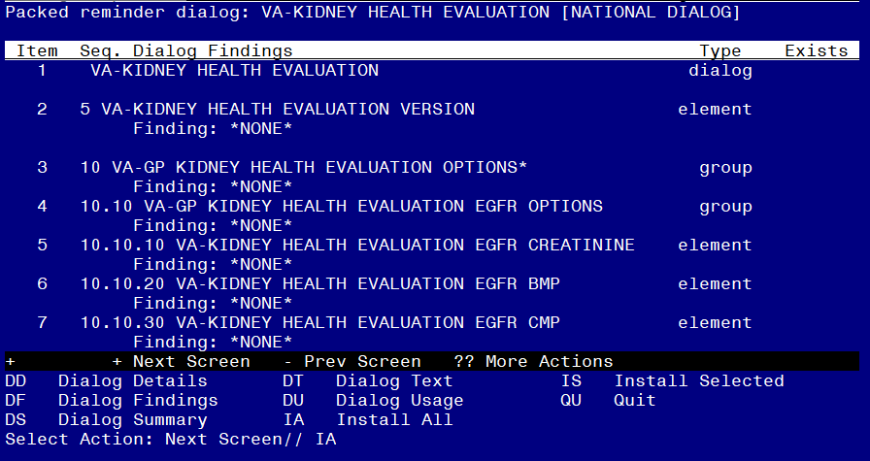

At the **Select Action** prompt, type **IA** to install the dialog – **VA-KIDNEY HEALTH EVALUATION**

**Hit enter when prompted to link to the definition:**

Install reminder dialog and all components with no further changes: Y// ES....

Reminder Dialog VA-KIDNEY HEALTH EVALUATION is not linked to a reminder.

Select Reminder to Link: VA-KIDNEY HEALTH EVALUATION//

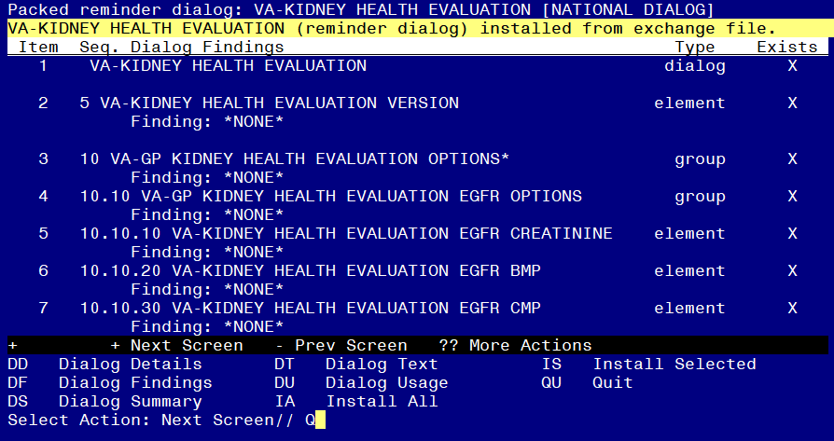

When the dialog has completed installation, you will then be returned to this screen. At the **Select Action** prompt, type **Q.**

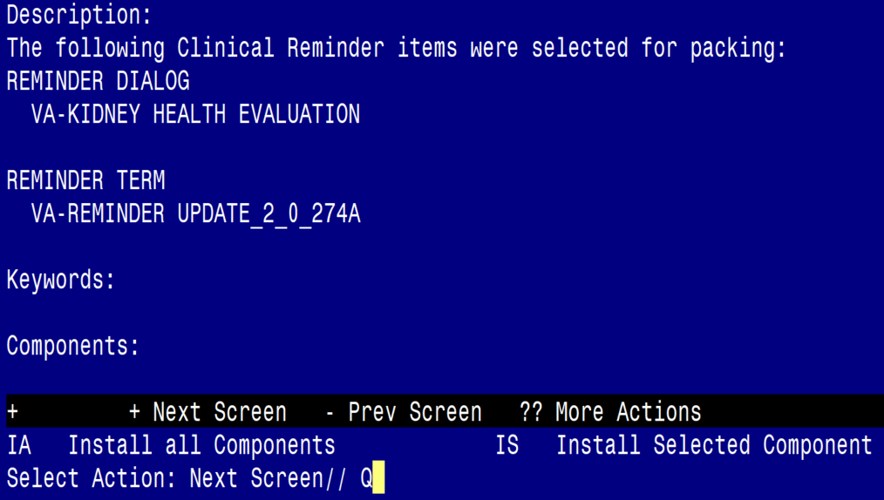

You will then be returned to this screen. At the **Select Action** prompt, type **Q.**

Install complete.

# Post Installation

1. **Add lab orders to the reminder dialog.** Using the Vista Menu, Reminder Dialog Manager, DI- Reminder Dialog, change view to element and edit the following elements adding your quick order as a finding item or additional finding, for those that have more than one test, you can create an order set and add the order set as your finding item or add both quick orders (one as a finding item and one as an additional finding)

|  |  |
| --- | --- |
| Element name | Quick Order(s) |
| VA-KIDNEY HEALTH EVALUATION EGFR CREATININE | plasma or serum creatinine |
| VA-KIDNEY HEALTH EVALUATION EGFR BMP | basic metabolic panel (BMP) |
| VA-KIDNEY HEALTH EVALUATION EGFR CMP | comprehensive metabolic panel (CMP) |
| VA-KIDNEY HEALTH EVALUATION UACR CREATININE | urine albumin-creatinine ratio (uACR) |
| VA-KIDNEY HEALTH EVALUATION EGFR/UACR CREATININE | plasma or serum creatinine  urine albumin-creatinine ratio (uACR) |
| VA-KIDNEY HEALTH EVALUATION EGFR/UACR BMP | basic metabolic panel (BMP)  urine albumin-creatinine ratio (uACR) |
| VA-KIDNEY HEALTH EVALUATION EGFR/UACR CMP | comprehensive metabolic panel (CMP)  urine albumin-creatinine ratio (uACR) |

1. Add your patient data objects for last eGFR and uACR to reminder dialog element VAL-CKD UACR AND EGFR DATA OBJECTS. Currently the dialog text is



You will need to edit the dialog/progress note text to replace “Most recent eGFR within past 12 months” and “Most recent uACR/MicroAlbumin within past 12 months” with your patient data objects. If your site chooses not to have these objects show, you can disable this element.

1. Reminder dilaog element VAL-INCORRECT DIABETES DIAGNOSES INFO BUTTON contains information to contact your local HIMS to have incorrect diabetes diagnoses removed from record. Edit the progress note text to add contact information for HIMS or remove that piece altogether.