

**Update _2_0_274**

Clinical Reminders

VA-KIDNEY HEALTH EVALUATION REMINDER

Install Guide

**May 2023**

Product Development

Office of Information Technology

Department of Veterans Affairs

Table of Contents

Introduction 1

Pre-Install 2

Install Details 3

Install Example 3

Post Installation 7

# Introduction

The national kidney health clinical reminder is the product of collaboration between the national Nephrology program, EPRP, and national Pathology and Laboratory Medicine. It is intended to help staff with monitoring the kidney health of diabetics per new guidelines and meeting the associated EPRP measure.

VHA recommends an annual evaluation of kidney health for patients aged 18-85

with:

Diabetes diagnosis within the past two years AND NOT on dialysis or

already diagnosed with ESRD They need

1. at least one estimated Glomerular Filtration Rate (eGFR) measurement

2. and at least one urine albumin creatinine ratio (uACR) on the same or

different dates. (In patients with normal urine albumin excretion, the urine albumin concentration may be below the detectable threshold, resulting in the inability of the lab to calculate uACR. If this is the case, the measure will be met based on the presence of urine albumin and urine creatinine measurements on the same sample)

UPDATE_2_0_274 contains 1 Reminder Exchange entry:

UPDATE_2_0_274 VA-KIDNEY HEALTH EVALUATION REMINDER

**The exchange file contains the following components:**

TIU TEMPLATE FIELD

1 VA-DOD CKD LINK

HEALTH FACTORS

2 VA-REMINDER UPDATES [C]

3 VA-UPDATE_2_0_274

4 VA-KIDNEY HEALTH EVALUATION [C]

5 VA-KIDNEY HEALTH EVALUATION URINE CR COMPLETED

PREVIOUSLY

6 VA-KIDNEY HEALTH EVALUATION URINE ALB PREV NO

RESULTS

7 VA-KIDNEY HEALTH EVALUATION URINE ALB COMPLETED

PREVIOUSLY

8 VA-KIDNEY HEALTH EVALUATION PATIENT DECLINES LABS

9 VA-KIDNEY HEALTH EVALUATION UACR COMPLETED

PREVIOUSLY

10 VA-KIDNEY HEALTH EVALUATION EGFR COMPLETED

PREVIOUSLY

11 REMINDER FACTORS [C]

12 LIFE EXPECTANCY <6 MONTHS

13 LIFE EXPECTANCY < 6 MONTHS

REMINDER SPONSOR

14 OFFICE OF PATIENT CARE SERVICES

15 OFFICE OF KIDNEY MEDICINE

16 NATIONAL CENTER FOR HEALTH PROMOTION AND DISEASE

PREVENTION (NCP)

17 VHA CARDIOLOGY SERVICES

REMINDER TAXONOMY

18 VA-DIABETES

19 VA-ESRD/DIALYSIS

20 VA-TERMINAL CANCER PATIENTS

REMINDER TERM

21 VA-REMINDER UPDATE_2_0_274

22 VA-BL DIABETES DX 2Y

23 VA-KIDNEY HEALTH EVALUATION URINE CR COMPLETED

PREVIOUSLY

24 VA-KIDNEY HEALTH EVALUATION URINE ALB COMPLETED

PREVIOUSLY

25 VA-KIDNEY HEALTH EVALUATION PATIENT DECLINES

26 VA-KIDNEY HEALTH EVALUATION LAB ORDERED

27 VA-KIDNEY HEALTH EVALUATION URINE CREATININE

28 VA-KIDNEY HEALTH EVALUATION URINE ALBUMIN

29 VA-KIDNEY HEALTH EVALUATION UACR COMPLETED

PREVIOUSLY

30 VA-KIDNEY HEALTH EVALUATION UACR LAB TEST

31 VA-KIDNEY HEALTH EVALUATION EGFR COMPLETED

PREVIOUSLY

32 VA-KIDNEY HEALTH EVALUATION EGFR LAB TEST

33 VA-KIDNEY HEALTH EVALUATION EXCLUSIONS

34 VA-DIABETES DX

REMINDER DEFINITION

35 VA-KIDNEY HEALTH EVALUATION

36 VA-BL KIDNEY HEALTH EGFR AND UACR DONE

37 VA-BL KIDNEY HEALTH UACR DONE

38 VA-BL KIDNEY HEALTH NO EGFR UACR DONE

39 VA-BL KIDNEY HEALTH EGFR DONE

REMINDER DIALOG

40 VA-KIDNEY HEALTH EVALUATION

# Pre-Install

1. Check with your laboratory to identify the lab tests for these two items:

estimated Glomerular Filtration Rate (eGFR)

the eGFR is a calculated value based on serum creatinine and/or cystatin C along with patient age and sex

urine albumin creatinine ratio (uACR)

the uACR is a calculated value, based on the quotient of

urine albumin concentration

urine creatinine concentration

1. Identify the quick orders your site uses for these laboratory tests:

plasma or serum creatinine

basic metabolic panel (BMP)

comprehensive metabolic panel (CMP)

urine albumin-creatinine ratio (uACR)

1. Ensure with lab adpac/LIM that lab tests eGFR, uACR, Quantitative Urine Albumin and Urine Creatine are mapped to correct LOINC codes in VistA file 60 (Laboratory Test file)
   1. eGFR codes – 50210-4, 98979-8 or 98980-6
   2. uACR codes - 9318-7, 13705-9, 14958-3, 14959-1, 30000-4, 32294-1, 44292-1, 59159-4, 76401-9, 77253-3, 77254-1, 89998-9
   3. Quantitative Urine Albumin codes - 1754-1, 14957-5, 21059-1, 30003-8, 43605-5, 53530-2, 53531-0, 57369-1, 89999-7
   4. Urine Creatinine codes - 2161-8, 20624-3, 35674-1, 39982-4, 57344-4, 57346-9, 58951-5

# Install Details

This update is being distributed as a web host file. The address for the host file is: https://REDACTED/UPDATE_2_0_274.PRD

The file will be installed using Reminder Exchange, programmer access is not required.

Installation:

=============

This update can be loaded with users on the system. Installation will take less than 10 minutes.

# Install Example

To Load the exchange file, use LWH. The URL is https://REDACTED /UPDATE_2_0_274.PRD

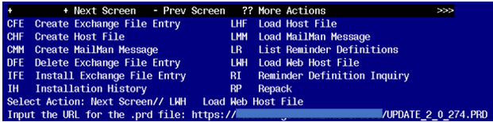

You should see a message that the file was loaded successfully.

Terminal window screen shot of the message displaying the URL of the file that was successfully loaded.  Part of the URL has been redacted as it is a VA only internal web site URL.

Search and locate an entry titled UPDATE_2_0_274 VA-KIDNEY HEALTH EVALUATION REMINDER in reminder exchange.

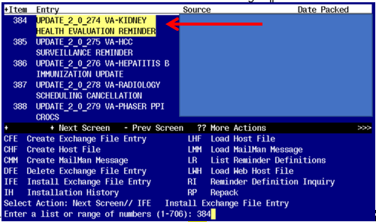

At the **Select Action** prompt, enter **IFE** for Install Exchange File Entry

Enter the number that corresponds with your entry titled UPDATE_2_0_274 VA-KIDNEY HEALTH EVALUATION REMINDER *(in this example it is entry 384, it will vary by site)* that is dated 05/02/2023.

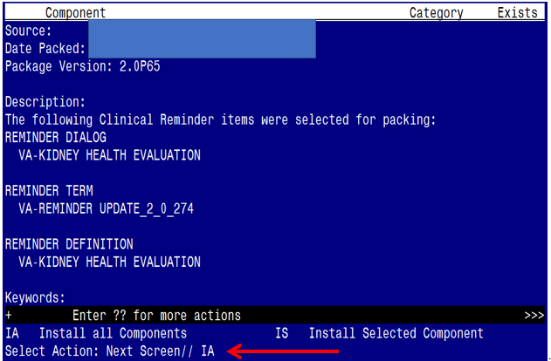 At the **Select Action** prompt, you will need to install a new sponsor prior to doing an INSTALL ALL action. Choose IS and then select item 15 (reminder sponsor ‘OFFICE OF KIDNEY MEDICINE’)

**Once this is done, you will be able to use action IA** for Install all Components and hit enter.

**For all new entries in any category you will choose I to Install**

**Skip any items in any category you are prompted to overwrite**

You will then be prompted to install the Dialog component.

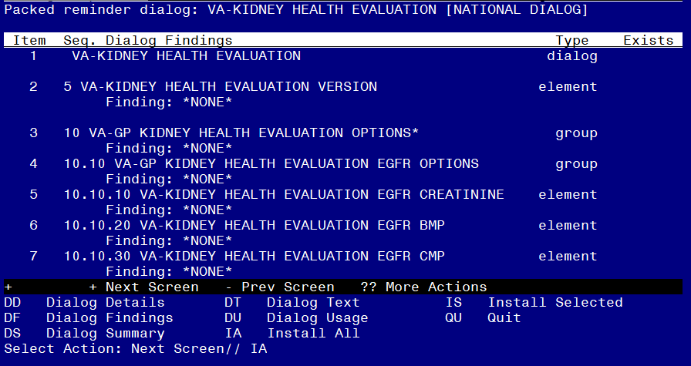

At the **Select Action** prompt, type **IA** to install the dialog – **VA-KIDNEY HEALTH EVALUATION**

**Hit enter when prompted to link to the definition:**

Install reminder dialog and all components with no further changes: Y// ES....

Reminder Dialog VA-KIDNEY HEALTH EVALUATION is not linked to a reminder.

Select Reminder to Link: VA-KIDNEY HEALTH EVALUATION//

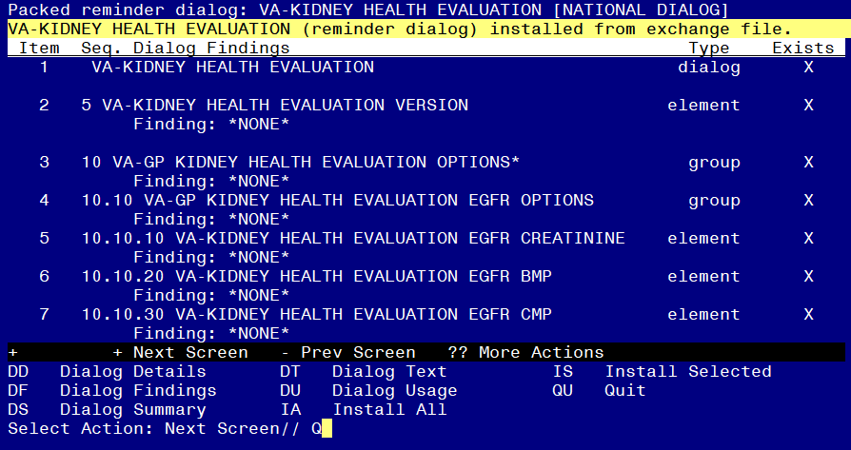

When the dialog has completed installation, you will then be returned to this screen. At the **Select Action** prompt, type **Q.**

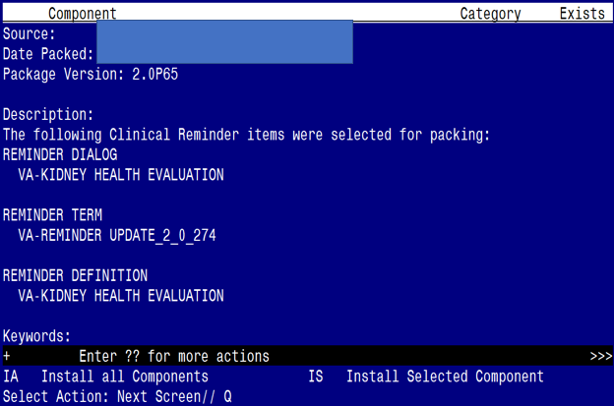

You will then be returned to this screen. At the **Select Action** prompt, type **Q.**

Install complete.

# Post Installation

1. **Add local LAB TESTS that represent uACR to the reminder term VA-KIDNEY HEALTH EVALUATION UACR LAB TEST.** The findings that you add should be LT type findings. Ex: LT.UACR. You do not need to add a status or info in any other field.
2. **Add local LAB TESTS that represent eGFR to the reminder term VA-KIDNEY HEALTH EVALUATION EGFR LAB TEST.** The findings that you add should be LT type findings. Ex: LT.EGFR. You do not need to add a status or info in any other field.
3. **Add orderable items that represent Serum or Plasma Creatinine, BMP, CMP and UACR to the reminder term VA-KIDNEY HEALTH EVALUATION LAB ORDERED.** The findings that you add should be OI type findings. Ex: OI.BMP. You do not need to add a status or info in any other field.
4. **Add lab orders to the reminder dialog.** Using the Vista Menu, Reminder Dialog Manager, DI- Reminder Dialog, change view to element and edit the following elements adding your quick order as a finding item or additional finding, for those that have more than one test, you can create an order set and add the order set as your finding item or add both quick orders (one as a finding item and one as an additional finding)

|  |  |
| --- | --- |
| Element name | Quick Order(s) |
| VA-KIDNEY HEALTH EVALUATION EGFR CREATININE | plasma or serum creatinine |
| VA-KIDNEY HEALTH EVALUATION EGFR BMP | basic metabolic panel (BMP) |
| VA-KIDNEY HEALTH EVALUATION EGFR CMP | comprehensive metabolic panel (CMP) |
| VA-KIDNEY HEALTH EVALUATION UACR CREATININE | urine albumin-creatinine ratio (uACR) |
| VA-KIDNEY HEALTH EVALUATION EGFR/UACR CREATININE | plasma or serum creatinine  urine albumin-creatinine ratio (uACR) |
| VA-KIDNEY HEALTH EVALUATION EGFR/UACR BMP | basic metabolic panel (BMP)  urine albumin-creatinine ratio (uACR) |
| VA-KIDNEY HEALTH EVALUATION EGFR/UACR CMP | comprehensive metabolic panel (CMP)  urine albumin-creatinine ratio (uACR) |

1. **Add the new reminder to the cover sheet for the appropriate users.** You will use the Add Cover Sheet Reminder option in CPRS. The print name is Kidney Health Evaluation. Because this is a new reminder, you may want to turn on only for a few individuals to test before expanding usage.
2. Your site may consider having nursing protocol updated to allow nurses to enter orders for diabetic labs. A sample order set is below.

