

**Update _2_0_276**

Clinical Reminders

VA-Hepatitis B Immunization Update

Install Guide

**May 2022**

Product Development

Office of Information Technology

Department of Veterans Affairs

Table of Contents

Introduction 1

Install Details 5

Install Example 6

Post Installation 11

# Introduction

Hepatitis B vaccination is now recommended for all individuals age 19-59 and also for all high risk patients age 60 and older.  Prior to this recent update, HBV vaccination was recommended for all high risk individuals of any age and for patients with diabetes ages 19-59.

[HBV Adult schedule](https://www.cdc.gov/vaccines/schedules/hcp/imz/adult.html#note-hepb)

Redacted internal VA document.

Reminder definition

Change cohort logic from including patients age 19-59 who have diabetes to include all patients age 19-59. The inclusion criteria for high risk patients age 60 and older remains the same.

No change in the sequence or other logic: if no serology has been done, then the serology/immunization reminder is due. If serology is done and negative or if the immunization series has been started, then the immunization reminder is applicable. Both reminders are resolved by prior infection as indicated by serology.

Reminder dialog:

1. Change detailed text in both reminder dialogs to indicate that vaccination of all persons 18-59 should be considered. No other changes are needed.  
     
   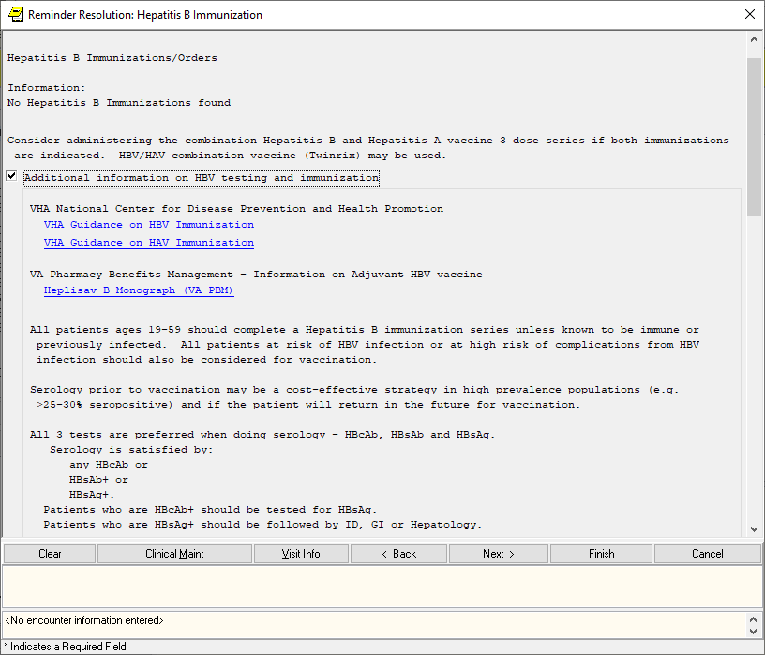

UPDATE_2_0_276 contains 1 Reminder Exchange entry:

**UPDATE_2_0_276 VA-HEPATITIS B IMMUNIZATION UPDATE**

**The exchange file contains the following components:**

**TIU TEMPLATE FIELD**

BLANK TEXT FIELD FOR DIALOGS

PBM HEPLISAV-B MONOGRAPH

NCP HAV IMMUNIZATION GUIDANCE

PBM HEPLISAV-B TRAVEL RECOMMEND

PBM HEPLISAV-B LIST OF COUNTRIES

VA-LOCATIONS

IM VIS HBV URL

IM VIS HBV DT

IM VIS HAV DT

IM COMMENT COMPLICATONS

IM HAV/HBV ADJ LOT# EXP DATE

IM HAV/HBV MANUF

IM INJECTION RIGHT/LEFT

IM VIS HBV ADJ URL

IM HBV ADJ LOT# EXP DATE

IM HBV ADJ MANUF

IM HBV LOT# EXP DATE

IM HBV MANUF

IM HBV DOSE

**HEALTH FACTORS**

VA-REMINDER UPDATES [C]

VA-UPDATE_2_0_276

OUTSIDE SEROLOGY [C]

OUTSIDE HEPATITIS A SEROPOSITIVE

OUTSIDE HEPATITIS B SURFACE AB POSITIVE

OUTSIDE HEPATITIS B SURFACE AB NEGATIVE

OUTSIDE HEPATITIS B SURFACE AG POSITIVE

OUTSIDE HEPATITIS B SURFACE AG NEGATIVE

OUTSIDE HEPATITIS B CORE AB POSITIVE

OUTSIDE HEPATITIS B CORE AB NEGATIVE

IMMUNIZATION [C]

VA-HEP B EDUCATION VVC/TELEHEALTH VST

HEPATITIS B VACCINATION DEFER TEMPORARY

HEPATITIS B [C]

HEPATITIS B VACCINATION NOT INDICATED

REFUSED HEPATITIS B VACCINE

HEPATITIS B SEROLOGY NOT INDICATED

REFUSED HEPATITIS B SEROLOGY

REMINDER FACTORS [C]

LIFE EXPECTANCY < 6 MONTHS

INCORRECT DIAGNOSES [C]

VA-INCORRECT DIABETES DIAGNOSIS

VA-HBV AB EDUCATION VVC/TELEHEALTH VST

**REMINDER SPONSOR**

VA NATIONAL CENTER FOR HEALTH PROMOTION AND DISEASE PREVENTION (NCP)

OFFICE OF QUALITY & PERFORMANCE

NATIONAL CENTER FOR HEALTH PROMOTION AND DISEASE PREVENTION (NCP)

VHA ONCOLOGY

VHA CARDIOLOGY SERVICES

OFFICE OF PATIENT CARE SERVICES

OFFICE OF PUBLIC HEALTH AND ENVIRONMENTAL HAZARDS

**REMINDER TAXONOMY**

VA-IMMUNIZATION INJECTION 90471

VA-TERMINAL CANCER PATIENTS

VA-DIABETES

VA-CIRRHOSIS

VA-HEPATIC STEATOSIS

VA-CHRONIC LIVER DISEASE (NON-HBV/HCV)

VA-GASTRIC VARICES

VA-HEPATIC FIBROSIS

VA-HEPATITIS B RISK DRUG USE

VA-HEPATITIS B RISK SEXUAL TRANSMISSION

VA-END STAGE RENAL DISEASE

VA-ESOPHAGEAL VARICES

VA-HIV INFECTION

VA-HEPATITIS C INFECTION

**REMINDER TERM**

VA-REMINDER UPDATE_2_0_276

VA-HEPATITIS A VACCINATION INDICATED

VA-HEPATITIS A IMMUNE/SEROPOS

VA-HEPATITIS A SEROLOGY IGG/TOTAL

VA-OUTSIDE HEPATITIS B SURFACE AB POSITIVE

VA-OUTSIDE HEPATITIS B SURFACE AB NEGATIVE

VA-OUTSIDE HEPATITIS B SURFACE AG POSITIVE

VA-OUTSIDE HEPATITIS B SURFACE AG NEGATIVE

VA-OUTSIDE HEPATITIS B CORE AB POSITIVE

VA-OUTSIDE HEPATITIS B CORE AB NEGATIVE

VA-HEPATITIS B SURFACE ANTIBODY

VA-HEPATITIS B SURFACE ANTIGEN

VA-HEPATITIS B CORE ANTIBODY (IGG/TOTAL)

VA-BL HBV SEROLOGY SECTION SUPPRESS

VA-HEPATITIS B IMMUNIZATION 3/4 DOSE SERIES

VA-HEPATITIS B PHARMACY/NURSING ORDERABLE ITEM

VA-HEPATITIS B IMMUNIZATION ADJUVANT

VA-LAST SERVICE SEPARATION >1/1/2001

VA-HBV ADMINISTRATION SUPPRESSION

VA-HEPATITIS B IMMUNIZATION STD ONLY

VA-HEPATITIS B IMMUNIZATION NOT INDICATED

VA-HEPATITIS B SEROLOGY NOT INDICATED

VA-HEPATITIS B IMMUNIZATION REFUSED/DEFERRED

VA-HEPATITIS B SEROLOGY REFUSED/DEFERRED

VA-LIFE EXPECTANCY < 6 MONTHS

VA-DIABETES DX INCORRECT

VA-DIABETES DX

VA-HEPATITIS B RISK

**REMINDER DEFINITION**

VA-BL HBV SEROLOGY SECTION SUPPRESS

VA-HEPATITIS B IMM/ORDERABLE ITEMS OBJECT

VA-HEPATITIS B IMMUNIZATION

VA-HEPATITIS B SEROLOGY/IMMUNIZATION

**HEALTH SUMMARY TYPE**

OB HAV HBV SEROLOGY OUTSIDE

OB HAV HBV SEROLOGY

VA-HEP B IMMUNIZATIONS

**HEALTH SUMMARY OBJECTS**

HAV HBV SEROLOGY OUTSIDE (TIU)

HAV HBV SEROLOGY

VA-HEP B IMMUNIZATIONS (TIU)

**TIU DOCUMENT DEFINITION**

HAV HBV SEROLOGY OUTSIDE

HAV HBV SEROLOGY

VA-HEP B IMMUNIZATIONS

**REMINDER DIALOG**

VA-HEPATITIS B IMMUNIZATION

VA-HEPATITIS B SEROLOGY/IMMUNIZATION

# Pre-install

1. **Do a reminder term inquiry for the following reminder terms for reference post install**:

VA-HEPATITIS B SURFACE ANTIBODY

VA-HEPATITIS B SURFACE ANTIGEN

VA-HEPATITIS B CORE ANTIBODY (IGG/TOTAL)

VA-HEPATITIS A VACCINATION INDICATED

VA-HEPATITIS B IMMUNIZATION NOT INDICATED

VA-HEPATITIS B SEROLOGY NOT INDICATED

VA-HEPATITIS B IMMUNIZATION REFUSED/DEFERRED

VA-HEPATITIS B SEROLOGY REFUSED/DEFERRED

VA-OUTSIDE HEPATITIS B SURFACE AB POSITIVE

VA-OUTSIDE HEPATITIS B SURFACE AB NEGATIVE

VA-OUTSIDE HEPATITIS B SURFACE AG POSITIVE

VA-OUTSIDE HEPATITIS B SURFACE AG NEGATIVE

VA-OUTSIDE HEPATITIS B CORE AB POSITIVE

VA-OUTSIDE HEPATITIS B CORE AB NEGATIVE

VA-HEPATITIS A IMMUNE/SEROPOS

1. Using the Vista Menu, Reminder Dialog Manager, DI- Reminder Dialog, change view to element view and Inq/Print the reminder dialog elements:

VA-HBV OI SEROLOGIC PANEL

VA-HBV OI IMMUNIZATION

You will need to identify the local order or menu used as a finding item and add this order back post install.

# Install Details

This update is being distributed as a web host file. The address for the host file is:

https://REDACTED /UPDATE_2_0_276.PRD

The file will be installed using Reminder Exchange, programmer access is not required.

Installation:

=============

This update can be loaded with users on the system. Installation will take less than 5 minutes.

# Install Example

To Load the Web Host File. Navigate to Reminder exchange in Vista

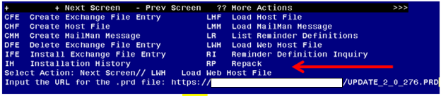

At the **Select Action:** prompt, enter **LWH** for Load Web Host File

At the **Input the url for the .prd file:** prompt, type the following web address:

**https://REDACTED/UPDATE_2_0_276.PRD.**

Terminal window screen shot of the message displaying the URL of the file that was successfully loaded.  Part of the URL has been redacted as it is a VA only internal web site URL.

You should see a message at the top of your screen that the file successfully loaded.

Search and locate an entry titled UPDATE_2_0_276 VA-HEPATITIS B IMMUNIZATION UPDATE in reminder exchange

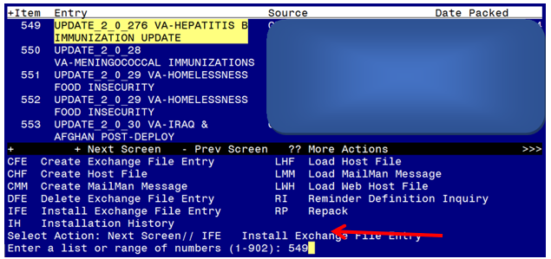

At the **Select Action** prompt, enter **IFE** for Install Exchange File Entry

Enter the number that corresponds with your entry titled UPDATE_2_0_276 VA-HEPATITIS B IMMUNIZATION UPDATE *(in this example it is entry 549, it will vary by site). Ensure the file date is 04/19/2022.*

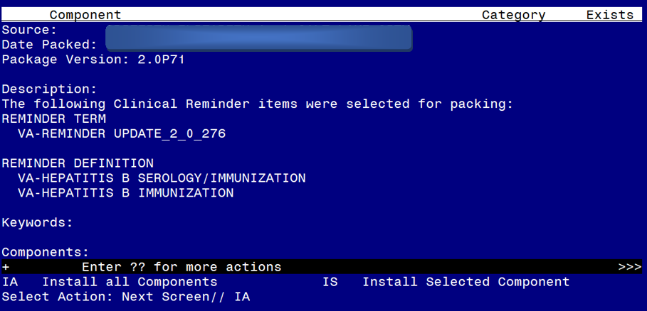

At the **Select Action** prompt, type **IA** for Install all Components and hit enter.

You will **INSTALL** ALL new components.

You will **OVERWRITE** **TIU TEMPLATE FIELDS** except for these that you may have edited locally, If you get the message that these already exists but the packed component is different for these three TIU template fields, choose skip:

IM HAV/HBV ADJ LOT# EXP DATE

IM HBV ADJ LOT# EXP DATE

IM HBV LOT# EXP DATE

You will **SKIP** any **HEALTH FACTORS** that already exists, but the packed component is different.

You will **OVERWRITE** any **REMINDER TAXONOMIES** that already exists, but the packed component is different

You will **SKIP** any **REMINDER TERMS** that already exists, but the packed component is different

You will **OVERWRITE** any **REMINDER DEFINITIONS** that already exists, but the packed component is different

You will **SKIP** any **HEALTH SUMMARY** components that already exists, but the packed component is different

***If your site has CPRS 32B installed, you will not install the reminder dialog from this file, you will have a separate install guide for immunization reminder dialogs.* You will be promped to install the first dialog component, VA-HEPATITIS B IMMUNIZATION. You will install all even though all components have an X to indicate they already exist in your system.**

For the VA-HEPATITIS B IMMUNIZATION (NATIONAL DIALOG):
Screen shot of the terminal window showing a list of elements, groups and dialogs with the text with IA for "Install All" entered at the "Select Action:" Prompt.  The correct entry is described in the text.

At the **Select Action** prompt, type **IA** to install the dialog – VA-HEPATITIS B IMMUNIZATION

Select Action: Next Screen// IA Install All

Install reminder dialog and all components with no further changes: Y// Y

For the VA-HEPATITIS B IMMUNIZATION (NATIONAL DIALOG):
Screen shot of the last of the list of elements, groups and dialogs that needed to be installed with a Q for quit entered at the "Select Action:" prompt because they now all exist.  

When the dialog has completed installation, you will then be returned to this screen. At the **Select Action** prompt, type **Q.**

***If your site has CPRS 32B installed, you will not install the reminder dialog from this file, you will have a separate install guide for immunization reminder dialogs.* You will be promped to install the second dialog component, VA-HEPATITIS B SEROLOGY/ IMMUNIZATION. You will install all even though all components have an X to indicate they already exist in your system.**

For the VA-HEPATITIS B SEROLOGY/IMMUNIZATION (NATIONAL DIALOG):
Screen shot of the terminal window showing a list of elements, groups and dialogs with the text with IA for "Install All" entered at the "Select Action:" Prompt.  The correct entry is described in the text.

At the **Select Action** prompt, type **IA** to install the dialog – **VA-HEPATITIS B SEROLOGY/IMMUNIZATION**

Select Action: Next Screen// IA Install All

Install reminder dialog and all components with no further changes: Y// Y

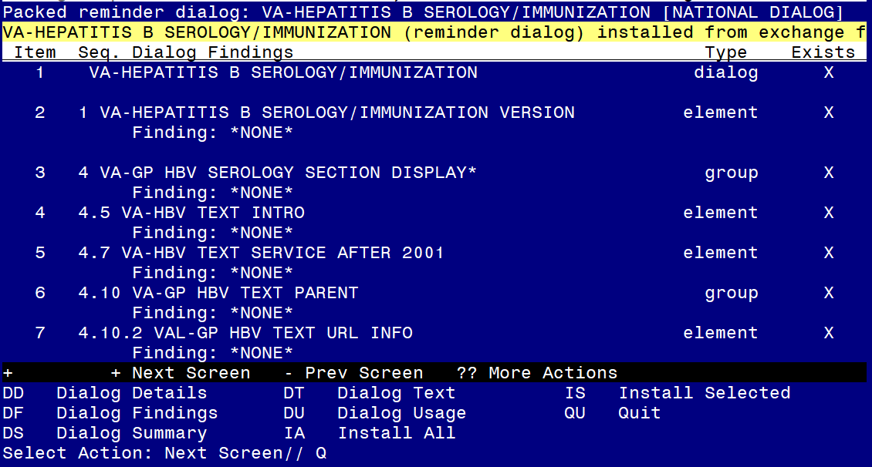

When the dialog has completed installation, you will then be returned to this screen. At the **Select Action** prompt, type **Q.**

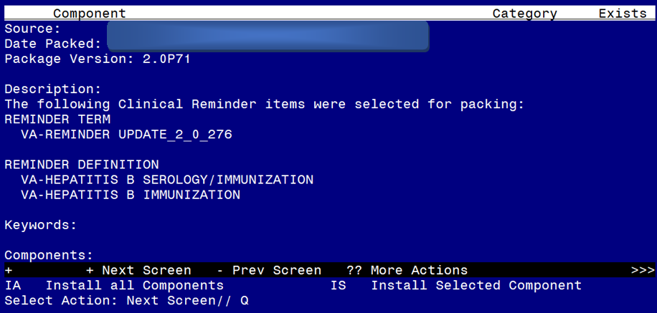

At the Select Action prompt, type Q to quit.

Install Completed

# Post Installation

1. Review the pre-install inquiry for the following reminder terms and make changed if needed, if you skipped during install as instructed, no changed should be needed.

VA-HEPATITIS B SURFACE ANTIBODY

VA-HEPATITIS B SURFACE ANTIGEN

VA-HEPATITIS B CORE ANTIBODY (IGG/TOTAL)

VA-HEPATITIS A VACCINATION INDICATED

VA-HEPATITIS B IMMUNIZATION NOT INDICATED

VA-HEPATITIS B SEROLOGY NOT INDICATED

VA-HEPATITIS B IMMUNIZATION REFUSED/DEFERRED

VA-HEPATITIS B SEROLOGY REFUSED/DEFERRED

VA-OUTSIDE HEPATITIS B SURFACE AB POSITIVE

VA-OUTSIDE HEPATITIS B SURFACE AB NEGATIVE

VA-OUTSIDE HEPATITIS B SURFACE AG POSITIVE

VA-OUTSIDE HEPATITIS B SURFACE AG NEGATIVE

VA-OUTSIDE HEPATITIS B CORE AB POSITIVE

VA-OUTSIDE HEPATITIS B CORE AB NEGATIVE

VA-HEPATITIS A IMMUNE/SEROPOS

1. Add quick orders/order menus to the reminder dialogs for serology and immunization. Review your pre-install inquiry and add back the finding items to the following reminder dialog elements. Using the Vista Menu, Reminder Dialog Manager, DI- Reminder Dialog, change view to element view and edit the reminder dialog elements:

VA-HBV OI SEROLOGIC PANEL

VA-HBV OI IMMUNIZATION