

**Update _2_0_289**

Clinical Reminders

VA-CARE COORDINATION & INTEGRATED CASE MANAGEMENT (CC&ICM) COMPLEXITY ASSESSMENT TOOL

Install Guide

**May 2023**

Product Development

Office of Information Technology

Department of Veterans Affairs

Table of Contents

Introduction 1

Install Details 2

Install Example 3

Post Installation 7

# Introduction

The CC&ICM Complexity Assessment tool helps determine the appropriate level of care coordination by reviewing aspects of Maslow’s Hierarchy of Needs to assess a Veteran’s most prominent need(s). The level of care coordination varies and is impacted by multiple dimensions of health. All domains of health are assessed to determine the appropriate level of care coordination, to include Self-Management, Mental Health/Behavioral Health, Social, and Medical/Physical. The Complexity Assessment tool identifies a Veteran at one of the three levels of care coordination: Basic, Moderate, or Complex. The care manager usually delivers moderate care coordination, while the case manager typically delivers complex care coordination. Basic care coordination is delivered by all team members, including administrative staff. The CC&ICM framework currently offers one complexity assessment tool to use in facility implementation. A facility must utilize the 20-question tool, to assess the four different domains of health in determining the appropriate level of care coordination.

Who is(are) the representative user(s):

Any staff who want the Care Coordination Review Team (CCRT) to review their Veteran to decide of who would be the most appropriate to serve as the Lead Coordinator will complete the 20 Question Complexity Assessment. This could include any of the following: providers (i.e. physicians, nurse practitioners and physician assistants), mental health specialists, pharmacists, ethics committee members, Physical Medicine & Rehabilitation Services, specialty services, Geriatric & Extended/Non-Institutional Care, Whole Health, Patient Aligned Care Team etc.

Staff from any of the following programs could also complete the 20 Question Complexity Assessment:

* M2VA Program
* Homeless Program
* Mental Health Intensive Case Management (MHICM)/RANGE Program
* Suicide Prevention Program
* Caregiver Support Program
* Home Telehealth
* PACT Social Work
* PACT Nursing
* Specialty Care Nursing
* Mental Health Nursing
* Mental Health Social Work
* Residential Treatment/DOM Case Management
* Inpatient Care Coordination
* Acute Care Social Worker
* Whole Health Program
* Community Care
* Medicine Service
* Ambulatory Care Service
* Mental Health Service

**The CCICM20 mental health instrument will be distributed as a host file.**

UPDATE_2_0_289 contains 1 Reminder Exchange entry:

**UPDATE_2_0_289 VA-CC&ICM COMPLEXITY ASSESSMENT**

**The exchange file contains the following components:**

**TIU TEMPLATE FIELD**

EDIT 45(REQUIRED)

EDIT 20+ REQ

WORD 2 LINES INDENT 2 REQ

**HEALTH FACTORS**

|  |
| --- |
| VA-CARE COORDINATION AND INTEGRATED CASE MANAGEMENT [C]  VA-CC&ICM COMPLEXITY ASSMT NOTE DONE |
| VA-REMINDER UPDATES [C] |
| VA-UPDATE_2_0_289 |

**REMINDER SPONSOR**

NATIONAL OFFICE OF NURSING

**REMINDER TERM**

VA-REMINDER UPDATE_2_0_289

**REMINDER DIALOG**

VA-CC&ICM COMPLEXITY ASSESSMENT TOOL

# Pre Installation

1. **Coordinate with nursing to identify local consult order to the Care Coordination Review Team.**

**Install Details**

The CCICM20 mental health instrument will be distributed as a host file**.** The address for the instrument is: **CCICM20.JSON**

This update is being distributed as a web host file. The address for the host file is: **https://REDACTED/UPDATE_2_0_289.PRD**

The file will be installed using Reminder Exchange, programmer access is not required.

Installation:

=============

This update can be loaded with users on the system. Installation will take less than 10 minutes.

# Install Example

First, load the new mental health instrument using the Instrument Exchange Menu (YTQ INSTRUMENT EXCHANGE) in VistA. **The secondary menu of YTQ INSTRUMENT EXCHANGE is required to install this update.** THIS IS NOT REMINDER EXCHANGE.

To Load the exchange file, use LH Load Host File. The URL is **/REDACTED/CCICM20.JSON**

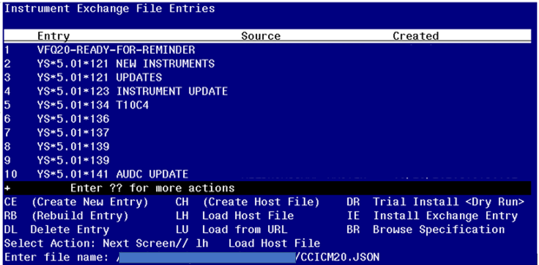

You will see this prompt:

This will load: CCICM20-B3

created on: 01/20/2023@11:43:55

source REDACTED

Description ---

(no description)

Do you want to continue? Yes// **YES**

Search and locate an entry titled **CCICM20 FOR REMINDER** in instrument exchange.

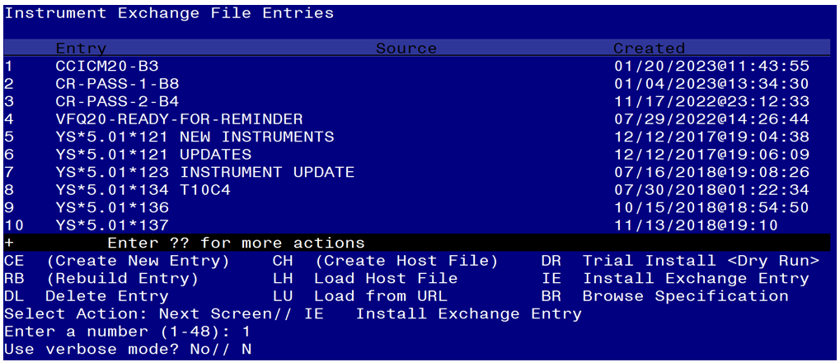

At the **Select Action** prompt, type **IE** for Install all Components and hit enter.

Enter the number that corresponds with your entry titled **CCICM20-B3** *(in this example it is entry 1 it will vary by site)* that is dated 1/20/2023.

At the Use verbose mode prompt enter: **N**

You should see the following:

Installing CCICM20-B3

Gathering installed instruments.............................

Installing CCICM20..............................................................

..............................................................................

..............................................................................

..............................................................................

393 records added.

0 records updated.

0 records deleted.

0 errors.

Installation complete.

Now the reminder exchange file can be installed. Go to Reminder exchange in Vista.

To Load the Web Host File. Navigate to Reminder exchange in Vista

At the **Select Action:** prompt, enter **LWH** for Load Web Host File

At the **Input the url for the .prd file:** prompt, type the following web address:

**https://REDACTED/UPDATE_2_0_289.PRD**

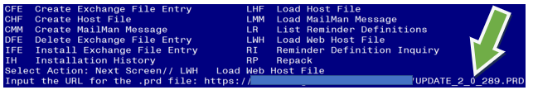

You should see a message at the top of your screen that the file successfully loaded.

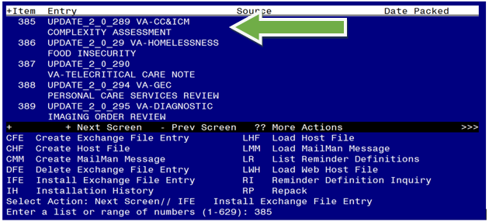

Search and locate an entry titled **UPDATE_2_0_289 VA- CC&ICM COMPLEXITY ASSESSMENT** in reminder exchange.

At the **Select Action** prompt, enter **IFE** for Install Exchange File Entry

Enter the number that corresponds with your entry UPDATE_2_0_289 VA-CC&ICM COMPLEXITY ASSESSMENT *(In this example it is entry 385. It will vary by site).* The date of the exchange file should be 5/24/2023.

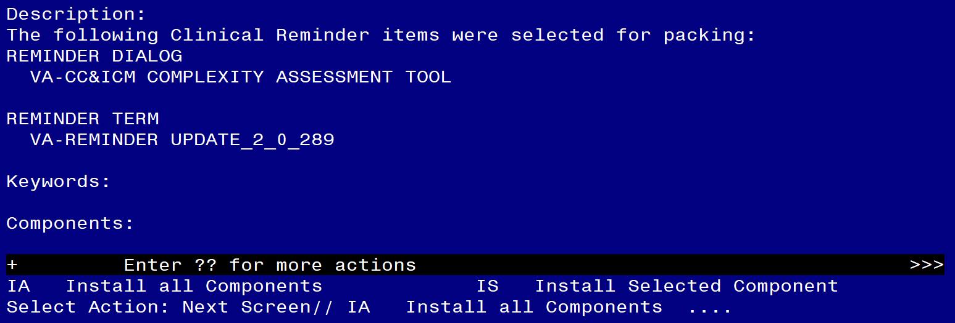

At the **Select Action** prompt, type **IA** for Install all Components and hit enter.

Select Action: Next Screen// IA Install all Components

You will see several prompts, for all **new entries you will choose I to Install**

For components that already exists but the packed component is different, choose **O to Overwrite.**

**You will be promped to install the reminder dialog component VA-CC&ICM COMPLEXITY ASSESSMENT TOOL).** You will choose to install all even though some components may have an X to indicate that they exist.

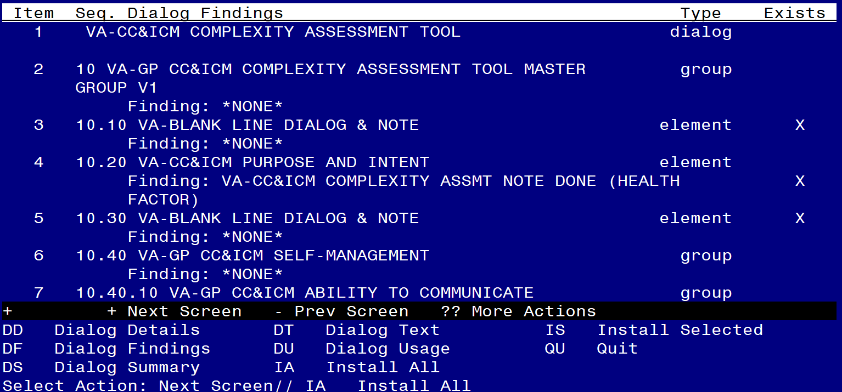

At the **Select Action** prompt, type **IA** to install the dialog: **VA-CC&ICM COMPLEXITY ASSESSMENT TOOL).**

Select Action: Next Screen// **IA**

Install reminder dialog and all components with no further changes: Y// **Yes**

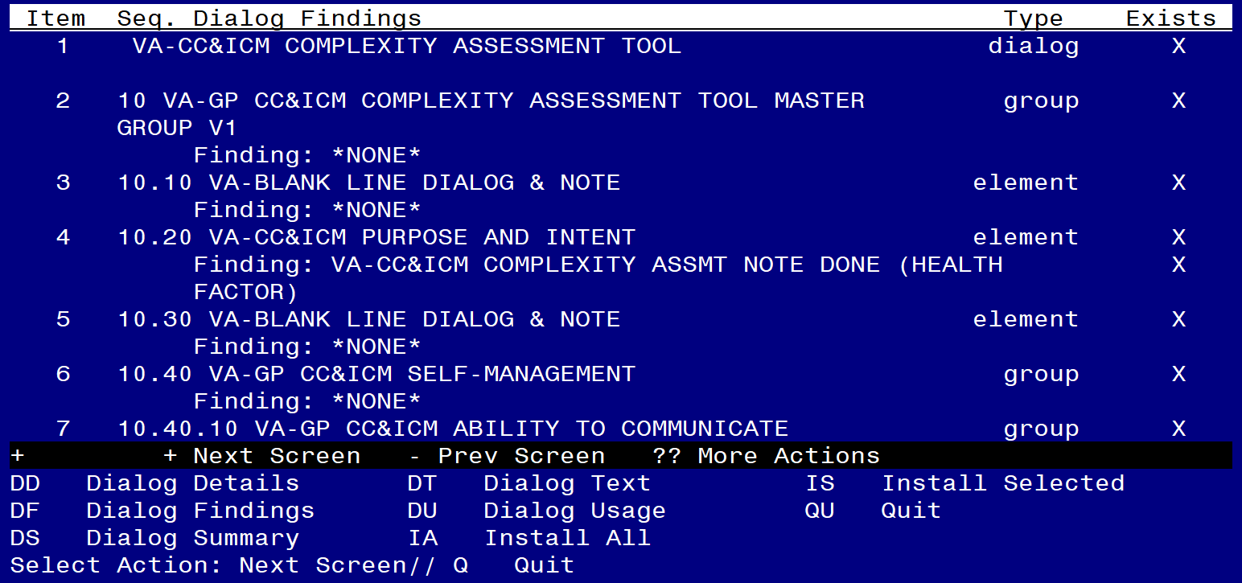

After completing this dialog install, you will type **Q**.

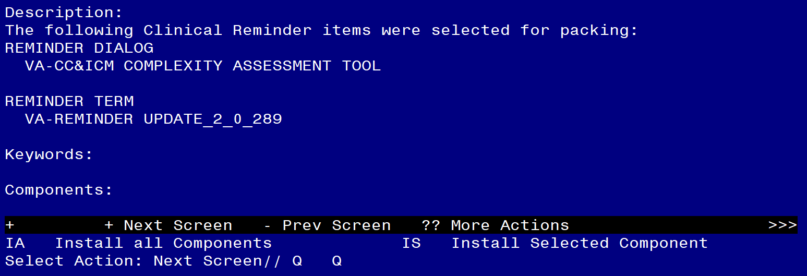

You will then be returned to this screen. At the **Select Action** prompt, type **Q.**

Install complete.

# Post Installation

1. **Insert local Care Coordination Review Team consult order and edit text fields in the VAL-CC&ICM COMPLEXITY OPTIONAL ORDER element. If no local consult exists, this element can be disabled.**

NAME: **VAL-CC&ICM COMPLEXITY OPTIONAL ORDER**

DISABLE:

CLASS: LOCAL//

SPONSOR:

REVIEW DATE:

RESOLUTION TYPE:

ORDERABLE ITEM:

FINDING ITEM: Enter “Q.” then name of local Care Coordination Review Team consult order dialog

Additional findings: none

Select ADDITIONAL FINDING:

DIALOG/PROGRESS NOTE TEXT:

(Add local text e.g. "Select here to launch consult to Care Coordination

Review Team upon completion of this template")

Edit? NO// **YES**

==[ WRAP ]==[INSERT ]=======< DIALOG/PROGRESS NOTE TE[Press <PF1>H for

(Add local text e.g. "Select here to launch consult to Care Coordination

Review Team upon completion of this template")

<=======T=======T=======T=======T=======T=======T=======T=======T=======T>====

ALTERNATE PROGRESS NOTE TEXT:

(Add local text e.g. "Consult submitted to Care Coordination Review Team")

Edit? NO// **YES**

==[ WRAP ]==[INSERT ]=====< ALTERNATE PROGRESS NOTE T[Press <PF1>H for

(Add local text e.g. "Consult submitted to Care Coordination Review Team")

<=======T=======T=======T=======T=======T=======T=======T=======T=======T>====

1. **Make the Dialog template available to be attached to a Personal or Shared template or to be able to attach the dialog to a progress note title.**

Select Reminder Managers Menu <TEST ACCOUNT> Option: **CP** CPRS Reminder Configuration

CA Add/Edit Reminder Categories

CL CPRS Lookup Categories

CS CPRS Cover Sheet Reminder List

MH Mental Health Dialogs Active

PN Progress Note Headers

RA Reminder GUI Resolution Active

TIU TIU Template Reminder Dialog Parameter

DEVL Evaluate Coversheet List on Dialog Finish

DL Default Outside Location

PT Position Reminder Text at Cursor

LINK Link Reminder Dialog to Template

TEST CPRS Coversheet Time Test

NP New Reminder Parameters

GEC GEC Status Check Active

WH WH Print Now Active

Select CPRS Reminder Configuration <TEST ACCOUNT> Option: **TIU** TIU Template Reminder Dialog Parameter

Reminder Dialogs allowed as Templates may be set for the following:

1 User USR [choose from NEW PERSON]

3 Service SRV [choose from SERVICE/SECTION]

4 Division DIV [SALT LAKE CITY]

5 System SYS [NATREM.FO-SLC.MED.VA.GOV]

Enter selection: **5** *Choose the appropriate number for your site. Your site may do this by System or other levels. The example below uses SYSTEM level.*

Setting Reminder Dialogs allowed as Templates for System: NATREM.FO-SLC.MED.VA.GOV

Select Display Sequence: **?**

388 VA-COVID-19 TELEPHONE FOLLOW-UP

389 VA-SRA-CONSULT RESPONSE (D)

*When you type a question mark above, you will see the list of #’s (with dialogs) that are already taken. Choose a number* ***NOT*** *on this list. For this example, 390 is not present so I will use 390.*

Select Display Sequence: **390**

Are you adding 390 as a new Display Sequence? Yes// **YES**

Display Sequence: 390// <Enter>

Clinical Reminder Dialog: **VA-CC&ICM COMPLEXITY ASSESSMENT TOOL** reminder dialog

...OK? Yes// <Enter>

1. **Setup of Note Title (optional).**

The note title to create to associate with this template is: **CARE COORDINATION COMPLEXITY ASSESSMENT TOOL**

VHA Enterprise Standard Title: NURSING NOTE

You can add this to the appropriate document class.

***Note:*** *Comprehensive information on Creating new Document Classes and Titles can be found beginning on page 54 of the TIU/ASU Implementation Guide at the following link:* [*http://www.va.gov/vdl/documents/Clinical/CPRS-Text_Integration_Utility_(TIU)/tiuim.pdf*](http://www.va.gov/vdl/documents/Clinical/CPRS-Text_Integration_Utility_(TIU)/tiuim.pdf)

1. **Associate the reminder dialog with the note title in CPRS**

In CPRS, open the Template Editor, expand Document Titles, select the appropriate folder (if applicable), then click New Template (top right-hand corner).

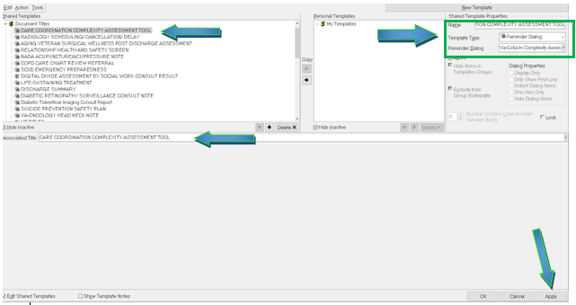

Type in the following information:

Name: **CARE COORDINATION COMPLEXITY ASSESSMENT TOOL**

Template Type: **Reminder Dialog**

Reminder Dialog: **VA-CC&ICM COMPLEXITY ASSESSMENT TOOL**

Next, type in the Associated Title name –– then click Apply.