

**Update _2_0_294A**

Clinical Reminders

VA-GEC PERSONAL CARE SERVICES REVIEW UPDATE

Install Guide

**July 2023**

Product Development

Office of Information Technology

Department of Veterans Affairs

Table of Contents

Introduction 1

Install Details 4

Install Example 5

Post Installation 7

# Introduction

The GEC Personal Care Services review template was nationally released in August of 2022.  (Update 294 VA-Geriatrics & Extended Care (GEC)  Personal Care Services Review Template)

The template was initially designed for documentation of a Reauthorization of services (annually) or a 180 day review.

The OIG asked the program office to establish a report to capture data on a quarterly basis regarding monthly contacts for the Veteran Directed Care program.

The following changes were made:

1. The version was updated to 2.2
2. A new option was added under type of review: Quarterly for Veteran Directed care (VDC) only, this option should be used to document the required monthly contacts:

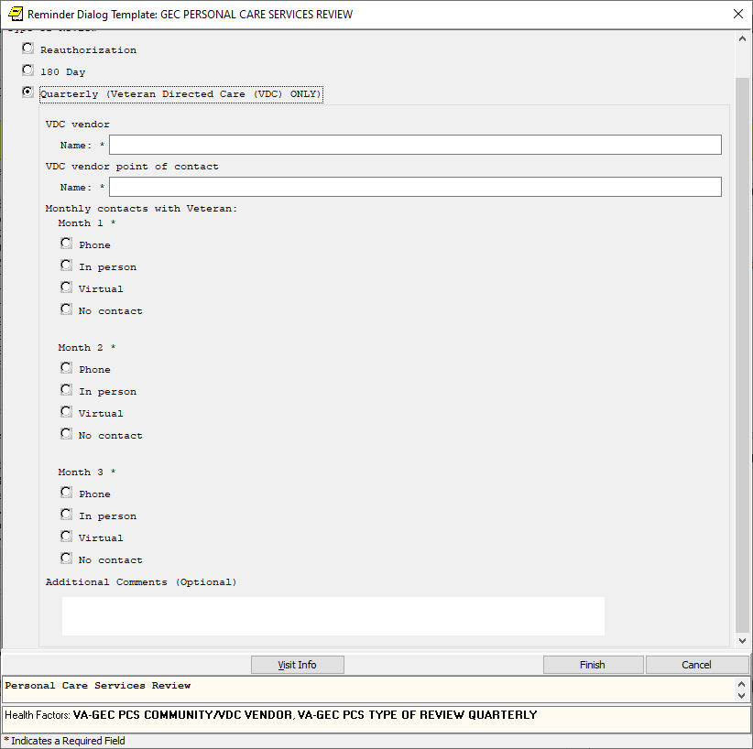

1. The existing questions were placed under the type of review and the three monthly contacts were added to the reauthorization and 180 day review if VDC is chosen under the care plan review section.

1. The community vendor wording was simplified to match the new section.

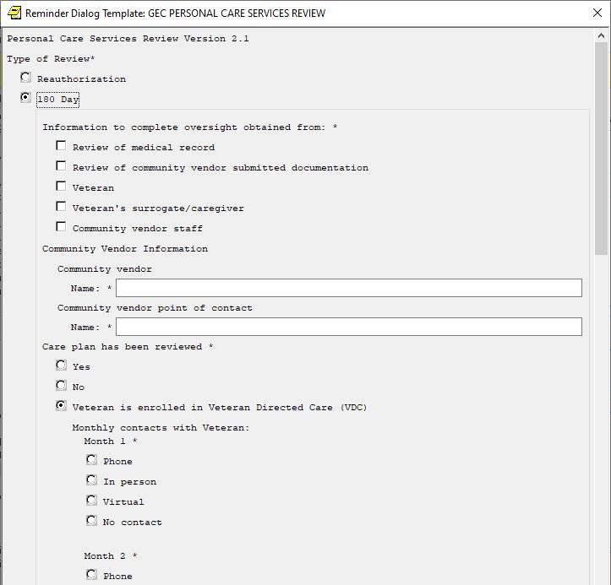

UPDATE_2_0_294A contains 1 Reminder Exchange entry:

**UPDATE_2_0_294A VA-GEC PERSONAL CARE SERVICES REVIEW UPDATE**

**The exchange file contains the following components:**

**TIU TEMPLATE FIELD**

VA-TEXT (1-30 CHAR)R

VA-WORD

VA-BLANK

VA-GEC PCS HOURS

VA-CASE MIX SCORE

VA-GEC PCS FROM MHA

VA-DATE ONLY R

**HEALTH FACTORS**

VA-REMINDER UPDATES [C]

VA-UPDATE_2_0_294A

VA-GEC PERSONAL CARE REVIEW [C]

VA-GEC PCS MONTH 3 CONTACT NO CONTACT MADE

VA-GEC PCS MONTH 3 CONTACT VIRTUAL

VA-GEC PCS MONTH 3 CONTACT IN PERSON

VA-GEC PCS MONTH 3 CONTACT PHONE

VA-GEC PCS MONTH 2 CONTACT NO CONTACT MADE

VA-GEC PCS MONTH 2 CONTACT VIRTUAL

VA-GEC PCS MONTH 2 CONTACT IN PERSON

VA-GEC PCS MONTH 2 CONTACT PHONE

VA-GEC PCS MONTH 1 CONTACT NO CONTACT MADE

VA-GEC PCS MONTH 1 CONTACT VIRTUAL

VA-GEC PCS MONTH 1 CONTACT IN PERSON

VA-GEC PCS MONTH 1 CONTACT PHONE

VA-GEC PCS COMMUNITY/VDC VENDOR

VA-GEC PCS TYPE OF REVIEW QUARTERLY

VA-GEC PCS NEXT REVIEW DATE

VA-GEC PCS NO LONGER MEETS CLINICAL CRITERIA DISCHARGE DATE

VA-GEC PCS PLAN VDC REMAIN THE SAME

VA-GEC PCS ADC SEOC DAYS

VA-GEC PCS ADC SEOC DURATION

VA-GEC PCS PLAN ADC REMAIN THE SAME

VA-GEC PCS RESPITE SEOC HOURS

VA-GEC PCS RESPITE SEOC DURATION

VA-GEC PCS PLAN RESPITE REMAIN THE SAME

VA-GEC PCS HOMEMAKER SEOC HOURS

VA-GEC PCS HOMEMAKER SEOC DURATION

VA-GEC PCS PLAN HOMEMAKER REMAIN THE SAME

VA-GEC PCS NO LONGER MEETS ADMIN CRITERIA DISCHARGE DATE

VA-GEC PCS PLAN VDC NEWLY AUTHORIZED

VA-GEC PCS PLAN ADC NEWLY AUTHORIZED

VA-GEC PCS PLAN RESPITE NEWLY AUTHORIZED

VA-GEC PCS PLAN HOMEMAKER NEWLY AUTHORIZED

VA-GEC PCS PLAN AUTHORIZATION VDC UPDATED

VA-GEC PCS PLAN AUTHORIZATION ADC UPDATED

VA-GEC PCS PLAN AUTHORIZATION RESPITE UPDATED

VA-GEC PCS PLAN AUTHORIZATION HOMEMAKER UPDATED

VA-GEC PCS VETERAN APPROVED PCAFC

VA-GEC PCS SECOND RANGE OF HOURS USED

VA-GEC PCS FIRST RANGE OF HOURS USED

VA-GEC PCS PATIENT DOES NOT FEEL SAFE WITH SERVICES

VA-GEC PCS PATIENT FEELS SAFE WITH SERVICES

VA-GEC PCS PROGRAM SUCCESS IN MEETING VET NEEDS

VA-GEC PCS PATIENT SATISFACTION PERSONAL CAREGIVER(S)

VA-GEC PCS PATIENT SATISFACTION AGENCY

VA-GEC PCS TYPE OF REVIEW 180 DAY

VA-GEC PCS TYPE OF REVIEW REAUTHORIZATION

**REMINDER SPONSOR**

OFFICE OF GERIATRIC EXTENDED CARE

**REMINDER TERM**

VA-REMINDER UPDATE_2_0_294A

**REMINDER DIALOG**

VA-GEC PERSONAL CARE SERVICES REVIEW

# Install Details

This update is being distributed as a web host file. The address for the host file is: https://REDACTED /UPDATE_2_0_294A.PRD

The file will be installed using Reminder Exchange, programmer access is not required.

Installation:

=============

This update can be loaded with users on the system. Installation will take less than 5 minutes.

# Install Example

To Load the exchange file, use LWH. The URL is https://REDACTED/UPDATE_2_0_294A.PRD

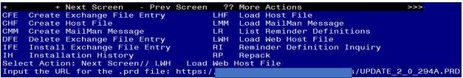

If you use LWH and it works, you will see something like this message. Make sure the file was loaded successfully.

Search and locate an entry titled UPDATE_2_0_294A VA-GEC PERSONAL CARE SERVICES REVIEW UPDATE in reminder exchange.

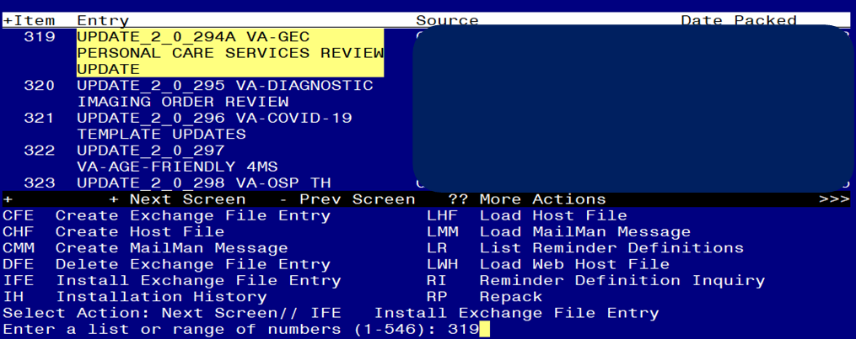

At the **Select Action** prompt, enter **IFE** for Install Exchange File Entry

Enter the number that corresponds with your entry titled UPDATE_2_0_294A VA-GEC PERSONAL CARE SERVICES REVIEW UPDATE *(in this example it is entry 319, it will vary by site)* that is dated 07/06/2023.

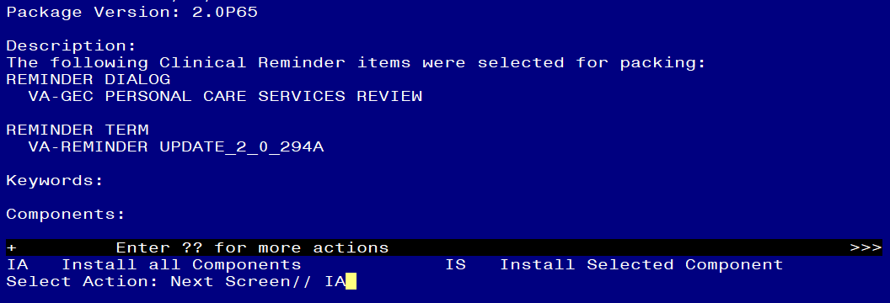

At the **Select Action** prompt, type **IA** for Install all Components and hit enter.

**For all new entries in any category you will choose I to Install**

**Skip any items in any category you are prompted to overwrite**

You will then be prompted to install the dialog component.

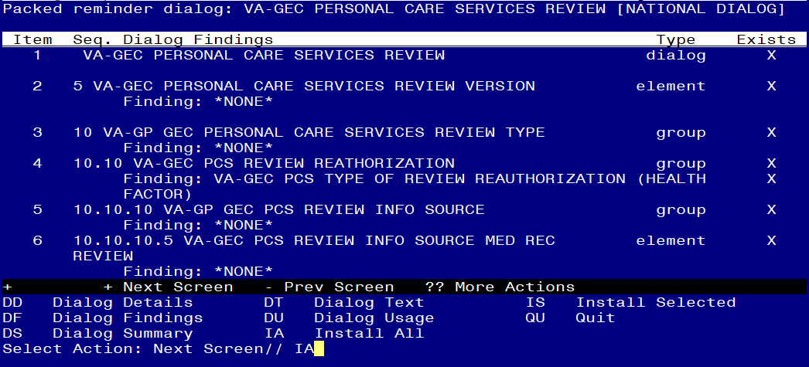

At the **Select Action** prompt, type **IA** to install the dialog – **VA-GEC PERSONAL CARE SERVICES REVIEW**

Install reminder dialog and all components with no further changes: Y//ES

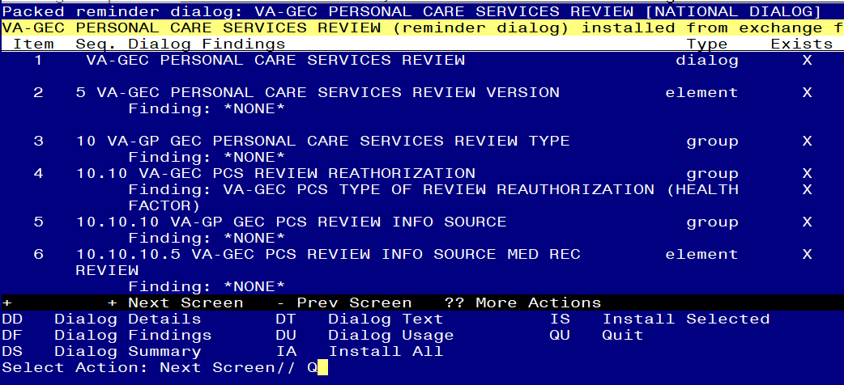

When the dialog has completed installation, you will then be returned to this screen. At the **Select Action** prompt, type **Q.**

Screen shot of the terminal window showing that after all of the groups, templates, elements, terms, components and dialogs required for this update have been installed, the reminder that was installed with Q entered for quit to finish. The name of the VA employee at the Source line label has been redacted.



You will then be returned to this screen. At the **Select Action** prompt, type **Q.**

Install complete.

# Post Installation

1. **Open the note title****d PERSONAL CARE SERVICES REVIEW** (reminder dialog name VA-GEC PERSONAL CARE SERVICES REVIEW )and confirm the version now displays as 2.2