

**Update _2_0_299**

Clinical Reminders

VA-POST ANESTHESIA SEDATION SCORE

Install Guide

**March 2023**

Product Development

Office of Information Technology

Department of Veterans Affairs

Table of Contents

Introduction 1

Install Details 2

Install Example 2

Post Installation 10

# Introduction

This reminder update will install a new reminder dialog for documentation of Post Anesthesia Sedation Scores using newly released MH instruments named PASS-1 and PASS-2. These instruments will auto score the answers to questions for Post Anesthesia rating.

As a part of this update, we were notified that EPRP was failing sites due to the incorrect verbiage being placed in the progress note when a PTSD-5 instrument was completed. This was updated and included in reminder dialog VA-MH PC-PTSD+I9 SCREEN. This extra piece in this update has nothing to do with Post Anesthesia.

UPDATE_2_0_299 contains 1 Reminder Exchange entry:

**UPDATE_2_0_299 VA-AES POST ANESTHEISA/SEDATION SCORE**

**The exchange file contains the following components:**

MH TESTS AND SURVEYS

PASS-2

PASS-1

PC-PTSD-5

REMINDER DIALOG LINK TYPE

1 VA-PTSD POSITIVE WARM HANDOFF CHECK

TIU TEMPLATE FIELD

2 ONS STANDARDIZED NURSING DOCUMENTATION

3 VHA DIRECTIVE 1073

HEALTH FACTORS

4 VA-REMINDER UPDATES [C]

5 VA-UPDATE_2_0_299

6 VA-VAAES VAPAS [C]

7 VA-VAAES VAPAS PH2 TIME

8 VA-VAAES VAPAS PH1 TIME

9 VA-VAAES VAPAS VERSION 1.4

REMINDER SPONSOR

10 OFFICE OF NURSING INFORMATICS

11 OFFICE OF NURSING SERVICE

12 OFFICE OF MH AND SUICIDE PREVENTION

13 OFFICE OF MENTAL HEALTH SERVICES

REMINDER TERM

14 VA-REMINDER UPDATE_2_0_299

REMINDER DIALOG

15 VA-AES POST ANESTHESIA/SEDATION SCORE-VAPAS -

VERSION 1.0

16 VA-MH PC-PTSD+I9 SCREEN

# Install Details

This update is being distributed as a web host file. The address for the host file is: https://REDACTED /UPDATE_2_0_299.PRD

The file will be installed using Reminder Exchange, programmer access is not required.

Installation:

=============

This update can be loaded with users on the system. Installation will take less than 5 minutes.

# Install Example

**Step 1 – (must be completed first) Load the Mental Health Instruments**

You will first load the instruments using the INSTRUMENT EXCHANGE Menu (YTQ INSTRUMENT EXCHANGE) in Vista. If you do not have access to this menu, you will need to go through your facility process to request a new Vista menu. The two instruments you will load are PASS-1 and PASS-2

**THIS IS NOT REMINDER EXCHANGE.**

**\*\*\*\*\*\*\*\*\*\*\*\*\*\*\*\*\*\*\*\*\***

ADDED NOTE NOT PART OF THIS ORIGINAL DOCUMENT:

Select OPTION NAME: MHA3 UTILITIES  YTQ MHA3 MENU     MHA3 Utilities

                             *** Mental Health ***

                                 MHA3 Utilities

   1      Print Test Form

   2      Detailed Definition

   3      Delete Patient Data

   4      Stop/Re-Start Progress Notes for an Instrument

   5      Exempt Test

   6      Test Usage

   7      XML Output

   8      Instrument Exchange

   10     Display Administration Details

Theses are PASS-1.JSON and PASS-2.JSON

Use this url for install REDACTED but they may be found here outside of the VA:

*********************

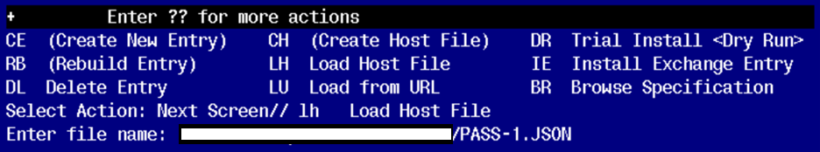

This will load: PASS1 for Reminder

created on: 01/04/2023@13:34:30

source: XXXXX@REDACTED

Description ---

(no description)

Do you want to continue? Yes//

PASS1 for Reminder loaded.

Press return to continue...

Once the PASS-1 is loaded, you will need to install

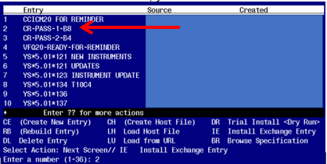

Find entry named “CR-PASS-1-B8” and then select IE. In this instance, you would select number 2 to install. When prompted to Use verbose mode, you will choose YES

You will then repeat this process for PASS-2 instrument install

Use this url for install /srv/vista/patches/SOFTWARE/PASS-2.JSON

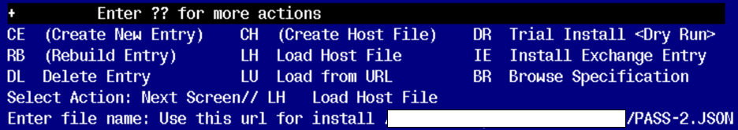

This will load: CR-PASS-2-B4

created on: 11/17/2022@23:12:33

source: XXXXX@REDACTED

Description ---

(no description)

Do you want to continue? Yes//

PASS1 for Reminder loaded.

Press return to continue...

Once the PASS-2 is loaded, you will need to install

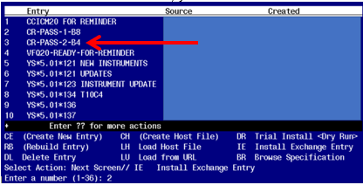

Find entry named “CR-PASS-2-B4” and then select IE. In this instance, you would select number 3 to install. When prompted to Use verbose mode, you will choose YES

This completes the Mental Health instrument exchange install piece. You will now move to reminder exchange to install the remaining parts.

Go to Reminder exchange in Vista.

To Load the exchange file, use LWH. The URL is

https://REDACTED /UPDATE_2_0_299.PRD

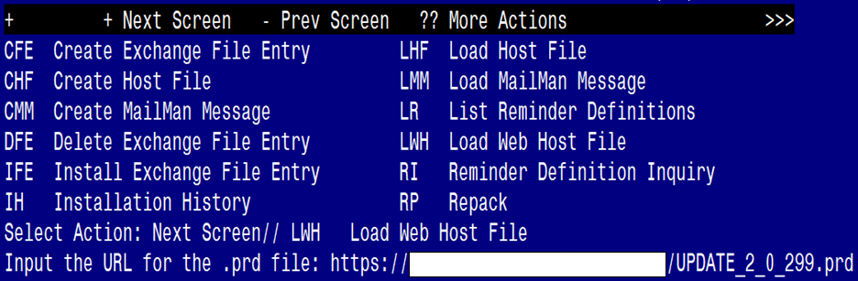

You will see a message indicating the file was loaded successfully.

Search and locate an entry titled UPDATE_2_0_299 VA-AES POST ANESTHESIA/SEDATION SCORE in reminder exchange.

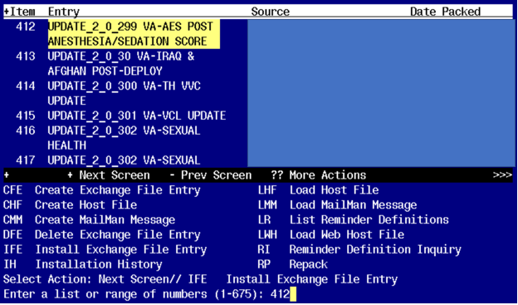

At the **Select Action** prompt, enter **IFE** for Install Exchange File Entry

Enter the number that corresponds with your entry titled UPDATE_2_0_299 VA-ASE POST ANESTHESIA/SEDATION SCORE *(in this example it is entry 412, it will vary by site)* that is dated 01/26/2023.

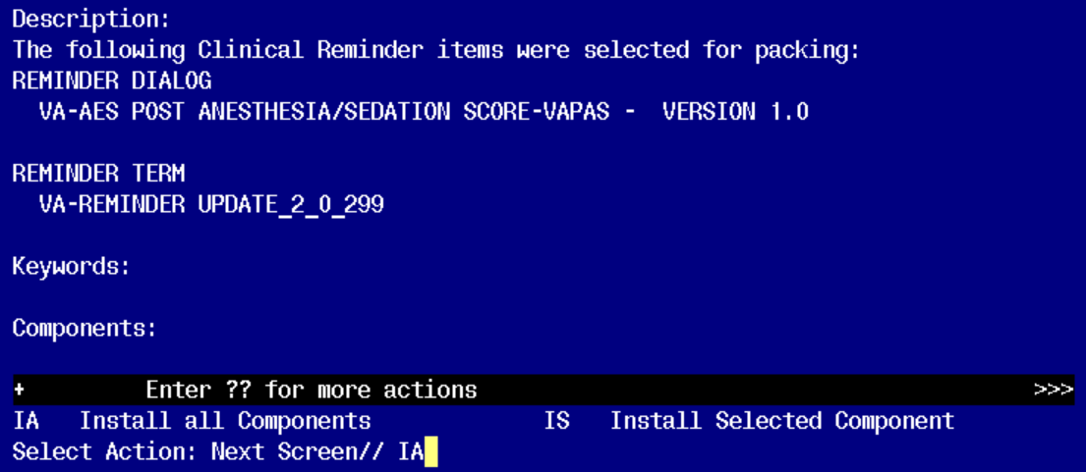

At the **Select Action** prompt, type **IA** for Install all Components and hit enter.

**Install all new components.  
Overwrite any components that exist but are different**

You will then be prompted to install the first dialog component.

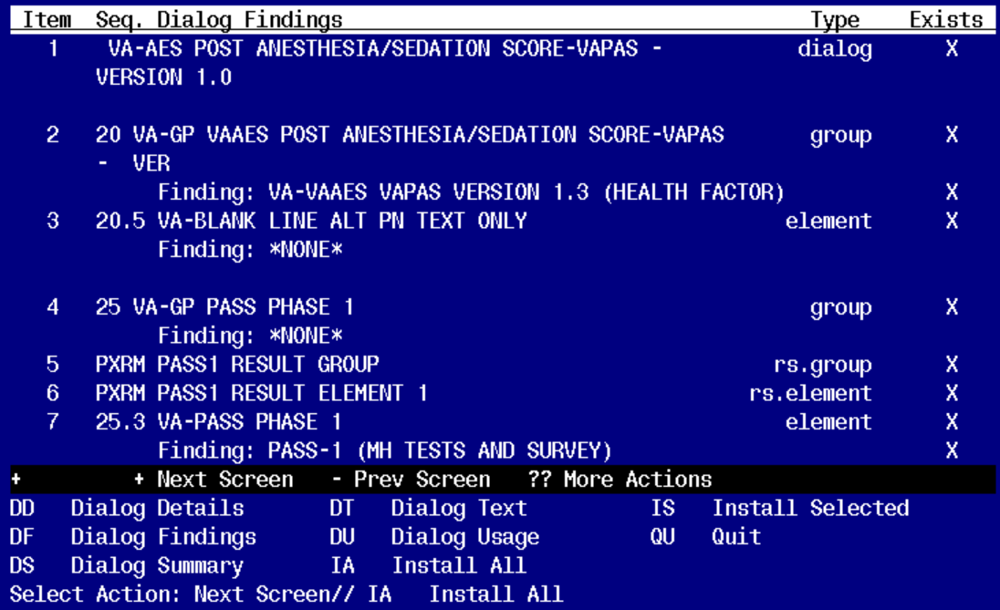

At the **Select Action** prompt, type **IA** to install the dialog – **VA-AES POST ANESTHESIA/SEDATION SCORE-VAPAS – VERSION 1.0**

Install reminder dialog and all components with no further changes: Y//ES

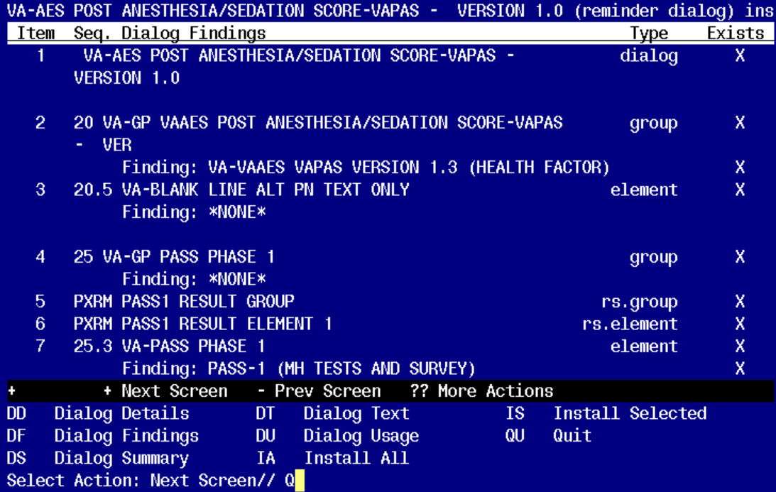

When the dialog has completed installation, you will then be returned to this screen. At the **Select Action** prompt, type **Q.**

You will then be prompted to install the second dialog component

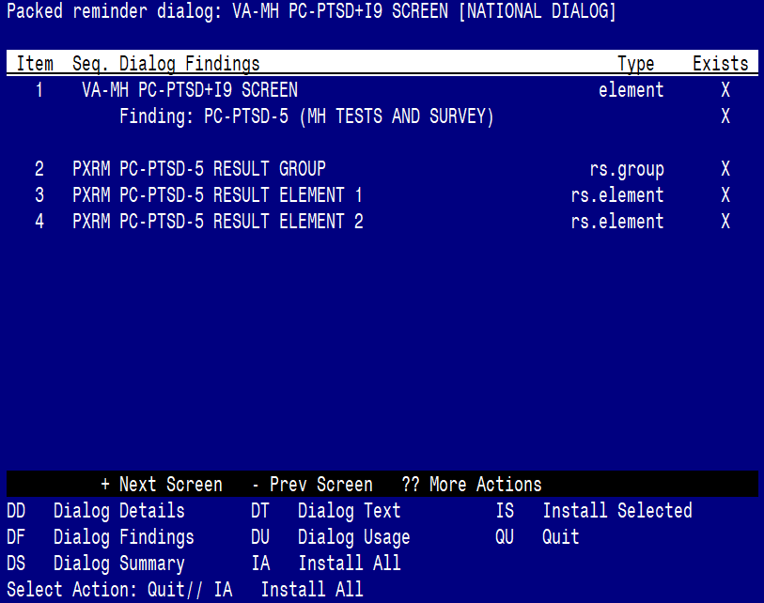

At the **Select Action** prompt, type **IA** to install the dialog – **VA-MH PC-PTSD+I9 SCREEN**

Install reminder dialog and all components with no further changes: Y//ES

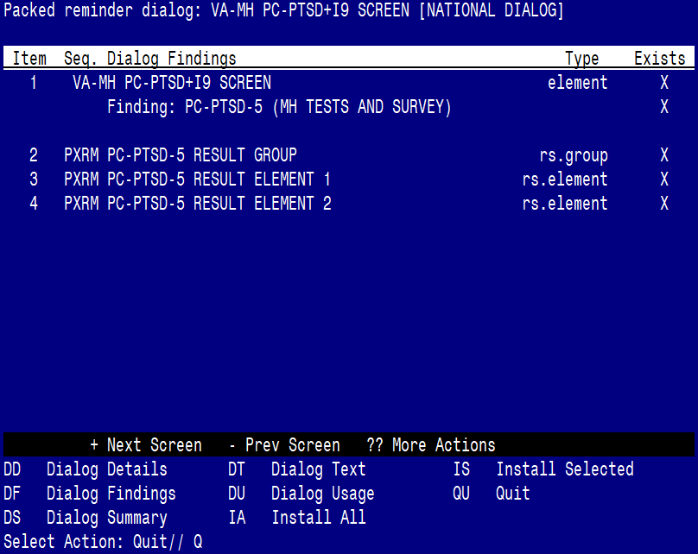

When the dialog has completed installation, you will then be returned to this screen. At the **Select Action** prompt, type **Q.**

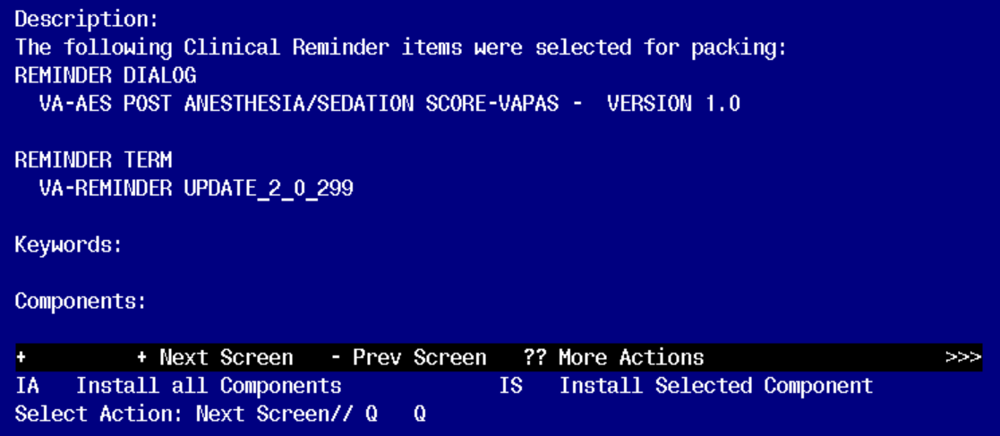

You will then be returned to this screen. At the **Select Action** prompt, type **Q.**

Install complete.

# Post Installation

1. **Make the Dialog templates available to be attached to a Personal or Shared templates or to be able to attach the dialog to a progress note title.**

Select Reminder Managers Menu <TEST ACCOUNT> Option: **CP** CPRS Reminder Configuration

CA Add/Edit Reminder Categories

CL CPRS Lookup Categories

CS CPRS Cover Sheet Reminder List

MH Mental Health Dialogs Active

PN Progress Note Headers

RA Reminder GUI Resolution Active

TIU TIU Template Reminder Dialog Parameter

DEVL Evaluate Coversheet List on Dialog Finish

DL Default Outside Location

PT Position Reminder Text at Cursor

LINK Link Reminder Dialog to Template

TEST CPRS Coversheet Time Test

NP New Reminder Parameters

GEC GEC Status Check Active

WH WH Print Now Active

Select CPRS Reminder Configuration <TEST ACCOUNT> Option: **TIU** TIU Template Reminder Dialog Parameter

Reminder Dialogs allowed as Templates may be set for the following:

1 User USR [choose from NEW PERSON]

3 Service SRV [choose from SERVICE/SECTION]

4 Division DIV [SALT LAKE CITY]

5 System SYS [NATREM.FO-SLC.MED.VA.GOV]

Enter selection: **5** *Choose the appropriate number for your site. Your site may do this by System or other levels. The example below uses SYSTEM level.*

Setting Reminder Dialogs allowed as Templates for System: NATREM.FO-SLC.MED.VA.GOV

Select Display Sequence: **?**

388 VA-COVID-19 TELEPHONE FOLLOW-UP

389 VA-SRA-CONSULT RESPONSE (D)

*When you type a question mark above, you will see the list of #’s (with dialogs) that are already taken. Choose a number* ***NOT*** *on this list. For this example, 390 is not present so I will use 390.*

Select Display Sequence: **390**

Are you adding 390 as a new Display Sequence? Yes// **YES**

Display Sequence: 390// <Enter> 390

Clinical Reminder Dialog: **VA-AES POST ANESTHESIA/SEDATION SCORE-VAPAS – VERSION 1.0** reminder dialog NATIONAL

...OK? Yes// <Enter> (Yes)

1. **Add the template to** your shared template folder so it can be used with any note title.
   1. In CPRS, open the Template Editor, expand Shared Templates, select the appropriate oncology folder (if applicable), then click New Template (top right-hand corner).

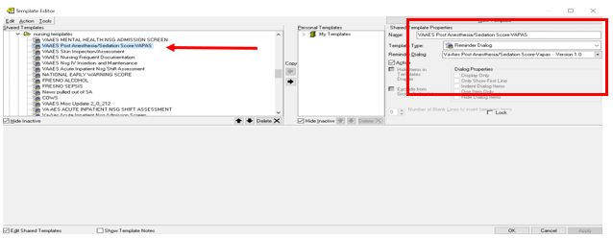

Type in the following information:

Name: **<Give your template a reasonable name>**

Template Type: **Reminder Dialog**

Reminder Dialog: **VA-AES POST ANESTHESIA/SEDATION SCORE-VAPAS – VERSION 1.0**

–– then click Apply.