

Update _2_0_307C

Clinical Reminders

TOXIC EXPOSURE SCREEN REMINDER UPDATE

Install Guide

May 2023

Product Development
Office of Information Technology
Department of Veterans Affairs

Table of Contents
Introduction 1
Install Details 4
Install Example 4
Post Installation 9

Introduction
This update contains the following changes to the existing Toxic Exposure Screening and Toxic Exposure Screening Follow-up Clinical Reminders:

- The Toxic Exposure Screening reminder dialog template was updated:
  - Version is now 3.1
  - Date in PRA statement extended from 2023 to 2026
  - Removed references to MD/DO/PA/APRN or RN TES NAVIGATOR and replaced with “authorized closer”

- The Toxic Exposure Screening Follow-Up reminder dialog was updated
  - Version is now 3.1
  - Removed references to MD/DO/PA/APRN or RN TES NAVIGATOR and replaced with “authorized closer”
  - Disabled VetText in follow up contact options
  - Included exposure concern and questions that display from the screen to the progress note.

- The Toxic Exposure Screening combined version will no longer display for an RN TES NAVIGATOR. The user class was removed from the reminder term used in the branching logic.

UPDATE_2_0_307C contains 1 Reminder Exchange entry:
UPDATE_2_0_307C TOXIC EXPOSURE SCREEN REMINDER UPDATE

The exchange file contains the following components:

REMINDER GENERAL FINDINGS
VIEW PROGRESS NOTE TEXT

TIU TEMPLATE FIELD
VA-ENV EXP VBA
VA-ENV EXP SYMP CL
VA-ENV EXP SYMP RA
VA-ENV EXP SYMP AO
VA-ENV EXP SYMP GW2
VA-ENV EXP SYMP GW
VA-ENV EXP SYMP AH
VA-ENV EXP OTHER
VA-TOX EXP VSO
VA-WORD
VA-TOXIC CONTACT
VA-TES OMB DATE
VA-TES OMB NUM

HEALTH FACTORS
VA-REMINDER UPDATES [C]
VA-UPDATE_2_0_307C
VA-TOXIC EXPOSURE SCREEN [C]
VA-TOX EXP SCRN VETERAN CONCERN OTHER EXPOSURE
VA-TOX EXP SCRN VETERAN CONCERN RADIATION EXPOSUR
VA-TOX EXP SCRN VETERAN CONCERN GULF WAR EXPOSURE
VA-TOX EXP SCRN VETERAN CONCERN CAMP LEJEUNE EXPOSURE
VA-TOX EXP SCRN VETERAN CONCERN AIRBORNE HAZARD BURN PIT
VA-TOX EXP SCRN VETERAN CONCERN AGENT ORANGE
VA-TOX EXP SCRN VETERAN CONCERN TOXIC EXP DECLINE FOLLOWUP
VA-TOX EXP SCRN VETERAN CONCERN TOXIC EXP FOLLOW LETTER 2 ATT
VA-TOX EXP SCRN VETERAN CONCERN TOXIC EXP FOLLOW VETTEXT 2 ATT
VA-TOX EXP SCRN VETERAN CONCERN TOXIC EXP FOLLOW SECUR MSG 2 ATT
VA-TOX EXP SCRN VETERAN CONCERN TOXIC EXP FOLL PHONE NO MSG 2ATT
VA-TOX EXP SCRN VETERAN CONCERN TOXIC EXP FOLLOW PHONE MSG 2 ATT
VA-TOX EXP SCRN VETERAN CONCERN TOXIC EXP 2ND ATTEMPT FOLLOWUP
VA-TOX EXP SCRN VETERAN CONCERN TOXIC EXP FOLLOW LETTER
VA-TOX EXP SCRN VETERAN CONCERN TOXIC EXP FOLLOW VETTEXT
VA-TOX EXP SCRN VETERAN CONCERN TOXIC EXP FOLLOW SECURE MESSAGE
VA-TOX EXP SCRN VETERAN CONCERN TOXIC EXP FOLLOW PHONE NO MSG
VA-TOX EXP SCRN VETERAN CONCERN TOXIC EXP FOLLOW PHONE LEFT MSG
VA-TOX EXP SCRN VETERAN CONCERN TOXIC EXP FIRST ATTEMPT FOLLOWUP
VA-TOX EXP SCRN VETERAN CONCERN TOXIC EXP UNABLE CONTACT FOLLOW
VA-TOX EXP SCRN FOLLOW UP NO CONNECTIONS GIVEN
VA-TOX EXP SCRN FOLLOW UP CONSULT TO SOCIAL WORK
VA-TOX EXP SCRN FOLLOW UP CONSULT TO TES NAVIGATO
VA-TOX EXP SCRN FOLLOW UP CONSULT TO REGISTRY PROGRAM
VA-TOX EXP SCRN FOLLOW UP CONNECTED WITH VSO
VA-TOX EXP SCRN FOLLOW UP CONNECTED WITH VBA
VA-TOX EXP SCRN VETERAN CONCERN TOXIC EXP NO MED CONCERNS
VA-TOX EXP SCRN VETERAN CONCERN TOXIC EXP MED CONCERNS
VA-TOX EXP SCRN VETERAN CONCERN TOXIC EXP MED QUESTIONS
VA-TOX EXP SCRN VETERAN CONCERN TOXIC EXP NO QUESTIONS
VA-TOX EXP SCRN VETERAN CONCERN TOXIC EXP PRESUMP COND QUESTIONS
VA-TOX EXP SCRN VETERAN CONCERN TOXIC EXP BENEFIT QUESTIONS
VA-TOX EXP SCRN VETERAN CONCERN TOXIC EXP VA ENROLL QUESTIONS
VA-TOX EXP SCRN VETERAN CONCERN TOXIC EXP REGISTRY QUESTIONS
VA-TOX EXP SCRN VETERAN CONCERN DOESNT KNOW
VA-TOX EXP SCRN VETERAN CONCERN DECLINED
VA-TOX EXP SCRN VETERAN CONCERN NONE
VA-TOX EXP SCRN VETERAN CONCERN EDUCATION PROVIDED OTHER
VA-TOX EXP SCRN VETERAN CONCERN EDUCATION PROVIDED RADIATION
VA-TOX EXP SCRN VETERAN CONCERN EDUCATION PROVIDED GULF WAR
VA-TOX EXP SCRN VETERAN CONCERN EDUCATION PROVIDED CL
VA-TOX EXP SCRN VETERAN CONCERN EDUCATION PROVIDED AHBP
VA-TOX EXP SCRN VETERAN CONCERN EDUCATION PROVIDED AO

REMINDER TAXONOMY
VA-TOXIC EXPOSURE

REMINDER TERM
VA-REMINDER UPDATE_2_0_307C
VA-TOXIC EXPOSURE
VA-TOXIC EXPOSURE SCREEN QUESTIONS
VA-TOX EXP SCRN VETERAN CONCERN DECLINED TO ANSWER
VA-TOXIC EXPOSURE SCREEN CONCERN NONE
VA-TOX EXP SCRN VETERAN CONCERN DOESNT KNOW
VA-TOXIC EXPOSURE FOLLOW UP
VA-USER CLASS FOR TES FOLLOWUP
VA-TOXIC EXPOSURE SCREEN RESOLUTION

REMINDER DEFINITION
VA-TOXIC EXPOSURE SCREENING FOLLOW-UP
VA-TOXIC EXPOSURE

HEALTH SUMMARY TYPE:
VA-TOXIC EXP QUESTIONS
VA-TOXIC EXPOSURE

HEALTH SUMMARY OBJECTS
VA-TOXIC EXP QUESTIONS (TIU)
VA-TOXIC EXPOSURE (TIU)

TIU DOCUMENT DEFINITION:
VA-TOXIC EXP QUESTIONS
VA-TOXIC EXPOSURE

REMINDER DIALOG
VA-TOXIC EXPOSURE SCREENING PROVIDER FOLLOW UP
VA-TOXIC EXPOSURE

Install Details

This update is being distributed as a web host file. The address for the host file is: https://vaww.va.gov/reminders/docs/UPDATE_2_0_307C.PRD

The file will be installed using Reminder Exchange, programmer access is not required.

Installation:
=============
This update can be loaded with users on the system. Installation will take less than 10 minutes.

Pre-Install
- Any local modifications to template fields or to the dialog will be overwritten. Please make note of your local modifications prior to re-entering them in the post-install.

Inquire/print the following reminder dialog elements to identify if you have any orders added as an additional finding and/or if you have changed the reminder dialog text (you can also create an exchange file to back them up and install that exchange file backup after this install if you would like):
VAL-TOXIC EXPOSURE SCREENING LOCAL CONTACT INFO
VAL-TOXIC EXPOSURE SCREENING REGISTRY EXAM CONSULT
VAL-TOXIC EXPOSURE SCREENING REGISTRY EXAM TES NAV
VAL-TOXIC EXPOSURE SCREENING REGISTRY EXAM SOCIAL WORK

You will add these orders back and update the dialog text in the post install.

Install Example
To Load the exchange file, use LWH. The URL is https://vaww.va.gov/reminders/docs/UPDATE_2_0_307C.PRD

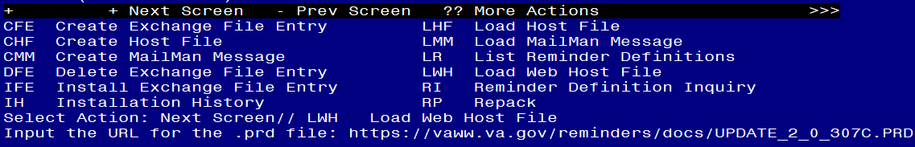
You should see a message that the file was loaded successfully.

Search and locate an entry titled UPDATE_2_0_307C TOXIC EXPOSURE SCREEN REMINDER UPDATE in reminder exchange.
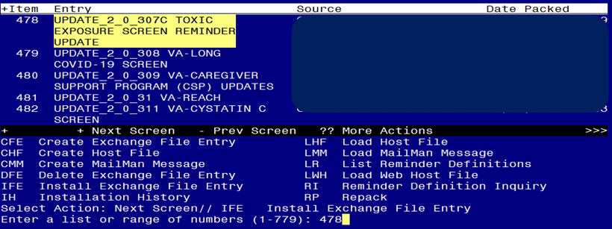
At the Select Action prompt, enter IFE for Install Exchange File Entry
Enter the number that corresponds with your entry titled UPDATE_2_0_307C TOXIC EXPOSURE SCREEN REMINDER (in this example it is entry 478, it will vary by site) that is dated 05/10/2023.
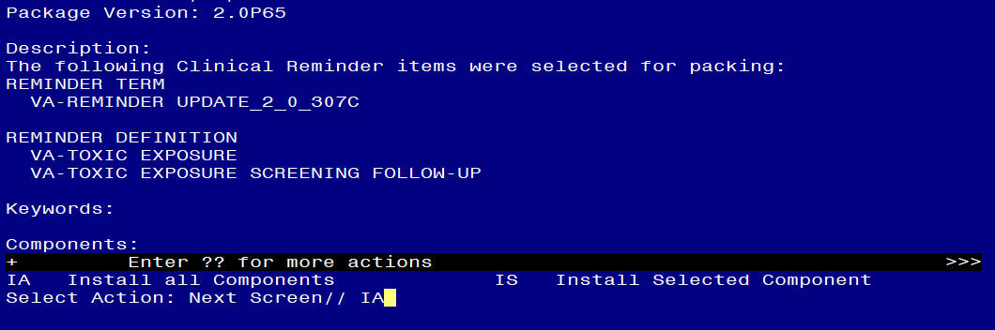
At the Select Action prompt, type IA for Install all Components and hit enter.
Any items that are NEW in any of the below categories, you should INSTALL
OVERWRITE any TIU TEMPLATE FIELDS that you are prompted to overwrite EXCEPT for this field: VA-TOX EXP VSO Do not overwrite your local changes to that txml template field.
SKIP any HEALTH FACTORS if you are prompted to overwrite
SKIP any REMINDER TAXONOMIES that you are prompted to overwrite
OVERWRITE any REMINDER TERMS that you are prompted to overwrite
OVERWRITE any REMINDER DEFINITIONS that you are prompted to overwrite.
SKIP any HEALTH SUMMARY TYPE entries if you are prompted to overwrite
SKIP any HEALTH SUMMARY OBJECTS entries if you are prompted to overwrite
SKIP any TIU DOCUMENT DEFINITION entries if you are prompted to overwrite
You will then be prompted to install the first Dialog component.
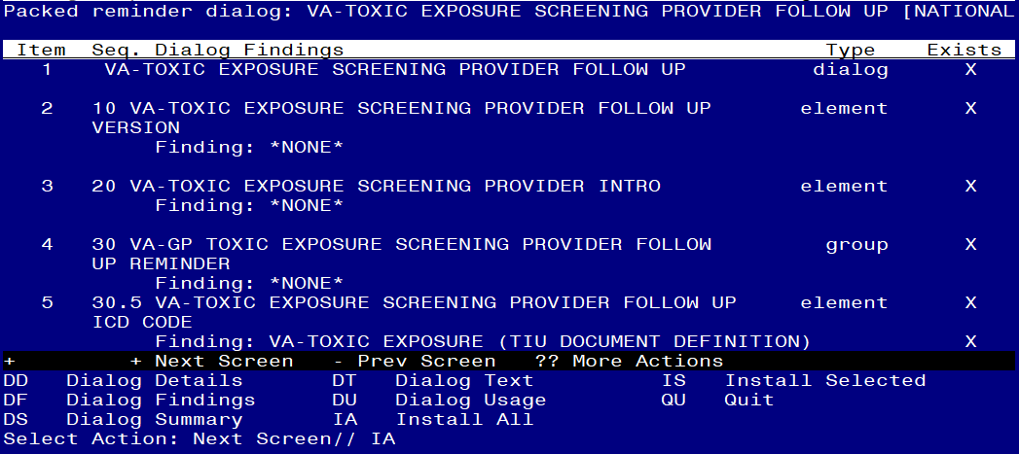

At the Select Action prompt, type IA to install the dialog – VA-TOXIC EXPOSURE SCREENING PROVIDER FOLLOW UP
Install reminder dialog and all components with no further changes: Y// ES

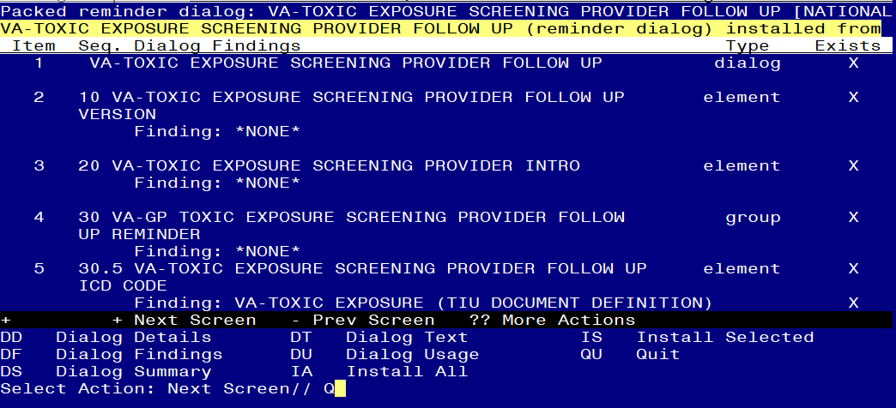

When the dialog has completed installation, you will then be returned to this screen. At the Select Action prompt, type Q.

You will then be prompted to install the next Dialog component.

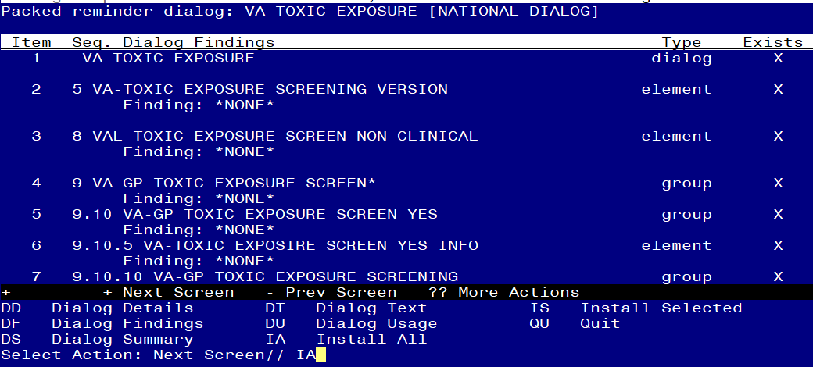
At the Select Action prompt, type IA to install the dialog – VA-TOXIC EXPOSURE
Install reminder dialog and all components with no further changes: Y// ES....

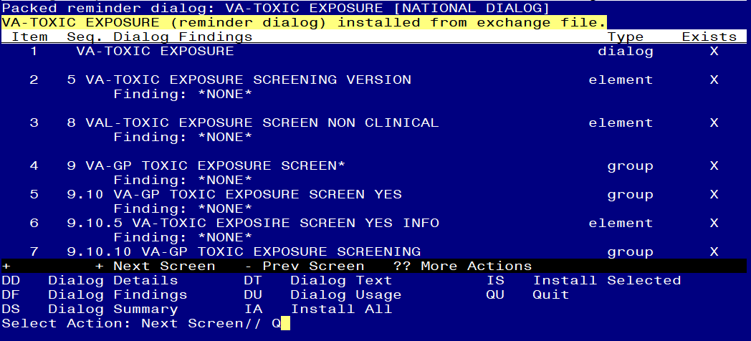

When the dialog has completed installation, you will then be returned to this screen. At the Select Action prompt, type Q.

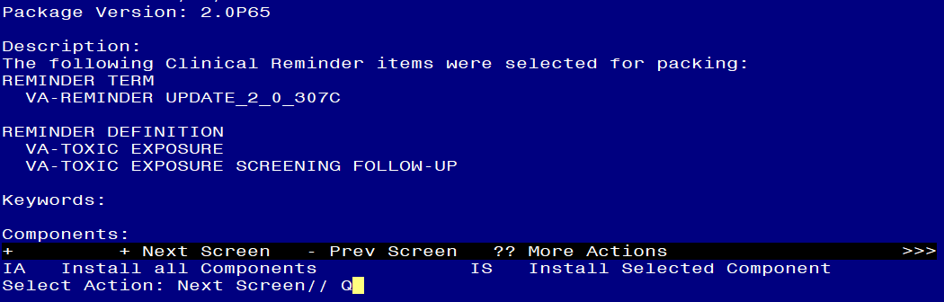

You will then be returned to this screen. At the Select Action prompt, type Q.

Install complete.

Post Installation

- Open the reminder Toxic Exposure Screening and confirm the version displays as 3.1
- Open the reminder Toxic Exposure Screening Follow-up and confirm the version displays as 3.1.
- Using your pre-install inquiry, update the dialog text and findings:
  - In Vista, using the menu, Reminder Dialog Management, Reminder Dialogs, change your view to Element view. Search for and find the element VAL-TOXIC EXPOSURE SCREENING LOCAL CONTACT INFO. Edit the DIALOG/PROGRESS NOTE TEXT and replace the lines with “xxxxxxx” with the text for local contacts you identified in the pre-install.
  - Add consult/referrals to follow up reminder if you previously attached a consult to these items. Review your pre-install inquiry and edit the additional findings and dialog text to match.
    - VAL-TOXIC EXPOSURE SCREENING REGISTRY EXAM CONSULT – represents a Consult/Referral to Registry Program
    - VAL-TOXIC EXPOSURE SCREENING REGISTRY EXAM TES NAV – represents a Consult/Referral to TES Navigator
    - VAL-TOXIC EXPOSURE SCREENING REGISTRY EXAM SOCIAL WORK – represents a Consult/Referral to Social Work
To add a quick order, in Vista, using the menu, Reminder Dialog Management, Reminder Dialogs, change your view to Element view. Search for and find the appropriate element and add your quick order as an Additional Finding – DO NOT CHANGE OR REMOVE THE HEALTH FACTOR IN THE FINDING FIELD.

NOTE: If there are any questions or problems during the installation, please notify your local IT support to log a national help desk ticket or contact the VA Service Desk and have them submit a national ticket to:
Category: Affected Service
Affected Service: VistA - Clinical Reminders

