

**Update _2_0_308**

Clinical Reminders

VA-LONG COVID-19 SCREEN

Install Guide

**January 2023**

Product Development

Office of Information Technology

Department of Veterans Affairs

Table of Contents

Introduction 1

Install Details 4

Pre-Install 5

Install Example 5

Post Installation 9

# Introduction

Description:

*History*: The approach to Long COVID Care between VA clinical facilities is inconsistent and was originally designed in isolation of each other. The Long COVID IPT was developed to standardize process for identifying, assessing and treatment of Long COVID. Workstream 2 specifically, is focusing on developing templates, notes, and other tools required to operationalize guidance. The pre-screen template was developed in conjunction with the Long COVID Technical Team to be used to document responses of digital pre-screen sent to veterans identified on the COVID dashboard

*Purpose:* The Long COVID Pre-Screen template will be used to document responses of the digital pre-screen questions.

This template may also be used as a stand-alone initial contact to assess veteran prior to scheduled appointment as a part of initial screen, phone assessment or other setting.

The template includes the initial plan for follow-up and next steps in the care of the veteran and allows for flexibility in completion of various additional assessments and system review.

In addition to the pre-screen template, there is a new template that can be used to document and send a letter to a patient when you have been unable to reach them.

UPDATE_2_0_308 contains 1 Reminder Exchange entry:

**UPDATE_2_0_308 VA-LONG COVID-19 SCREEN**

**The exchange file contains the following components:**

**REMINDER DIALOG LINK TYPE**

VA-WHS VITALITY/WELL-BEING SCORE LESS THAN 20

**TIU TEMPLATE FIELD**

VA-LONG COVID CLINIC SIGNATURE

VA-LONG COVID CLINIC PHONE

VA-LONG COVID CLINIC

VA-TEXT (3 CHAR)R

PCFS TEXT 1

VA-WORD

OTHER NON-VA

OTHER TEXT

**HEALTH FACTORS**

VA-REMINDER UPDATES [C]

VA-UPDATE_2_0_308

VA-COVID-19 [C]

VA-LONG COVID VETERAN DID NOT RESPOND PRESCREEN LETTER SENT

VA-LONG COVID VETERAN WANTS CARE UNABLE TO REACH LETTER SENT

VA-HEALTH AND WELL BEING [C]

VA-WHS SCORE OF 20% OR LESS

VA-WHS VITALITY/WELL-BEING NOTE

VA-WHS VITALITY/WELL BEING SCORE

VA-LONG COVID SCRN C19 WHAT IS MOST IMPORTANT TO DISCUSS

VA-COVID-19 OUTSIDE PCR SPEC COLLECTED

VA-COVID-19 NON PCR AG LAB OUTSIDE NEG

VA-COVID-19 UNK OUTSIDE LAB TEST NEG

VA-COVID-19 PCR LAB OUTSIDE NEGATIVE

VA-COVID-19 NON PCR AG LAB OUTSIDE POS

VA-COVID-19 UNK OUTSIDE LAB TEST POS

VA-COVID-19 PCR LAB OUTSIDE POSITIVE

VA-LONG COVID SCRN C19 ECG REVIEWED

VA-LONG COVID SCRN C19 LABS REVIEWED

VA-LONG COVID SCRN C19 IMAGING REVIEWED

VA-LONG COVID SCRN C19 HX TREATMENT RECVD

VA-LONG COVID SCRN C19 HX SERIOUS HEALTH ISSUES

VA-LONG COVID C19 HX DISCHARGED HOME ON O2

VA-LONG COVID SCRN C19 HX O2

VA-LONG COVID SCRN C19 HX VENT

VA-LONG COVID SCRN C19 HX ICU

VA-LONG COVID SCRN C19 HX HOSPITAL ADMIT

VA-LONG COVID SCRN C19 HX ACUTE SXS

VA-LONG COVID SCRN C19 HX EXPOSURE SOURCE

VA-LONG COVID SCRN PLAN ATTEMPT ADDITIONAL CONTACT

VA-LONG COVID SCRN PLAN REFER TO SOCIAL WORK

VA-LONG COVID SCRN PLAN FU NOT INDICATED

VA-LONG COVID SCRN PLAN OTHER

VA-LONG COVID SCRN PLAN ORDER IMAGING

VA-LONG COVID SCRN PLAN ORDER LABS

VA-LONG COVID SCRN PLAN MONITOR PRIMARY CARE

VA-LONG COVID SCRN PLAN REFER PATIENT DECLINES

VA-LONG COVID SCRN PLAN REFER PROVIDER NOTIFIED

VA-LONG COVID SCRN PLAN REFER TO SPECIALTY CLINIC

VA-LONG COVID SCRN PLAN REFER TO LONG C19 CLINIC

VA-LONG COVID FNCTL SCRN GR 4 SEVERE FUNC LIMIT

VA-LONG COVID FNCTL SCRN CANNOT LIVE ALONE NO ASSIST

VA-LONG COVID FNCTL SCRN GR 0 NO FUNC LIMIT

VA-LONG COVID FNCTL SCRN DOESNT SUFFER SXS PAIN DEP ANXIETY

VA-LONG COVID FNCTL SCRN GR 1 NEGLIGIBLE FUNC LIMIT

VA-LONG COVID FNCTL SCRN DOESNT AVOID SPREAD OUT ACTIVITIES

VA-LONG COVID FNCTL SCRN GR 2 SLIGHT FUNC LIMIT

VA-LONG COVID FNCTL SCRN AVOIDS OR SPREADS OUT ACTIVITIES

VA-LONG COVID FNCTL SCRN SUFFERS SXS PAIN DEP ANXIETY

VA-LONG COVID FNCTL SCRN NO ACTIVITES CANNOT PERFORM ALONE

VA-LONG COVID FNCTL SCRN GR 3 MOD FUNC LIMIT

VA-LONG COVID FNCTL SCRN ACTIVITES CANNOT PERFORM ALONE

VA-LONG COVID FNCTL SCRN LIVES ALONE NO ASSIST

VA-LONG COVID C19 PRESCRN VA HELP WANTED NA

VA-LONG COVID C19 PRESCRN VA HELP WANTED NO

VA-LONG COVID C19 PRESCRN VA HELP WANTED YES

VA-LONG COVID C19 PRESCRN VA HELP WANTED NOT SURE

VA-LONG COVID SCRN C19 CONTINUED SYMPTOM COUGH

VA-LONG COVID SCRN C19 CONTINUED SYMPTOM PAIN

VA-LONG COVID SCRN C19 CONTINUED SYMPTOM DIZZINESS

VA-LONG COVID SCRN C19 CONTINUED SYMPTOM DEPRESSION

VA-LONG COVID SCRN C19 CONTINUED SYMPTOM ANXIETY

VA-LONG COVID SCRN C19 CONTINUED SYMPTOM OTHER SYMPTOM

VA-LONG COVID SCRN C19 CONTINUED SYMPTOM CHEST PAIN

VA-LONG COVID SCRN C19 CONTINUED SYMPTOM INSOMNIA

VA-LONG COVID SCRN C19 CONTINUED SYMPTOM MEMORY IMPAIRMENT

VA-LONG COVID SCRN C19 CONTINUED SYMPTOM HEADACHE

VA-LONG COVID SCRN C19 CONTINUED SYMPTOM CONCENTRATION IMPAIRMNT

VA-LONG COVID SCRN C19 CONTINUED SYMPTOM ANOSMIA PAROSMIA

VA-LONG COVID SCRN C19 CONTINUED SYMPTOM DYSPNEA

VA-LONG COVID SCRN C19 CONTINUED SYMPTOM FATIGUE

VA-LONG COVID C19 PRESCRN CONTD SXS

VA-LONG COVID C19 PRESCRN NO SXS

VA-LONG COVID SCRN C19 NEW SYMPTOM COUGH

VA-LONG COVID SCRN C19 NEW SYMPTOM PAIN

VA-LONG COVID SCRN C19 NEW SYMPTOM DIZZINESS

VA-LONG COVID SCRN C19 NEW SYMPTOM DEPRESSION

VA-LONG COVID SCRN C19 NEW SYMPTOM ANXIETY

VA-LONG COVID SCRN C19 NEW SYMPTOM OTHER SYMPTOM

VA-LONG COVID SCRN C19 NEW SYMPTOM CHEST PAIN

VA-LONG COVID SCRN C19 NEW SYMPTOM INSOMNIA

VA-LONG COVID SCRN C19 NEW SYMPTOM MEMORY IMPAIRMENT

VA-LONG COVID SCRN C19 NEW SYMPTOM HEADACHE

VA-LONG COVID SCRN C19 NEW SYMPTOM CONCENTRATION IMPAIRMENT

VA-LONG COVID SCRN C19 NEW SYMPTOM ANOSMIA PAROSMIA

VA-LONG COVID SCRN C19 NEW SYMPTOM DYSPNEA

VA-LONG COVID SCRN C19 NEW SYMPTOM FATIGUE

VA-LONG COVID C19 PRESCRN NEW SXS ISSUES

VA-LONG COVID C19 PRESCRN TELEPHONE CONTACT

VA-LONG COVID C19 PRESCRN CONDUCTED BY PHONE/IN PERSON

VA-LONG COVID C19 PRESCRN VVC CONTACT

VA-LONG COVID C19 PRESCRN UNABLE TO REACH

VA-LONG COVID C19 DASH PRESCRN VET RESP YES

VA-LONG COVID C19 DASH PRESCRN VET RESP NO

**REMINDER TERM**

VA-REMINDER UPDATE_2_0_308

VA-COVID-19 IMMUNIZATION BL

**HEALTH SUMMARY TYPE**

VA-WELL BEING SIGNS TOTAL

SARS-COV-2 IMMUNIZATION

COVID19 LAB RESULTS

**HEALTH SUMMARY OBJECTS**

VA-WELL BEING SIGNS TOTAL (TIU)

SARS-COV-2 IMMUNIZATION (TIU)

COVID19 LAB RESULTS (TIU)

**TIU DOCUMENT DEFINITION**

VA-WELL BEING SIGNS TOTAL

SARS-COV-2 IMMUNIZATION

COVID19 LAB RESULTS

**REMINDER DIALOG**

VA-COVID-19 LONG COVID SCREEN

VA-COVID-19 LONG COVID CONTACT LETTER

# Install Details

This update is being distributed as a web host file. The address for the host file is: https://REDACTED/docs/UPDATE_2_0_308.PRD

The file will be installed using Reminder Exchange, programmer access is not required.

Installation:

=============

This update can be loaded with users on the system. Installation will take less than 5 minutes.

# Pre-Install

1. **Review the dialog text of the following element and identify what local DATA OBJECT is used for** PATIENT ADDRESS, you will need to add it back post install.

Using the menu Reminder Dialog Management, Reminder Dialogs, change your view to Element.

Inquire/Print information for the following element: VAL-TH VVC TELEPHONE TRIAGE PATIENT LOCATION HOME

1. **Review the dialog text of the following element and identify what local DATA OBJECT** is used for PATIENT PHONE NUMBER, you will need to add it back post install.

Using the menu Reminder Dialog Management, Reminder Dialogs, change your view to Element.

Inquire/Print information for the following element: VAL-TH VVC TELEPHONE TRIAGE CONTACT PHONE OBJECT

# Install Example

To Load the exchange file, use LWH. The URL is

https://REDACTED/UPDATE_2_0_308.PRD

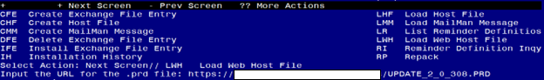

You should see a message that the file was loaded successfully.

Search and locate an entry titled UPDATE_2_0_308 VA-LONG COVID-19 SCREEN in reminder exchange. 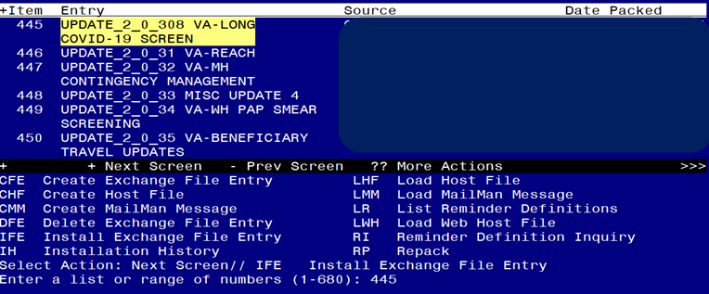

At the **Select Action** prompt, enter **IFE** for Install Exchange File Entry

Enter the number that corresponds with your entry titled UPDATE_2_0_308 VA-LONG COVID-19 SCREEN *(in this example it is entry 445, it will vary by site)* that is dated 12/28/2022.

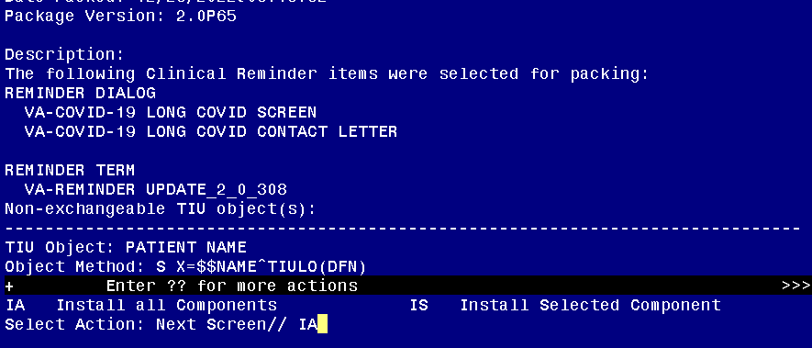

At the **Select Action** prompt, type **IA** for Install all Components and hit enter.

**For all new entries in any category you will choose I to Install**

**Skip any items in any category you are prompted to overwrite**

You will then be prompted to install the first dialog component.

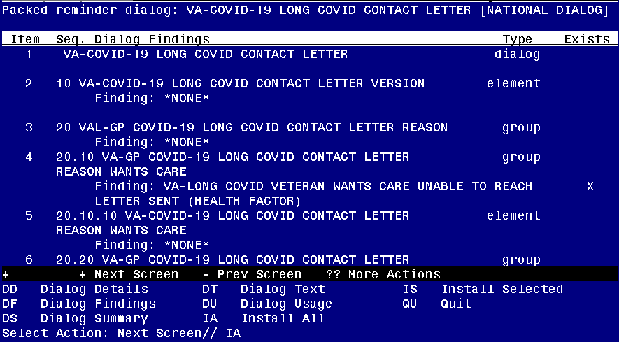

At the **Select Action** prompt, type **IA** to install the dialog – **VA-COVID-19 LONG COVID CONTACT LETTER**

Install reminder dialog and all components with no further changes: Y//ES

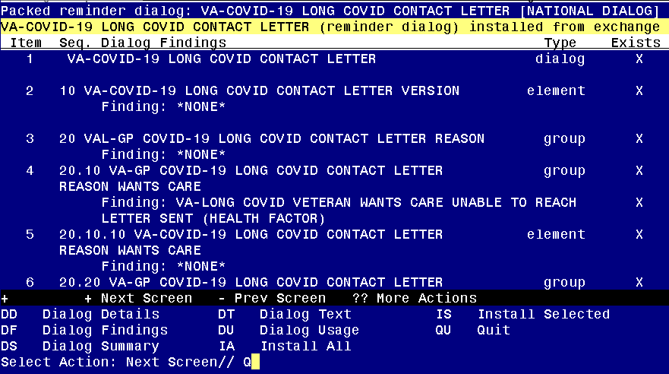

When the dialog has completed installation, you will then be returned to this screen. At the **Select Action** prompt, type **Q.**

You will then be prompted to install the next dialog component.

Regarding the VA-COVID-19 LONG COVID SCREEN:
Screen shot of the terminal window showing a list of elements, groups and dialogs with the text with IA for "Install All" entered at the "Select Action:" Prompt.  The correct entry is described in the text.

At the **Select Action** prompt, type **IA** to install the dialog – **VA-COVID-19 LONG COVID SCREEN**

Install reminder dialog and all components with no further changes: Y//ES

VA-COVID-19 LONG COVID SCREEN:
Screen shot of the last of the list of elements, groups and dialogs that needed to be installed with a Q for quit entered at the "Select Action:" prompt because they now all exist.  

When the dialog has completed installation, you will then be returned to this screen. At the **Select Action** prompt, type **Q.**

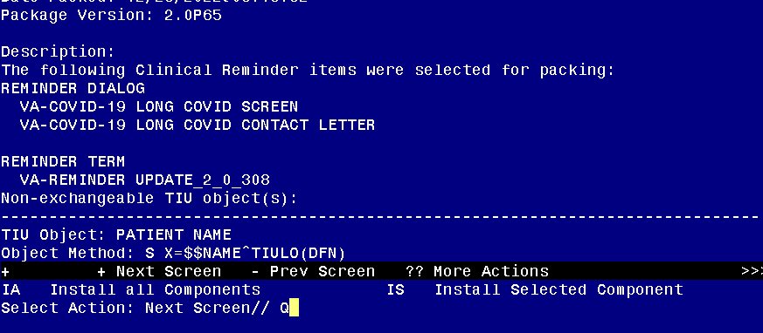

You will then be returned to this screen. At the **Select Action** prompt, type **Q.**

Install complete.

# Post Installation

1. **Setup of Note Titles.**
2. The note title to create to associate with the prescreen template is:

COVID-19 LONG COVID PRE-SCREEN/SCREEN

VHA Enterprise Standard Title: INFECTIOUS DISEASE NOTE

**You can add this to your document class where COVID-19 progress notes are located.**

1. The note title to create to associate with the letter template is – ***YOU ONLY NEED TO SET UP THIS LETTER IF YOUR FACILITY IS PARTICIPATING IN THE DIGITAL PRE-SCREEN PROGRAM FOR LONG COVID***:

COVID-19 LONG COVID CONTACT LETTER

VHA Enterprise Standard Title: INFECTIOUS DISEASE NOTE

**You can add these to your document class where FORM LETTERS are located.**

***Note:*** *Comprehensive information on Creating new Document Classes and Titles can be found beginning on page 54 of the TIU/ASU Implementation Guide at the following link:* [*http://www.va.gov/vdl/documents/Clinical/CPRS-Text_Integration_Utility_(TIU)/tiuim.pdf*](http://www.va.gov/vdl/documents/Clinical/CPRS-Text_Integration_Utility_(TIU)/tiuim.pdf)

1. **Make the Dialog templates available to be attached to a Personal or Shared templates or to be able to attach the dialog to a progress note title.**

Select Reminder Managers Menu <TEST ACCOUNT> Option: **CP** CPRS Reminder Configuration

CA Add/Edit Reminder Categories

CL CPRS Lookup Categories

CS CPRS Cover Sheet Reminder List

MH Mental Health Dialogs Active

PN Progress Note Headers

RA Reminder GUI Resolution Active

TIU TIU Template Reminder Dialog Parameter

DEVL Evaluate Coversheet List on Dialog Finish

DL Default Outside Location

PT Position Reminder Text at Cursor

LINK Link Reminder Dialog to Template

TEST CPRS Coversheet Time Test

NP New Reminder Parameters

GEC GEC Status Check Active

WH WH Print Now Active

Select CPRS Reminder Configuration <TEST ACCOUNT> Option: **TIU** TIU Template Reminder Dialog Parameter

Reminder Dialogs allowed as Templates may be set for the following:

1 User USR [choose from NEW PERSON]

3 Service SRV [choose from SERVICE/SECTION]

4 Division DIV [SALT LAKE CITY]

5 System SYS [NATREM.FO-SLC.MED.VA.GOV]

Enter selection: **5** *Choose the appropriate number for your site. Your site may do this by System or other levels. The example below uses SYSTEM level.*

Setting Reminder Dialogs allowed as Templates for System: NATREM.FO-SLC.MED.VA.GOV

Select Display Sequence: **?**

388 VA-COVID-19 TELEPHONE FOLLOW-UP

389 VA-SRA-CONSULT RESPONSE (D)

*When you type a question mark above, you will see the list of #’s (with dialogs) that are already taken. Choose a number* ***NOT*** *on this list. For this example, 390 is not present so I will use 390.*

Select Display Sequence: **390**

Are you adding 390 as a new Display Sequence? Yes// **YES**

Display Sequence: 390// <Enter> 390

Clinical Reminder Dialog: **VA-COVID-19 LONG COVID SCREEN** reminder dialog NATIONAL

...OK? Yes// <Enter> (Yes)

Select Display Sequence: **391**

Are you adding 391 as a new Display Sequence? Yes// **YES**

Display Sequence: 391// <Enter> 391

Clinical Reminder Dialog: **VA-COVID-19 LONG COVID CONTACT LETTER** reminder dialog NATIONAL

...OK? Yes// <Enter> (Yes)

1. **Associate the reminder dialogs with the note title in CPRS**
2. In CPRS, open the Template Editor, expand Document Titles, select the appropriate folder (if applicable), then click New Template (top right-hand corner).

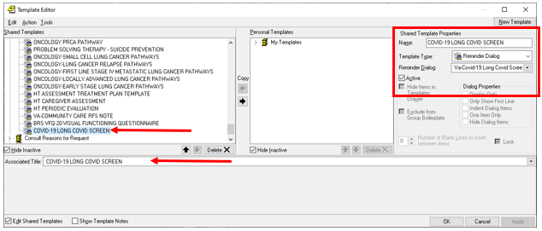

Type in the following information:

Name: **COVID-19 LONG COVID PRE-SCREEN/SCREEN**

Template Type: **Reminder Dialog**

Reminder Dialog: **VA-COVID-19 LONG COVID SCREEN**

Next, type in the Associated Title name **COVID-19 LONG COVID PRE-SCREEN/SCREEN**

–– then click Apply.

1. ***YOU ONLY NEED TO SET UP THIS LETTER IF YOUR FACILITY IS PARTICIPATING IN THE DIGITAL PRE-SCREEN PROGRAM FOR LONG COVID***: In CPRS, open the Template Editor, expand Document Titles, select the appropriate folder (if applicable), then click New Template (top right-hand corner).

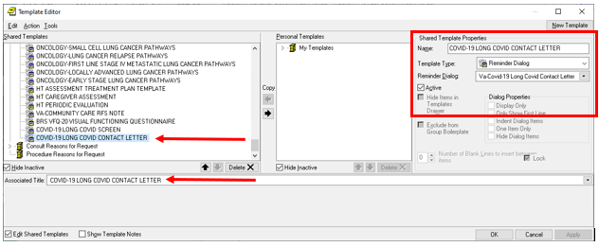

Type in the following information:

Name: **COVID-19 LONG COVID CONTACT LETTER**

Template Type: **Reminder Dialog**

Reminder Dialog: **VA-COVID-19 LONG COVID CONTACT LETTER**

Next, type in the Associated Title name **COVID-19 LONG COVID CONTACT LETTER** –– then click Apply.

1. **Add orders** to the plan section – optional

The following elements have a class of local and you can add a menu or quick orders as additional finding items or disable any of the following reminder dialog elements:

In Vista, using the menu, Reminder Dialog Management, Reminder Dialogs, change your view to Element view. Search for and find the element below, add your quick order or menu as an additional finding.

VAL-COVID-19 LONG COVID PLAN ORDER IMAGING

VAL-COVID-19 LONG COVID PLAN ORDER LAB

VAL-COVID-19 LONG COVID PLAN REFER TO SPECIALTY

VAL-COVID-19 LONG COVID PLAN REFER TO SOCIAL WORK

VAL-COVID-19 LONG COVID PLAN REFER TO COVID CLINIC

1. **Add your local DATA OBJECT** FOR PATIENT ADDRESS to the following element: VAL-TH VVC TELEPHONE TRIAGE PATIENT LOCATION HOME

Using the menu Reminder Dialog Management, Reminder Dialogs, change your view to Element.

Search for and edit the following element: VAL-TH VVC TELEPHONE TRIAGE PATIENT LOCATION HOME

1. **Add your local DATA OBJECT** FOR PATIENT PHONE NUMBER to the following element: VAL-TH VVC TELEPHONE TRIAGE CONTACT PHONE OBJECT

Using the menu Reminder Dialog Management, Reminder Dialogs, change your view to Element.

Search for and edit the following element: VAL-TH VVC TELEPHONE TRIAGE CONTACT PHONE OBJECT

1. **Update TXML fields (optional)** – ***YOU ONLY NEED TO SET UP THIS LETTER IF YOUR FACILITY IS PARTICIPATING IN THE DIGITAL PRE-SCREEN PROGRAM FOR LONG COVID***: The following txml template fields are used in the letter. They are currently text boxes, you can update and add default text or change the field type if you would like to give options for the user to choose from:

Clinic: {FLD:VA-LONG COVID CLINIC}

Telephone: {FLD:VA-LONG COVID CLINIC PHONE}