

**Update _2_0_316**

Clinical Reminders

VA-WH BREAST CANCER RISK ASSESSMENT

Install Guide

**February 2023**

Product Development

Office of Information Technology

Department of Veterans Affairs

Table of Contents

Introduction 1

Install Details 2

Install Example 3

Post Installation 6

# Introduction

**Description:**

​​ The Dr Kate Hendricks Thomas Supported Expanded Review for Veterans in Combat Environments Act (Dr. Kate Hendricks Thomas SERVICE Act) mandates access to mammograms for all female Veterans who have had military toxic exposures.

This dialog captures information around breast cancer risk, including a family history pointing to a possible genetic propensity for breast cancer.  It also includes the military toxic exposure clinical reminder for efficient review and completion.  The template guides clinicians in their decision making around breast cancer screening. This dialog is designed for primary care providers and/or nurses.

Installation and implementation are mandatory, but use is optional. The dialog can be linked to a shared template or the note title detailed in the post-installation step. Implementation should be coordinated with primary care and/or women’s health staff.

UPDATE_2_0_316 contains 1 Reminder Exchange entry:

**UPDATE_2_0_316 VA-BREAST CANCER RISK ASSESSMENT**

**The exchange file contains the following components:**

**TIU TEMPLATE FIELD**

|  |
| --- |
| VA-WORD |
| VA-TOXIC CONTACT |

**HEALTH FACTORS**

|  |  |  |  |  |  |  |  |  |  |  |  |  |  |  |  |  |  |  |  |  |  |  |  |  |  |  |  |  |  |  |  |  |  |  |  |  |  |  |
| --- | --- | --- | --- | --- | --- | --- | --- | --- | --- | --- | --- | --- | --- | --- | --- | --- | --- | --- | --- | --- | --- | --- | --- | --- | --- | --- | --- | --- | --- | --- | --- | --- | --- | --- | --- | --- | --- | --- |
| |  | | --- | | VA-UPDATE_2_0_316 | | VA-WH BREAST CA ASHKENAZI JEWISH ANCESTRY | | VA-WH BREAST CA FH RISK ASSMNT NEGATIVE | | VA-WH BREAST CA GENETIC COUNSELING REFER NO | | VA-WH BREAST CA GENETIC COUNSELING REFER YES | | VA-WH BREAST CA HX AGE<51 BIOLOGIC DAUGHTER | | VA-WH BREAST CA HX AGE<51 BIOLOGIC MATERNAL AUNT | | VA-WH BREAST CA HX AGE<51 BIOLOGIC MGM | | VA-WH BREAST CA HX AGE<51 BIOLOGIC MOTHER | | VA-WH BREAST CA HX AGE<51 BIOLOGIC PATERNAL AUNT | | VA-WH BREAST CA HX AGE<51 BIOLOGIC PGM | | VA-WH BREAST CA HX AGE<51 BIOLOGIC SISTER | | VA-WH BREAST CA HX AGE<51 PERSONAL | | VA-WH BREAST CA HX AGE>50 2 OR MORE CASES SAME SIDE FAM | | VA-WH BREAST CA HX BIOL MALE RELATIVE | | VA-WH BREAST CA PERSONAL/FH RISK ASSMNT TOTAL | | VA-WH BREAST CANCER RISK ASSESSMENT [C] | | VA-WH OVARIAN CA/FTC/PPC HX BIOLOGIC DAUGHTER | | VA-WH OVARIAN CA/FTC/PPC HX BIOLOGIC MATERNAL AUNT | | VA-WH OVARIAN CA/FTC/PPC HX BIOLOGIC MGM | | VA-WH OVARIAN CA/FTC/PPC HX BIOLOGIC MOTHER | | VA-WH OVARIAN CA/FTC/PPC HX BIOLOGIC PATERNAL AUNT | | VA-WH OVARIAN CA/FTC/PPC HX BIOLOGIC PGM | | VA-WH OVARIAN CA/FTC/PPC HX BIOLOGIC SISTER | | VA-WH OVARIAN CA/FTC/PPC HX PERSONAL | | VA-WH PERSONAL HISTORY ADH | | VA-WH PERSONAL HX BREAST CANCER | | VA-WH PERSONAL HX CHEST WALL RADIATION 10-30YO | | VA-WH PERSONAL HX DCIS | | VA-WH PERSONAL HX LCIS | | VA-WH PERSONAL/FDR BREAST CA HX NEGATIVE | | VA-WH PERSONAL/FDR HX BRCA 1/BCRA 2 | | VA-WH PERSONAL/FDR HX BRRS | | VA-WH PERSONAL/FDR HX COWDEN SYNDROME | | VA-WH PERSONAL/FDR HX LI-FRAUMENI SYNDROME | | VA-WH PERSONAL/FDR HX OTHER BC GENETIC CONDITIONS | | WH MAMMOGRAM [C] | | WH ORDER MAMMOGRAM SCREEN HF | |
|  |

**REMINDER SPONSOR**

WOMEN VETERANS HEALTH PROGRAM

**REMINDER TERM**

|  |
| --- |
| VA-REMINDER UPDATE_2_0_316 |
| VA-SEX MALE |
| VA-WH BL AGE 30-34 |
| VA-AGE<30 |
| VA-WH BL AGE 35-39 |
| VA-TOXIC EXPOSURE SCREEN RESOLUTION |
| VA-WH BL TES REMINDER |
| VA-WH BL AGE>34  VA-WH BL TES REMINDER |

**REMINDER DIALOG**

VA-WH BREAST CANCER RISK ASSESSMENT

**TIU OBJECTS**

VA-WH TES REMINDER RESULTS

VA-WH BREAST CA RISK ASSMNT HX

# Pre-Installation

1. Identify local screening mammogram order or order menu. The order or menu will be mapped to the dialog during post-installation.

Install Details

This update is being distributed as a web host file. The address for the host file is: **https://REDACTED/UPDATE_2_0_316.PRD**

The file will be installed using Reminder Exchange, programmer access is not required.

Installation:

=============

This update can be loaded with users on the system. Installation will take less than 5 minutes.

# Install Example

To Load the Web Host File. Navigate to Reminder exchange in Vista

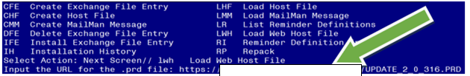

At the **Select Action:** prompt, enter **LWH** for Load Web Host File

At the **Input the url for the .prd file:** prompt, type the following web address:

**https://REDACTED/UPDATE_2_0_316.PRD**

You should see a message at the top of your screen that the file successfully loaded.

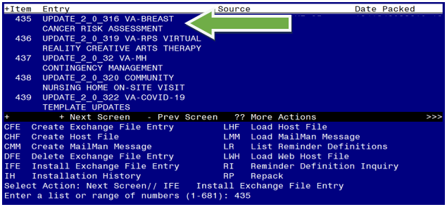

Search and locate an entry titled **UPDATE_2_0_316 VA-BREAST CANCER RISK ASSESSMENT** in reminder exchange.

At the **Select Action** prompt, enter **IFE** for Install Exchange File Entry

Enter the number that corresponds with your entry UPDATE_2_0_316 VA-BREAST CANCER RISK ASSESSMENT

*(In this example it is entry 435. It will vary by site).* The date of the exchange file should be 02/06/2023.

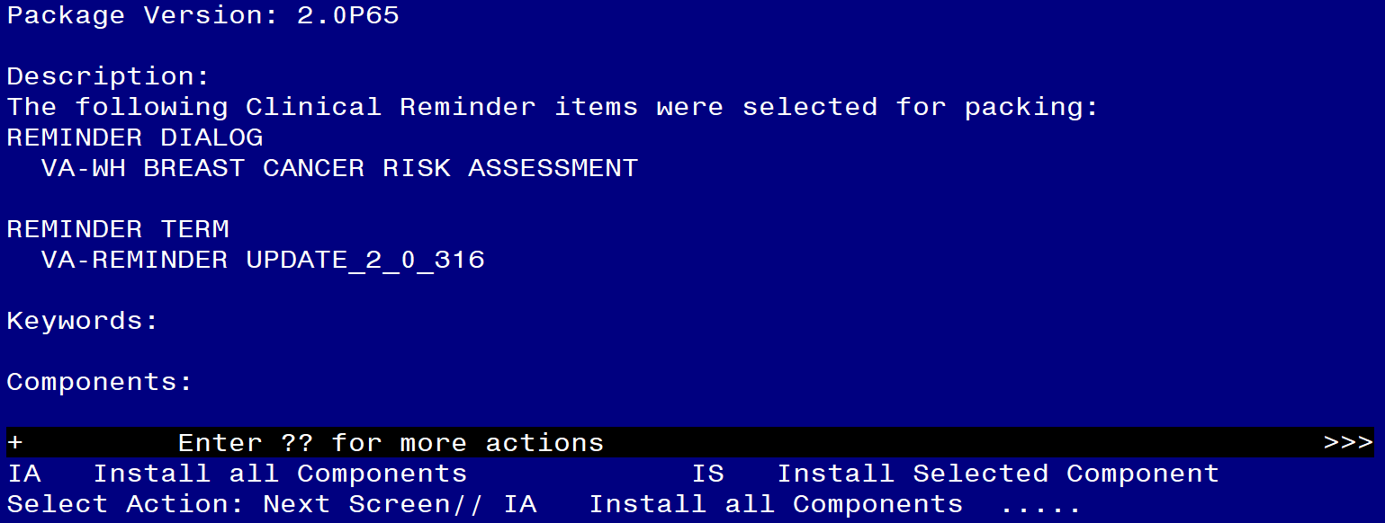

At the **Select Action** prompt, type **IA** for Install all Components and hit enter.

Select Action: Next Screen// IA Install all Components

You will see several prompts, for all new entries you will choose **I to Install**

For components that already exists but the packed component is different, choose **S to Skip.**

**You will be promped to install the reminder dialog component (VA-WH BREAST CANCER RISK ASSESSMENT).** You will choose to install all even though some components may have an X to indicate that they exist.

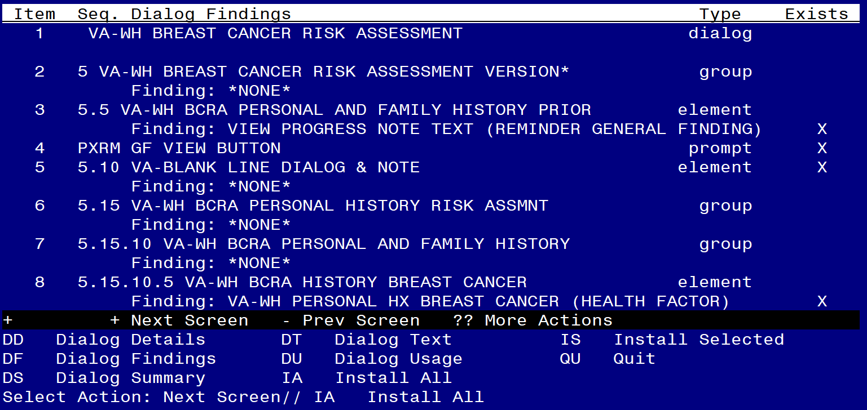

At the **Select Action** prompt, type **IA** to install the dialog: **VA-WH BREAST CANCER RISK ASSESSMENT**

Select Action: Next Screen// IA Install All

Install reminder dialog and all components with no further changes: Y// Yes

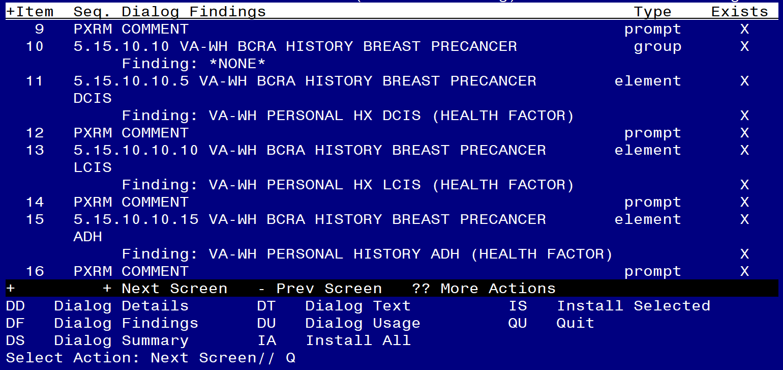

After completing this dialog install, you will type Q.

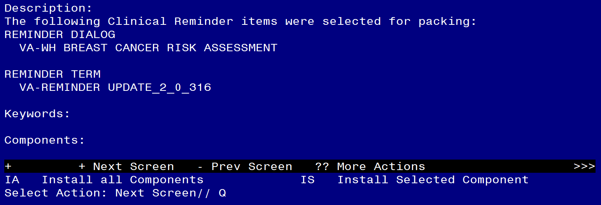

You will then be returned to this screen. At the **Select Action** prompt, type **Q.**

Install complete.

# Post Installation

1. **Coordinate implementation with local primary care and/or women’s health staff.**
2. **Map the VA-TOXIC EXPOSURE reminder definition to the VA-WH BL TES REMINDER reminder term.** 
   1. Navigate to the Reminder Manager Menu in VistA. Follow the prompts below.

Select Reminder Dialog Management <TEST ACCOUNT> Option:

CF Reminder Computed Finding Management ...

RM Reminder Definition Management ...

SM Reminder Sponsor Management ...

TXM Reminder Taxonomy Management

TRM Reminder Term Management ...

LM Reminder Location List Management ...

RX Reminder Exchange

RT Reminder Test

OS Other Supporting Menus ...

INFO Reminder Information Only Menu ...

DM Reminder Dialog Management ...

CP CPRS Reminder Configuration ...

RP Reminder Reports ...

MST Reminders MST Synchronization Management ...

PL Reminder Patient List Menu ...

PAR Reminder Parameters ...

VS NLM Value Set Menu

ROC Reminder Order Check Menu ...

CQM NLM Clinical Quality Measures Menu

XM Reminder Extract Menu ...

Select Reminder Managers Menu <TEST ACCOUNT> Option: **TRM**

TL List Reminder Terms

TI Inquire about Reminder Term

TE Add/Edit Reminder Term

TC Copy Reminder Term

TICS Integrity Check Selected

TICA Integrity Check All

TEST Term Test

Select Reminder Term Management <TEST ACCOUNT> Option: **TE**

Select Reminder **VA-WH BL TES REMINDER**

...OK? Yes//**Yes**

NAME: VA-WH BL TES REMINDER **<enter>**

CLASS: NATIONAL// **<enter>**

SPONSOR: **<enter>**

REVIEW DATE: **<enter>**

DESCRIPTION: **<enter>**

Edit? NO//

Choose from:

CF VA-REMINDER DEFINITION Finding # 1

Select Finding: **`1**

**BE SURE TO: Replace the existing reminder with the VA-TOXIC EXPOSURE reminder.**

Display help for CF.VA-REMINDER DEFINITION? **NO**

Editing Finding Number: 1 **<enter>**

FINDING ITEM: VA-REMINDER DEFINITION// **<enter>**

BEGINNING DATE/TIME: **<enter>**

ENDING DATE/TIME: **<enter>**

OCCURRENCE COUNT: **<enter>**

COMPUTED FINDING PARAMETER: VA-REPLACE DEFINITION

Replace **...** With **VA-TOXIC EXPOSURE**

CONDITION: I V["DUE"**<enter>**

CONDITION CASE SENSITIVE: NO// **<enter>**

USE STATUS/COND IN SEARCH: **<enter>**

1. **Embed the VA-TOXIC EXPOSURE dialog into the VAL-WH BCRA TOXIC EXPOSURE SCREEN group.**
   1. Navigate to the reminder dialog group menu in VistA and locate the VAL-WH BCRA TOXIC EXPOSURE SCREEN group.

NAME: **VAL-WH BCRA TOXIC EXPOSURE SCREEN**

DISABLE: **<enter>**

CLASS: LOCAL/**<enter>**/

SPONSOR: **<enter>**

REVIEW DATE: **<enter>**

RESOLUTION TYPE: **<enter>**

ORDERABLE ITEM: **<enter>**

FINDING ITEM: **<enter>**

Additional findings: **<enter>**none

Select ADDITIONAL FINDING: **<enter>**

GROUP CAPTION: **<enter>**

PUT A BOX AROUND THE GROUP: **<enter>**

SHARE COMMON PROMPTS: **<enter>**

MULTIPLE SELECTION: **<enter>**

HIDE/SHOW GROUP: HIDE// **<enter>**

GROUP HEADER DIALOG TEXT:

Environmental Military Exposure Screen\\

(use to document the Veteran's Military Exposure history)

Edit? NO// **<enter>**

GROUP HEADER ALTERNATE P/N TEXT:

Environmental Military Exposure Screen

Edit? NO// **<enter>**

EXCLUDE FROM PROGRESS NOTE: **<enter>**

SUPPRESS CHECKBOX: **<enter>**

NUMBER OF INDENTS: 2// **<enter>**

INDENT PROGRESS NOTE TEXT: INDENT//**<enter>**

Select SEQUENCE: **5**

DIALOG ELEMENT: **VA-TOXIC EXPOSURE SCREENING VERSION** dialog element

...OK? Yes// **Yes**

EXCLUDE FROM PN TEXT: **<enter>**

Select SEQUENCE: **10**

DIALOG ELEMENT: **VAL-TOXIC EXPOSURE SCREEN NON CLINICAL** dialog element

...OK? Yes// **Yes**

EXCLUDE FROM PN TEXT: **<enter>**

Select SEQUENCE: **15**

DIALOG ELEMENT: **VA-GP TOXIC EXPOSURE SCREEN**

1 VA-GP TOXIC EXPOSURE SCREEN dialog group

2 VA-GP TOXIC EXPOSURE SCREEN AHBP INFO dialog element

3 VA-GP TOXIC EXPOSURE SCREEN ELIG QU CONTACTS dialog group

4 VA-GP TOXIC EXPOSURE SCREEN ELIG QUESTIONS dialog group

5 VA-GP TOXIC EXPOSURE SCREEN ENROLL QU CONTACTS dialog group

CHOOSE 1-5: **1** VA-GP TOXIC EXPOSURE SCREEN dialog group NATIONAL

EXCLUDE FROM PN TEXT: **<enter>**

Select SEQUENCE: 15//**<enter>**

Select BRANCHING LOGIC SEQUENCE: 5// **<enter>**

BRANCHING LOGIC SEQUENCE: 5// **<enter>**

EVALUATION ITEM: VA-WH BL TES REMINDER// **<enter>**

EVALUATION STATUS: FALSE// **<enter>**

ACTION: REPLACE// **<enter>**

REPLACEMENT ITEM: VA-WH BCRA TES RESULTS//**<enter>**

Select BRANCHING LOGIC SEQUENCE: **<enter>**

Checking reminder dialog for errors..

NO ERRORS FOUND

Input your edit comments.

Edit? NO//**<enter>**

1. **Map local screening mammogram order/menu to the VA-WH BCRA ORDER MAMMOGRAM element and VA-WH BCRA MAMMOGRAM ORDER DECISION element.**

NAME: **VA-WH BCRA ORDER MAMMOGRAM**

Finding item: HF WH ORDER MAMMOGRAM SCREEN HF **<enter>**

FINDING ITEM: WH ORDER MAMMOGRAM SCREEN HF // **<enter>**

Additional findings: none

Select ADDITIONAL FINDING: **Enter “Q.”, then name of local screening mammogram quick order or menu.**

Repeat steps for the VA-WH BCRA MAMMOGRAM ORDER DECISION element.

1. **Make the Dialog template available to be attached to a Personal or Shared template or to be able to attach the dialog to a progress note title.**

Select Reminder Managers Menu <TEST ACCOUNT> Option: **CP** CPRS Reminder Configuration

CA Add/Edit Reminder Categories

CL CPRS Lookup Categories

CS CPRS Cover Sheet Reminder List

MH Mental Health Dialogs Active

PN Progress Note Headers

RA Reminder GUI Resolution Active

TIU TIU Template Reminder Dialog Parameter

DEVL Evaluate Coversheet List on Dialog Finish

DL Default Outside Location

PT Position Reminder Text at Cursor

LINK Link Reminder Dialog to Template

TEST CPRS Coversheet Time Test

NP New Reminder Parameters

GEC GEC Status Check Active

WH WH Print Now Active

Select CPRS Reminder Configuration <TEST ACCOUNT> Option: **TIU** TIU Template Reminder Dialog Parameter

Reminder Dialogs allowed as Templates may be set for the following:

1 User USR [choose from NEW PERSON]

3 Service SRV [choose from SERVICE/SECTION]

4 Division DIV [SALT LAKE CITY]

5 System SYS [NATREM.FO-SLC.MED.VA.GOV]

Enter selection: **5** *Choose the appropriate number for your site. Your site may do this by System or other levels. The example below uses SYSTEM level.*

Setting Reminder Dialogs allowed as Templates for System: NATREM.FO-SLC.MED.VA.GOV

Select Display Sequence: **?**

388 VA-COVID-19 TELEPHONE FOLLOW-UP

389 VA-SRA-CONSULT RESPONSE (D)

*When you type a question mark above, you will see the list of #’s (with dialogs) that are already taken. Choose a number* ***NOT*** *on this list. For this example, 390 is not present so I will use 390.*

Select Display Sequence: **390**

Are you adding 390 as a new Display Sequence? Yes// **YES**

Display Sequence: 390// <Enter> 390

Clinical Reminder Dialog: **VA-WH BREAST CANCER RISK ASSESSMENT** reminder dialog NATIONAL

...OK? Yes// <Enter> (Yes)

1. **Setup of Note Title (optional).**

The note title to create to associate with this template is: **BREAST CANCER RISK ASSESSMENT**

VHA Enterprise Standard Title: WOMENS HEALTH NOTE

You can add this to the appropriate document class.

***Note:*** *Comprehensive information on Creating new Document Classes and Titles can be found beginning on page 54 of the TIU/ASU Implementation Guide at the following link:* [*http://www.va.gov/vdl/documents/Clinical/CPRS-Text_Integration_Utility_(TIU)/tiuim.pdf*](http://www.va.gov/vdl/documents/Clinical/CPRS-Text_Integration_Utility_(TIU)/tiuim.pdf)

1. **Associate the reminder dialogs with the note titles in CPRS**

In CPRS, open the Template Editor, expand Document Titles, select the appropriate folder (if applicable), then click New Template (top right-hand corner).

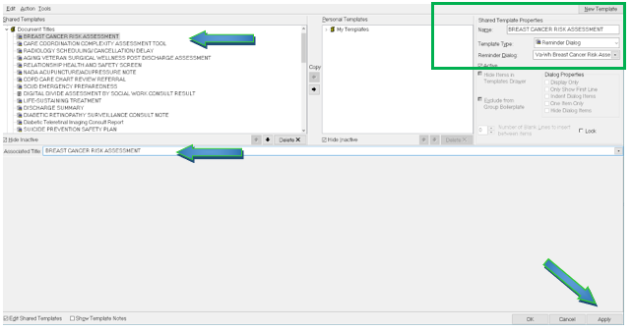

Type in the following information:

Name: **BREAST CANCER RISK ASSESSMENT**

Template Type: **Reminder Dialog**

Reminder Dialog: **VA-WH BREAST CANCER RISK ASSESSMENT**

Next, type in the Associated Title name –– then click Apply.

1. **Associate the reminder dialog with a shared template in CPRS, if needed.**