

**Update _2_0_318**

Clinical Reminders

VA-WHS WELL-BEING SIGNS UPDATE

Install Guide

**December 2022**

Product Development

Office of Information Technology

Department of Veterans Affairs

Table of Contents

Introduction 1

Install Details 5

Pre-install 5

Install Example 5

Post Installation 8

# Introduction

The whole health wellbeing signs template approved and released in 2021 required that users manually calculate the average of 3 scores. The YS*5.01*202 patch released in October of 2022 included a new MH instrument for wellbeing signs in MHA that auto-calculates the average score.

This reminder dialog template was updated to remove the three questions and add the MH button. There are technically no wording changes, just a change to how the user sees the questions and they don’t have to manually calculate/document the total score.

Before (the score must be manually calculated and typed)

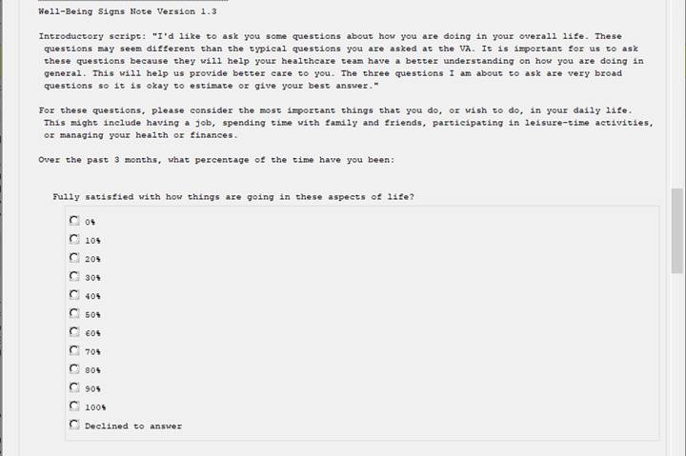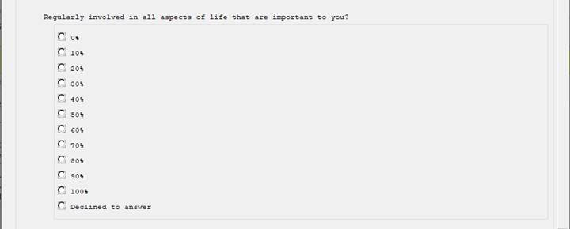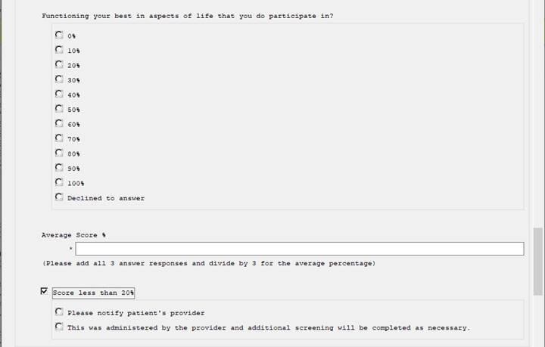

After : The MH instrument will auto calculate the average score and insert into the note and an average score less than 20% will now auto-check update based on a score of 19 or lower.

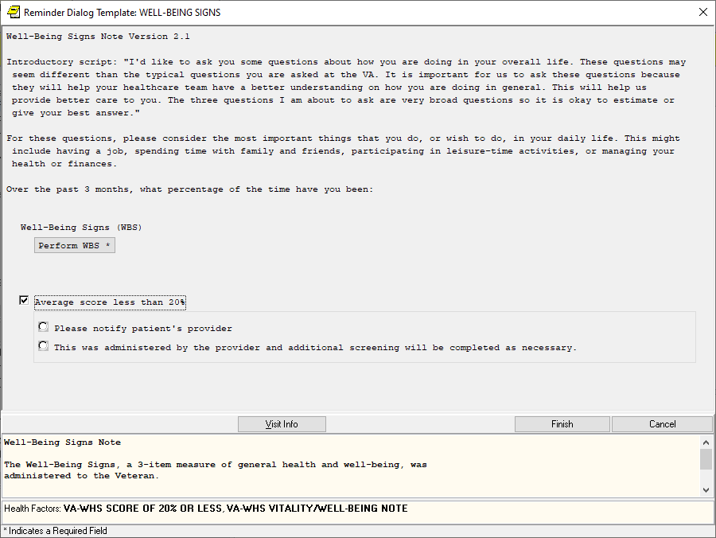

Clicking on the button opens the questions in MHA:

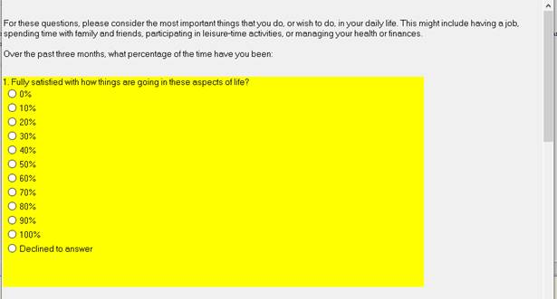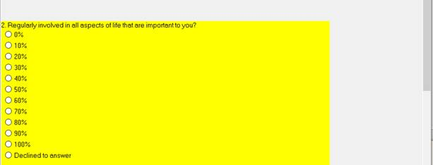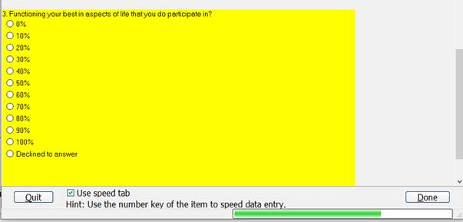

UPDATE_2_0_318 contains 1 Reminder Exchange entry:

**UPDATE_2_0_318 VA-WHS WELL-BEING SIGNS UPDATE**

**The exchange file contains the following components:**

**REMINDER DIALOG LINK TYPE**

VA-WHS VITALITY/WELL-BEING SCORE LESS THAN 20

**HEALTH FACTORS**

VA-REMINDER UPDATES [C]

VA-UPDATE_2_0_318

VA-HEALTH AND WELL BEING [C]

VA-WHS SCORE OF 20% OR LESS

VA-WHS VITALITY/WELL-BEING NOTE

**REMINDER SPONSOR**

WHOLE HEALTH

**REMINDER TERM**

VA-REMINDER UPDATE_2_0_318

**REMINDER DIALOG**

VA-WHS WELL-BEING SIGNS

# Pre-install

You should have installed update 215 prior to installing this update.

The Install Guide can be found here: REDACTED

# Install Details

This update is being distributed as a web host file. The address for the host file is: **https://REDACTED /UPDATE_2_0_318.PRD**

The file will be installed using Reminder Exchange, programmer access is not required.

Installation:

=============

This update can be loaded with users on the system. Installation will take less than 2 minutes.

# Install Example

To Load the Web Host File. Navigate to Reminder exchange in Vista

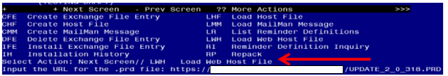

At the **Select Action:** prompt, enter **LWH** for Load Web Host File

At the **Input the url for the .prd file:** prompt, type the following web address:

**https://REDACTED /UPDATE_2_0_318.PRD**

You should see a message at the top of your screen that the file successfully loaded.

Search and locate an entry titled **UPDATE_2_0_318 VA-WHS WELL-BEING SIGNS UPDATE** in reminder exchange.

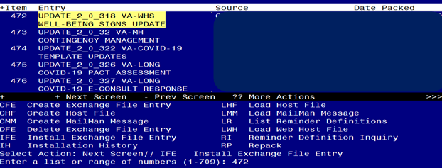

At the **Select Action** prompt, enter **IFE** for Install Exchange File Entry

Enter the number that corresponds with your entry UPDATE_2_0_318 VA-WHS WELL-BEING SIGNS UPDATE *(in this example it is entry 472. It will vary by site).* The date of the exchange file should be 11/30/2022.

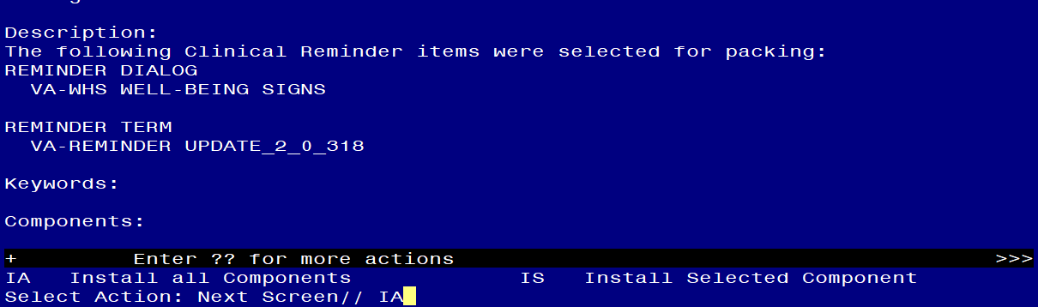

At the **Select Action** prompt, type **IA** for Install all Components and hit enter.

Select Action: Next Screen// IA Install all Components

You will see several prompts, for all new entries you will choose **I to Install**

For components that already exists but the packed component is different, choose **S to Skip.**

**You will be promped to install the reminder dialog component (VA-WHS WELL-BEING SIGNS).** You will choose to install all even though some components may have an X to indicate that they exist.

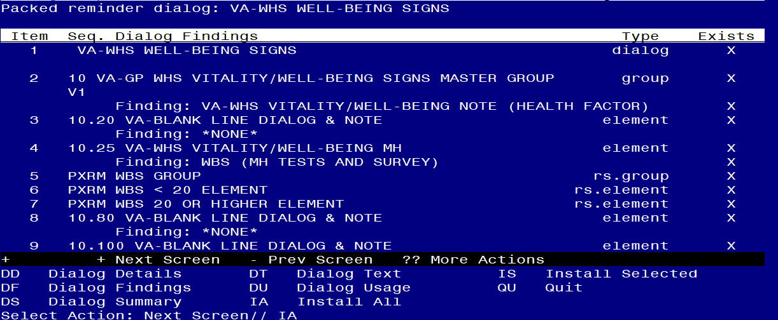

At the **Select Action** prompt, type **IA** to install the dialog: **VA-WHS WELL-BEING SIGNS**

Select Action: Next Screen// IA Install All

Install reminder dialog and all components with no further changes: Y// Yes

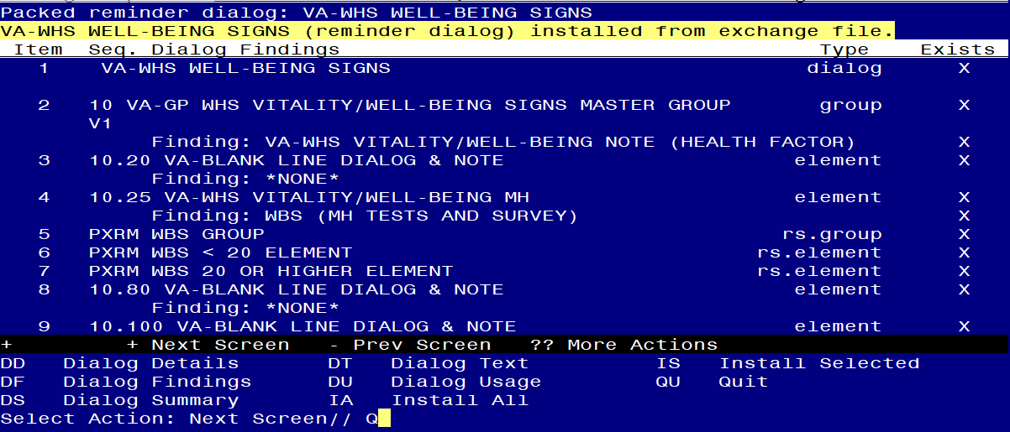

After completing this dialog install, you will type Q.

Screen shot of the terminal window showing that after all of the groups, elements and dialogs have been installed, the reminder that was installed with Q entered for quit to finish. The name of the VA employee at the Source line label has been redacted.



You will then be returned to this screen. At the **Select Action** prompt, type **Q.**

Install complete.

# Post Installation

1. **Open the note titled WELL-BEING SIGNS (reminder dialog VA-WHS WELL-BEING SIGNS**) and confirm the version displays as 2.1.