

**Update _2_0_320**

Clinical Reminders

VA-COMMUNITY NURSING HOME (CNH) RESIDENT ASSESSMENT

Install Guide

**March 2023**

Product Development

Office of Information Technology

Department of Veterans Affairs

Table of Contents

Introduction 1

Install Details 3

Install Example 4

Post Installation 7

# Introduction

VHA’s Community Nursing Home (CNH) program, is dedicated to strengthening the quality and oversight of our program through national standardization and quality monitoring. In September 2022, new content was released in the Integrated Veteran Care (IVC) Field Guidebook (FGB) outlining the requirements for review and documentation for CNH on-site resident assessment. Through the development of a standardized documentation template, we can improve monitoring and documentation while ensuring they meet program requirements.

A new CPRS note template has been created for the following note title:

Error! Reference source not found.

Std. Title: COMMUNITY NURSING HOME CARE NOTE

Dialog: VA-CNH RESIDENT ASSESSMENT

The template meets all the requirements for information gathering in accordance with the IVC FGB and is required to be utilized by VA CNH program staff effective February 1, 2023.

**The exchange file contains the following components:**

**TIU DOCUMENT DEFINITION**

VA-CSRE DONE TODAY

VA-CNH LST STATUS

VA-CNH PROGRAM DATE

VA-CNH CURRENT HOME ADMIT DATE

**TIU TEMPLATE FIELD**

|  |
| --- |
| WORD PROCESSING (REQUIRED) |
| VA CNH RESPIRATORY TYPE |
| VA CNH RESPIRATORY CARE |
| YES OR NO |
| VA CNH SOCIALIZATION ABILITY |
| VA CNH SPEECH |
| VA CNH HEARING |
| VA CNH EYESIGHT |
| VA CNH LST BASIC INFOGRAPHIC-V4 2022-09 |
| DATE (REQ) |
| EDIT 45(REQUIRED) |
| YES NO NA |
| VA CNH THERAPIES |
| EDIT 15* |
| VA-BLANK |
| VA CNH MOOD/BEHAVIOR |
| VA CNH THOUGHT CONTENT |
| VA CNH THOUGHT PROCESS |
| VA CNH MENTAL STATUS |
| VA CNH COMMUNICATION2 |
| VA CNH COMMUNICATION |
| VA CNH JOB TYPES |

**HEALTH FACTORS**

|  |
| --- |
| VA-UPDATE_2_0_320 |
| VA-COMMUNITY NURSING HOME [C] |
| VA-CNH LST VA COMPLETED |
| VA-CNH VA LST ACCEPTED |
| VA-CNH SAPO |
| VA-CNH ADVANCE DIRECTIVE |
| VA-CNH LST NURSING HOME COMPLETED |
| VA-CNH MDS/PDPM [C] |
| VA-CNH RETURN TO COMMUNITY CODE YES |
| VA-CNH EXPECT DISCHARGE TO COMMUNITY |
| VA-CNH OVERALL EXPECTATION CODE 1 |
| VA-CNH RUG SCORE PA1 OR PA2 |
| VA-CNH MDS/PDPM SCORE |
| VA-CNH VETERAN SATISFACTION YES |
| VA-CNH VETERAN SATISFACTION NO |
| VA-CNH VETERAN RESPECTED NO |
| VA-CNH VETERAN RESPECTED YES |
| VA-CNH MEDICATION ERROR YES |
| VA-CNH MEDICATION ERROR INJURY |
| VA-NH MEDICATION ERROR NO |
| VA-CNH FALL INJURY |
| VA-CNH FALL YES |
| VA-CNH FALL NO |
| VA-SUICIDE RISK EVALUATION TYPE [C] |
| VA-SUICIDE RISK UPDATE EVALUATION |
| VA-SUICIDE RISK NEW EVALUATION |
| MENTAL HEALTH [C] |
| SEVERE CHRONIC COGNITIVE IMPAIRMENT |
| VA-PROBABLE PERMANENT COG IMPAIRMENT |
| VA-CSSRS DECLINED |
| UNABLE TO SCREEN - ACUTE ILLNESS |
| VA-CNH SUICIDAL IDEATION ASSESSED NO |
| VA-CNH POSITIVE SI SAFETY PLAN |
| VA-NH SUICIDAL IDEATION ASSESSED YES |
| VA-CNH EMERGENCY ROOM VISIT |
| VA-CNH HOSPITALIZATION |
| VA-CNH PLACEMENT OTHER REASON |
| VA-CNH PLACEMENT LONG TERM CARE |
| VA-CNH PLACEMENT HOSPICE |
| VA-CNH PLACEMENT SKILLED NC RESPIRATORY |
| VA-CNH PLACEMENT SKILLED NURSING |
| VA-CNH PLACEMENT COGNITIVE IMPAIRMENT |
| VA-CNH PLACEMENT REHABILITATION |
| VA-CNH PLACEMENT RESPITE CARE |
| VA-CNH VIRTUAL VISIT |

|  |
| --- |
| VA-REMINDER UPDATE_2_0_320 |
| VA-BL C-SSRS DONE TODAY |
| VA-C-SSRS DONE TODAY POSITIVE QUESTION 8 |
| VA-C-SSRS DONE TODAY POSITIVE QUESTION 5 |
| VA-C-SSRS DONE TODAY POSITIVE QUESTION 4 |
| VA-C-SSRS DONE TODAY POSITIVE QUESTION 3 |
| VA-BL C-SSRS DONE TODAY POSITIVE |
| VA-USER CLASS FOR COGNITIVE IMPAIRMENT |
| VA-COGNITIVE IMPAIRMENT |
| VA-DEMENTIA DIAGNOSIS PERMANENT SCREENING EXCLUSION |
| VA-BL PROBABLE PERMANENT COGNITIVE IMPAIRMENT |
| VA-USER CLASS NURSE |

**REMINDER SPONSOR**

OFFICE OF GERIATRIC EXTENDED CARE

OFFICE OF MENTAL HEALTH SERVICES

NATIONAL CLINICAL PRACTICE GUIDELINE COUNCIL

OFFICE OF MH AND SUICIDE PREVENTION

MENTAL HEALTH AND BEHAVIORAL SCIENCE STRATEGIC GROUP

**REMINDER DIALOG**

VA-CNH RESIDENT ASSESSMENT

Install Details

This update is being distributed as a web host file. The address for the host file is: **https://REDACTED /UPDATE_2_0_320.PRD**

Installation:

=============

This update can be loaded with users on the system. Installation will take less than 5 minutes.

# Install Example

To Load the Web Host File. Navigate to Reminder exchange in Vista

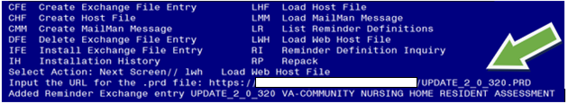

At the **Select Action:** prompt, enter **LWH** for Load Web Host File

At the **Input the url for the .prd file:** prompt, type the following web address:

**https://REDACTED /UPDATE_2_0_320.PRD**

You should see a message at the top of your screen that the file successfully loaded.

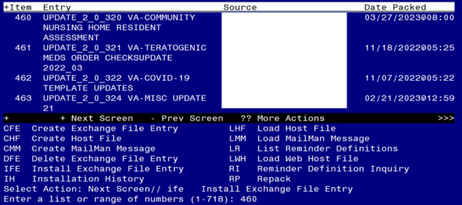 Search and locate an entry titled **UPDATE_2_0_320 COMMUNITY NURSING HOME RESIDENT HOME ASSESSMENT** in reminder exchange.

At the **Select Action** prompt, enter **IFE** for Install Exchange File Entry

Enter the number that corresponds with your entry UPDATE_2_0_320 COMMUNITY NURSING HOME RESIDENT ASSESSMENT.

*(In this example it is entry 460. It will vary by site).* The date of the exchange file should be 3/27/2023.

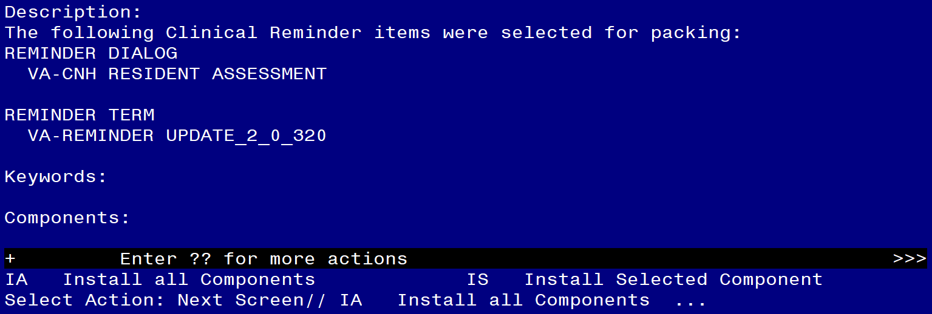

At the **Select Action** prompt, type **IA** for Install all Components and hit enter.

Select Action: Next Screen// **IA**  Install all Components

You will see several prompts, for all new entries you will choose **I to Install**

**Do not overwrite the VA-CSRE DONE TODAY, VA-SUICIDE SCREEN, and OB SERVICE CONNECTION health summary types. Skip these components.**

**Do not overwrite the VA-DEMENTIA DIAGNOSIS taxonomy, if asked. Skip this component.**

**Do not overwrite the VA-BL C-SSRS DONE TODAY, VA-GP SUICIDE RISK ASSESSMENT C-SSRS RN RESULTS, VA-SUICIDE RISK ASSESSMENT C-SSRS RN POSITIVE dialog items, if asked. Skip this components.**

**Do not overwrite the VA-CSSRS RN WARM HANDOFF CHECK reminder dialog link type. Skip this components.**

REMINDER DIALOG LINK TYPE entry named VA-CSSRS RN WARM HANDOFF CHECK

already exists but the packed component is different, what do you

want to do?

Select one of the following:

C Create a new entry by copying to a new name

O Overwrite the current entry

U Update

Q Quit the install

S Skip, do not install this entry

Enter response: O// **SKIP**

For all other components that already exists but the packed component is different, choose **O to Overwrite.**

**You will be promped to install the reminder dialog component (VA-CNH RESIDENT ASSESSMENT).** You will choose to install all even though some components may have an X to indicate that they exist.

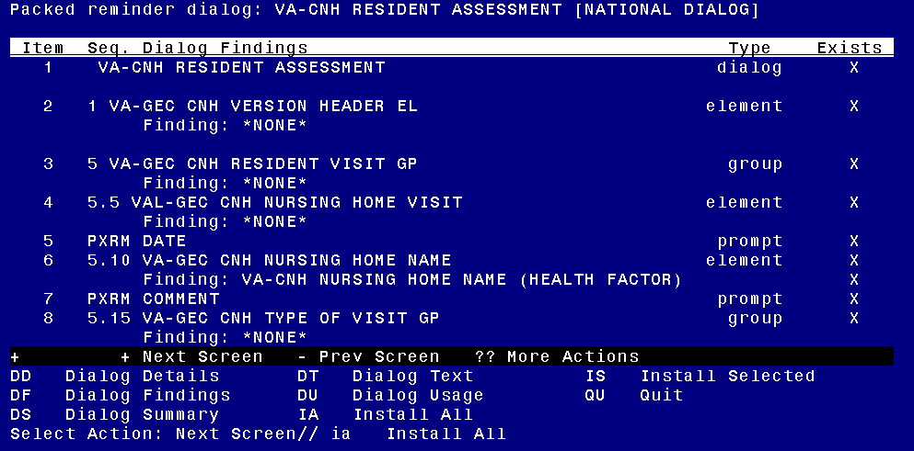

At the **Select Action** prompt, type **IA** to install the dialog.

Install reminder dialog and all components with no further changes: **Yes**

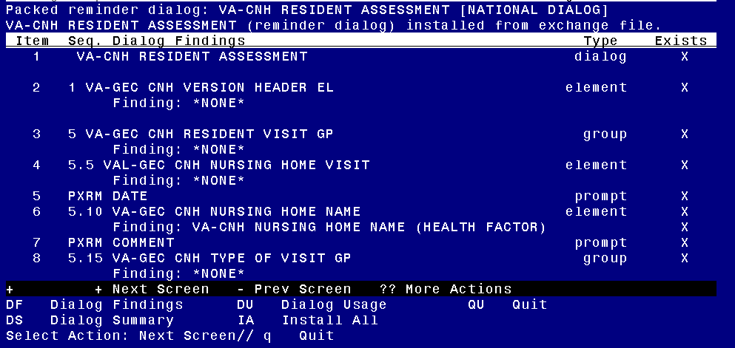

After completing this dialog install, you will type **Q**.

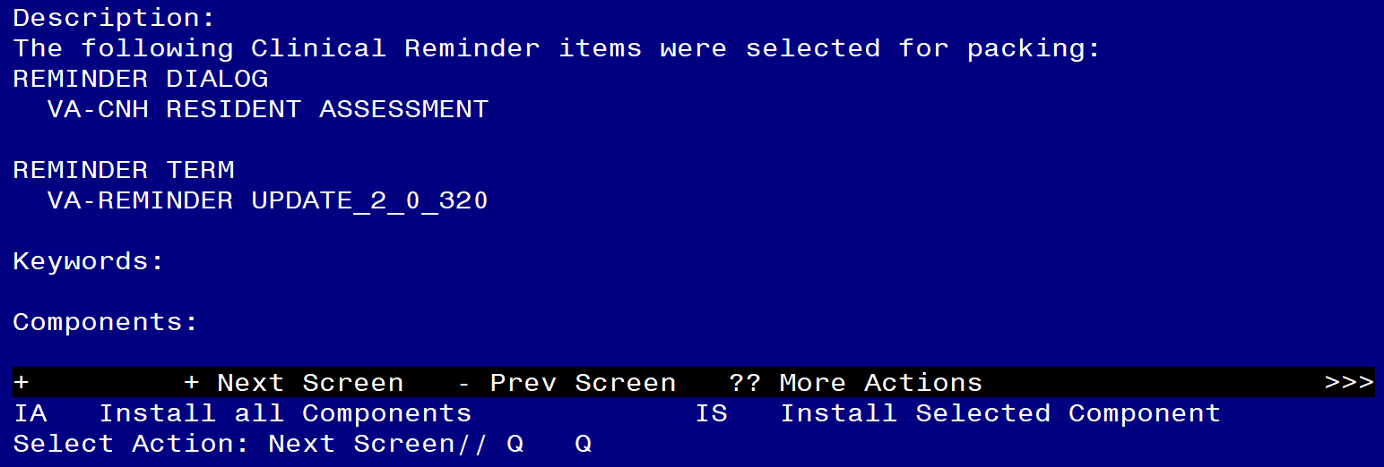

You will then be returned to this screen. At the **Select Action** prompt, type **Q.**

Install complete.

# Post Installation

1. Confirm the reminder mapping of the VA-PRIMARY SUICIDE SCREEN to the health summary type matches below. If not, remap the VA-PRIMARY SUICIDE SCREEN reminder.

1      Create/Modify Health Summary Type

   2      Delete Health Summary Type

   3      Health Summary Objects Menu ...

   4      Information Menu ...

   5      Print Health Summary Menu ...

Select Build Health Summary Type Menu <TEST ACCOUNT> Option: **1  Create/Modify Health Summary Type**

Select Health Summary Type: VA-SUICIDE SCREEN  VA-SUICIDE SCREEN

  VA-Suicide Screen (Suicide Screen)

  OK?  YES//

WARNING:  You are about to edit a Health Summary Type that is being used

by a Health Summary Object.  Changing the structure of this Health Summary

Type will alter how the Object will display.

Do want to continue?  NO// **YES**

NAME: VA-SUICIDE SCREEN//

TITLE: Suicide Screen//

SUPPRESS PRINT OF COMPONENTS WITHOUT DATA: yes//

SUPPRESS SENSITIVE PRINT DATA: NO SSN//

LOCK:

OWNER: OCONNOR,DAWN M//

Do you wish to review the Summary Type structure before continuing? NO// **YES**

                       HEALTH SUMMARY TYPE INQUIRY

         Type Name:  VA-SUICIDE SCREEN

             Title:  Suicide Screen

             Owner:  OCONNOR,DAWN M

SUPPRESS PRINT OF COMPONENTS WITHOUT DATA:  yes

SUPPRESS SENSITIVE PRINT DATA:  NO SSN

                                   Max        Hos  ICD   Pro  CPT

Abb   Ord    Component Name        Occ  Time  Loc  Text  Nar  Mod  Selection

------------------------------------------------------------------------------

CM    5       Suicide Screen

             * = Disabled Components

Select COMPONENT: **CM**

     1   CM  CLINICAL REMINDERS MAINTENANCE CM

     2   CMB  CLINICAL REMINDERS BRIEF   CMB

CHOOSE 1-2: **1  CLINICAL REMINDERS MAINTENANCE CM**

CLINICAL REMINDERS MAINTENANCE is already a component of this summary.

     Select one of the following:

          E         Edit component parameters

          D         Delete component from summary

Select Action: **Edit component parameters**

SUMMARY ORDER: 5// 5

HEADER NAME: Suicide Screen//

No selection items chosen.

Select new items one at a time in the sequence you want them displayed.

You may select any number of items.

Select SELECTION ITEM: **VA-PRIMARY SUICIDE SCREEN**

     Searching for a REMINDER DEFINITION, (pointed-to by SELECTION ITEM)

     Searching for a REMINDER DEFINITION

  VA-PRIMARY SUICIDE SCREEN     NATIONAL

        ...OK? Yes// **Yes**

1. The following local elements/groups can be edited if needed.
2. Element: VAL-GEC CNH NURSING HOME VISIT

This element contains the SERVICE CONNECTION/DISABILITIES TIU object. The deployed object can be replaced, if a local object to display service connections and disabilities is preferred.

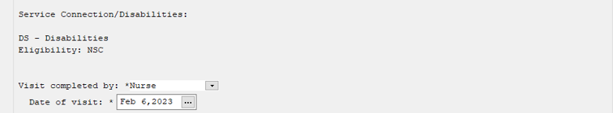

1. Group: VAL-GEC CNH C-SSRS FOLLOW UP GP

This group contains the TIU object to display the status of the suicide screen. An example of the information displayed is below.

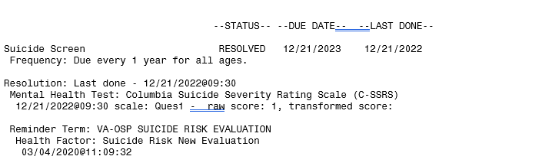

1. Group: VAL-GEC CNH VA PLAN OF CARE GP

This group contains the VA Plan of Care section and can be edited locally.

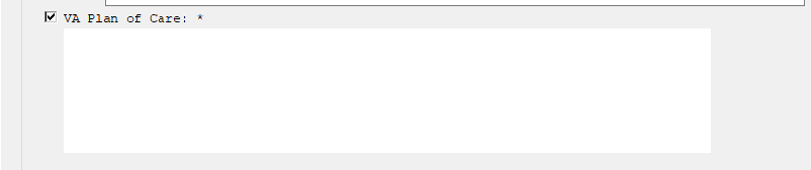

1. **Make the Dialog template available to be attached to a Personal or Shared template or to be able to attach the dialog to a progress note title.**

Select Reminder Managers Menu <TEST ACCOUNT> Option: **CP** CPRS Reminder Configuration

CA Add/Edit Reminder Categories

CL CPRS Lookup Categories

CS CPRS Cover Sheet Reminder List

MH Mental Health Dialogs Active

PN Progress Note Headers

RA Reminder GUI Resolution Active

TIU TIU Template Reminder Dialog Parameter

DEVL Evaluate Coversheet List on Dialog Finish

DL Default Outside Location

PT Position Reminder Text at Cursor

LINK Link Reminder Dialog to Template

TEST CPRS Coversheet Time Test

NP New Reminder Parameters

GEC GEC Status Check Active

WH WH Print Now Active

Select CPRS Reminder Configuration <TEST ACCOUNT> Option: **TIU** TIU Template Reminder Dialog Parameter

Reminder Dialogs allowed as Templates may be set for the following:

1 User USR [choose from NEW PERSON]

3 Service SRV [choose from SERVICE/SECTION]

4 Division DIV [SALT LAKE CITY]

5 System SYS [NATREM.FO-SLC.MED.VA.GOV]

Enter selection: **5** *Choose the appropriate number for your site. Your site may do this by System or other levels. The example below uses SYSTEM level.*

Setting Reminder Dialogs allowed as Templates for System: NATREM.FO-SLC.MED.VA.GOV

Select Display Sequence: **?**

388 VA-COVID-19 TELEPHONE FOLLOW-UP

389 VA-SRA-CONSULT RESPONSE (D)

*When you type a question mark above, you will see the list of #’s (with dialogs) that are already taken. Choose a number* ***NOT*** *on this list. For this example, 390 and 391 are not present so those numbers can be used.*

Select Display Sequence: **390**

Are you adding 390 as a new Display Sequence? Yes// **YES**

Display Sequence: 390// **<Enter>**

Clinical Reminder Dialog: **VA-CNH RESIDENT ASSESSMENT**

reminder dialog NATIONAL

...OK? Yes// **Yes**

1. **Setup of Note Titles.**

The note titles to create to associate with this template is:

Title: **COMMUNITY NURSING HOME RESIDENT ASSESSMENT**

Std. Title: COMMUNITY NURSING HOME CARE NOTE

Dialog: VA-CNH RESIDENT ASSESSMENT

***Note:*** *Comprehensive information on Creating new Document Classes and Titles can be found beginning on page 54 of the TIU/ASU Implementation Guide at the following link:* [*http://www.va.gov/vdl/documents/Clinical/CPRS-Text_Integration_Utility_(TIU)/tiuim.pdf*](http://www.va.gov/vdl/documents/Clinical/CPRS-Text_Integration_Utility_(TIU)/tiuim.pdf)

1. **Associate the reminder dialogs with the note titles in CPRS**

In CPRS, open the Template Editor, expand Document Titles, select the appropriate folder (if applicable), then click New Template (top right-hand corner).

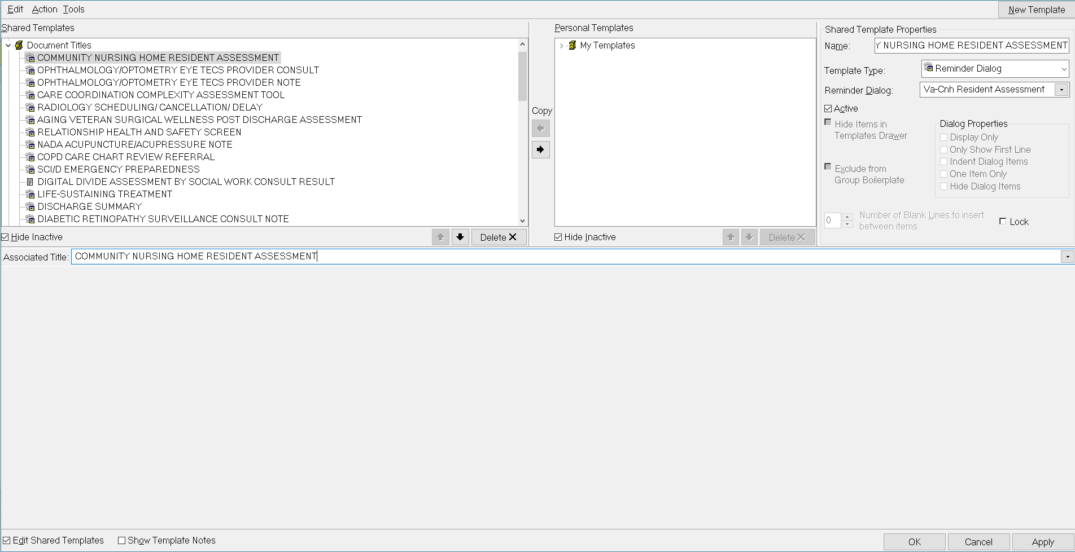

Type in the following information:

Name: **COMMUNITY NURSING HOME RESIDENT ASSESSMENT**

Template Type: **Reminder Dialog**

Reminder Dialog: **VA-CNH RESIDENT ASSESSMENT**

Next, type in the Associated Title name –– then click Apply.