

**Update_2_0_324**

Clinical Reminders

VA-MISC Update 21

Install Guide

**February 2023**

Product Development

Office of Information Technology

Department of Veterans Affairs

**Table of Contents**

Introduction 1

Pre-Installation 8

Install Details 8

Install Example 8

Post Installation 29

# Introduction

This update contains minor spelling corrections and other changes/edits to existing clinical reminder content, a full list of the changes can be found here:

**REDACTED. Document is entitled MISC_UPDATE_21_CHANGES.pdf**

**UPDATE_2_0_324 contains 1 Reminder Exchange entry:**

UPDATE_2_0_324 VA-MISC UPDATE 21

**The exchange file contains the following components:**

**REMINDER GENERAL FINDINGS**

VIEW PROGRESS NOTE TEXT

**REMINDER DIALOG LINK TYPE**

VA-PTSD POSITIVE WARM HANDOFF CHECK

**TIU TEMPLATE FIELD**

VA-ENV EXP VBA

VA-ENV EXP OTHER

VA-ENV EXP SYMP CL

VA-ENV EXP SYMP RA

VA-ENV EXP SYMP AO

VA-ENV EXP SYMP GW2

VA-ENV EXP SYMP GW

VA-ENV EXP SYMP AH

VA-ONLINE CALCULATOR

DATE (*)

DATE (REQ)

VA-MHRRTP EDIT

DATE & TIME (REQ)

VA-PTSD PCL INFO

VA-NSG URINE CATH SITE

VA-NSG DATE/TIME

VA-EDIT 50

EDIT 12+

WORD 65

ED BLANK 5

**HEALTH FACTORS**

VA-REMINDER UPDATES [C]

VA-UPDATE_2_0_324

VA-CRC HF CATEGORY [C]

VA-CRC CC NO FU DOCUMENTED

VA-CRC PROMPT COLONOSCOPY 2.5YR

VA-CRC PROMPT COLONOSCOPY 1.5YR

VA-CRC PROMPT COLONOSCOPY 10YR

VA-CRC PROMPT COLONOSCOPY 9YR

VA-CRC PROMPT COLONOSCOPY 8YR

VA-CRC PROMPT COLONOSCOPY 7YR

VA-CRC PROMPT COLONOSCOPY 6YR

VA-CRC PROMPT COLONOSCOPY 5YR

VA-CRC PROMPT COLONOSCOPY 4YR

VA-CRC PROMPT COLONOSCOPY 3YR

VA-CRC PROMPT COLONOSCOPY 2YR

VA-CRC PROMPT COLONOSCOPY 1 YEAR OR LESS

VA-MH-RRTP [C]

VA-MH-RRTP EBP MET

VA-MH-RRTP DC MONTHLY INCOME NOT AVAIL

VA-MH-RRTP DC MONTHLY INCOME

VA-MH-RRTP ADDL SVC NONE

VA-MH-RRTP ADDL SVC OTHER

VA-MH-RRTP ADDL SVC CHAPLAIN

VA-MH-RRTP ADDL SVC PEER SUPPORT

VA-MH-RRTP ADDL SVC INTEG DUAL DX

VA-MH-RRTP ADDL SVC NUTRITION

VA-MH-RRTP ADDL SVC WHOLE HEALTH

VA-MH-RRTP ADDL SVC FAMILY COUNSEL

VA-MH-RRTP ADDL SVC MUTUAL SUPPORT

VA-MH-RRTP ADDL SVC NON-VA VOC SVC

VA-MH-RRTP ADDL SVC VA VOC SVC

VA-MH-RRTP ADDL SVC CWT SUPP EDU

VA-MH-RRTP ADDL SVC CWT TW

VA-MH-RRTP ADDL SVC CWT SUPP EMP

VA-MH-RRTP ADDL SVC OCC THERAPY

VA-MH-RRTP ADDL SVC KINESIOTHERAPY

VA-MH-RRTP ADDL SVC REC THERAPY

VA-MH-RRTP ADDL SVC PSYCHOTHERAPY

VA-MH-RRTP EBP NONE

VA-MH-RRTP EBP OTHER

VA-MH-RRTP EBP WET

VA-MH-RRTP EBP 12 STEP

VA-MH-RRTP EBP SIT

VA-MH-RRTP EBP SOCIAL SKILLS

VA-MH-RRTP EBP PE

VA-MH-RRTP EBP PST

VA-MH-RRTP EBP PCT

VA-MH-RRTP EBP NET

VA-MH-RRTP EBP MBCT

VA-MH-RRTP EBP IPT

VA-MH-RRTP EBP EMDR

VA-MH-RRTP EBP DBT

VA-MH-RRTP EBP CM SUD

VA-MH-RRTP EBP CPT GROUP

VA-MH-RRTP EBP CPT IND

VA-MH-RRTP EBP CBSG SUD

VA-MH-RRTP EBP CBT SP

VA-MH-RRTP EBP CBT SUD

VA-MH-RRTP EBP CBT DEPRESSION

VA-MH-RRTP EBP CBT PAIN

VA-MH-RRTP EBP ASPI

VA-MH-RRTP EBP ACT

VA-MH-RRTP EBP YES

VA-MH-RRTP PTSD CC OTHER

VA-MH-RRTP PTSD CC NONVA RRTP

VA-MH-RRTP PTSD CC NONVA INPT

VA-MH-RRTP PTSD CC NONVA OUTPT

VA-MH-RRTP PTSD CC VET CENT

VA-MH-RRTP PTSD CC VA

VA-MH-RRTP VET DECLINED MH F/U APPT

VA-MH-RRTP LEFT DID NOT SPEAK TO STAFF

VA-MH-RRTP LEFT F/U APPT SCH W/IN 24 HRS

VA-MH-RRTP MHTC UNKNOWN

VA-MH-RRTP MHTC NOTIFIED D/C

VA-MH-RRTP PTSD NO TX

VA-MH-RRTP PTSD NON-MASD NO

VA-MH-RRTP PTSD NO EBP NOTAVAIL

VA-MH-RRTP PTSD NO EBP NOTAPPRO

VA-MH-RRTP PTSD NO EBP VET DECLIN

VA-MH-RRTP PTSD NO EBP ALR COMP

VA-MH-RRTP PTSD NO EBP

VA-MH-RRTP PTSD EBP SESS NUM PARTIAL

VA-MH-RRTP PTSD EBP PARTIAL TEXT

VA-MH-RRTP PTSD EBP PARTIAL

VA-MH-RRTP PTSD EBP OTHER

VA-MH-RRTP PTSD EBP EXP

VA-MH-RRTP PTSD EBP TFCBT

VA-MH-RRTP PTSD EBP EMDR

VA-MH-RRTP PTSD EBP PE

VA-MH-RRTP PTSD EBP CPT GRP

VA-MH-RRTP PTSD EBP CPT IND

VA-MH-RRTP PTSD EBP SESS NUM

VA-MH-RRTP PTSD EBP COMPLETE

VA-MH-RRTP PTSD MASD NO

VA-MH-RRTP PTSD MASD ADDITIONAL NO

VA-MH-RRTP PTSD MASD ADDITIONAL YES

VA-MH-RRTP PTSD NON-MASD YES

VA-MH-RRTP PTSD MASD SESSIONS

VA-MH-RRTP PTSD MASD DAYS

VA-MH-RRTP PTSD MASD STARTED

VA-MH-RRTP PTSD MASD TRANSFER

VA-MH-RRTP PTSD MASD COMPLETE

VA-MH-RRTP PTSD TX ANY

VA-MH-RRTP DCEMP UNKNOWN

VA-MH-RRTP DCEMP VOLUNTEER

VA-MH-RRTP DCEMP STUDENT

VA-MH-RRTP DCEMP TRAIN

VA-MH-RRTP DCEMP CWT

VA-MH-RRTP DCEMP FULL

VA-MH-RRTP DCEMP PART

VA-MH-RRTP DCEMP UNEMPSEEK

VA-MH-RRTP DCEMP UNEMPNOT

VA-MH-RRTP DCEMP RETIRE

VA-MH-RRTP DCDISP FAMFRIENDS TEMP

VA-MH-RRTP DCDISP UNKNOWN

VA-MH-RRTP DCDISP INCARCERATE

VA-MH-RRTP DCDISP NOTHABIT

VA-MH-RRTP DCDISP SHELTER

VA-MH-RRTP DCDISP HOTEL

VA-MH-RRTP DCDISP LTC

VA-MH-RRTP DCDISP INPTMED

VA-MH-RRTP DCDISP INPTMH

VA-MH-RRTP DCDISP RRTP

VA-MH-RRTP DCDISP TRANSHOUSE

VA-MH-RRTP DCDISP FAMFRIENDS

VA-MH-RRTP DCDISP OWNHOUSE

VA-MH-RRTP DC OTHER RRTP

VA-MH-RRTP DC INCARCERATE

VA-MH-RRTP DC AMA

VA-MH-RRTP DC INCREASE

VA-MH-RRTP DC RULE OTHER

VA-MH-RRTP DC RULE USE

VA-MH-RRTP DC RULE THREAT

VA-MH-RRTP DC RULE

VA-MH-RRTP DC PARTIAL

VA-MH-RRTP DC COMPLETE

VA-MH-RRTP DC DISCHARGE

VA-MH-RRTP UPDATE ALT REFERRAL CC

VA-MH-RRTP UPDATE ALT REFERRAL VA

VA-ACUTE STROKE TRIAGE [C]

VA-ACUTE STROKE TRIAGE LKW WAKE UP STRK

VA-ACUTE STROKE TRIAGE LKW > 4.5 HRS

VA-ACUTE STROKE TRIAGE LKW W/IN 4.5 HRS

VA-VAAES URO [C]

VA-VAAES URO CATH IND URO OTHER ASSESS

VA-VAAES URO CATH IND URO SURGERY ASSESS

VA-VAAES URO CATH IND URO OBSTRUCTION ASSESS

VA-VAAES URO CATH IND URO IRRIGATION ASSESS

VA-VAAES URO CATH IND URO IMMOBILE ASSESS

VA-VAAES URO CATH IND URO PERIOP ASSESS

VA-VAAES URO CATH IND URO NEURO BLADDER ASSESS

VA-VAAES URO CATH IND URO INCONT ASSESS

VA-VAAES URO CATH IND URO EPI/SPI/PM ASSESS

VA-VAAES URO CATH IND URO CRIT ILL ASSESS

VA-VAAES URO CATH IND URO COMFORT ASSESS

VA-VAAES URO CATH IND URO RET ASSESS

VA-VAAES URO CATH IND SUPRAPUBIC

VA-VAAES URO CATH IND URETHRAL OTHER

VA-VAAES URO CATH IND URETHRAL DUAL

VA-VAAES URO CATH IND URETHRAL 2 WAY IRR

VA-VAAES URO CATH IND URETHRAL 3 WAY IRR

VA-VAAES URO CATH IND URETHRAL TIEMAN

VA-VAAES URO CATH IND URETHRAL COUDE

VA-VAAES URO CATH IND URETHRAL REG

VA-VAAES URO CATH IND URETHRAL

VA-VAAES URO CATH IND INDICATE CONT

VA-VAAES URO CATH IND SECURED ABD RLQ

VA-VAAES URO CATH IND SECURED ABD LLQ

VA-VAAES URO CATH IND SECURED RIGHT LEG

VA-VAAES URO CATH IND SECURED LEFT LEG

VA-VAAES CAUTI MAIN BUNDLE DAILY PERIURETHRAL HYGIENE

VA-VAAES CAUTI MAIN BUNDLE BAG EMPTIED IN CLEAN CONTAINER

VA-VAAES CAUTI MAIN BUNDLE CATH/COLLECT TUBE NO KINKS/OFF FLOOR

VA-VAAES CAUTI MAIN BUNDLE BAG BELOW LEVEL OF BLADDER/OFF FLOOR

VA-VAAES CAUTI MAIN BUNDLE MAINTAIN CLOSED DRAINAGE SYSTEM

VA-VAAES URO CATH IND ASSESSED

VA-VAAES URO CATH IND SUPRAPUBIC INSERT

VA-VAAES URO CATH IND DC SUPRAPUBIC

VA-VAAES URO CATH IND URETHRAL INSERT

VA-VAAES URO CATH IND DC URETHRAL

VA-VAAES URO CATH INDWELL POA

VA-VAAES URO CATH IND DISCONTINUE

VA-VAAES URO CATH INDWELL INSERT IN ANOTHER LOCATION/PROCEDURE

VA-VAAES URO CATH IND URO OTHER INSERT

VA-VAAES URO CATH IND URO SURGERY INSERT

VA-VAAES URO CATH IND URO OBSTRUCTION INSERT

VA-VAAES URO CATH IND URO IRRIGATION INSERT

VA-VAAES URO CATH IND URO IMMOBILE INSERT

VA-VAAES URO CATH IND URO PERIOP INSERT

VA-VAAES URO CATH IND URO NEURO BLADDER INSERT

VA-VAAES URO CATH IND URO INCONT INSERT

VA-VAAES URO CATH IND URO EPI/SPI/PM INSERT

VA-VAAES URO CATH IND URO CRIT ILL INSERT

VA-VAAES URO CATH IND URO COMFORT INSERT

VA-VAAES URO CATH IND URO RET INSERT

VA-VAAES URO CATH IND STER FLD LUBE

VA-VAAES URO CATH IND STER FLD CLEANING

VA-VAAES URO CATH IND STER FLD DRAPE

VA-VAAES URO CATH IND STER FLD GLOVES

VA-VAAES URO CATH IND STER FLD HW

VA-VAAES URO CATH INDWELL INSERT

VA-VAAES URO CATH INDWELL

VA-PAVE PACT FOOT CHECK [C]

VA-PAVE PACT SENSORY FOOT CHECK ABNORMAL

VA-PAVE PACT SENSORY FOOT CHECK NORMAL

VA-HIGH RISK FOR SUICIDE [C]

VA-HRS PRF CARING COMM NO OPT OUT

VA-HRS PRF CARING COMM NO DIED

VA-SUICIDE RISK MANAGEMENT [C]

VA-SRM FU HRF

**REMINDER SPONSOR**

VA COOPERATIVE STUDIES PROGRAM

OFFICE OF MH AND SUICIDE PREVENTION

OFFICE OF MENTAL HEALTH SERVICES

OFFICE OF NURSING SERVICE

OFFICE OF MH AND SUICIDE PREVENTION

OFFICE OF TELEHEALTH SERVICES STORE AND FORWARD TELEHEALTH

VHA OFFICE OF COMMUNITY CARE

**REMINDER COMPUTED FINDING**

VA-ACTIVE PATIENT RECORD FLAGS

VA-IS INPATIENT

VA-REMINDER DEFINITION

VA-FILEMAN DATE

**REMINDER TERM**

VA-REMINDER UPDATE_2_0_324

VA-INV-CSP #2002 METFORMIN OR PLACEBO TAB (TERM)

VA-BL NSG ADMISSION DATE

**REMINDER DEFINITION**

VA-BL HIGH RISK FOR SUICIDE

VA-BL NSG URINARY CATH SUPRAPUBIC DC

VA-BL NSG URINARY CATH URETHRAL DC

VA-BL 24 HOURS FROM ADMISSION

**HEALTH SUMMARY COMPONENT**

CLINICAL REMINDERS FINDINGS

MHA SCORE

PCE HEALTH FACTORS SELECTED

**HEALTH SUMMARY TYPE**

VA-BL HIGH RISK FOR SUICIDE

OB PC-PTSD PCL

HST NSG URINE CATH SUPRAPUBIC

HST NSG URINE CATH URETHRAL

**HEALTH SUMMARY OBJECTS**

BL HIGH RISK FOR SUIC (TIU)

PC-PTSD PCL (TIU)

HSO NSG URINE CATH SUPRAPUBIC

HSO NSG URINE CATH URETHRAL

**TIU DOCUMENT DEFINITION**

TODAY'S DATE

BL HIGH RISK FOR SUIC

PC-PTSD PCL

VA-NSG URINE CATH SUPRAPUBIC

VA-NSG URINE CATH URETHRAL

**REMINDER DIALOG**

VA-GP MISC UPDATE 21

# Pre-Installation

Prior to installing this Update:

1. Check **Reminder Exchange** Install History (IH) and ensure your facility has installed the following (previously released) Updates:
   * UPDATE_2_0_199 VA-TELE STROKE NURSE TRIAGE - ACUTE STROKE
   * UPDATE_2_0_325 VA-MHRRTP DIALOG UPDATE
   * UPDATE_2_0_314 VA-COMMUNITY CARE COLONOSCOPY FOLLOW-UP RECOMMENDATIONS
   * UPDATE_2_0_307B VA-TOXIC EXPOSURE SCREENING REMINDER UPDATE

# Install Details

This update is being distributed as a web host file. The address for the host file is: **https://REDACTED/UPDATE_2_0_324.PRD**

The file will be installed using Reminder Exchange, programmer access is not required.

Installation:

=============

This update can be loaded with users on the system. Installation will take less than 30 minutes.

# Install Example

To Load the Web Host File. Navigate to Reminder exchange in Vista

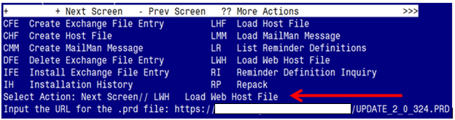

At the **Select Action:** prompt, enter **LWH** for Load Web Host File

At the **Input the url for the .prd file:** prompt, type the following web address:

**https://REDACTED /UPDATE_2_0_324.PRD**

You should see a message at the top of your screen that the file successfully loaded.

Terminal window screen shot of the message displaying the URL of the file that was successfully loaded.  Part of the URL has been redacted as it is a VA only internal web site URL.

Search for and locate the reminder exchange entry titled UPDATE_2_0_324 VA-MISC UPDATE 21.

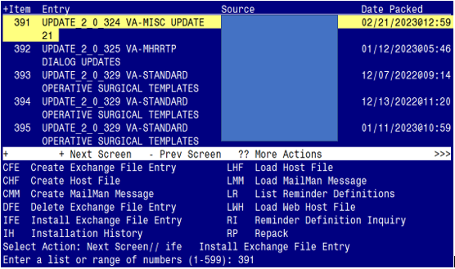

At the **Select Action** prompt, enter **IFE** for Install Exchange File Entry

Enter the number that corresponds with your entry titled **UPDATE_2_0_324 VA-MISC UPDATE 21** *(in this example it is entry 391, it will vary by site).* The exchange file date should be 02/21/2023@12:59.

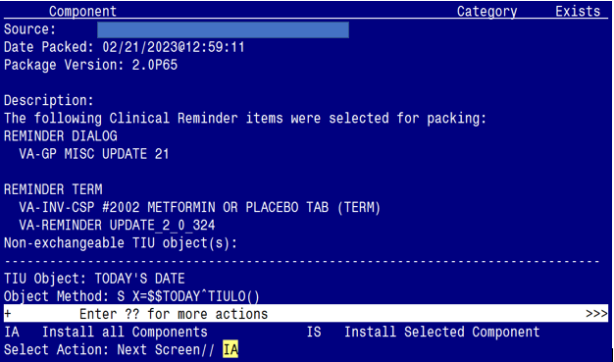

At the **Select Action** prompt, type **IA** for Install all Components and hit enter.

Select Action: Next Screen// IA Install all Components

**You will see several prompts**:

**Individual components for which you may (or may not) be prompted are listed below, along with the response you should provide.**

**I to Install:**

All new components

**Skip:**

**REMINDER DIALOG LINK TYPE:**

VA-PTSD POSITIVE WARM HANDOFF

**HEALTH FACTORS:**

VA-CRC HF CATEGORY [C]

PC-PTSD PCL (TIU)

**Overwrite:**

**TIU TEMPLATE FIELD:**

VA-PTSD PCL INFO

**HEALTH FACTORS:**

VA-MH-RRTP [C]

VA-ACUTE STROKE TRIAGE [C]

VA-VAAES URO CATH IND URETHRAL OTHER

VA-VAAES URO CATH IND URETHRAL DUAL

VA-VAAES URO CATH IND SECURED ABD RLQ

VA-VAAES URO CATH IND SECURED ABD LLQ

VA-VAAES URO CATH IND SECURED RIGHT LEG

VA-VAAES URO CATH IND SECURED LEFT LEG

VA-VAAES URO CATH IND DC SUPRAPUBIC

VA-VAAES URO CATH IND DC URETHRAL

VA-VAAES URO CATH INDWELL POA

**REMINDER TERM:**

VA-INV-CSP #2002 METFORMIN OR PLACEBO TAB(TERM)

**REMINDER DEFINITION:**

VA-BL NSG URINARY CATH SUPRAPUBIC DC

VA-BL NSG URINARY CATH URETHRAL DC

**HEALTH SUMMARY TYPE:**

VA-BL HIGH RISK FOR SUICIDE

OB PC-PTSD PCL

HST NSG URINE CATH SUPRAPUBIC

HST NSG URINE CATH URETHRAL

**HEALTH SUMMARY OBJECTS:**

HSO NSG URINE CATH SUPRAPUBIC

HSO NSG URINE CATH URETHRAL

(**Starting on the next page, each of the above components are listed individually**)

**Note: Any component NOT listed below (for which you may be prompted) should be skipped.**

REMINDER DIALOG LINK TYPE entry named **VA-PTSD POSITIVE WARM HANDOFF**

CHECK already exists but the packed component is different, what do

you want to do?

Select one of the following:

C Create a new entry by copying to a new name

O Overwrite the current entry

U Update

Q Quit the install

S Skip, do not install this entry

Enter response: O// Skip, do not install this entry

TIU TEMPLATE FIELD entry named **VA-PTSD PCL INFO** already exists but

the packed component is different, what do you want to do?

Select one of the following:

C Create a new entry by copying to a new name

O Overwrite the current entry

U Update

Q Quit the install

S Skip, do not install this entry

Enter response: O// verwrite the current entry

Are you sure you want to overwrite? N// Y

HEALTH FACTORS entry **VA-UPDATE_2_0_324** is NEW,

what do you want to do?

Select one of the following:

C Create a new entry by copying to a new name

I Install

Q Quit the install

S Skip, do not install this entry

Enter response: I// nstall

HEALTH FACTORS entry named **VA-MH-RRTP [C]** already exists but the

packed component is different, what do you want to do?

Select one of the following:

C Create a new entry by copying to a new name

O Overwrite the current entry

U Update

Q Quit the install

S Skip, do not install this entry

Enter response: O// verwrite the current entry

Are you sure you want to overwrite? N// Y

HEALTH FACTORS entry **VA-MH-RRTP DC MONTHLY INCOME NOT AVAIL** is NEW,

what do you want to do?

Select one of the following:

C Create a new entry by copying to a new name

I Install

Q Quit the install

S Skip, do not install this entry

Enter response: I// nstall

HEALTH FACTORS entry **VA-MH-RRTP EBP NONE** is NEW,

what do you want to do?

Select one of the following:

C Create a new entry by copying to a new name

I Install

Q Quit the install

S Skip, do not install this entry

Enter response: I// nstall

HEALTH FACTORS entry **VA-MH-RRTP EBP YES** is NEW,

what do you want to do?

Select one of the following:

C Create a new entry by copying to a new name

I Install

Q Quit the install

S Skip, do not install this entry

Enter response: I// nstall

HEALTH FACTORS entry **VA-MH-RRTP PTSD NON-MASD YES** is NEW,

what do you want to do?

Select one of the following:

C Create a new entry by copying to a new name

I Install

Q Quit the install

S Skip, do not install this entry

Enter response: I// nstall

HEALTH FACTORS entry **VA-MH-RRTP UPDATE ALT REFERRAL CC** is NEW,

what do you want to do?

Select one of the following:

C Create a new entry by copying to a new name

I Install

Q Quit the install

S Skip, do not install this entry

Enter response: I// nstall

HEALTH FACTORS entry **VA-MH-RRTP UPDATE ALT REFERRAL VA** is NEW,

what do you want to do?

Select one of the following:

C Create a new entry by copying to a new name

I Install

Q Quit the install

S Skip, do not install this entry

Enter response: I// nstall

HEALTH FACTORS entry named **VA-ACUTE STROKE TRIAGE [C]** already exists

but the packed component is different, what do you want to do?

Select one of the following:

C Create a new entry by copying to a new name

O Overwrite the current entry

U Update

Q Quit the install

S Skip, do not install this entry

Enter response: O// verwrite the current entry

Are you sure you want to overwrite? N// y YES.

HEALTH FACTORS entry **VA-ACUTE STROKE TRIAGE LKW > 4.5 HRS** is NEW,

what do you want to do?

Select one of the following:

C Create a new entry by copying to a new name

I Install

Q Quit the install

S Skip, do not install this entry

Enter response: I// nstall

HEALTH FACTORS entry **VA-ACUTE STROKE TRIAGE LKW W/IN 4.5 HRS** is NEW,

what do you want to do?

Select one of the following:

C Create a new entry by copying to a new name

I Install

Q Quit the install

S Skip, do not install this entry

Enter response: I// nstall

HEALTH FACTORS entry **VA-VAAES URO CATH IND URO OTHER ASSESS** is NEW,

what do you want to do?

Select one of the following:

C Create a new entry by copying to a new name

I Install

Q Quit the install

S Skip, do not install this entry

Enter response: I// nstall

HEALTH FACTORS entry **VA-VAAES URO CATH IND URO SURGERY ASSESS** is NEW,

what do you want to do?

Select one of the following:

C Create a new entry by copying to a new name

I Install

Q Quit the install

S Skip, do not install this entry

Enter response: I// nstall

HEALTH FACTORS entry **VA-VAAES URO CATH IND URO OBSTRUCTION ASSESS** is NEW,

what do you want to do?

Select one of the following:

C Create a new entry by copying to a new name

I Install

Q Quit the install

S Skip, do not install this entry

Enter response: I// nstall

HEALTH FACTORS entry **VA-VAAES URO CATH IND URO IRRIGATION ASSESS** is NEW,

what do you want to do?

Select one of the following:

C Create a new entry by copying to a new name

I Install

Q Quit the install

S Skip, do not install this entry

Enter response: I// nstall

HEALTH FACTORS entry **VA-VAAES URO CATH IND URO IMMOBILE ASSESS** is NEW,

what do you want to do?

Select one of the following:

C Create a new entry by copying to a new name

I Install

Q Quit the install

S Skip, do not install this entry

Enter response: I// nstall

HEALTH FACTORS entry **VA-VAAES URO CATH IND URO PERIOP ASSESS** is NEW,

what do you want to do?

Select one of the following:

C Create a new entry by copying to a new name

I Install

Q Quit the install

S Skip, do not install this entry

Enter response: I// nstall

HEALTH FACTORS entry **VA-VAAES URO CATH IND URO NEURO BLADDER ASSESS** is NEW,

what do you want to do?

Select one of the following:

C Create a new entry by copying to a new name

I Install

Q Quit the install

S Skip, do not install this entry

Enter response: I// nstall

HEALTH FACTORS entry **VA-VAAES URO CATH IND URO INCONT ASSESS** is NEW,

what do you want to do?

Select one of the following:

C Create a new entry by copying to a new name

I Install

Q Quit the install

S Skip, do not install this entry

Enter response: I// nstall

HEALTH FACTORS entry **VA-VAAES URO CATH IND URO EPI/SPI/PM ASSESS** is NEW,

what do you want to do?

Select one of the following:

C Create a new entry by copying to a new name

I Install

Q Quit the install

S Skip, do not install this entry

Enter response: I// nstall

HEALTH FACTORS entry **VA-VAAES URO CATH IND URO CRIT ILL ASSESS** is NEW,

what do you want to do?

Select one of the following:

C Create a new entry by copying to a new name

I Install

Q Quit the install

S Skip, do not install this entry

Enter response: I// nstall

HEALTH FACTORS entry **VA-VAAES URO CATH IND URO COMFORT ASSESS** is NEW,

what do you want to do?

Select one of the following:

C Create a new entry by copying to a new name

I Install

Q Quit the install

S Skip, do not install this entry

Enter response: I// nstall

HEALTH FACTORS entry **VA-VAAES URO CATH IND URO RET ASSESS** is NEW,

what do you want to do?

Select one of the following:

C Create a new entry by copying to a new name

I Install

Q Quit the install

S Skip, do not install this entry

Enter response: I// nstall

HEALTH FACTORS entry named **VA-VAAES URO CATH IND URETHRAL OTHER**

already exists but the packed component is different, what do you

want to do?

Select one of the following:

C Create a new entry by copying to a new name

O Overwrite the current entry

U Update

Q Quit the install

S Skip, do not install this entry

Enter response: O// verwrite the current entry

Are you sure you want to overwrite? N// Y

HEALTH FACTORS entry named **VA-VAAES URO CATH IND URETHRAL DUAL**

already exists but the packed component is different, what do you

want to do?

Select one of the following:

C Create a new entry by copying to a new name

O Overwrite the current entry

U Update

Q Quit the install

S Skip, do not install this entry

Enter response: O// verwrite the current entry

Are you sure you want to overwrite? N// Y

HEALTH FACTORS entry named **VA-VAAES URO CATH IND SECURED ABD RLQ**

already exists but the packed component is different, what do you

want to do?

Select one of the following:

C Create a new entry by copying to a new name

O Overwrite the current entry

U Update

Q Quit the install

S Skip, do not install this entry

Enter response: O// verwrite the current entry

Are you sure you want to overwrite? N// Y

HEALTH FACTORS entry named **VA-VAAES URO CATH IND SECURED ABD LLQ**

already exists but the packed component is different, what do you

want to do?

Select one of the following:

C Create a new entry by copying to a new name

O Overwrite the current entry

U Update

Q Quit the install

S Skip, do not install this entry

Enter response: O// verwrite the current entry

Are you sure you want to overwrite? N// Y

HEALTH FACTORS entry named **VA-VAAES URO CATH IND SECURED RIGHT LEG**

already exists but the packed component is different, what do you

want to do?

Select one of the following:

C Create a new entry by copying to a new name

O Overwrite the current entry

U Update

Q Quit the install

S Skip, do not install this entry

Enter response: O// verwrite the current entry

Are you sure you want to overwrite? N// Y

HEALTH FACTORS entry named **VA-VAAES URO CATH IND SECURED LEFT LEG**

already exists but the packed component is different, what do you

want to do?

Select one of the following:

C Create a new entry by copying to a new name

O Overwrite the current entry

U Update

Q Quit the install

S Skip, do not install this entry

Enter response: O// verwrite the current entry

Are you sure you want to overwrite? N// Y

HEALTH FACTORS entry **VA-VAAES CAUTI MAIN BUNDLE DAILY PERIURETHRAL HYGIENE** is NEW, what do you want to do?

Select one of the following:

C Create a new entry by copying to a new name

I Install

Q Quit the install

S Skip, do not install this entry

Enter response: I// nstall

HEALTH FACTORS entry **VA-VAAES CAUTI MAIN BUNDLE BAG EMPTIED IN CLEAN CONTAINER** is NEW, what do you want to do?

Select one of the following:

C Create a new entry by copying to a new name

I Install

Q Quit the install

S Skip, do not install this entry

Enter response: I// nstall

HEALTH FACTORS entry **VA-VAAES CAUTI MAIN BUNDLE CATH/COLLECT TUBE NO KINKS/OFF FLOOR** is NEW, what do you want to do?

Select one of the following:

C Create a new entry by copying to a new name

I Install

Q Quit the install

S Skip, do not install this entry

Enter response: I// nstall

HEALTH FACTORS entry **VA-VAAES CAUTI MAIN BUNDLE BAG BELOW LEVEL OF BLADDER/OFF FLOOR** is NEW, what do you want to do?

Select one of the following:

C Create a new entry by copying to a new name

I Install

Q Quit the install

S Skip, do not install this entry

Enter response: I// nstall

HEALTH FACTORS entry **VA-VAAES CAUTI MAIN BUNDLE MAINTAIN CLOSED DRAINAGE SYSTEM** is NEW, what do you want to do?

Select one of the following:

C Create a new entry by copying to a new name

I Install

Q Quit the install

S Skip, do not install this entry

Enter response: I// nstall

HEALTH FACTORS entry named **VA-VAAES URO CATH IND DC SUPRAPUBIC**

already exists but the packed component is different, what do you

want to do?

Select one of the following:

C Create a new entry by copying to a new name

O Overwrite the current entry

U Update

Q Quit the install

S Skip, do not install this entry

Enter response: O// verwrite the current entry

Are you sure you want to overwrite? N// Y

HEALTH FACTORS entry named **VA-VAAES URO CATH IND DC URETHRAL** already

exists but the packed component is different, what do you want to do?

Select one of the following:

C Create a new entry by copying to a new name

O Overwrite the current entry

U Update

Q Quit the install

S Skip, do not install this entry

Enter response: O// verwrite the current entry

Are you sure you want to overwrite? N// Y

HEALTH FACTORS entry named **VA-VAAES URO CATH INDWELL POA** already

exists but the packed component is different, what do you want to do?

Select one of the following:

C Create a new entry by copying to a new name

O Overwrite the current entry

U Update

Q Quit the install

S Skip, do not install this entry

Enter response: O// verwrite the current entry

Are you sure you want to overwrite? N// Y

HEALTH FACTORS entry **VA-VAAES URO CATH INDWELL INSERT IN ANOTHER LOCATION/PROCEDURE** is NEW, what do you want to do?

Select one of the following:

C Create a new entry by copying to a new name

I Install

Q Quit the install

S Skip, do not install this entry

Enter response: I// nstall

HEALTH FACTORS entry **VA-VAAES URO CATH IND URO OTHER INSERT** is NEW,

what do you want to do?

Select one of the following:

C Create a new entry by copying to a new name

I Install

Q Quit the install

S Skip, do not install this entry

Enter response: I// nstall

HEALTH FACTORS entry **VA-VAAES URO CATH IND URO SURGERY INSERT** is NEW,

what do you want to do?

Select one of the following:

C Create a new entry by copying to a new name

I Install

Q Quit the install

S Skip, do not install this entry

Enter response: I// nstall

HEALTH FACTORS entry **VA-VAAES URO CATH IND URO OBSTRUCTION INSERT** is NEW,

what do you want to do?

Select one of the following:

C Create a new entry by copying to a new name

I Install

Q Quit the install

S Skip, do not install this entry

Enter response: I// nstall

HEALTH FACTORS entry **VA-VAAES URO CATH IND URO IRRIGATION INSERT** is NEW,

what do you want to do?

Select one of the following:

C Create a new entry by copying to a new name

I Install

Q Quit the install

S Skip, do not install this entry

Enter response: I// nstall

HEALTH FACTORS entry **VA-VAAES URO CATH IND URO IMMOBILE INSERT** is NEW,

what do you want to do?

Select one of the following:

C Create a new entry by copying to a new name

I Install

Q Quit the install

S Skip, do not install this entry

Enter response: I// nstall

HEALTH FACTORS entry **VA-VAAES URO CATH IND URO PERIOP INSERT** is NEW,

what do you want to do?

Select one of the following:

C Create a new entry by copying to a new name

I Install

Q Quit the install

S Skip, do not install this entry

Enter response: I// nstall

HEALTH FACTORS entry **VA-VAAES URO CATH IND URO NEURO BLADDER INSERT** is NEW,

what do you want to do?

Select one of the following:

C Create a new entry by copying to a new name

I Install

Q Quit the install

S Skip, do not install this entry

Enter response: I// nstall

HEALTH FACTORS entry **VA-VAAES URO CATH IND URO INCONT INSERT** is NEW,

what do you want to do?

Select one of the following:

C Create a new entry by copying to a new name

I Install

Q Quit the install

S Skip, do not install this entry

Enter response: I// nstall

HEALTH FACTORS entry **VA-VAAES URO CATH IND URO EPI/SPI/PM INSERT** is NEW,

what do you want to do?

Select one of the following:

C Create a new entry by copying to a new name

I Install

Q Quit the install

S Skip, do not install this entry

Enter response: I// nstall

HEALTH FACTORS entry **VA-VAAES URO CATH IND URO CRIT ILL INSERT** is NEW,

what do you want to do?

Select one of the following:

C Create a new entry by copying to a new name

I Install

Q Quit the install

S Skip, do not install this entry

Enter response: I// nstall

HEALTH FACTORS entry **VA-VAAES URO CATH IND URO COMFORT INSERT** is NEW,

what do you want to do?

Select one of the following:

C Create a new entry by copying to a new name

I Install

Q Quit the install

S Skip, do not install this entry

Enter response: I// nstall

HEALTH FACTORS entry **VA-VAAES URO CATH IND URO RET INSERT** is NEW,

what do you want to do?

Select one of the following:

C Create a new entry by copying to a new name

I Install

Q Quit the install

S Skip, do not install this entry

Enter response: I// nstall

HEALTH FACTORS entry **VA-VAAES URO CATH IND STER FLD GLOVES** is NEW,

what do you want to do?

Select one of the following:

C Create a new entry by copying to a new name

I Install

Q Quit the install

S Skip, do not install this entry

Enter response: I// nstall

HEALTH FACTORS entry **VA-HRS PRF CARING COMM NO OPT OUT** is NEW,

what do you want to do?

Select one of the following:

C Create a new entry by copying to a new name

I Install

Q Quit the install

S Skip, do not install this entry

Enter response: I// nstall

REMINDER SPONSOR entry **VA COOPERATIVE STUDIES PROGRAM** is NEW,

what do you want to do?

Select one of the following:

C Create a new entry by copying to a new name

I Install

Q Quit the install

S Skip, do not install this entry

Enter response: I// nstall

REMINDER TERM entry **VA-REMINDER UPDATE_2_0_324** is NEW,

what do you want to do?

Select one of the following:

C Create a new entry by copying to a new name

I Install

Q Quit the install

S Skip, do not install this entry

Enter response: I// nstall

REMINDER TERM entry named **VA-INV-CSP #2002 METFORMIN OR PLACEBO TAB**

**(TERM)** already exists but the packed component is different, what do

you want to do?

Select one of the following:

C Create a new entry by copying to a new name

M Merge findings

O Overwrite the current entry

U Update

Q Quit the install

S Skip, do not install this entry

Enter response: O// verwrite the current entry

Are you sure you want to overwrite? N// Y

REMINDER DEFINITION entry named **VA-BL NSG URINARY CATH SUPRAPUBIC DC**

already exists but the packed component is different, what do you

want to do?

Select one of the following:

C Create a new entry by copying to a new name

O Overwrite the current entry

U Update

Q Quit the install

S Skip, do not install this entry

Enter response: O// verwrite the current entry

Are you sure you want to overwrite? N// Y

REMINDER DEFINITION entry named **VA-BL NSG URINARY CATH URETHRAL DC**

already exists but the packed component is different, what do you

want to do?

Select one of the following:

C Create a new entry by copying to a new name

O Overwrite the current entry

U Update

Q Quit the install

S Skip, do not install this entry

Enter response: O// o Overwrite the current entry

Are you sure you want to overwrite? N// Y

HEALTH SUMMARY TYPE entry named **VA-BL HIGH RISK FOR SUICIDE** already

exists but the packed component is different, what do you want to do?

Select one of the following:

C Create a new entry by copying to a new name

O Overwrite the current entry

U Update

Q Quit the install

S Skip, do not install this entry

Enter response: O// verwrite the current entry

Are you sure you want to overwrite? N// Y

HEALTH SUMMARY TYPE entry named **OB PC-PTSD PCL** already exists but the

packed component is different, what do you want to do?

Select one of the following:

C Create a new entry by copying to a new name

O Overwrite the current entry

U Update

Q Quit the install

S Skip, do not install this entry

Enter response: O// verwrite the current entry

Are you sure you want to overwrite? N// Y

HEALTH SUMMARY TYPE entry named **HST NSG URINE CATH SUPRAPUBIC** already

exists but the packed component is different, what do you want to do?

Select one of the following:

C Create a new entry by copying to a new name

O Overwrite the current entry

U Update

Q Quit the install

S Skip, do not install this entry

Enter response: O// verwrite the current entry

Are you sure you want to overwrite? N// Y

HEALTH SUMMARY TYPE entry named **HST NSG URINE CATH URETHRAL** already

exists but the packed component is different, what do you want to do?

Select one of the following:

C Create a new entry by copying to a new name

O Overwrite the current entry

U Update

Q Quit the install

S Skip, do not install this entry

Enter response: O// verwrite the current entry

Are you sure you want to overwrite? N// Y

HEALTH SUMMARY OBJECTS entry named **HSO NSG URINE CATH SUPRAPUBIC**

already exists but the packed component is different, what do you

want to do?

Select one of the following:

C Create a new entry by copying to a new name

O Overwrite the current entry

U Update

Q Quit the install

S Skip, do not install this entry

Enter response: O// verwrite the current entry

Are you sure you want to overwrite? N// Y

HEALTH SUMMARY OBJECTS entry named **HSO NSG URINE CATH URETHRAL**

already exists but the packed component is different, what do you

want to do?

Select one of the following:

C Create a new entry by copying to a new name

O Overwrite the current entry

U Update

Q Quit the install

S Skip, do not install this entry

Enter response: O// verwrite the current entry

Are you sure you want to overwrite? N// Y

**You will be promped to install the dialog component:**

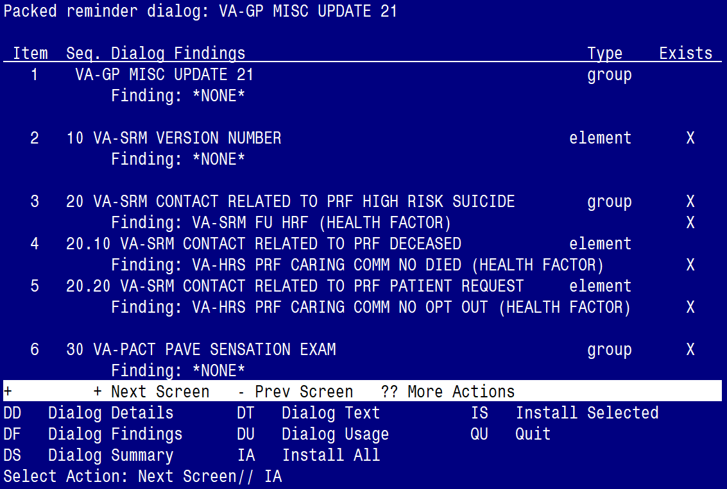

At the **Select Action** prompt, type **IA** to install the dialog – **VA-GP MISC UPDATE 21**

Select Action: Next Screen// IA Install All

Install reminder dialog and all components with no further changes: Y// ES

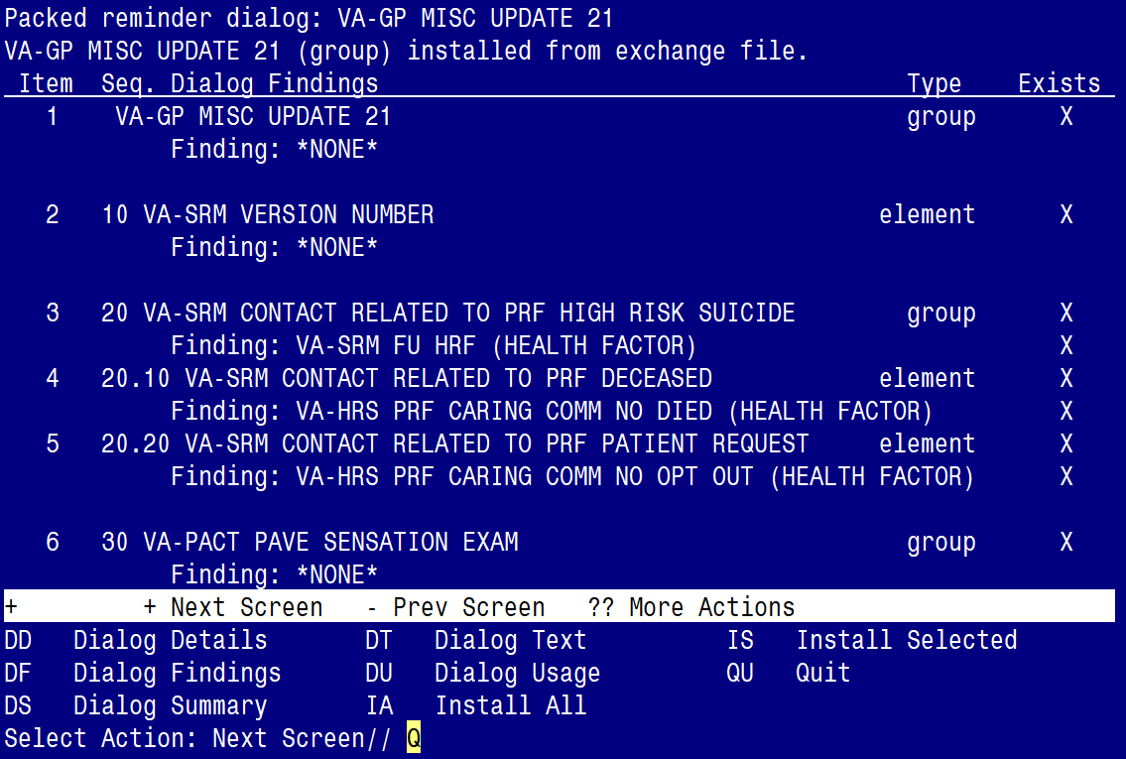

When the dialog has completed installation, you will then be returned to this screen. At the **Select Action** prompt, type **Q.**

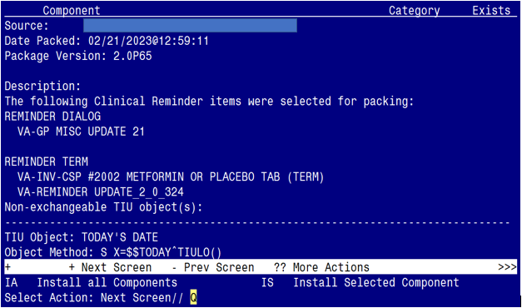

You will be returned to this screen. Type Q to quit.

Install Completed

# Post Installation

There are no post-Installation steps to complete for this Update.