

**Update_2_0_335**

Clinical Reminders

VA-PERSONAL HEALTH INVENTORY (PHI) NOTE UPDATE

Install Guide

**January 2023**

Product Development

Office of Information Technology

Department of Veterans Affairs

Table of Contents

Introduction 1

Install Details 3

Install Example 3

Post Installation 6

# Introduction

*BACKGROUND*

*The Personal Health Inventory (PHI) is a tool providers may use to explore with their patients what matters to them, and assess where they are and where they want to be in eight areas of self-care from the Circle of Health. VHA Office of Patient-Centered Care and Cultural Transformation has partnered with the National Template Workgroup to update the national reminder dialogue template for the PHI, for use with Veterans as a part of the Whole Health approach to care. For a more in-depth explanation of the Circle of Health, please visit* [*https://www.va.gov/WHOLEHEALTH/circle-of-health/index.asp*](https://gcc02.safelinks.protection.outlook.com/?url=https%3A%2F%2Fwww.va.gov%2FWHOLEHEALTH%2Fcircle-of-health%2Findex.asp&data=04%7C01%7C%7Ca4245c3fc8c24e490c6f08da05f4cd27%7Ce95f1b23abaf45ee821db7ab251ab3bf%7C0%7C0%7C637828846209232297%7CUnknown%7CTWFpbGZsb3d8eyJWIjoiMC4wLjAwMDAiLCJQIjoiV2luMzIiLCJBTiI6Ik1haWwiLCJXVCI6Mn0%3D%7C3000&sdata=yR2O6KMo9EaQVV9PMkRh1oOGCWb3KzQuS3l4U4YqrHE%3D&reserved=0)

What has changed?

To improve the end-user experience with the PHI, this update changes how numeric fields are entered in order to make the completion of the note faster. The health factors used in the sections “Self-reflection scales” and “Where you are and where you’d like to be” sections are being updated to indicate they represent a numeric value between 1 and 5. This will make sure that users only enter numeric results.  It also streamlines the template and progress note output.

BEFORE example, entry was not restricted to number only, there were additional lines in the progress note (this is just one example, every item in this section was updated):

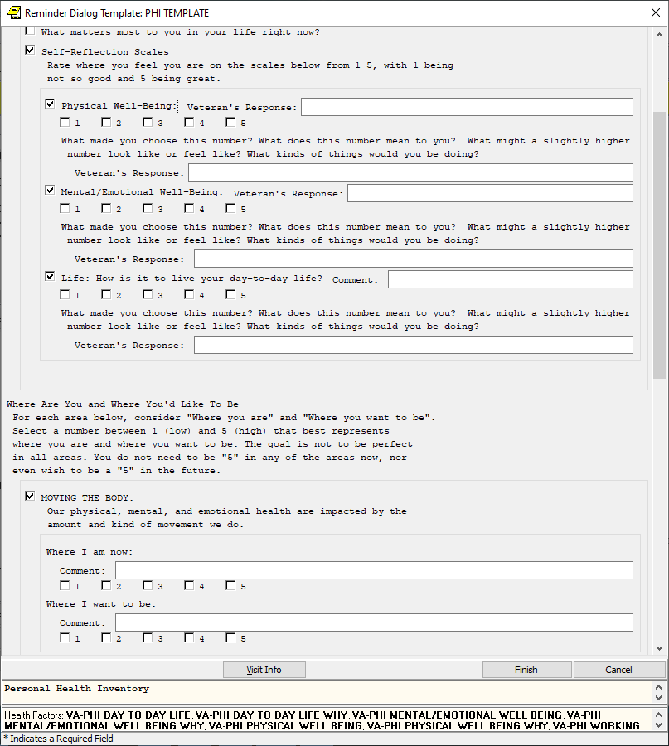

**Before, progress note example:**

Where Are You and Where You'd Like To Be

(Patient rating from 1-5,

with 1=low and 5=high that best represents

where patient is and where patient wants to be.)

-----------------------------

MOVING THE BODY:

Where I am now:

Comment: 3 additional text can be added here

Where I want to be:

Comment: 3

After example, the fields require a numeric response, the note is easier to read (this is just one example, every item in this section was updated)::

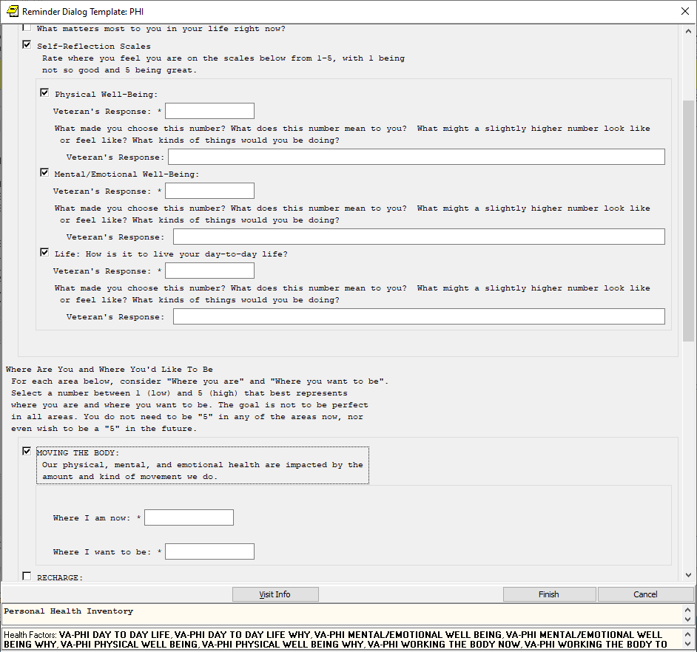

**After progress note example:**

Where Are You and Where You'd Like To Be

(Patient rating from 1-5,

with 1=low and 5=high that best represents

where patient is and where patient wants to be.)

-----------------------------

MOVING THE BODY:

Where I am now: 3

Where I want to be: 3

**UPDATE_2_0_335 contains 1 Reminder Exchange entry:**

UPDATE_2_0_335 VA-PERSONAL HEALTH INVENTORY (PHI) NOTE UPDATE

**The exchange file contains the following components:**

**HEALTH FACTORS**

VA-REMINDER UPDATES [C]

VA-UPDATE_2_0_335

VA-PERSONAL HEALTH INVENTORY [C]

VA-PHI REFLECTIONS AREAS TO WORK ON

VA-PHI REFLECTIONS VISION BEST SELF

VA-PHI PROFESSIONAL CARE TO BE

VA-PHI PROFESSIONAL CARE NOW

VA-PHI POWER OF MIND TO BE

VA-PHI POWER OF MIND NOW

VA-PHI SURROUNDINGS TO BE

VA-PHI SURROUNDINGS NOW

VA-PHI SPIRIT AND SOUL TO BE

VA-PHI SPIRIT AND SOUL NOW

VA-PHI FAMILY AND FRIENDS TO BE

VA-PHI FAMILY AND FRIENDS NOW

VA-PHI PERSONAL DEVELOPMENT TO BE

VA-PHI PERSONAL DEVELOPMENT NOW

VA-PHI FOOD AND DRINK TO BE

VA-PHI FOOD AND DRINK NOW

VA-PHI RECHARGE TO BE

VA-PHI RECHARGE NOW

VA-PHI WORKING THE BODY TO BE

VA-PHI WORKING THE BODY NOW

VA-PHI DAY TO DAY LIFE WHY

VA-PHI DAY TO DAY LIFE

VA-PHI PHYSICAL WELL BEING WHY

VA-PHI PHYSICAL WELL BEING

VA-PHI MENTAL/EMOTIONAL WELL BEING WHY

VA-PHI MENTAL/EMOTIONAL WELL BEING

VA-PHP [C]

VA-PHP MAP

**REMINDER SPONSOR**

OFFICE OF PATIENT CENTERED CARE AND CULTURAL TRANSFORMATION

**REMINDER TERM**

VA-REMINDER UPDATE_2_0_335

**REMINDER DIALOG**

VA-PERSONAL HEALTH INVENTORY (PHI) NOTE

# Install Details

This update is being distributed as a web host file. The address for the host file is: **https://REDACTED/UPDATE_2_0_335.PRD**

The file will be installed using Reminder Exchange, programmer access is not required.

Installation:

=============

This update can be loaded with users on the system. Installation will take less than 2 minutes.

# Install Example

To Load the Web Host File. Navigate to Reminder exchange in Vista

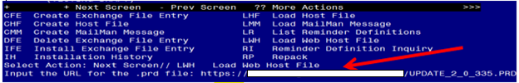

At the **Select Action:** prompt, enter **LWH** for Load Web Host File

At the **Input the url for the .prd file:** prompt, type the following web address:

You should see a message at the top of your screen that the file successfully loaded. **https://REDACTED /UPDATE_2_0_335.PRD**

Search and locate an entry titled **UPDATE_2_0_335 VA-PERSONAL HEALTH INVENTORY (PHI) NOTE UPDATE** in reminder exchange

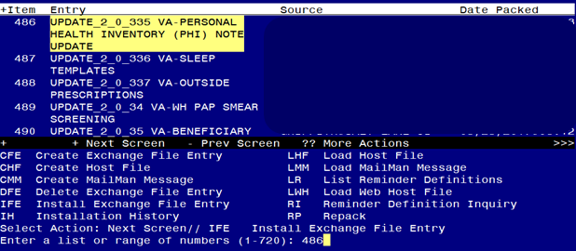

At the **Select Action** prompt, enter **IFE** for Install Exchange File Entry

Enter the number that corresponds with your entry titled **UPDATE_2_0_335 VA-PERSONAL HEALTH INVENTORY (PHI) NOTE UPDATE** *(in this example it is entry 486, it will vary by site) The exchange file date should be 01/12/2023.*

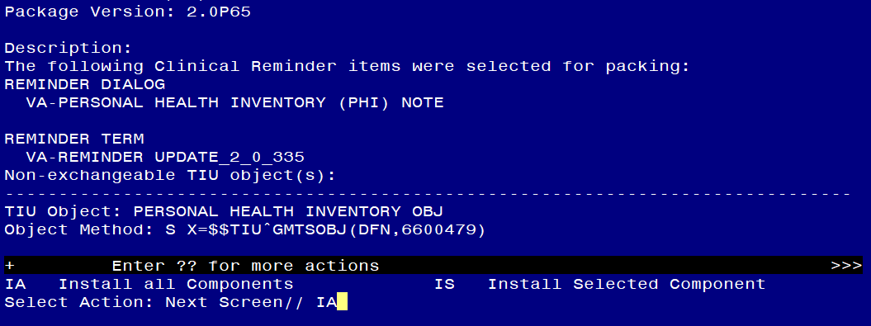

At the **Select Action** prompt, type **IA** for Install all Components and hit enter.

Select Action: Next Screen// IA Install all Components

During the installation, you will see several prompts: *Note that you will Install all new components* If you are prompted to overwrite any items, choose OVERWRITE.

***The health factors MUST be overwritten for the template to work properly.***

**You will be promped to install the dialog component, you should Install All even though all components will have an X in the “Exists” column:**

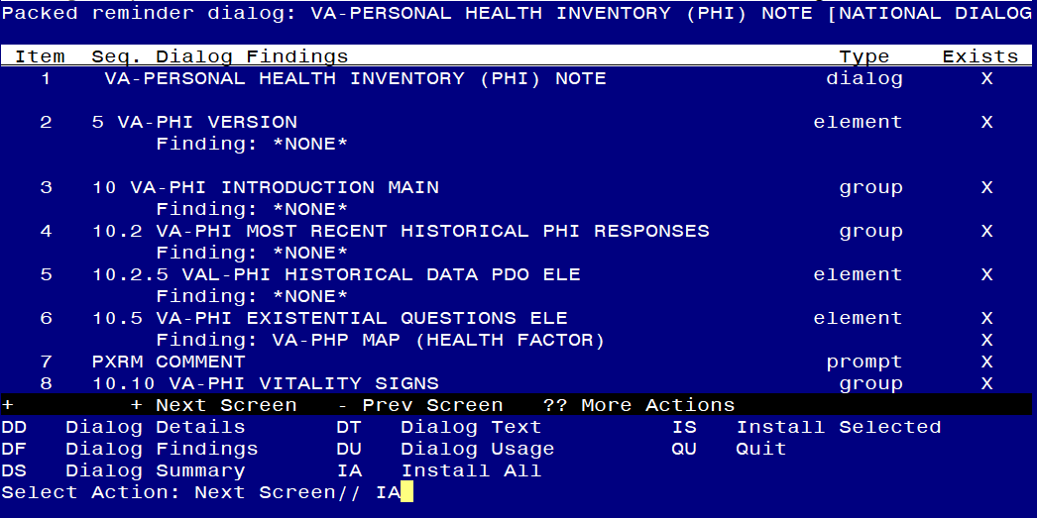

At the **Select Action** prompt, type **IA** to install the dialog – **VA-PERSONAL HEALTH INVENTORY (PHI) NOTE**

Select Action: Next Screen// IA Install All

Install reminder dialog and all components with no further changes: Y// ES

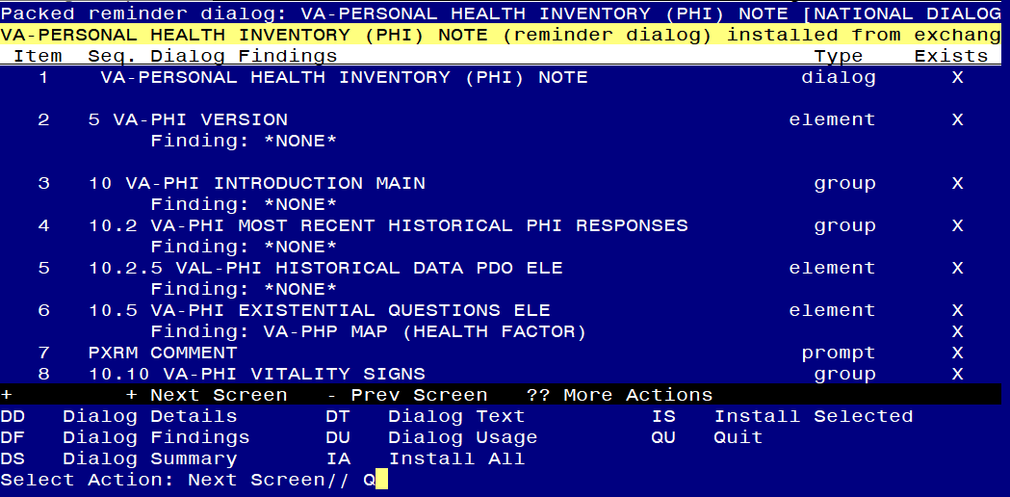

When the dialog has completed installation, you will then be returned to this screen. At the **Select Action** prompt, type **Q.**

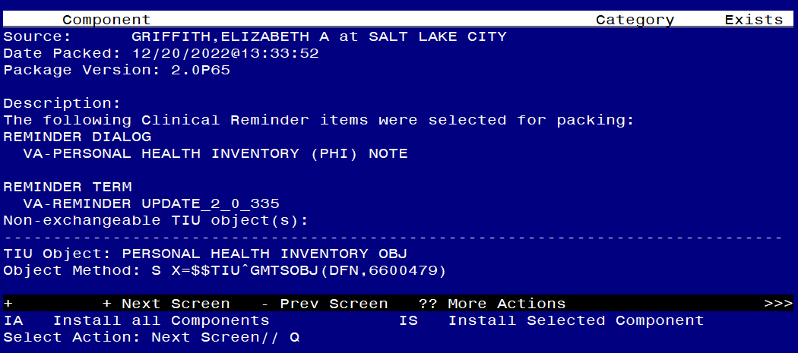

You will be returned to this screen. Type Q to quit.

Install Completed

# Post Installation

1. **Open the note titled PERSONAL HEALTH INVENTORY NOTE (Reminder dialog VA-PERSONAL HEALTH INVENTORY (PHI) NOTE) and confirm the version is 3.1.**