

**Update_2_0_348**

Clinical Reminders

VA-OSP CSRE UPDATES

Install Guide

**March 2023**

Product Development

Office of Information Technology

Department of Veterans Affairs

**Table of Contents**

Introduction 1

Pre-Install 12

Install Details 13

Install Example 13

Post Installation 16

# Introduction

The Under Secretary for Health ensures clinician completion of comprehensive suicide risk evaluations including the discussion and documentation of firearms access and safe storage as required, and monitors compliance. The proposed modifications to the CSRE allows for alignment with Joint Commission requirements and Office of Inspector General required action items for compliance. Additionally, modifications to formatting are to enhance flow of clinical evaluation and documentation for users.

|  |  |
| --- | --- |
| **Update** | **Rationale** |
| Added “Unable to Complete CSRE” section | Allows users to clearly document:   * Reason CSRE could not be completed * Efforts made to attempt completion * Risk mitigation plan for acute risk concerns * Follow-up plan for CSRE and mental health support, if indicated |
| Changes to lethal means assessment and risk mitigation | * More clearly differentiates and requires specific assessment and documentation of firearms access vs. other lethal means * Risk mitigation now includes space to document lethal means safety counseling for lethal means other than firearm. |
| Added historical self-harm behaviors with unknown intent | * Ease user review of previously reported potential suicidal behavior by pulling in data about behaviors reported in prior CSREs and SBORs where “unknown” intent was selected. |
| Suicidal behaviors via overdose section expanded | * Improve risk mitigation by expanding assessment of overdose to clarify if attempt involved opioid and/or stimulants and if naloxone was used to align with Naloxone Memorandum and CSRE overdose OEND sections to align with the SBOR. |
| Risk mitigation strategies reorganized | * Ease user identification of both general and setting specific risk mitigation strategies by requiring setting selection and including all relevant strategies in that setting’s menu. * Similar items are also clustered together to improve flow (e.g., acute risk response, environmental considerations, treatment and discharge planning) |
| Required item to improve use of National HRS-PRF consult | * Improve user compliance with submission of indicated HRS-PRF consults to local SPCs by including text describing when a HRS-PRF consult is mandated and requiring a yes or no response. * Local CACs will be instructed to attach the National HRS-PRF consult to this item. |
| Opioid Overdose Education and Naloxone Distribution (OEND) section expanded | * Facilitate effective use of OEND strategies via embedded text and links to educational materials to align with Naloxone Memorandum and CSRE overdose OEND sections to align with the SBOR. |

Additional information is available in the REDACTED.

**UPDATE_2_0_348 contains 1 Reminder Exchange entry:**

UPDATE_2_0_348 VA-OSP CSRE UPDATES

**The exchange file contains the following components:**

**TIU TEMPLATE FIELD**

VA SP 3 LINES

VA-SUICIDE ATTEMPT DESCRIBE

VA-OSP LMS LINK

VA-OPIOID NALOXONE AUTO

VA-OPIOID NALOXONE NASAL

VA-OPIOID INTRO TO NALOXONE DISORDER

VA-OPIOID INTRO TO NALOXONE PRESCRIBE

VA-NALOXONE PATIENT GUIDE

VA-OSP OEND SHAREPOINT

TEXT (6 CHAR)

VA-OSP SP RISK MGMT

VA-OSP SRM CONSULT EMAIL

VA-OSP WARNING SIGNS

VA-OSP CRISTAL

VA SP 3 LINES R

VA-OSP PRIOR ATTEMPTS

VA-OSP CSRE GUIDE LINK

**HEALTH FACTORS**

VA-REMINDER UPDATES [C]

VA-UPDATE_2_0_348

VA-SUICIDE RISK ASSESSMENT [C]

VA-SUICIDE ACCESS LETHAL MNS-FIREARM UNKNOWN

OTHER REASON

VA-SUICIDE ACCESS LETHAL MNS-FIREARM UNKNOWN VET

UNABLE ANSWER

VA-SUICIDE ACCESS LETHAL MNS-FIREARM UNKNOWN VET

DECLINES

VA-SUICIDE ACCESS TO LETHAL MNS - FIREARM UNKNOWN

VA-SUICIDE ACCESS TO LETHAL MNS - NO FIREARM

VA-SUICIDE ACCESS TO LETHAL MNS FIREARM

VA-SUICIDE ACCESS LETHAL MNS-OTHER MNS UNKNOWN

OTHER REASON

VA-SUICIDE ACCESS LETHAL MNS-OTHER MNS UNKNOWN

VET UNABLE ANSWER

VA-SUICIDE ACCESS LETHAL MNS-OTHER MNS UNKNOWN

VET DECLINES

VA-SUICIDE ACCESS TO LETHAL MNS - OTHER LETHAL

MEANS UNKNOWN

VA-SUICIDE ACCESS TO LETHAL MNS - NO OTHER LETHAL

MEANS

VA-SUICIDE ACCESS TO LETHAL MEANS OTHER

VA-SUICIDE THOUGHTS UNKNOWN

VA-SUICIDE THOUGHTS NEVER

VA-SUICIDAL INTENT UNKNOWN

VA-SUICIDAL INTENT YES

VA-SUICIDAL INTENT NO

VA-SUICIDE PLAN UNKNOWN

VA-SUICIDE PLAN YES

VA-SUICIDE PLAN NO

VA-SUICIDE THOUGHTS MORE THAN 91 DAYS

VA-SUICIDE THOUGHTS WI 31 TO 90 DAYS

VA-SUICIDAL IDEATION SEVERE LAST 30D UNK

VA-SUICIDAL PLAN WITH IDEATION UNKNOWN

VA-SUICIDAL PLAN WITH IDEATION YES

VA-SUICIDAL PLAN WITH IDEATION NO

VA-SUICIDAL INTENT WITH IDEATION UNKNOWN

VA-SUICIDAL INTENT WITH IDEATION NO

VA-SUICIDAL INTENT WITH IDEATION YES

VA-SUICIDAL IDEATION SEVERE LAST 30D NO

VA-SUICIDAL IDEATION SEVERE LAST 30D YES

VA-SUICIDE THOUGHTS WI 30 DAYS

VA-SUICIDE THOUGHTS WI 24 HRS

VA-SUICIDE ACTION OBTAIN INFORMATION

VA-SUICIDE ACTION VET UNABLE TO FOLLOW UP

VA-SUICIDE ACTION FOLLOW-UP DECLINE

VA-SUICIDE ACTION INFORM FOLLOW-UP

VA-SUICIDE ACTION SAFETY PLAN

VA-SUICIDE ACTION CONNECT WITH PEER SPECIALIST

VA-SUICIDE ACTION INCREASE CONTACT

VA-SUICIDE ACTION ASSIGN BDRM CLOSE STN

VA-SUICIDE ACTION OTHER

VA-SUICIDE ACTION PROVIDE BENEFITS INFO

VA-SUICIDE ACTION PHONE APP

VA-SUICIDE ACTION EDUCATE EMER SERVICES

VA-SUICIDE ACTION PROVIDE CRISISLINE

VA-SUICIDE ACTION HOMELESS PROGRAM CONSULT

VA-SUICIDE ACTION REF PSYCHIATRY MED

VA-SUICIDE ACTION RESID CONSULT

VA-SUICIDE ACTION SMI CONSULT

VA-SUICIDE ACTION VOC REHAB CONSULT

VA-SUICIDE ACTION REFER CHAPLAIN

VA-SUICIDE ACTION REFER PSYCHOTHERAPY

VA-SUICIDE ACTION REFER OTHER

VA-SUICIDE ACTION SP2.0 CLINICAL TELEHEALTH

VA-SUICIDE ACTION INVOLVE FAMILY

VA-SUICIDE ACTION DISCUSS WAYS TO INCREASE

CONNECTION

VA-SUICIDE ACTION ADDRESS PSYCH NEEDS

VA-SUICIDE ACTION BEHAV ACTIVATION IP

VA-SUICIDE ACTION DISCUSS PURPOSE

VA-SUICIDE ACTION ADDRESS BARRIERS

VA-SUICIDE ACTION MONITOR UDS

VA-SUICIDE ACTION PHARMACOTHERAPY

VA-SUICIDE ACTION ADDRESS MED CONDITIONS

VA-NALOXONE [C]

VA-NALOXONE RX OTHER

VA-HAS NALOXONE RX

VA-PATIENT DECLINED NALOXONE

VA-NALOXONE RX REQUEST PROVIDER NOTIFIED

VA-NALOXONE RX ORDERED

VA-NALOXONE ED-TEACH BACK

VA-NALOXONE RESOURCES-OTHER

VA-NALOXONE VIDEO-AUTO-INJECTOR

VA-NALOXONE VIDEO-SPRAY

VA-NALOXONE VIDEO-OUD

VA-NALOXONE VIDEO-RX OPIOIDS

VA-NALOXONE ED TO CAREGIVER OR OTHER

VA-NALOXONE ED TO PATIENT

VA-SUICIDE ACTION PROVIDE OEND EDUCATION

VA-SUICIDE ACTION PROVIDE OTHER LETHAL MEANS

SAFETY COUNSELING

VA-SUICIDE ACTION PROVIDE GUN LOCK

VA-SUICIDE ACTION SAFETY COUNSEL

VA-SUICIDE ACTION INCREASE ROUNDING RT

VA-SUICIDE ACTION INITIATE UNIT PROTOCOL

VA-SUICIDE ACTION INITIATE HOSPITAL TRANSPORT PLAN

VA-SUICIDE ACTION INVOLUNTARY HOSPITAL

VA-SUICIDE ACTION VOLUNTARY HOSPITAL

VA-SUICIDE ACTION REVIEW PERSONAL ITEMS

VA-SUICIDE ACTION SAFE OBS

VA-SUICIDE ACTION ARMS REACH OBSERV

VA-SUICIDE ACTION LINE OF SIGHT MONITOR

VA-SUICIDE ACTION NO ALERT SPC

VA-SUICIDE ACTION ALERT SPC

VA-CSRE ENVIRONMENT ED/UC

VA-SUICIDE ACTION HR 4 APPTS REMIND

VA-SUICIDE ACTION HIGH RISK 4 APPTS

VA-SUICIDE ACTION HR 3 MH REMIND

VA-SUICIDE ACTION HIGH RISK 3 MH VISITS

VA-SUICIDE ACTION REVIEW ITEMS AVAILABLE

VA-SUICIDE ACTION RECOVERY PLAN

VA-SUICIDE ACTION INCREASE RISK SCREEN

VA-SUICIDE ACTION ADMISSION BEDROOM MONI

VA-SUICIDE ACTION REQUIRE CHECK IN

VA-CSRE ENVIRONMENT INPATIENT

VA-SUICIDE ACTION DEPENDENT MEDS MANAGE

VA-SUICIDE ACTION 2 APPOINTMENTS

VA-SUICIDE ACTION CONNECT WITH PEER SPECIALIST

REC BUDDY

VA-SUICIDE ACTION INCREASE THERAPY

VA-SUICIDE ACTION REVIEW PASSES

VA-SUICIDE ACTION LIMIT POV ACCESS

VA-SUICIDE ACTION SEMI INDEPENDENT MEDS MANAGE

VA-SUICIDE ACTION ADMISSION BEDROOM ASSE

VA-SUICIDE ACTION ITEM CALL 911

VA-SUICIDE ACTION ONE ON ONE

VA-CSRE ENVIRONMENT RESIDENTIAL

VA-SUICIDE ACTION FOLLOW APPOINTMENT

VA-SUICIDE ACTION BEHAV ACTIVATION INFO

VA-CSRE ENVIRONMENT OUTPATIENT

VA-TREATMENT PLAN COLLABORATION PROVIDER

VA-TREATMENT PLAN COLLABORATION GUARDIAN

VA-TREATMENT PLAN COLLABORATION FAMILY

VA-TREATMENT PLAN COLLABORATION VETERAN

VA-SUICIDE RISK CHRONIC LOW

VA-SUICIDE RISK CHRONIC INTERMEDIATE

VA-SUICIDE RISK CHRONIC HIGH

VA-SUICIDE RISK ACUTE LOW

VA-SUICIDE RISK ACUTE INTERMEDIATE

VA-SUICIDE RISK ACUTE HIGH

VA-SUICIDE PROTECTIVE FACTORS [C]

VA-SUICIDE PF NONE

VA-SUICIDE PF UNKNOWN

VA-SUICIDE PF DESIRE TO LIVE

VA-SUICIDE PF HOPE FOR FUTURE

VA-SUICIDE PF ACCESS TO MH CARE

VA-SUICIDE PF MOTIVATION FOR MH TX

VA-SUICIDE PF INTERPERSONAL RELATION

VA-SUICIDE PF SIGNIFICANT OTHER

VA-SUICIDE PF HAS RESPONSIBILITIES

VA-SUICIDE PF POS BELIEFS

VA-SUICIDE PF RELIGIOUS BELIEFS

VA-SUICIDE PF CONNECTION TO CULTURE

VA-SUICIDE PF OTHER

VA-SUICIDE PF SOCIAL SUPPORT

VA-SUICIDE PF MOTIVATION FOR MED TX

VA-SUICIDE PF ACCESS TO HEALTH CARE

VA-SUICIDE RISK FACTORS [C]

VA-SUICIDE RISK NONE

VA-SUICIDE RISK UNKNOWN

VA-SUICIDE RISK TRANS FROM MILITARY

VA-SUICIDE RISK MINORITY GROUP

VA-SUICIDE RISK PREEXISTING FACTORS

VA-SUICIDE RISK MED CONDITIONS

VA-SUICIDE RISK LOSSES

VA-SUICIDE RISK HX OF SELF VIOLENCE

VA-SUICIDE RISK PSYCH CONDITIONS

VA-SUICIDE RISK HX OF PSYCH HOSPITAL

VA-SUICIDE RISK ACCESS TO LETHAL MEANS

VA-SUICIDE RISK RECENT STRESSORS

VA-SUICIDE RISK HX OF SUICIDE ATTEMPT

VA-SUICIDE RISK OTHER

VA-SUICIDE RISK HOMELESSNESS

VA-SUICIDE RISK SOCIAL PROBLEMS

VA-SUICIDE RISK LEGAL PROBLEMS

VA-SUICIDE RISK FINANCE PROBLEMS

VA-SUICIDE RISK HX SELF VIOLENCE

VA-SUICIDE WARNING SIGNS [C]

VA-SUICIDE WARN UNKNOWN

VA-SUICIDE WARN INCREASED ISOLATION

VA-SUICIDE WARN DIRECT OTHER

VA-SUICIDE WARN IND SUBSTANCE ABUSE

VA-SUICIDE WARN IND RECKLESS

VA-SUICIDE WARN IND SLEEP DISTURBANCES

VA-SUICIDE WARN IND HOPELESSNESS

VA-SUICIDE WARN IND ANXIETY

VA-SUICIDE WARN DIRECT COMMUNICATION

VA-SUICIDE WARN IND GUILT

VA-SUICIDE WARN DIRECT SEEK ACCESS

VA-SUICIDE WARN DIRECT PREPARATIONS

VA-SUICIDE WARN IND ANGER

VA-SUICIDE WARN NONE

VA-SUICIDE WARN IND OTHER

VA-SUICIDE WARN IND SOCIAL WITHDRAWAL

VA-SUICIDE WARN IND PURPOSELESS

VA-SUICIDE WARN IND MOOD CHANGE

VA-SUICIDE WARN IND FEEL TRAPPED

VA-SUICIDE WARN IND NA

VA-SUICIDE WARN DIRECT NA

VA-SUICIDE BEHAVIOR AND OVERDOSE REPORT [C]

VA-SBOR EVENT TYPE SUICIDE ATT UNK

VA-SBOR EVENT TYPE SUICIDE ATT YES

VA-SUICIDE PRIOR ATTEMPT DATE

VA-SUICIDE PREP BEHAVIOR UNKNOWN

VA-SUICIDE PREP METHOD NA

VA-SUICIDE PREP METHOD SUFFOCATION

VA-SUICIDE PREP METHOD STABBED/CUT SELF

VA-SUICIDE PREP METHOD OVERDOSE STIMULANTS

VA-SUICIDE PREP METHOD OVERDOSE OTHER TYPE

VA-SUICIDE PREP METHOD OVERDOSE NON PRESCRIPTION

OPIOIDS

VA-SUICIDE PREP METHOD OVERDOSE PRESCRIPTION

OPIOIDS

VA-SUICIDE PREP METHOD OVERDOSE

VA-SUICIDE PREP METHOD JUMP IN FO TRAIN

VA-SUICIDE PREP METHOD JUMP FROM HEIGHT

VA-SUICIDE PREP METHOD INJURY BY OTHER

VA-SUICIDE PREP METHOD POISON

VA-SUICIDE PREP METHOD HANGING

VA-SUICIDE PREP METHOD FIREARM

VA-SUICIDE PREP METHOD AUTO

VA-SUICIDE PREP METHOD CARBON MONOXIDE

VA-SUICIDE PREP METHOD DROWNING

VA-SUICIDE PREP METHOD NOT PROVIDED

VA-SUICIDE PREP METHOD OTHER

VA-PREP EVENT 7 DAYS DISCHARGE YES

VA-PREP EVENT 7 DAYS DISCHARGE UNK

VA-PREP EVENT 7 DAYS DISCHARGE NO

VA-PREP EVENT STATUS CONTRACT BED

VA-PREP EVENT STATUS CLC

VA-PREP EVENT STATUS RRTP

VA-PREP EVENT LOCATION VA PROPERTY UNK

VA-PREP EVENT LOCATION VA PROPERTY YES

VA-PREP EVENT LOCATION VA PROPERTY NO

VA-PREP EVENT STATUS UNK

VA-PREP EVENT STATUS OTHER

VA-PREP EVENT STATUS INPATIENT

VA-PREP EVENT STATUS OUTPATIENT

VA-PREP BEHAVIOR RECENT DATE

VA-SUICIDE PREP BEHAVIOR YES

VA-SUICIDE PREP BEHAVIOR NO

VA-SBOR PREP ONLY YES

VA-UNKNOWN HISTORY OF SUICIDE ATTEMPTS

VA-SUICIDE ATT MOST RECENT LETHAL UNKN

VA-LETHAL EVENT 7 DAYS DISCHARGE YES

VA-LETHAL EVENT 7 DAYS DISCHARGE UNK

VA-LETHAL EVENT 7 DAYS DISCHARGE NO

VA-LETHAL EVENT STATUS CONTRACT BED

VA-LETHAL EVENT STATUS CLC

VA-LETHAL EVENT STATUS RRTP

VA-LETHAL EVENT LOCATION VA PROPERTY UNK

VA-LETHAL EVENT LOCATION VA PROPERTY YES

VA-LETHAL EVENT LOCATION VA PROPERTY NO

VA-LETHAL EVENT STATUS UNK

VA-LETHAL EVENT STATUS OTHER

VA-LETHAL EVENT STATUS INPATIENT

VA-LETHAL EVENT STATUS OUTPATIENT

VA-SUICIDE HELP UNKNOWN

VA-SUICIDE HELP OTHER LETHAL

VA-SUICIDE HELP OP MH LETHAL

VA-SUICIDE HELP OP MED LETHAL

VA-SUICIDE HELP HOSPITAL LETHAL

VA-SUICIDE HELP NONE LETHAL

VA-SUICIDE ATT LETHAL INJURY UNKNOWN

VA-SUICIDE ATT LETHAL INJURY

VA-SUICIDE ATT LETHAL NO INJURY

VA-SUICIDE ATT LETHAL INTERRUPTED UNKNWN

VA-SUICIDE ATT LETHAL INTERRUPTED OTHER

VA-SUICIDE ATT LETHAL INTERRUPTED SELF

VA-SUICIDE ATT LETHAL NOT INTERRUPTED

VA-SUICIDE ATT LETHAL SUFFOCATION

VA-SUICIDE ATT LETHAL STABBED CUT SELF

VA-SBOR NALOXONE ADMINISTERED UNK

VA-SBOR NALOXONE ADMINISTERED NO

VA-NALOXONE ADMINISTERED TO PATIENT

VA-SUICIDE LETHAL ATT OVERDOSE STIMULANTS

VA-SUICIDE LETHAL ATT OVERDOSE OTHER TYPE

VA-SUICIDE LETHAL ATT OVERDOSE NON PRESCRIPTION

OPIOIDS

VA-SUICIDE LETHAL ATT OVERDOSE PRESCRIPTION

OPIOIDS

VA-SUICIDE LETHAL ATT OVERDOSE

VA-SUICIDE ATT LETHAL JUMP IN FO AUTO/TR

VA-SUICIDE ATT LETHAL JUMPING FR HEIGHT

VA-SUICIDE ATT LETHAL INJURY BY OTHER

VA-SUICIDE ATT LETHAL POISON CHEMICAL

VA-SUICIDE LETHAL ATT HANG OTHER

VA-SUICIDE LETHAL ATT FIREARM

VA-SUICIDE ATT LETHAL AUTO OTHER

VA-SUICIDE ATT LETHAL CARBON MONOXIDE

VA-SUICIDE ATT LETHAL DROWNING

VA-SUICIDE ATT LETHAL OTHER NOT PROVIDED

VA-SUICIDE ATT LETHAL OTHER METHOD

VA-SUICIDE ATT MOST LETHAL DOC SBOR NO

VA-SUICIDE ATT MOST LETHAL DOC SBOR

VA-SUICIDE PRIOR ATTEMPT DATE LETHAL

VA-SUICIDE ATTEMPT MOST RECENT LETHAL NO

VA-SUICIDE ATTEMPT MOST RECENT LETHAL

VA-SBOR EVENT 7 DAYS DISCHARGE YES

VA-SBOR EVENT 7 DAYS DISCHARGE UNK

VA-SBOR EVENT 7 DAYS DISCHARGE NO

VA-SBOR EVENT STATUS CONTRACT BED

VA-SBOR EVENT STATUS CLC

VA-SBOR EVENT STATUS RRTP

VA-SBOR EVENT LOCATION VA PROPERTY UNK

VA-SBOR EVENT LOCATION VA PROPERTY YES

VA-SBOR EVENT LOCATION VA PROPERTY NO

VA-SBOR EVENT STATUS UNK

VA-SBOR EVENT STATUS OTHER

VA-SBOR EVENT STATUS INPATIENT

VA-SBOR EVENT STATUS OUTPATIENT

VA-SUICIDE HELP OP MH

VA-SUICIDE HELP OP MED

VA-SUICIDE HELP HOSPITAL

VA-SUICIDE HELP OTHER

VA-SUICIDE HELP NONE

VA-SUICIDE ATTEMPT INJURY UNKNOWN

VA-SUICIDE ATTEMPT INJURY

VA-SUICIDE ATTEMPT NO INJURY

VA-SUICIDE ATTEMPT INTERRUPTED UNKNOWN

VA-SUICIDE ATTEMPT INTERRUPTED BY OTHER

VA-SUICIDE ATTEMPT INTERRUPTED BY SELF

VA-SUICIDE ATTEMPT NOT INTERRUPTED

VA-SUICIDE ATTEMPT SUFFOCATION

VA-SUICIDE ATTEMPT STABBED CUT SELF

VA-SUICIDE ATTEMPT OVERDOSE STIMULANT

VA-SUICIDE ATTEMPT OVERDOSE OTHER TYPE

VA-SUICIDE ATTEMPT OVERDOSE NON PRESCRIPTION

OPIOIDS

VA-SUICIDE ATTEMPT OVERDOSE PRESCRIPTION OPIOIDS

VA-SUICIDE ATTEMPT OVERDOSE

VA-SUICIDE ATTEMPT JUMP IN FO AUTO/TRAIN

VA-SUICIDE ATTEMPT JUMPING FROM HEIGHT

VA-SUICIDE ATTEMPT INJURY BY OTHER

VA-SUICIDE ATTEMPT POISON CHEMICAL

VA-SUICIDE ATT HANG OTHER

VA-SUICIDE ATT FIREARM

VA-SUICIDE ATTEMPT AUTO OTHER

VA-SUICIDE ATTEMPT CARBON MONOXIDE

VA-SUICIDE ATTEMPT DROWNING

VA-SUICIDE ATTEMPT OTHER NOT PROVIDED

VA-SUICIDE ATTEMPT OTHER METHOD

VA-SBOR DOESNT EXIST MOST RECENT ATTEMPT

VA-SBOR EXISTS FOR MOST RECENT ATTEMPT

VA-SUICIDE ATTEMPT NUMBER

VA-HISTORY OF SUICIDE ATTEMPTS YES

VA-HISTORY OF SUICIDE ATTEMPTS NO

VA-SUICIDE RISK INFO VALID

VA-SUICIDE RISK EVALUATION TYPE [C]

VA-SUICIDE RISK UPDATE EVALUATION

VA-SUICIDE RISK UNABLE COMPLETE-OTHER ACTION

VA-SUICIDE RISK UNABLE COMPLETE-ATTEMPTED TO

REACH PHONE OR VVC

VA-SUICIDE RISK UNABLE COMPLETE-PROVIDED EDUCATION

VA-SUICIDE RISK UNABLE COMPLETE-ATTEMPT BRIEF

ACUTE RISK SCREEN

VA-SUICIDE RISK UNABLE COMPLETE-ENCOURAGED

VETERAN TO REMAIN

VA-SUICIDE RISK UNABLE COMPLETE-OTHER PLAN

VA-SUICIDE RISK UNABLE COMPLETE-PLAN REFER

EXISTING MH PROVIDER

VA-SUICIDE RISK UNABLE COMPLETE-PLAN REFER MH

VA-SUICIDE RISK UNABLE COMPLETE-PLAN COMPLETE CSRE

VA-SUICIDE RISK UNABLE COMPLETE-VETERAN NOT HIGH

ACUTE RISK

VA-SUICIDE RISK UNABLE COMPLETE-WELFARE CHECK

VA-SUICIDE RISK UNABLE COMPLETE-INITIATE CODE

VA-SUICIDE RISK UNABLE COMPLETE-CONTACT VA POLICE

VA-SUICIDE RISK UNABLE COMPLETE-INITIATE LOCAL

EVAL PROCESS

VA-SUICIDE RISK UNABLE COMPLETE-VETERAN AT HIGH

ACUTE RISK

VA-SUICIDE RISK UNABLE TO COMPLETE-OTHER REASON

VA-SUICIDE RISK UNABLE TO COMPLETE-VETERAN UNABLE

TO PARTICIPATE

VA-SUICIDE RISK UNABLE TO COMPLETE-VETERAN LEFT

AMA

VA-SUICIDE RISK UNABLE TO COMPLETE-VETERAN

DECLINE WARM HANDOFF

VA-SUICIDE RISK UNABLE TO COMPLETE

VA-SUICIDE RISK INFO NOT VALID

VA-SUICIDE RISK NEW EVALUATION

**REMINDER SPONSOR**

OFFICE OF MENTAL HEALTH SERVICES

MENTAL HEALTH SERVICES

**REMINDER TERM**

VA-REMINDER UPDATE_2_0_348

VA-BL C-SSRS DONE TODAY

VA-C-SSRS DONE TODAY POSITIVE QUESTION 8

VA-C-SSRS DONE TODAY POSITIVE QUESTION 5

VA-C-SSRS DONE TODAY POSITIVE QUESTION 4

VA-C-SSRS DONE TODAY POSITIVE QUESTION 3

VA-BL C-SSRS DONE TODAY POSITIVE

**REMINDER DEFINITION**

VA-BL C-SSRS DONE TODAY POSITIVE

**HEALTH SUMMARY TYPE**

VA-SUICIDE PROTECTIVE FACTORS

VA-SUICIDE RISK FACTORS

VA-SUICIDE WARNING SIGNS

VA-SBOR EVENT DATE

VA-OSP PREP

**HEALTH SUMMARY OBJECTS**

VA-SUICIDE PROTECTIVE FACTORS (TIU)

VA-SUICIDE RISK FACTORS (TIU)

VA-SUICIDE WARNING SIGNS (TIU)

VA-SBOR EVENT DATE (TIU)

VA-OSP PREP (TIU)

**TIU DOCUMENT DEFINITION**

VA-SUICIDE PROTECTIVE FACTORS

VA-SUICIDE RISK FACTORS

VA-SUICIDE WARNING SIGNS

VA-SBOR EVENT DATE

VA-OSP PREP

**REMINDER DIALOG**

VA-OSP SUICIDE RISK ASSESSMENT

**Pre-Install**

1. Using the VistA menu Reminder Dialog Manager, Reminder Dialog, change your view to GROUPS and do an inquire/print on the following reminder dialog groups as you will need to use these as reference to use when adding orderable items during post-install:

* VAL-NALOXONE REQUEST
* VA-GP SUICIDE PREP BEHAVIOR YES
* VA-GP SUICIDE PRIOR ATTEMPTS YES
* VA-GP SUICIDE RISK ACUTE HIGH
* VA-SBOR FOR MOST RECENT ATTEMPT N
* VA-MOST RECENT METHOD OVERDOSE

1. Change your view to ELEMENTS and do an inquire/print for the following reminder dialog elements:

* VAL-SUICIDE ACTION ALERT SPC
* VAL-SUICIDE ACTION REF PSYCHOTHERAPY
* VAL-SUICIDE ACTION REF CHAPLAIN.
* VAL-SUICIDE ACTION REF PEER SUPPORT
* VAL-SUICIDE ACTION CONSULT OTHER
* VAL-SUICIDE ACTION VOC REHAB CON
* VAL-SUICIDE ACTION SMI CONSULT
* VAL-SUICIDE ACTION RESID CONSULT
* VAL-SUICIDE ACTION REF PSYCHIATRY MEDICATION ASSESSMENT

Note: not all sites will have an order attached to these options

# Install Details

This update is being distributed as a web host file. The address for the host file is: **https://REDACTED /UPDATE_2_0_348.PRD**

The file will be installed using Reminder Exchange, programmer access is not required.

Installation:

=============

This update can be loaded with users on the system. Installation will take less than 30 minutes.

# Install Example

To Load the Web Host File. Navigate to Reminder exchange in Vista

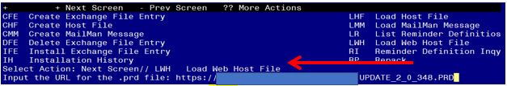

At the **Select Action:** prompt, enter **LWH** for Load Web Host File

At the **Input the url for the .prd file:** prompt, type the following web address:

**https://REDACTED/UPDATE_2_0_348.PRD**

You should see a message at the top of your screen that the file successfully loaded.

Search for and locate the reminder exchange entry titled UPDATE_2_0_348 VA-OSP CSRE UPDATES.

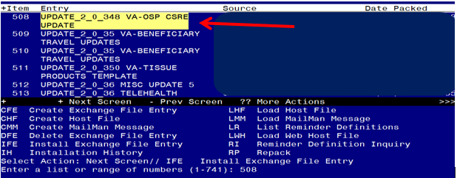

At the **Select Action** prompt, enter **IFE** for Install Exchange File Entry

Enter the number that corresponds with your entry titled **UPDATE_2_0_348 VA-OSP CSRE UPDATES**  *(in this example it is entry 508, it will vary by site).* The exchange file date should be 03/21/2023.

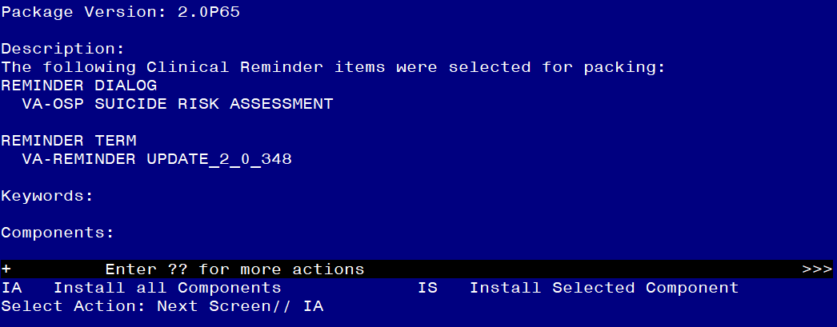

At the **Select Action** prompt, type **IA** for Install all Components and hit enter.

Select Action: Next Screen// IA Install all Components

**You will see several prompts**:

For all new components, choose **I to Install**

**For existing components, choose S to Skip** **with one exception**, for the health summary type VA-SBOR EVENT DATE choose **O to Overwrite.**

HEALTH SUMMARY TYPE entry named VA-SBOR EVENT DATE already exists but

the packed component is different, what do you want to do?

Select one of the following:

C Create a new entry by copying to a new name

O Overwrite the current entry

U Update

Q Quit the install

S Skip, do not install this entry

Enter response: O// verwrite the current entry

Are you sure you want to overwrite? N// YES

**You will be promped to install the dialog component:**

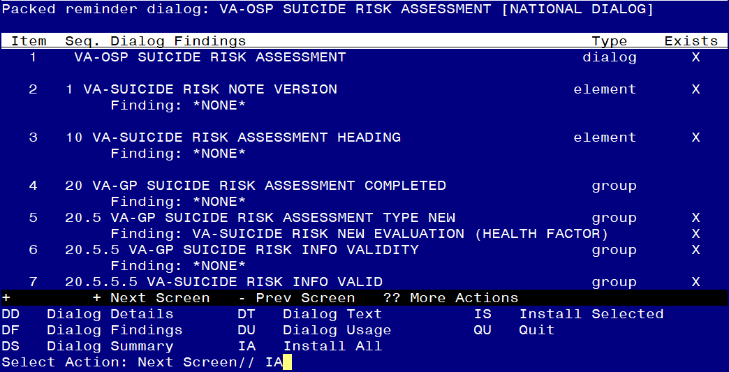

At the **Select Action** prompt, type **IA** to install the dialog – **VA-OSP SUICIDE RISK ASSESSMENT**

Select Action: Next Screen// IA Install All

Install reminder dialog and all components with no further changes: Y// ES

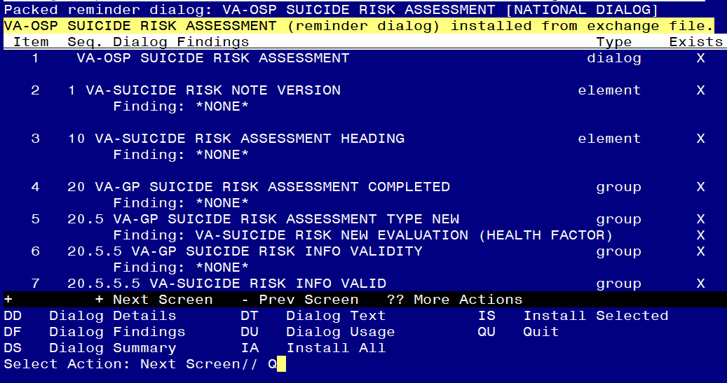

When the dialog has completed installation, you will then be returned to this screen. At the **Select Action** prompt, type **Q.**

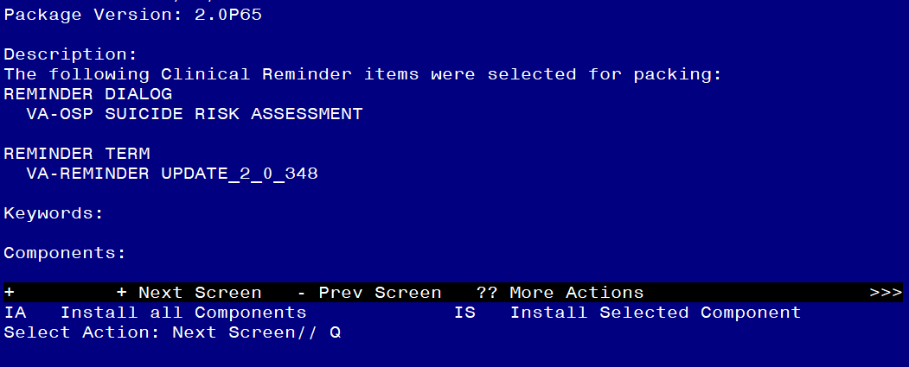

You will be returned to this screen. Type Q to quit.

Install Completed

# Post Installation

1. Launch the **VA-OSP SUICIDE RISK ASSESSMENT (NOTE TITLE: COMPREHENSIVE SUICIDE RISK EVALUATION)**  and confirm the version number is 3.2.
2. Add the orderable items and local information within the dialog:

There are several components for local information, identification of local contacts, and/or referrals. These groups and elements are all classified as local so that you can update, add to, or remove elements if needed. If you are unsure what information and/or order(s) to add, consult with your local services to determine what is appropriate for each section.

Using the menu, Reminder Dialog Management → Reminder Dialogs, Change the view to dialog and search for the reminder dialog VA-OSP SUICIDE RISK ASSESSMENT. Within that dialog, you can search for the following components and edit.

For several of the elements listed below, please review your saved inquiry from the pre-install. Do NOT remove the national health factors attached to these elements. If you did not have an order previously on an element, you can discuss with your suicide prevention team to see if they would like to add one.

1. Add the order for naloxone that was identified in the pre-install inquiry to the reminder dialog group VAL-NALOXONE REQUEST.
2. If your site previously mapped a quick order used to notify your suicide prevention coordinators, you can add this quick order as an additional finding to the dialog group VA-SBOR FOR MOST RECENT ATTEMPT N. This will alert your team when a new suicide attempt is documented if your order is set up appropriately.
3. Add your quick order that represents a High Risk for Suicide Patient Record Flag E-consult as an additional finding to the dialog element VAL-SUICIDE ACTION ALERT SPC YES. **NEW ELEMENT
4. If your site previously mapped a quick order used to notify your suicide prevention coordinators, you can add this quick order as an additional finding to the dialog element VA-GP SUICIDE PREP BEHAVIOR YES .
5. If your site has a quick order that is used to notify your suicide prevention coordinators, you can add this quick order as an additional finding to the dialog element VA-GP SUICIDE PRIOR ATTEMPTS YES.
6. If your site previously mapped a quick order used to notify your suicide prevention coordinators, you can add this quick order as an additional finding to the dialog group VA-GP SUICIDE RISK ACUTE HIGH.
7. If your site previously mapped a quick order used to notify your opioid risk review team when an overdose has been reported, you can add this quick order as an additional finding to the dialog group VA-MOST RECENT METHOD OVERDOSE. This will alert your team when a new suicide attempt with a method of overdose is documented if your order is set up appropriately.
8. Add a quick order that represents a referral or consult for evidence-based psychotherapy as an additional finding to the element VAL-SUICIDE ACTION REF PSYCHOTHERAPY.
9. Add a quick order that represents a referral or consult to your Chaplain/Pastoral service as an additional finding to the element VAL-SUICIDE ACTION REF CHAPLAIN.
10. Add a quick order that represents a referral or consult to your peer specialist program as an additional finding to the element VA-SUICIDE ACTION CONNECT PEER SUPPORT.
11. Add a quick order that represents a referral or consult to you’re a “recovery buddy” or peer specialist program as an additional finding to the element VA-SUICIDE ACTION CONNECT PEER SUPPORT REC BUDDY. **NEW ELEMENT
12. Add the menu name for your consult menu to the option VAL-SUICIDE ACTION CONSULT OTHER if appropriate. In the dialog, this represents Other Referral/Consult. If you do not want a menu to automatically open when the user clicks finish, do not map anything.
13. Add a quick order that represents a referral or consult to vocational rehabilitation/occupational rehabilitation services as an additional finding to the element VAL-SUICIDE ACTION VOC REHAB CON.
14. Add a quick order that represents a referral or consult to psychiatry/medication assessment or management services as an additional finding to the element VAL-SUICIDE ACTION REF PSYCHIATRY MEDICATION ASSESSMENT.
15. Add a quick order that represents a referral for Psychosocial Rehabilitation and Recovery Center (PRRC) and/or Intensive Community Mental Health Recovery (ICMHR)/Mental Health Intensive Case Management (MHICM) services as an additional finding to the element VAL-SUICIDE ACTION SMI CONSULT.
16. Add a quick order that represents a referral or consult to residential mental health services as an additional finding to the element VAL-SUICIDE ACTION RESID CONSULT.
17. Add a quick order that represents an additional referral or consult to residential mental health services as an additional finding to the element VAL-SUICIDE ACTION RESID CONSULT RRTP. ** NEW ELEMENT
18. Add a quick order that represents a referral or consult to homeless program services as an additional finding to the element VAL-SUICIDE ACTION REFER HOMELESS PROGRAM **NEW ELEMENT
19. Add a quick order that represents a consult to Suicide Prevention Telehealth program (SP 2.0) for Suicide Prevention Evidence-based Psychotherapy as an additional finding to the element VA-SUICIDE ACTION TO SP TH PROGRAM **NEW GROUP