

**Update_2_0_351**

Clinical Reminders

VA-OSP CLINICAL TELEHEALTH PROGRAM TEMPLATE UPDATES

Install Guide

**May 2023**

Product Development

Office of Information Technology

Department of Veterans Affairs

**Table of Contents**

Introduction 1

Install Details 9

Install Example 10

Post Installation 18

# Introduction

The Suicide Prevention 2.0 (SP2.0) Clinical Telehealth program utilizes a national standardized Consult and Intake Assessment Note Template. Further, the SP2.0 Clinical Telehealth program uses note templates for evidence-based psychotherapy services for suicide prevention including Cognitive Behavioral Therapy for Suicide Prevention (CBT-SP), Problem Solving Therapy for Suicide Prevention (PST-SP) and Dialectical Behavior Therapy (DBT).

These note templates were developed by the Veterans Health Administration Office of Mental Health and Suicide Prevention (OMHSP) in collaboration with CBT-SP, PST-SP and DBT subject matter experts within the SP 2.0 Clinical Telehealth Workgroup. These notes were designed to create a documentation system within the Veterans Integrated Service Network (VISN) Clinical Resource Hubs (CRH) when treating Veterans and other individuals that qualify for VA care who present with a history of suicidal self-directed violence. All of the SP2.0 treatments and interventions are delivered through video telehealth.

SP 2.0 Clinical Telehealth psychiatrists, psychologists, social workers, and licensed counselors in the CRHs who have been trained in these treatments and interventions will utilize these note templates. The purpose of the templates is to accurately document SP2.0 treatments and interventions in the health record, in addition to the use of health factors to capture data, collecting and tracking Veteran process and outcome measures.

**The following dialogs have been updated (see after-screenshot version #’s):**

**Dialog #1 – VA-OSP TH INTAKE**

Before

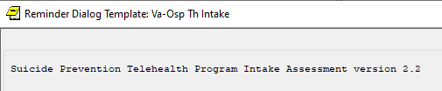

After

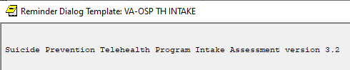

**Dialog #2 - VA-OSP PST-SP**

Before

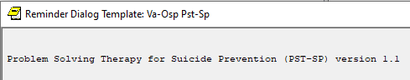

After

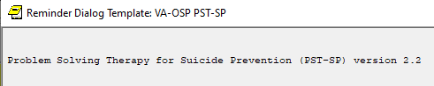

**Dialog #3 - VA-OSP CBT-SP**

Before

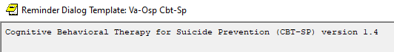

After

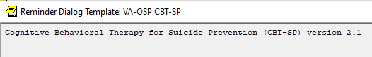

**Dialog #4 - VA-OSP DBT IND**

Before

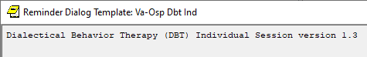

After

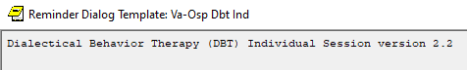

**Dialog #5 - VA-OSP DBT PHONE**

Before

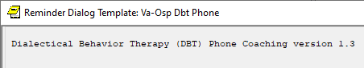

After

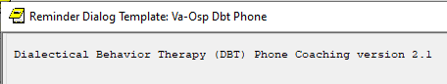

**Dialog #6 - VA-OSP DBT GRP**

Before

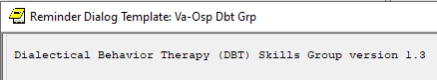

After

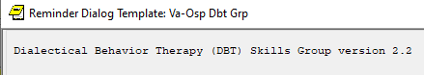

**UPDATE_2_0_351 contains 1 Reminder Exchange entry:**

UPDATE_2_0_351 VA-OSP CLINICAL TH PROGRAM TEMPLATE UPDATES

**The exchange file contains the following components:**

**ROUTINE**

PXRMTIU

**MH TESTS AND SURVEYS**

PHQ9

**REMINDER GENERAL FINDINGS**

VIEW PROGRESS NOTE TEXT

**TIU TEMPLATE FIELD**

VA-BLANK SP

VA-OSP SP RISK MGMT

VA-OSP SRM CONSULT EMAIL

WP 2/50 NOT REQ

DATE

VA-OSP TOPICS

VA-WORD

VA-DISPLAY TEXT SP OPTIONAL

WP 3/70

VA-DBT SKILLS

ED BLANK 3

VA-OSP DBT IND EARLY HOMEWORK

VA-OSP OTHER BEHAVIORS

VA-OSP URGE FOR SUICIDE

VA-OSP DBT IND EARLY ORIENTATION TARGETS

VA-CBT SI

VA-INDENT 2

DISPLAY TEXT SP THOUGHTS DESCRIPTION

VA-OTHER TEXT

VA-OSP CRISTAL

VA-OTHER REASON TEXT

VA-OSP INTAKE INTERVENTION CSP

VA-WP 65/3

**HEALTH FACTORS**

VA-REMINDER UPDATES [C]

VA-UPDATE_2_0_351

VA-SUICIDE RISK MANAGEMENT [C]

VA-SRM FU LOW ACUTE RISK

VA-SRM FU INTERMEDIATE ACUTE RISK

VA-SRM FU HIGH ACUTE RISK

VA-SUICIDE RISK ASSESSMENT [C]

VA-SUICIDE RISK ACUTE LOW

VA-SUICIDE RISK ACUTE INTERMEDIATE

VA-SUICIDE RISK ACUTE HIGH

VA-OSP TH DISCHARGE [C]

VA-OSP TH ACUTE RISK LOW

VA-OSP TH ACUTE RISK INTERMEDIATE

VA-OSP TH ACUTE RISK HIGH

VA-SUICIDE RISK EVALUATION TYPE [C]

VA-SUICIDE RISK UPDATE EVALUATION

VA-SUICIDE RISK NEW EVALUATION

VA-OSP TH CHRONIC RISK LOW

VA-OSP TH CHRONIC RISK INTERMEDIATE

VA-OSP TH CHRONIC RISK HIGH

VA-OSP PST-SP [C]

VA-OSP PST-SP VISIT

VA-OSP PST-SP VETERAN CONSENTS TO TREATMENT PLAN

VA-OSP PST-SP DISCONTINUE PST-SP TREATMENT

VA-OSP PST-SP CONTINUE PST-SP TREATMENT

VA-OSP PST-SP SKILLS REVIEW AND FUTURE FORECAST

VA-OSP PST-SP PLANFUL PROBLEM SOLVING

VA-OSP PST-SP OVERCOMING BRAIN OVERLOAD

VA-OSP PST-SP VISUALIZATION HOPE AND MOTIVATION

VA-OSP PST-SP STOP AND SLOW DOWN

VA-OSP PST-SP INTRODUCTION AND RATIONALE

VA-OSP PST-SP SUIC THOT PAST WK SUIC IDEATION SPEC PLAN YES

VA-OSP PST-SP SUIC THOT PAST WK SUIC IDEATION INTENT YES

VA-OSP PST-SP SUIC THOT PAST WK SUIC IDEATION SPEC PLAN NO

VA-OSP PST-SP SUIC THOT PAST WK SUIC IDEATION MTHD YES

VA-OSP PST-SP SUIC THOT PAST WK SUIC IDEATION INTENT NO

VA-OSP PST-SP SUIC THOT PAST WK SUIC IDEATION MTHD NO

VA-OSP PST-SP SUIC THOT PAST WK WISH TO BE DEAD

VA-OSP PST-SP SUIC THOT PAST WK DENIED

VA-OSP PST-SP PRACTICE ASSIGNMENTS DIFFICULTY

VA-OSP PST-SP PRACTICE ASSIGNMENTS HELPFULNESS

VA-OSP PST-SP PRACTICED PST-SP SKILLS

VA-OSP PST-SP REVIEWED HANDOUTS

VA-OSP PST-SP HOPELESSNESS INTENSITY

VA-OSP PST-SP SUIC ATT PAST WK SELF DIRECTED VIOLENCE PREP

VA-OSP PST-SP SUIC ATT PAST WK YES INJURY INTRPT BY SELF

VA-OSP PST-SP SUIC ATT PAST WK NO INJURY INTRPT BY SELF

VA-OSP PST-SP SUIC ATT PAST WK YES INJURY INTRPT BY OTHER

VA-OSP PST-SP SUIC ATT PAST WK NO INJURY INTRPT BY OTHER

VA-OSP PST-SP SUIC ATT PAST WK YES INJURY

VA-OSP PST-SP SUIC ATT PAST WK NO INJURY

VA-OSP PST-SP SUIC ATT PAST WK DENIED

VA-OSP PST-SP SUICIDAL THOUGHTS INTENSITY

VA-OSP PST-SP FACE TO FACE

VA-OSP DBT [C]

VA-OSP DBT TELEPHONE CONSENT

VA-OSP PST-SP TELEPHONE CONSENT

VA-OSP PST-SP ENTIRELY TELEPHONE

VA-OSP PST-SP PART TELEPHONE

VA-OSP PST-SP VIDEO ATLAS

VA-OSP PST-SP VTC

VA-OSP PST-SP VTH UNDISCLOSED

VA-OSP PST-SP VTH OTHER

VA-OSP PST-SP VTH HOME

VA-MH EBP TEMPLATE

VA-OSP DBT FACE TO FACE

VA-OSP DBT ENTIRELY TELEPHONE

VA-OSP DBT PART TELEPHONE

VA-OSP DBT VTH OTHER LOCATION

VA-OSP DBT VIDEO ATLAS

VA-OSP DBT VTC

VA-OSP DBT VTH RESIDENCE

VA-OSP DBT GRP DISTRESS TOLERANCE

VA-OSP DBT GRP INTERPERSONAL EFFECTIVENESS

VA-OSP DBT GRP EMOTION REGULATION

VA-OSP DBT GRP MINDFULNESS

MH EVIDENCED BASED PSYCHOTHER TEMPLATES [C]

MH EBP TEMPLATE

VA-OSP DBT GRP NOTE

VA-OSP DBT PHONE TARGET OTHER

VA-OSP DBT PHONE RELATIONSHIP REPAIR

VA-OSP DBT PHONE OTHER TARGET BEHAVIORS

VA-OSP DBT PHONE OTHER BEHAVIOR URGES

VA-OSP DBT PHONE NON-SUIC SELF INJ BEHAV

VA-OSP DBT PHONE NON-SUIC SELF INJ URGES

VA-OSP DBT PHONE SUICIDAL BEHAVIORS

VA-OSP DBT PHONE SUICIDAL URGES

VA-OSP DBT PHONE NOTE

VA-OSP DBT VTH UNDISCLOSED

VA-OSP DBT IND OTHER BEHAVIORS

VA-OSP DBT IND MH APPTS MISSED

VA-OSP DBT IND CRISIS SERVICES

VA-OSP DBT IND URGE SUICIDE

VA-OSP DBT IND NON-SUIC SELF INJ BEHAV

VA-OSP DBT IND SUICIDE PREP BEHAVIORS

VA-OSP DBT IND SUICIDE ATTEMPTS

VA-OSP DBT IND REGULAR NOTE

VA-OSP DBT IND EARLY NOTE

VA-OSP CBT-SP [C]

VA-OSP CBT-SP VISIT

VA-OSP CBT-SP SELF EFFICACY 6 MONTHS

VA-OSP CBT-SP SELF EFFICACY 1 WEEK

VA-OSP CBT-SP HOMEWORK NOT COMPLETED

VA-OSP CBT-SP HOMEWORK PARTIAL

VA-OSP CBT-SP HOMEWORK COMPLETED

VA-OSP CBT-SP RELAPSE PREV PRACTICE

VA-OSP CBT-SP RELAPSE PREV SKILLS CONSOLIDATION

VA-OSP CBT-SP DEVELOPING MORE HELPFUL RESPONSES

VA-OSP CBT-SP AUTOMATIC THOUGHTS

VA-OSP CBT-SP PROBLEM SOLVING

VA-OSP CBT-SP COPING STRATEGIES

VA-OSP CBT-SP INCREASING PLEASURABLE ACTIVITIES

VA-OSP CBT-SP TX PLANNING AND INCREASING HOPEFULNESS

VA-OSP CBT-SP FULL NARRATIVE TIMELINE

VA-OSP CBT-SP BRIEF NARRATIVE OF PAST CRISIS AND SAFETY PLAN

VA-OSP CBT-SP INTRODUCTION SESSION

VA-OSP CBT-SP REVIEW OF PROGRESS AND LOOKING AHEAD

VA-OSP CBT-SP URGE ALCOHOL SUBS POST

VA-OSP CBT-SP INTENT KILL SELF POST

VA-OSP CBT-SP URGE KILL SELF POST

VA-OSP CBT-SP MOOD POST

VA-OSP CBT-SP URGE ALCOHOL SUBS PRE

VA-OSP CBT-SP INTENT KILL SELF PRE

VA-OSP CBT-SP URGE KILL SELF PRE

VA-OSP CBT-SP HOPELESSNESS INTENSITY

VA-OSP CBT-SP SUICIDAL THOUGHTS INTENSITY

VA-OSP CBT-SP FACE TO FACE

VA-OSP CBT-SP TELEPHONE CONSENT

VA-OSP CBT-SP ENTIRELY TELEPHONE

VA-OSP CBT-SP PART TELEPHONE

VA-OSP CBT-SP VIDEO ATLAS

VA-OSP CBT-SP VTC

VA-OSP CBT-SP VTH UNDISCLOSED

VA-OSP CBT-SP VTH OTHER

VA-OSP CBT-SP VTH HOME

VA-OSP TH INTAKE ASSESSMENT [C]

VA-OSP TH COMPACT

VA-OSP TH NOT REC OTHER

VA-OSP TH NOT REC NOT INDICATED

VA-OSP TH NOT REC INCLUSION

VA-OSP TH NOT REC RECEIVING TX

VA-OSP TH NOT REC DIFFERENT ISSUE

VA-OSP TH DECLINED ATTENDANCE EVENING

VA-OSP TH DECLINED ATTENDANCE WEEKEND

VA-OSP TH DECLINED NEEDS MET

VA-OSP TH DECLINED OTHER

VA-OSP TH DECLINED NOT MAIN CONCERN

VA-OSP TH DECLINED DISCUSS SUICIDE

VA-OSP TH DECLINED VIRTUAL

VA-OSP TH DECLINED MOTIVATION

VA-OSP TH DECLINED ATTENDANCE

VA-OSP TH PST-SP CONSENTED

VA-OSP TH DBT CONSENTED

VA-OSP TH CBT-SP CONSENTED

VA-OSP TH SAFETY PLANNING CONSENTED

VA-OSP TH INTAKE SP INTERVENTION

VA-SUICIDE SAFETY PLAN [C]

VA-SP SAFETY PLAN REVIEWED

VA-OSP TH SAFETY PLAN UPDATED

VA-OSP TH SAFETY PLAN NEW

VA-OSP TH TREATMENT DISCUSSION NONE

VA-OSP TH PST-SP DISCUSSED

VA-OSP TH DBT DISCUSSED

VA-OSP TH CBT-SP DISCUSSED

VA-OSP TH SAFETY PLANNING DISCUSSED

VA-OSP TH FACE TO FACE

VA-OSP INTAKE TELEPHONE CONSENT

VA-OSP TH TELEPHONE

VA-OSP TH SESSION PARTIALLY VIDEO

VA-OSP TH VIDEO TO ATLAS

VA-OSP TH VIDEO TO CLINIC

VA-OSP TH INTAKE VTH UNDISCLOSED

VA-OSP TH VIDEO TO HOME OUTSIDE

VA-OSP TH VIDEO TO HOME RESIDENCE

VA-OSP TH REFERRAL ED

VA-OSP TH REFERRAL OTHER

VA-OSP TH REFERRAL MH SPECIALTY

VA-OSP TH REFERRAL INPATIENT

VA-OSP TH REFERRAL RRTP

VA-OSP TH REFERRAL SP TEAM

VA-OSP TH REFERRAL PCMHI

VA-OSP TH REFERRAL MHC/BHIP

VA-OSP TH INTAKE ASSESSMENT NOTE

**REMINDER SPONSOR**

VHA OFFICE OF MENTAL HEALTH AND SUICIDE PREVENTION

VHA NATIONAL CENTER FOR HEALTH PROMOTION AND DISEASE PREVENTION (NCP) AND VHA OFFICE OF WOMEN'S HEALTH

**REMINDER COMPUTED FINDING**

VA-PROGRESS NOTE

**REMINDER TERM**

VA-REMINDER UPDATE_2_0_351

VA-OSP DBT TELEPHONE CONSENT

VA-OSP CBT-SP TELEPHONE CONSENT

**REMINDER DEFINITION**

VA-OSP TH REFERRAL

**HEALTH SUMMARY COMPONENT**

PROGRESS NOTE SELECTED

PCE HEALTH FACTORS SELECTED

MAS CONTACTS

MHA SCORE

CLINICAL REMINDERS FINDINGS

**HEALTH SUMMARY TYPE**

VA-CSRE MOST RECENT NOTE

VA-CSRE MOST RECENT

VA-OSP TH ACUTE RISKS LEVEL 6M

NOK/DEMO/CONTACTS

VA-OSP SELF EFFICACY 1Y

VA-PHQ9 1Y

VA-OSP TH REFERRAL

**HEALTH SUMMARY OBJECTS**

VA-CSRE MOST RECENT NOTE

VA-CSRE MOST RECENT

VA-OSP TH ACUTE RISKS LEVEL 6M

CONTACTS (TIU)

VA-OSP SELF EFFICACY 1Y

VA-PHQ9 1Y

VA-OSP TH REFERRAL (TIU)

**TIU DOCUMENT DEFINITION**

VA-WRIISC ACTIVE PROBLEMS

VA-CSRE MOST RECENT NOTE

VA-CSRE MOST RECENT

VA-OSP TH ACUTE RISKS LEVEL 6M

CONTACTS

VA-OSP SELF EFFICACY 1Y

VA-PHQ9 1Y

VA-OSP TH REFERRAL

**REMINDER DIALOG**

VA-OSP PST-SP

VA-OSP DBT GRP

VA-OSP DBT IND

VA-OSP DBT PHONE

VA-OSP CBT-SP

VA-OSP TH INTAKE

# Install Details

This update is being distributed as a web host file. The address for the host file is: **https://Redacted/UPDATE_2_0_351.PRD**

The file will be installed using Reminder Exchange, programmer access is not required.

Installation:

=============

This update can be loaded with users on the system. Installation will take less than 30 minutes.

# Install Example

To Load the Web Host File. Navigate to Reminder exchange in Vista

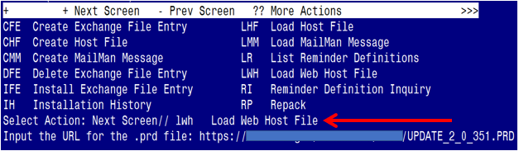

At the **Select Action:** prompt, enter **LWH** for Load Web Host File

At the **Input the url for the .prd file:** prompt, type the following web address:

**https://REDACTED/UPDATE_2_0_351.PRD**

You should see a message at the top of your screen that the file successfully loaded.

Terminal window screen shot of the message displaying the URL of the file that was successfully loaded.  Part of the URL has been redacted as it is a VA only internal web site URL.

Search for and locate the reminder exchange entry titled:

UPDATE_2_0_351 VA-OSP CLINICAL TH PROGRAM TEMPLATE UPDATES

(see screenshot on the next page)

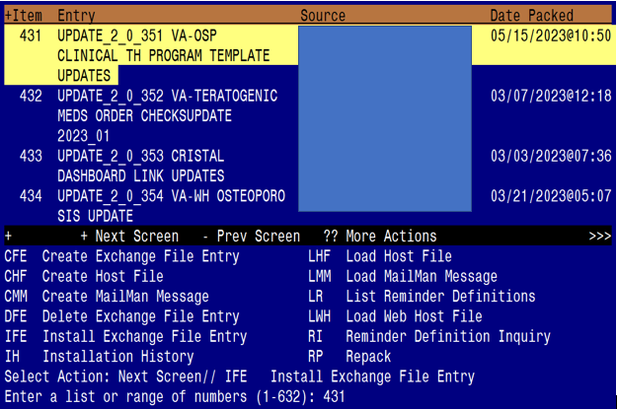

At the **Select Action** prompt, enter **IFE** for Install Exchange File Entry

Enter the number that corresponds with your entry titled:

**UPDATE_2_0_351 VA-OSP CLINICAL TH PROGRAM TEMPLATE UPDATES**

*(In this example it is entry 431, it will vary by site).*

The exchange file date should be 05/15/2023@10:50.

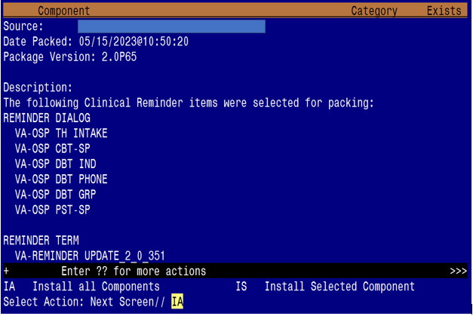

At the **Select Action** prompt, type **IA** for Install all Components and hit enter.

Select Action: Next Screen// IA Install all Components

**You will see several prompts**:

**1** - For all new components, choose **I to Install**

**2** - If prompted to overwriteTIU template field **VA-OSP CRISTAL**, choose S to SKIP

**3** - For all other existing components, choose **O to Overwrite**

**You will be promped to install the 1st dialog component:**

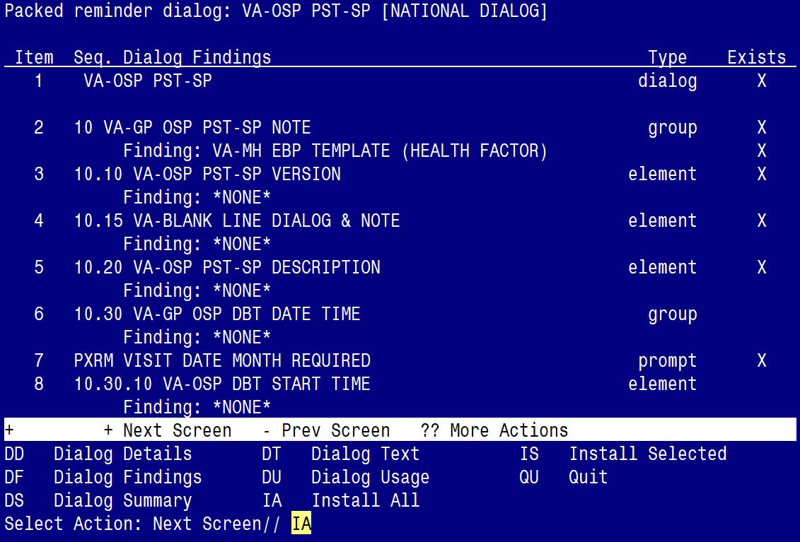

At the **Select Action** prompt, type **IA** to install the dialog – **VA-OSP PST-SP**

Select Action: Next Screen// IA Install All

Install reminder dialog and all components with no further changes: Y// ES

Regarding the VA-OSP PST-SP [NATIONAL DIALOG]:
Screen shot of the last of the list of elements, groups and dialogs that needed to be installed with a Q for quit entered at the "Select Action:" prompt because they now all exist.  

When the dialog has completed installation, you will then be returned to this screen. At the **Select Action** prompt, type **Q.**

**You will be promped to install the 2nd dialog component:**

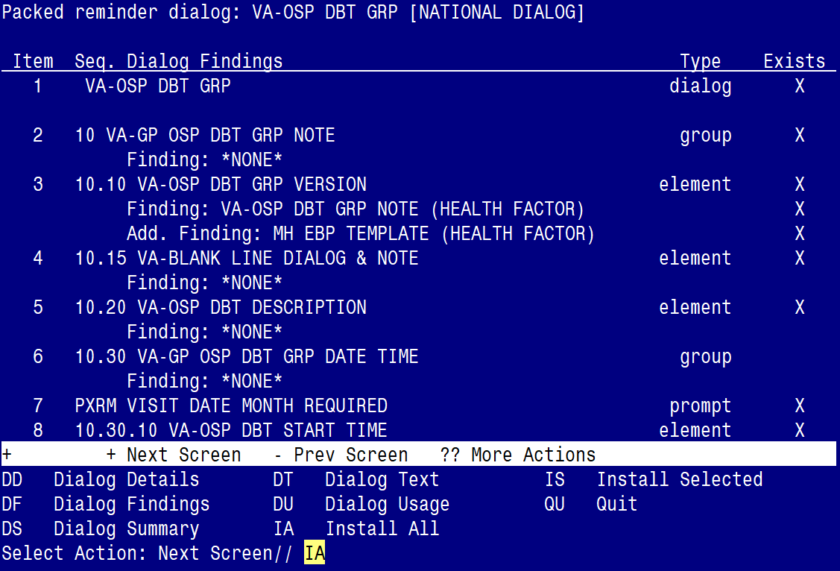

At the **Select Action** prompt, type **IA** to install the dialog – **VA-OSP DBT GRP**

Select Action: Next Screen// IA Install All

Install reminder dialog and all components with no further changes: Y// ES

Regarding the VA-OSP DBT GRP [NATIONAL DIALOG]:
Screen shot of the last of the list of elements, groups and dialogs that needed to be installed with a Q for quit entered at the "Select Action:" prompt because they now all exist.  

When the dialog has completed installation, you will then be returned to this screen. At the **Select Action** prompt, type **Q.**

**You will be promped to install the 3rd dialog component:**

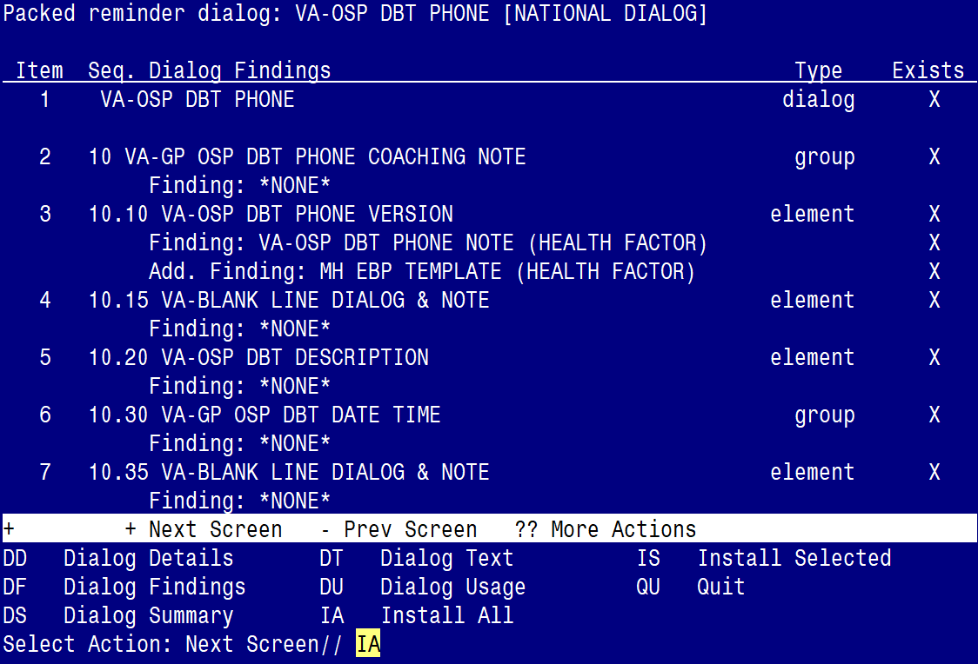

At the **Select Action** prompt, type **IA** to install the dialog – **VA-OSP DBT PHONE**

Select Action: Next Screen// IA Install All

Install reminder dialog and all components with no further changes: Y// ES

Regarding the VA-OSP DBT PHONE [NATIONAL DIALOG]:
Screen shot of the last of the list of elements, groups and dialogs that needed to be installed with a Q for quit entered at the "Select Action:" prompt because they now all exist.  

When the dialog has completed installation, you will then be returned to this screen. At the **Select Action** prompt, type **Q.**

**You will be promped to install the 4th dialog component:**

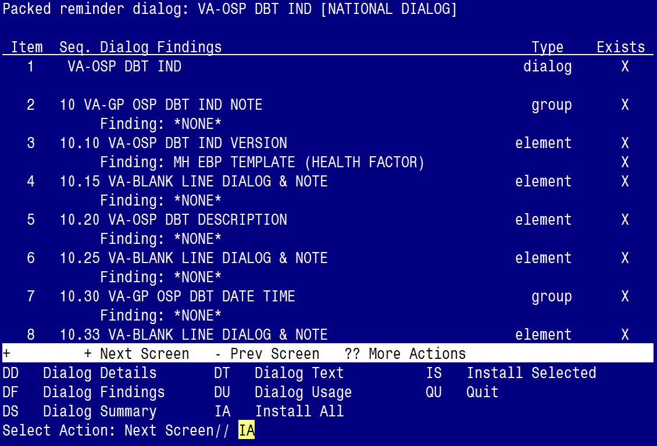

At the **Select Action** prompt, type **IA** to install the dialog – **VA-OSP DBT IND**

Select Action: Next Screen// IA Install All

Install reminder dialog and all components with no further changes: Y// ES

Regarding the VA-OSP DBT IND [NATIONAL DIALOG]:
Screen shot of the last of the list of elements, groups and dialogs that needed to be installed with a Q for quit entered at the "Select Action:" prompt because they now all exist.  

When the dialog has completed installation, you will then be returned to this screen. At the **Select Action** prompt, type **Q.**

**You will be promped to install the 5th dialog component:**

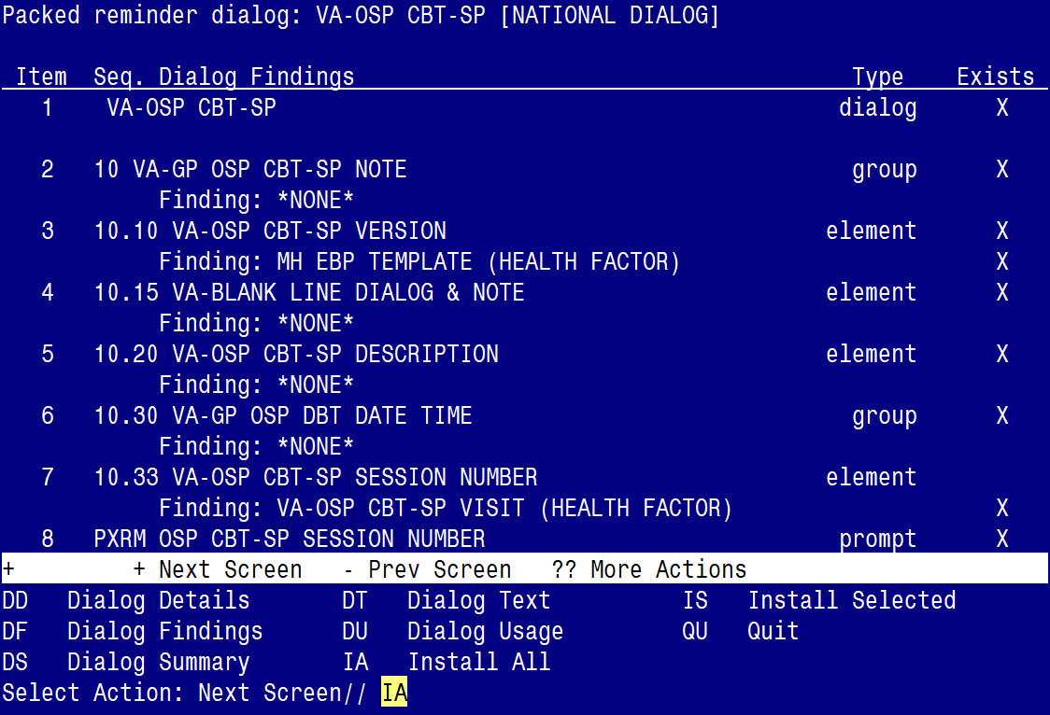

At the **Select Action** prompt, type **IA** to install the dialog – **VA-OSP CBT-SP**

Select Action: Next Screen// IA Install All

Install reminder dialog and all components with no further changes: Y// ES

Regarding the VA-OSP CBT CRT-SP [NATIONAL DIALOG]:
Screen shot of the last of the list of elements, groups and dialogs that needed to be installed with a Q for quit entered at the "Select Action:" prompt because they now all exist.  

When the dialog has completed installation, you will then be returned to this screen. At the **Select Action** prompt, type **Q.**

**You will be promped to install the 6th dialog component:**

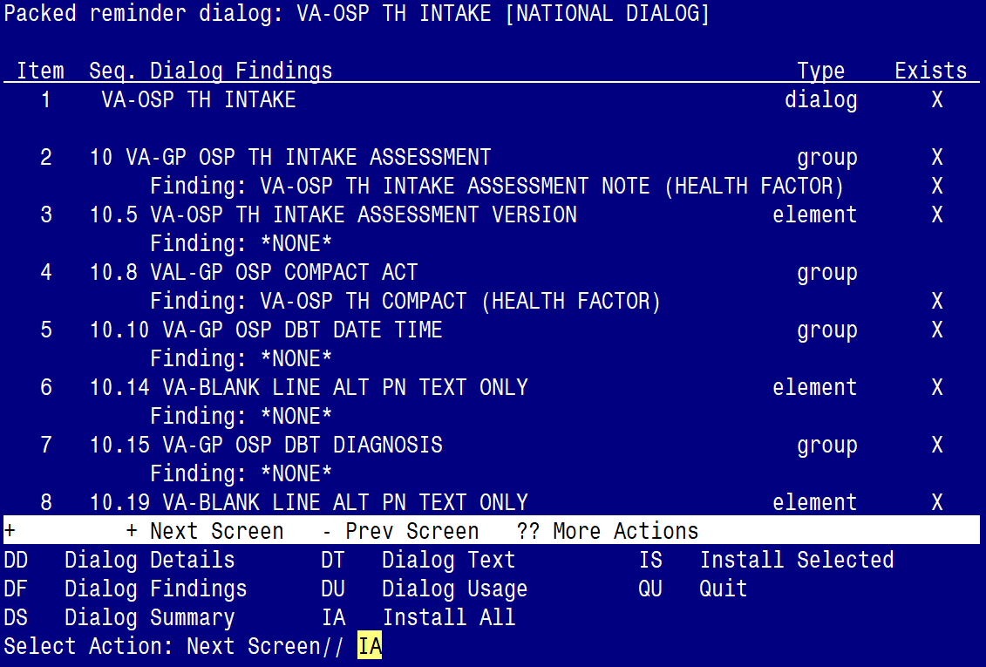

At the **Select Action** prompt, type **IA** to install the dialog – **VA-OSP TH INTAKE**

Select Action: Next Screen// IA Install All

Install reminder dialog and all components with no further changes: Y// ES

Regarding the VA-OSP TH INTAKE [NATIONAL DIALOG]:
Screen shot of the last of the list of elements, groups and dialogs that needed to be installed with a Q for quit entered at the "Select Action:" prompt because they now all exist.  

When the dialog has completed installation, you will then be returned to this screen. At the **Select Action** prompt, type **Q.**

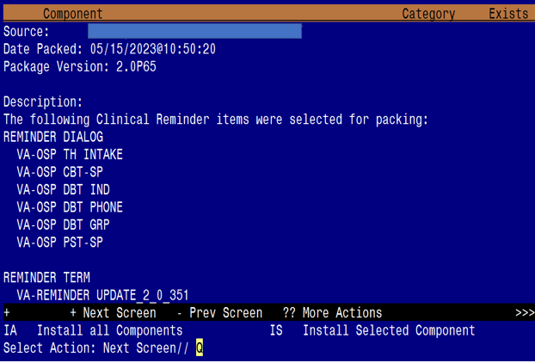

You will be returned to this screen. Type Q to quit.

Install Completed

# Post Installation

1. Launch all six (6) dialogs and confirm the updated version numbers (see screenshots below) are displayed at the top of the dialog.
   1. You should be able to launch the dialogs using note titles:
      1. SUICIDE PREVENTION TELEHEALTH INTAKE ASSESSMENT
      2. COGNITIVE BEHAVIORAL THERAPY-SUICIDE PREVENTION
      3. DIALECTICAL BEHAVIOR THERAPY SKILLS GROUP
      4. DIALECTICAL BEHAVIOR THERAPY INDIVIDUAL SESSION
      5. DIALECTICAL BEHAVIOR THERAPY PHONE COACHING
      6. PROBLEM SOLVING THERAPY – SUICIDE PREVENTION

If your site does not have the note titles established, refer to the original install guides and the post-installation step instructions for note title creation. The links to those install guides are: LINKS REDACTED, but the 4 Updates listed were

UPDATE_2_0_193

UPDATE_2_0_208

UPDATE_2_0_224

UPDATE_2_0_238

**VA-OSP TH INTAKE**



**VA-OSP PST-SP**



**VA-OSP CBT-SP**



**VA-OSP DBT IND**



**VA-OSP DBT PHONE**



**VA-OSP DBT GRP**



1. Confirm the highlighted objects below are in the Alternate Progress Note text for the following five (5) ELEMENTS:

**ELEMENT**: **VAL-OSP TH DIAGNOSIS ACTIVE PROBLEMS DISPLAY**

CLASS: LOCAL//

DIALOG/PROGRESS NOTE TEXT:

Active Problems List

ALTERNATE PROGRESS NOTE TEXT:

|VA-WRIISC ACTIVE PROBLEMS|

**ELEMENT**: **VAL-OSP TH ACUTE RISK DISPLAY**

CLASS: LOCAL//

DIALOG/PROGRESS NOTE TEXT:

Display previous Acute Risk levels in past 6 months

ALTERNATE PROGRESS NOTE TEXT:

|VA-OSP TH ACUTE RISK LEVELS 6M|

**ELEMENT**: **VAL-OSP CBT-SP MH ASSESSMENT PHQ9 DISPLAY**

CLASS: LOCAL//

DIALOG/PROGRESS NOTE TEXT:

Display previous PHQ9 scores in past year

ALTERNATE PROGRESS NOTE TEXT:

|VA-PHQ9 1Y|

**ELEMENT**: **VAL-OSP CBT-SP MH ASSESSMENT SELF EFFICACY DISPLAY**

CLASS: LOCAL//

DIALOG/PROGRESS NOTE TEXT:

Display previous Self Efficacy scores in past year

ALTERNATE PROGRESS NOTE TEXT:

|VA-OSP SELF EFFICACY 1Y|

**ELEMENT**: **VAL-OSP TH CSRE DISPLAY**

CLASS: LOCAL//

DIALOG/PROGRESS NOTE TEXT:

|VA-CSRE MOST RECENT|

ALTERNATE PROGRESS NOTE TEXT:

|VA-CSRE MOST RECENT NOTE|

1. Add your site’s local data objects for PATIENT ADDRESS or PATIENT PHONE in the dialog/progress note text for the following elements:

**ELEMENT**: **VAL-OSP DBT HOME ADDRESS**

CLASS: LOCAL//

DIALOG/PROGRESS NOTE TEXT:

Home: **INSERT PATIENT ADDRESS OBJECT**

**ELEMENT**: **VAL-OSP DBT HOME ADDRESS AO**

CLASS: LOCAL//

DIALOG/PROGRESS NOTE TEXT:

Home: **INSERT PATIENT ADDRESS OBJECT**

**ELEMENT**: **VAL-OSP TH INTAKE HOME ADDRESS V2**

CLASS: LOCAL//

DIALOG/PROGRESS NOTE TEXT:

Home: **INSERT PATIENT ADDRESS OBJECT**

**ELEMENT**: **VAL-OSP PST-SP HOME ADDRESS V2**

CLASS: LOCAL//

DIALOG/PROGRESS NOTE TEXT:

Home: **INSERT PATIENT ADDRESS OBJECT**

**ELEMENT**: **VAL-OSP PST-SP HOME ADDRESS**

CLASS: LOCAL//

DIALOG/PROGRESS NOTE TEXT:

Home: **INSERT PATIENT ADDRESS OBJECT**

**ELEMENT**: **VAL-OSP CBT-SP VTH RESIDENCE HOME ADDRESS**

CLASS: LOCAL//

DIALOG/PROGRESS NOTE TEXT:

Home: **INSERT PATIENT ADDRESS OBJECT**

**ELEMENT**: **VAL-OSP CBT-SP AO RESIDENCE HOME ADDRESS**

CLASS: LOCAL//

DIALOG/PROGRESS NOTE TEXT:

Home: **INSERT PATIENT ADDRESS OBJECT**

**ELEMENT**: **VAL-OSP DBT PHONE**

CLASS: LOCAL//

DIALOG/PROGRESS NOTE TEXT:

Home: **INSERT PATIENT PHONE OBJECT**

**ELEMENT**: **VAL-OSP CBT-SP VTH PHONE**

CLASS: LOCAL//

DIALOG/PROGRESS NOTE TEXT:

Home: **INSERT PATIENT PHONE OBJECT**

**ELEMENT**: **VAL-OSP PST-SP PHONE**

CLASS: LOCAL//

DIALOG/PROGRESS NOTE TEXT:

Home: **INSERT PATIENT PHONE OBJECT**

For Post-Installation step #4, you will need to import the updated **SUICIDE PREVENTION TELEHEALTH** consult reason-for-request TXML file and replacing the existing file in CPRS for the SUICIDE PREVENTION TELEHEALTH IFC consult service.

All sites should have already created this consult service (see Update_2_0_193), so follow Step 4 below to import and replace the consult reason-for-request TXML file.

Should you need a reference, the link to the original setup guide for the Suicide Prevention Telehealth IFC consult service is below:

REDACTED LINK for Suicide Prevention Telehealth Consult Guide.docx

1. Download and replace the Consult Reason-for-Request TXML file for the following consult service:

SUICIDE PREVENTION TELEHEALTH IFC V## STA6A

(Where V## represents your two-digit VISN and STA6A is your facility station number)

Follow the instructions below to update the Consult Reason for Request in CPRS.

Download the TXML file from here REDACTED LINK for the Update_2_0_351 TXML file

1. Select the three ellipses next to the name “SUICIDE PREVENTION TELEHEALTH CONSULT” and then select the three ellipses next to the word “FOLLOW”

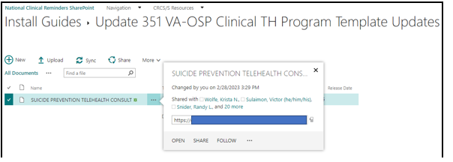

1. Select “Download”

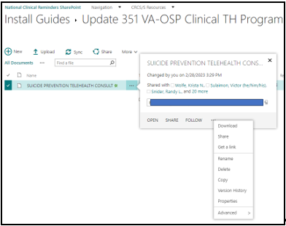

1. Select “Save as”

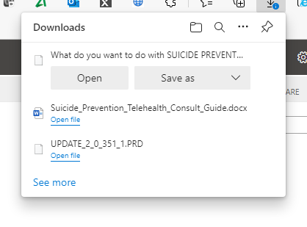

1. Choose a location to save the TXML file. (In this example it was saved to the desktop)

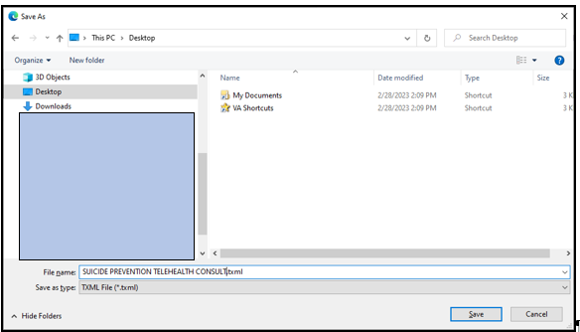

1. In CPRS, select the NOTES tab > then OPTIONS > then Edit Shared Templates. Locate the Consult Reasons for Request folder and then locate the Consult Service for:

SUICIDE PREVENTION TELEHEALTH REDACTED

(Where V## represents your two-digit VISN and REDACTED is your facility station number)

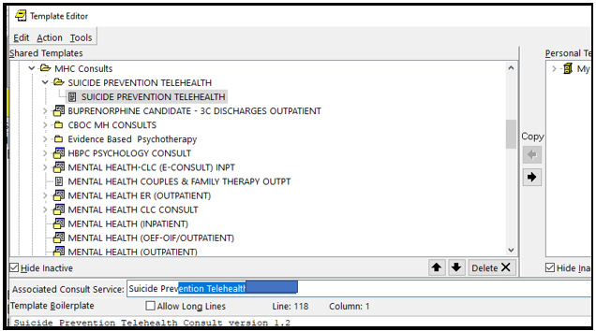

1. Disassociate (remove) the ‘Associated Consult Service’ so it can be re-associated after importing the updated Reason for Request TXML file (see next step below)

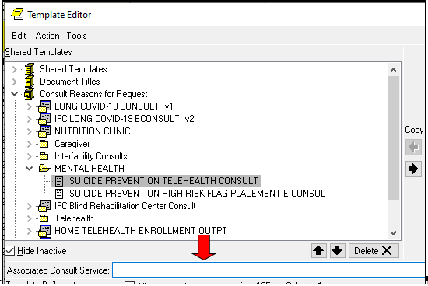

1. Import the SUICIDE PREVENTION TELEHEALTH CONSULT Reason for Request TXML file that you previously downloaded and saved.

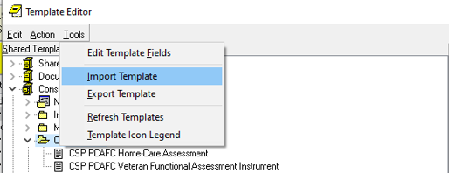

In the ‘Associated Consult Service’ field enter the SUICIDE PREVENTION TELEHEALTH IFC V##REDACTED consult service to associate the consult service name to the newly imported TXML file.

(Where V## represents your two-digit REDACTED and REDACTED is your facility station number)

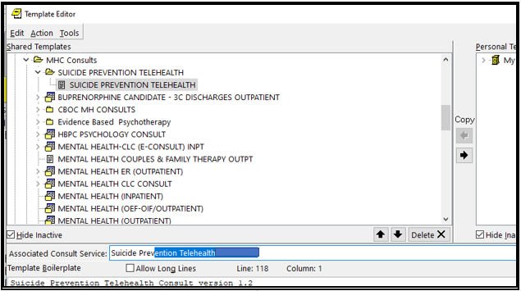

1. If you choose to do so, you can mark the ‘old’ TXML file as inactive. To do so, highlight the ‘old’ the file and mouse-click the check box in the ‘Active’ field

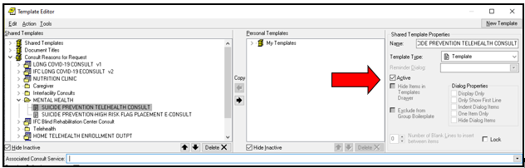

1. Review the CPRS template field titled “VA-OSP CRISTAL” Confirm the URL contains your station number. If not, you need to replace the text “STATIONIDHERE” with your facility’s station number (see instructions and screenshot below).

The address is in the VA-OSP CRISTAL template field should be:

REDACTED

1. Replace STATIONIDHERE with your 3- or 5-digit numeric station number.
2. DO NOT replace the DUZ or APP code.

