

**Update _2_0_352**

Clinical Reminders

TERATOGENIC MEDICATIONS UPDATE 2023_01

Install Guide

**April 2023**

Product Development

Office of Information Technology

Department of Veterans Affairs

Table of Contents

Introduction 1

Install Details 3

Installation: 4

Install Example 5

Post-Install Set-up Instructions 8

# Introduction

UPDATE_2_0_352 contains 1 Reminder Exchange entry: **UPDATE_2_0_352 VA-TERATOGENIC MEDS ORDER CHECKS UPDATE 2023_01**

The Teratogenic Medications Order Check Interim Solution was originally released as VistA patch PXRM*2*22 in July 2012. The interim solution is intended to have regular updates for clinical content, primarily to add newly approved medications that have a noted risk during pregnancy and that warrant an order check. This update, UPDATE_2_0_352 represents the FIRST update in 2023.

* Drugs added to the high risk, pregnancy order checks and lactation level 1 order check are the result of routine review and update from First Databank for new medications that have a risk to the fetus or breastfeeding child.
* Cyclosporine ophthalmic products have been removed from lactation level 1 alerts in response to a field request and review of supportive information. There is minimal systemic absorption of ophthalmic cyclosporine products, and these are not expected to have negative effects on a breastfed infant (References: LactMed and Restasis prescribing information 12/2022).
* Oxarbazepine has been added to the high risk and pregnancy order checks for consistency with carbamazepine.

Below are the changes:

1. Reminder order check group VA-WH HIRISK MEDICATIONS (LACTATION LEVEL 1) GROUP updated.

The following DG (Drug Generic) finding was removed from the ORDER CHECK ITEM LIST:

DG.CYCLOSPORINE

The following DG (Drug Generic) findings were added to the ORDER CHECK ITEM LIST:

DG.ADAGRASIB

DG.MIRVETUXIMAB SORAVTANSINE-GYNX

DG.OLUTASIDENIB

DG.FUTIBATINIB

DG.TECLISTAMAB-CQYV

DG.TREMELIMUMAB-ACTL

The following DP (VA Drug Product) findings were added to the ORDER CHECK ITEM LIST:

DP.CYCLOSPORINE (EON) 100MG CAP

DP.CYCLOSPORINE (EON) 25MG CAP

DP.CYCLOSPORINE (GENGRAF) 100MG CAP

DP.CYCLOSPORINE (GENGRAF) 100MG CAP,UD

DP.CYCLOSPORINE (GENGRAF) 100MG/ML SOLN,ORAL

DP.CYCLOSPORINE (GENGRAF) 25MG CAP

DP.CYCLOSPORINE (GENGRAF) 25MG CAP,UD

DP.CYCLOSPORINE (GENGRAF) 50MG CAP,UD

DP.CYCLOSPORINE (NEORAL) 100MG CAP

DP.CYCLOSPORINE (NEORAL) 25MG CAP

DP.CYCLOSPORINE (SANDIMMUNE) 100MG CAP

DP.CYCLOSPORINE (SANDIMMUNE) 100MG/ML SOLN,ORAL

DP.CYCLOSPORINE (SANDIMMUNE) 25MG CAP

DP.CYCLOSPORINE (SANDIMMUNE) 50MG CAP

DP.CYCLOSPORINE (SIDMAK) 100MG CAP

DP.CYCLOSPORINE (SIDMAK) 100MG/ML SOLN,ORAL

DP.CYCLOSPORINE (SIDMAK) 25MG CAP

DP.CYCLOSPORINE 100MG CAP

DP.CYCLOSPORINE 100MG/ML SOLN,ORAL

DP.CYCLOSPORINE 25MG CAP

DP.CYCLOSPORINE 50MG CAP

DP.CYCLOSPORINE 50MG/ML INJ

DP.CYCLOSPORINE MICROEMULSION 100MG CAP

DP.CYCLOSPORINE MICROEMULSION 100MG/ML SOLN

DP.CYCLOSPORINE MICROEMULSION 25MG CAP

DP.CYCLOSPORINE MODIFIED 100MG CAP

DP.CYCLOSPORINE MODIFIED 100MG/ML SOLN,ORAL

DP.CYCLOSPORINE MODIFIED 25MG CAP

DP.CYCLOSPORINE MODIFIED 50MG CAP

DP.CYCLOSPORINE NON-MODIFIED 100MG CAP

DP.CYCLOSPORINE NON-MODIFIED 100MG/ML SOLN,ORAL

DP.CYCLOSPORINE NON-MODIFIED 25MG CAP

DP.CYCLOSPORINE NON-MODIFIED 50MG/ML SOLN,ORAL

1. Reminder order check groups updated:

VA-WH HIRISK MEDICATIONS (MOD/HIGH RISK DURING PREGNANCY) GROUP   
VA-WH HIRISK MEDICATIONS (MODERATE/HIGH RISK) GROUP

The following DG (Drug Generic) findings were added to the ORDER CHECK ITEM LIST:

DG.ACALABRUTINIB

DG.ADAGRASIB

DG.ETRANACOGENE DEZAPARVOVEC-DRLB

DG.FUTIBATINIB

DG.MIRVETUXIMAB SORAVTANSINE-GYNX

DG.OLIPUDASE ALFA-RPCP

DG.OLUTASIDENIB

DG.OXCARBAZEPINE

DG.RANIBIZUMAB-EQRN

DG.RANIBIZUMAB-NUNA

DG.TECLISTAMAB-CQYV

DG.TEPLIZUMAB-MZWV

DG.TERLIPRESSIN

DG.TREMELIMUMAB-ACTL

# Install Details

This update is being distributed as a web host file. The address for the host file is: **https://REDACTED/UPDATE_2_0_352.PRD**

The following reminder content is included in this UPDATE:

**HEALTH FACTORS**

WH PAP SMEAR [C]

WH HYSTERECTOMY W/CERVIX REMOVED

VA-REMINDER UPDATES [C]

VA-UPDATE_2_0_352

**REMINDER SPONSOR**

WOMEN VETERANS HEALTH PROGRAM

OFFICE OF NURSING INFORMATICS

VHA NATIONAL CENTER FOR HEALTH PROMOTION AND DISEASE PREVENTION (NCP) AND VHA OFFICE OF WOMEN'S HEALTH

**REMINDER TAXONOMY**

VA-WH TUBAL REANASTOMOSIS (TAXONOMY)

VA-WH TUBAL LIGATION CODES (TAXONOMY)

VA-WH HYSTERECTOMY W/CERVIX REMOVED

VA-WH TERATOGENIC MEDICATIONS EXCLUSIONS TAXONOMY

**REMINDER TERM**

VA-WH TUBAL REANASTOMOSIS (TERM)

VA-WH TUBAL LIGATION CODES (TERM)

VA-WH HIRISK LACTATING EXPIRED DOC

VA-WH HIRISK LACTATING CURRENT DOC

VA-REMINDER UPDATE_2_0_352

**REMINDER DEFINITION**

VA-WH HIRISK ORDER CHECK - PREGNANT

VA-WH HIRISK ORDER CHECK - NO PREG DOC

VA-WH MEDICALLY UNABLE TO CONCEIVE

VA-WH HIRISK ORDER CHECK - NOT PREGNANT

VA-WH UPDATE LACTATION STATUS

VA-WH HIRISK ORDER CHECK - LACTATING

**REMINDER ORDER CHECK RULES**

VA-WH HIRISK MEDS (MODERATE/HIGH RISK) NO PREG DOC RULE

VA-WH HIRISK MEDS (MODERATE/HIGH RISK) NOT PREG RULE

VA-WH HIRISK MEDS (MODERATE/HIGH RISK) PREG RULE

VA-WH HIRISK MEDS (LACT 1) EXPIRED DOC RULE

VA-WH HIRISK MEDS (LACT 1) RULE

**REMINDER ORDER CHECK ITEMS GROUP**

VA-WH HIRISK MEDICATIONS (MODERATE/HIGH RISK) GROUP

VA-WH HIRISK MEDICATIONS (MOD/HIGH RISK DURING PREGNANCY) GROUP

VA-WH HIRISK MEDICATIONS (LACTATION LEVEL 1) GROUP

# Pre-Installation

Prior to installing this Update:

1. Clinical Reminder Update_2_0_284 Teratogenic Medications Update 2022_02 and Clinical Reminder Update_2_0_321 Teratogenic Medications Update 2022_03 should be installed before installing this update. Review the install history in reminder exchange to confirm that you have installed.

The 284 Install Guide is available at the following link:

Internal VA Link to Update_2_0_284 Redacted.

The 321 Install Guide is available at the following link:

Internal VA Link to Update_2_0_321 Redacted

# Installation:

This update can be loaded with users on the system. Installation will take less than five minutes.

The file will be installed using Reminder Exchange, programmer access is not required.

# Install Example

To Load the Web Host File. Navigate to Reminder exchange in Vista

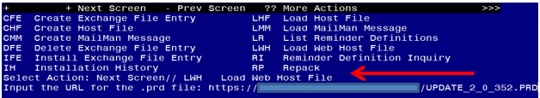

At the **Select Action:** prompt, enter **LWH** for Load Web Host File

At the **Input the url for the .prd file:** prompt, type the following web address:

**https://REDACTED/UPDATE_2_0_352.PRD**

You should see a message at the top of your screen that the file successfully loaded.

Navigate to the exchange entry named UPDATE_2_0_352 VA-TERATOGENIC MEDS ORDER CHECKSUPDATE 2023_01

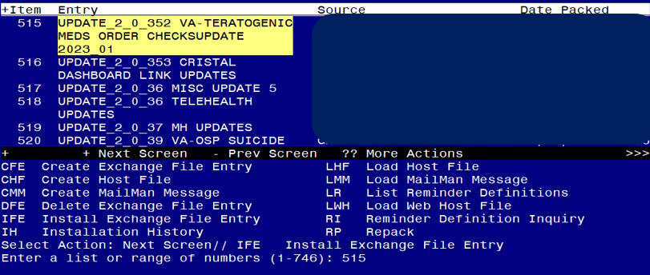

At the **Select Action** prompt, enter **IFE** for Install Exchange File Entry

Enter the number that corresponds with your entry **UPDATE_2_0_352 VA-TERATOGENIC MEDS ORDER CHECKSUPDATE 2023_01** *(in this example it is entry 515, it will vary by site, The exchange date should be 03/07/2023).*

Screen shot of a list of the items that were selected by the reminder developers for packing to include with the selected reminder exchange item.  For the Select Action for Install Exchange File IA for Install All is entered.



At the **Select Action** prompt, type **IA** for Install all Components and hit enter.

Any items that are NEW in any categories, you should INSTALL

If you are prompted to overwrite any reminder general findings, you should choose SKIP – you will install the new ones

If you are prompted to overwrite any health factors, you should choose SKIP - You will install the new ones

If you are prompted to overwrite any reminder sponsor, you should choose SKIP

If you are prompted to overwrite any reminder taxonomies, you should choose SKIP

If you are prompted to overwrite any reminder terms, you should choose SKIP – You will install the new terms

If you are prompted to overwrite any reminder definitions, you should choose SKIP

If you are prompted to overwrite any REMINDER ORDER CHECK RULES, you should choose SKIP

If you are prompted to overwrite any REMINDER ORDER CHECK ITEMS GROUP, you should choose Overwrite

** In your test account, when overwriting the reminder order check groups, some newer drugs (DG findings) may not exist, choose Delete if prompted to replace an entry**

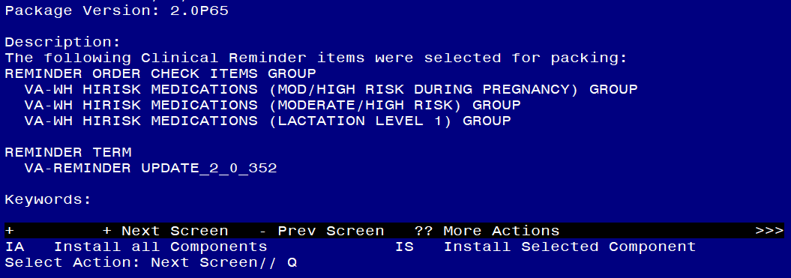

You will then be returned to this screen. At the **Select Action** prompt, type **Q.**

Install Complete

# Post-Install Set-up Instructions

Installation of this update should not have impacted your order check rules, but as a safety measure, you should confirm the WH order check rules listed below are in PROD status and if they are not, update them using the Vista Menu Add/Edit Reminder Order Check Rule

VA-WH HIRISK MEDS (MODERATE/HIGH RISK) NO PREG DOC RULE

VA-WH HIRISK MEDS (MODERATE/HIGH RISK) NOT PREG RULE

VA-WH HIRISK MEDS (MODERATE/HIGH RISK) PREG RULE

VA-WH HIRISK MEDS (LACT 1) EXPIRED DOC RULE

VA-WH HIRISK MEDS (LACT 1) RULE

The option represented here is **Add/Edit Reminder Order Check Rule [PXRM ORDER CHECK RULE EDIT].**

Select Reminder Order Check Menu <TEST ACCOUNT> Option: **RE** Add/Edit Reminder Order Check Rule

Select Reminder Order Check Rule by one of the following:

N: ORDER CHECK RULE NAME

R: REMINDER DEFINITION

T: REMINDER TERM

Q: QUIT

Select Reminder Order Check Rule by: (N/R/T/Q): N// <ENTER>

ORDER CHECK RULE NAME

Select Reminder Order Check Rule: **VA-WH HIRISK MEDS (MODERATE/HIGH RISK) NO PREG DOC RULE**

**RULE NAME:** **VA-WH HIRISK MEDS (MODERATE/HIGH RISK) NO PREG DOC RULE**

**DISPLAY NAME**: **Known/Potential Unsafe Medication (High Risk-to-Benefit Ratio)**

**STATUS**: **PROD**

**CLASS**: **NATIONAL**

SPONSOR: **WOMEN VETERANS HEALTH PROGRAM**

REVIEW DATE:

_____________________________________________________________

I=INACTIVE, P=PRODUCTION, T=TESTING

**Repeat for all the listed Reminder Order Check Rules**