

**Update _2_0_353**

Clinical Reminders

VA-CRISTAL DASHBOARD Link Updates

Install Guide

**March 2023**

Product Development

Office of Information Technology

Department of Veterans Affairs

Table of Contents

Introduction 1

Install Details 2

Install Example 3

Post Installation 6

# Introduction

This installation will update the CRISTAL Dashboard TIU hyperlink and text in the four following reminder dialogs. Also, a new option and health factor is added to the VA-MH COMPACT ACT 201 ENCOUNTER dialog.

The post-installation steps must be completed immediately following installation.

Updated VA-COMMUNITY CARE-EMER SP CARE COORD PLAN NOTE dialog:

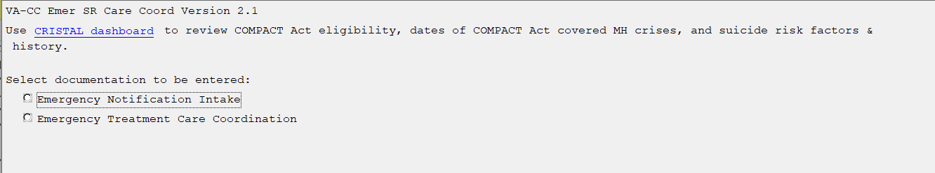

Update VA-COMMUNITY CARE-CARE COORD PLAN NOTE dialog:

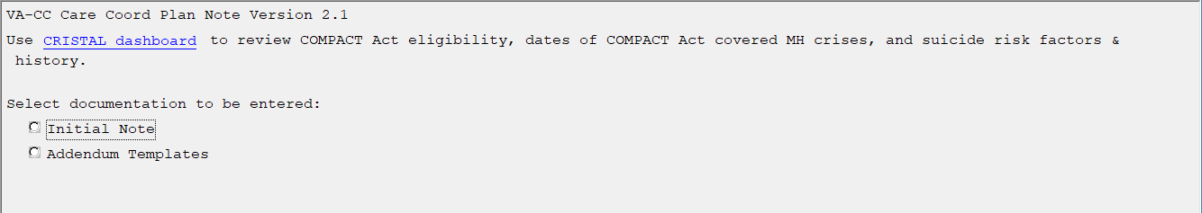

Updated VA-OSP SBOR NOTE dialog:

Screen shot showing the Update VA-OSP SBOR NOTE dialog that reads:
Use this template to report both drug overdoses and suicidal behavior, specifically:
-Behaviors with suicidal or undetermined intent. (For this note, suicidal intent is not considered a behavior; only behaviors, including preparatory behaviors, should be reported.)
-Any overdoses, including accidental, intentional and adverse effect overdoses.

Only one event at a time should be reported withing this template.  If multiple events need to be reported, please enter a new SBOR note for each event.

CRISTAL dashboard: The CAPRI, REACH VET, Risk Indicators, SORM Tool for Analytic Lookup (CRISTAL) dashboard provides patient summary information from all VA records to quickly assess known health care needs and risks of suicide, overdose and other adverse events.

Click here for a printable blank SBOR template as an alternative to referring on-screen instructions.

Updated VA-MH COMPACT ACT 201 ENCOUNTER dialog:

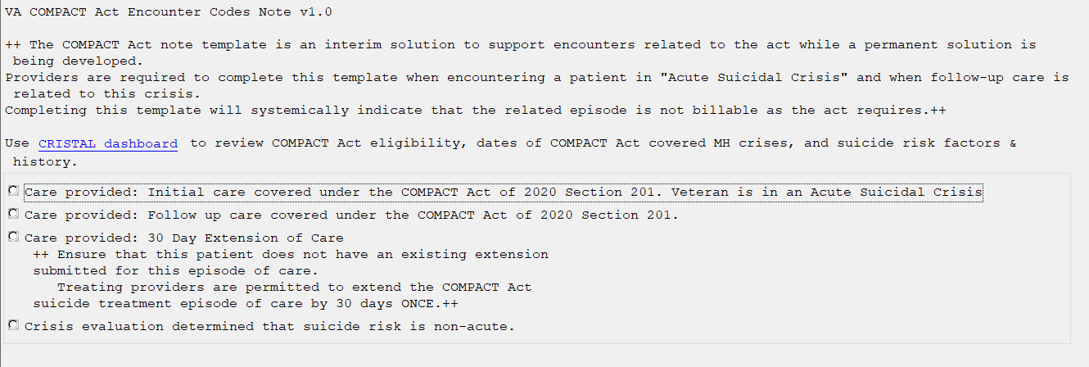

**The exchange file contains the following components:**

**TIU TEMPLATE FIELD**

|  |
| --- |
| VA-OSP CRISTAL  VA-OSP DATE EG  VA-OSP BLANK SBOR  GEN WORD PROC REQ LARGE |

**HEALTH FACTORS**

VA-UPDATE_2_0_353

VA-COMPACT ACT 201

VA-COMPACT ACT SUICIDE RISK NONACUTE

VA-COMPACT ACT SUICIDE TX ENCOUNTER EXTENSION OF CARE

VA-COMPACT ACT SUICIDE TX ENCOUNTER FOLLOW UP

VA-COMPACT ACT SUICIDE TX ENCOUNTER INITIAL

VA-SUICIDE BEHAVIOR AND OVERDOSE REPORT

VA-SBOR EVENT DATE

**REMINDER SPONSOR**

OFFICE OF MH AND SUICIDE PREVENTION

VHA OFFICE OF COMMUNITY CARE

**REMINDER TAXONOMY**

VA-MH COMPACT ACT R45.851

VA-MH COMPACT ACT T14.91XS

VA-MH COMPACT ACT T14.91XD

VA-MH COMPACT ACT CPT T2034

VA-MH COMPACT ACT SI CODE AND CPT

VA-MH COMPACT ACT T14.91XA

**REMINDER DIALOG**

VA-COMMUNITY CARE-EMER SP CARE COORD PLAN NOTE

VA-COMMUNITY CARE-CARE COORD PLAN NOTE

VA-MH COMPACT ACT 201 ENCOUNTER

VA-OSP SBOR NOTE

Install Details

This update is being distributed as a web host file. The address for the host file is: **https://vaww.va.gov/reminders/docs/UPDATE_2_0_353.PRD**

Installation:

=============

This update can be loaded with users on the system. Installation will take less than 5 minutes.

# Install Example

To Load the Web Host File. Navigate to Reminder exchange in Vista

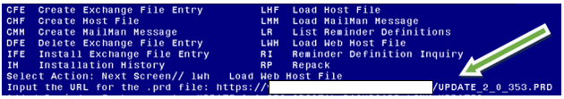

At the **Select Action:** prompt, enter **LWH** for Load Web Host File

At the **Input the url for the .prd file:** prompt, type the following web address:

**https://vaww.va.gov/reminders/docs/UPDATE_2_0_353.PRD**

You should see a message at the top of your screen that the file successfully loaded.

Search and locate an entry titled **UPDATE_2_0_353 CRISTAL DASHBOARD LINK UPDATES** in reminder exchange. 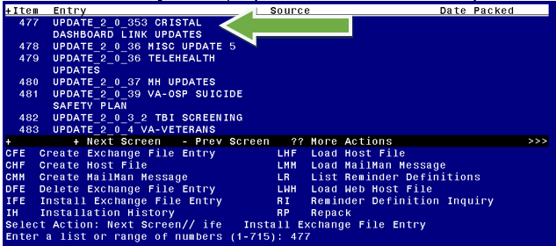

At the **Select Action** prompt, enter **IFE** for Install Exchange File Entry

Enter the number that corresponds with your entry **UPDATE_2_0_353 CRISTAL DASHBOARD LINK UPDATES**

*(In this example it is entry 477. It will vary by site).* The date of the exchange file should be 3/3/2023.

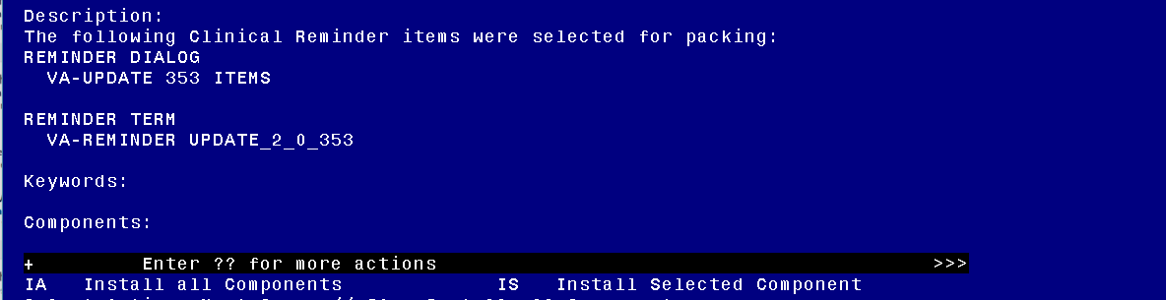

At the **Select Action** prompt, type **IA** for Install all Components and hit enter.

Select Action: Next Screen// **IA**  Install all Components

You will see several prompts, for all new entries you will choose **I to Install**

For the existing **VA-OSP-CRISTAL** template field, choose **O to Overwrite**.

TIU TEMPLATE FIELD entry named VA-OSP CRISTAL already exists but the

packed component is different, what do you want to do?

Select one of the following:

C Create a new entry by copying to a new name

O Overwrite the current entry

U Update

Q Quit the install

S Skip, do not install this entry

Enter response: O// Overwrite the current entry

Are you sure you want to overwrite? N// YES...

For all other existing items, choose **S to Skip**.

**You will be promped to install the reminder dialog component (VA-UPDATE 353 ITEMS).** You will choose to install all even though some components may have an X to indicate that they exist.

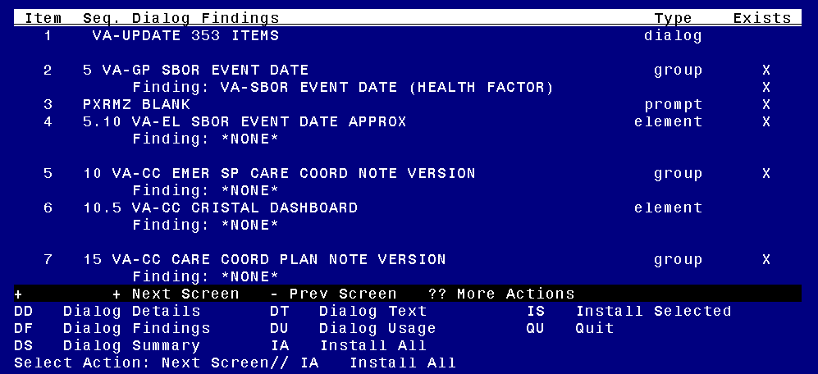

At the **Select Action** prompt, type **IA** to install the dialog.

Install reminder dialog and all components with no further changes: **Yes**

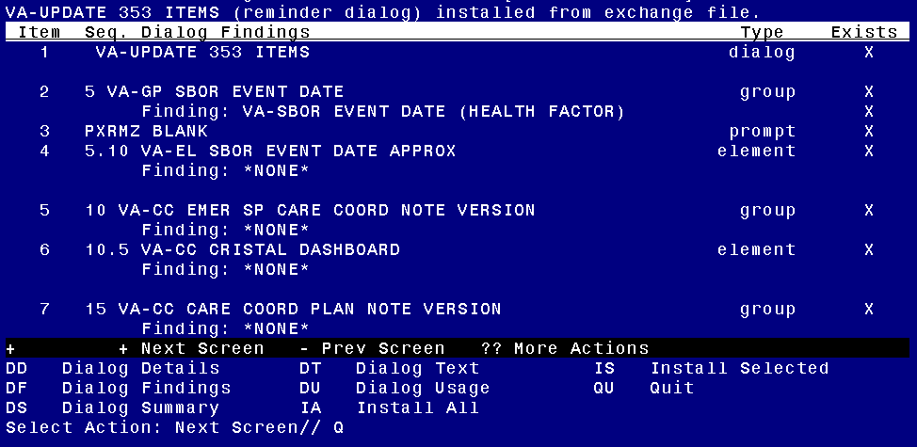

After completing this dialog install, you will type **Q**.

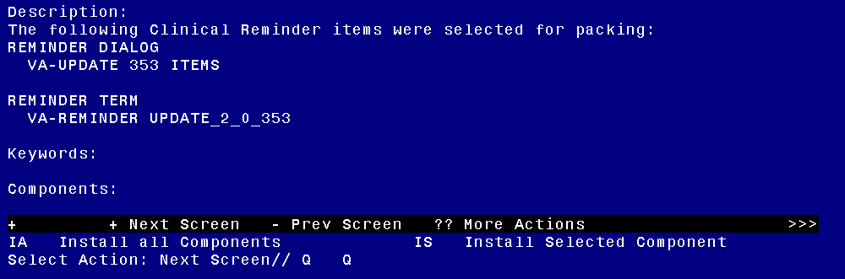

You will then be returned to this screen. At the **Select Action** prompt, type **Q.**

Install complete.

# Post Installation

1. In CPRS, edit the URL in the Template Field titled “VA-OSP CRISTAL”. You will only need to replace the text “STATIONIDHERE” with your facility’s station number.
2. Replace STATIONIDHERE with your 3- or 5-digit numeric station number.
3. DO NOT replace the DUZ or APP code and DO NOT add any other characters (e.g., brackets, parentheses, spaces)

*Example:* <https://redacted/>

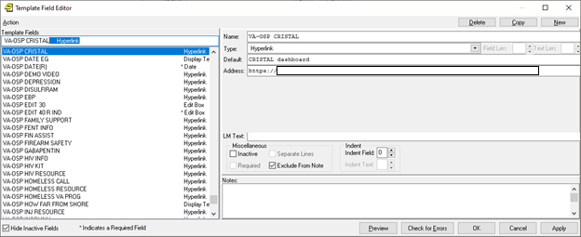

***NOTE****: If there are any questions or problems during the installation, please notify your local IT support to log a national help desk ticket or contact the VA Service Desk and have them submit a national ticket to:*

*Category: Affected Service*

*Affected Service: VistA – CPRS: Clinical Reminders*