

**Update_2_0_354**

Clinical Reminders

VA-WH OSTEOPOROSIS UPDATE

Install Guide

**April 2023**

Product Development

Office of Information Technology

Department of Veterans Affairs

**Table of Contents**

Introduction 1

Install Details 3

Install Example 3

Post Installation 6

# Introduction

The osteoporosis screening clinical reminder has been updated in the following ways:

1. Add an option to temporarily satisfy the reminder by documenting that the exam had been ordered or had been scheduled has been added
2. Update the period of time in which options satisfy the clinical reminder
   1. The Office of Women’s Health reviewed all the WH clinical reminders for these time periods and found they were not consistent between reminders. These include when documenting an order has been place, the reminder is deferred, or when the patient declines the screen.  Updates to the timeframes were changed in this reminder to be consistent:
      1. Order documentation resolve for 3 months
      2. Patient decline resolve for 1 year

Updated reminder dialog:

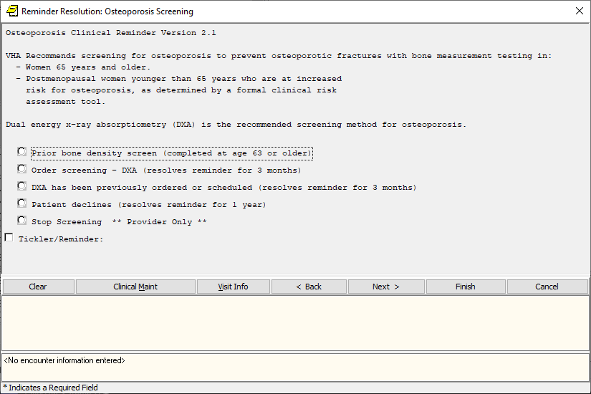

**UPDATE_2_0_354 contains 1 Reminder Exchange entry:**

UPDATE_2_0_354 VA-WH OSTEOPOROSIS UPDATE

**The exchange file contains the following components:**

**REMINDER GENERAL FINDINGS**

TICKLER REMINDER COMMENT

TICKLER REMINDER

**HEALTH FACTORS**

VA-REMINDER UPDATES [C]

VA-UPDATE_2_0_354

VA-WH OSTEOPOROSIS [C]

VA-WH OSTEO DXA ORDERED OR SCHEDULED

VA-WH OSTEO STOP SCREENING COMORBID

VA-WH OSTEO LIFE EXPECTANCY LESS THAN 5Y

REMINDER FACTORS [C]

LIFE EXPECTANCY < 6 MONTHS

VA-WH OSTEO DECLINE DXA

VA-WH OSTEO ORDER DXA

VA-WH OSTEO DXA SCREEN COMP WRITTEN NO

VA-WH OSTEO DXA SCREEN COMP WRITTEN YES

**REMINDER SPONSOR**

NATIONAL CENTER FOR HEALTH PROMOTION AND DISEASE PREVENTION (NCP)

WOMEN VETERANS HEALTH PROGRAM

**REMINDER TAXONOMY**

VA-WH OSTEOPOROSIS

VA-TERMINAL CANCER PATIENTS

VA-WH OSTEO DXA COMPLETE

**REMINDER TERM**

VA-REMINDER UPDATE_2_0_354

VA-WH OSTEO STOP SCREENING

VA-WH OSTEO PATIENT DECLINED

VA-WH OSTEO SCREEN ORDER

VA-WH OSTEO OUTSIDE SCREEN

VA-WH OSTEO SCREEN COMPLETED

**REMINDER DEFINITION**

VA-WH OSTEOPOROSIS

**REMINDER DIALOG**

VA-WH OSTEOPOROSIS SCREENING

**Pre-Install**

1. Using the VistA menu Reminder Dialog Manager, Reminder Dialog, change your view to elements and do an inquire/print on the reminder dialog element VA-OSTEO ORDER SCREEN, you will need to use this as a reference to use when adding the orderable items during post-install:

# Install Details

This update is being distributed as a web host file. The address for the host file is: **https://REDACTED/UPDATE_2_0_354.PRD**

The file will be installed using Reminder Exchange, programmer access is not required.

Installation:

=============

This update can be loaded with users on the system. Installation will take less than 30 minutes.

# Install Example

To Load the Web Host File. Navigate to Reminder exchange in Vista

At the **Select Action:** prompt, enter **LWH** for Load Web Host File

At the **Input the url for the .prd file:** prompt, type the following web address:

**https://REDACTED/UPDATE_2_0_354.PRD**

You should see a message at the top of your screen that the file successfully loaded.

Search for and locate the reminder exchange entry titled UPDATE_2_0_354 VA-WH OSTEOPOROSIS UPDATE.

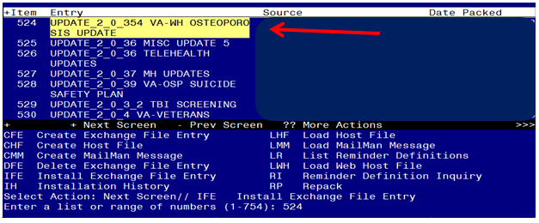

At the **Select Action** prompt, enter **IFE** for Install Exchange File Entry

Enter the number that corresponds with your entry titled **UPDATE_2_0_354 VA-WH OSTEOPOROSIS UPDATE**  *(in this example it is entry 508, it will vary by site).* The exchange file date should be 03/21/2023.

Screen shot of a list of the items that were selected by the reminder developers for packing to include with the selected reminder exchange item.  For the Select Action for Install Exchange File IA for Install All is entered.



At the **Select Action** prompt, type **IA** for Install all Components and hit enter.

Select Action: Next Screen// IA Install all Components

**You will see several prompts**:

For all new components, choose **I to Install**

**For existing components, choose O to Overwrite.**

**You will be promped to install the dialog component:**

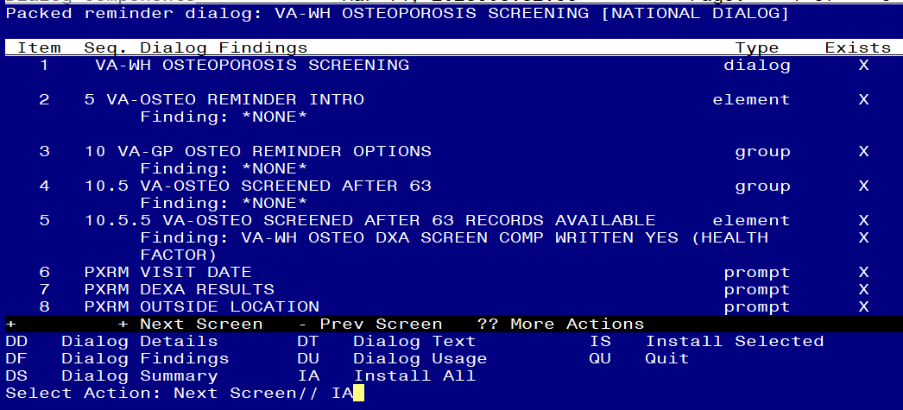

At the **Select Action** prompt, type **IA** to install the dialog – **VA-WH OSTEOPOROSIS SCREENING**

Select Action: Next Screen// IA Install All

Install reminder dialog and all components with no further changes: Y// ES

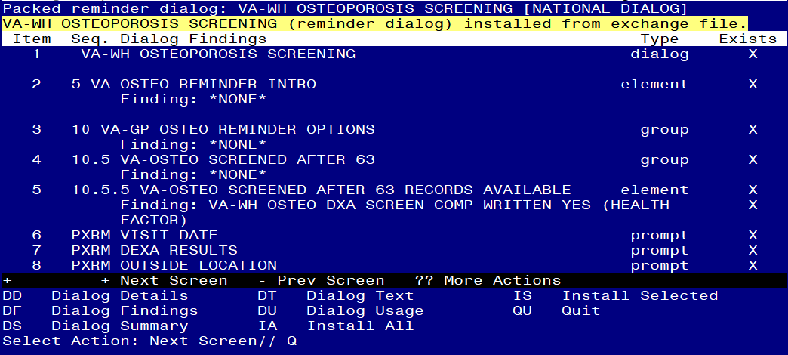

When the dialog has completed installation, you will then be returned to this screen. At the **Select Action** prompt, type **Q.**

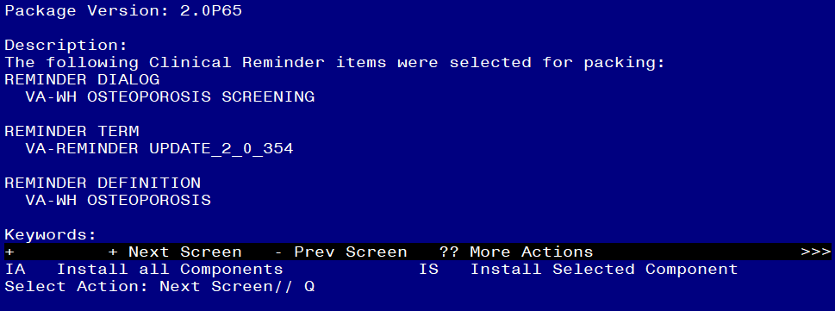

You will be returned to this screen. Type Q to quit.

Install Completed

# Post Installation

1. Add Order to the reminder dialog - Add the local quick order identified in the pre-install for dual energy x-ray absorptiometry (DXA) as an additional finding to the element: VA-OSTEO ORDER SCREEN.
2. Launch the **Osteoporosis Screening clinical reminder** and confirm the version number is 2.1