

**Update _2_0_355**

Clinical Reminders

VA-MENTAL HEALTH TEMPLATES

Install Guide

**September 2023**

Product Development

Office of Information Technology

Department of Veterans Affairs

Table of Contents

Introduction 1

Install Details 7

Install Example 8

Post Installation 13

# Introduction

This reminder update contains three new reminder dialogs templates. Only one will be activated for use in CPRS at this time.

1. **MENTAL HEALTH TREATMENT COORDINATOR (MHTC) ASSIGNMENT/REASSIGNMENT/UNASSIGNMENT NOTE**

The Mental Health Treatment Coordinator (MHTC) Assignment/Reassignment/Unassignment note template used by the MHTC 2.0 Care Coordinator (CC) or other member of the BHIP team to document the Veteran’s MHTC 2.0 assignment/reassignment/unassignment in the medical record.

MHTC assignment should be made as soon as possible after it is determined the Veteran is need of BHIP level of care.

MHTC Reassignment should be made:

* + Changes should be minimal and based on clinical need
  + Need to be planned and occur in collaboration with the Veteran (as possible)
  + If role of the MHTC changes (e.g., retirement or job change), the MHTC can be reassigned – batch assignments may be used.

MHTC Unassignment should be made:

* + MH care plan should specify treatment course
  + If intended contact frequency is less than once every six months – consider step down to lower level of care.
  + MHTC should outreach Veterans who have not been seen in six months and have no future BHIP appointment.
  + Exception to six-month inactivity:
    - Veteran prefers MHTC to be unassigned
    - Veteran transfers to another facility (where MHTC assigned)
    - Veteran is discharged to PACT
    - Veteran dies

1. **MENTAL HEALTH TREATMENT COORDINATOR (MHTC) CARE COORDINATION (CC) NEEDS ASSESSMENT AND INTERVENTION NOTE**

The Mental Health Treatment Coordinator (MHTC) Care Coordination (CC) Needs Assessment and Intervention note is a note template used by the MHTC 2.0 Care Coordinator to assess the current needs and interventions needed for Veterans referred to the Behavioral Health Integrated Program (BHIP).

This template will be used by the MHTC 2.0 CC throughout a Veteran’s episode of care on the BHIP Team. The first time this note will be utilized is after the Veteran has had a warm handoff or is consulted to the BHIP Team. Prior to the usage of this note, the MHTC 2.0 will ensure the Veteran has received a five elemental mental health screen as clinically appropriate. The CC Needs Assessment and Intervention note is completed during the warm handoff from various clinic locations or at receipt of a BHIP consult. Depending on a facility’s access, if the intake provided by the BHIP LIP/APP may be completed prior to the completion of the CC Needs Assessment and Intervention note. After assessment with this note, it may be determined the MHTC 2.0 will serve as a point of contact (POC) only, thus no further documentation is required. However, if an intervention plan is assessed as clinically necessary, the MHTC 2.0 will determine the cadence for follow-up and utilize the CC Needs Assessment and Intervention note to document subsequent needs assessments and interventions made.

1. **MENTAL HEALTH FLOW DISCHARGE NOTE**

The Offices of MH and PC have collaborated in developing this mental health discharge template that will improve quality and efficiency of care provided to Veterans with mental health (MH) needs, enabling them to receive follow up care in a PC setting when discharge from specialty MH care is indicated.

More specifically, the form will be used by VA MH providers to discharge Veterans receiving specialty MH care back to PC when they have:

* completed the goals of MH specialty care,
* are stable on medications routinely prescribed by PC providers

and/or

* are disinclined or unable to engage further in specialty MH care.

UPDATE_2_0_355 contains 1 Reminder Exchange entry:

**UPDATE_2_0_355 VA-MENTAL HEALTH TEMPLATES**

**The exchange file contains the following components:**

**TIU TEMPLATE FIELD**

VA-MH TREATMENT COORDINATOR VETERAN AND/OR FAMILY

VA-OTHER TEXT

VA-BLANK SP

VA-DATE ONLY

VA-DATE DEFAULT TODAY

VA-WP 65/3

VA-ADDITIONAL COMMENTS

VA-WORD

VA-BLANK IN PN TEXT

VA-MOBILE

VA-STORM LINK

VA-WORDR

VA-DATE ONLY R

**HEALTH FACTORS**

VA-REMINDER UPDATES [C]

VA-UPDATE_2_0_355

VA-MH TX ASSIGNMENT [C]

VA-MH-BHIP-VET OTHER

VA-MH-BHIP-VET DISCHARGE

VA-MH-BHIP-VET NEW FACILITY

VA-MH-BHIP-VET CITC

VA-MH-BHIP-VET PREFER UN

VA-MH-BHIP-UNASSIGN

VA-MHTC CCI [C]

VA-MHTC PCMM NOTES

VA-MH-BHIP-REASS-OTH

VA-MH-BHIP-REASS-REQUEST

VA-MH-BHIP-REASS-TEAM

VA-MH-BHIP-REASS-TRANS

MENTAL HEALTH [C]

MENTAL HEALTH TREATMENT COORDINATOR

VA-MH-BHIP-REASSIGN

VA-MH-BHIP-INITIAL ASSIGN

VA-MH-BHIP-INT-OTHGEN-OG

VA-MH-BHIP-INT-OTHGEN-FU

VA-MH-BHIP-INT-OTHGEN-TODAY

VA-MH-BHIP-FU-MODALITY

VA-MH-BHIP-FU-FREQUENCY

VA-MH-BHIP-INT-COMRESOURCES-OG

VA-MH-BHIP-INT-COMRESOURCES-FU

VA-MH-BHIP-INT-COMRESOURCES-TODAY

VA-MH-BHIP-INT-WH-OG

VA-MH-BHIP-INT-WH-FU

VA-MH-BHIP-INT-WH-TODAY

VA-MH-BHIP-INT-MMOBILE-OG

VA-MH-BHIP-INT-MMOBILE-FU

VA-MH-BHIP-INT-MMOBILE-TODAY

VA-MH-BHIP-INT-SELF-OG

VA-MH-BHIP-INT-SELF-FU

VA-MH-BHIP-INT-SELF-TODAY

VA-MH-BHIP-INT-PEER-OG

VA-MH-BHIP-INT-PEER-FU

VA-MH-BHIP-INT-PEER-TODAY

VA-MH-BHIP-INT-SUBMITCONS-OG

VA-MH-BHIP-INT-SUBMITCONS-FU

VA-MH-BHIP-INT-SUBMITCONS-TODAY

VA-MH-BHIP-INT-SUBMITCONS

VA-MH-BHIP-INT-EDSERVICE-OG

VA-MH-BHIP-INT-EDSERVICE-FU

VA-MH-BHIP-INT-EDSERVICE-TODAY

VA-MH-BHIP-INT-REVIEWSTORM-OG

VA-MH-BHIP-INT-REVIEWSTORM-FU

VA-MH-BHIP-INT-REVIEWSTORM-TODAY

VA-MH-BHIP-INT-NALOX-OG

VA-MH-BHIP-INT-NALOX-FU

VA-MH-BHIP-INT-NALOX-TODAY

VA-MH-BHIP-INT-EDREFILL-OG

VA-MH-BHIP-INT-EDREFILL-FU

VA-MH-BHIP-INT-EDREFILL-TODAY

VA-MH-BHIP-INT-MEDREFILL-OG

VA-MH-BHIP-INT-MEDREFILL-FU

VA-MH-BHIP-INT-MEDREFILL-TODAY

VA-MH-BHIP-INT-EDMEDAD-OG

VA-MH-BHIP-INT-EDMEDAD-FU

VA-MH-BHIP-INT-EDMEDAD-TODAY

VA-MH-BHIP-INT-CONSHRF-OG

VA-MH-BHIP-INT-CONSHRF-FU

VA-MH-BHIP-INT-CONSHRF-TODAY

VA-MH-BHIP-INT-HRF-OG

VA-MH-BHIP-INT-HRF-FU

VA-MH-BHIP-INT-HRF-TODAY

VA-MH-BHIP-INT-DCFU-OG

VA-MH-BHIP-INT-DCFU-FU

VA-MH-BHIP-INT-DCFU-TODAY

VA-MH-BHIP-INT-PDENEEDS-OG

VA-MH-BHIP-INT-PDENEEDS-FU

VA-MH-BHIP-INT-PDENEEDS-TODAY

VA-MH-BHIP-INT-COR-SPC-OG

VA-MH-BHIP-INT-COR-SPC-FU

VA-MH-BHIP-INT-COR-SPC-TODAY

VA-MH-BHIP-INT-SP2-OG

VA-MH-BHIP-INT-SP2-FU

VA-MH-BHIP-INT-SP2-TODAY

VA-MH-BHIP-INT-GUNLOCK-OG

VA-MH-BHIP-INT-GUNLOCK-FU

VA-MH-BHIP-INT-GUNLOCK-TODAY

VA-MH-BHIP-INT-LMA-OG

VA-MH-BHIP-INT-LMA-FU

VA-MH-BHIP-INT-LMA-TODAY

VA-MH-BHIP-INT-SAFEPLAN-OG

VA-MH-BHIP-INT-SAFEPLAN-FU

VA-MH-BHIP-INT-SAFEPLAN-TODAY

VA-MH-BHIP-INT-CSRE-OG

VA-MH-BHIP-INT-CSRE-FU

VA-MH-BHIP-INT-CSRE-TODAY

VA-MH-BHIP-INT-CONSULTEAM-OG

VA-MH-BHIP-INT-CONSULTEAM-FU

VA-MH-BHIP-INT-CONSULTEAM-TODAY

VA-MH-BHIP-INT-COPROVIDER-OG

VA-MH-BHIP-INT-COPROVIDER-FU

VA-MH-BHIP-INT-COPROVIDER-TODAY

VA-MH-BHIP-INT-CASEREV-OG

VA-MH-BHIP-INT-CASEREV-FU

VA-MH-BHIP-INT-CASEREV-TODAY

VA-MH-BHIP-INT-OTHGEN

VA-MH-BHIP-FOLLOWUP-CC-SIGNIFICANT CHANGES

VA-MH-BHIP-INT-OTHGEN-NA

VA-MH-BHIP-INT-COMRESOURCES-NA

VA-MH-BHIP-INT-WH-NA

VA-MH-BHIP-INT-MMOBILE-NA

VA-MH-BHIP-INT-SELF-NA

VA-MH-BHIP-INT-PEER-NA

VA-MH-BHIP-INT-SUBMITCONS-NA

VA-MH-BHIP-INT-EDSERVICE-NA

VA-MH-BHIP-INT-REVIEWSTORM-NA

VA-MH-BHIP-INT-NALOX-NA

VA-MH-BHIP-INT-EDREFILL-NA

VA-MH-BHIP-INT-MEDREFILL-NA

VA-MH-BHIP-INT-EDMEDAD-NA

VA-MH-BHIP-INT-CONSHRF-NA

VA-MH-BHIP-INT-HRF-NA

VA-MH-BHIP-INT-DCFU-NA

VA-MH-BHIP-INT-PDENEEDS-NA

VA-MH-BHIP-INT-COR-SPC-NA

VA-MH-BHIP-INT-SP2-NA

VA-MH-BHIP-INT-GUNLOCK-NA

VA-MH-BHIP-INT-LMA-NA

VA-MH-BHIP-INT-SAFEPLAN-NA

VA-MH-BHIP-INT-CSRE-NA

VA-MH-BHIP-INT-CONSULTEAM-NA

VA-MH-BHIP-INT-COPROVIDER-NA

VA-MH-BHIP-INT-CASEREV-NA

VA-MH-BHIP-FOLLOWUP-CC-PLAN

VA-MH-BHIP-INITIAL-CC-PLAN

VA-MH DISCHARGE FLOW [C]

VA-MH FLOW DC REASON VETERAN PERSUING COMMUNITY MH CARE

VA-MH FLOW DC REASON VETERAN PREFER OTHER

VA-MH FLOW DC REASON VETERAN MOVING

VA-MH FLOW DC REASON VETERAN NOT INTERESTED

VA-MH FLOW DC REASON VETERAN PREFER

VA-MH FLOW DC REASON LACK OF ENGAGEMENT

VA-MH FLOW DC REASON POOR ADHERE MED

VA-MH FLOW DC REASON INCONSISTENT ATTENDANCE

VA-MH FLOW DC REASON UNABLE TO ENGAGE

VA-MH FLOW DC REASON COMPLETED PHARMACOTHERAPY

VA-MH FLOW DC REASON COMPLETED PSYCHOTHERAPY

VA-MH FLOW DC OTHER

VA-MH FLOW DC OCC ED FUNCTIONING

VA-MH FLOW DC BEHAVIOR

VA-MH FLOW DC INTERPERSONAL FUNCTION

VA-MH FLOW DC QUALITY OF LIFE

VA-MH FLOW DC SELF REPORT MH MEASURE

VA-MH FLOW DC REASON COMPLETED TREATMENT

VA-MH FLOW DC REASON MED STABLE

**REMINDER SPONSOR**

OFFICE OF MENTAL HEALTH SERVICES

OFFICE OF MH AND SUICIDE PREVENTION

VHA OFFICE OF MENTAL HEALTH AND SUICIDE PREVENTION

**REMINDER TERM**

VA-REMINDER UPDATE_2_0_355

**REMINDER DEFINITION**

VA-BL MH PCMM MHTC

VA-BL MHTC OTHER FU

VA-BL MHTC REFERRALS COMMUNITY FU

VA-BL MHTC REFERRALS WH FU

VA-BL MHTC REFERRALS MOBILE FU

VA-BL MHTC REFERRALS SELF FU

VA-BL MHTC REFERRALS PEER FU

VA-BL MHTC REFERRALS SUBMIT FU

VA-BL MHTC REFERRALS AVAILABLE FU

VA-BL MHTC MMI STORM FU

VA-BL MHTC MMI OVERDOSE FU

VA-BL MHTC MMI CONTACT FU

VA-BL MHTC MMI REFILL FU

VA-BL MHTC MMI ADHERENCE FU

VA-BL MHTC SRR ECONSULT FU

VA-BL MHTC SRR HRF FU

VA-BL MHTC SRR SBOB FU

VA-BL MHTC SRR DC FU

VA-BL MHTC SRR SPC FU

VA-BL MHTC SRR OFFER EB FU

VA-BL MHTC SRR GUNLOCK FU

VA-BL MHTC SRR LETHAL FU

VA-BL MHTC SRR NEW PLAN FU

VA-BL MHTC SRR NEW CSRE FU

VA-BL MHTC GI CONSULT FU

VA-BL MHTC GI COORDINATE FU

VA-BL MHTC GI CCR FU

**HEALTH SUMMARY TYPE**

VA-MH TREATMENT COORDINATOR

VA-MHTC OTHER INTERVENTION

VA-MHTC CONSULT ORDER

**HEALTH SUMMARY OBJECT**

VA-MH TREATMENT COORDINATOR (TIU)

VA-MHTC OTHER INTERVENTION (TIU)

VA-MHTC CONSULT ORDER (TIU)

**TIU DOCUMENT DEFINITION**

VA-MH TREATMENT COORDINATOR

VA-MHTC OTHER INTERVENTION

VA-MHTC CONSULT ORDER

**REMINDER DIALOG**

VA-MH TREATMENT COORDINATOR ASSIGNMENT

VA-MHTC CARE COORDINATION INTERVENTION

VA-MH FLOW DISCHARGE NOTE

# Install Details

This update is being distributed as a web host file. The address for the host file is: https://Redacted/UPDATE_2_0_355.PRD

The file will be installed using Reminder Exchange, programmer access is not required.

Installation:

=============

This update can be loaded with users on the system. Installation will take less than 5 minutes.

# Install Example

Go to Reminder exchange in Vista.

To Load the exchange file, use LWH. The URL is https://REDACTED/UPDATE_2_0_355.PRD

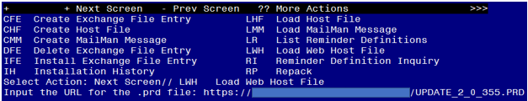

You will see a message indicating the file was loaded successfully.

Search and locate an entry titled UPDATE_2_0_355 VA-MENTAL HEALTH TEMPLATES in reminder exchange.

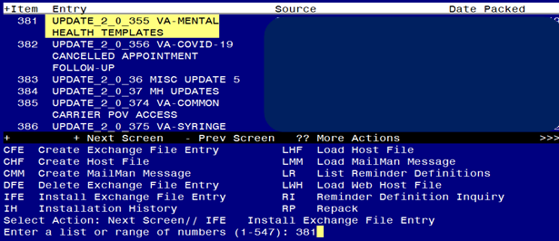

At the **Select Action** prompt, enter **IFE** for Install Exchange File Entry

Enter the number that corresponds with your entry titled UPDATE_2_0_355 VA-MENTAL HEALTH TEMPLATES *(in this example it is entry 381, it will vary by site)* that is dated 08/29/2023.

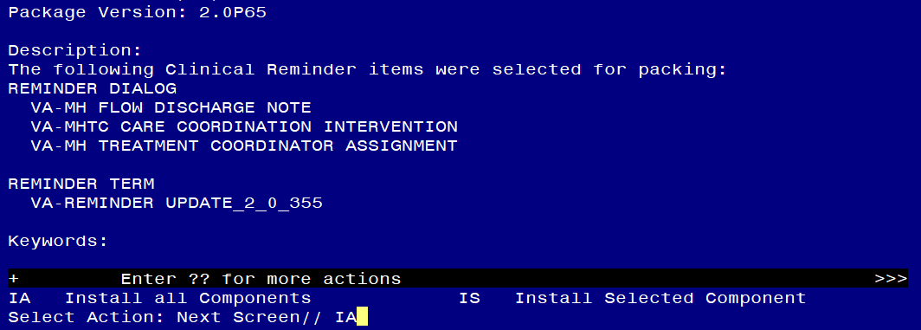

At the **Select Action** prompt, type **IA** for Install all Components and hit enter.

**For all new entries in any category you will choose I to Install**

**SKIP any items in any category you are prompted to overwrite.**

You will then be prompted to install the first dialog component.

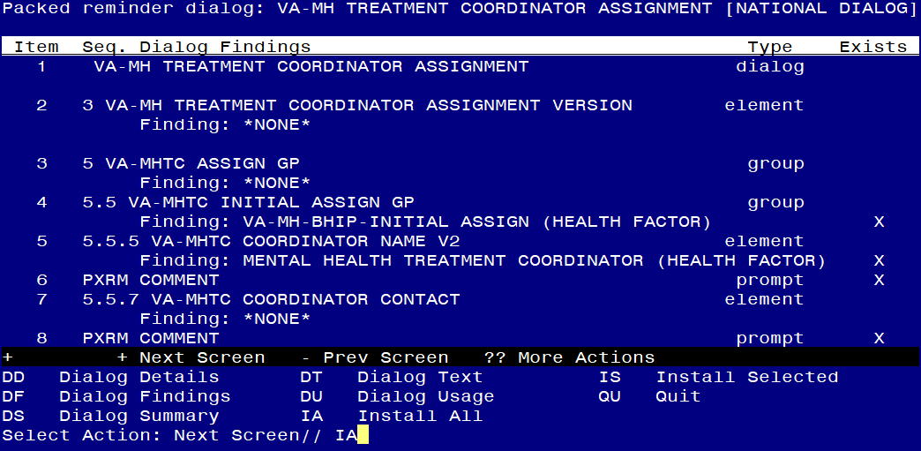

At the **Select Action** prompt, type **IA** to install the dialog – **VA-MH TREATMENT COORDINATOR ASSIGNMENT**

Install reminder dialog and all components with no further changes: Y//ES

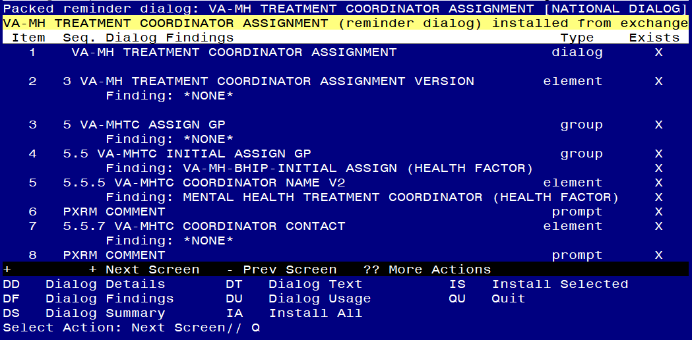

When the dialog has completed installation, you will then be returned to this screen. At the **Select Action** prompt, type **Q.**

You will then be prompted to install the next dialog component.

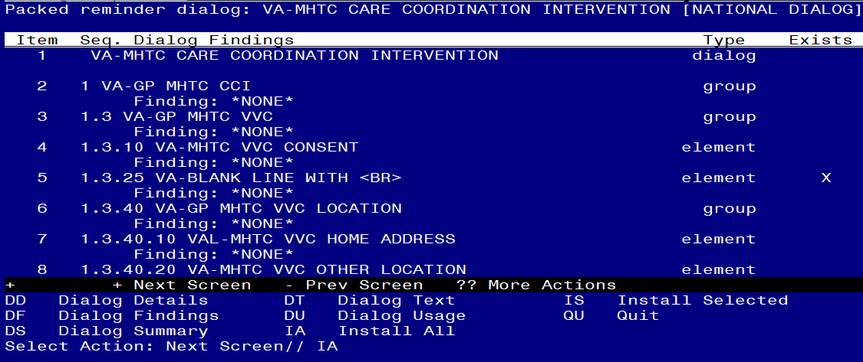

At the **Select Action** prompt, type **IA** to install the dialog – **VA-MHTC CARE COORDINATION INTERVENTION**

Install reminder dialog and all components with no further changes: Y//ES

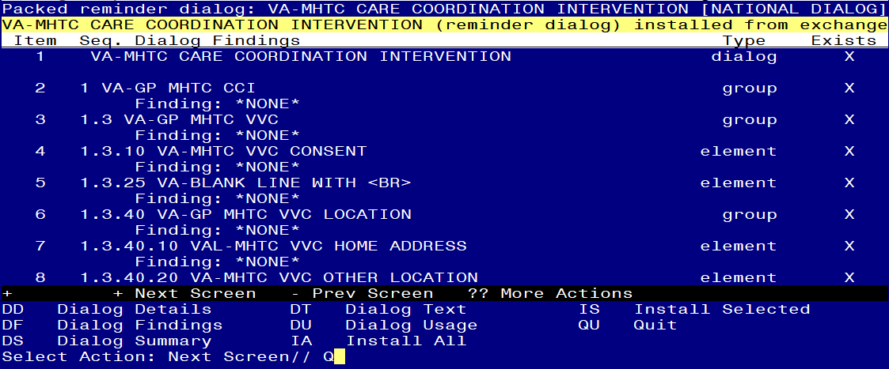

When the dialog has completed installation, you will then be returned to this screen. At the **Select Action** prompt, type **Q.**

You will then be prompted to install the next dialog component.

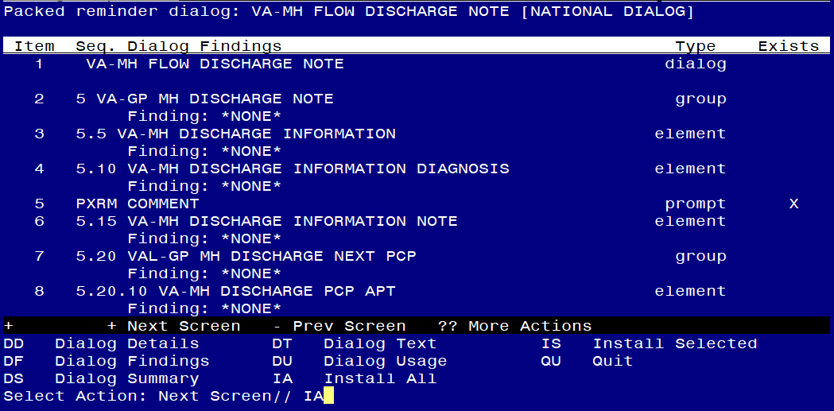

At the **Select Action** prompt, type **IA** to install the dialog – **VA-MH FLOW DISCHARGE NOTE**

Install reminder dialog and all components with no further changes: Y//ES

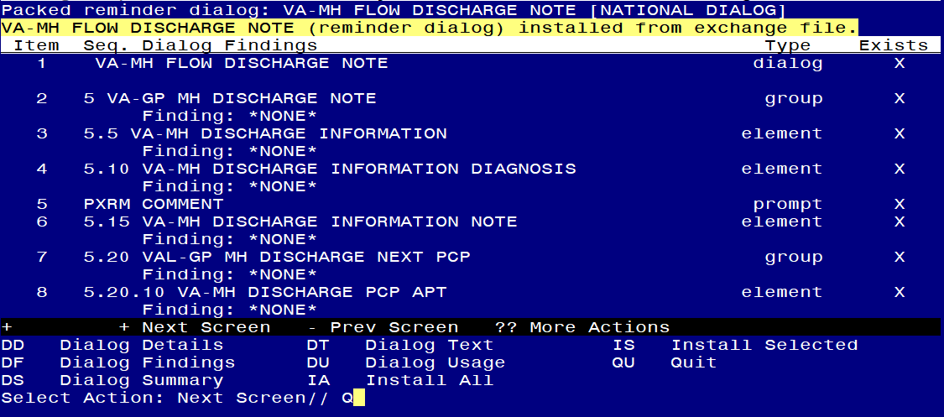

When the dialog has completed installation, you will then be returned to this screen. At the **Select Action** prompt, type **Q.**

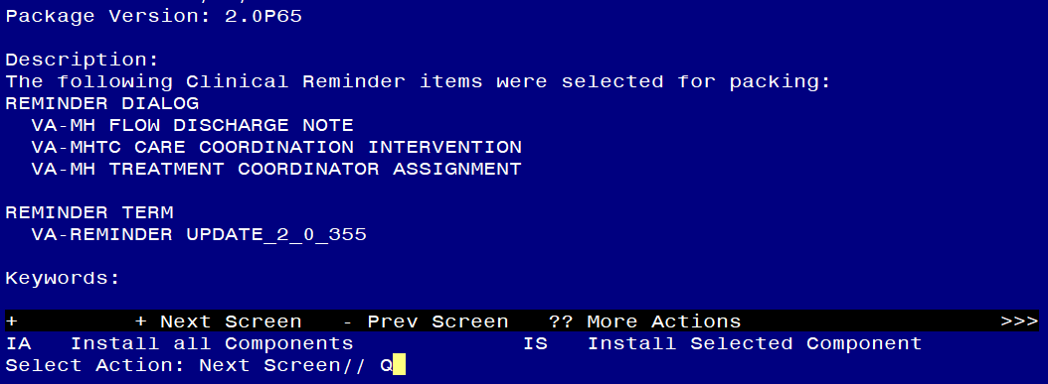

You will then be returned to this screen. At the **Select Action** prompt, type **Q.**

Install complete.

# Post Installation

**At the time of release, the post install will only be completed for one of the three templates, further guidance will come when the other two templates are ready to be used in CPRS.**

1. **Insert local objects into the VAL-GP MH DISCHARGE NEXT PCP group.**

Navigate to reminder dialog groups in VistA, locate the group, and follow the prompts below.

NAME: **VAL-GP MH DISCHARGE NEXT PCP** **<enter>**

DISABLE: **<enter>**

CLASS: LOCAL// **<enter>**

SPONSOR: **<enter>**

REVIEW DATE: **<enter>**

RESOLUTION TYPE: **<enter>**

ORDERABLE ITEM: **<enter>**

FINDING ITEM: **<enter>**

Additional findings: none

Select ADDITIONAL FINDING: **<enter>**

GROUP CAPTION: **<enter>**

PUT A BOX AROUND THE GROUP: **<enter>**

SHARE COMMON PROMPTS: **<enter>**

MULTIPLE SELECTION: ONE SELECTION ONLY// **<enter>**

HIDE/SHOW GROUP: **<enter>**

GROUP HEADER DIALOG TEXT:

\\NEXT PRIMARY CARE PROVIDER (PCP) APPOINTMENT

PCP name: INSERT OBJECT HERE

PACT team: INSERT OBJECT HERE

Edit? NO// **YES**

==[ WRAP ]==[INSERT ]====< GROUP HEADER DIALOG TEX[Press <PF1>H for help]====

\\NEXT PRIMARY CARE PROVIDER (PCP) APPOINTMENT

PCP name: INSERT OBJECT HERE

PACT team: INSERT OBJECT HERE

Replace the highlighted text with local TIU objects.

1. **Setup of Note Title.**

The suggested note titles to create to associate with these templates are:

MH FLOW DISCHARGE

VHA Enterprise Standard Title: MENTAL HEALTH NOTE

You can add this to the document class where mental health notes are stored.

***Note:*** *Comprehensive information on Creating new Document Classes and Titles can be found beginning on page 54 of the TIU/ASU Implementation Guide at the following link:* [*http://www.va.gov/vdl/documents/Clinical/CPRS-Text_Integration_Utility_(TIU)/tiuim.pdf*](http://www.va.gov/vdl/documents/Clinical/CPRS-Text_Integration_Utility_(TIU)/tiuim.pdf)

1. **Make the Dialog templates available to be attached to a Personal or Shared templates or to be able to attach the dialog to a progress note title.**

Select Reminder Managers Menu <TEST ACCOUNT> Option: **CP** CPRS Reminder Configuration

CA Add/Edit Reminder Categories

CL CPRS Lookup Categories

CS CPRS Cover Sheet Reminder List

MH Mental Health Dialogs Active

PN Progress Note Headers

RA Reminder GUI Resolution Active

TIU TIU Template Reminder Dialog Parameter

DEVL Evaluate Coversheet List on Dialog Finish

DL Default Outside Location

PT Position Reminder Text at Cursor

LINK Link Reminder Dialog to Template

TEST CPRS Coversheet Time Test

NP New Reminder Parameters

GEC GEC Status Check Active

WH WH Print Now Active

Select CPRS Reminder Configuration <TEST ACCOUNT> Option: **TIU** TIU Template Reminder Dialog Parameter

Reminder Dialogs allowed as Templates may be set for the following:

1 User USR [choose from NEW PERSON]

3 Service SRV [choose from SERVICE/SECTION]

4 Division DIV [SALT LAKE CITY]

5 System SYS [NATREM.FO-SLC.MED.VA.GOV]

Enter selection: **5** *Choose the appropriate number for your site. Your site may do this by System or other levels. The example below uses SYSTEM level.*

Setting Reminder Dialogs allowed as Templates for System: NATREM.FO-SLC.MED.VA.GOV

Select Display Sequence: **?**

388 VA-COVID-19 TELEPHONE FOLLOW-UP

389 VA-SRA-CONSULT RESPONSE (D)

*When you type a question mark above, you will see the list of #’s (with dialogs) that are already taken. Choose a number* ***NOT*** *on this list. For this example, 390 is not present so I will use 390.*

Select Display Sequence: **390**

Are you adding 390 as a new Display Sequence? Yes// **YES**

Display Sequence: 390// <Enter> 390

Clinical Reminder Dialog: **VA-MH FLOW DISCHARGE NOTE** reminder dialog NATIONAL

...OK? Yes// <Enter> (Yes)

1. **Connect the template to** the note titles.
2. In CPRS, open the Template Editor, expand Shared Templates, select the appropriate folder (if applicable), then click New Template (top right-hand corner).

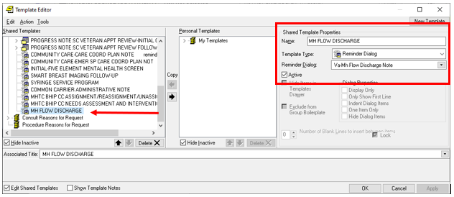

Type in the following information:

Name: **MH FLOW DISCHARGE**

Template Type: **Reminder Dialog**

Reminder Dialog: **VA-MH FLOW DISCHARGE NOTE**

Associated Title: **MH FLOW DISCHARGE**

–– then click Apply.

This template can also be added to your shared template folder for use with any note title.