

### Update _2_0_356

**Clinical Reminders**

**VA-COVID-19 CANCELLED APPOINTMENT FOLLOW-UP UPDATE**

**Install Guide**

### April 2022

Product Development Office of Information Technology Department of Veterans Affairs

Table of Contents

Introduction 3

Install Details 5

Install Example 5

Post Installation 8

# Introduction

DESCRIPTION:

The CPRS COVID-19 Cancelled Appointment Follow-up reminder dialog template is used in conjunction with the national VSSC COVID-19 report to document follow-up care for cancelled appointments.

Based on an OIG action item, updates to the Action Indicated section have been made:

* Removed the selection None, other
* Added four more selections –
  + None, Veteran moved/Relocated
  + None, Veteran discharged or withdrew from group/care
  + None, Veteran not eligible for care
  + None, scheduling error

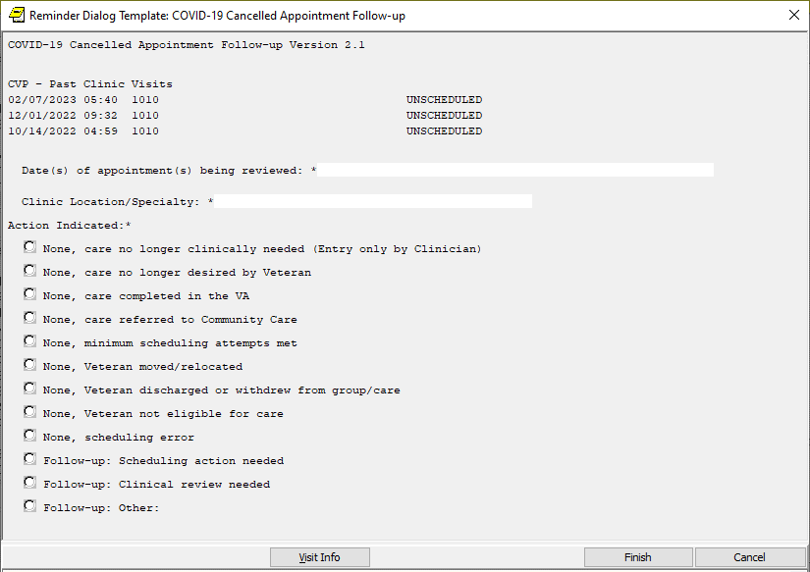

UPDATE_2_0_356 contains 1 Reminder Exchange entry:

#### UPDATE_2_0_356 VA-COVID-19 CANCELLED APPOINTMENT FOLLOW-UP

**The exchange file contains the following components:**

**TIU TEMPLATE FIELD**

VA-CLINIC LOCATION2

VA-TEXT (1-50 CHAR)R

**HEALTH FACTORS**

VA-REMINDER UPDATES [C]

VA-UPDATE_2_0_356

VA-COVID-19 [C]

VA-COVID-19 SCHEDULING ERROR

VA-COVID-19 VETERAN NOT ELIGIBLE FOR CARE

VA-COVID-19 VETERAN DISCHARGED/WITHDREW

VA-COVID-19 VETERAN MOVE/RELOCATED

VA-COVID-19 FOLLOW UP OTHER

VA-COVID-19 CLINICAL REVIEW NEEDED

VA-COVID19 SCHEDULING ACTION NEEDED

VA-COVID-19 COMPLETED MIN SCHED ATTEMPTS

VA-COVID-19 VET NO LONGER DESIRES CARE

VA-COVID-19 APPT NO LONGER NEEDED

VA-COVID-19 CARE REFERRED TO COMMUNITY

VA-COVID-19 CARE RENDERED IN VA

**REMINDER TERM**

VA-REMINDER UPDATE_2_0_356

**HEALTH SUMMARY TYPE**

VA-APTS PAST 6M

**HEALTH SUMMARY OBJECTS**

VA-APTS PAST 6M (TIU)

**TIU DOCUMENT DEFINITION**

VA-APTS PAST 6M

**REMINDER DIALOG**

VA-COVID-19 CANCELLED APPT FOLLOW-UP

# Install Details

This update is being distributed as a web host file. The address for the host file is:

### https://REDACTED /UPDATE_2_0_356.PRD

The file will be installed using Reminder Exchange, programmer access is not required.

Installation:

=============

This update can be loaded with users on the system. Installation will take less than 5 minutes.

# Install Example

To Load the Web Host File. Navigate to Reminder exchange in Vista

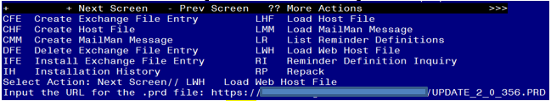

At the **Select Action:** prompt, enter **LWH** for Load Web Host File

At the **Input the url for the .prd file:** prompt, type the following web address:

### https://REDACTED/UPDATE_2_0_356.PRD

You should see a message at the top of your screen that the file loaded successfully

Search and locate an entry titled **UPDATE_2_0_356 VA-COVID-19 CANCELLED APPOINTMENT FOLLOW-UP UPDATE** in reminder exchange.

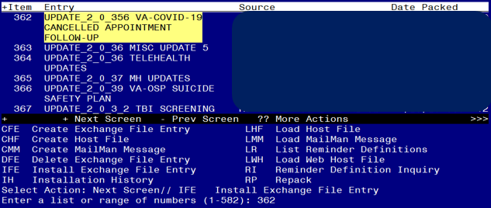

At the **Select Action** prompt, enter **IFE** for Install Exchange File Entry

Enter the number that corresponds with your entry UPDATE_2_0_356 VA-COVID-19 CANCELLED APPOINTMENT FOLLOW-UP UPDATE *(in this example it is entry 362 it will vary by site).* The date of the exchange file should be 03/21/2023.

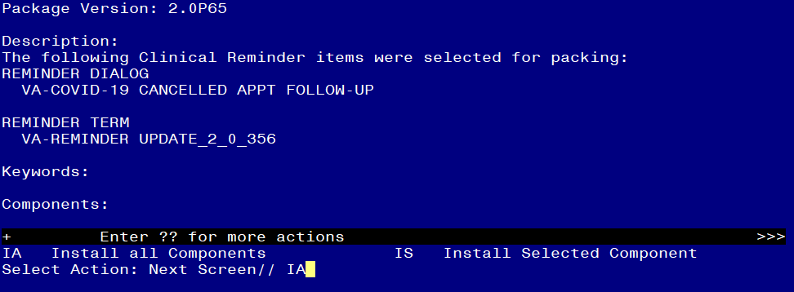

At the **Select Action** prompt, type **IA** for Install all Components and hit enter. Select Action: Next Screen// IA Install all Components

You will see several prompts, for all new entries you will choose **I to Install**

If you are prompted to overwrite any existing items, choose S to SKIP

**You will be prompted to install the reminder first dialog component – You will choose install all even though the components have an X that they exist.**

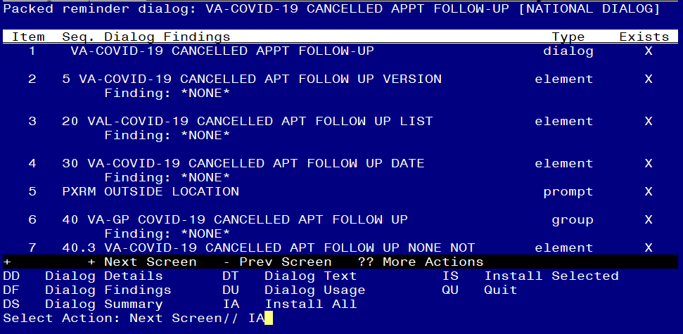

At the **Select Action** prompt, type **IA** to install the dialog –**VA-COVID-19 CANCELLED APPT FOLLOW-UP**

Select Action: Next Screen// IA Install All

Install reminder dialog and all components with no further changes: Y// Yes

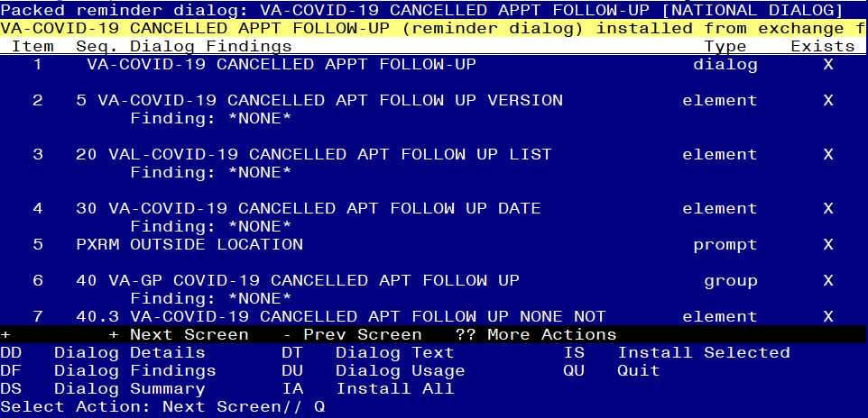

After completing this dialog install, you will type Q.

#### You will then be brought back to this screen where you will type Q for quit

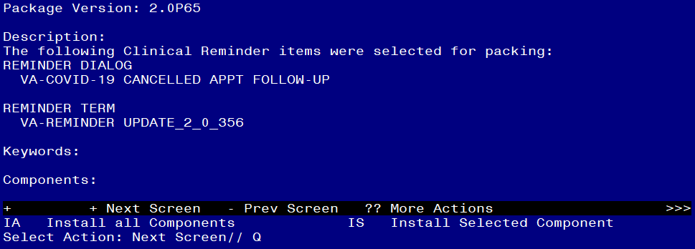

You will then be returned to this screen. At the **Select Action** prompt, type **Q.**

Install complete.

# Post Installation

#### Open the template (Reminder Dialog VA-COVID-19 CANCELLED APPT FOLLOW-UP) and make sure the version displays as 2.1