

**Update _2_0_357**

Clinical Reminders

VA-MATERNITY CARE COORDINATION DIALOG UPDATE

Install Guide

**August 2023**

Product Development

Office of Information Technology

Department of Veterans Affairs

Table of Contents

Introduction 1

Pre-Installation 9

Install Details 9

Install Example 9

Post Installation 18

# Introduction

The Maternity Care Coordinator (MCC) reminder dialog has been updated to better assist MCC’s to complete documentation as outlined in the MCC Telephone Care Manual. MCCs reference this manual to direct them to what should be covered during patient contacts. This current update was addressed to support the mandates from the Protecting Moms Who Served Act and the White House Blueprint for Maternal Health, which require following patients through pregnancy and 12 months post-partum.

The intended use is for MCCs, or those acting in that capacity, to document and track pregnant Veterans whose maternity care is being paid for by the VA, according to the VHA Directive 1330.03.

The MCC dialog is mandated for use by MCCs.  A link to the directive is here: <https://www.va.gov/vhapublications/ViewPublication.asp?pub_ID=9095>

Link to a PDF outlining the edits/changes made: REDACTED

UPDATE_2_0_357 contains 1 Reminder Exchange entry:

**UPDATE_2_0_357 VA-MATERNITY CARE COORDINATION DIALOG UPDATE**

**The exchange file contains the following components:**

**ROUTINE**

PXRMCALT

PXRMCDEF

PXRMCWH1

PXRMDATE

PXRMPDEM

**MH TESTS AND SURVEYS**

EPDS

**REMINDER GENERAL FINDINGS**

LACTATION END DATE

PATIENT IS NOT LACTATING

PATIENT IS LACTATING

WH-LACTATION DATA SOURCE

CLEAR ALL FOR ALL USER

LACTATION CLEAR SMART DATA

LACTATION ALERT ID

PREGNANCY ENDED REASON PT LOST TO FOLLOWUP

PREGNANCY ENDED REASON PT DECLINES TO ANSWER

PREGNANCY ENDED REASON MATERNAL MORTALITY

PREGNANCY ENDED REASON VAGINAL DELIVERY AND CSECTION

PREGNANCY ENDED REASON ECTOPIC

PREGNANCY ENDED REASON TERMINATION

PREGNANCY ENDED REASON MISCARRIAGE

PREGNANCY ENDED REASON STILLBIRTH

PREGNANCY ENDED REASON C SECTION

PREGNANCY ENDED REASON VAGINAL DELIVERY

PREGNANCY END DATE

HYSTEROSCOPIC STERILIZATION

LAPAROSCOPIC STERILIZATION

NO CURRENT PARTNER

WITHDRAWAL

EMERGENCY CONTRACEPTION

NATURAL FAMILY PLANNING

SPERMICIDE ALONE

CONTRACEPTIVE SPONGE

CERVICAL CAP WITH SPERMICIDE

DIAPHRAGM WITH SPERMICIDE

FEMALE CONDOM

MALE CONDOM

CONTRACEPTIVE PILL, RING OR PATCH

CONTRACEPTIVE SHOT

CURRENT PARTNER

CONTRACEPTIVE IMPLANT

IUD

NOTHING

PATIENT IS UNSURE ABOUT BECOMING PREGNANT

PATIENT DOES NOT WANT TO BECOME PREGNANT

PATIENT WANTS TO BECOME PREGNANT

PATIENT DOES NOT KNOW PREGNANCY STATUS

PATIENT IS NOT PREGNANT

OVERRIDE CALCULATED EDD REASON

EXPECTED DUE DATE

LAST MENSTRUAL PERIOD DATE

PATIENT IS PREGNANT

PATIENT MEDICALLY ABLE TO CONCEIVE

MEDICAL REASON

PATIENT MEDICALLY UNABLE TO CONCEIVE

WH-PREGNANCY DATA SOURCE

CLEAR ALL FOR ALL USER

PREGNANCY CLEAR SMART DATA

PREGNANCY ALERT ID

WH-TD PREGNANCY EDIT RECORD

WH-TD LACTATION EDIT RECORD

LACTATION CLEAR SMART DATA

LACTATION ALERT ID

TICKLER REMINDER COMMENT

TICKLER REMINDER

VIEW PROGRESS NOTE TEXT

**REMINDER DIALOG FUNCTION FILE**

DATE_HIST

DATE_DIFF

DATE_OFFSET

**REMINDER DIALOG LINK TYPE**

VA-WH UPDATE HISTORICAL FV

VA-WH HIDE CONTRA OTHER

VA-WH SUPPRESS EDD OVERRIDE PROMPT

VA-WH SET EDD FROM LMPD

**TIU TEMPLATE FIELD**

WH US SPR LINK

WH US MEC LINK

TEXT NO LIMIT

NUM

TEXT (1-40 CHAR)

VA-MCC BABY SEX

TEXT - ONE LINE ONLY

DATE

BLANK TEXT FIELD FOR DIALOGS

TEXT (1-60 CHAR)1

MCC GESTATE AGE

VA-MCC SHAREPOINT SITE

**HEALTH FACTORS**

VA-REMINDER UPDATES [C]

VA-UPDATE_2_0_357

VA-WH MEDICATION REVIEW [C]

VA-WH MED REVIEW HARMFUL MEDS COUNSELING BY ANOTHER

VA-WH MED REVIEW HARMFUL MEDS COUNSELING NOT INDICATED

VA-WH MED REVIEW HARMFUL MEDS COUNSELING COMPLETED

VA-WH MED REVIEW HARMFUL MEDS NOTIFIED PROVIDER

WH PAP SMEAR [C]

WH HYSTERECTOMY W/CERVIX REMOVED

VA-MCC DELIVERY INFORMATION (C) [C]

VA-MCC COMPLICATION GEST DIABETES

VA-MCC COMPLICATION DVT/PE

VA-MCC COMPLICATION POSTPARTUM DEPR

VA-MCC COMPLICATION NONE

VA-MCC COMPLICATION INFECTIONS

VA-MCC COMPLICATION HEMORRHAGE

VA-MCC COMPLICATION ECLAMPSIA

VA-MCC COMPLICATION PREECLAMPSIA

VA-MCC COMPLICATION GEST HYPERTENSION

VA-MCC BABY #3 WT ABOVE NORMAL

VA-MCC BABY #3 WT NORMAL

VA-MCC BABY #3 WT BELOW NORMAL

VA-MCC MOM HOSPITAL STAY

VA-MCC BABY HOSPITAL STAY

VA-MCC BABY #2 WT ABOVE NORMAL

VA-MCC BABY #2 WT NORMAL

VA-MCC BABY #2 WT BELOW NORMAL

VA-MCC BABY #1 WT ABOVE NORMAL

VA-MCC BABY #1 WT NORMAL

VA-MCC BABY #1 WT BELOW NORMAL

VA-MCC BIRTH MULTIPLES

VA-MCC BIRTH TWINS

VA-MCC BIRTH SINGLETON

VA-MCC LIVE BIRTH

VA-MCC CALLS (C) [C]

VA-MCC 9M POSTPARTUM CONTACT

VA-MCC 6M POSTPARTUM CONTACT

VA-MCC 3M POSTPARTUM CONTACT

VA-MCC POSTPARTUM FUP PT DECLINES AWAITING PCP ASSIGNMENT

VA-MCC POSTPARTUM FUP PT DECLINES SCHED SPECIALITY

VA-MCC POSTPARTUM FUP PT DECLINES SEEN LAST 3MONTHS

VA-MCC POSTPARTUM FUP PT DECLINES FEELS UNNECESSARY

VA-MCC POSTPARTUM FUP PT DECLINES USING PRIVATE PAY PCP FUP

VA-MCC POSTPARTUM FUP PT DECLINES CHILDCARE ISSUES

VA-MCC POSTPARTUM FUP PT DECLINES TRANSPORTATION ISSUES

VA-MCC SIDS DISCUSSED

VA-MCC WHOLE HEALTH HANDOUTS

VA-MCC WHOLE HEALTH GUIDES

VA-MCC WHOLE HEALTH EXERCISE

VA-MCC WHOLE HEALTH NUTRITION RESOURCES

VA-MCC FAMILY PLAN PT OBTAINED

VA-MCC FAMILY PLAN DISCUSSED RISKS

VA-MCC FAMILY PLAN PT NOT INTERESTED

VA-MCC FAMILY PLAN INTEREST TUBAL LIGATION

VA-MCC FAMILY PLAN DISCUSSED PLAN

VA-MCC BREASTFEEDING [C]

VA-MCC BREASTFEED GREATER THAN 12 MONTHS

VA-MCC BREASTFEED DELIVERY TO 6 WEEKS

VA-MCC BREASTFEED NONE MONTHS

VA-MCC BREASTFEED 9 MONTHS TO 12 MONTHS

VA-MCC BREASTFEED 6 MONTHS TO 9 MONTHS

VA-MCC BREASTFEED 3 MONTHS TO 6 MONTHS

VA-MCC BREASTFEED 6 WEEKS TO 3 MONTHS

VA-MCC BREASTFEED STOPPED LACK OF SUPPORT

VA-MCC BREASTFEED STOPPED FINISHED AS PLANNED

VA-MCC BREASTFEED STOPPED INCONVENIENT

VA-MCC BREASTFEED STOPPED UNSUPPORTIVE WORK

VA-MCC BREASTFEED STOPPED CONCERNS ABOUT MEDS

VA-MCC BREASTFEED STOPPED PAINFUL

VA-MCC BREASTFEED STOPPED CONCERNS INFANT NUTRITION

VA-MCC BREASTFEED STOPPED ISSUES WITH LACTATION

VA-MCC BREASTFEED INFANT DIET OTHER

VA-MCC BREASTFEED INFANT DIET FORMULA

VA-MCC BREASTFEED INFANT DIET HUMAN MILK AND FORMULA

VA-MCC BREASTFEED INFANT DIET HUMAN MILK

VA-MCC BREASTFEED LACTATION CONSULTANT

VA-MCC BREASTFEED ISSUES

VA-MCC BREASTFEED NO ISSUES

VA-MCC BREASTFEED IS BREASTFEEDING

VA-MCC BREASTFEED PT NOT INTERESTED

VA-MCC INTIMATE PARTNER VIOLENCE (C) [C]

VA-MCC IPV DISCUSSED

VA-MCC ALCOHOL USE (C) [C]

VA-MCC ALCOHOL DOES CONSUME

VA-MCC ALCOHOL DOES NOT CONSUME

VA-MCC TOBACCO USE (C) [C]

VA-MCC TOBACCO SMOKES RECENTLY QUIT

VA-MCC TOBACCO SMOKES CONTEMPLATE QUIT

VA-MCC TOBACCO SMOKES YES

VA-MCC TOBACCO SMOKES DOES NOT

VA-MCC HISTORY OF HEALTH PROBLEMS (C) [C]

VA-MCC HISTORY OF THROMBOEMBOLISM

VA-MCC HISTORY OF PTSD

VA-MCC HISTORY OF MH NOT SPECIFIED

VA-MCC HISTORY OF DEPRESSION/MH DISORDER

VA-MCC HISTORY OF BIPOLAR DISORDER

VA-MCC HISTORY OF ANXIETY

VA-MCC HISTORY OF SUBSTANCE ABUSE

VA-MCC HISTORY OF OBESITY

VA-MCC HISTORY OF THYROID

VA-MCC HISTORY OF STI

VA-MCC HISTORY OF SEIZURE DISORDER

VA-MCC HISTORY OF RENAL DISEASE

VA-MCC HISTORY OF LUPUS

VA-MCC HISTORY OF HYPERTENSION

VA-MCC HISTORY OF HYPERCOAGULABLE

VA-MCC HISTORY OF HIV

VA-MCC HISTORY OF DIABETES

VA-MCC HISTORY OF CHRONIC PAIN

VA-MCC HISTORY OF ASTHMA

VA-MCC WIC BENEFITS

VA-MCC 3RD TRIMESTER CONTACT

VA-MCC 2ND TRIMESTER CONTACT

VA-MCC 1ST TRIMESTER CONTACT

VA-MCC PREGNANCY CLASSES [C]

VA-MCC PARENTING CLASSES DECLINED MAY CONSIDER IN FUTURE

VA-MCC PARENTING CLASSES DECLINED NOT INTERESTED

VA-MCC PARENTING CLASSES DECLINED EXPERIENCED PARENT

VA-MCC PARENTING CLASSES DECLINED PREVIOUSLY ATTENDED

VA-MCC PARENTING CLASSES DECLINED DISTANCE

VA-MCC PARENTING CLASSES DECLINED COST

VA-MCC PARENTING CLASSES DECLINED EDUCATOR NOT AVAILABLE

VA-MCC PARENTING CLASSES COMPLETED

VA-MCC PARENTING CLASSES SCHEDULED

VA-MCC LACTATION CLASSES DECLINED MAY CONSIDER IN FUTURE

VA-MCC LACTATION CLASSES DECLINED NOT INTERESTED

VA-MCC LACTATION CLASSES DECLINED EXPERIENCED PARENT

VA-MCC LACTATION CLASSES DECLINED PREVIOUSLY ATTENDED

VA-MCC LACTATION CLASSES DECLINED DISTANCE

VA-MCC LACTATION CLASSES DECLINED COST

VA-MCC LACTATION CLASSES DECLINED EDUCATOR NOT AVAILABLE

VA-MCC LACTATION CLASSES COMPLETED

VA-MCC LACTATION CLASSES SCHEDULED

VA-MCC CHILDBIRTH CLASSES DECLINED MAY CONSIDER IN FUTURE

VA-MCC CHILDBIRTH CLASSES DECLINED NOT INTERESTED

VA-MCC CHILDBIRTH CLASSES DECLINED EXPERIENCED PARENT

VA-MCC CHILDBIRTH CLASSES DECLINED PREVIOUSLY ATTENDED

VA-MCC CHILDBIRTH CLASSES DECLINED DISTANCE

VA-MCC CHILDBIRTH CLASSES DECLINED COST

VA-MCC CHILDBIRTH CLASSES DECLINED EDUCATOR NOT AVAILABLE

VA-MCC CHILDBIRTH CLASSES COMPLETED

VA-MCC CHILDBIRTH CLASSES SCHEDULED

VA-MCC BREASTFEED SUPPLIES TO BE ORDERED

VA-MCC BREASTFEED SUPPLIES RECEIVED

VA-MCC BREASTFEED SUPPLIES ORDERED

VA-MCC BREASTFEED PLANS TO

VA-MCC 12M POSTPARTUM CONTACT

VA-MCC UNABLE TO CONTACT

VA-MCC ADDITIONAL CONTACT

VA-MCC 4TH TRIMESTER CONTACT

**REMINDER SPONSOR**

WOMEN VETERANS HEALTH PROGRAM

OFFICE OF NURSING INFORMATICS

WOMEN VETERANS HEALTH PROGRAM AND NATIONAL CENTER FOR HEALTH PROMOTION AND DISEASE PREVENTION (NCP)

VHA NATIONAL CENTER FOR HEALTH PROMOTION AND DISEASE PREVENTION (NCP) AND VHA OFFICE OFWOMEN'S HEALTH MENTAL HEALTH SERVICES

**REMINDER COMPUTED FINDING**

VA-DATE OF DEATH

VA-SEX

VA-WH PATIENT IS PREGNANT/LACTATING

VA-WH PATIENT DOCUMENTATION

VA-WH UNSAFE ORDER COUNT

VA-SMART PATIENT HAS ALERT

VA-FILEMAN DATE

VA-REMINDER DEFINITION

**REMINDER TAXONOMY**

VA-WH RECENTLY PREGNANT

VA-WH CURRENTLY PREGNANT

VA-WH TUBAL REANASTOMOSIS (TAXONOMY)

VA-WH TUBAL LIGATION CODES (TAXONOMY)

VA-WH HYSTERECTOMY W/CERVIX REMOVED

VA-WH TERATOGENIC MEDICATIONS EXCLUSIONS TAXONOMY

**REMINDER TERM**

VA-REMINDER UPDATE_2_0_357

VA-WH BL PREGNANCY CURRENT

VA-WH PREGNANCY ALERT

VA-WH TUBAL REANASTOMOSIS (TERM)

VA-WH TUBAL LIGATION CODES (TERM)

VA-WH PREGNANCY TEST ORDERED

VA-WH BL TD INCOMPLETE MUC

VA-WH BL TD INCOMPLETE DON'T KNOW

VA-WH BL TD INCOMPLETE NOT PREGNANT

VA-WH BL PREGNANCY EDIT END DOCUMENTATION

VA-WH LACTATION ALERT

**REMINDER DEFINITION**

VA-WH PREGNANCY AND LACTATION DATA ENTRY ALLOWED

VA-WH BL LACTATION ADD END DATE

VA-WH BL POTENTIALLY UNSAFE ORDERS

VA-WH BL POTENTIALLY TERATOGENIC ORDERS

VA-WH MEDICALLY UNABLE TO CONCEIVE

VA-WH UPDATE PREGNANCY STATUS

VA-WH BL LACTATION STATUS DOCUMENTATION

VA-WH BL PREGNANCY EDIT END DOCUMENTATION

VA-WH BL LACTATION EDIT END DATE

VA-WH UPDATE LACTATION STATUS

VA-WH BL PREGNANCY STATUS DOCUMENTATION

**HEALTH SUMMARY COMPONENT**

WH LACTATION DOCUMENTATION

WH PREGNANCY DOCUMENTATION

PROGRESS NOTES SELECTED

**HEALTH SUMMARY TYPE**

VA-WH LACTATION STATUS

VA-WH PREGNANCY STATUS

VA-MCC (TIU)

**HEALTH SUMMARY OBJECTS**

VA-WH LACTATION STATUS (TIU)

VA-WH PREGNANCY STATUS (TIU)

VA-MCC (TIU) (TIU)

**TIU DOCUMENT DEFINTION**

VA-WH RECENT LACTATION STATUS

VA-WH POTENTIAL UNSAFE ORDERS

VA-WH LACTATION STATUS

VA-WH SRN TEXT LACTATION

VA-WH RECENT PREGNANT STATUS

VA-WH POTENTIAL TERATOGENIC ORDERS

VA-WH PREGNANCY STATUS

VA-WH SRN TEXT PREGNANCY

VA-WH RECENT LABORATORY PREGNANCY TEST

VA-MCC (TIU)

ALL ACTIVE MEDICATIONS

VA-WRIISC ACTIVE PROBLEMS

**REMINDER DIALOG**

VA-WH UPDATE LACTATION STATUS

VA-WH UPDATE PREGNANCY STATUS

VA-MATERNITY CARE COORDINATION

# Pre-Installation

Prior to installing this Update:

1. From the Reminder Dialog Management menu, Inquire/Print (INQ) and capture/save the following ELEMENTS:
   * VA-WH TD PREGNANCY ORDER PREGNANCY TEST
   * VA-WH TD PREGNANCY ORDER EMERGENCY CONTRACEPTIVE

# Install Details

This update is being distributed as a web host file. The address for the host file is: **https://vaww.va.gov/reminders/docs/UPDATE_2_0_357.PRD**

The file will be installed using Reminder Exchange, programmer access is not required.

Installation:

=============

This update can be loaded with users on the system. Installation will take less than 30 minutes.

# Install Example

To Load the Web Host File. Navigate to Reminder exchange in Vista

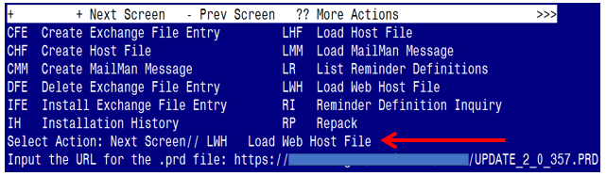

At the **Select Action:** prompt, enter **LWH** for Load Web Host File

At the **Input the url for the .prd file:** prompt, type the following web address: https://Redacted/UPDATE_2_0_357.PRD

You should see a message at the top of your screen that the file successfully loaded.

Terminal window screen shot of the message displaying the URL of the file that was successfully loaded.  Part of the URL has been redacted as it is a VA only internal web site URL.

Search reminder exchange and locate an entry titled:

**UPDATE_2_0_357 VA-MATERNITY CARE COORDINATION DIALOG UPDATE**

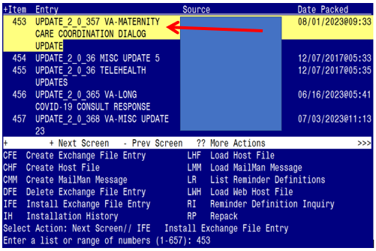

At the **Select Action** prompt, enter **IFE** for Install Exchange File Entry

Enter the number that corresponds with your entry:

UPDATE_2_0_357 VA-MATERNITY CARE COORDINATION DIALOG UPDATE

*(In this example it is entry 453. It will vary by site).* The date of the exchange file should be 08/01/2023@09:33.

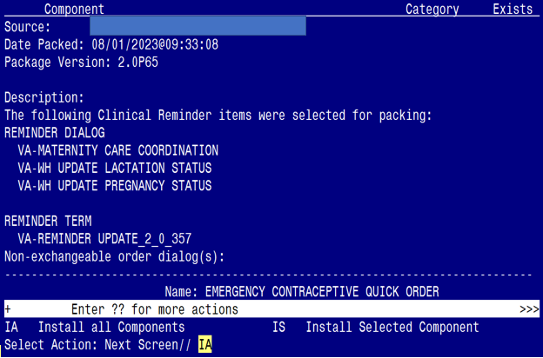

At the **Select Action** prompt, type **IA** for Install all Components and hit enter.

Select Action: Next Screen// IA Install all Components

**You will see several prompts:**

* For all new entries you will choose **I to Install**
* For components that exist but packed component is different, choose **O to Overwrite.**
* Ten Exceptions (listed below) – There are ten (10) components that exist but the packed component is different for which you may be prompted. For these items, choose **S to Skip**.

**For the specific components below, make sure you select the responses highlighted for each**

**REMINDER TAXONOMY** entry named VA-WH CURRENTLY PREGNANT already exists

but the packed component is different, what do you want to do?

Select one of the following:

C Create a new entry by copying to a new name

O Overwrite the current entry

U Update

Q Quit the install

S Skip, do not install this entry

Enter response: O// s Skip, do not install this entry

**REMINDER TAXONOMY** entry named VA-WH RECENTLY PREGNANT already exists

but the packed component is different, what do you want to do?

Select one of the following:

C Create a new entry by copying to a new name

O Overwrite the current entry

U Update

Q Quit the install

S Skip, do not install this entry

Enter response: O// s Skip, do not install this entry

**REMINDER TAXONOMY** entry named VA-WH TUBAL LIGATION CODES (TAXONOMY) already exists but the packed component is different, what do you want to do?

Select one of the following:

C Create a new entry by copying to a new name

O Overwrite the current entry

U Update

Q Quit the install

S Skip, do not install this entry

Enter response: O// s Skip, do not install this entry

**REMINDER TAXONOMY** entry named VA-WH TERATOGENIC MEDICATIONS

EXCLUSIONS TAXONOMY already exists but the packed component is different, what do you want to do?

Select one of the following:

C Create a new entry by copying to a new name

O Overwrite the current entry

U Update

Q Quit the install

S Skip, do not install this entry

Enter response: O// s Skip, do not install this entry

**REMINDER TAXONOMY** entry named VA-WH HYSTERECTOMY W/CERVIX REMOVED already exists but the packed component is different, what do you want to do?

Select one of the following:

C Create a new entry by copying to a new name

M Merge findings

O Overwrite the current entry

U Update

Q Quit the install

S Skip, do not install this entry

Enter response: O// s Skip, do not install this entry

**REMINDER TERM** entry named VA-WH PREGNANCY ALERT already exists but

the packed component is different, what do you want to do?

Select one of the following:

C Create a new entry by copying to a new name

M Merge findings

O Overwrite the current entry

U Update

Q Quit the install

S Skip, do not install this entry

Enter response: O// s Skip, do not install this entry

**REMINDER TERM** entry named VA-WH PREGNANCY TEST ORDERED already exists but

the packed component is different, what do you want to do?

Select one of the following:

C Create a new entry by copying to a new name

M Merge findings

O Overwrite the current entry

U Update

Q Quit the install

S Skip, do not install this entry

Enter response: O// s Skip, do not install this entry

For **REMINDER DEFINITION** entry named VA-WH UPDATE PREGNANCY STATUS already exists but the packed component is different, what do you want to do?

Select one of the following:

C Create a new entry by copying to a new name

O Overwrite the current entry

U Update

Q Quit the install

S Skip, do not install this entry

Enter response: O// s Skip, do not install this entry

For **HEALTH SUMMARY TYPE** entry named VA-WH PREGNANCY STATUS already exists but the packed component is different, what do you want to do?

Select one of the following:

C Create a new entry by copying to a new name

O Overwrite the current entry

U Update

Q Quit the install

S Skip, do not install this entry

Enter response: O// s Skip, do not install this entry

For **HEALTH SUMMARY TYPE** entry named VA-WH LACTATION STATUS already exists

but the packed component is different, what do you want to do?

Select one of the following:

C Create a new entry by copying to a new name

O Overwrite the current entry

U Update

Q Quit the install

S Skip, do not install this entry

Enter response: O// Skip, do not install this entry

**You will be promped to install the 1st reminder dialog component**

**(VA-WH UPDATE PREGNANCY STATUS)**

You will install all even though some components may have an X to indicate that they exist.

Regarding the Reminder Dialog Component, VA-WH UPDATE PREGNANCY STATUS:
Screen shot of the terminal window showing a list of elements, groups and dialogs with the text with IA for "Install All" entered at the "Select Action:" Prompt.  The correct entry is described in the text.

At the **Select Action** prompt, type **IA** to install the dialog:

**VA-WH UPDATE PREGNANCY STATUS**

Select Action: Next Screen// IA Install All

Install reminder dialog and all components with no further changes: Y// Yes

**YOU WILL SEE THE FOLLOWING TWO PROMPTS:**

(Refer to the INQ you saved during the Pre-Installation Steps)

FINDING entry Q.EMERGENCY CONTRACEPTIVE QUICK ORDER does not exist.

Select one of the following:

D Delete

P Replace with an existing entry

Q Quit the install

Enter response: P

Select ORDER DIALOG NAME: enter your local order dialog for emergency contraceptive here

FINDING entry Q.PREGNANCY TEST QUICK ORDER does not exist.

Select one of the following:

D Delete

P Replace with an existing entry

Q Quit the install

Enter response: P

Select ORDER DIALOG NAME: enter your local order dialog for pregnancy test here

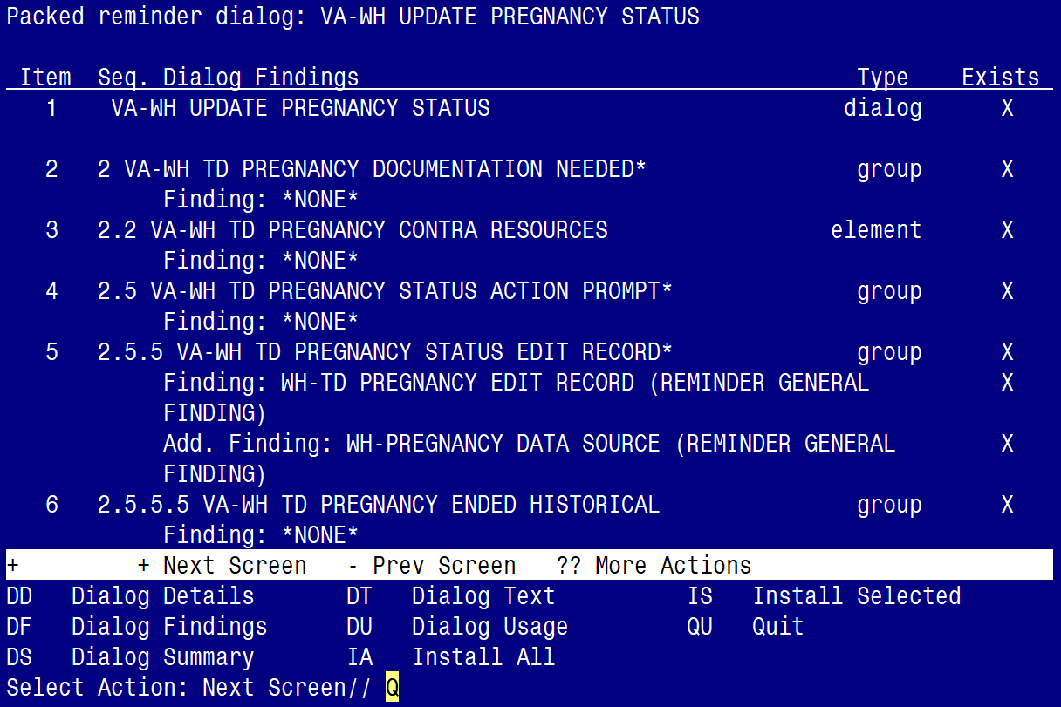

After completing this dialog install, you will type Q.

**You will be promped to install the 2nd reminder dialog component**

**(VA-WH UPDATE LACTATION STATUS)**

You will install all even though some components may have an X to indicate that they exist.

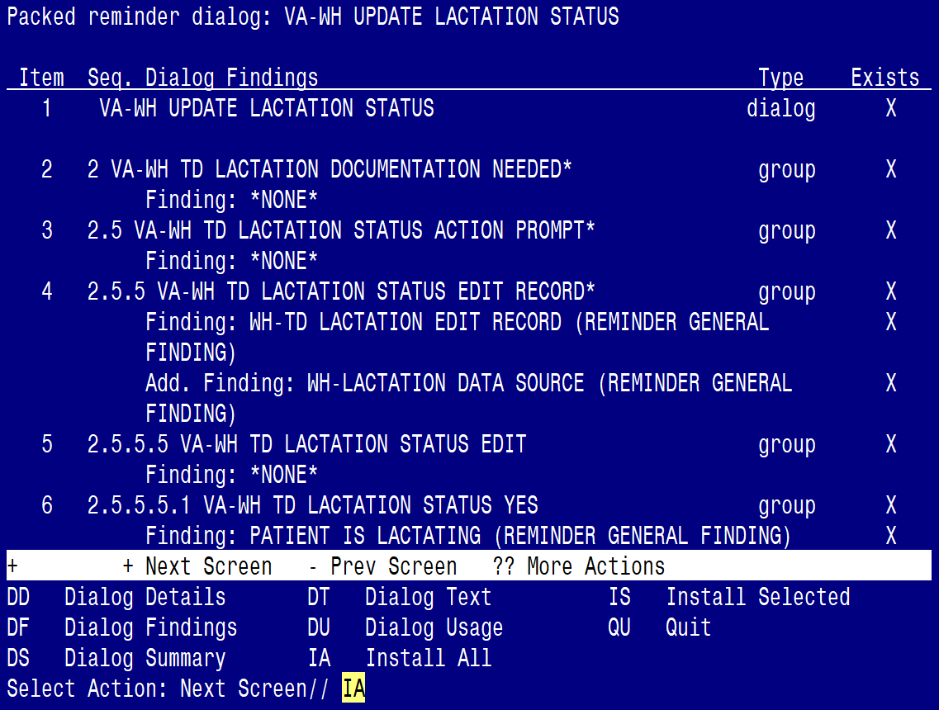

At the **Select Action** prompt, type **IA** to install the dialog:

**VA-WH UPDATE LACTATION STATUS**

Select Action: Next Screen// IA Install All

Install reminder dialog and all components with no further changes: Y// Yes

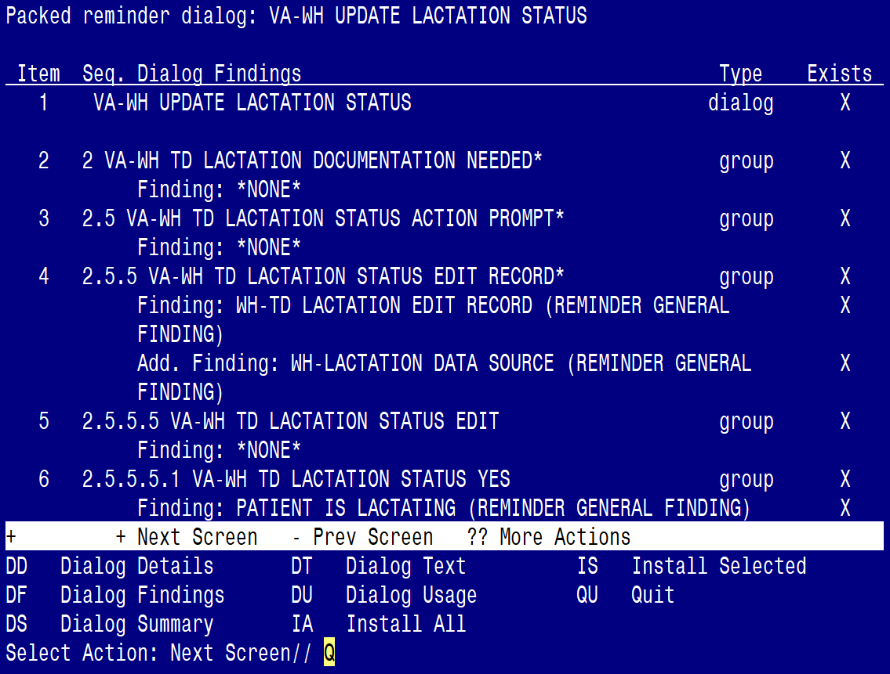

After completing this dialog install, you will type Q.

**You will be promped to install the 3rd reminder dialog component**

**(VA-MATERNITY CARE COORDINATION)**

You will install all even though some components may have an X to indicate that they exist.

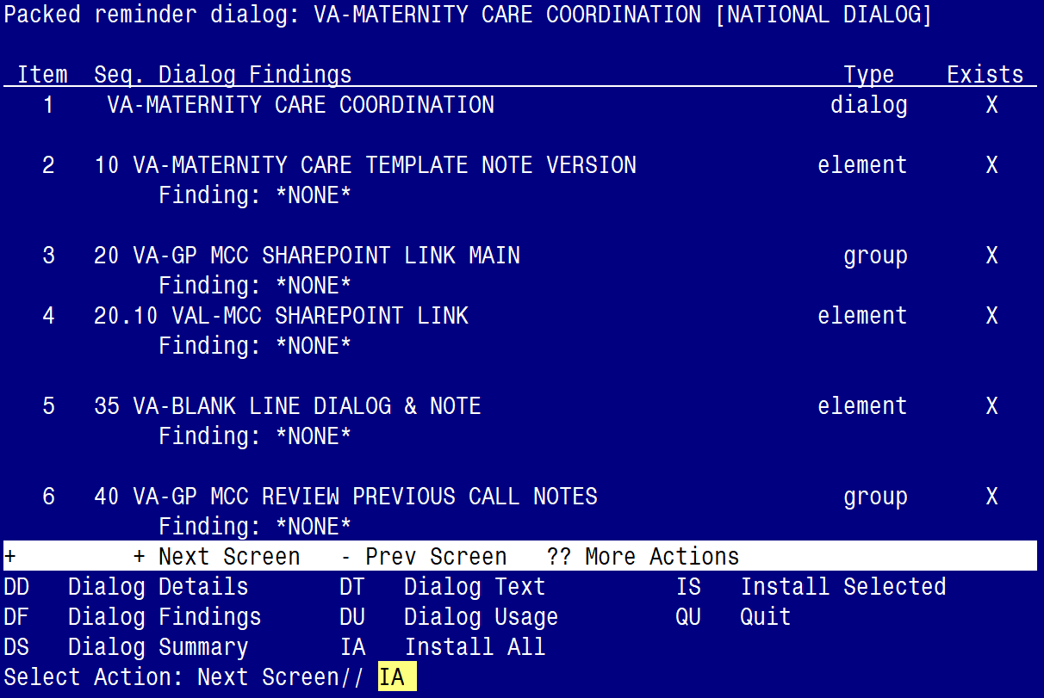

At the **Select Action** prompt, type **IA** to install the dialog:

**VA-MATERNITY CARE COORDINATION**

Select Action: Next Screen// IA Install All

Install reminder dialog and all components with no further changes: Y// Yes

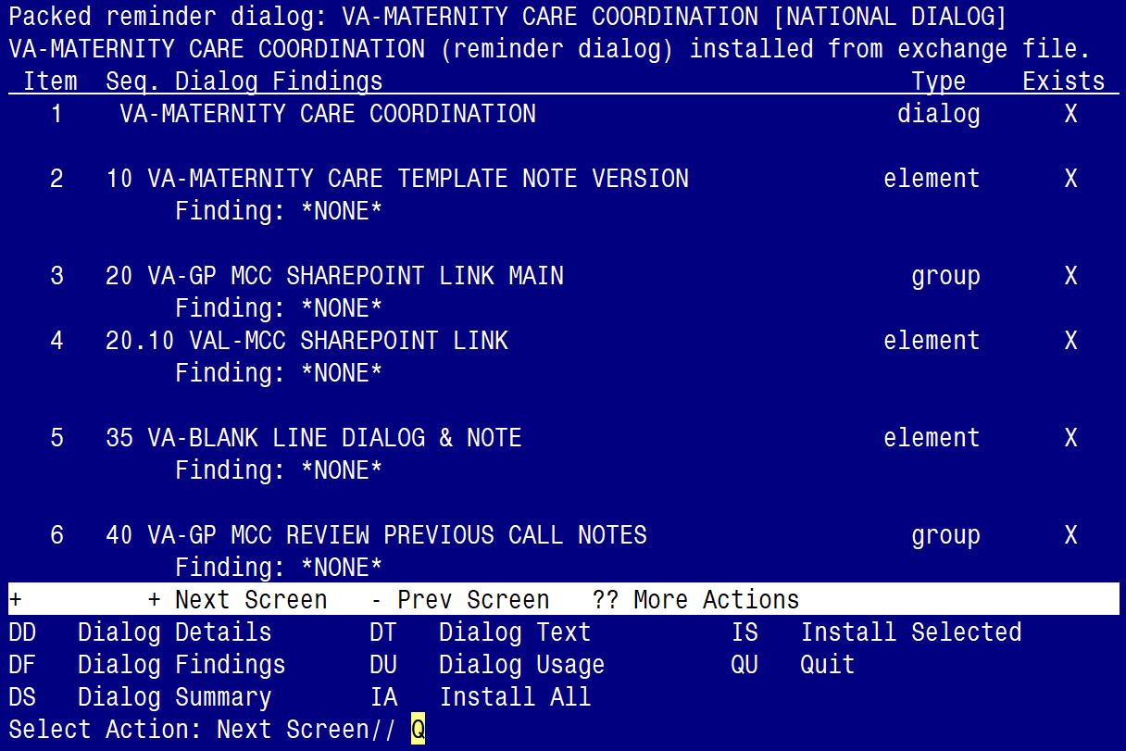

After completing this dialog install, you will type Q.

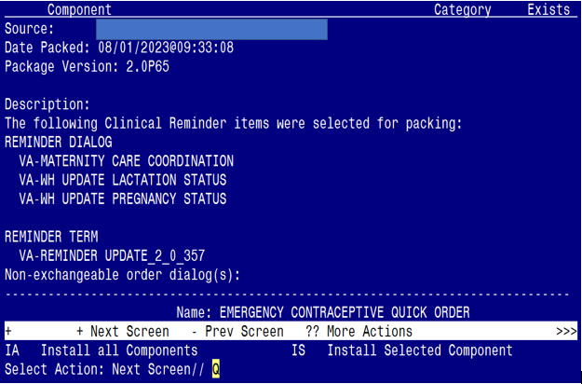

You will then be returned to this screen. At the **Select Action** prompt, type **Q.**

Install complete.

# Post Installation

1. Launch the **VA-MATERNITY CARE COORDINATION** dialogand confirm the version number is 4.3 (displayed at the top of the dialog). See screenshot below.
   1. Launch the dialog using note title: VA-MATERNITY CARE COORDINATION
   2. If your site does not have the note title established, refer to the original install guide and the post-installation step instructions for note title creation. The link to that install guide UPDATE_2_0_190_IG.xlsx

Screen shot of the beginning of the Reminder Dialog Template: VA-MATERNITY CARE COORDINATION
Maternity Care Coordination Note Version 4.3.  This link is internal to the VA and is now shown.
SHAREPOINT LINK
Link connects to the VA Maternity Care Coordinator Telephone Care Program Manual which should guide  your contacts.

1. Confirm the ACTIVE MEDS COMBINED object is added in the Element: **VA-MCC MEDS ACTIVE**. If not, add your site’s objects for ACTIVE MEDICATIONS.

Element: **VA-MCC MEDS ACTIVE**

VA Health Record: |ACTIVE MEDS COMBINED|

1. Confirm the VA-WRIISC ACTIVE PROBLEMS object is added in the Element: **VA-MCC HEALTH PROBLEM LIST**. If not, add your site’s objects for ACTIVE PROBLEMS.

Element: **VA-MCC HEALTH PROBLEM LIST**

Active Problems: |VA-WRIISC ACTIVE PROBLEMS|

1. Re-map quick orders. Refer to the Inquire/Print (INQ) you saved from the pre-installation instructions to re-map the quick orders are mapped to the Finding Items of the two ELEMENTS below:
   * VA-WH TD PREGNANCY ORDER PREGNANCY TEST
   * VA-WH TD PREGNANCY ORDER EMERGENCY CONTRACEPTIVE
2. Confirm the **VA-MCC (TIU) Health Summary Type** is set with the SPN component and the VA-MATERNITY CARE COORDINATION title is mapped as a selection (see screenshot below)

Screen shot showing this:
Type Name: VA-NCC (TIU)
Title:  VA-NCC (TIU)

SUPRESS PRINT OF COMPONENTS WITHOUT DATA: yes
SUPRESS SENDITIVE PRINT DATA: NO SSN

In the table underneath, the entries tat are not empty are Abb - SPN, Ord - 5, Component Name - Selected Prog Notes, Max Occ- 8 and Selection - VA-MATERNITY CARE COORDINATION;  Empty entries are time, Hos Loc, ICD Text, Pro Nar, CPT MOD

**If not, complete the action below to add the SPN component to the VA-MCC (TIU) Health Summary Type:**

Select Health Summary Maintenance Menu <TEST ACCOUNT> Option: 6 Create/Modify Health Summary Type

Select Health Summary Type: VA-MCC (TIU)

VA-Mcc (TIU)

OK? YES//

WARNING: You are about to edit a Health Summary Type that is being used

by a Health Summary Object. Changing the structure of this Health Summary

Type will alter how the Object will display.

Do want to continue? NO// y YES

NAME: VA-MCC (TIU)//

TITLE: VA-MCC (TIU)//

SUPPRESS PRINT OF COMPONENTS WITHOUT DATA: yes//

SUPPRESS SENSITIVE PRINT DATA: NO SSN//

LOCK:

OWNER: << your name here >>

Do you wish to copy COMPONENTS from an existing Health Summary Type? YES// NO

Select COMPONENT: SPN PROGRESS NOTES SELECTED SPN

SUMMARY ORDER: 5// 5

OCCURRENCE LIMIT: 8

TIME LIMIT:

HEADER NAME: Selected Prog Notes//

No selection items chosen.

Select new items one at a time in the sequence you want them displayed.

You may select any number of items.

Select SELECTION ITEM: VA-MATERNITY CARE COORDINATION

Searching for a TIU DOCUMENT DEFINITION, (pointed-to by SELECTION ITEM)

Searching for a TIU DOCUMENT DEFINITION

VA-MATERNITY CARE COORDINATION TITLE

Std Title: WOMENS HEALTH PROGRESS NOTE

...OK? Yes// (Yes)

Select SELECTION ITEM:

Select COMPONENT:

Do you wish to review the Summary Type structure before continuing? NO//

1. Embed the **Tobacco Use Screen** dialog into the **VAL-GP MCC TOBACCO USE CR MAIN** group:
   1. In VISTA, navigate to the Reminder Dialog Management. Select Reminder Dialogs (DI), then Change View (CV) to Dialog Group View
   2. Locate the group titled: VAL-GP MCC TOBACCO USE CR MAIN
   3. Add a sequence number and the group titled: VA-GP TOBACCO USE QUESTION

NAME: **VAL-GP MCC TOBACCO USE CR MAIN**

DISABLE: **<enter>**

CLASS: LOCAL/**<enter>**/

SPONSOR: **<enter>**

REVIEW DATE: **<enter>**

RESOLUTION TYPE: **<enter>**

ORDERABLE ITEM: **<enter>**

FINDING ITEM: **<enter>**

Additional findings: **<enter>**none

Select ADDITIONAL FINDING: **<enter>**

GROUP CAPTION: **<enter>**

PUT A BOX AROUND THE GROUP: **<enter>**

SHARE COMMON PROMPTS: **<enter>**

MULTIPLE SELECTION:NO SELECTION REQUIRED// **<enter>**

HIDE/SHOW GROUP: **<enter>**

GROUP HEADER DIALOG TEXT:

Edit? NO// **<enter>**

GROUP HEADER ALTERNATE P/N TEXT:

Edit? NO// **<enter>**

EXCLUDE FROM PROGRESS NOTE: YES// **<enter>**

SUPPRESS CHECKBOX: SUPPRESS// **<enter>**

NUMBER OF INDENTS: **<enter>**

INDENT PROGRESS NOTE TEXT: **enter>**

Select SEQUENCE: **10**

DIALOG ELEMENT: **VA-GP TOBACCO USE QUESTION** dialog group

...OK? Yes// **Yes**

EXCLUDE FROM PN TEXT: **<enter>**

Select SEQUENCE:

Select BRANCHING LOGIC SEQUENCE: **<enter>**

Checking reminder dialog for errors

NO ERRORS FOUND

Input your edit comments.

Edit? NO//**<enter>**

1. Embed the **Alcohol Use Screen** dialog into the **VAL-GP MCC ALCOHOL USE SCREEN CR MAIN** group:
   1. In VISTA, navigate to the Reminder Dialog Management. Select Reminder Dialogs (DI), then Change View (CV) to Dialog Group View
   2. Locate the group titled: VAL-GP MCC ALCOHOL USE SCREEN CR MAIN
   3. Add a three sequence numbers and the group and elements titled: VA-TEXT ALCOHOL MISUSE SCREEN INSTRUCTION, VAL-GP ALC SCREEN AUDC and VA-TEXT SUD CPG URL

NAME: **VAL-GP MCC ALCOHOL USE SCREEN CR MAIN**

DISABLE: **<enter>**

CLASS: LOCAL/**<enter>**/

SPONSOR: **<enter>**

REVIEW DATE: **<enter>**

RESOLUTION TYPE: **<enter>**

ORDERABLE ITEM: **<enter>**

FINDING ITEM: **<enter>**

Additional findings: **<enter>**none

Select ADDITIONAL FINDING: **<enter>**

GROUP CAPTION: **<enter>**

PUT A BOX AROUND THE GROUP: **<enter>**

SHARE COMMON PROMPTS: **<enter>**

MULTIPLE SELECTION:NO SELECTION REQUIRED// **<enter>**

HIDE/SHOW GROUP: **<enter>**

GROUP HEADER DIALOG TEXT:

Edit? NO// **<enter>**

GROUP HEADER ALTERNATE P/N TEXT:

Edit? NO// **<enter>**

EXCLUDE FROM PROGRESS NOTE: YES// **<enter>**

SUPPRESS CHECKBOX: SUPPRESS// **<enter>**

NUMBER OF INDENTS: **<enter>**

INDENT PROGRESS NOTE TEXT: **enter>**

Select SEQUENCE: **10**

DIALOG ELEMENT: **VA-TEXT ALCOHOL MISUSE SCREEN INSTRUCTIONS** element

...OK? Yes// **Yes**

EXCLUDE FROM PN TEXT: **<enter>**

Select SEQUENCE: **20**

DIALOG ELEMENT: **VAL-GP ALC SCREEN AUDC**  group

...OK? Yes// **Yes**

EXCLUDE FROM PN TEXT: **<enter>**

Select SEQUENCE: **40**

DIALOG ELEMENT: **VA-TEXT SUD CPG URL**  element

...OK? Yes// **Yes**

EXCLUDE FROM PN TEXT: **<enter>**

Select SEQUENCE:

Select BRANCHING LOGIC SEQUENCE: **<enter>**

Checking reminder dialog for errors

NO ERRORS FOUND

Input your edit comments.

Edit? NO//**<enter>**

1. Embed the **Homelessness and Food Insecurity Screen** dialog into the **VAL-GP MCC HOMELESS FOOD INSEC CR MAIN** group:
   1. In VISTA, navigate to the Reminder Dialog Management. Select Reminder Dialogs (DI), then Change View (CV) to Dialog Group View
   2. Locate the group titled: VAL-GP MCC HOMELESS FOOD INSEC CR MAIN
   3. Add a two sequence numbers and the group and element titled: VA-GP HOMELESSNESS SCREEN AND FOOD INSECURITY and VA-HOMELESSNESS URL FOR PATIENT MATERIALS

NAME: **VAL-GP MCC HOMELESS FOOD INSEC CR MAIN**

DISABLE: **<enter>**

CLASS: LOCAL/**<enter>**/

SPONSOR: **<enter>**

REVIEW DATE: **<enter>**

RESOLUTION TYPE: **<enter>**

ORDERABLE ITEM: **<enter>**

FINDING ITEM: **<enter>**

Additional findings: **<enter>**none

Select ADDITIONAL FINDING: **<enter>**

GROUP CAPTION: **<enter>**

PUT A BOX AROUND THE GROUP: **<enter>**

SHARE COMMON PROMPTS: **<enter>**

MULTIPLE SELECTION:NO SELECTION REQUIRED// **<enter>**

HIDE/SHOW GROUP: **<enter>**

GROUP HEADER DIALOG TEXT:

Edit? NO// **<enter>**

GROUP HEADER ALTERNATE P/N TEXT:

Edit? NO// **<enter>**

EXCLUDE FROM PROGRESS NOTE: YES// **<enter>**

SUPPRESS CHECKBOX: SUPPRESS// **<enter>**

NUMBER OF INDENTS: **<enter>**

INDENT PROGRESS NOTE TEXT: **enter>**

Select SEQUENCE: **10**

DIALOG ELEMENT: **VA-GP HOMELESSNESS SCREEN AND FOOD INSECURITY** group

...OK? Yes// **Yes**

EXCLUDE FROM PN TEXT: **<enter>**

Select SEQUENCE: **20**

DIALOG ELEMENT: **VA-HOMELESSNESS URL FOR PATIENT MATERIALS**  element

...OK? Yes// **Yes**

EXCLUDE FROM PN TEXT: **<enter>**

Select BRANCHING LOGIC SEQUENCE: **<enter>**

Checking reminder dialog for errors

NO ERRORS FOUND

Input your edit comments.

Edit? NO//**<enter>**

1. Embed the **PTSD Screen** dialog into the **VAL-GP MCC PTSD SCREEN CR MAIN** group:
   1. In VISTA, navigate to the Reminder Dialog Management. Select Reminder Dialogs (DI), then Change View (CV) to Dialog Group View
   2. Locate the group titled: VAL-GP MCC PTSD SCREEN CR MAIN
   3. Add a sequence number and the group titled: VA-PTSD SCREENING VERSION

NAME: **VAL-GP MCC PTSD SCREEN CR MAIN**

DISABLE: **<enter>**

CLASS: LOCAL/**<enter>**/

SPONSOR: **<enter>**

REVIEW DATE: **<enter>**

RESOLUTION TYPE: **<enter>**

ORDERABLE ITEM: **<enter>**

FINDING ITEM: **<enter>**

Additional findings: **<enter>**none

Select ADDITIONAL FINDING: **<enter>**

GROUP CAPTION: **<enter>**

PUT A BOX AROUND THE GROUP: **<enter>**

SHARE COMMON PROMPTS: **<enter>**

MULTIPLE SELECTION:NO SELECTION REQUIRED// **<enter>**

HIDE/SHOW GROUP: **<enter>**

GROUP HEADER DIALOG TEXT:

Edit? NO// **<enter>**

GROUP HEADER ALTERNATE P/N TEXT:

Edit? NO// **<enter>**

EXCLUDE FROM PROGRESS NOTE: YES// **<enter>**

SUPPRESS CHECKBOX: SUPPRESS// **<enter>**

NUMBER OF INDENTS: **<enter>**

INDENT PROGRESS NOTE TEXT: **enter>**

Select SEQUENCE: **10**

DIALOG ELEMENT: **VA-PTSD SCREENING VERSION** group

...OK? Yes// **Yes**

EXCLUDE FROM PN TEXT: **<enter>**

Select BRANCHING LOGIC SEQUENCE: **<enter>**

Checking reminder dialog for errors

NO ERRORS FOUND

Input your edit comments.

Edit? NO//**<enter>**

1. Map your facility’s Return to Clinic (RTC) order to the Additional Findings field in the element titled **VA-MCC POSTPARTUM VISIT RTC**

ELEMENT: **VA-MCC POSTPARTUM VISIT RTC**

DISABLE:

CLASS: LOCAL

SPONSOR:

REVIEW DATE:

RESOLUTION TYPE:

ORDERABLE ITEM:

FINDING ITEM:

Additional findings: none

Select ADDITIONAL FINDING: <<< Add your RTC quick order here >>>