

**Update\_2\_0\_368**

Clinical Reminders

VA-MISC Update 23

Install Guide

**July 2023**

Product Development

Office of Information Technology

Department of Veterans Affairs

**Table of Contents**

[Introduction 1](#_Toc139285211)

[Pre-Installation 11](#_Toc139285212)

[Install Details 12](#_Toc139285213)

[Install Example 12](#_Toc139285214)

[Post Installation 26](#_Toc139285215)

# Introduction

This update contains minor spelling corrections and other changes/edits to existing clinical reminder content, a full list of the changes can be found here in the document MISC\_UPDATE\_23\_CHANGES.docx.

**UPDATE\_2\_0\_368 contains 1 Reminder Exchange entry:**

UPDATE\_2\_0\_368 VA-MISC UPDATE 23

**The exchange file contains the following components:**

**ROUTINE**

PXRMPDEM

**VA GENERIC**

BENDROFLUMETHIAZIDE/NADOLOL

EPINEPHRINE/LIDOCAINE

DOPAMINE

RITODRINE

QUININE

ERYTHROMYCIN

PROBUCOL

DESIPRAMINE

HYDRALAZINE/HYDROCHLOROTHIAZIDE

AMANTADINE

PSEUDOEPHEDRINE

HYDROCHLOROTHIAZIDE/PROPRANOLOL

PIMOZIDE

DOBUTAMINE

TAMOXIFEN

FENFLURAMINE

TERBUTALINE

HYDROCHLOROTHIAZIDE/METOPROLOL

APOMORPHINE

COCAINE

NORTRIPTYLINE

ADAGRASIB

PACRITINIB

TEBENTAFUSP-TEBN

HYDROXYCHLOROQUINE

FEXINIDAZOLE

PHENYLEPHRINE

PRALSETINIB

NOREPINEPHRINE

ISOPROTERENOL

CHLOROQUINE/PRIMAQUINE

MACIMORELIN

CHLOROQUINE

CLOZAPINE (SANDOZ)

MIDOSTAURIN

VALBENAZINE

CLOZAPINE (AUROBINDO)

CLOZAPINE (ACCORD)

DEUTETRABENAZINE

RIBOCICLIB

NUSINERSEN

METHYLPHENIDATE

FORMOTEROL/GLYCOPYRROLATE

PIMAVANSERIN

CLOZAPINE (ACTAVIS)

NECITUMUMAB

OSIMERTINIB

TIPIRACIL/TRIFLURIDINE

OLODATEROL/TIOTROPIUM

IVABRADINE

DONEPEZIL/MEMANTINE

PANOBINOSTAT

LENVATINIB

QUINIDINE

ATAZANAVIR/COBICISTAT

DIPHENHYDRAMINE/NAPROXEN

ELIGLUSTAT

OLODATEROL

DROXIDOPA

CERITINIB

HYDROCODONE

LEUPROLIDE/NORETHINDRONE

CLOZAPINE (VERSACLOZ)

PHENTERMINE

AMPHETAMINE RESIN COMPLEX

FLUTICASONE/VILANTEROL

DABRAFENIB

BEDAQUILINE

PASIREOTIDE

CABOZANTINIB

MIRABEGRON

BOSUTINIB

PHENTERMINE/TOPIRAMATE

CRIZOTINIB

VEMURAFENIB

DOMPERIDONE

EZOGABINE

INDACATEROL

RILPIVIRINE

TELAPREVIR

VANDETANIB

FAMOTIDINE/IBUPROFEN

ALISKIREN/AMLODIPINE/HYDROCHLOROTHIAZIDE

ERIBULIN

FINGOLIMOD

AMLODIPINE/HYDROCHLOROTHIAZIDE/OLMESARTAN

ESOMEPRAZOLE/NAPROXEN

FORMOTEROL/MOMETASONE

TELAVANCIN

PAZOPANIB

ROMIDEPSIN

ASENAPINE

DRONEDARONE

HALOPERIDOL

AMLODIPINE/HYDROCHLOROTHIAZIDE/VALSARTAN

ILOPERIDONE

DEGARELIX

TETRABENAZINE

ALISKIREN/HYDROCHLOROTHIAZIDE

BENDAMUSTINE

NILOTINIB

DIPHENHYDRAMINE/IBUPROFEN

ARFORMOTEROL

LISDEXAMFETAMINE

LAPATINIB

PALIPERIDONE

VORINOSTAT

POSACONAZOLE

OMEPRAZOLE/SODIUM BICARBONATE

EFAVIRENZ/EMTRICITABINE/TENOFOVIR

DASATINIB

SUNITINIB

RANOLAZINE

SORAFENIB

CLOZAPINE (TEVA)

CLOZAPINE (FAZACLO)

EPROSARTAN/HYDROCHLOROTHIAZIDE

SOLIFENACIN

HYDROCHLOROTHIAZIDE/TELMISARTAN

TELITHROMYCIN

LANSOPRAZOLE/NAPROXEN

DIPHENHYDRAMINE/PHENYLEPHRINE

HYDROCHLOROTHIAZIDE/OLMESARTAN

FLUOXETINE/OLANZAPINE

CLOZAPINE (CARACO)

AMIODARONE

VARDENAFIL

PALONOSETRON

ATAZANAVIR

ALFUZOSIN

BORTEZOMIB

GEMIFLOXACIN

TRIMIPRAMINE

BUPRENORPHINE/NALOXONE

ARIPIPRAZOLE

ATOMOXETINE

ESCITALOPRAM

OXALIPLATIN

VORICONAZOLE

DEXMETHYLPHENIDATE

CLOZAPINE (CLOZARIL)

CLOZAPINE (UDL)

CLOZAPINE (MYLAN)

CLOZAPINE (IVAX)

PROMETHAZINE/PSEUDOEPHEDRINE

FORMOTEROL

ESOMEPRAZOLE

GALANTAMINE

ZIPRASIDONE

OXYTOCIN

CANDESARTAN/HYDROCHLOROTHIAZIDE

FOSINOPRIL/HYDROCHLOROTHIAZIDE

ARSENIC

MIFEPRISTONE

DEXMEDETOMIDINE

PANTOPRAZOLE

DOFETILIDE

HYDROCHLOROTHIAZIDE/QUINAPRIL

EPINEPHRINE

EPIRUBICIN

GATIFLOXACIN

MOXIFLOXACIN

LOPERAMIDE/SIMETHICONE

LEVALBUTEROL

HYDROCHLOROTHIAZIDE/IRBESARTAN

CILOSTAZOL

EFAVIRENZ

CITALOPRAM

HALOFANTRINE

TOLTERODINE

CAPECITABINE

HYDROCHLOROTHIAZIDE/VALSARTAN

SIBUTRAMINE

TOREMIFENE

GREPAFLOXACIN

HYDROCODONE/IBUPROFEN

HYDROCHLOROTHIAZIDE/MOEXIPRIL

DOLASETRON

QUETIAPINE

ANAGRELIDE

ALBUTEROL/IPRATROPIUM

TIZANIDINE

NELFINAVIR

DONEPEZIL

LEVOFLOXACIN

MIDODRINE

OLANZAPINE

SPARFLOXACIN

MIRTAZAPINE

LITHIUM

RITONAVIR

DEXTROAMPHETAMINE

IBUTILIDE

SAQUINAVIR

BISOPROLOL/HYDROCHLOROTHIAZIDE

BENAZEPRIL/HYDROCHLOROTHIAZIDE

EPHEDRINE

MOEXIPRIL

SEVOFLURANE

LANSOPRAZOLE

HYDROCHLOROTHIAZIDE/LOSARTAN

FLUVOXAMINE

SALMETEROL

TACROLIMUS

GRANISETRON

TORSEMIDE

VENLAFAXINE

RISPERIDONE

PIPERACILLIN/TAZOBACTAM

CISAPRIDE

LEVOMETHADYL

FELBAMATE

FAMOTIDINE

DIPHENHYDRAMINE/TRIPELENNAMINE

AMILORIDE/HYDROCHLOROTHIAZIDE

AMITRIPTYLINE/PERPHENAZINE

HYDROCHLOROTHIAZIDE/TIMOLOL

ITRACONAZOLE

SOTALOL

PAROXETINE

HYDROCHLOROTHIAZIDE/RESERPINE

AZITHROMYCIN

SERTRALINE

CLARITHROMYCIN

METOCLOPRAMIDE

HYDROCHLOROTHIAZIDE/TRIAMTERENE

HYDROCHLOROTHIAZIDE/METHYLDOPA

HYDRALAZINE/HYDROCHLOROTHIAZIDE/RESERPINE

DIPHENHYDRAMINE/PSEUDOEPHEDRINE

THIORIDAZINE

HYDROCHLOROTHIAZIDE

HYDROCHLOROTHIAZIDE/SPIRONOLACTONE

ENALAPRIL/HYDROCHLOROTHIAZIDE

HYDROXYZINE

OFLOXACIN

ONDANSETRON

ISRADIPINE

BEPRIDIL

CIPROFLOXACIN/DEXTROSE

DIPHENHYDRAMINE

IMIPRAMINE

CHLORPROMAZINE

PROMETHAZINE

NORFLOXACIN

PROPOFOL

FLUCONAZOLE

CLOMIPRAMINE

DOXEPIN

CLOZAPINE

HYDROCHLOROTHIAZIDE/LABETALOL

QUININE SULFATE/VITAMIN E

DISOPYRAMIDE

OMEPRAZOLE

METRONIDAZOLE

HYDROCHLOROTHIAZIDE/LISINOPRIL

FLUOXETINE

ASTEMIZOLE

FUROSEMIDE

NICARDIPINE

CIPROFLOXACIN

TERFENADINE

SULFAMETHIZOLE/TRIMETHOPRIM

EPINEPHRINE/LIDOCAINE/POVIDONE

EPINEPHRINE/LIDOCAINE/POVIDONE/SODIUM CHLORIDE

EPINEPHRINE/LIDOCAINE/SODIUM CHLORIDE

DROPERIDOL/FENTANYL

EPINEPHRINE,RACEMIC

LITHIUM CARBONATE/SODIUM CHLORIDE

LOPERAMIDE

DIPHENHYDRAMINE/GUAIFENESIN/MENTHOL/SODIUM CITRATE

PHENYLPROPANOLAMINE

EPINEPHRINE/ZINC PHENOLSULFONATE

EPINEPHRINE/ZINC CHLORIDE

CHLORAL HYDRATE/SALICYLIC ACID

EPINEPHRINE/PILOCARPINE

MESORIDAZINE BESYLATE

METOCLOPRAMIDE/SODIUM CHLORIDE

DROPERIDOL

PENTAMIDINE ISETHIONATE

IBOGAINE

LEUPROLIDE

AMPHETAMINE

METRONIDAZOLE/SODIUM CHLORIDE

AMITRIPTYLINE

EPINEPHRINE/ETIDOCAINE

EPINEPHRINE/PRILOCAINE

BUPRENORPHINE

AMITRIPTYLINE/CHLORDIAZEPOXIDE

CHLORAL HYDRATE

METHADONE

BENDROFLUMETHIAZIDE

AMPHETAMINE/DEXTROAMPHETAMINE

BENDROFLUMETHIAZIDE/POTASSIUM CHLORIDE

ISOPROTERENOL/PHENYLEPHRINE

FLECAINIDE

TRAZODONE

ALBUTEROL

PERPHENAZINE

GUANETHIDINE/HYDROCHLOROTHIAZIDE

METAPROTERENOL

PAPAVERINE

AMPHOTERICIN B/TETRACYCLINE

INDAPAMIDE

ERYTHROMYCIN/SULFISOXAZOLE

PROCAINAMIDE

DESERPIDINE/HYDROCHLOROTHIAZIDE

AMPHOTERICIN B

ISOPROTERENOL/SODIUM CHLORIDE

METHAMPHETAMINE

CAPTOPRIL/HYDROCHLOROTHIAZIDE

**VA PRODUCT**

KENTOCONAZOLE 200MG TAB

**REMINDER GENERAL FINDINGS**

SO NO ANSWER

SO DESCRIPTION

SO OTHER

SO UNKNOWN

SO QUEER

SO BISEXUAL

SO STRAIGHT

SO HOMOSEXUAL

SO SEXUAL ORIENTATION RECORD ID

VIEW PROGRESS NOT TEXT

**TIU TEMPLATE FIELD**

VA-DIRECT1340

IM SARS COV-2 PROVIDER EUA FACT URL B1

IM SARS COV-2 PROVIDER EUA FACT URL A1

IM SARS COV-2 PROVIDER EUA FACT URL C2

IM SARS COV-2 PROVIDER EUA FACT URL D2

IM SARS COV-2 VIS/EUA INFO URL B1

IM SARS COV-2 VIS/EUA INFO URL A1

IM SARS COV-2 VIS/EUA INFO URL C2

IM SARS COV-2 VIS/EUA INFO URL D2

VA-LIPID MGMT GUIDANCE

VA-RX BILLING INFO

VA-ONC PATHWAYS SHAREPOINT

VA-LST BLANK LINE FOR TEMPLATE SPACING

**HEALTH FACTORS**

VA-REMINDER UPDATES [C]

VA-UPDATE\_2\_0\_368

VA-SEXUAL ORIENTATION [C]

VA-SEXUAL ORIENTATION DEFER REMINDER

VA-SOR MELANOMA [C]

VA-SOR MELANOMA WLE WITH CURATIVE INTENT NO

VA-SOR MELANOMA WLE WITH CURATIVE INTENT YES

VA-TECS TECHNICIAN [C]

VA-TECS EYE F/U TRMNT PLAN-DECLINES

VA-TECS EYE F/U TRMNT PLAN-AGREES

VA-TECS EYE F/U-PT VERBALIZED UNDERSTANDING

VA-HCC LIVER CANCER [C]

VA-HCC INCORRECT DIAGNOSIS CHRONIC HBV

VA-HCC INCORRECT DIAGNOSIS CIRRHOSIS

VA-SUICIDE RISK EVALUATION TYPE [C]

VA-SUICIDE RISK UPDATE EVALUATION

VA-SUICIDE RISK NEW EVALUATION

VA-MH-RRTP [C]

VA-MH RRTP UPDATE ACCEPT PRI SCHED

VA-MH-RRTP SCREEN ACCEPT ROUTINE SCHED

VA-MH-RRTP SCREEN ACCEPT PRI SCHED

VA-MH-RRTP PTSD NO EBP NOTAVAIL

VA-MH-RRTP PTSD NO EBP NOTAPPRO

VA-MH-RRTP PTSD NO EBP VET DECLIN

VA-MH-RRTP PTSD NO EBP ALR COMP

VA-MH-RRTP PTSD NO EBP

VA-MH-RRTP PTSD EBP SESS NUM PARTIAL

VA-MH-RRTP PTSD EBP PARTIAL TEXT

VA-MH-RRTP PTSD EBP PARTIAL

VA-MH-RRTP PTSD EBP OTHER

VA-MH-RRTP PTSD EBP EXP

VA-MH-RRTP PTSD EBP TFCBT

VA-MH-RRTP PTSD EBP EMDR

VA-MH-RRTP PTSD EBP PE

VA-MH-RRTP PTSD EBP CPT GRP

VA-MH-RRTP PTSD EBP CPT IND

VA-MH-RRTP PTSD EBP SESS NUM

VA-MH-RRTP PTSD EBP COMPLETE

VA-MH-RRTP PTSD NON-MASD YES

VA-MH-RRTP PTSD MASD ADDITIONAL NO

VA-MH-RRTP PTSD MASD ADDITIONAL YES

VA-KIDNEY HEALTH EVALUATION [C]

VA-KIDNEY HEALTH EVALUATION URINE CR COMPLETED PREVIOUSLY

ETHICS-TIME SPENT [C]

ETHICS-TIME-91-120 MIN

ETHICS-TIME-61-90 MIN

ETHICS-TIME-31-60 MIN

ETHICS-TIME-UP TO 30 MIN

OUTSIDE SEROLOGY [C]

OUTSIDE HEPATITIS B SURFACE AG POSITIVE

VA-HCC SURVEILLANCE DECLINES IMAGING

OUTSIDE RESULTS [C]

OUTSIDE ULTRASOUND/CT OF LIVER RESULT

VA-HCC SURVEILLANCE NOT INDICATED

VA-HCC NON-VA LIVER CARE

**REMINDER SPONSOR**

NATIONAL GASTROENTEROLOGY & HEPATOLOGY PROGRAM

OFFICE OF KIDNEY MEDICINE

OFFICE OF NUTRITION AND FOOD SERVICES

POPULATION HEALTH

OFFICE OF PATIENT CARE SERVICES

OFFICE OF TELEHEALTH SERVICES STORE AND FORWARD TELEHEALTH

MENTAL HEALTH SERVICES

OFFICE OF MENTAL HEALTH SERVICES

NATIONAL CENTER FOR ETHICS IN HEALTH CARE

VA NATIONAL CENTER FOR HEALTH PROMOTION AND DISEASE PREVENTION (NCP)

**REMINDER COMPUTED FINDING**

VA-SEXUAL ORIENTATION

VA-RACE 2003

**REMINDER TAXONOMY**

VA-LONG QT SYNDROME (TAXONOMY)

VA-HCC LIVER TRANSPLANT

VA-ESRD/DIALYSIS

VA-ADVANCED LIVER DISEASE INPT DX

VA-HEPATOCELLULAR CARCINOMA

VA-LIVER CANCER PROCEDURE/IMAGING

VA-ADVANCED LIVER DISEASE OUTPT VISIT

**REMINDER TERM**

VA-LONG QT SYNDROME (TERM)

VA-REMINDER UPDATE\_2\_0\_368

VA-ACTIVE SEXUAL ORIENTATION ON FILE

VA-HCC ADVANCED LIVER DISEASE INPT DX

VA-RACE BLACK OR AFRICAN AMERICAN RT

VA-OUTSIDE HEPATITIS B SURFACE AG POSITIVE

VA-HCC DECLINES IMAGING FOR SURVEILLANCE

VA-HCC IMAGING FOR LIVER CANCER

VA-HCC IMAGING OI RT

VA-HCC INCORRECT DIAGNOSIS OF CIRRHOSIS

VA-HCC INCORRECT DIAGNOSIS OF CHRONIC HBV

VA-RACE ASIAN OR NATIVE HAWAIIAN/PACIFIC ISLANDER RT

VA-HCC SURVEILLANCE NOT INDICATED

VA-HCC HEPATITIS B POSITIVE LABS RT

VA-HCC ADVANCED LIVER DISEASE OUTPT DX

**REMINDER DEFINITION**

VA-HCC SURVEILLANCE

**HEALTH SUMMARY COMPONENT**

PCE HEALTH FACTORS SELECTED

**HEALTH SUMMARY TYPE**

VA-SUICIDE ASSESSMENT TYPE

**HEALTH SUMMARY OBJECTS**

VA-SUICIDE ASSESSMENT TYPE (TIU)

**TIU DOCUMENT DEFINITION**

VA-SUICIDE ASSESSMENT TYPE

PATIENT DATE OF BIRTH

PATIENT SSN

**REMINDER ORDER CHECK RULES**

VA-LONG QT SYNDROME (RULE)

**REMINDER ORDER CHECK ITEMS GROUP**

VA-QT PROLONGING MEDICATIONS (GROUP)

**REMINDER DIALOG**

VA-SEXUAL ORIENTATION

VA-GP MISC UPDATE 23

# Pre-Installation

1. Check **Reminder Exchange** Install History (IH) and ensure your facility has installed the following (previously released) Updates:
   * **UPDATE\_2\_0\_258 VA-MISCELLANEOUS UPDATE 16**
   * **UPDATE\_2\_0\_270 VA-MISCELLANEOUS UPDATE 17**
   * **UPDATE\_2\_0\_274 VA-KIDNEY HEALTH EVALUATION**
   * **UPDATE\_2\_0\_281 VA-MISCELLANEOUS UPDATE 18**
   * **UPDATE\_2\_0\_292 VA-MISCELLANEOUS UPDATE 19**
   * **UPDATE\_2\_0\_293 VA-TECHNOLOGY BASED EYE CARE SERVICES (TECS)**
   * **UPDATE\_2\_0\_304 VA-MISCELLANEOUS UPDATE 20**
   * **UPDATE\_2\_0\_324 VA-MISCELLANEOUS UPDATE 21**
   * **UPDATE\_2\_0\_345 VA-MISCELLANEOUS UPDATE 22**
   * **UPDATE\_2\_0\_337 VA-OUTSIDE PRESCRIPTIONS TEMPLATE**
2. From the **Reminder Definition Management** menu, Inquire about Reminder Definition (RI) and capture/save the following reminder definition:

* **VA-HCC SURVEILLANCE**

*(As a post-installation step, you will use this capture to verify/confirm all terms have the same mappings and that the Reminder Dialog is linked)*

# Install Details

This update is being distributed as a web host file. The address for the host file is: **https://REDACTED /docs/UPDATE\_2\_0\_368.PRD**

The file will be installed using Reminder Exchange, programmer access is not required.

Installation:

=============

This update can be loaded with users on the system. Installation will take less than 30 minutes.

# Install Example

To Load the Web Host File. Navigate to Reminder exchange in Vista

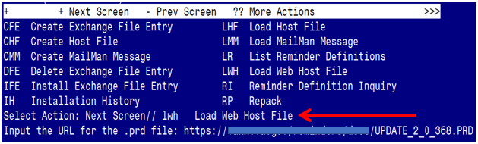

At the **Select Action:** prompt, enter **LWH** for Load Web Host File

At the **Input the url for the .prd file:** prompt, type the following web address:

**https://REDACTED/UPDATE\_2\_0\_368.PRD**

You should see a message at the top of your screen that the file successfully loaded.

Terminal window screen shot of the message displaying the URL of the file that was successfully loaded.  Part of the URL has been redacted as it is a VA only internal web site URL.

Search for and locate the reminder exchange entry titled UPDATE\_2\_0\_368 VA-MISC UPDATE 23.

(*see screenshot on the next page*)

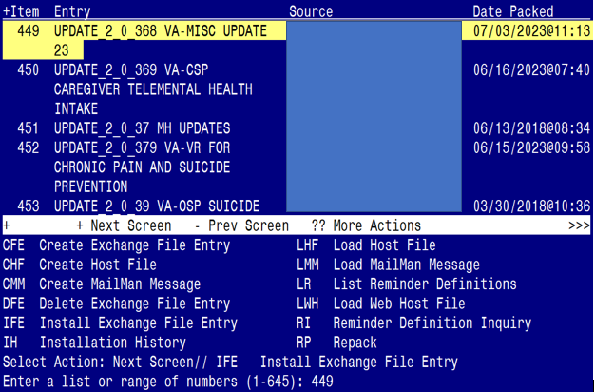

At the **Select Action** prompt, enter **IFE** for Install Exchange File Entry

Enter the number that corresponds with your entry titled **UPDATE\_2\_0\_368 VA-MISC UPDATE 23** *(in this example it is entry 449, it will vary by site).* The exchange file date is 07/03/2023@11:13.

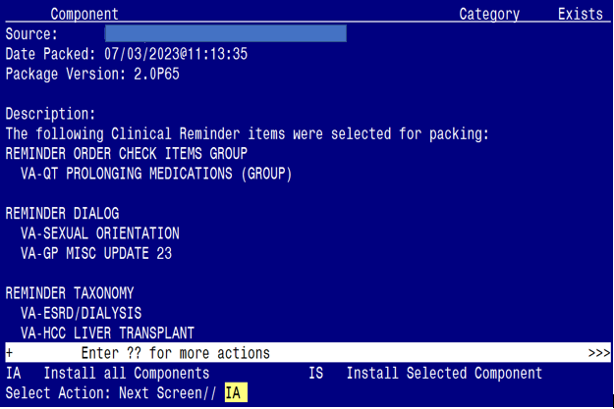

At the **Select Action** prompt, type **IA** for Install all Components and hit enter.

Select Action: Next Screen// IA Install all Components

*(You will see several prompts. Refer to the next page for responses to each prompt.)*

**You will see several prompts**:

**Individual components for which you may (or may not) be prompted are listed below, along with the response you should provide.**

**Install:**

All New Components

**Skip:**

Screen shot showing REMINDER ORDER CHECK RULES for VA-LONG QT SYNDROME (RULE)  on the left and on the right, REMINDER TERMS:
VA-HCC ADVANCED LIVER DISEASE OUTPT DX
VA-HCC HEPATITIS B POSITIVE LABS RT
VA_HCC SURVEILLANCE NOT INDICATED
VA-RACE ASIAN OR NATIVE HAWAIIAN/PACIFIC ISLANDER RT
VA-HCC INCORRECT DIAGNOSIS OF CHRONIC HBV
VA-HCC INCORRECT DIAGNOSIS OF CIRRHOSIS
VA-HCC IMAGING OI RT
VA-HCC IMAGING FOR LIVER CANCER
VA-HCC DECLINES IMAGING FOR SURVEILLANCE
VA-OUTSIDE HEPATITIS B SURFACE AG POSITIVE
VA-RACE OR AFRICAN AMERICAN RT

**Overwrite:**

Screen shot showing what to overwrite.  These items are discussed individually below this screen shot.
TIU TEMPLATE FIELD:
IM SARS COV-2 PROVIDER EUA FACT URL D2
VA LIPID MGMT GUIDANCE

HEALTH FACTORS:
VA-TECS TECHNICIAN [C]
VA-MH-RRTP [C]
VA-KIDNEY HEALTH EVALUATION URIND CR COMPLETED PREVIOUSLY
ETHICS-TIME SPENT [C]
ETHICS-TIME-91-120 MIN
ETHICS-TIME-61-90 MIN
ETHICS-TIME-31-60 MIN
ETHICS-TIME-UP TO 30 MIN

REMINDER TAXONOMY:
VA-ESRD/DIALYSIS

REMINDER DEFINITIONS:
VA-HCC SURVEILLANCE

HEALTH SUMMARY TYPE:
VA-SUICIDE ASSESSMENT TYPE

REMINDER ORDER CHECK ITEMS GROUP:
VA-QT PROLONGING MEDICATIONS (GROUP)


(*Each of the above components are also listed out individually, starting on the next page*)

**Note: Any component NOT listed individually should be skipped.**

TIU TEMPLATE FIELD entry named **IM SARS COV-2 PROVIDER EUA FACT URL D2**

already exists but the packed component is different, what do you

want to do?

Select one of the following:

C Create a new entry by copying to a new name

O Overwrite the current entry

U Update

Q Quit the install

S Skip, do not install this entry

Enter response: O// Overwrite the current entry

Are you sure you want to overwrite? N// Y

TIU TEMPLATE FIELD entry named **VA-LIPID MGMT GUIDANCE** already exists

but the packed component is different, what do you want to do?

Select one of the following:

C Create a new entry by copying to a new name

O Overwrite the current entry

U Update

Q Quit the install

S Skip, do not install this entry

Enter response: O// Overwrite the current entry

Are you sure you want to overwrite? N// Y

TIU TEMPLATE FIELD entry **VA-ONC PATHWAYS SHAREPOINT** is NEW,

what do you want to do?

Select one of the following:

C Create a new entry by copying to a new name

I Install

Q Quit the install

S Skip, do not install this entry

Enter response: I// Install

HEALTH FACTORS entry **VA-UPDATE\_2\_0\_368** is NEW,

what do you want to do?

Select one of the following:

C Create a new entry by copying to a new name

I Install

Q Quit the install

S Skip, do not install this entry

Enter response: I// Install

HEALTH FACTORS entry named **VA-TECS TECHNICIAN [C]** already exists but

the packed component is different, what do you want to do?

Select one of the following:

C Create a new entry by copying to a new name

O Overwrite the current entry

U Update

Q Quit the install

S Skip, do not install this entry

Enter response: O// Overwrite the current entry

Are you sure you want to overwrite? N// Y

HEALTH FACTORS entry named **VA-MH-RRTP [C]** already exists but the

packed component is different, what do you want to do?

Select one of the following:

C Create a new entry by copying to a new name

O Overwrite the current entry

U Update

Q Quit the install

S Skip, do not install this entry

Enter response: O// Overwrite the current entry

Are you sure you want to overwrite? N// Y

HEALTH FACTORS entry named **VA-KIDNEY HEALTH EVALUATION URINE CR**

**COMPLETED PREVIOUSLY** already exists but the packed component is

different, what do you want to do?

Select one of the following:

C Create a new entry by copying to a new name

O Overwrite the current entry

U Update

Q Quit the install

S Skip, do not install this entry

Enter response: O// Overwrite the current entry

Are you sure you want to overwrite? N// Y

HEALTH FACTORS entry named **ETHICS-TIME SPENT [C]** already exists but

the packed component is different, what do you want to do?

Select one of the following:

C Create a new entry by copying to a new name

O Overwrite the current entry

U Update

Q Quit the install

S Skip, do not install this entry

Enter response: O// Overwrite the current entry

Are you sure you want to overwrite? N// Y

HEALTH FACTORS entry named **ETHICS-TIME-91-120 MIN** already exists but

the packed component is different, what do you want to do?

Select one of the following:

C Create a new entry by copying to a new name

O Overwrite the current entry

U Update

Q Quit the install

S Skip, do not install this entry

Enter response: O// Overwrite the current entry

Are you sure you want to overwrite? N// Y

HEALTH FACTORS entry named **ETHICS-TIME-61-90 MIN** already exists but

the packed component is different, what do you want to do?

Select one of the following:

C Create a new entry by copying to a new name

O Overwrite the current entry

U Update

Q Quit the install

S Skip, do not install this entry

Enter response: O// Overwrite the current entry

Are you sure you want to overwrite? N// Y

HEALTH FACTORS entry named **ETHICS-TIME-31-60 MIN** already exists but

the packed component is different, what do you want to do?

Select one of the following:

C Create a new entry by copying to a new name

O Overwrite the current entry

U Update

Q Quit the install

S Skip, do not install this entry

Enter response: O// Overwrite the current entry

Are you sure you want to overwrite? N// Y

HEALTH FACTORS entry named **ETHICS-TIME-UP TO 30 MIN** already exists

but the packed component is different, what do you want to do?

Select one of the following:

C Create a new entry by copying to a new name

O Overwrite the current entry

U Update

Q Quit the install

S Skip, do not install this entry

Enter response: O// Overwrite the current entry

Are you sure you want to overwrite? N// Y

REMINDER TAXONOMY entry **VA-HCC LIVER TRANSPLANT** is NEW,

what do you want to do?

Select one of the following:

C Create a new entry by copying to a new name

I Install

Q Quit the install

S Skip, do not install this entry

Enter response: I// Install

REMINDER TAXONOMY entry named **VA-ESRD/DIALYSIS** already exists but the

packed component is different, what do you want to do?

Select one of the following:

C Create a new entry by copying to a new name

O Overwrite the current entry

U Update

Q Quit the install

S Skip, do not install this entry

Enter response: O// Overwrite the current entry

Are you sure you want to overwrite? N// Y

REMINDER TERM entry **VA-REMINDER UPDATE\_2\_0\_368** is NEW,

what do you want to do?

Select one of the following:

C Create a new entry by copying to a new name

I Install

Q Quit the install

S Skip, do not install this entry

Enter response: I// Install

REMINDER TERM entry **VA-HCC ADVANCED LIVER DISEASE OUTPT DX** already exists

but the packed component is different, what do you want to do?

Select one of the following:

C Create a new entry by copying to a new name

O Overwrite the current entry

U Update

Q Quit the install

S Skip, do not install this entry

Enter response: S// SKIP

REMINDER TERM entry **VA-HCC HEPATITIS B POSITIVE LABS RT** already exists

but the packed component is different, what do you want to do?

Select one of the following:

C Create a new entry by copying to a new name

O Overwrite the current entry

U Update

Q Quit the install

S Skip, do not install this entry

Enter response: S// SKIP

REMINDER TERM entry **VA-HCC SURVEILLANCE NOT INDICATED** already exists

but the packed component is different, what do you want to do?

Select one of the following:

C Create a new entry by copying to a new name

O Overwrite the current entry

U Update

Q Quit the install

S Skip, do not install this entry

Enter response: S// SKIP

REMINDER TERM entry **VA-RACE ASIAN OR NATIVE HAWAIIAN/PACIFIC ISLANDER RT** already exists but the packed component is different, what do you want to do?

Select one of the following:

C Create a new entry by copying to a new name

O Overwrite the current entry

U Update

Q Quit the install

S Skip, do not install this entry

Enter response: S// SKIP

REMINDER TERM entry **VA-HCC INCORRECT DIAGNOSIS OF CHRONIC HBV** already exists but the packed component is different, what do you want to do?

Select one of the following:

C Create a new entry by copying to a new name

O Overwrite the current entry

U Update

Q Quit the install

S Skip, do not install this entry

Enter response: S// SKIP

REMINDER TERM entry **VA-HCC INCORRECT DIAGNOSIS OF CIRRHOSIS** already exists but the packed component is different, what do you want to do?

Select one of the following:

C Create a new entry by copying to a new name

O Overwrite the current entry

U Update

Q Quit the install

S Skip, do not install this entry

Enter response: S// SKIP

REMINDER TERM entry **VA-HCC IMAGING OI RT** already exists but the packed component is different, what do you want to do?

Select one of the following:

C Create a new entry by copying to a new name

O Overwrite the current entry

U Update

Q Quit the install

S Skip, do not install this entry

Enter response: S// SKIP

REMINDER TERM entry **VA-HCC IMAGING FOR LIVER CANCER** already exists but the packed component is different, what do you want to do?

Select one of the following:

C Create a new entry by copying to a new name

O Overwrite the current entry

U Update

Q Quit the install

S Skip, do not install this entry

Enter response: S// SKIP

REMINDER TERM entry **VA-HCC DECLINES IMAGING FOR SURVEILLANCE** already exists but the packed component is different, what do you want to do?

Select one of the following:

C Create a new entry by copying to a new name

O Overwrite the current entry

U Update

Q Quit the install

S Skip, do not install this entry

Enter response: S// SKIP

REMINDER TERM entry **VA-OUTSIDE HEPATITIS B SURFACE AG POSITIVE** already exists but the packed component is different, what do you want to do?

Select one of the following:

C Create a new entry by copying to a new name

O Overwrite the current entry

U Update

Q Quit the install

S Skip, do not install this entry

Enter response: S// SKIP

REMINDER TERM entry **VA-RACE BLACK OR AFRICAN AMERICAN RT** already exists but the packed component is different, what do you want to do?

Select one of the following:

C Create a new entry by copying to a new name

O Overwrite the current entry

U Update

Q Quit the install

S Skip, do not install this entry

Enter response: S// SKIP

REMINDER DEFINITION entry named **VA-HCC SURVEILLANCE** already exists

but the packed component is different, what do you want to do?

Select one of the following:

C Create a new entry by copying to a new name

O Overwrite the current entry

U Update

Q Quit the install

S Skip, do not install this entry

Enter response: O// Overwrite the current entry

Are you sure you want to overwrite? N// Y

HEALTH SUMMARY TYPE entry named **VA-SUICIDE ASSESSMENT TYPE** already

exists but the packed component is different, what do you want to do?

Select one of the following:

C Create a new entry by copying to a new name

O Overwrite the current entry

U Update

Q Quit the install

S Skip, do not install this entry

Enter response: O// Overwrite the current entry

Are you sure you want to overwrite? N// Y

REMINDER ORDER CHECK RULES entry named **VA-LONG QT SYNDROME (RULE)**

already exists but the packed component is different, what do you

want to do?

Select one of the following:

C Create a new entry by copying to a new name

O Overwrite the current entry

U Update

Q Quit the install

S Skip, do not install this entry

Enter response: O// Skip, do not install this entry

REMINDER ORDER CHECK ITEMS GROUP entry named **VA-QT PROLONGING**

**MEDICATIONS (GROUP**) already exists but the packed component is

different, what do you want to do?

Select one of the following:

C Create a new entry by copying to a new name

O Overwrite the current entry

U Update

Q Quit the install

S Skip, do not install this entry

Enter response: O// Overwrite the current entry

Are you sure you want to overwrite? N// Y

**You will be promped to install the 1st dialog component:**

Regarding the Reminder Dialog VA-SEXUAL ORIENTATION:
Screen shot of the terminal window showing a list of elements, groups and dialogs with the text with IA for "Install All" entered at the "Select Action:" Prompt.  The correct entry is described in the text.

At the **Select Action** prompt, type **IA** to install the dialog – **VA-SEXUAL ORIENTATION**

Select Action: Next Screen// IA Install All

Install reminder dialog and all components with no further changes: Y// ES

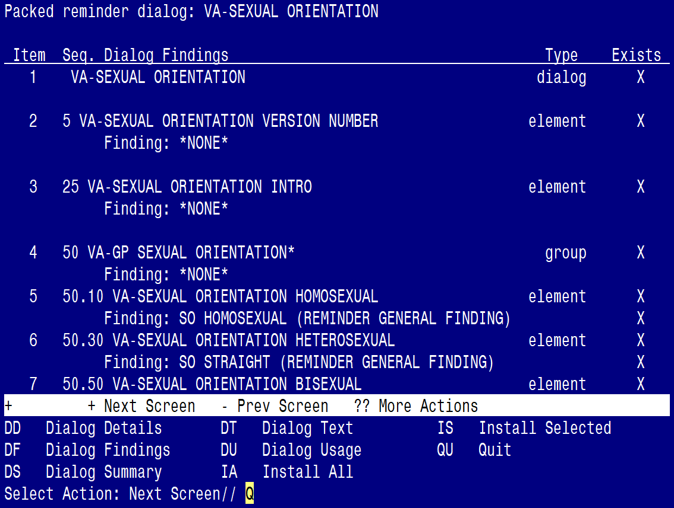

When the dialog has completed installation, you will then be returned to this screen. At the **Select Action** prompt, type **Q.**

**You will be promped to install the 2nd dialog component:**

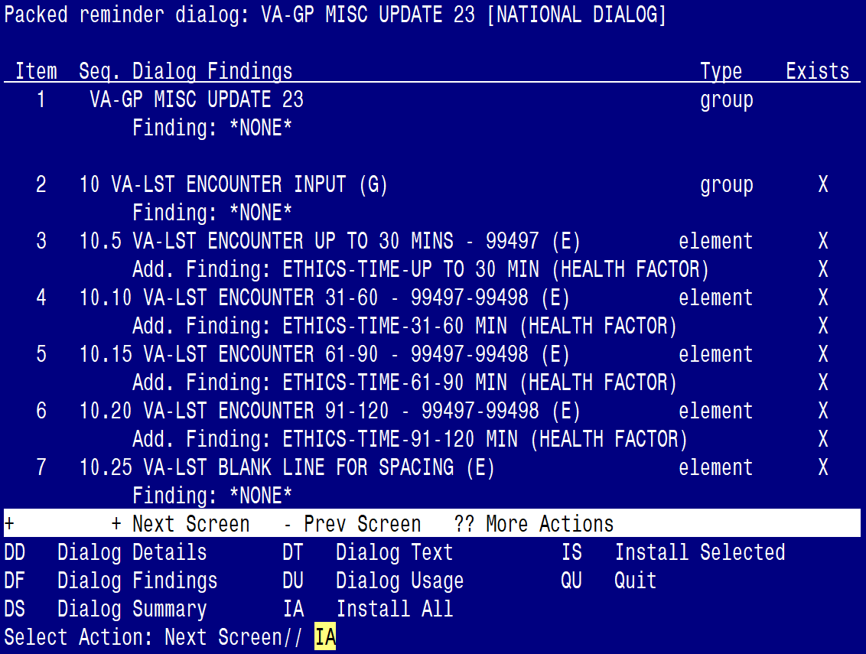

At the **Select Action** prompt, type **IA** to install the dialog – **VA-GP MISC UPDATE 23**

Select Action: Next Screen// IA Install All

Install reminder dialog and all components with no further changes: Y// ES

Regarding the VA-GP MISC UPDATE 23 [NATIONAL DIALOG}:
Screen shot of the last of the list of elements, groups and dialogs that needed to be installed with a Q for quit entered at the "Select Action:" prompt because they now all exist. 

When the dialog has completed installation, you will then be returned to this screen. At the **Select Action** prompt, type **Q.**

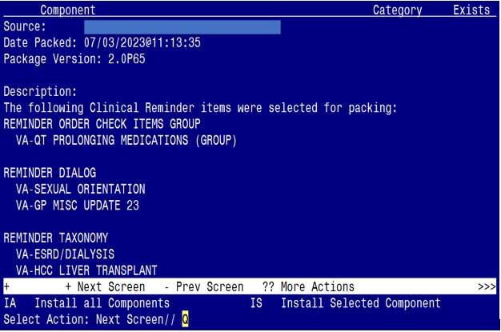

You will be returned to this screen. Type Q to quit.

Install Completed

# Post Installation

1. Reminder Order Check Rule: **VA-LONG QT SYNDROME (RULE)**

Ensure the “Status” is set to **PRODUCTION**. If not edit from Inactive to Production.

Screen shot showing the following on the left:  

BEFORE:
RULE NAME VA-LONG QT SYNDROME (RULE)
DISPLAY NAME ISSUE: Patient with documented long QT syndrome
STATUS INAC <<< change to PRODUCTION

CLASS NATIONAL

AFTER:
RULE NAME VA-LONG QT SYNDROME (RULE)
DISPLAY NAME ISSUE: Patient with documented long QT syndrome
STATUS PROD

To set the Reminder Order Check Rule to PROD, follow the steps below:

1. Go to the Add/Edit Reminder Order Check Rule Menu option:

GE Add/Edit Reminder Order Check Items Group

GI Reminder Order Check Items Inquiry

**RE Add/Edit Reminder Order Check Rule**

RI Reminder Order Check Rule Inquiry

TEST Reminder Order Check Test

Select Reminder Order Check Menu <TEST ACCOUNT> Option: **RE Add/Edit Reminder Order Check Rule**

Select Reminder Order Check Rule by one of the following:

1. Select the Order Check Rule Name option:

**N: ORDER CHECK RULE NAME**

R: REMINDER DEFINITION

T: REMINDER TERM

Q: QUIT

Select Reminder Order Check Rule by: (N/R/T/Q): **N// n ORDER CHECK RULE NAME**

1. Type VA-LONG QT SYNDROME (RULE)

Select Reminder Order Check Rule: VA-LONG QT SYNDROME (RULE)

1. Change the ‘Status’ field to PROD

**RULE NAME**: **VA-LONG QT SYNDROME (RULE)**

**DISPLAY NAME**: **ISSUE: Patient with documented long QT syndrome**

**STATUS**: **PROD**

**CLASS**: **NATIONAL**

SPONSOR:

REVIEW DATE:

\_\_\_\_\_\_\_\_\_\_\_\_\_\_\_\_\_\_\_\_\_\_\_\_\_\_\_\_\_\_\_\_\_\_\_

I=INACTIVE, P=PRODUCTION, T=TESTING

1. Refer to the Inquiry/Print (INQ) you saved during the Pre-Installation steps for the following REMINDER DEFINITION: VA-HCC SURVEILLANCE
2. Confirm all Reminder Terms have the same finding items mapped. If not, add any ‘local’ finding items back to each term, as needed.
3. Link the VA-HCC SURVEILLANCE dialog to the VA-HCC SURVEILLANCE reminder definition.
   * Use the **Reminder Dialog Management Menu** to link the dialog to the definition.
4. After you link the dialog, can go to the Reminder Definition Management Menu and perform a Reminder Inquiry (RI) to confirm the linkage (see highlighted text below).

REMINDER DEFINITION INQUIRY

VA-HCC SURVEILLANCE

-----------------------------------

Print Name: Liver Cancer (HCC) Surveillance

Class: NATIONAL

Sponsor: NATIONAL GASTROENTEROLOGY & HEPATOLOGY

Review Date:

Rescission Date:

Usage: CPRS, DATA EXTRACT, REPORTS

Related VA-\* Reminder:

Reminder Dialog: VA-HCC SURVEILLANCE