

**Update _2_0_370**

Clinical Reminders

VA-TELERETINOPATHY Reminder and Dialog Updates

Install Guide

**October 2023**

Product Development

Office of Information Technology

Department of Veterans Affairs

Table of Contents

Introduction 1

Install Details 8

Pre Installation 9

Install Example 9

Post Installation 17

# Introduction

DESCRIPTION:

This update revises several items in the VA-TELERETINOPATHY READER NOTE, VA- TELERETINOPATHY IMAGER NOTE, and VA-TELE-EYE RESULTS LETTER dialogs, the VA-EYE CARE AT-RISK SCREEN (NURSE), the VA-GP TECS TECH-DIABETES dialog group, and VA-EYE CARE AT-RISK SCREEN (PROV) reminder definitions. A detailed description of the revisions is listed below.

For a description of the reminder dialogs and definitions, see the original installation guides on the VA Software Documentation Library (VDL)

* UPDATE_2_0_167 Tele-Eye and Tele-Derm Updates
* UPDATE_2_0_146 VA-EYE CARE AT-RISK SCREEN
* UPDATE_2_0_42 Teleretinal Imaging Dialogs
* UPDATE_2_0_217 VA-Teleretinopathy Reminder Updates

*Note: The VA-Eye Care At-Risk Screen Reminder Definition may only be activated at sites prepared for

expansion. Coordinate implementation on CPRS cover sheet with the Facility Telehealth Coordinator.

*Note: Use of the VA-EYE CARE AT-RISK SCREEN ‘NURSE’ reminder is by Primary Care Nursing and/or

Telehealth Imager/staff.

*Note: Reminders may be installed and activated on a community-based outpatient clinic (CBOC) by CBOC

basis.

Updates to the two reminders and five dialogs are listed here:

UPDATE_2_0_370 contains 1 Reminder Exchange entry:

**UPDATE_2_0_370 VA-TELERETINOPATHY UPDATE**

**The exchange file contains the following components:**

**TEMPLATE FIELDS**

VA-TECS DURATION OF DIABETES

WP FREE TEXT FL55 I3

COMMENT OPTIONAL

VA-TECS OD/OS/OU

BLANK SPACE1

VA-YES NO REQUIRED

DATE

VA-TRR DATE 9M

VA-TRR DATE 2Y

VA-TRR DATE 1Y

VA-TRR DATE 6M

VA-TRR DATE 4M

VA-TRR DATE 3M

VA-TRR DATE 2M

VA-TRR DATE 1M

TEXT (1-60 CHAR)

**EXAM**

TRR EXAM OTH ASSESS-U/A

TRR EXAM OTH ASSESS-ABN

TRR EXAM OTH ASSESS-NORM

TRR EXAM OPTC NRV-NORMAL

TRR EXAM OPTC NRV-ABN

TRR EXAM OPTC NRV-U/A

TRR EXAM MACULA-U/A

TRR EXAM MACULA-ABN

TRR EXAM MACULA-NORMAL

VA-TRR DM EXAM RTNOPTY-U/A

VA-TRR DM EXAM RTNOPTY-ABN

VA-TRR DM EXAM RTNOPTY-NORMAL

**HEALTH FACTORS**

INCORRECT DIAGNOSES [C]

LIFE EXPECTANCY < 6 MONTHS

REMINDER FACTORS [C]

VA-UPDATE_2_0_370

VA-COMP EYE EXAM SCHEDULED

VA-EYE AT RISK SCREEN HX LASER TX/INJ LAST 2YRS

VA-EYE CARE AT-RISK SCREEN [C]

VA-INCORRECT DIABETES DIAGNOSIS

VA-INCORRECT DIABETES DIAGNOSIS-PROVIDER

VA-OUTSIDE DIAB EYE ABN AT-RISK SCRN

VA-OUTSIDE DIAB EYE NORMAL AT-RISK SCRN

VA-OUTSIDE DIAB EYE UNK AT-RISK SCRN

VA-OUTSIDE EYE AT-RISK SCREEN

VA-REFUSED NURS AT-RISK SCREEN

VA-REFUSED PROV AT-RISK SCREEN

VA-TECS EYE DX HX DM-INSULIN

VA-TECS EYE DX HX-DIABETES

VA-TECS TECHNICIAN [C]

VA-TELE EYE GLAUC EXAM UNABLE TO ASSESS

VA-TELE EYE GLAUCOMA EXAM ABNORMAL

VA-TELE EYE GLAUCOMA EXAM NORMAL

VA-TRI CATEGORY-DM EYE EXAM [C]

VA-TRI DM RETINOP EXAM ABNORMAL

VA-TRI DM RETINOP EXAM NORMAL

VA-TRI DM RETINOP EXAM UNABLE TO ASSESS

VA-TRI EYE EXAM FUTURE

VA-TRI EYE EXAM SCHEDULED

VA-TRI MACULA EXAM ABNORMAL

VA-TRI MACULA EXAM NORMAL

VA-TRI MACULA EXAM UNABLE TO ASSESS

VA-TRR AT RISK FOR GLAUCOMA

VA-TRR AT RISK FOR MAC DEGEN & GLAUCOMA

VA-TRR AT RISK FOR MAC DEGENERATION

VA-TRR AT RISK OTHER EYE CONDITION

VA-TRR CATEGORY-DM EXAM FINDINGS LT EYE [C]

VA-TRR CATEGORY-DM EXAM FINDINGS RT EYE [C]

VA-TRR CATEGORY-DM EYE EXAM [C]

VA-TRR CATEGORY-EYE SCREENING EXAM FINDINGS [C]

VA-TRR CATEGORY-IMAGE QUALITY [C]

VA-TRR CATEGORY-NON DM EYE EXAM [C]

VA-TRR CATEGORY-NON DM FINDINGS LT EYE [C]

VA-TRR CATEGORY-NON DM FINDINGS RT EYE [C]

VA-TRR CATEGORY-RECOMMENDATIONS [C]

VA-TRR CATEGORY-RESULTS NOTIFICATION [C]

VA-TRR CATEGORY-SCREEN [C]

VA-TRR DIABETES TYPE 1

VA-TRR DIABETES TYPE 2

VA-TRR DM MACULA EXAM UNABLE TO ASSESS

VA-TRR DM OPTIC NRV EXAM NORMAL

VA-TRR DM RETINOP EXAM ABNORMAL

VA-TRR DM RETINOP EXAM NORMAL

VA-TRR DM RETINOP EXAM UNABLE TO ASSESS

VA-TRR DM1 FIND DR MLD MAC NO EDEMA LT

VA-TRR DM1 FIND DR MLD MAC NO EDEMA RT

VA-TRR DM1 FIND DR MOD MAC NO EDEMA LT

VA-TRR DM1 FIND DR MOD MAC NO EDEMA RT

VA-TRR DM1 FIND DR PDR MAC NO EDEMA LT

VA-TRR DM1 FIND DR PDR MAC NO EDEMA RT

VA-TRR DM1 FIND DR PREV RET LASER TX LT

VA-TRR DM1 FIND DR PREV RET LASER TX RT

VA-TRR DM1 FIND DR SEV MAC NO EDEMA LT

VA-TRR DM1 FIND DR SEV MAC NO EDEMA RT

VA-TRR DM1 FINDING DR INADQ ASSESS LT

VA-TRR DM1 FINDING DR INADQ ASSESS RT

VA-TRR DM1 FINDING DR MLD MAC EDEMA LT

VA-TRR DM1 FINDING DR MLD MAC EDEMA RT

VA-TRR DM1 FINDING DR MOD MAC EDEMA LT

VA-TRR DM1 FINDING DR MOD MAC EDEMA RT

VA-TRR DM1 FINDING DR NO RETINOPATHY LT

VA-TRR DM1 FINDING DR NO RETINOPATHY RT

VA-TRR DM1 FINDING DR OTHER RT

VA-TRR DM1 FINDING DR PDR MAC EDEMA LT

VA-TRR DM1 FINDING DR PDR MAC EDEMA RT

VA-TRR DM1 FINDING DR SEV MAC EDEMA LT

VA-TRR DM1 FINDING DR SEV MAC EDEMA RT

VA-TRR DM2 FIND DR MLD MAC NO EDEMA LT

VA-TRR DM2 FIND DR MLD MAC NO EDEMA RT

VA-TRR DM2 FIND DR MOD MAC NO EDEMA LT

VA-TRR DM2 FIND DR MOD MAC NO EDEMA RT

VA-TRR DM2 FIND DR PDR MAC NO EDEMA LT

VA-TRR DM2 FIND DR PDR MAC NO EDEMA RT

VA-TRR DM2 FIND DR PREV RET LASER TX LT

VA-TRR DM2 FIND DR PREV RET LASER TX RT

VA-TRR DM2 FIND DR SEV MAC NO EDEMA LT

VA-TRR DM2 FIND DR SEV MAC NO EDEMA RT

VA-TRR DM2 FINDING DR INADQ ASSESS LT

VA-TRR DM2 FINDING DR INADQ ASSESS RT

VA-TRR DM2 FINDING DR MLD MAC EDEMA LT

VA-TRR DM2 FINDING DR MLD MAC EDEMA RT

VA-TRR DM2 FINDING DR MOD MAC EDEMA LT

VA-TRR DM2 FINDING DR MOD MAC EDEMA RT

VA-TRR DM2 FINDING DR NO RETINOPATHY LT

VA-TRR DM2 FINDING DR NO RETINOPATHY RT

VA-TRR DM2 FINDING DR OTHER LT

VA-TRR DM2 FINDING DR OTHER RT

VA-TRR DM2 FINDING DR PDR MAC EDEMA LT

VA-TRR DM2 FINDING DR PDR MAC EDEMA RT

VA-TRR DM2 FINDING DR SEV MAC EDEMA LT

VA-TRR DM2 FINDING DR SEV MAC EDEMA RT

VA-TRR IMAGE QUAL ADEQUATE

VA-TRR IMAGE QUAL INADEQUATE

VA-TRR IMAGE QUAL INADQ-BLURRED IMAGE

VA-TRR IMAGE QUAL INADQ-FIELD MISSING

VA-TRR IMAGE QUAL INADQ-MEDIA

VA-TRR IMAGE QUAL INADQ-OTHER REASON

VA-TRR IMAGE QUAL INADQ-PT POSITION

VA-TRR IMAGE QUAL INADQ-PUPIL SIZE

VA-TRR MAC FINDING ATROPHY LT

VA-TRR MAC FINDING ATROPHY RT

VA-TRR MAC FINDING DRUSEN LT

VA-TRR MAC FINDING DRUSEN RT

VA-TRR MAC FINDING DRUSEN-LG LT

VA-TRR MAC FINDING DRUSEN-LG RT

VA-TRR MAC FINDING DRUSEN-SMALL LT

VA-TRR MAC FINDING DRUSEN-SMALL RT

VA-TRR MAC FINDING EXUDATES LT

VA-TRR MAC FINDING EXUDATES RT

VA-TRR MAC FINDING GEOG ATROPHY LT

VA-TRR MAC FINDING GEOG ATROPHY RT

VA-TRR MAC FINDING INADEQ ASSESS LT

VA-TRR MAC FINDING INADEQ ASSESS RT

VA-TRR MAC FINDING INTRARETINAL HEMORRHAGE LT

VA-TRR MAC FINDING INTRARETINAL HEMORRHAGE RT

VA-TRR MAC FINDING MAC HOLE-LT

VA-TRR MAC FINDING MAC HOLE-RT

VA-TRR MAC FINDING NEOVASC MACULOPTHY LT

VA-TRR MAC FINDING NEOVASC MACULOPTHY RT

VA-TRR MAC FINDING NO APPARENT ABN LT

VA-TRR MAC FINDING NO APPARENT ABN RT

VA-TRR MAC FINDING OTHER LT

VA-TRR MAC FINDING OTHER RT

VA-TRR MAC FINDING PIGMENTARY CHANGE LT

VA-TRR MAC FINDING PIGMENTARY CHANGE RT

VA-TRR MAC FINDING PUCKERING LT

VA-TRR MAC FINDING PUCKERING RT

VA-TRR MACULA EXAM ABNORMAL

VA-TRR MACULA EXAM NORMAL

VA-TRR MACULA EXAM UNABLE TO ASSESS

VA-TRR NOT CANDIDATE FOR SCRN

VA-TRR ON FINDING DISC DRUSEN LT

VA-TRR ON FINDING DISC DRUSEN RT

VA-TRR ON FINDING DISC EDEMA SUSP LT

VA-TRR ON FINDING DISC EDEMA SUSP RT

VA-TRR ON FINDING DISC NEOVASCULARIZATION LT

VA-TRR ON FINDING DISC NEOVASCULARIZATION RT

VA-TRR ON FINDING DISC W/ SHARP MARGINS LT

VA-TRR ON FINDING DISC W/ SHARP MARGINS RT

VA-TRR ON FINDING ELEVATED IOP LT

VA-TRR ON FINDING ELEVATED IOP RT

VA-TRR ON FINDING INADQ ASSESS LT

VA-TRR ON FINDING INADQ ASSESS RT

VA-TRR ON FINDING KNOWN GLAUCOMA LT

VA-TRR ON FINDING KNOWN GLAUCOMA RT

VA-TRR ON FINDING LG CUP/DISC LT

VA-TRR ON FINDING LG CUP/DISC RT

VA-TRR ON FINDING NO APP ABN LT

VA-TRR ON FINDING NO APP ABN RT

VA-TRR ON FINDING OTHER LT

VA-TRR ON FINDING OTHER RT

VA-TRR ON FINDING PALLOR LT

VA-TRR ON FINDING PALLOR RT

VA-TRR ON FINDING PAPILLEDEMA SUSPECTED LT

VA-TRR ON FINDING PAPILLEDEMA SUSPECTED RT

VA-TRR ON FINDING PERIPAPILLARY ATROPHY LT

VA-TRR ON FINDING PERIPAPILLARY ATROPHY RT

VA-TRR ON FINDING PHYSIOLOGIC CUPPING SUSPECTED LT

VA-TRR ON FINDING PHYSIOLOGIC CUPPING SUSPECTED RT

VA-TRR OPTIC NRV EXAM ABNORMAL

VA-TRR OPTIC NRV EXAM NORMAL

VA-TRR OPTIC NRV EXAM UNABLE TO ASSES

VA-TRR OTH ASSESS EXAM ABNORMAL

VA-TRR OTH ASSESS EXAM NORMAL

VA-TRR OTH ASSESS EXAM UNABLE TO ASSESS

VA-TRR OTH ASSESS FIND INADQ ASSESS LT

VA-TRR OTH ASSESS FIND INADQ ASSESS RT

VA-TRR OTH ASSESS FINDING CATARACT LT

VA-TRR OTH ASSESS FINDING CATARACT RT

VA-TRR OTH ASSESS FINDING CHOR NEVUS LT

VA-TRR OTH ASSESS FINDING CHOR NEVUS RT

VA-TRR OTH ASSESS FINDING CHORIORETINAL SCAR LT

VA-TRR OTH ASSESS FINDING CHORIORETINAL SCAR RT

VA-TRR OTH ASSESS FINDING COTTON WOOL SPOT LT

VA-TRR OTH ASSESS FINDING COTTON WOOL SPOT RT

VA-TRR OTH ASSESS FINDING FAMILY HX GLAUCOMA LT

VA-TRR OTH ASSESS FINDING FAMILY HX GLAUCOMA RT

VA-TRR OTH ASSESS FINDING HTN RTNPTHY LT

VA-TRR OTH ASSESS FINDING HTN RTNPTHY RT

VA-TRR OTH ASSESS FINDING LENS IMPLANT LT

VA-TRR OTH ASSESS FINDING LENS IMPLANT RT

VA-TRR OTH ASSESS FINDING LENTICULAR OPACIFICATION LT

VA-TRR OTH ASSESS FINDING LENTICULAR OPACIFICATION RT

VA-TRR OTH ASSESS FINDING NO ABN FIND LT

VA-TRR OTH ASSESS FINDING NO ABN FIND RT

VA-TRR OTH ASSESS FINDING OCCLUSION LT

VA-TRR OTH ASSESS FINDING OCCLUSION RT

VA-TRR OTH ASSESS FINDING OTH LT

VA-TRR OTH ASSESS FINDING OTH RT

VA-TRR OTH ASSESS FINDING PERIPH RET DEGEN LT

VA-TRR OTH ASSESS FINDING PERIPH RET DEGEN RT

VA-TRR OTH ASSESS FINDING RET EMBOLUS LT

VA-TRR OTH ASSESS FINDING RET EMBOLUS RT

VA-TRR OTH ASSESS FINDING RETINAL VASC CHANGE LT

VA-TRR OTH ASSESS FINDING RETINAL VASC CHANGE RT

VA-TRR RECOMMEND VA EYE CLINIC APPT

VA-TRR REFER COMP EYE CARE

VA-TRR REFER MACULA DISEASE

VA-TRR REFER OPHTH/OPTOM 1 MONTH

VA-TRR REFER OPHTH/OPTOM 1 YR

VA-TRR REFER OPHTH/OPTOM 2 MONTHS

VA-TRR REFER OPHTH/OPTOM 2 YRS

VA-TRR REFER OPHTH/OPTOM 3 MONTHS

VA-TRR REFER OPHTH/OPTOM 4 MONTHS

VA-TRR REFER OPHTH/OPTOM 6 MONTHS

VA-TRR REFER OPHTH/OPTOM 9 MONTHS

VA-TRR REFER OPHTH/OPTOM ASAP

VA-TRR REFER OPHTH/OPTOM-OTHER FREQ

VA-TRR REFER OPHTHALMOLOGY 1 MONTH

VA-TRR REFER OPHTHALMOLOGY 1 YR

VA-TRR REFER OPHTHALMOLOGY 2 MONTHS

VA-TRR REFER OPHTHALMOLOGY 2 YRS

VA-TRR REFER OPHTHALMOLOGY 3 MONTHS

VA-TRR REFER OPHTHALMOLOGY 4 MONTHS

VA-TRR REFER OPHTHALMOLOGY 6 MONTHS

VA-TRR REFER OPHTHALMOLOGY 9 MONTHS

VA-TRR REFER OPHTHALMOLOGY ASAP

VA-TRR REFER OPHTHALMOLOGY-OTHER FREQ

VA-TRR REFER OPTIC NERVE DISEASE

VA-TRR REFER OPTOMETRY 1 MONTH

VA-TRR REFER OPTOMETRY 1 YR

VA-TRR REFER OPTOMETRY 2 MONTHS

VA-TRR REFER OPTOMETRY 2 YRS

VA-TRR REFER OPTOMETRY 3 MONTHS

VA-TRR REFER OPTOMETRY 4 MONTHS

VA-TRR REFER OPTOMETRY 6 MONTHS

VA-TRR REFER OPTOMETRY 9 MONTHS

VA-TRR REFER OPTOMETRY ASAP

VA-TRR REFER OPTOMETRY-OTHER FREQ

VA-TRR REFER OTHER EYE DISEASE

VA-TRR REFER OUTSIDE PROV 1 MONTH

VA-TRR REFER OUTSIDE PROV 1 YR

VA-TRR REFER OUTSIDE PROV 2 MONTHS

VA-TRR REFER OUTSIDE PROV 2 YRS

VA-TRR REFER OUTSIDE PROV 3 MONTHS

VA-TRR REFER OUTSIDE PROV 4 MONTHS

VA-TRR REFER OUTSIDE PROV 6 MONTHS

VA-TRR REFER OUTSIDE PROV 9 MONTHS

VA-TRR REFER OUTSIDE PROV ASAP

VA-TRR REFER RETINOPATHY

VA-TRR REFER UNABLE TO ASSESS

VA-TRR REFER VISUALLY SIGNF CATARACT

VA-TRR REPEAT IMAGING-RET NEXT AVAIL

VA-TRR REPEAT IMAGING-RETURN 1 YR

VA-TRR REPEAT IMAGING-RETURN 2 YRS

VA-TRR REPEAT IMAGING-RETURN OTH

VA-TRR RESULTS NOTIFICATION COMPLETED

**REMINDER SPONSOR**

OFFICE OF TELEHEALTH SERVICES STORE AND FORWARD TELEHEALH

OFFICE OF PATIENT CARE SERVICES

NATIONAL CENTER FOR HEALTH PROMOTION AND DISEASE PREVENTION (NCP)

**REMINDER TERM**

TELE EYE GLAUCOMA EXAM-ABNORMAL

TELE EYE GLAUCOMA EXAM-NORMAL

TELE EYE GLAUCOMA EXAM-UNABLE TO ASSESS

TELE EYE MACULA EXAM-ABNORMAL

TELE EYE MACULA EXAM-NORMAL

TELE EYE MACULA EXAM-UNABLE TO ASSESS

TELE EYE RETINOPATHY EXAM-ABNORMAL

TELE EYE RETINOPATHY EXAM-NORMAL

TELE EYE RETINOPATHY EXAM-UNABLE TO ASSESS

TELE EYE SCREEN ORDERS

VA-AMD RISK FACTORS

VA-BL TECS DIABETES HX

VA-BL TELE EYE AMD PT

VA-BL TELE EYE DIABETIC PT

VA-BL TELE EYE GLAUCOMA PT

VA-BL TELE EYE GLAUCOMA/AMD PT

VA-BL TELE EYE INCORRECT DIABETIC DX

VA-EYE AT RISK NSG SCREEN INCORRECT DM DIAGNOSIS

VA-EYE AT RISK NSG SCREEN REFUSAL

VA-GLAUCOMA RISK FACTORS

VA-LIFE EXPECTANCY < 6 MONTHS

VA-OUTSIDE EYE AT-RISK SCREEN

VA-TRI SCREEN EXCLUSIONS

VA-REMINDER UPDATE_2_0_370

**REMINDER TAXONOMY**

LONG TERM STEROID USE

TOBACCO USE CODES

TRI EX DM RETINOPATHY U/A

VA-ABNORMAL BMI

VA-AMD RISK FACTORS

VA-CAD

VA-DIABETES

VA-DIABETES HEDIS

VA-DIABETIC W/ EYE CONDITIONS

VA-DIABETIC W/O EYE CONDITIONS

VA-EYE AT-RISK SCRN CPT EXCLUSIONS

VA-EYE AT-RISK SCRN ICD EXCLUSIONS

VA-GLAUCOMA RISK FACTORS

VA-GLAUCOMA/AMD W EYE CONDITION

VA-GLAUCOMA/AMD W/O EYE CONDITION

VA-TERMINAL CANCER PATIENTS

VA-TRI BRANCH RETINAL VEIN OCCLUSION

VA-TRI CHOROIDAL NEVUS L

VA-TRI CHOROIDAL NEVUS R

VA-TRI DM1 MILD NONPROLIF RETINOPATHY NO MACULAR EDEMA

VA-TRI DM1 MILD NONPROLIF RETINOPATHY NO MACULAR EDEMA R

VA-TRI DM1 MILD NONPROLIF RETINOPATHY PROB MACULAR EDEMA L

VA-TRI DM1 MILD NONPROLIF RETINOPATHY PROB MACULAR EDEMA R

VA-TRI DM1 MOD NONPROLIF RETINOPATHY NO MACULAR EDEMA L

VA-TRI DM1 MOD NONPROLIF RETINOPATHY NO MACULAR EDEMA R

VA-TRI DM1 MOD NONPROLIF RETINOPATHY PROB MACULAR EDEMA L

VA-TRI DM1 MOD NONPROLIF RETINOPATHY PROB MACULAR EDEMA R

VA-TRI DM1 PROLIF RETINOPATHY NO MACULAR EDEMA L

VA-TRI DM1 PROLIF RETINOPATHY NO MACULAR EDEMA R

VA-TRI DM1 PROLIF RETINOPATHY PROB MACULAR EDEMA L

VA-TRI DM1 PROLIF RETINOPATHY PROB MACULAR EDEMA R

VA-TRI DM1 SEVERE NONPROLIF RETINOPATHY NO MACULAR EDEMA L

VA-TRI DM1 SEVERE NONPROLIF RETINOPATHY NO MACULAR EDEMA R

VA-TRI DM1 SEVERE NONPROLIF RETINOPATHY PROB MACULAR EDEMA L

VA-TRI DM1 SEVERE NONPROLIF RETINOPATHY PROB MACULAR EDEMA R

VA-TRI DM1/DM2 NO RETINOPATHY NO MACULAR EDEMA R/L

VA-TRI DM2 MILD NONPROLIF RETINOPATHY NO MACULAR EDEMA L

VA-TRI DM2 MILD NONPROLIF RETINOPATHY NO MACULAR EDEMA R

VA-TRI DM2 MILD NONPROLIF RETINOPATHY PROB MACULAR EDEMA L

VA-TRI DM2 MILD NONPROLIF RETINOPATHY PROB MACULAR EDEMA R

VA-TRI DM2 MOD NONPROLIF RETINOPATHY NO MACULAR EDEMA L

VA-TRI DM2 MOD NONPROLIF RETINOPATHY NO MACULAR EDEMA R

VA-TRI DM2 MOD NONPROLIF RETINOPATHY PROB MACULAR EDEMA L

VA-TRI DM2 MOD NONPROLIF RETINOPATHY PROB MACULAR EDEMA R

VA-TRI DM2 PROLIF RETINOPATHY NO MACULAR EDEMA L

VA-TRI DM2 PROLIF RETINOPATHY NO MACULAR EDEMA R

VA-TRI DM2 PROLIF RETINOPATHY PROB MACULAR EDEMA L

VA-TRI DM2 PROLIF RETINOPATHY PROB MACULAR EDEMA R

VA-TRI DM2 SEVERE NONPROLIF RETINOPATHY NO MACULAR EDEMA L

VA-TRI DM2 SEVERE NONPROLIF RETINOPATHY NO MACULAR EDEMA R

VA-TRI DM2 SEVERE NONPROLIF RETINOPATHY PROB MACULAR EDEMA L

VA-TRI DM2 SEVERE NONPROLIF RETINOPATHY PROB MACULAR EDEMA R

VA-TRI ELEVATED IOP L

**REMINDER DEFINITION**

VA-OBJ AMD RISK FACTORS

VA-OBJ GLAUCOMA RISK FACTORS

VA-DIABETES OBJECT

VA-TRI SCREENING EXCLUSIONS

VA-BL TELE-EYE SCREEN-AMD

VA-BL TELE-EYE SCREEN-GLAUCOMA

VA-BL TELE-EYE SCREEN-GLAUCOMA/AMD RISKS

VA-BL TELE-EYE SCREEN-INCORRECT DM DX

VA-EYE CARE AT-RISK SCREEN (PROV)

VA-EYE CARE AT-RISK SCREEN (NURSE)

**REMINDER DIALOG**

VA-EYE CARE AT-RISK SCREEN (NURSING)

VA-EYE CARE AT-RISK SCREEN (PROV)

VA-TELERETINOPATHY IMAGER NOTE

VA-TELERETINOPATHY READER NOTE

VA-TELE-EYE RESULTS LETTER

**HEALTH SUMMARY TYPE**

VA-TECS DIABETES HX

VA-TELE EYE RECOMMENDATIONS

VA-TELE EYE SCREENING RESULTS

VA-AMD RISK FACTORS

VA-GLAUCOMA RISK FACTORS

VA-DIABETES OBJECT

VA-TRI SCREEN EXCLUSIONS

VA-TRI HGBA1C

**TIU DOCUMENT DEFINITION**

VA-TECS DIABETES HX

VA-TELE EYE RECOMMENDATIONS

VA-TELE EYE SCREENING RESULTS

VA-AMD RISK FACTORS

VA-GLAUCOMA RISK FACTORS

VA-DIABETES OBJECT

VA-TRI SCRN EXCLUSIONS

# Install Details

This update is being distributed as a web host file. The address for the host file is: **https://REDACTED/UPDATE_2_0_370.PRD**

The file will be installed using Reminder Exchange, programmer access is not required.

Installation:

=============

This update can be loaded with users on the system. Installation will take less than 30 minutes.

# Pre Installation

1. **Print/Screen capture the following terms to capture any mapped local findings. Terms should be merged during installation. The copy will be helpful to confirm the findings were maintained post installation.** 
   1. TELE EYE GLAUCOMA EXAM-ABNORMAL
   2. TELE EYE GLAUCOMA EXAM-NORMAL
   3. TELE EYE GLAUCOMA EXAM-UNABLE TO ASSESS
   4. TELE EYE MACULA EXAM-ABNORMAL
   5. TELE EYE MACULA EXAM-NORMAL
   6. TELE EYE MACULA EXAM-UNABLE TO ASSESS
   7. TELE EYE RETINOPATHY EXAM-ABNORMAL
   8. TELE EYE RETINOPATHY EXAM-NORMAL
   9. TELE EYE RETINOPATHY EXAM-UNABLE TO ASSESS
   10. TELE EYE SCREEN ORDERS
   11. VA-OUTSIDE EYE AT-RISK SCREEN
   12. VA-EYE AT RISK NSG SCREEN REFUSAL
   13. VA-EYE AT RISK NSG SCREEN INCORRECT DM DIAGNOSIS
   14. VA-BL TELE EYE INCORRECT DIABETIC DX
2. **Identify orders mapped to the following elements as additional findings. The orders will need to be re-mapped after installation.**
   1. Element VAL-OI EYE CARE AT-RISK RETINAL IMAGE CONSULT
   2. Element VAL-OI EYE CARE AT-RISK EYE GLASS CONSULT
   3. Element VAL-OI EYE CARE AT-RISK COMP EYE EXAM CONSULT
3. **Identify local consult order for nutrition services. It will be mapped to an element in post-installation.**
4. **Identify local TIU object that displays the most recent eye exam dates, if available.**
5. **Print/Screen capture the Health Summary Type TRI HGBA1C to capture mapped local hemoglobin A1C lab tests. The copy will be helpful to confirm the lab tests were maintained post installation.**
6. **Note: The VA-Eye Care At-Risk Screen Reminder Definitions were only activated at expansion locations after the Facility Telehealth Coordinator (FTC) notified the CAC when to activate. Coordinate activation of these cover sheet reminders with the local FTC, if not already active.**

# Install Example

To Load the Web Host File. Navigate to Reminder exchange in Vista

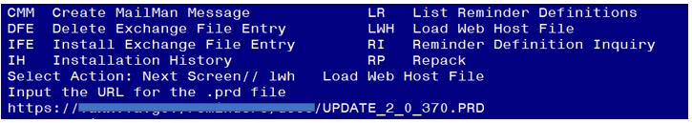

At the **Select Action:** prompt, enter **LWH** for Load Web Host File

At the **Input the url for the .prd file:** prompt, type the following web address:

**https://REDACTD/UPDATE_2_0_370.PRD**

**Follow the steps below to install**

**UPDATE_2_0_370 VA-TELERETINOPATHY UPDATES.**

Search and locate an entry titled UPDATE_2_0_370 VA-TELERETINOPATHY UPDATE in reminder exchange.

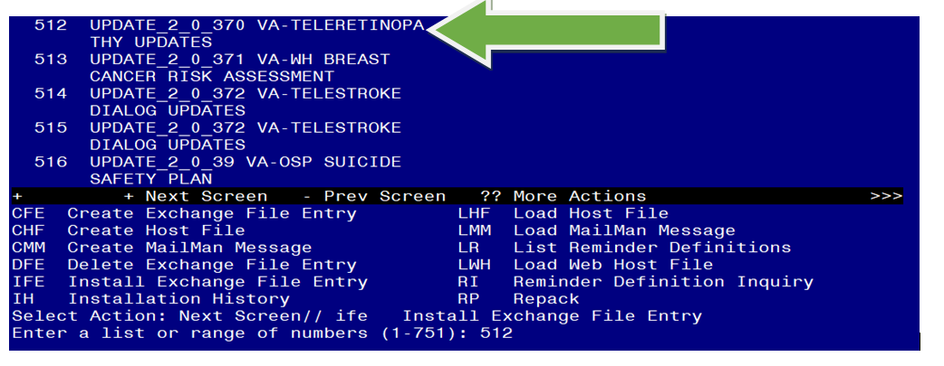

At the **Select Action** prompt, enter **IFE** for Install Exchange File Entry

Enter the number that corresponds with your entry **UPDATE_2_0_370 VA-TELERETINOPATHY UPDATE**  *(in this example it is entry 509 it will vary by site).* The date of the exchange file should be 10/024/2023.

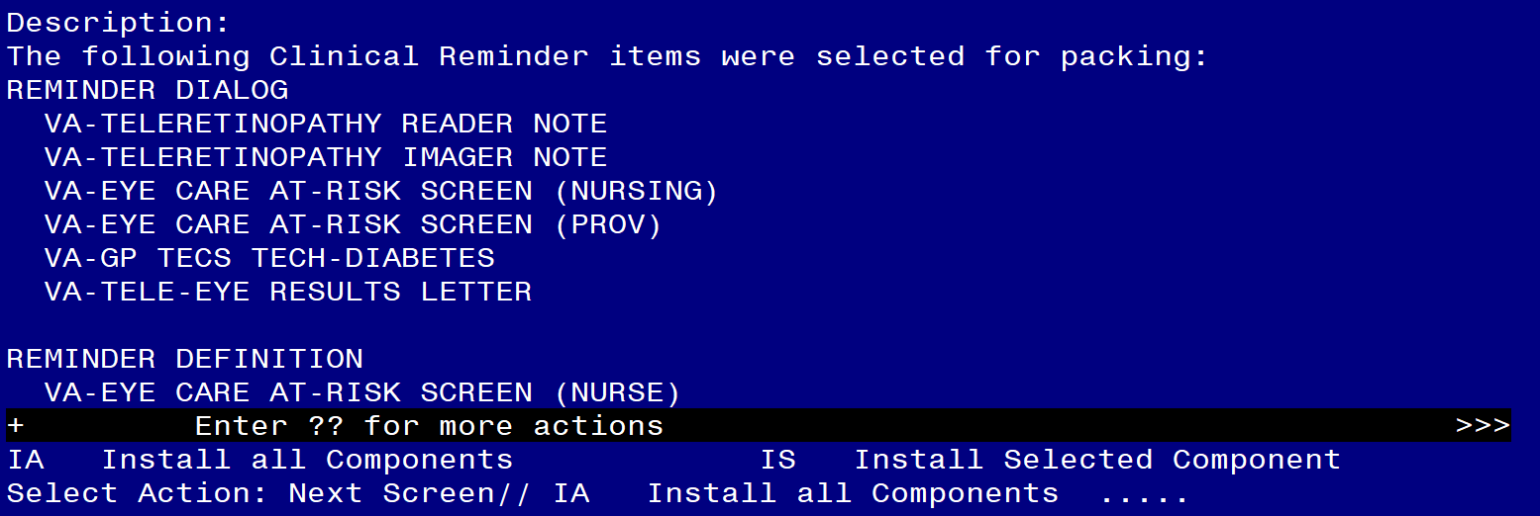

At the **Select Action** prompt, type **IA** for Install all Components and hit enter.

Select Action: Next Screen// IA Install all Components

You will see several prompts, for all new entries you will choose **I to Install**

* **Overwrite** existing health factors, reminder taxonomies, reminder definitions, and health summary types.
* **Skip** all exams that already exists but the packed component is different.
* **Merge** existing reminder terms.

**Six dialogs need to be installed. Follow these steps to install each one.**

You will be promped to install the **first** reminder dialog component – VA-EYE CARE AT-RISK SCREEN (PROV)

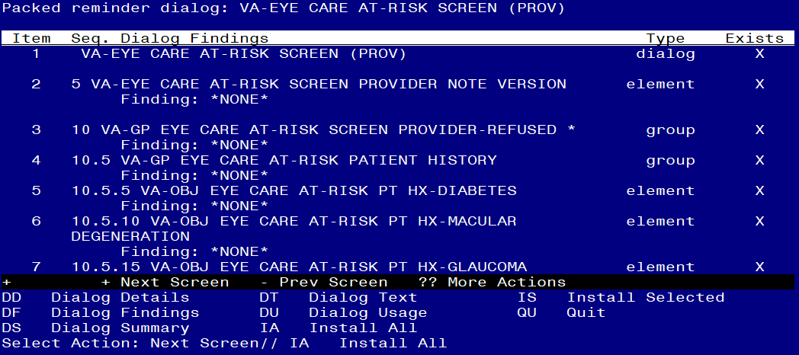

At the **Select Action** prompt, type **IA** to install the dialog – VA-EYE CARE AT-RISK SCREEN (PROV)

Select Action: Next Screen// IA Install All

Install reminder dialog and all components with no further changes: Y// Yes

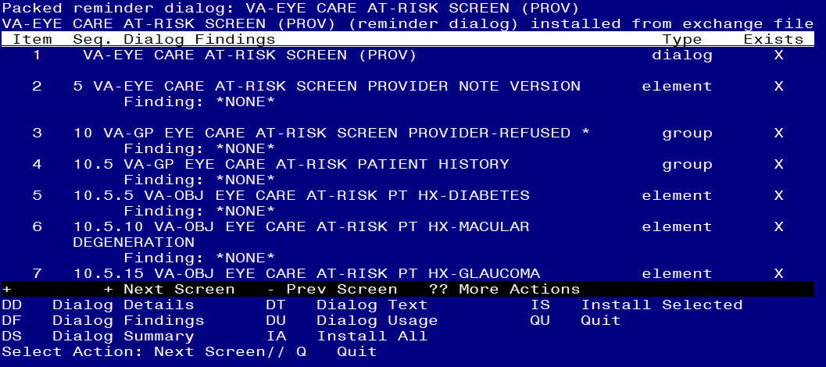

After completing this dialog install, you will type Q.

You will then be promped to install the **second** reminder dialog component –

VA-EYE CARE AT-RISK SCREEN (NURSING)

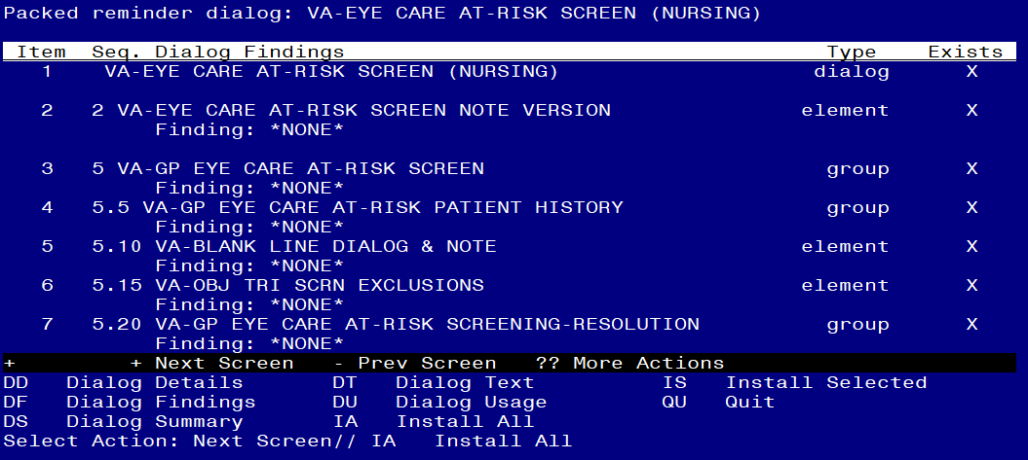

At the **Select Action** prompt, type **IA** to install the dialog – VA-EYE CARE AT-RISK SCREEN (NURSING)

Select Action: Next Screen// IA Install All

Install reminder dialog and all components with no further changes: Y// Yes

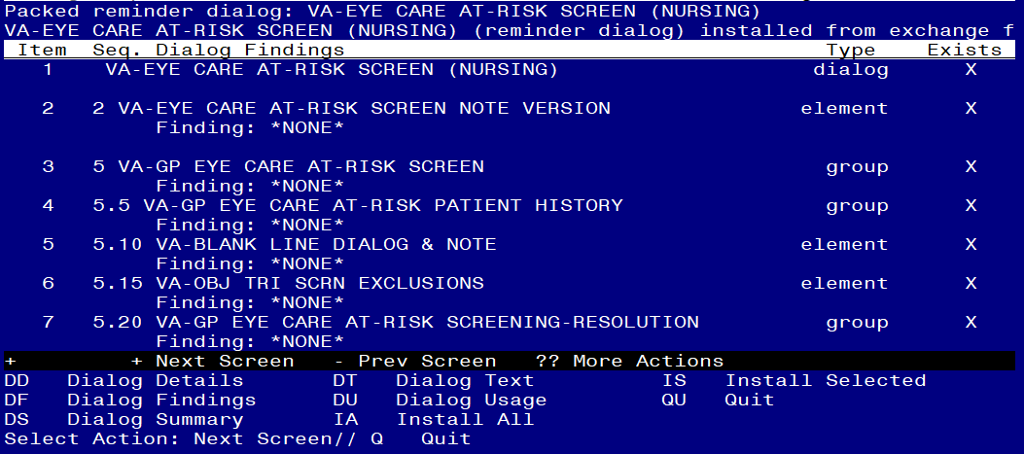

After completing this dialog install, you will type Q.

You will then be promped to install the **third** reminder dialog component – VA-TELE-EYE RESULTS LETTER

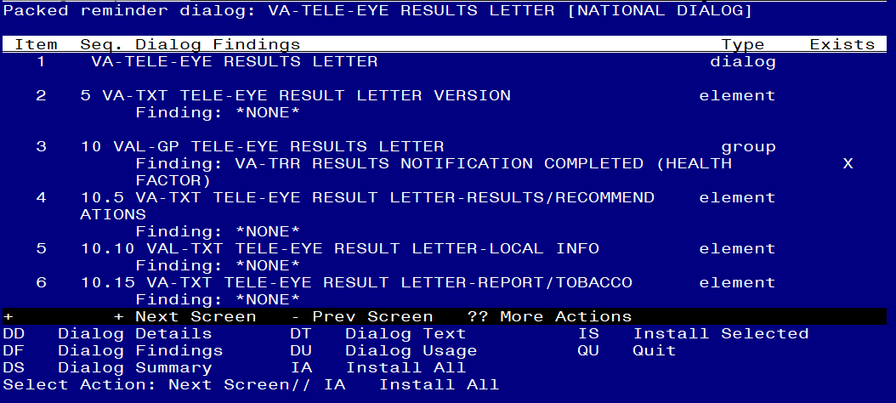

At the **Select Action** prompt, type **IA** to install the dialog – VA-TELE-EYE RESULTS LETTER

Select Action: Next Screen// IA Install All

Install reminder dialog and all components with no further changes: Y// Yes

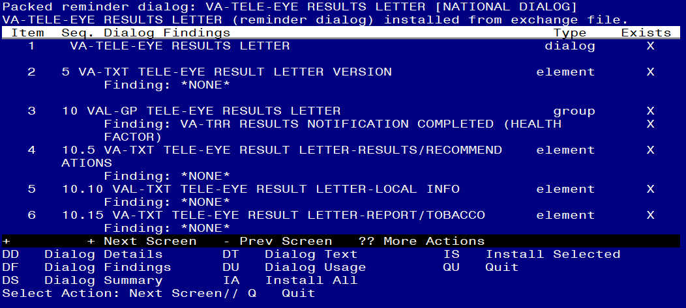

After completing this dialog install, you will type Q.

You will then be promped to install the **fourth** reminder dialog component - VA-GP TECS TECH-DIABETES 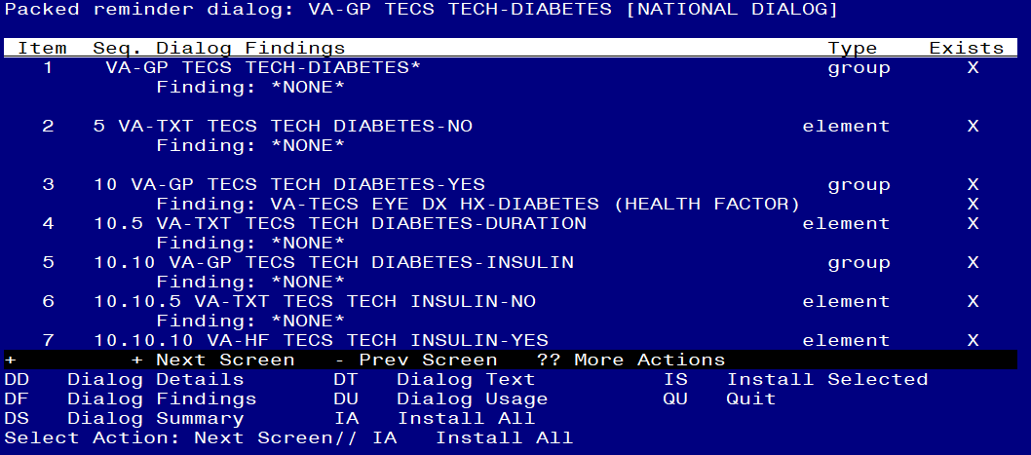

At the **Select Action** prompt, type **IA** to install the dialog – VA-GP TECS TECH-DIABETES

Select Action: Next Screen// IA Install All

Install reminder dialog and all components with no further changes: Y// Yes

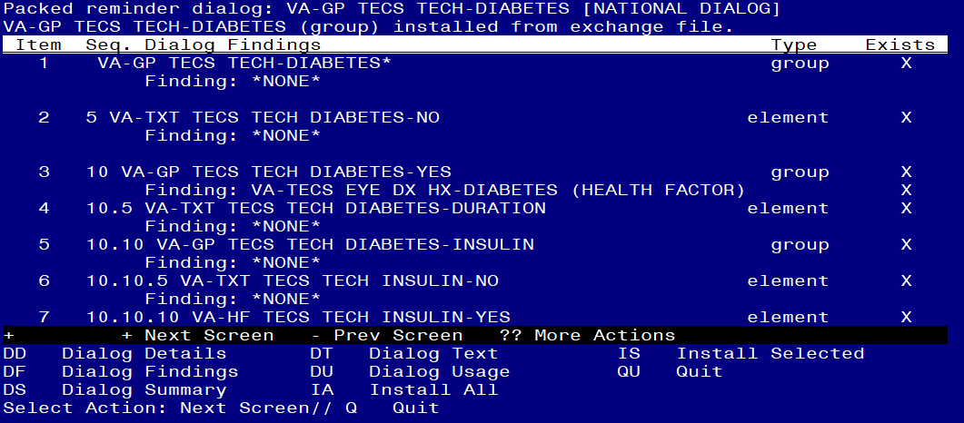

After completing this dialog install, you will type **Q**.

You will then be promped to install the **fifth** reminder dialog – VA-TELERETINOPATHY READER NOTE

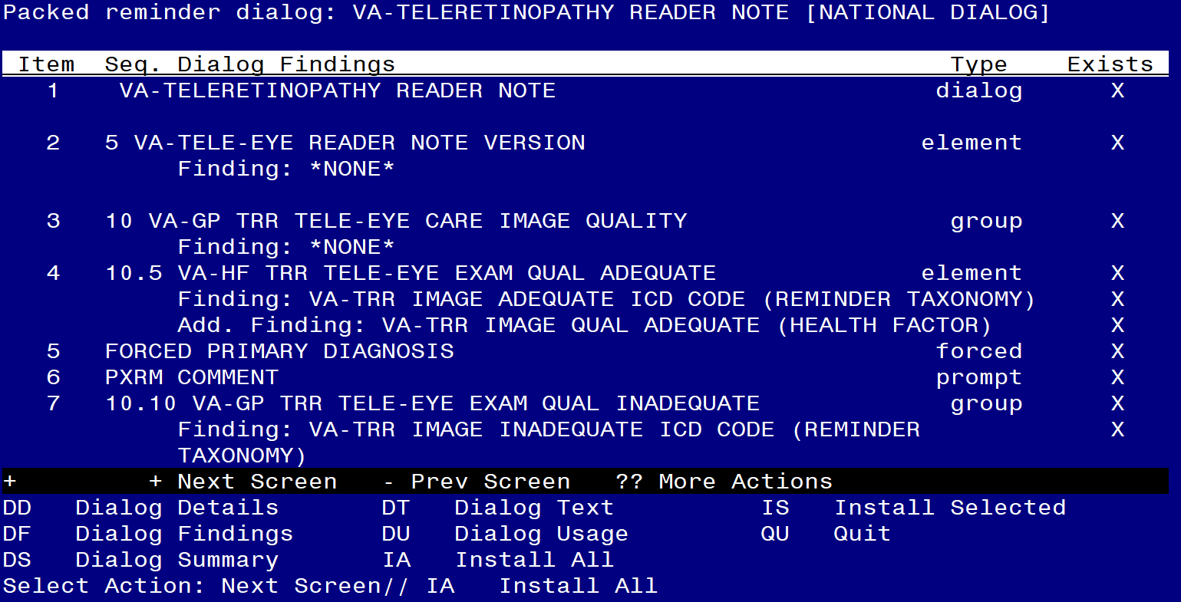

At the **Select Action** prompt, type **IA** to install the dialog – VA-TELERETINOPATHY READER NOTE

Select Action: Next Screen// IA Install All

Install reminder dialog and all components with no further changes: Y// Yes

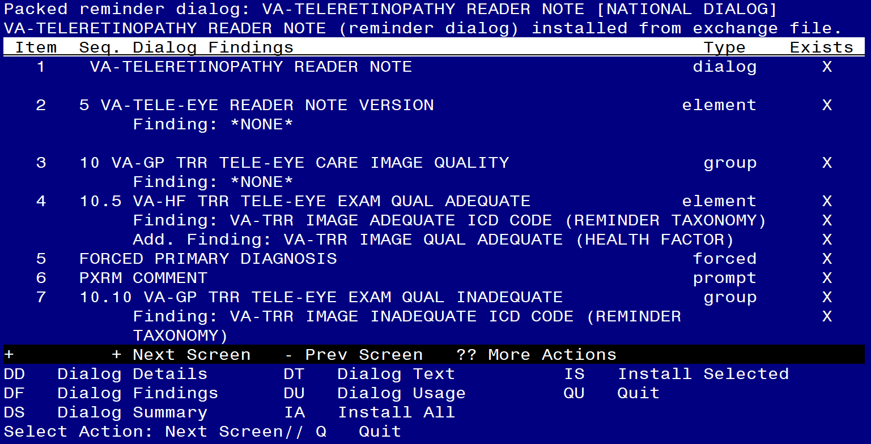

After completing this dialog install, you will type **Q**.

You will then be promped to install the **sixth** reminder dialog – VA-TELERETINOPATHY IMAGER NOTE

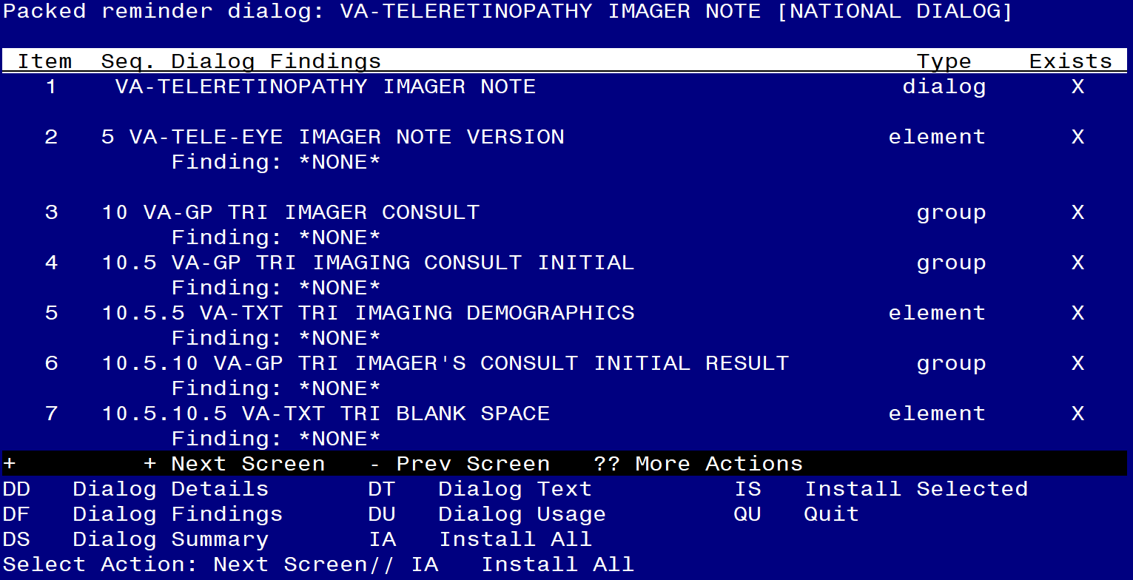

At the **Select Action** prompt, type **IA** to install the dialog – VA-TELERETINOPATHY IMAGER NOTE

Select Action: Next Screen// IA Install All

Install reminder dialog and all components with no further changes: Y// Yes

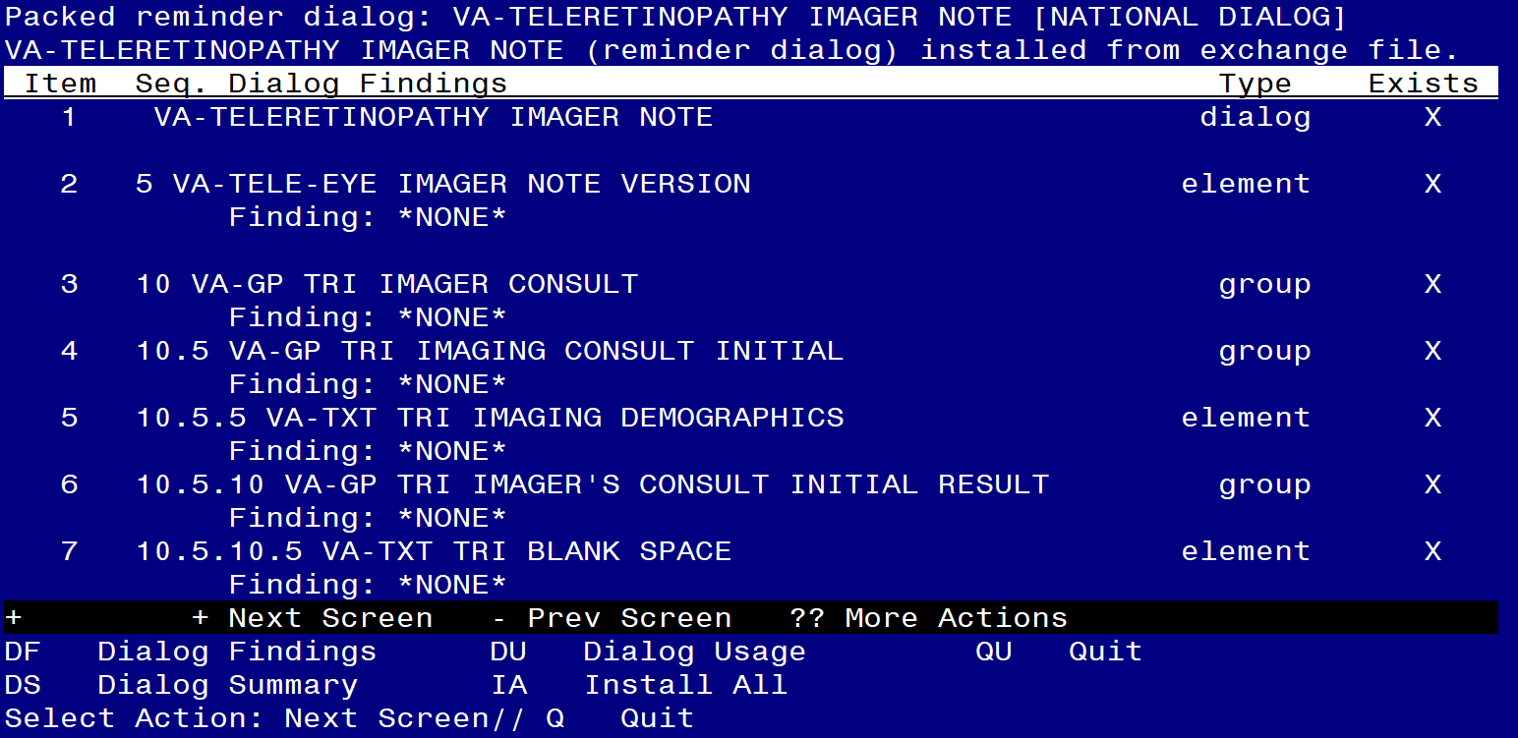

After completing this dialog install, you will type **Q**.

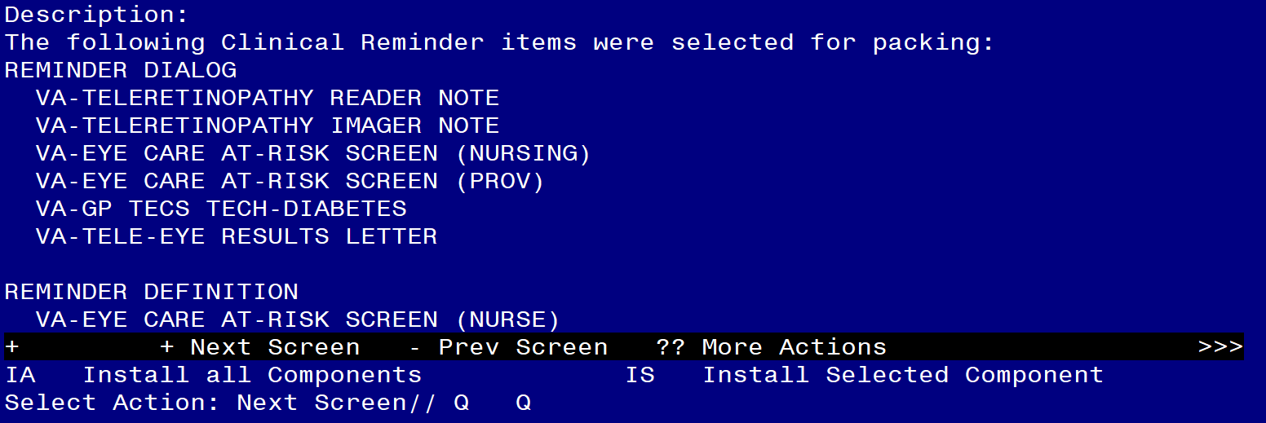

You will then be returned to this screen. At the **Select Action** prompt, type **Q.**

Install complete.

# Post Installation

1. **Confirm all local findings are still mapped to the following reminder terms:**
   1. TELE EYE GLAUCOMA EXAM-ABNORMAL
   2. TELE EYE GLAUCOMA EXAM-NORMAL
   3. TELE EYE GLAUCOMA EXAM-UNABLE TO ASSESS
   4. TELE EYE MACULA EXAM-ABNORMAL
   5. TELE EYE MACULA EXAM-NORMAL
   6. TELE EYE MACULA EXAM-UNABLE TO ASSESS
   7. TELE EYE RETINOPATHY EXAM-ABNORMAL
   8. TELE EYE RETINOPATHY EXAM-NORMAL
   9. TELE EYE RETINOPATHY EXAM-UNABLE TO ASSESS
   10. TELE EYE SCREEN ORDERS
   11. VA-OUTSIDE EYE AT-RISK SCREEN
   12. VA-EYE AT RISK NSG SCREEN REFUSAL
   13. VA-EYE AT RISK NSG SCREEN INCORRECT DM DIAGNOSIS
   14. VA-BL TELE EYE INCORRECT DIABETIC DX
2. **Add orders as an additional finding item to the following reminder dialog elements.** 
   1. Element VAL-OI EYE CARE AT-RISK RETINAL IMAGE CONSULT
      1. Add local quick order for Retinal Image Consult

NAME: **VAL-OI EYE CARE AT-RISK RETINAL IMAGE CONSULT**

DISABLE:

CLASS: LOCAL//

SPONSOR:

REVIEW DATE:

RESOLUTION TYPE: ORDERED//

ORDERABLE ITEM:

FINDING ITEM: Enter “Q.”, then name of local quick order for Retinal Image Consult

* 1. Element VAL-OI EYE CARE AT-RISK EYE GLASS CONSULT
     1. Add local quick order/process for scheduling an eye clinic appointment for glasses

NAME: **VAL-OI EYE CARE AT-RISK EYE GLASS CONSULT**

DISABLE:

CLASS: LOCAL//

SPONSOR:

REVIEW DATE:

RESOLUTION TYPE: ORDERED//

ORDERABLE ITEM:

FINDING ITEM: Enter “Q.”, then name of local quick order for scheduling an eye clinic appointment for glasses

* 1. Element VAL-OI EYE CARE AT-RISK COMP EYE EXAM CONSULT
     1. Add local quick order/process for scheduling an eye clinic appointment

NAME: **VAL-OI EYE CARE AT-RISK COMP EYE EXAM CONSULT**

DISABLE:

CLASS: LOCAL//

SPONSOR:

REVIEW DATE:

RESOLUTION TYPE: ORDERED//

ORDERABLE ITEM:

FINDING ITEM: Enter “Q.”, then name of local quick order for scheduling an eye clinic appointment

NAME: **VA-TXT TRR RECOMMENDATION OTH OPTIONS-NUTRITION REFERRAL**

FINDING ITEM: Enter “Q.”, then name of local quick order for referral to Nutrition.

1. **Map local hemoglobin A1C lab tests to the Health Summary Type TRI HGBA1C.**

Begin in the Health Summary Coordinator’s Menu

1 Print Health Summary Menu ...

2 Build Health Summary Type Menu ...

3 Set-up Batch Print Locations

4 List Batch Health Summary Locations

5 CPRS Reports Tab 'Health Summary Types List' Menu ...

Select Health Summary Coordinator's Menu <TEST ACCOUNT> Option: **2** Build Health

Summary Type Menu

1 Create/Modify Health Summary Type

2 Delete Health Summary Type

3 Health Summary Objects Menu ...

4 Information Menu ...

5 Print Health Summary Menu ...

Select Build Health Summary Type Menu <TEST ACCOUNT> Option: **1** Create/Modify He

alth Summary Type

Select Health Summary Type: **Tri Hgba1c**

WARNING: You are about to edit a Health Summary Type that is being used

by a Health Summary Object. Changing the structure of this Health Summary

Type will alter how the Object will display.

Do want to continue? NO// **YES**

NAME: TRI HGBA1C//

TITLE: TRI HGBA1C//

SUPPRESS PRINT OF COMPONENTS WITHOUT DATA: yes//

SUPPRESS SENSITIVE PRINT DATA: NO SSN//

LOCK:

OWNER:

Do you wish to review the Summary Type structure before continuing? NO// **YES**

HEALTH SUMMARY TYPE INQUIRY

Type Name: TRI HGBA1C

Title: TRI HGBA1C

Owner:

SUPPRESS PRINT OF COMPONENTS WITHOUT DATA: yes

SUPPRESS SENSITIVE PRINT DATA: NO SSN

Max Hos ICD Pro CPT

Abb Ord Component Name Occ Time Loc Text Nar Mod Selection

------------------------------------------------------------------------------

SLT 5 Lab Tests Selected **3**  **2Y**  Confirm the max occurrence and time limit matches the

highlighted text

* = Disabled Components

Select COMPONENT: **SLT** LAB TESTS SELECTED SLT

LAB TESTS SELECTED is already a component of this summary.

Select one of the following:

E Edit component parameters

D Delete component from summary

Select Action: **Edit component parameters**

SUMMARY ORDER: 5// 5

OCCURRENCE LIMIT: **3**

TIME LIMIT: **2Y**

HEADER NAME: Lab Tests Selected//

No selection items chosen.

Select new items one at a time in the sequence you want them displayed.

You may select up to 99 items.

Select SELECTION ITEM: Enter local lab(s) for hemoglobin A1C

1. **Map local drug(s) for Semaglutide to the VA-BL SEMAGLUTIDE RX reminder term.**

Select Reminder Term: **VA-BL SEMAGLUTIDE RX**

Choose from:

FINDING ITEM: **SEMAGLUTIDE** Enter all local drug(s) for Semaglutide

BEGINNING DATE/TIME: **T-18M**

ENDING DATE/TIME:

OCCURRENCE COUNT:

RXTYPE: **A**

USE START DATE: **YES**

CONDITION:

CONDITION CASE SENSITIVE: NO//

USE STATUS/COND IN SEARCH: **YES**

Statuses already defined for this finding item: **ACTIVE**

Select one of the following:

A ADD STATUS

D DELETE A STATUS

S SAVE AND QUIT

Q QUIT WITHOUT SAVING CHANGES

1. **Add local data objects to the VAL-GP TELE-EYE RESULTS LETTER group.**

NAME: **VAL-GP TELE-EYE RESULTS LETTER**

DISABLE:

CLASS: LOCAL//

SPONSOR: OFFICE OF TELEHEALTH SERVICES STORE AND FORWARD TELEHEALTH//

REVIEW DATE:

RESOLUTION TYPE:

ORDERABLE ITEM:

Finding item: HF VA-TRR RESULTS NOTIFICATION COMPLETED

FINDING ITEM: VA-TRR RESULTS NOTIFICATION COMPLETED//

Additional findings: none

Select ADDITIONAL FINDING:

GROUP CAPTION:

PUT A BOX AROUND THE GROUP:

SHARE COMMON PROMPTS:

MULTIPLE SELECTION:

HIDE/SHOW GROUP: SHOW//

GROUP HEADER DIALOG TEXT:. . .

. . .

Placeholder for PATIENT NAME\\

Placeholder for PATIENT STREET\\

Placeholder for PATIENT CITY\\

Placeholder for PATIENT STATE\\

Placeholder for PATIENT ZIP CODE

Dear Veteran Placeholder for Patient's First Name Patient's Last

Name:

Edit? NO// **YES**

==[ WRAP ]==[INSERT ]=======< GROUP HEADER DIALOG TEX[Press <PF1>H for help]====

Placeholder for Today's Date

Placeholder for PATIENT NAME\\

Placeholder for PATIENT STREET\\

Placeholder for PATIENT CITY\\

Placeholder for PATIENT STATE\\

Placeholder for PATIENT ZIP CODE

Dear Veteran Placeholder for Patient's First Name Patient's Last Name:

Replace highlighted text with local objects.

<=======T=======T=======T=======T=======T=======T=======T=======T=======T>======

1. **Add local data object to the VAL-OBJ MOST RECENT EYE EXAM DATES element. The local object should display the most recent eye exam dates. Remove placeholder text if no local objects exists.**

NAME: **VAL-OBJ MOST RECENT EYE EXAM DATES**

DISABLE:

CLASS: LOCAL//

SPONSOR: OFFICE OF TELEHEALTH SERVICES STORE AND FORWARD TELEHEALTH//

REVIEW DATE:

RESOLUTION TYPE:

ORDERABLE ITEM:

Finding item:

Additional findings: none

Select ADDITIONAL FINDING:

SHARE COMMON PROMPTS:

GROUP HEADER DIALOG TEXT:. . .

Last Retinal Evaluation:

**Place local data object for most recent eye exam dates**

Edit? NO// **YES**

==[ WRAP ]==[INSERT ]=======< GROUP HEADER DIALOG TEX[Press <PF1>H for help]====

Last Retinal Evaluation:

**Place local data object for most recent eye exam dates**

Replace highlighted text with local objects or remove it from group if no object exists.

<=======T=======T=======T=======T=======T=======T=======T=======T=======T>======

1. **Element VAL-TXT TELE-EYE RESULT LETTER-LOCAL INFO is a local class in the VA-TELE-EYE RESULTS LETTER dialog, so sites can revise text to meet local processes.**

NAME: **VAL-TXT TELE-EYE RESULT LETTER-LOCAL INFO**

DISABLE:

CLASS: LOCAL//

SPONSOR:

REVIEW DATE:

RESOLUTION TYPE: OTHER//

ORDERABLE ITEM:

FINDING ITEM:

Additional findings: none

Select ADDITIONAL FINDING:

DIALOG/PROGRESS NOTE TEXT:

If you have not received a call within 30 days of the recommended

appointment date, or have vision or eye problems prior to your next

appointment, please call to schedule an appointment:

Scheduling Number: XXX-XXX-XXXX

Edit? NO// **YES**

==[ WRAP ]==[INSERT ]=======< DIALOG/PROGRESS NOTE TE[Press <PF1>H for help]====

If you have not received a call within 30 days of the recommended

appointment date, or have vision or eye problems prior to your next

appointment, please call to schedule an appointment:

Scheduling Number: XXX-XXX-XXXX

Replace highlighted text as needed. Add scheduling phone number.

1. **Make the Dialog template available to be attached to a Personal or Shared template or to be able to attach the dialog to a progress note title.**

Select Reminder Managers Menu <TEST ACCOUNT> Option: **CP**

CA Add/Edit Reminder Categories

CL CPRS Lookup Categories

CS CPRS Cover Sheet Reminder List

MH Mental Health Dialogs Active

PN Progress Note Headers

RA Reminder GUI Resolution Active

TIU TIU Template Reminder Dialog Parameter

DEVL Evaluate Coversheet List on Dialog Finish

DL Default Outside Location

PT Position Reminder Text at Cursor

LINK Link Reminder Dialog to Template

TEST CPRS Coversheet Time Test

NP New Reminder Parameters

GEC GEC Status Check Active

WH WH Print Now Active

Select CPRS Reminder Configuration <TEST ACCOUNT> Option: **TIU** TIU Template Reminder Dialog Parameter

Reminder Dialogs allowed as Templates may be set for the following:

1 User USR [choose from NEW PERSON]

3 Service SRV [choose from SERVICE/SECTION]

4 Division DIV [SALT LAKE CITY]

5 System SYS [NATREM.FO-SLC.MED.VA.GOV]

Enter selection: **5** Choose the appropriate number for your site. Your site may do this by System or other levels. The example below uses SYSTEM level.

Setting Reminder Dialogs allowed as Templates for System: NATREM.FO-SLC.MED.VA.GOV

Select Display Sequence: **?**

388 VA-COVID-19 TELEPHONE FOLLOW-UP

389 VA-SRA-CONSULT RESPONSE (D)

When you type a question mark above, you will see the list of #’s (with dialogs) that are already taken. Choose a number **NOT** on this list. For this example, 390 and 391 are not present so those numbers can be used.

Select Display Sequence: **390**

Are you adding 390 as a new Display Sequence? Yes// **YES**

Display Sequence: 390// **<Enter>**

Clinical Reminder Dialog: **VA-TELE-EYE RESULTS LETTER**

reminder dialog NATIONAL

...OK? Yes// **Yes**

1. **Setup of Note Title.**

The note title to create to associate with this template is: **TELE-EYE RESULTS LETTER**

VHA Enterprise Standard Title: **LETTERS**

You can add this to the appropriate document class.

***Note:*** *Comprehensive information on Creating new Document Classes and Titles can be found beginning on page 54 of the TIU/ASU Implementation Guide at the following link:* [*http://www.va.gov/vdl/documents/Clinical/CPRS-Text_Integration_Utility_(TIU)/tiuim.pdf*](http://www.va.gov/vdl/documents/Clinical/CPRS-Text_Integration_Utility_(TIU)/tiuim.pdf)

1. **Associate the reminder dialog with the note title in CPRS**

In CPRS, open the Template Editor, expand Document Titles, select the appropriate folder (if applicable), then click New Template (top right-hand corner).

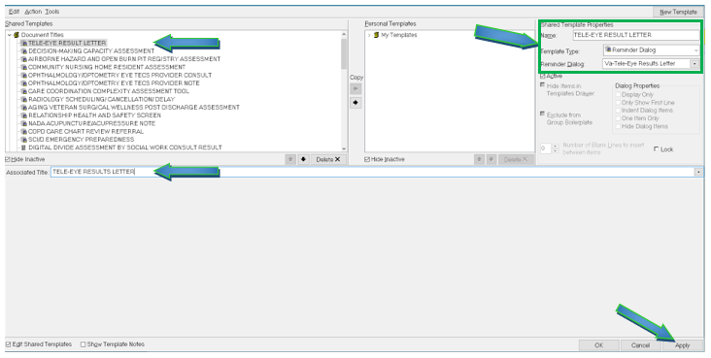

Type in the following information:

Name: **TELE-EYE RESULTS LETTER**

Template Type: **Reminder Dialog**

Reminder Dialog: **VA-TELE-EYE RESULTS LETTER**

Next, type in the Associated Title name –– then click Apply.