

**Update _2_0_374**

Clinical Reminders

VA-COMMON CARRIER POV ACCESS

Install Guide

**July 2023**

Product Development

Office of Information Technology

Department of Veterans Affairs

Table of Contents

Introduction 1

Install Details 1

Install Example 2

Post Installation 4

# Introduction

This update contains one new reminder dialog that should be installed and connected to a note title.

To be used for Beneficiary Travel (BT) eligible Veterans; completed by administrative staff in BT/HAS for the use of a common carrier vehicle when a privately owned vehicle (POV) is not readily accessible

UPDATE_2_0_374 contains 1 Reminder Exchange entry:

**UPDATE_2_0_374 VA-COMMON CARRIER POV ACCESS**

**The exchange file contains the following components:**

**TIU TEMPLATE FIELD**

VA-DATE ONLY R

VA-TEXT (1-50 CHAR)R

**HEALTH FACTORS**

VA-REMINDER UPDATES [C]

VA-UPDATE_2_0_374

VA-COMMON CARRIER NO ACCESS [C]

VA-COMMON CARRIER NO ACCESS TO POV

VA-COMMON CARRIER ACCESS TO POV

**REMINDER TERM**

VA-REMINDER UPDATE_2_0_374

**REMINDER DIALOG**

VA-COMMON CARRIER POV ACCESS

# Install Details

This update is being distributed as a web host file. The address for the host file is: https://REDACTED /UPDATE_2_0_374.PRD

The file will be installed using Reminder Exchange, programmer access is not required.

Installation:

=============

This update can be loaded with users on the system. Installation will take less than 5 minutes.

# Install Example

Go to Reminder exchange in Vista.

To Load the exchange file, use LWH. The URL is https://REDACTED /UPDATE_2_0_374.PRD

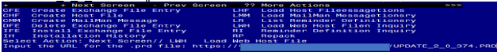

You will see a message indicating the file was loaded successfully.

Search and locate an entry titled UPDATE_2_0_374 VA-COMMON CARRIER POV ACCESS in reminder exchange.

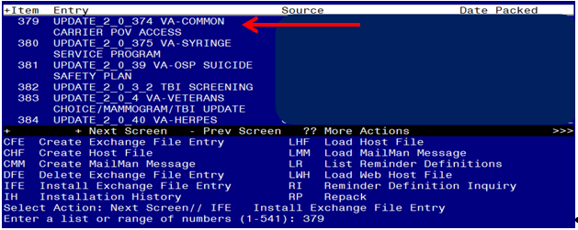

At the **Select Action** prompt, enter **IFE** for Install Exchange File Entry

Enter the number that corresponds with your entry titled UPDATE_2_0_374 VA-COMMON CARRIER POV ACCESS *(in this example it is entry 379, it will vary by site)* that is dated 05/30/2023.

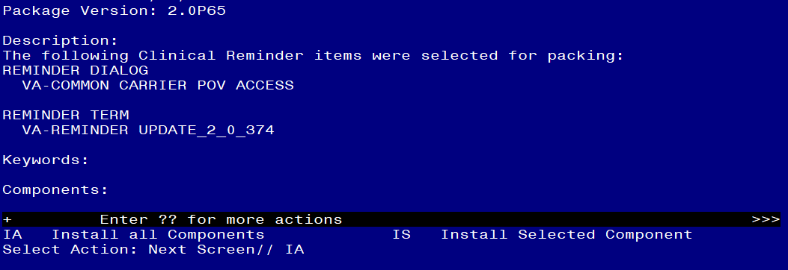

At the **Select Action** prompt, type **IA** for Install all Components and hit enter.

**For all new entries in any category you will choose I to Install**

**SKIP any items in any category you are prompted to overwrite.**

You will then be prompted to install the dialog component.

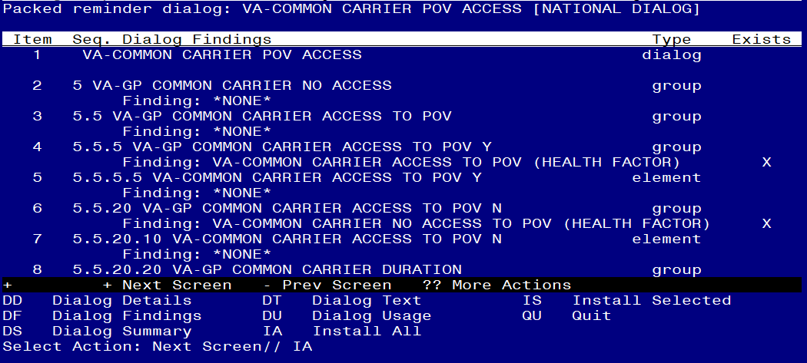

At the **Select Action** prompt, type **IA** to install the dialog – **VA-COMMON CARRIER POV ACCESS**

Install reminder dialog and all components with no further changes: Y//ES

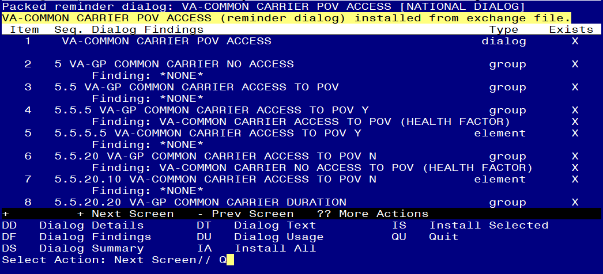

When the dialog has completed installation, you will then be returned to this screen. At the **Select Action** prompt, type **Q.**

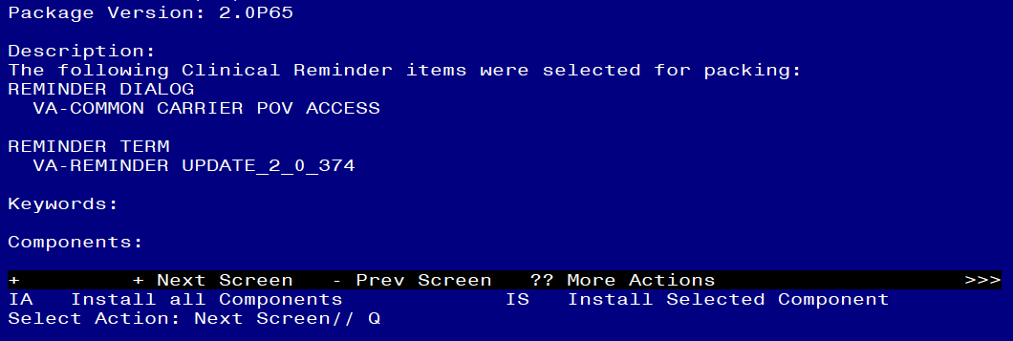

You will then be returned to this screen. At the **Select Action** prompt, type **Q.**

Install complete.

# Post Installation

1. **Setup of Note Title.**

The suggested note title to create to associate with this template is:

COMMON CARRIER ADMINISTRATIVE NOTE

VHA Enterprise Standard Title: ADMINISTRATIVE NOTE

You can add this to the document class where administrative notes are stored.

***Note:*** *Comprehensive information on Creating new Document Classes and Titles can be found beginning on page 54 of the TIU/ASU Implementation Guide at the following link:* [*http://www.va.gov/vdl/documents/Clinical/CPRS-Text_Integration_Utility_(TIU)/tiuim.pdf*](http://www.va.gov/vdl/documents/Clinical/CPRS-Text_Integration_Utility_(TIU)/tiuim.pdf)

1. **Make the Dialog templates available to be attached to a Personal or Shared templates or to be able to attach the dialog to a progress note title.**

Select Reminder Managers Menu <TEST ACCOUNT> Option: **CP** CPRS Reminder Configuration

CA Add/Edit Reminder Categories

CL CPRS Lookup Categories

CS CPRS Cover Sheet Reminder List

MH Mental Health Dialogs Active

PN Progress Note Headers

RA Reminder GUI Resolution Active

TIU TIU Template Reminder Dialog Parameter

DEVL Evaluate Coversheet List on Dialog Finish

DL Default Outside Location

PT Position Reminder Text at Cursor

LINK Link Reminder Dialog to Template

TEST CPRS Coversheet Time Test

NP New Reminder Parameters

GEC GEC Status Check Active

WH WH Print Now Active

Select CPRS Reminder Configuration <TEST ACCOUNT> Option: **TIU** TIU Template Reminder Dialog Parameter

Reminder Dialogs allowed as Templates may be set for the following:

1 User USR [choose from NEW PERSON]

3 Service SRV [choose from SERVICE/SECTION]

4 Division DIV [SALT LAKE CITY]

5 System SYS [NATREM.FO-SLC.MED.VA.GOV]

Enter selection: **5** *Choose the appropriate number for your site. Your site may do this by System or other levels. The example below uses SYSTEM level.*

Setting Reminder Dialogs allowed as Templates for System: NATREM.FO-SLC.MED.VA.GOV

Select Display Sequence: **?**

388 VA-COVID-19 TELEPHONE FOLLOW-UP

389 VA-SRA-CONSULT RESPONSE (D)

*When you type a question mark above, you will see the list of #’s (with dialogs) that are already taken. Choose a number* ***NOT*** *on this list. For this example, 390 is not present so I will use 390.*

Select Display Sequence: **390**

Are you adding 390 as a new Display Sequence? Yes// **YES**

Display Sequence: 390// <Enter> 390

Clinical Reminder Dialog: **VA-COMMON CARRIER POV ACCESS** reminder dialog NATIONAL

...OK? Yes// <Enter> (Yes)

1. **Add the template to** your document title.
   1. In CPRS, open the Template Editor, expand Document Titles, select the appropriate folder (if applicable), then click New Template (top right-hand corner).

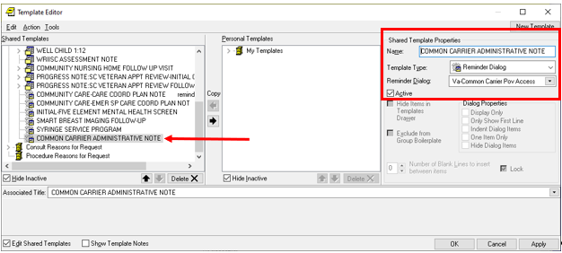

Type in the following information:

Name: **COMMON CARRIER ADMINISTRATIVE NOTE**

Template Type: **Reminder Dialog**

Reminder Dialog: **VA-COMMON CARRIER POV ACCESS**

Associated Title: **COMMON CARRIER ADMINISTRATIVE NOTE**

–– then click Apply.