

**Update _2_0_380**

Clinical Reminders

VA-ONC PROSTATE CANCER FOLLOW UP AND CONSULT TEMPLATES

Install Guide

**November 2023**

Product Development

Office of Information Technology

Department of Veterans Affairs

Table of Contents

Introduction 1

Pre-Install 1

Install Details 16

Install Example 16

Post Installation 25

# Introduction

The purpose of these prostate cancer follow-up and consult notes are to standardize follow-up care, regulate data capture, and to acquire the required documentation as determined by the National Oncology Program Office (NOPO). Every VA with an Oncology program should be utilizing these notes to ensure standardized data capture for NOPO dashboards.

In addition, the prostate cancer clinical pathways are included in the follow-up/consult templates to facilitate ease of use. Oncology Clinical Pathways (CPs) are decision-support tools that translate published evidence into standardized treatment process maps to help guide cancer treatment decisions. Oncology CPs are different from treatment guidelines, as CPs recommend a standard treatment based on efficacy, toxicity, and cost. VA Oncology CPs are developed by an interdisciplinary subject matter expert (SME) group and approved by national program offices.

The prostate cancer follow-up reminder dialogs were built with the Cerner APSO (assessment, plan, subjective, objective) format. Furthermore, there are only 2 required mandatory fields. The 3 reminder dialog templates will be utilized by all VA medical centers with an Oncology service. Additionally, the 3 reminder dialog templates will also be used as consult notes and utilized by all Oncology providers:

Nurse Practitioners

Physician Assistants

Residents

Fellows

Physicians

VHA Directive 1415 requires that all sites use the National Oncology templates. If your site does not provide oncology services, the site must request a waiver to exempt it from the requirement to use the National Oncology templates. The waiver can be requested by emailing REDACTED

REDACTED URL for EDUCATION

# Pre-Install

**Check to see if you have installed and completed the post installation for** **Clinical Reminder Update_2_0_367**

**If not, STOP and install Clinical Reminder Update_2_0_367 before installing this update. If installing 367, do not add objects to the elements, you will do this in the post install of this update.**

Using the VistA menu Reminder Dialog Manager, Reminder Dialog, change your view to elements and do an inquire/print on the following reminder dialog elements, you will need to use this as a reference for the quick orders/objects during post-install. You may not have any quick orders mapped to these elements.

VA-EL ONC PRCA ON PATHWAY

VA-EL ONC PRCA PTHWY NOT SUFF LIQUID BIOPSY

VA-ONC PALLIATIVE CARE CONSULT

VA-ONC RADIATION ONCOLOGY CONSULT

VA-ONC UROLOGY CONSULT

VAL-ONC CN PATIENT DEMOGRAPHICS

VAL-ONC CN ALLERGIES

VAL-ONC CN MED REC OBJECT

VAL-ONC CN VITALS TXT

VAL-ONC CN LABS & IMAGING

VAL-ONC CN VISIT VVC CONTACT HOME ADDRESS

VAL-ONC CN VISIT VVC CONTACT PHONE NUMBER HOME/CELL

VA-ONC HOSPICE REFERRAL

UPDATE_2_0_380 contains 1 Reminder Exchange entry named **UPDATE_2_0_380 VA-ONC PROSTATE CANCER FOLLOW UP**

This contains 3 updated reminder dialogs.

1. VA-ONCOLOGY PROSTATE CANCER LOCALIZED FOLLOW-UP
2. VA-ONCOLOGY PROSTATE CANCER RECURRENCE/PROSTATECTOMY FOLLOW-UP
3. VA-ONCOLOGY PROSTATE CANCER REGIONAL/METASTATIC FOLLOW-UP

**The exchange file contains the following components:**

REMINDER GENERAL FINDINGS

1 TICKLER REMINDER COMMENT

2 TICKLER REMINDER

3 VIEW PROGRESS NOTE TEXT

TIU TEMPLATE FIELD

4 TEXT (1-50 CHAR)

5 VA-ONC CN EMOTIONAL WB

6 VA-ONC VAMC SITE NAME

7 DATE

8 VA-ONC WP 2 LINES

9 VA-ONC DAY/WEEK/MONTH/YEAR

10 EDIT 3*

11 VA-ONC PRESUMPTIVE CONDITIONS

12 VA-ONC OFF REASON TXT

13 VA-ONC NEITHER ON/OFF

14 VA-ONC PATHWAYS SHAREPOINT

15 VA-ONC INSTRUCTIONS ON/OFF PATHWAY

16 VA-ONC TREATMENT REASON

17 VA-ONC CLINICAL TRIAL

18 VA-ONC CN PREVIOUS NOTE VIEW

19 EDIT 55+

20 TELEHEALTH EMERGENCIES VA LOCATIONS

21 TELEHEALTH EMERGENCIES NON-VA LOCATIONS

22 VA-ONC CN PRCA CHIEF COMPLAINT

23 VA-ONC NPOP SHAREPOINT

24 VA-ONC CONFIRMATION TEXT

HEALTH FACTORS

25 VA-REMINDER UPDATES [C]

26 VA-UPDATE_2_0_380

27 VA-ONC CN [C]

28 VA-ONC CN PROSTATE

29 VA-ONC PRCA MOLECULAR TESTING PATHWAY [C]

30 VA-ONC PRCA GERM CGP ORDER: ON PATH

31 VA-CCGS CLINICAL CANCER GENETICS SERVICE [C]

32 VA-CCGS GERMLINE TESTING DECLINED

33 VA-ONC PRCA GERM CGP PT DECLINE: ON PATH

34 VA-ONC PRCA GERM CGP ORDER: OFF PATH

35 VA-ONC PRCA PRETEST CONSENT: OFF PATH

36 VA-ONC PRCA GERMLINE TEST CONSENT DISCUSSION IN FUTURE

37 VA-CCGS COMMON HEREDITARY PANEL ORDERED

38 VA-CCGS GERMLINE EXPEDITED TESTING

39 VA-CCGS GERMLINE PRETEST COUNSELING CONSULT OTHER

40 VA-CCGS GERMLINE PRETEST COUNSELING CONSULT CCGS

41 VA-CCGS GERMLINE PRETEST CONSENT DISCUSSION

42 VA-ONC PRCA PRETEST CONSENT: ON PATH

43 VA-CCGS GERMLINE PRETEST DOCUMENTATION

44 VA-ONC PRCA RADICAL PROSTATECTOMY PATHWAY [C]

45 VA-ONC PRCA RAD PROSTATECTOMY NEG DISTANT METS >=5Y EBRT

46 VA-ONC PRCA RAD PROSTATECTOMY NEG DISTANT METS <5Y OFF PATH RSN

47 VA-ONC PRCA RAD PROSTATECTOMY NEG DISTANT METS <5Y OFF PATH TX

48 VA-ONC PRCA RAD PROSTATECTOMY NEG DISTANT METS <5Y ADT

49 VA-ONC PRCA RAD PROSTATECTOMY NEG DISTANT METS <5Y OBS

50 VA-ONC PRCA RAD PROSTATECTOMY NEG DISTANT METS <5Y CLIN TRIAL

51 VA-ONC PRCA RAD PROSTATECTOMY NEG DISTANT METS >=5Y OFF PATH RSN

52 VA-ONC PRCA RAD PROSTATECTOMY NEG DISTANT METS >=5Y OFF PATH TX

53 VA-ONC PRCA RAD PROSTATECTOMY NEG DISTANT METS >=5Y OBS

54 VA-ONC PRCA RAD PROSTATECTOMY NEG DISTANT METS >=5Y EBRT+ADT

55 VA-ONC PRCA RAD PROSTATECTOMY NEG DISTANT METS >=5Y CLIN TRIAL

56 VA-ONC PRCA RADIATION THERAPY RECURRENCE PATHWAY [C]

57 VA-ONC PRCA RAD TX RECUR S/P BIOPSY + CANCER SBRT

58 VA-ONC PRCA RAD TX RECUR S/P BIOPSY – CANCER OFF PATH RSN

59 VA-ONC PRCA RAD TX RECUR S/P BIOPSY – CANCER OFF PATH TX

60 VA-ONC PRCA RAD TX RECUR S/P BIOPSY – CANCER ADT

61 VA-ONC PRCA RAD TX RECUR S/P BIOPSY – CANCER OBSERVATION

62 VA-ONC PRCA RAD TX RECUR S/P BIOPSY – CANCER CLIN TRIAL

63 VA-ONC PRCA RAD TX RECUR S/P BIOPSY + CANCER OFF PATH RSN

64 VA-ONC PRCA RAD TX RECUR S/P BIOPSY + CANCER OFF PATH TX

65 VA-ONC PRCA RAD TX RECUR S/P BIOPSY + CANCER HIFU

66 VA-ONC PRCA RAD TX RECUR S/P BIOPSY + CANCER ADT

67 VA-ONC PRCA RAD TX RECUR S/P BIOPSY + CANCER CRYOTHERAPY

68 VA-ONC PRCA RAD TX RECUR S/P BIOPSY + CANCER BRACHYTHERAPY

69 VA-ONC PRCA RAD TX RECUR S/P BIOPSY + CANCER RAD PROSTATE

70 VA-ONC PRCA RAD TX RECUR S/P BIOPSY + CANCER OBSERVATION

71 VA-ONC PRCA RAD TX RECUR S/P BIOPSY + CANCER CLIN TRIAL

72 VA-ONC PRCA RAD TX RECUR LOCAL NO METS NO OFF PATH RSN

73 VA-ONC PRCA RAD TX RECUR LOCAL NO METS NO OFF PATH TX

74 VA-ONC PRCA RAD TX RECUR LOCAL NO METS NO OBSERVATION

75 VA-ONC PRCA RAD TX RECUR LOCAL NO METS NO CLIN TRIAL

76 VA-ONC PRCA RAD TX RECUR LOCAL YES METS NO OFF PATH RSN

77 VA-ONC PRCA RAD TX RECUR LOCAL YES METS NO OFF PATH TX

78 VA-ONC PRCA RAD TX RECUR LOCAL YES METS NO BIOPSY

79 VA-ONC PRCA RAD TX RECUR LOCAL YES METS NO CLIN TRIAL

80 VA-ONC PRCA TISSUE SUFFICIENCY UNKNOWN

81 VA-ONC PRCA TUMOR GENOMIC TEST ORDER FUTURE DATE

82 VA-ONC PRCA TISSUE SUFFICIENT: OFF PATH

83 VA-ONC PRCA REASSESS: ON PATH

84 VA-ONC PRCA LIQUID BIOPSY: ON PATH

85 VA-ONC PRCA REPEAT BIOPSY: ON PATH

86 VA-ONC PRCA TISSUE SUFFICIENT: ON PATH

87 VA-ONC PRCA CGP ORDER: ON PATH

88 VA-ONC PRCA CGP ORDER: OFF PATH

89 VA-ONC PRCA CRPC M1 PATHWAY [C]

90 VA-ONC PRCA CRPC M1 2ND ECOG <=2 CONTRA DOCE LU177+ADT

91 VA-ONC PRCA CRPC M1 1ST ECOG <=2 BRCA – OFF PATH RSN

92 VA-ONC PRCA CRPC M1 1ST ECOG <=2 BRCA – OFF PATH TX

93 VA-ONC PRCA CRPC M1 1ST ECOG <=2 BRCA – ABIRATERONE

94 VA-ONC PRCA CRPC M1 1ST ECOG <=2 BRCA – CLIN TRIAL

95 VA-ONC PRCA CRPC M1 1ST ECOG <=2 BRCA + OFF PATH RSN

96 VA-ONC PRCA CRPC M1 1ST ECOG <=2 BRCA + OFF PATH TX

97 VA-ONC PRCA CRPC M1 1ST ECOG <=2 BRCA + OFF PATHWAY

98 VA-ONC PRCA CRPC M1 1ST ECOG <=2 BRCA + OLAPARIB/ABIRATERONE

99 VA-ONC PRCA CRPC M1 1ST ECOG <=2 BRCA + CLIN TRIAL

100 VA-ONC PRCA CRPC M1 3RD ECOG <=2 LU177 OFF PATH RSN

101 VA-ONC PRCA CRPC M1 3RD ECOG <=2 LU177 OFF PATH TX

102 VA-ONC PRCA CRPC M1 3RD ECOG <=2 LU177+ADT

103 VA-ONC PRCA CRPC M1 3RD ECOG <=2 LU177 CLIN TRIAL

104 VA-ONC PRCA CRPC M1 3RD ECOG <=2 CONTRA CABA OFF PATH RSN

105 VA-ONC PRCA CRPC M1 3RD ECOG <=2 CONTRA CABA OFF PATH TX

106 VA-ONC PRCA CRPC M1 3RD ECOG <=2 CONTRA LU177 OFF PATH RSN

107 VA-ONC PRCA CRPC M1 3RD ECOG <=2 CONTRA LU177 CLIN TRIAL

108 VA-ONC PRCA CRPC M1 2ND ECOG <=2 CONTRA DOCE OFF PATH RSN

109 VA-ONC PRCA CRPC M1 2ND ECOG <=2 CONTRA DOCE OFF PATH TX

110 VA-ONC PRCA CRPC M1 2ND ECOG <=2 CONTRA DOCE CLINICAL TRIAL

111 VA-ONC PRCA CRPC M1 2ND ECOG <=2 OFF PATH RSN

112 VA-ONC PRCA CRPC M1 1ST NEUROENDOCRINE OFF PATH RSN

113 VA-ONC PRCA CRPC M1 1ST ECOG >2 OFF PATH RSN

114 VA-ONC PRCA CRPC M1 1ST ECOG >2 CLINICAL TRIAL

115 VA-ONC PRCA CRPC M1 1ST ECOG <=2 CONTRA ABI OFF PATH RSN

116 VA-ONC PRCA CRPC M1 1ST ECOG <=2 CONTRA ABI OFF PATH TX

117 VA-ONC PRCA CRPC M1 1ST ECOG <=2 CONTRA ABI CLINICAL TRIAL

118 VA-ONC PRCA CRPC M1 1ST ECOG <=2 OFF PATH RSN

119 VA-ONC PRCA CRPC M1 1ST NEUROENDOCRINE CLINICAL TRIAL

120 VA-ONC PRCA CRPC M1 3RD ECOG <=2 CONTRA CABA CLINICAL TRIAL

121 VA-ONC PRCA CRPC M1 2ND ECOG <=2 CLIN TRIAL

122 VA-ONC PRCA CRPC M1 1ST ECOG <=2 CLINICAL TRIAL

123 VA-ONC PRCA CRPC M1 1ST NEUROENDOCRINE OFF PATH TX

124 VA-ONC PRCA CRPC M1 1ST NEUROENDOCRINE PLATINUM

125 VA-ONC PRCA CRPC M1 1ST ECOG >2 OFF PATH TX

126 VA-ONC PRCA CRPC M1 1ST ECOG >2 REFER PALLIATIVE CARE

127 VA-ONC PRCA CRPC M1 3RD ECOG <=2 CONTRA LU177 OFF PATH TX

128 VA-ONC PRCA CRPC M1 3RD ECOG <=2 CONTRA CABA OLAPARIB+ADT

129 VA-ONC PRCA CRPC M1 3RD ECOG <=2 CONTRA CABA RADIUM 223+ADT

130 VA-ONC PRCA CRPC M1 3RD ECOG <=2 CONTRA CABA ABI+PRED+ADT

131 VA-ONC PRCA CRPC M1 3RD ECOG <=2 CONTRA CABA ENZALUT+ADT

132 VA-ONC PRCA CRPC M1 3RD ECOG <=2 CONTRA CABA PEMBRO+ADT

133 VA-ONC PRCA CRPC M1 3RD ECOG <=2 CONTRA LU177 CABA+ADT

134 VA-ONC PRCA CRPC M1 2ND ECOG <=2 OFF PATH TX

135 VA-ONC PRCA CRPC M1 2ND ECOG <=2 CONTRA DOCE OLAPARIB+ADT

136 VA-ONC PRCA CRPC M1 2ND ECOG <=2 CONTRA DOCE RADIUM 223+ADT

137 VA-ONC PRCA CRPC M1 2ND ECOG <=2 CONTRA DOCE CABAZIT+ADT

138 VA-ONC PRCA CRPC M1 2ND ECOG <=2 CONTRA DOCE ABI+PRED+ADT

139 VA-ONC PRCA CRPC M1 2ND ECOG <=2 CONTRA DOCE ENZALUT+ADT

140 VA-ONC PRCA CRPC M1 2ND ECOG <=2 CONTRA DOCE PEMBRO+ADT

141 VA-ONC PRCA CRPC M1 2ND ECOG <=2 DOCETAXEL+ADT

142 VA-ONC PRCA CRPC M1 1ST ECOG <=2 OFF PATH TX

143 VA-ONC PRCA CRPC M1 1ST ECOG <=2 CONTRA ABI DOCE+ADT

144 VA-ONC PRCA CRPC M1 1ST ECOG <=2 CONTRA ABI ENZALUT+ADT

145 VA-ONC PRCA CRPC M1 1ST ECOG <=2 ABI+PRED+ADT

146 VA-ONC PRCA CRPC M0 PATHWAY [C]

147 VA-ONC PRCA CRPC M0 <=10M APALUTAMIDE+ADT

148 VA-ONC PRCA CRPC M0 >10M OFF PATH RSN

149 VA-ONC PRCA CRPC M0 <=10M OFF PATH RSN

150 VA-ONC PRCA CRPC M0 >10M CLIN TRIAL

151 VA-ONC PRCA CRPC M0 <=10M CLIN TRIAL

152 VA-ONC PRCA CRPC M0 >10M OFF PATH TX

153 VA-ONC PRCA CRPC M0 >10M CONTINUE ADT

154 VA-ONC PRCA CRPC M0 <=10M OFF PATH TX

155 VA-ONC PRCA CRPC M0 <=10M DAROLUTAMIDE+ADT

156 VA-ONC PRCA CSPC M1 PATHWAY [C]

157 VA-ONC PRCA CSPC M1 HV NO TRIPLE YES ABI OFF PATH RSN

158 VA-ONC PRCA CSPC M1 HV NO TRIPLE YES ABI OFF PATH TX

159 VA-ONC PRCA CSPC M1 HV NO TRIPLE YES ABI CLINICAL TRIAL

160 VA-ONC PRCA CSPC M1 HV NO TRIPLE/ABI OFF PATH RSN

161 VA-ONC PRCA CSPC M1 HV NO TRIPLE/ABI OFF PATH TX

162 VA-ONC PRCA CSPC M1 HV NO TRIPLE/ABI CLINICAL TRIAL

163 VA-ONC PRCA CSPC M1 LV NO ABI OFF PATH RSN

164 VA-ONC PRCA CSPC M1 LV CAND ABI OFF PATH RSN

165 VA-ONC PRCA CSPC M1 HV TRIPLE OFF PATH RSN

166 VA-ONC PRCA CSPC M1 HV TRIPLE CLINICAL TRIAL

167 VA-ONC PRCA CSPC M1 LV CAND ABI CLINICAL TRIAL

168 VA-ONC PRCA CSPC M1 LV NO ABI CLINICAL TRIAL

169 VA-ONC PRCA CSPC M1 HV TRIPLE OFF PATH TX

170 VA-ONC PRCA CSPC M1 HV NO TRIPLE YES ABI ADT+ABI+PRED

171 VA-ONC PRCA CSPC M1 HV NO TRIPLE/ABI ADT+ENZALUTAMIDE

172 VA-ONC PRCA CSPC M1 HV TRIPLE DAROLUTAMIDE+DOCE+ADT

173 VA-ONC PRCA CSPC M1 LV NO ABI OFF PATH TX

174 VA-ONC PRCA CSPC M1 LV NO ABI RAD ONC+ADT+ENZALUTAMIDE

175 VA-ONC PRCA CSPC M1 LV CAND ABI RAD ONC+ADT+ABI+PRED

176 VA-ONC PRCA CSPC M1 LV CAND ABI OFF PATH TX

177 VA-ONC PRCA REGIONAL RISK PATHWAY [C]

178 VA-ONC PRCA REGION LE>=5Y ADT

179 VA-ONC PRCA REGION LE>=5Y RAD TX+ADT

180 VA-ONC PRCA REGION LE<5Y OFF PATH RSN

181 VA-ONC PRCA REGION LE<5Y OFF PATH TX

182 VA-ONC PRCA REGION LE<5Y ADT

183 VA-ONC PRCA REGION LE<5Y OBSERVATION

184 VA-ONC PRCA REGION LE<5Y CLIN TRIAL

185 VA-ONC PRCA REGION LE>=5Y OFF PATH RSN

186 VA-ONC PRCA REGION LE>=5Y ADT+ABI

187 VA-ONC PRCA REGION LE>=5Y RAD TX+ADT+ABI

188 VA-ONC PRCA REGION LE>=5Y OFF PATH TX

189 VA-ONC PRCA REGION LE>=5Y CLIN TRIAL

190 VA-ONC PRCA HIGH/VERY HIGH RISK PATHWAY [C]

191 VA-ONC PRCA HI/VHI LE >=5Y RAD+ADT

192 VA-ONC PRCA HI/VHI NODE METS OFF PATH RSN

193 VA-ONC PRCA HI/VHI NODE METS OFF PATH TX

194 VA-ONC PRCA HI/VHI NODE METS ADT+/-EBRT

195 VA-ONC PRCA HI/VHI NODE METS CLINICAL TRIAL

196 VA-ONC PRCA HI/VHI T3/PSA/+MAR OFF PATH RSN

197 VA-ONC PRCA HI/VHI T3/PSA/+MAR OFF PATH TX

198 VA-ONC PRCA HI/VHI T3/PSA/+MAR REFER RAD ONC

199 VA-ONC PRCA HI/VHI T3/PSA/+MAR CLINICAL TRIAL

200 VA-ONC PRCA HI/VHI LE <5Y OFF PATH RSN

201 VA-ONC PRCA HI/VHI LE <5Y OFF PATH TX

202 VA-ONC PRCA HI/VHI LE <5Y ADT

203 VA-ONC PRCA HI/VHI LE <5Y RADIATION TX

204 VA-ONC PRCA HI/VHI LE <5Y OBSERVATION

205 VA-ONC PRCA HI/VHI LE <5Y CLINICAL TRIAL

206 VA-ONC PRCA HI/VHI LE >=5Y OFF PATH RSN

207 VA-ONC PRCA HI/VHI LE >=5Y OFF PATH TX

208 VA-ONC PRCA HI/VHI LE >=5Y PROSTECTOMY+NODES

209 VA-ONC PRCA HI/VHI LE >=5Y RAD+ADT+ABI

210 VA-ONC PRCA HI/VHI LE >=5Y CLINICAL TRIAL

211 VA-ONC PRCA UNFAVORABLE INTERMEDIATE RISK PATHWAY [C]

212 VA-ONC PRCA UNFAVOR INTER LE >=10Y AFTER SURG T3/PSA/+MAR/METS

213 VA-ONC PRCA UNFAVOR INTER LE >=10Y OFF PATH RSN

214 VA-ONC PRCA UNFAVOR INTER LE >=10Y OFF PATH TX

215 VA-ONC PRCA UNFAVOR INTER LE <10Y OFF PATH RSN

216 VA-ONC PRCA UNFAVOR INTER LE <10Y OFF PATH TX

217 VA-ONC PRCA UNFAVOR INTER LE <10Y RAD TX + ADT

218 VA-ONC PRCA UNFAVOR INTER LE <10Y OBSERVATION

219 VA-ONC PRCA UNFAVOR INTER LE <10Y CLINICAL TRIAL

220 VA-ONC PRCA UNFAVOR INTER LE >=10Y RAD PROSTATECTOMY

221 VA-ONC PRCA UNFAVOR INTER LE >=10Y RAD TX+ADT

222 VA-ONC PRCA UNFAVOR INTER LE >=10Y CLINICAL TRIAL

223 VA-ONC PRCA FAVORABLE INTERMEDIATE RISK PATHWAY [C]

224 VA-ONC PRCA FI LE >=10Y ACTIVE SURV MRI Q 1-2Y

225 VA-ONC PRCA FI LE >=10Y ACTIVE SURV PROG MRI Q 1-2Y

226 VA-ONC PRCA FI LE >=10Y ACTIVE SURV PROG BIOPSY Q 1-2Y

227 VA-ONC PRCA FI LE >=10Y ACTIVE SURV REPEAT BIOPSY Q 1-2Y

228 VA-ONC PRCA FI LE >=10Y ACTIVE SURV PSA Q 6-12M

229 VA-ONC PRCA FI LE >=10Y ACTIVE SURV DRE Q 6M

230 VA-ONC PRCA FI LE >=10Y ACTIVE SURV CONCERN PROGRESS

231 VA-ONC PRCA FI LE >=10Y AFTER SURG T3/PSA/+MAR/METS

232 VA-ONC PRCA FI LE <10Y OFF PATH RSN

233 VA-ONC PRCA FI LE <10Y OFF PATH TX

234 VA-ONC PRCA FI LE <10Y RADIATION THERAPY

235 VA-ONC PRCA FI LE <10Y OBSERVATION

236 VA-ONC PRCA FI LE <10Y CLINICAL TRIAL

237 VA-ONC PRCA FI LE >=10Y OFF PATH RSN

238 VA-ONC PRCA FI LE >=10Y OFF PATH TX

239 VA-ONC PRCA FI LE >=10Y RADICAL PROSTATECTOMY

240 VA-ONC PRCA FI LE >=10Y RADIATION THERAPY

241 VA-ONC PRCA FI LE >=10Y ACTIVE SURVEILLANCE

242 VA-ONC PRCA FI LE >=10Y CLINICAL TRIAL

243 VA-ONC PRCA LOW RISK PATHWAY [C]

244 VA-ONC PRCA LR LE >=10Y ACTIVE SURV PROG MRI

245 VA-ONC PRCA LR LE >=10Y ACTIVE SURV PROG BIOPSY

246 VA-ONC PRCA LR LE >=10Y ACTIVE SURV MRI Q 1-2Y

247 VA-ONC PRCA LR LE >=10Y ACTIVE SURV REPEAT BIOPSY Q 1-2Y

248 VA-ONC PRCA LR LE >=10Y ACTIVE SURV PSA Q 6-12M

249 VA-ONC PRCA LR LE >=10Y ACTIVE SURV DRE Q 6M

250 VA-ONC PRCA LR LE >=10Y ACTIVE SURV CONCERN PROGRESS

251 VA-ONC PRCA LR LE <10Y OFF PATHWAY RSN

252 VA-ONC PRCA LR LE <10Y OFF PATHWAY TX

253 VA-ONC PRCA LR LE <10Y OBSERVATION

254 VA-ONC PRCA LR LE <10Y CLINICAL TRIAL

255 VA-ONC PRCA LR LE >=10Y OFF PATHWAY RSN

256 VA-ONC PRCA LR LE >=10Y OFF PATHWAY TX

257 VA-ONC PRCA LR LE >=10Y RADICAL PROSTATECTOMY

258 VA-ONC PRCA LR LE >=10Y RADIATION THERAPY

259 VA-ONC PRCA LR LE >=10Y ACTIVE SURVEILLANCE

260 VA-ONC PRCA LR LE >=10Y CLINICAL TRIAL

261 VA-ONC PRCA VERY LOW RISK PATHWAY [C]

262 VA-ONC PRCA VLR LE 10-20Y ACTIVE SURV PROG MRI

263 VA-ONC PRCA VLR LE 10-20Y ACTIVE SURV PROG BIOPSY

264 VA-ONC PRCA VLR LE 10-20Y ACTIVE SURV MRI Q 1-2Y

265 VA-ONC PRCA VLR LE 10-20Y ACTIVE SURV REPEAT BIOPSY Q 1-2Y

266 VA-ONC PRCA VLR LE 10-20Y ACTIVE SURV PSA Q 6-12M

267 VA-ONC PRCA VLR LE 10-20Y ACTIVE SURV DRE Q 6M

268 VA-ONC PRCA VLR LE 10-20Y ACTIVE SURV CONCERN PROGRESS

269 VA-ONC PRCA VLR LE >20Y ACTIVE SURV CONCERN PROGRESS

270 VA-ONC PRCA VLR LE >20Y ACTIVE SURV PROG MRI

271 VA-ONC PRCA VLR LE >20Y ACTIVE SURV PROG BIOPSY

272 VA-ONC PRCA VLR LE >20Y ACTIVE SURV MRI Q 1-2Y

273 VA-ONC PRCA VLR LE >20Y ACTIVE SURV REPEAT BIOPSY Q 1-2Y

274 VA-ONC PRCA VLR LE >20Y ACTIVE SURV PSA Q 6-12M

275 VA-ONC PRCA VLR LE >20Y ACTIVE SURV DRE Q 6M

276 VA-ONC PRCA VLR LE <10Y OFF PATHWAY RSN

277 VA-ONC PRCA VLR LE <10Y OFF PATHWAY TX

278 VA-ONC PRCA VLR LE <10Y OBSERVATION

279 VA-ONC PRCA VLR LE <10Y CLINICAL TRIAL

280 VA-ONC PRCA VLR LE 10-20Y OFF PATHWAY RSN

281 VA-ONC PRCA VLR LE 10-20Y OFF PATHWAY TX

282 VA-ONC PRCA VLR LE 10-20Y ACTIVE SURVEILLANCE

283 VA-ONC PRCA VLR LE 10-20Y CLINICAL TRIAL

284 VA-ONC PRCA VLR LE >20Y OFF PATHWAY RSN

285 VA-ONC PRCA VLR LE >20Y OFF PATHWAY TX

286 VA-ONC PRCA VLR LE >20Y RADICAL PROSTATECTOMY

287 VA-ONC PRCA VLR LE >20Y RADIATION THERAPY

288 VA-ONC PRCA VLR LE >20Y ACTIVE SURVEILLANCE

289 VA-ONC PRCA VLR LE >20Y CLINICAL TRIAL

290 VA-ONCOLOGY PATHWAYS [C]

291 VA-ONC PRCA HIGH/VERY HIGH RISK PATHWAY

292 VA-ONC PRCA VERY LOW RISK PATHWAY

293 VA-ONC PRCA LOW RISK PATHWAY

294 VA-ONC PRCA FAVORABLE INTERMEDIATE RISK PATHWAY

295 VA-ONC PRCA UNFAVORABLE INTERMEDIATE RISK PATHWAY

296 PROSTATE CANCER (ONC PCA) DIAGNOSES [C]

297 VA-ONC PCA METASTASIS BONES

298 VA-ONC PCA SURGICAL MARGINS NOT ASSESSED

299 VA-ONC PCA HISTOLOGY INTRADUCTAL

300 VA-ONC PCA METASTASIS LYMPH NODES DISTANT

301 VA-ONC PCA METASTASIS LYMPH NODES REGIONAL

302 VA-ONC PROSTATE PATHOLOGY DATE

303 VA-ONC PCA SURGICAL MARGINS LIMITED

304 VA-ONC PCA SURGICAL MARGINS NEGATIVE

305 VA-ONC PCA SURGICAL MARGINS POSITIVE

306 VA-ONC PCA LOCATION OF SYSTEMATIC POSITIVE CORE SAMPLES

307 VA-ONC PCA NUMBER OF SYSTEMATIC POSITIVE SAMPLES

308 VA-ONC PCA NUMBER OF SYSTEMATIC CORE SAMPLES

309 VA-ONC PCA LOCATION OF TARGETED POSITIVE CORE SAMPLES

310 VA-ONC PCA NUMBER OF TARGETED POSITIVE SAMPLES

311 VA-ONC PCA NUMBER OF TARGETED CORE SAMPLES

312 VA-ONC PCA BIOPSY SYSTEMATIC CORE

313 VA-ONC PCA BIOPSY TARGETED CORE

314 VA-ONC PCA NUMBER OF TRANSPERINEAL POSITIVE SAMPLES

315 VA-ONC PCA NUMBER OF TRANSRECTAL POSITIVE SAMPLES

316 VA-ONC PCA NUMBER OF TRANSPERINEAL CORE SAMPLES

317 VA-ONC PCA NUMBER OF TRANSRECTAL CORE SAMPLES

318 VA-ONC PCA INITIAL PSA

319 VA-ONC PCA INITIAL TESTOSTERONE

320 VA-ONC PCA PATHOLOGICAL PRIMARY TUMOR-T2C

321 VA-ONC PCA PATHOLOGICAL PRIMARY TUMOR-T2B

322 VA-ONC PCA PATHOLOGICAL PRIMARY TUMOR-T2A

323 VA-ONC PCA PATHOLOGICAL PRIMARY TUMOR-T1C

324 VA-ONC PCA PATHOLOGICAL PRIMARY TUMOR-T1B

325 VA-ONC PCA PATHOLOGICAL PRIMARY TUMOR-T1A

326 VA-ONC PCA PATHOLOGICAL PRIMARY TUMOR-T1

327 VA-ONC PCA GRADE GROUP 5

328 VA-ONC PCA GRADE GROUP 4

329 VA-ONC PCA GRADE GROUP 3

330 VA-ONC PCA GRADE GROUP 2

331 VA-ONC PCA GRADE GROUP 1

332 VA-ONC PCA METASTASIS OTHER

333 VA-ONC PCA METASTASIS BRAIN

334 VA-ONC PCA METASTASIS ADRENAL GLAND

335 VA-ONC PCA METASTASIS LIVER

336 VA-ONC PCA METASTASIS LUNGS

337 VA-ONC PCA METASTASIS LYMPH NODES

338 VA-PROSTATE CA RISK: UNFAV INTERMED

339 VA-PROSTATE CA RISK: METASTATIC

340 VA-PROSTATE CA RISK: REGIONAL

341 VA-PROSTATE CA RISK: VERY HIGH

342 VA-PROSTATE CA RISK: HIGH

343 VA-PROSTATE CA RISK: FAV INTERMED

344 VA-PROSTATE CA RISK: LOW

345 VA-PROSTATE CA RISK: VERY LOW

346 VA-PROSTATE CA STAGE

347 VA-PROSTATE CA GLEASON SCORE

348 ONC PCA PATHOLOGICAL-SUMMARY STAGE IIIA

349 ONC PCA CLINICAL-SUMMARY STAGE IIIA

350 ONC PCA PATHOLOGICAL-SUMMARY STAGE IVB

351 ONC PCA PATHOLOGICAL-SUMMARY STAGE IVA

352 ONC PCA PATHOLOGICAL-SUMMARY STAGE IIIC

353 ONC PCA PATHOLOGICAL-SUMMARY STAGE IIIB

354 ONC PCA PATHOLOGICAL-SUMMARY STAGE IIC

355 ONC PCA CLINICAL-SUMMARY STAGE IVB

356 ONC PCA CLINICAL-SUMMARY STAGE IVA

357 ONC PCA CLINICAL-SUMMARY STAGE IIIC

358 ONC PCA CLINICAL-SUMMARY STAGE IIIB

359 ONC PCA CLINICAL-SUMMARY STAGE IIC

360 ONC PCA PATHOLOGICAL PRIMARY TUMOR-T3

361 ONC PCA PATHOLOGICAL PRIMARY TUMOR-T2

362 ONC PCA CLINICAL PRIMARY TUMOR-T3

363 ONC PCA CLINICAL PRIMARY TUMOR-T2

364 ONC PCA CLINICAL PRIMARY TUMOR-T1

365 ONC PCA PRECISION ONCOLOGY

366 ONC PCA TISSUE SAMPLE SENT TO POP

367 ONC PCA TISSUE SAMPLE SENT

368 ONC PCA PATHOLOGICAL PRIMARY TUMOR-T0

369 ONC PCA PATHOLOGICAL PRIMARY TUMOR-TX

370 ONC PCA PATHOLOGICAL STAGE DATE

371 ONC PCA CLINICAL METASTASIS-M1C

372 ONC PCA CLINICAL METASTASIS-M1B

373 ONC PCA CLINICAL METASTASIS-M1A

374 ONC PCA CLINICAL METASTASIS-M0

375 ONC PCA CLINICAL LYMPH NODES-N1

376 ONC PCA CLINICAL LYMPH NODES-N0

377 ONC PCA CLINICAL LYMPH NODES-NX

378 ONC PCA PATHOLOGICAL METASTASIS-M1C

379 ONC PCA PATHOLOGICAL METASTASIS-M1B

380 ONC PCA PATHOLOGICAL METASTASIS-M1A

381 ONC PCA PATHOLOGICAL METASTASIS-M0

382 ONC PCA PATHOLOGICAL LYMPH NODES-N1

383 ONC PCA PATHOLOGICAL LYMPH NODES-N0

384 ONC PCA PATHOLOGICAL LYMPH NODES-NX

385 ONC PCA PATHOLOGICAL PRIMARY TUMOR-T4

386 ONC PCA PATHOLOGICAL PRIMARY TUMOR-T3B

387 ONC PCA PATHOLOGICAL PRIMARY TUMOR-T3A

388 ONC PCA CLINICAL PRIMARY TUMOR-T4

389 ONC PCA CLINICAL PRIMARY TUMOR-T3B

390 ONC PCA CLINICAL PRIMARY TUMOR-T3A

391 ONC PCA CLINICAL PRIMARY TUMOR-T2C

392 ONC PCA CLINICAL PRIMARY TUMOR-T2B

393 ONC PCA CLINICAL PRIMARY TUMOR-T2A

394 ONC PCA CLINICAL PRIMARY TUMOR-T1C

395 ONC PCA CLINICAL PRIMARY TUMOR-T1B

396 ONC PCA CLINICAL PRIMARY TUMOR-T1A

397 ONC PCA CLINICAL PRIMARY TUMOR-T0

398 ONC PCA CLINICAL PRIMARY TUMOR-TX

399 ONC PCA CLINICAL STAGE DATE-

400 ONC PCA >12 POSITIVE-TRANSPERINEAL

401 ONC PCA >12 POSITIVE-TRANSRECTAL

402 ONC PCA >12 CORE-TRANSRECTAL

403 ONC PCA >12 CORE-TRANSPERINEAL

404 ONC PCA ADDITIONAL TESTOSTERONE

405 ONC PCA CORE SAMPLES-TRANSPERINEAL

406 ONC PCA POSITIVE SAMPLES-TRANSPERINEAL

407 ONC PCA BIOPSY-TRANSRECTAL

408 ONC PCA BIOPSY-TRANSPERINEAL

409 ONC PCA LAB TEST-OTHER:

410 ONC PCA ECOG-1

411 ONC PCA ECOG-0

412 ONC PCA ECOG-2

413 ONC PCA ECOG-3

414 ONC PCA ECOG-4

415 ONC PCA ECOG-5

416 ONC PCA 1 CORE-TRANSPERINEAL

417 ONC PCA 2 CORE-TRANSPERINEAL

418 ONC PCA 3 CORE-TRANSPERINEAL

419 ONC PCA 4 CORE-TRANSPERINEAL

420 ONC PCA 5 CORE-TRANSPERINEAL

421 ONC PCA 6 CORE-TRANSPERINEAL

422 ONC PCA 7 CORE-TRANSPERINEAL

423 ONC PCA 8 CORE-TRANSPERINEAL

424 ONC PCA 9 CORE-TRANSPERINEAL

425 ONC PCA 10 CORE-TRANSPERINEAL

426 ONC PCA 11 CORE-TRANSPERINEAL

427 ONC PCA 12 CORE-TRANSPERINEAL

428 ONC PCA 1 POS SAMPLE-TRANSPERINEAL

429 ONC PCA 2 POS SAMPLE-TRANSPERINEAL

430 ONC PCA 3 POS SAMPLE-TRANSPERINEAL

431 ONC PCA 4 POS SAMPLE-TRANSPERINEAL

432 ONC PCA 5 POS SAMPLE-TRANSPERINEAL

433 ONC PCA 6 POS SAMPLE-TRANSPERINEAL

434 ONC PCA 7 POS SAMPLE-TRANSPERINEAL

435 ONC PCA 8 POS SAMPLE-TRANSPERINEAL

436 ONC PCA 9 POS SAMPLE-TRANSPERINEAL

437 ONC PCA 10 POS SAMPLE-TRANSPERINEAL

438 ONC PCA 11 POS SAMPLE-TRANSPERINEAL

439 ONC PCA 12 POS SAMPLE-TRANSPERINEAL

440 ONC PCA ADDITIONAL PSA

441 ONC PCA 1 CORE-TRANSRECTAL

442 ONC PCA 2 CORE-TRANSRECTAL

443 ONC PCA 3 CORE-TRANSRECTAL

444 ONC PCA 4 CORE-TRANSRECTAL

445 ONC PCA 5 POS SAMPLE-TRANSRECTAL

446 ONC PCA 6 CORE-TRANSRECTAL

447 ONC PCA 7 CORE-TRANSRECTAL

448 ONC PCA 8 CORE-TRANSRECTAL

449 ONC PCA 9 CORE-TRANSRECTAL

450 ONC PCA 10 CORE-TRANSRECTAL

451 ONC PCA 11 CORE-TRANSRECTAL

452 ONC PCA 12 CORE-TRANSRECTAL

453 ONC PCA 1 POS SAMPLE-TRANSRECTAL

454 ONC PCA 2 POS SAMPLE-TRANSRECTAL

455 ONC PCA 3 POS SAMPLE-TRANSRECTAL

456 ONC PCA 4 POS SAMPLE-TRANSRECTAL

457 ONC PCA 5 CORE-TRANSRECTAL

458 ONC PCA 6 POS SAMPLE-TRANSRECTAL

459 ONC PCA 7 POS SAMPLE-TRANSRECTAL

460 ONC PCA 8 POS SAMPLE-TRANSRECTAL

461 ONC PCA 9 POS SAMPLE-TRANSRECTAL

462 ONC PCA 10 POS SAMPLE-TRANSRECTAL

463 ONC PCA 11 POS SAMPLE-TRANSRECTAL

464 ONC PCA 12 POS SAMPLE-TRANSRECTAL

465 ONC PCA DIAGNOSIS DATE-

466 ONC PCA CLINICAL-SUMMARY STAGE I

467 ONC PCA CLINICAL-SUMMARY STAGE IIA

468 ONC PCA CLINICAL-SUMMARY STAGE IIB

469 ONC PCA CLINICAL-SUMMARY STAGE III

470 ONC PCA CLINICAL-SUMMARY STAGE IV

471 ONC PCA PATHOLOGICAL-SUMMARY STAGE I

472 ONC PCA PATHOLOGICAL-SUMMARY STAGE IIA

473 ONC PCA PATHOLOGICAL-SUMMARY STAGE IIB

474 ONC PCA PATHOLOGICAL-SUMMARY STAGE III

475 ONC PCA PATHOLOGICAL-SUMMARY STAGE IV

476 ONC PCA HISTOLOGY-ADENOCARCINOMA

477 ONC PCA HISTOLOGY-SMALL CELL

478 ONC PCA HISTOLOGY-OTHER:

479 ONC PCA GLEASON SCORE ONE-1

480 ONC PCA GLEASON SCORE ONE-2

481 ONC PCA GLEASON SCORE ONE-3

482 ONC PCA GLEASON SCORE ONE-4

483 ONC PCA GLEASON SCORE ONE-5

484 ONC PCA GLEASON SCORE TWO-1

485 ONC PCA GLEASON SCORE TWO-2

486 ONC PCA GLEASON SCORE TWO-3

487 ONC PCA GLEASON SCORE TWO-4

488 ONC PCA GLEASON SCORE TWO-5

489 ONC PCA GLEASON SCORE COMBINED-2

490 ONC PCA GLEASON SCORE COMBINED-3

491 ONC PCA GLEASON SCORE COMBINED-4

492 ONC PCA GLEASON SCORE COMBINED-5

493 ONC PCA GLEASON SCORE COMBINED-6

494 ONC PCA GLEASON SCORE COMBINED-7

495 ONC PCA GLEASON SCORE COMBINED-8

496 ONC PCA GLEASON SCORE COMBINED-9

497 ONC PCA GLEASON SCORE COMBINED-10

498 ONC PCA RISK STATUS-LOW

499 ONC PCA RISK STATUS-INTERMEDIATE

500 ONC PCA RISK STATUS-HIGH

501 ONC PCA ECOG-UNKNOWN

502 PROSTATE CANCER (ONC PCA) TREATMENTS [C]

503 VA-ONC PCA SURGICAL RESECTION OTHER

504 VA-ONC PCA SURGICAL RESECTION TURP

505 VA-ONC PCA SURGICAL RESECTION CYSTOPROSTATECTOMY

506 VA-ONC PCA SURGICAL RESECTION OPEN

507 VA-ONC PCA SURGICAL RESECTION ROBOTIC

508 VA-ONC GOALS OF CARE [C]

509 VA-ONC GOALS OF CARE PALLIATIVE

510 VA-ONC GOALS OF CARE CURATIVE

511 VA-ONC PAIN MANAGEMENT PLAN [C]

512 VA-ONC PAIN PLAN INITIAL

513 VA-ONC PAIN PLAN MGT BY HEMONC

514 VA-ONC PAIN PLAN ADEQUATE

515 VA-ONC PAIN PLAN NEEDS ADJUSTMENT

516 VA-ONC PAIN MGT PLAN OPIOID PRESCRIBED

517 VA-ONC PAIN MGT PLAN BOWEL REGIMEN

518 VA-ONC PAIN MGT PLAN NON OPIOID PLAN

519 VA-ONC PAIN PLAN MANAGED BY

520 VA-ONC PAIN PLAN DECLINED

521 VA-ONC PAIN DENIES

522 VA-ONC CN TIME SPENT CHART REVIEW

523 VA-ONC CN TIME SPENT FACE TO FACE

524 VA-ONC CN TIME SPENT VVC CHART REVIEW

525 VA-ONC CN TIME SPENT VVC FACE TO FACE

526 VA-ONC CN TIME SPENT CVT FACE TO FACE

527 VA-ONC CN TIME SPENT CVT CHART REVIEW

528 VA-ONC PCA NOTE TITLES [C]

529 VA-ONC PCA CANCER LOCALIZED NOTE

530 VA-ONC PRCA RADIATION THERAPY RECURRENCE PATHWAY

531 VA-ONC PRCA RADICAL PROSTATECTOMY PATHWAY

532 VA-ONC PCA CANCER RECURRENCE/PROSTATECTOMY NOTE

533 VA-ONC PRCA MOLECULAR TESTING

534 VA-ONC PRCA CSPC M1 PATHWAY

535 VA-ONC PRCA REGIONAL RISK PATHWAY

536 VA-ONC PRCA CRPC M1 PATHWAY

537 VA-ONC PRCA CRPC M0 PATHWAY

538 VA-ONC PCA CANCER REGIONAL/METASTATIC NOTE

REMINDER SPONSOR

539 VHA ONCOLOGY

540 OFFICE OF PATIENT CARE SERVICES

541 Office of Nursing Service

REMINDER COMPUTED FINDINGS

VA-ASU USER CLASS

REMINDER TERM

542 VA-REMINDER UPDATE_2_0_380

543 VA-ONC CN BRANCH PROSTATE

544 VA-ONC PROSTATE METASTASIS RT

545 VA-ONC PCA PATHOLOGY RT

546 VA-ONC PCA ECOG RT

547 VA-ONC PCA STAGING RT

548 VA-ONC PCA DX DATE RT

549 VA-ONC GOALS OF CARE RT

550 VA-ONC PAIN EFFECTIVENESS RT

551 VA-ONC ASU ATTENDING

HEALTH SUMMARY COMPONENT

PCE HEALTH FACTORS SELECTED

LAB SURGICAL PATHOLOGY

LAB TESTS SELECTED

HEALTH SUMMARY TYPE

552 VA-ONCOLOGY PRCA PATHWAYS (HS)

553 VA-ONC CN PREVIOUS PROSTATE

554 VA-ONC CN PRCA HISTORY (HS)

555 VA-ONC PROSTATE METASTASIS

556 VA-ONC PCA SURG PATH REPORT

557 VA-ONC PCA PATHOLOGY

558 VA-ONC PCA TESTOSTERONE

559 VA-ONC PCA LAST PSA

560 VA-ONC PCA ECOG

561 VA-ONC PCA STAGING

562 VA-ONC PCA DX DATE

563 VA-ONC GOALS OF CARE HS

564 VA-ONC PCA PAIN

HEALTH SUMMARY OBJECTS

565 VA-ONCOLOGY PRCA PATHWAYS (TIU)

566 VA-ONC CN PREVIOUS PROSTATE (TIU)

567 VA-ONC CN PRCA HISTORY (TIU)

568 VA-ONC PROSTATE METASTASIS (TIU)

569 VA-ONC PCA SURG PATH REPORT

570 VA-ONC PCA PATHOLOGY

571 VA-ONC PCA TESTOSTERONE

572 VA-ONC PCA LAST PSA

573 VA-ONC PCA ECOG

574 VA-ONC PCA STAGING

575 VA-ONC PCA TS DX DATE

576 VA-ONC GOALS OF CARE HS (TIU)

577 VA-ONC PCA PAIN (TIU)

TIU DOCUMENT DEFINITION

578 VA-ONCOLOGY PRCA PATHWAYS

579 VA-ONC CN PREVIOUS PROSTATE

580 VA-ONC CN PRCA HISTORY

581 VA-ONC PROSTATE METASTASIS

582 VA-ONC PCA SURG PATH REPORT

583 VA-ONC PCA PATHOLOGY

584 VA-ONC PCA TESTOSTERONE

585 VA-ONC PCA LAST PSA

586 VA-ONC PCA ECOG

587 VA-ONC PCA STAGING

588 VA-ONC PCA DX DATE

589 VA-ONC GOALS OF CARE HS

590 VA-ONC PCA PAIN

ACTIVE MEDICATIONS

ALLERGIES/ADR

PATIENT SEX

PATIENT RACE

PATIENT AGE

PATIENT NAME

REMINDER DIALOG

591 VA-ONCOLOGY PROSTATE CANCER LOCALIZED FOLLOW-UP

592 VA-ONCOLOGY PROSTATE CANCER RECURRENCE/PROSTATECTOMY

FOLLOW-UP

593 VA-ONCOLOGY PROSTATE CANCER REGIONAL/METASTATIC

FOLLOW-UP

# Install Details

This update is being distributed as a web host file. The address for the host file is: https://REDACTED/UPDATE_2_0_380.PRD

The file will be installed using Reminder Exchange, programmer access is not required.

Installation:

=============

This update can be loaded with users on the system. Installation will take less than 15 minutes. Post install will take about an hour.

# Install Example

Go to Reminder exchange in Vista.

To Load the exchange file, use LWH. The URL is:

https://REDACTED/UPDATE_2_0_380.PRD

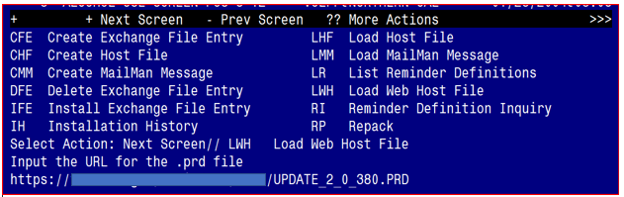

You should receive a message that the file was successfully loaded into your reminder exchange file.

Search and locate exchange file name UPDATE_2_0_380 VA-ONC PROSTATE CANCER FOLLOW UP

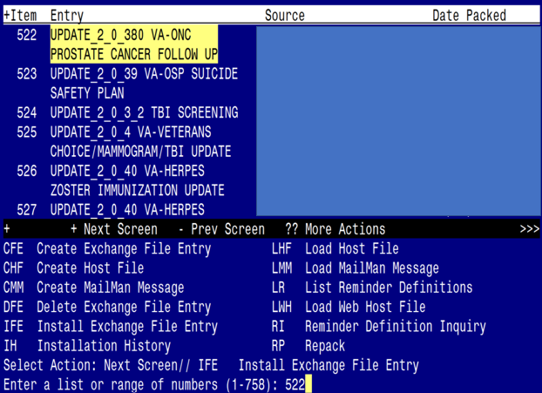

At the **Select Action** prompt, enter **IFE** for Install Exchange File Entry

Enter the number that corresponds with your entry titled UPDATE_2_0_380 VA-ONC PROSTATE CANCER FOLLOW UP *(in this example it is entry 522, it will vary by site)* that is dated 11/06/2023.

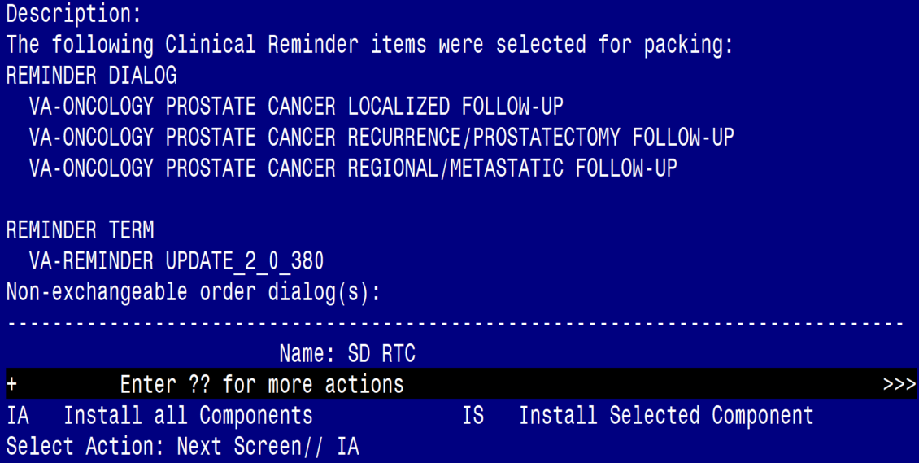

At the **Select Action** prompt, type **IA** for Install all Components and hit enter.

**For all new entries in any category, you will choose I to Install**

**All items below that are **SKIPS** are because you completed Update_2_0_367 and Update _2_0_20 (March 2017 release)** Do not skip if you have not completed these updates.

**For Template Fields that exist but are different, OVERWRITE**

**EXCEPT: VA-ONC VAMC SITE NAME, SKIP this item**

**For Reminder Terms that exist, but are different, OVERWRITE**

**EXCEPT:**  **VA-ONC ASU ATTENDING, MERGE this item**

**For Health Factors that exist, but are different, OVERWRITE**

**For Health Summary Type that exist, but are different, OVERWRITE**

**EXCEPT: VA-ONC PCA TESTOSTERONE SKIP this item**

**VA-ONC PCA LAST PSA SKIP this item.**

**For Health Summary Objects that exist, but are different, OVERWRITE**

**EXCEPT: VA-ONC PCA TESTOSTERONE SKIP this item**

**VA-ONC PCA LAST PSA** **SKIP this item.**

**TIU Document Definitions that exist, but are different:** **OVERWRITE**

**EXCEPT: VA-ONC PCA TESTOSTERONE SKIP this item**

**VA-ONC PCA LAST PSA** **SKIP this item.**

You will then be prompted to install the first dialog component.

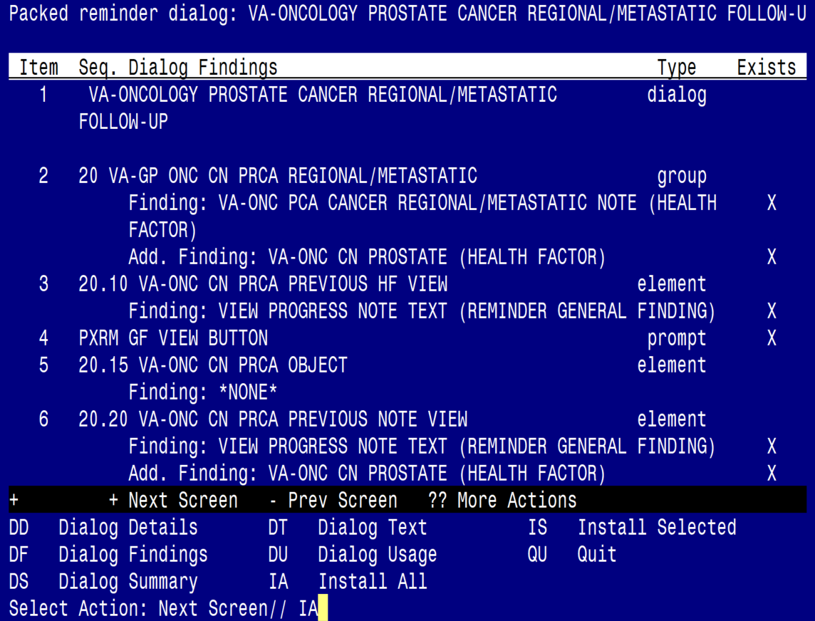

Select IA to install all.

Install reminder dialog and all components with no further changes: Y//Y

Regarding the VA-ONCOLOGY PROSTATE CANCER REGIONAL/METASTATIC FOLLOW-UP:  
Screen shot of the last of the list of elements, groups and dialogs that needed to be installed with a Q for quit entered at the "Select Action:" prompt because they now all exist.  

After install, select Q for quit to move to the next dialog.

You will then be prompted to install the second dialog component.

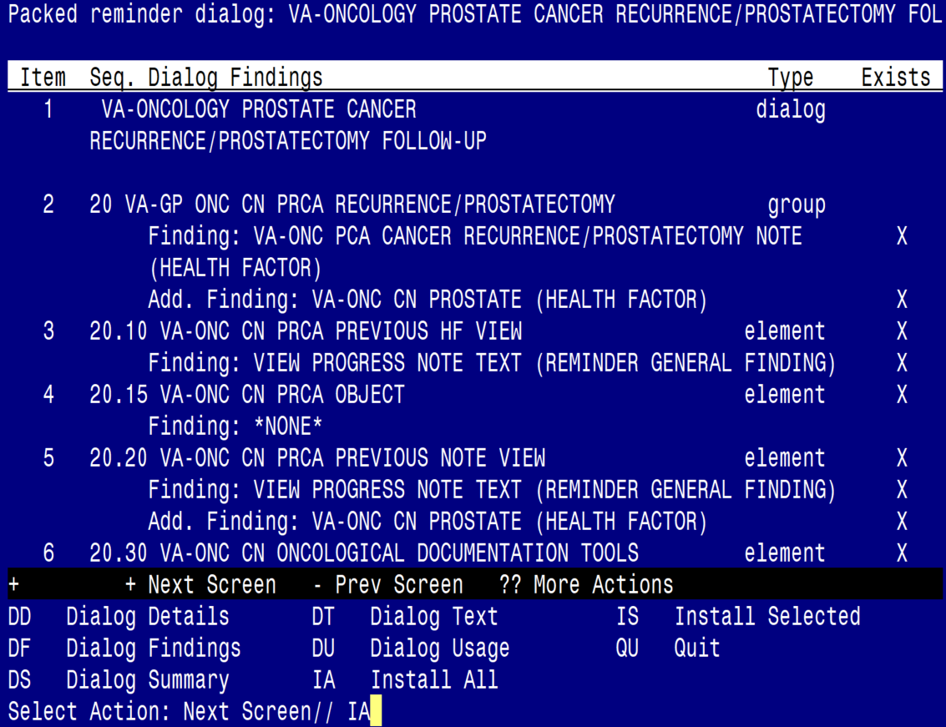

Select IA to install the dialog

Install reminder dialog and all components with no further changes: Y//Y

Regarding the VA-ONCOLOGY PROSTATE CANCER RECURRENCE/PROSTATECTOMY FOLLOW-UP (Reminder Dialog):
Screen shot of the last of the list of elements, groups and dialogs that needed to be installed with a Q for quit entered at the "Select Action:" prompt because they now all exist.  

Select Q to quit and move to the next dialog.

You will then be prompted to install the last dialog component.

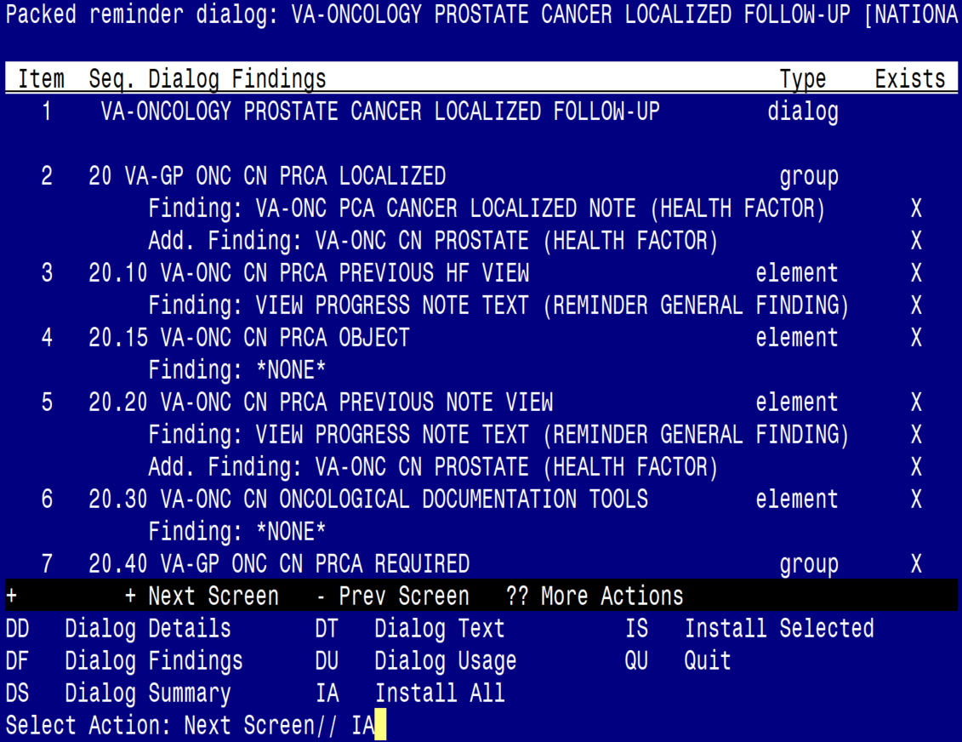

Select IA to install the dialog

Install reminder dialog and all components with no further changes: Y//Y

Regarding the VA-ONCOLOGY PROSTATE CANCER LOCALIZED  FOLLOW-UP (Reminder Dialog):
Screen shot of the last of the list of elements, groups and dialogs that needed to be installed with a Q for quit entered at the "Select Action:" prompt because they now all exist.  

Select Q to quit and you will be returned to the following screen

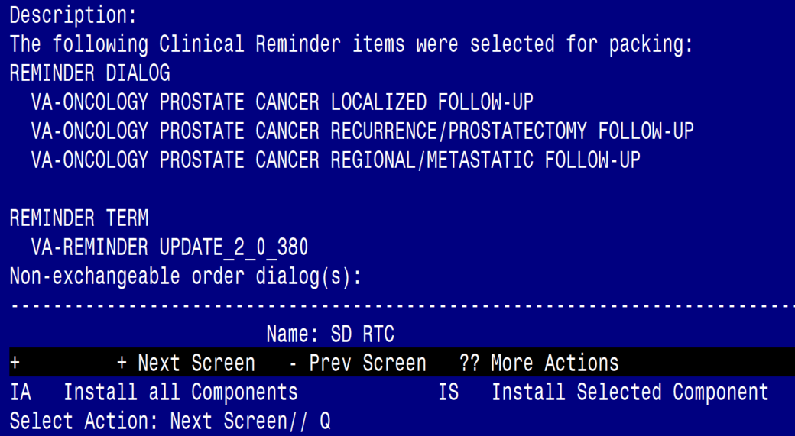

Select Q for quit to exit the install

# Post Installation

1. **Create Note Titles:**

The note titles to create to associate with these templates are:

ONCOLOGY PROSTATE CANCER LOCALIZED FOLLOW-UP

ONCOLOGY PROSTATE CANCER RECURRENCE/PROSTATECTOMY FOLLOW-UP

ONCOLOGY PROSTATE CANCER REGIONAL/METASTATIC FOLLOW-UP

VHA Enterprise Standard Title: HEMATOLOGY AND ONCOLOGY NOTE

You can add these to your document class where progress notes used by Oncology are located. **These titles should not be in your consult document class**.

In addition, you will also need to create 3 consult note titles:

ONCOLOGY PROSTATE CANCER LOCALIZED CONSULT

ONCOLOGY PROSTATE CANCER RECURRENCE/PROSTATECTOMY CONSULT

ONCOLOGY PROSTATE CANCER REGIONAL/METASTATIC CONSULT

VHA Enterprise Standard Title: HEMATOLOGY AND ONCOLOGY CONSULT

**These note titles should be in your consult document class.**

***Note:*** *Comprehensive information on Creating new Document Classes and Titles can be found beginning on page 54 of the TIU/ASU Implementation Guide at the following link:* [*http://www.va.gov/vdl/documents/Clinical/CPRS-Text_Integration_Utility_(TIU)/tiuim.pdf*](http://www.va.gov/vdl/documents/Clinical/CPRS-Text_Integration_Utility_(TIU)/tiuim.pdf)

1. **Make the Dialog template available to be attached to a Personal or Shared template or to be able to attach the dialog to a progress note title. (You can use the LINK feature in this menu for steps 2 and 3 if you choose to)**

Select Reminder Managers Menu <TEST ACCOUNT> Option:

**CP** CPRS Reminder Configuration

CA Add/Edit Reminder Categories

CL CPRS Lookup Categories

CS CPRS Cover Sheet Reminder List

MH Mental Health Dialogs Active

PN Progress Note Headers

RA Reminder GUI Resolution Active

TIU TIU Template Reminder Dialog Parameter

DEVL Evaluate Coversheet List on Dialog Finish

DL Default Outside Location

PT Position Reminder Text at Cursor

LINK Link Reminder Dialog to Template

TEST CPRS Coversheet Time Test

NP New Reminder Parameters

GEC GEC Status Check Active

WH WH Print Now Active

Select CPRS Reminder Configuration <TEST ACCOUNT> Option:

**TIU** TIU Template Reminder Dialog Parameter

Reminder Dialogs allowed as Templates may be set for the following:

1 User USR [choose from NEW PERSON]

3 Service SRV [choose from SERVICE/SECTION]

4 Division DIV [SALT LAKE CITY]

5 System SYS [NATREM.FO-SLC.MED.VA.GOV]

Enter selection: **5** Choose *the appropriate number for your site. Your site may do this by System or other levels. The example below uses SYSTEM level.*

Setting Reminder Dialogs allowed as Templates for System:

NATREM.FO-SLC.MED.VA.GOV

Select Display Sequence:

388 VA-COVID-19 TELEPHONE FOLLOW-UP

389 VA-SRA-CONSULT RESPONSE (D)

*When you type a question mark above, you will see the list of #’s (with dialogs) that are already taken. Choose a number* ***NOT*** *on this list. For this example, 391 is not present so I will use 391.*

Select Display Sequence: **391**

Are you adding 391 as a new Display Sequence? Yes// **YES**

Display Sequence: 391// <Enter> 391

Clinical Reminder Dialog: **VA-** **ONCOLOGY PROSTATE CANCER LOCALIZED FOLLOW-UP** reminder dialog NATIONAL ...OK? Yes// <Enter> (Yes)

Select Display Sequence: **392**

Are you adding 392 as a new Display Sequence? Yes// **YES**

Display Sequence: 392// <Enter> 392

Clinical Reminder Dialog: **VA-ONCOLOGY PROSTATE CANCER RECURRENCE/PROSTATECTOMY FOLLOW-UP** reminder dialog NATIONAL

...OK? Yes// <Enter> (Yes)

Select Display Sequence: **393**

Are you adding 393 as a new Display Sequence? Yes// **YES**

Display Sequence: 393// <Enter> 393

Clinical Reminder Dialog: **VA-ONCOLOGY PROSTATE CANCER REGIONAL/METASTATIC FOLLOW-UP reminder** dialog NATIONAL

...OK? Yes// <Enter> (Yes)

1. **Associate the reminder dialogs with the note title in CPRS.**

In CPRS, open the Template Editor, expand Document Titles, select the appropriate folder (if applicable), then click New Template (top right-hand corner).

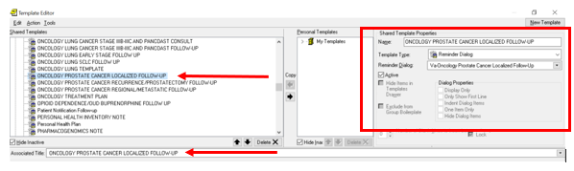

1. Type in the following information:

Name: **ONCOLOGY PROSTATE CANCER LOCALIZED FOLLOW-UP**

Template Type: **Reminder Dialog**

Reminder Dialog: **VA- ONCOLOGY PROSTATE CANCER LOCALIZED FOLLOW-UP**

Next, type in the Associated Title name –

**ONCOLOGY PROSTATE CANCER LOCALIZED FOLLOW-UP** - then click Apply.

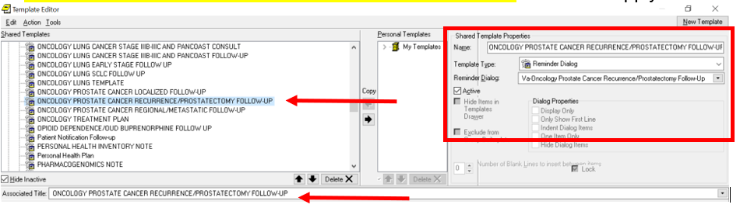

1. Type in the following information:

Name: **ONCOLOGY PROSTATE CANCER RECURRENCE/PROSTATECTOMY FOLLOW-UP**

Template Type: **Reminder Dialog**

Reminder Dialog **VA-ONCOLOGY PROSTATE CANCER RECURRENCE/PROSTATECTOMY FOLLOW-UP**

Next, type in the Associated Title name –

**ONCOLOGY PROSTATE CANCER RECURRENCE/PROSTATECTOMY FOLLOW-UP** - then click Apply.

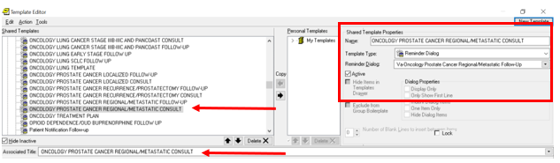

1. Type in the following information:

Name: **ONCOLOGY PROSTATE CANCER REGIONAL/METASTATIC FOLLOW-UP**

Template Type: **Reminder Dialog**

Reminder Dialog: **VA-ONCOLOGY PROSTATE CANCER REGIONAL/METASTATIC FOLLOW-UP**

Next, type in the Associated Title name –

**ONCOLOGY PROSTATE CANCER REGIONAL/METASTATIC FOLLOW-UP** - then click Apply.

1. Type in the following information:

Name: **ONCOLOGY PROSTATE CANCER LOCALIZED CONSULT**

Template Type: **Reminder Dialog**

Reminder Dialog: **VA-ONCOLOGY PROSTATE CANCER LOCALIZED FOLLOW-UP**

Next, type in the Associated Title name –

**ONCOLOGY PROSTATE CANCER LOCALIZED CONSULT** – then click Apply.

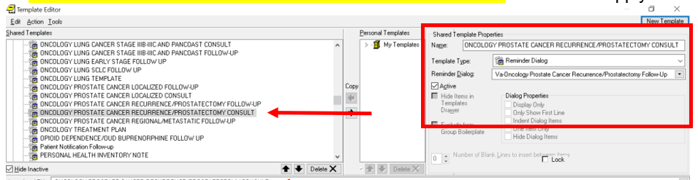

1. Type in the following information:

Name:**ONCOLOGY PROSTATE CANCER RECURRENCE/PROSTATECTOMY CONSULT**

Template Type: **Reminder Dialog**

Reminder Dialog: **VA-ONCOLOGY PROSTATE CANCER RECURRENCE/PROSTATECTOMY FOLLOW-UP**

Next, type in the Associated Title name –

**ONCOLOGY PROSTATE CANCER RECURRENCE/PROSTATECTOMY CONSULT** – then click Apply.

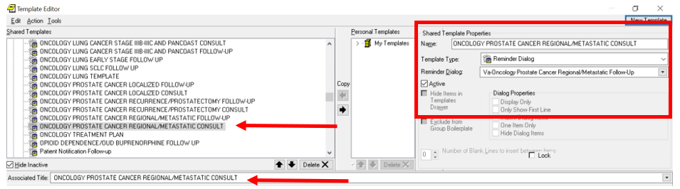

1. Type in the following information:

Name: **ONCOLOGY PROSTATE CANCER REGIONAL/METASTATIC CONSULT**

Template Type: **Reminder Dialog**

Reminder Dialog: **VA-ONCOLOGY PROSTATE CANCER REGIONAL/METASTATIC FOLLOW-UP**

Next, type in the Associated Title name –

**ONCOLOGY PROSTATE CANCER REGIONAL/METASTATIC CONSULT -** then click Apply.

**4. Add objects to the reminder dialog.**

**Using the VistA menu Reminder Dialog Management (DM), Reminder Dialogs (DI), and Change View (CV) to Dialog Elements (E) view.**

1. **Locate and edit the reminder dialog element:**

VAL-ONC CN PATIENT DEMOGRAPHICS

**Replace the following data objects** with your local data objects if you do not have the included objects.

* |PATIENT SEX|
* |PATIENT RACE|
* |PATIENT AGE|
* |PATIENT NAME|

1. **Locate and edit the reminder dialog element:**

VAL-ONC CN VITALS TXT

**Replace the text** (add local object here) **with your local data objects for the following:**

* Temperature
* Pulse
* Respiration
* Pulse Oximetry
* Blood Pressure
* Pain
* Height
* Weight

1. **Locate and edit the reminder dialog element:**

VAL-ONC CN LABS & IMAGING

You can replace the text “(please reference official report in record)” with your local data objectsfor the most recent LABS & IMAGING. Check with your local Oncologists to determine what labs and/or imaging that they would like in the note.

\***Or your site can choose to leave the verbiage “(please reference official report in record)”** without inserting data objects.

1. **Locate and edit the reminder dialog element:**

VAL-ONC CN VISIT VVC CONTACT HOME ADDRESS

**Replace the text:** (ADD local patient address object here) **with your local data object**.

1. **Locate and edit the reminder dialog element**:

VAL-ONC CN VISIT VVC CONTACT PHONE NUMBER HOME/CELL.

**Replace the text** (ADD patient xxx phone object here) **with your local data objects** for the following:

• Cell phone

• Home phone

• Work phone

1. **Locate and edit the reminder dialog element VAL-ONC CN MED REC OBJECT**

The reminder dialog element above is being sent out with object |VAL-ONC CN MED REC OBJECT|. If your site has their own object that is being use, you may want to replace this with your local object.

1. **Suppress the resident supervision statement (if applicable):**

The template utilizes branching logic via the element VAL-ONC CN ATTENDING OF RECORD to suppress documenting resident supervision in the dialog if needed.

*If **MERGED** in install, you do not need to complete this step.

**\***This is a local element and can be disabled if not applicable to your site.

You should add user classes that **do not** need to document resident supervision (i.e., Attending Physician, etc.). To add user classes, edit the reminder term VA-ONC ASU ATTENDING.

**To add an additional user class, use the quote ““characters

“CF.VA-ASU USER CLASS”

and set the computed finding parameter of your new finding to the appropriate user class.

The reminder term is being released with the ASU class of ATTENDING PHYSICIAN and NURSE PRACTITIONER. Edit according to your local practices.

If a user does not have one of the included user classes, the following will appear in the note.

Screen shot showing:
The Attending of record for this patient is Dr. followed by a Free text field that is required.  This case has been reviewed by the attending and they agree with the recommended plan.

1. **Enter your site name in the template field:** {FLD:VA-ONC VAMC SITE NAME}.

**SKIP adding your site name in the template field if previously done in Clinical Reminder Update_2_0_367.**

1. **Add orders as an additional finding to the elements identified in the pre-install (optional):**

VA-ONC RADIATION ONCOLOGY CONSULT – radiation oncology consult.

VA-ONC HOSPICE REFERRAL - hospice consult.

VA-ONC UROLOGY CONSULT–urology consult.

1. **Add consult quick order as an additional finding to the element:**

VA-ONC PRCA GENETIC PRETEST OPTION CONSULT CCGS

-**if NTO site**, map IFC CVT-TELEONCOLOGY TO DURHAM VAMC (if you have this consult, you are an NTO site)

-**if not NTO site,** map IFC PRECISION ONCOLOGY ELECTRONIC CONSULT

1. **Add orders as an additional finding to the element:**

VA-ONC PRCA GENETIC PRETEST OPTION OTHER

-map community care genetic consult, or any other genetic consult your site uses; may need to create order menu if have more than one genetics service (i.e. Community care and Genomic Medicine Service)

**If you don’t have genetic counseling consults, then inactivate this element.

Ex:

Screen shot showing Other Genetic Consults in the title and inside the box, Genetic Counseling Consults (not associated with National Teleoncology)
1  Community Care-Genetic Counseling/Testing Consult 
2 IFC Genomic Medicine Service (GMS)

1. **Add values to Additional Prompt:**

Navigate to reminder dialogs. Change view to Additional Prompts. Search for prompt:

VA-ONC CCGS GENETIC SERVICE

Add community care and any other genetic counseling that you have at your facility. If you don’t have any, then don’t add anything.

Ex: 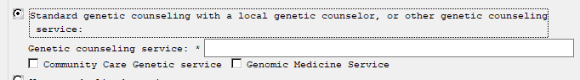

1. **Map HS Objects:**

**You may already have lab tests in these objects. If you do, and skipped them on install, go to #12.

| VA-ONC PCA LAST PSA|

| VA-ONC PCA TESTOSTERONE|.

Start with the TIU Maintenance Menu 🡪 Document Definitions (Manager) 🡪 Create TIU/Health Summary Objects 🡪 Detailed Display/Edit HS Object 🡪 Edit HS Type.

Screen shot showing the HS Object: VA-ONC PCA LAST PSA
Object Label: Prostate Specific Antigen (PSA)
Health Summary Type: VA-ONC PCA LAST PSA
Report Period: Blank
Creator:  REDACTED
HS Object List of two columns has all NO except
PRINT LABEL:  YES
Customize Header: YES
At the bottom Select Edit HS Type


Map your local PSA lab test(s) to the following object | VA-ONC PCA LAST PSA |

Select Item(s): Quit// Edit HS Type

Editing Health Summary Type VA-ONC PCA LAST PSA

NAME: VA-ONC PCA LAST PSA Replace

TITLE:

SUPPRESS PRINT OF COMPONENTS WITHOUT DATA: no//

LOCK:

OWNER:

Select COMPONENT: SLT

SLT LAB TESTS SELECTED SLT

SUMMARY ORDER: 5// 5

OCCURRENCE LIMIT: 1

TIME LIMIT:

HEADER NAME: Selected Lab Tests//

No selection items chosen.

Select new items one at a time in the sequence you want them displayed.

You may select any number of items.

Select SELECTION ITEM: PROSTATE SPECIFIC ANTIGEN

Continue to add PSA, Free; PSA, % Free; & PSA, Total. Check with your local LIM for the correct lab tests if these tests do not exist in your system. When you are finished, you should have the following:

LAB TESTS SELECTED (SLT)

Screen shot showing:
Type Name: PSA results
then a table with the following columns filled in
Abb  has SLT
Ord has 5
Component Name has Lab Tests Selected and Selection has 
PROSTATE SPECIFIC ANTIGEN
PSA, FREE [SPL]
PSA, % FREE [spl]
PSA, TOTAL [spl]

Screen shot showing the HS Object: VA-ONC PCA TESTOSTERONE
Object Label: Testosterone
Health Summary Type: VA-ONC PCA LAST TESTOSTERONE
Report Period: Blank
Creator:  REDACTED
HS Object List of two columns has all NO except
PRINT LABEL:  YES
Customize Header: YES
At the bottom Select Edit HS Type


Map your local Testosterone lab tests to the following object | VA-ONC PCA TESTOSTERONE |

Select Item(s): Quit// Edit HS Type

Editing Health Summary Type VA-ONC PCA TESTOSTERONE

NAME: VA-ONC PCA TESTOSTERONE Replace

TITLE:

SUPPRESS PRINT OF COMPONENTS WITHOUT DATA: no//

LOCK:

OWNER:

Select COMPONENT: SLT

SLT LAB TESTS SELECTED SLT

SUMMARY ORDER: 5// 5

OCCURRENCE LIMIT: 1

TIME LIMIT:

HEADER NAME: Selected Lab Tests//

No selection items chosen.

Select new items one at a time in the sequence you want them displayed.

You may select any number of items.

Select SELECTION ITEM: FREE TESTOSTERONE

Continue to add TESTOSTERONE, TOTAL. Check with your local LIM for the correct lab tests if these tests do not exist in your system. When you are finished, you should have the following:

LAB TESTS SELECTED (SLT)

Screen shot showing:
Type Name: Testosterone Results
then a table with the following columns filled in
Abb  has SLT
Ord has 5
Component Name has Lab Tests Selected and Selection has 

FREE TESTOSTERONE [QST]
TESTOSTERONE, TOTAL

1. **Map the six note titles to HS Object:**

|VA-ONC CN PREVIOUS PROSTATE|:

NOTE TITLES:

* ONCOLOGY PROSTATE CANCER LOCALIZED FOLLOW-UP
* ONCOLOGY PROSTATE CANCER RECURRENCE/PROSTATECTOMY FOLLOW-UP
* ONCOLOGY PROSTATE CANCER REGIONAL/METASTATIC FOLLOW-UP
* ONCOLOGY PROSTATE CANCER LOCALIZED CONSULT
* ONCOLOGY PROSTATE CANCER RECURRENCE/PROSTATECTOMY CONSULT
* ONCOLOGY PROSTATE CANCER REGIONAL/METASTATIC CONSULT

HS OBJECT:

|VA-ONC CN PREVIOUS PROSTATE|

Example:

Start with the TIU Maintenance Menu 🡪 Document Definitions (Manager) 🡪 Create TIU/Health Summary Objects 🡪 SL “VA-ONC CN PREVIOUS PROSTATE “ 🡪 Detailed Display/Edit HS Object.

Map the note title the 6 note titles to the following object.

HS Object: VA-ONC CN PREVIOUS PROSTATE (TIU)

Health Summary Type: VA-ONC CN PREVIOUS PROSTATE (HS)

Report Period:

Creator:

HS Object

Print Label: NO Print Report Date and Time: NO

Print Blank Line after Label: NO Print Confidentiality Banner: NO

Customized Header: YES Print Report Date and Time: NO

Suppress Components w/o Data: YES Print Component Header: NO

Print Deceased Information: NO Print Time-Occurrence Limits: NO

National Object: NO Underline Component Header: NO

Blank Line After Header: NO

Overwrite No Data: No Teleoncology note found

Select Item(s): Quit// Edit HS Type

Editing Health Summary Type VA-ONC CN PREVIOUS PROSTATE (HS)'

NAME: VA-ONC CN PREVIOUS PROSTATE (HS) Replace

TITLE:

SUPPRESS PRINT OF COMPONENTS WITHOUT DATA: yes//

LOCK:

OWNER:

Select COMPONENT: SPN

SPN PROGRESS NOTES SELECTED SPN

SUMMARY ORDER: 5// 5

OCCURRENCE LIMIT: 1

TIME LIMIT:

HEADER NAME: Selected Prog Notes//

No selection items chosen.

Select new items one at a time in the sequence you want them displayed.

You may select any number of items.

Select SELECTION ITEM: ONCOLOGY PROSTATE CANCER LOCALIZED FOLLOW-UP

Continue to add all the note titles listed above. When you are finished, you should have the following:

PROGRESS NOTES SELECTED (SPN)

1. ONCOLOGY PROSTATE CANCER LOCALIZED FOLLOW-UP
2. ONCOLOGY PROSTATE CANCER RECURRENCE/PROSTATECTOMY FOLLOW-UP
3. ONCOLOGY PROSTATE CANCER REGIONAL/METASTATIC FOLLOW-UP
4. ONCOLOGY PROSTATE CANCER LOCALIZED CONSULT
5. ONCOLOGY PROSTATE CANCER RECURRENCE/PROSTATECTOMY CONSULT
6. ONCOLOGY PROSTATE CANCER REGIONAL/METASTATIC CONSULT
7. **\*\*Optional** -** Add local reminder dialog groups and elements if needed. This template was built with the standard items needed for complete documentation. If a site would like to add guidance or information specific to that site, you can add text to the local reminder dialog group **VAL-GP ONC CN PROSTATE LOCAL GROUP** using the reminder dialog editor. This group is at the end of the dialog. This dialog group will install disabled, and you will need to remove the disable flag for it to be used.