

**Update _2_0_394**

Clinical Reminders

VA-RESPIRATORY SYNCYTIAL VIRUS

Install Guide

**October 2023**

Product Development

Office of Information Technology

Department of Veterans Affairs

Table of Contents

Introduction 1

Install Details 2

Install Example 3

Post Installation 6

# Introduction

In the United States, respiratory syncytial virus (RSV) causes seasonal epidemics of respiratory illness. Most adult RSV disease cases occur among older adults, with an estimated 60,000–160,000 hospitalizations and 6,000–10,000 deaths annually among adults aged ≥65 years in the United States. Unlike routine and risk-based vaccine recommendations, recommendations based on shared clinical decision-making do not target all persons in a particular age group or an identifiable risk group.

**VHA suggests that clinicians may offer a single dose RSV vaccine to adults aged 60 years or older.** **The decision to receive a RSV vaccine should include patient’s preferences and values regarding benefits and harms related to the patient’s risk for severe RSV-associated disease and known vaccine harm. Patients should only receive an RSV vaccine if they request vaccination after shared decision-making. VHA’s guidance on this Clinical Preventive Service may be found here: REDACTED**

CDC recommends a respiratory syncytial virus (RSV) vaccine during pregnancy to protect babies from severe RSV disease**: (NOTE: Only Pfizer’s RSV vaccine (Abrysvo) has been approved for use during pregnancy).** Pregnant Veterans should receive a single dose of Pfizer’s bivalent RSVpreF vaccine (Abrysvo) during weeks 32 through 36 of pregnancy during September through January. However, RSV seasons can vary in different parts of the United States. Local, state, and territorial health departments can determine the best times to start and stop administration of RSV vaccines in their jurisdictions. This is especially important in Alaska, parts of Florida, Hawaii, Puerto Rico, U.S. Virgin Islands, Guam, and the U.S.-affiliated Pacific Islands, where RSV seasonality can be different from most of the continental U.S.

**GlaxoSmithKline's RSV vaccine, adjuvanted (Arexvy) is NOT FDA approved for pregnant persons.**

<https://www.cdc.gov/vaccines/vpd/rsv/hcp/pregnant-people.html>

To facilitate the shared decision-making discussion and capture the interaction with patients, this new template is being deployed as a Shared Template.

UPDATE_2_0_394 contains 1 Reminder Exchange entry:

**UPDATE_2_0_****394 VA-RESPIRATORY SYNCYTIAL VIRUS**

**The exchange file contains the following components:**

**REMINDER GENERAL FINDINGS**

VIEW PROGRES NOTE TEXT

**TIU TEMPLATE FIELD**

BLANK TEXT FIELD FOR DIALOGS

VA-LOCATIONS

IM VIS RSV URL

**HEALTH FACTORS**

VA-REMINDER UPDATES [C]

VA-UPDATE_2_0_394

IMMUNIZATION [C]

VA-RSV EDUCATION VVC/TELEHEALTH VST

**REMINDER SPONSOR**

NATIONAL CENTER FOR HEALTH PROMOTION AND DISEASE PREVENTION (NCP)

**REMINDER TERM**

VA-REMINDER UPDATE_2_0_394

**REMINDER DIALOG**

VA-RESPIRATORY SYNCYTIAL VIRUS

# Install Details

This update is being distributed as a web host file. The address for the host file is: https://REDACTED/UPDATE_2_0_394.PRD

The file will be installed using Reminder Exchange, programmer access is not required.

Installation:

=============

This update can be loaded with users on the system. Installation will take less than 5 minutes.

# Install Example

Go to Reminder exchange in Vista.

To Load the exchange file, use LWH. The URL is https://REDACTED /UPDATE_2_0_394.PRD

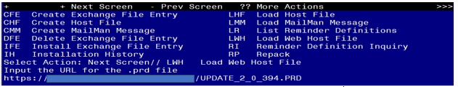

You will see a message indicating the file was loaded successfully.

Search and locate an entry titled UPDATE_2_0_394 VA-RESPIRATORY SYNCYTIAL VIRUS in reminder exchange.

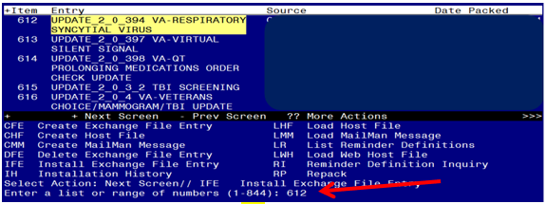

At the **Select Action** prompt, enter **IFE** for Install Exchange File Entry

Enter the number that corresponds with your entry titled UPDATE_2_0_394 VA-RESPIRATORY SYNCYTIAL VIRUS *(in this example it is entry 612, it will vary by site)* that is dated 10/18/2023.

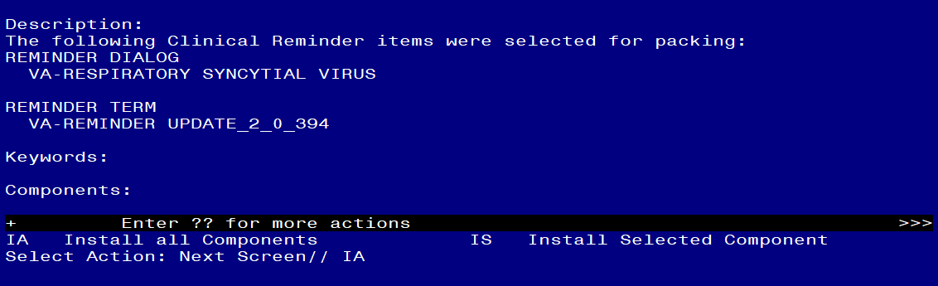

At the **Select Action** prompt, type **IA** for Install all Components and hit enter.

**For all new entries in any category you will choose I to Install**

**SKIP any items in any category you are prompted to overwrite.**

You will then be prompted to install the dialog component.

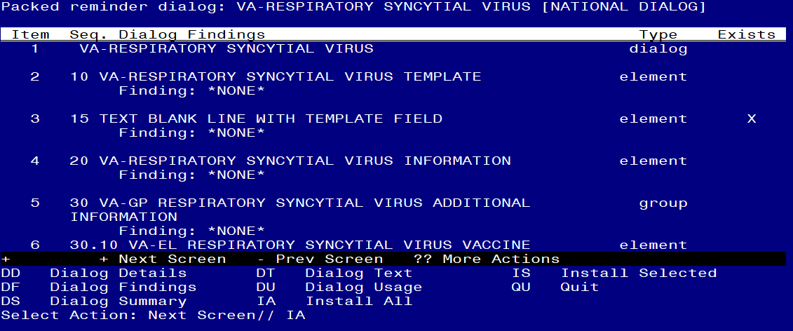

At the **Select Action** prompt, type **IA** to install the dialog – **VA-RESPIRATORY SYNCYTIAL VIRUS**

Install reminder dialog and all components with no further changes: Y//ES

In your test account, you may get prompted that the immunization finding does not exists, you can choose to replace with any other immunization in your test account only. You should not see that message in your production account.

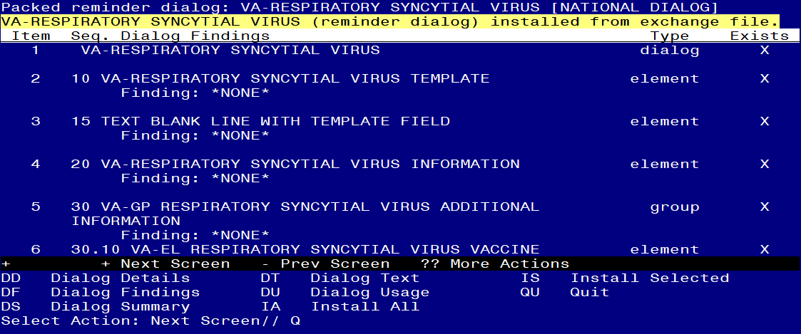

When the dialog has completed installation, you will then be returned to this screen. At the **Select Action** prompt, type **Q.**

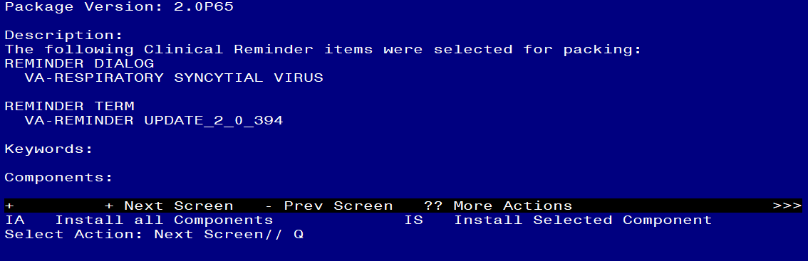

You will then be returned to this screen. At the **Select Action** prompt, type **Q.**

Install complete.

# Post Installation

1. **Make the Dialog templates available to be attached to a Personal or Shared templates or to be able to attach the dialog to a progress note title.**

Select Reminder Managers Menu <TEST ACCOUNT> Option: **CP** CPRS Reminder Configuration

CA Add/Edit Reminder Categories

CL CPRS Lookup Categories

CS CPRS Cover Sheet Reminder List

MH Mental Health Dialogs Active

PN Progress Note Headers

RA Reminder GUI Resolution Active

TIU TIU Template Reminder Dialog Parameter

DEVL Evaluate Coversheet List on Dialog Finish

DL Default Outside Location

PT Position Reminder Text at Cursor

LINK Link Reminder Dialog to Template

TEST CPRS Coversheet Time Test

NP New Reminder Parameters

GEC GEC Status Check Active

WH WH Print Now Active

Select CPRS Reminder Configuration <TEST ACCOUNT> Option: **TIU** TIU Template Reminder Dialog Parameter

Reminder Dialogs allowed as Templates may be set for the following:

1 User USR [choose from NEW PERSON]

3 Service SRV [choose from SERVICE/SECTION]

4 Division DIV [SALT LAKE CITY]

5 System SYS [NATREM.FO-SLC.MED.VA.GOV]

Enter selection: **5** *Choose the appropriate number for your site. Your site may do this by System or other levels. The example below uses SYSTEM level.*

Setting Reminder Dialogs allowed as Templates for System: NATREM.FO-SLC.MED.VA.GOV

Select Display Sequence: **?**

394 VA-COVID-19 TELEPHONE FOLLOW-UP

389 VA-SRA-CONSULT RESPONSE (D)

*When you type a question mark above, you will see the list of #’s (with dialogs) that are already taken. Choose a number* ***NOT*** *on this list. For this example, 390 is not present so I will use 390.*

Select Display Sequence: **390**

Are you adding 390 as a new Display Sequence? Yes// **YES**

Display Sequence: 390// <Enter> 390

Clinical Reminder Dialog: **VA-RESPIRATORY SYNCYTIAL VIRUS** reminder dialog NATIONAL

...OK? Yes// <Enter> (Yes)

1. **Add the template to your shared template folder.** This template is designed to be incorporated into any provider or nurse note (note title may vary site to site).

It should be added to the shared template folder so that it can be incorporated into an existing note by the user.

In CPRS, open the Template Editor, expand Shared Templates, select the appropriate folder (if applicable), then click New Template (top right-hand corner).

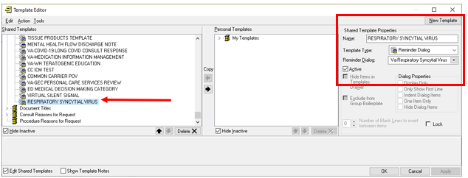

Type in the following information:

Name: **RESPIRATORY SYNCYTIAL VIRUS**

Template Type: **Reminder Dialog**

Reminder Dialog: **VA-RESPIRATORY SYNCYTIAL VIRUS**

–– then click Apply.

1. **Add quick order for the RSV vaccine to the reminder dialog element VA-RESPIRATORY SYNCYTIAL VIRUS ORDER**. Using the VistA menu Reminder Dialog Manager, Dialog Manager, change view to elements, search for the element VA-RESPIRATORY SYNCYTIAL VIRUS ORDER, edit the element and add your quick order at the finding item prompt.