

**Update _2_0_396**

Clinical Reminders

VA-HOMELESSNESS FOOD INSECURITY UPDATE

Install Guide

**November 2023**

Product Development

Office of Information Technology

Department of Veterans Affairs

Table of Contents

Introduction 1

Pre-Install 3

Install Details 3

Install Example 3

Post Installation 6

# Introduction

DESCRIPTION:

This reminder update contains an update to the existing HOMELESSNESS AND FOOD INSECURITY clinical reminder.

* The logic of the reminder was updated to no longer include a 2 year frequency. The other frequencies did not change.
* The dialog was updated so that if only the food insecurity question is due, the homelessness question will be optional or will not display depending on the patient history.

There are no changes in wording that should impact end users.

UPDATE_2_0_396 contains 1 Reminder Exchange entry:

**UPDATE_2_0_396 VA-HOMELESSNESS FOOD INSECURITY UPDATE**

**The exchange file contains the following components:**

**TIU TEMPLATE FIELD**

BLANK SPACE1

HOMELESSNESS EDUCATIONAL MATERIALS

**HEALTH FACTORS**

VA-REMINDER UPDATES

VA-UPDATE_2_0_396

HOMELESSNESS SCREENING

VA-FOOD UNABLE TO ANSWER

VA-FOOD DECLINES SCREENING

NURSING HOME RESIDENT

VA-FOOD ALREADY RECEIVING ASSISTANCE

VA-HOMELESS FOOD SCREEN NOT PERFORMED

VA-MONEY TO BUY FOOD-NO CURRENT CONCERN

REFERRED TO DIETICIAN FOOD

REFERRED TO SOCIAL WORK FOOD

NO REFERRALS REQUESTED FOOD

VA-MONEY TO BUY FOOD-YES CURRENT CONCERN

VA-FOOD 12MO ACTUALLY RAN OUT SOMETIMES

VA-FOOD 12MO ACTUALLY RAN OUT OFTEN

VA-FOOD 12MO WORRY RUN OUT SOMETIMES

VA-FOOD 12MO WORRY RUN OUT OFTEN

VA-FOOD 12MO ACTUALLY RAN OUT NEVER

VA-HOMELESSNESS FOOD SHORTAGE YES

VA-FOOD 12MO WORRY RUN OUT NEVER

ALREADY RECEIVING ASSIST WITH HOUSING

UNABLE TO PERFORM HOMELESS SCREEN

DECLINES HOMELESS SCREEN

VA-HOMELESS SCREENING NOT PERFORMED

BEST WAY TO REACH

DECLINES HOMELESS REFERRAL

REFERRED TO HOMELESS PROGRAM

CURRENT LIVING

LIVES OTHER

LIVES ON STREET

LIVES IN SHELTER

LIVES IN INSTITUTION

LIVES IN MOTEL/HOTEL

LIVES WITH FRIEND OR FAMILY

LIVES IN HOUSE WITH SUBSIDY

LIVES IN HOUSE NO SUBSIDY

POSITIVE - HAS NO STABLE HOUSING

NEGATIVE - HAS NO HOUSING CONCERNS

DECLINES SOCIAL WORK REFERRAL

REFERRED TO SOCIAL WORK

POSITIVE - HAS WORRIES ABOUT HOUSING

NEGATIVE - HAS STABLE HOUSING

VA-HOMELESSNESS FOOD SHORTAGE NO

**REMINDER SPONSOR**

HOMELESSNESS OFFICE

Mental Health Services

**REMINDER LOCATION LIST**

VA-HOMELESSNESS STOP CODES

**REMINDER TERM**

VA-REMINDER UPDATE_2_0_396

VA-BL FOOD INSECURITY POSITIVE

VA-UNABLE TO PERFORM HOMELESS SCREEN

VA-DECLINES HOMELESS SCREEN

VA-HOMELESSNESS - ALREADY RECEIVING SERVICES

VA-BL HOMELESSNESS SCREENING DUE

VA-HOMELESSNESS FOOD SHORTAGE NO

VA-HOMELESSNESS FOOD SHORTAGE YES

**REMINDER DEFINITION**

VA-BL HOMELESSNESS SCREENING

VA-HOMELESSNESS SCREENING

**REMINDER DIALOG**

VA-HOMELESSNESS SCREENING

# Pre-Install

1. Using the menu, Reminder Dialog Management, Reminder Dialogs, Change the view to element and do an inquiry into element VA-OI HOMELESS REFERRAL and note the orderable item that is a finding or an additional finding item for reference post install.
2. Using the menu, Reminder Dialog Management, Reminder Dialogs, Change the view to element and do an inquiry into element VA-OI SOCIAL WORK REFERRAL and note the orderable item that is a finding or an additional finding item for reference post install
3. Using the menu, Reminder Dialog Management, Reminder Dialogs, Change the view to element and do an inquiry into element VAL-OI SOCIAL WORK REFERRAL and note the orderable item that is a finding or an additional finding item for reference post install
4. Using the menu, Reminder Dialog Management, Reminder Dialogs, Change the view to element and do an inquiry into element VAL-OI DIETARY REFERRAL and note the orderable item that is a finding or an additional finding item for reference post install

# Install Details

This update is being distributed as a web host file. The address for the host file is: **https://Redacted /UPDATE_2_0_396.PRD**

The file will be installed using Reminder Exchange, programmer access is not required.

This update can be loaded with users on the system. Installation will take less than 15 minutes.

# Install Example

To Load the Web Host File. Navigate to Reminder exchange in Vista

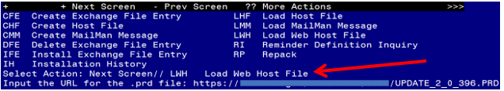

At the **Select Action:** prompt, enter **LWH** for Load Web Host File

At the **Input the url for the .prd file:** prompt, type the following web address:

**https://REDACTED/UPDATE_2_0_396.PRD**

You should see a message at the top of your screen that the file loaded successfully

Search and locate an entry titled **UPDATE_2_0_396 VA-HOMELESSNESS FOOD INSECURITY UPDATE**

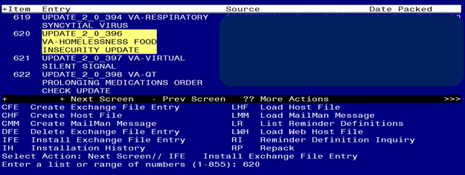

At the **Select Action** prompt, enter **IFE** for Install Exchange File Entry

Enter the number that corresponds with your entry **UPDATE_2_0_396 VA-HOMELESSNESS FOOD INSECURITY UPDATE**  *(in this example it is entry 620 it will vary by site).* The date of the exchange file should 10/17/2023).

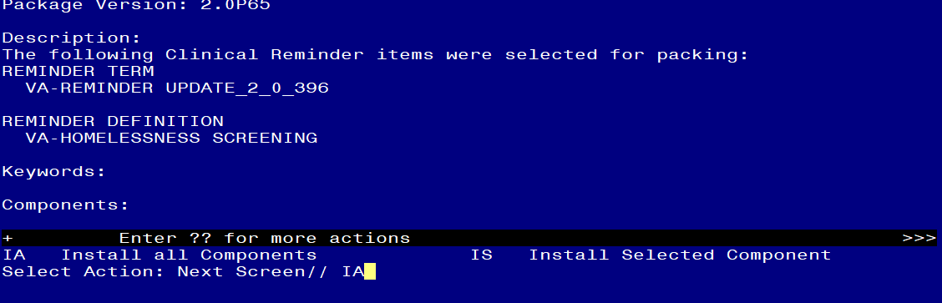

At the **Select Action** prompt, type **IA** for Install all Components and hit enter.

Select Action: Next Screen// IA Install all Components

As a general rule, you will Install all new Components,

SKIP any components you are prompted to overwrite **with the exception of Reminder Definitions**, you will OVERWRITE only the **reminder definition** when prompted.

**You will be promped to install the reminder dialog component – You will choose to install all even though some components may have an X to indicate that they exist.**

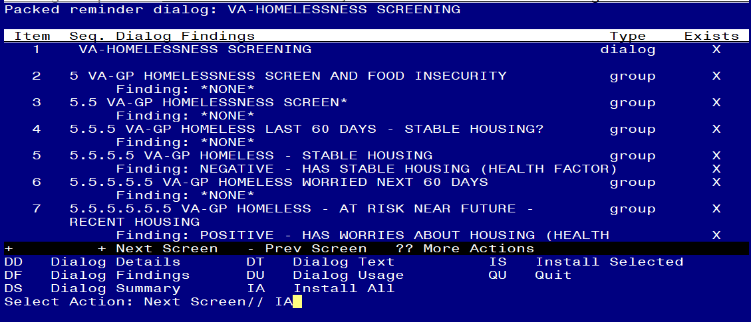

At the **Select Action** prompt, type **IA** to install the dialog – **VA-HOMELESSNESS SCREENING**

Select Action: Next Screen// IA Install All

Install reminder dialog and all components with no further changes: Y// Yes

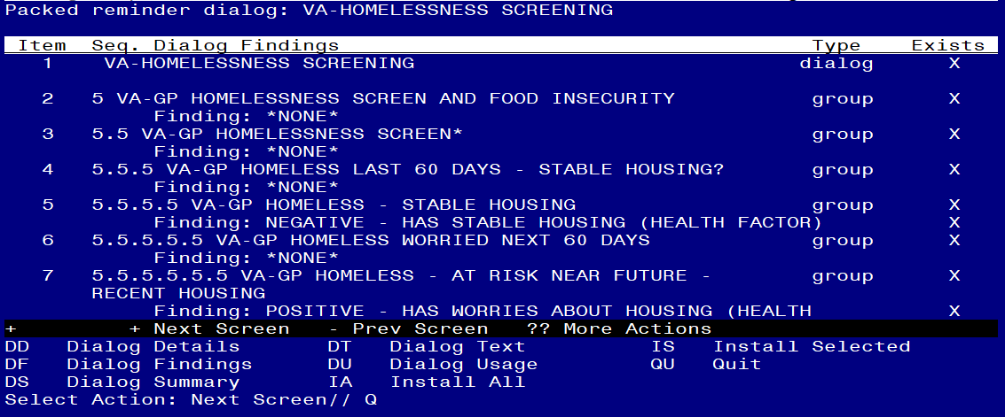

After completing this dialog install, you will type Q.

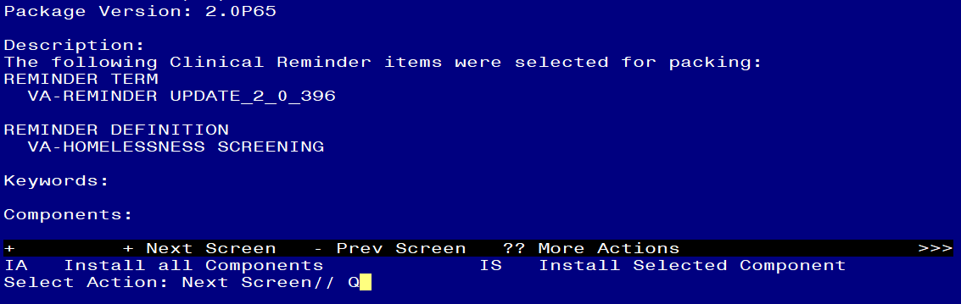

You will then be returned to this screen. At the **Select Action** prompt, type **Q.**

Install complete.

# Post Installation

1. **In CPRS, open the reminder Homelessness/Food Insecurity Screen (REMINDER DIALOG NAME VA-HOMELESSNESS SCREENING) and confirm the version displays as 3.1**
2. **Add the orderable items within the dialog:**

Using the menu, Reminder Dialog Management, Reminder Dialogs, Change the view to dialog and search for the reminder dialog VA-HOMELESSNESS SCREENING. Within that dialog, you can Search for the following components and edit.

* Add the same Quick Order from your pre-install inquiry as an additional finding to the element VA-OI HOMELESS REFERRAL
* Add the same Quick Order from your pre-install inquiry as an additional finding to the element VA-OI SOCIAL WORK REFERRAL
* Add the same Quick Order from your pre-install inquiry as an additional finding to the element VAL-OI SOCIAL WORK REFERRAL.
* Add the same Quick Order from your pre-install inquiry as an additional finding to the element VAL-OI DIETARY REFERRAL.