

**Update _2_0_402**

Clinical Reminders

VA-LONG COVID-19 BATCH QUESTIONNAIRE

Install Guide

**December 2023**

Product Development

Office of Information Technology

Department of Veterans Affairs

Table of Contents

Introduction 1

Install Details 2

Install Example 3

Post Installation 6

# Introduction

The Long COVID Batch Questionnaire is a rigorously evaluated group of validated questionnaires that attempt to better assess Veterans with Long COVID in a holistic manner, consistent with the VA Whole Health approach to Long COVID.  These questionnaires will be used during the initial assessment of any Veteran being seen in a Long COVID Clinic and can be used during follow-up visits to quantitatively trend various symptoms as Veterans engage in treatments for Long COVID.

UPDATE_2_0_402 contains 1 Reminder Exchange entry:

**UPDATE_2_0_402 VA-LONG COVID-19 BATCH QUESTIONNAIRE**

**The exchange file contains the following components:**

**REMINDER GENERAL FINDINGS**

VIEW PROGRESS NOTE TEXT

**REMINDER DIALOG LINK TYPE**

VA-WHS VITALITY/WELL-BEING SCORE LESS THAN 20

**TIU TEMPLATE FIELD**

VA-WORD

OTHER NON-VA

OTHER TEXT

VA-BLANK

**HEALTH FACTORS**

VA-REMINDER UPDATES [C]

VA-UPDATE_2_0_402

VA-COVID-19 [C]

VA-LONG COVID VVC CONTACT

VA-LONG COVID TELEPHONE CONTACT

VA-LONG COVID IN PERSON CONTACT

VA-LONG COVID-19 IMPORTANT TO DISCUSS DURING CLINIC VISIT

VA-LONG COVID-19 NUMBER OF STEPS TAKEN 2 MIN

VA-LONG COVID-19 DAYS MINUTES ENGAGE IN MOD EXERCISE

VA-LONG COVID-19 DAYS PER WEEK ENGAGE IN MOD EXERCISE

VA-HEALTH AND WELL BEING [C]

VA-WHS SCORE OF 20% OR LESS

VA-WHS VITALITY/WELL-BEING NOTE

VA-WHS VITALITY/WELL BEING SCORE

VA-WHOLE HEALTH WHAT YOU WANT HEALTH FOR

VA-WHOLE HEALTH LAST TIME FELT WELL

**REMINDER TERM**

VA-REMINDER UPDATE_2_0_402

**HEALTH SUMMARY TYPE**

VA-WELL BEING SIGNS TOTAL

**HEALTH SUMMARY OBJECTS**

VA-WELL BEING SIGNS TOTAL (TIU)

**TIU DOCUMENT DEFINITION**

VA-WELL BEING SIGNS TOTAL

**REMINDER DIALOG**

VA-COVID-19 LONG COVID BATCH QUESTIONNAIRE

# Install Details

This update is being distributed as a web host file. The address for the host file is: https://REDACTED /UPDATE_2_0_402.PRD

The file will be installed using Reminder Exchange, programmer access is not required.

Installation:

=============

This update can be loaded with users on the system. Installation will take less than 5 minutes.

# Install Example

Go to Reminder exchange in Vista.

To Load the exchange file, use LWH. The URL is

https://REDACTED /UPDATE_2_0_402.PRD

**
Screen shot of the Reminder Exchange terminal window with LWH for "Load Web Host File" entered and a URL for PRD file downloads filled in (that is only active from inside the VA firewall and some of the URL has been redacted for use outside of the VA. There may be an equivalent site outside of the VA.**

You will see a message indicating the file was loaded successfully.

Search and locate an entry titled UPDATE_2_0_402 VA-LONG COVID-19 BATCH QUESTIONNAIRE in reminder exchange.

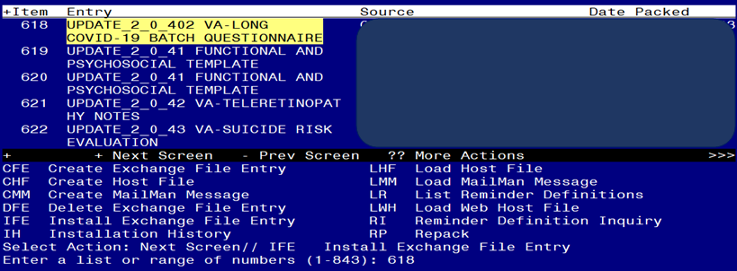

At the **Select Action** prompt, enter **IFE** for Install Exchange File Entry

Enter the number that corresponds with your entry titled UPDATE_2_0_402 VA-LONG COVID-19 BATCH QUESTIONNAIRE *(in this example it is entry 618, it will vary by site)* that is dated 11/30/2023.

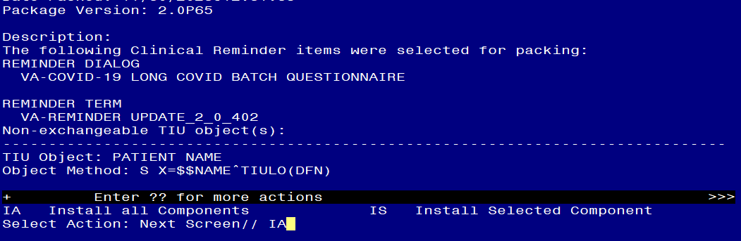

At the **Select Action** prompt, type **IA** for Install all Components and hit enter.

**For all new entries in any category you will choose I to Install**

**Overwrite any items in any category you are prompted to overwrite.**

You will then be prompted to install the dialog component.

Regarding the VA-COVID-19 LONG COVID BATCH QUESTIONNAIRE [ NATIONAL DIALOG ]:
Screen shot of the terminal window showing a list of elements, groups and dialogs with the text with IA for "Install All" entered at the "Select Action:" Prompt.  The correct entry is described in the text.

At the **Select Action** prompt, type **IA** to install the dialog – **VA-COVID-19 LONG COVID BATCH QUESTIONNAIRE.**

Install reminder dialog and all components with no further changes: Y//ES

Regarding the VA-COVID-19 LONG COVID BATCH QUESTIONNAIRE [ NATIONAL DIALOG ]:
Screen shot of the last of the list of elements, groups and dialogs that needed to be installed with a Q for quit entered at the "Select Action:" prompt because they now all exist.  

When the dialog has completed installation, you will then be returned to this screen. At the **Select Action** prompt, type **Q.**

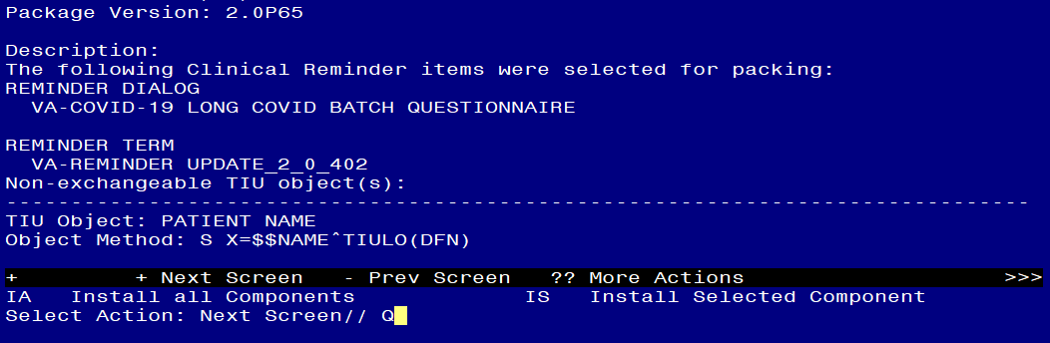

You will then be returned to this screen. At the **Select Action** prompt, type **Q.**

Install complete.

# Post Installation

**All sites should complete post install steps 1-3. Only sites with a Long COVID-19 program need to complete steps 4-6.**

1. **Add your local DATA OBJECT** FOR PATIENT ADDRESS to the following element: VAL-TH VVC TELEPHONE TRIAGE PATIENT LOCATION HOME

Using the menu Reminder Dialog Management, Reminder Dialogs, change your view to Element.

Search for and edit the dialog text of the following element: VAL-TH VVC TELEPHONE TRIAGE PATIENT LOCATION HOME

1. **Add your local DATA OBJECT** FOR PATIENT PHONE NUMBER to the following element: VAL-TH VVC TELEPHONE TRIAGE CONTACT PHONE OBJECT

Using the menu Reminder Dialog Management, Reminder Dialogs, change your view to Element.

Search for and edit the dialog text of the following element: VAL-TH VVC TELEPHONE TRIAGE CONTACT PHONE OBJECT

1. **Update dialog text to replace DATA OBJECTS** (if needed), this reminder dialog contains elements that have data objects for PATIENT NAME, PATIENT SSN and PATIENT DATE OF BIRTH. If you site does not have an object with those names, you can edit the element and replace the object in the dialog text with your local object.

Using the menu Reminder Dialog Management, Reminder Dialogs, change your view to Element. Search for and edit the dialog text of following elements:

VAL-LONG COVID ID FULL NAME

VAL-LONG COVID ID FULL SSN

VAL-LONG COVID ID DATE OF BIRTH

**Complete the below steps if your site has a Long COVID-19 program.**

1. **Setup of Note Title.**

The suggested note title to create to associate with this template is:

**LONG COVID-19 QUESTIONNAIRE**

VHA Enterprise Standard Title: **INFECTIOUS DISEASE NOTE**

**You can add this to the document class where progress notes are stored.**

***Note:*** *Comprehensive information on Creating new Document Classes and Titles can be found beginning on page 54 of the TIU/ASU Implementation Guide at the following link:* [*http://www.va.gov/vdl/documents/Clinical/CPRS-Text_Integration_Utility_(TIU)/tiuim.pdf*](http://www.va.gov/vdl/documents/Clinical/CPRS-Text_Integration_Utility_(TIU)/tiuim.pdf)

1. **Make the Dialog templates available to be attached to a Personal or Shared templates or to be able to attach the dialog to a progress note title.**

Select Reminder Managers Menu <TEST ACCOUNT> Option: **CP** CPRS Reminder Configuration

CA Add/Edit Reminder Categories

CL CPRS Lookup Categories

CS CPRS Cover Sheet Reminder List

MH Mental Health Dialogs Active

PN Progress Note Headers

RA Reminder GUI Resolution Active

TIU TIU Template Reminder Dialog Parameter

DEVL Evaluate Coversheet List on Dialog Finish

DL Default Outside Location

PT Position Reminder Text at Cursor

LINK Link Reminder Dialog to Template

TEST CPRS Coversheet Time Test

NP New Reminder Parameters

GEC GEC Status Check Active

WH WH Print Now Active

Select CPRS Reminder Configuration <TEST ACCOUNT> Option: **TIU** TIU Template Reminder Dialog Parameter

Reminder Dialogs allowed as Templates may be set for the following:

1 User USR [choose from NEW PERSON]

3 Service SRV [choose from SERVICE/SECTION]

4 Division DIV [SALT LAKE CITY]

5 System SYS [NATREM.FO-SLC.MED.VA.GOV]

Enter selection: **5** *Choose the appropriate number for your site. Your site may do this by System or other levels. The example below uses SYSTEM level.*

Setting Reminder Dialogs allowed as Templates for System: NATREM.FO-SLC.MED.VA.GOV

Select Display Sequence: **?**

388 VA-COVID-19 TELEPHONE FOLLOW-UP

389 VA-SRA-CONSULT RESPONSE (D)

*When you type a question mark above, you will see the list of #’s (with dialogs) that are already taken. Choose a number* ***NOT*** *on this list. For this example, 390 is not present so I will use 390.*

Select Display Sequence: **390**

Are you adding 390 as a new Display Sequence? Yes// **YES**

Display Sequence: 390// <Enter> 390

Clinical Reminder Dialog: **VA-COVID-19 LONG COVID BATCH QUESTIONNAIRE** reminder dialog NATIONAL

...OK? Yes// <Enter> (Yes)

1. **Connect the template to your note title.**

* In CPRS, open the Template Editor, expand Document Titles, select the appropriate folder (if applicable), then click New Template (top right-hand corner).

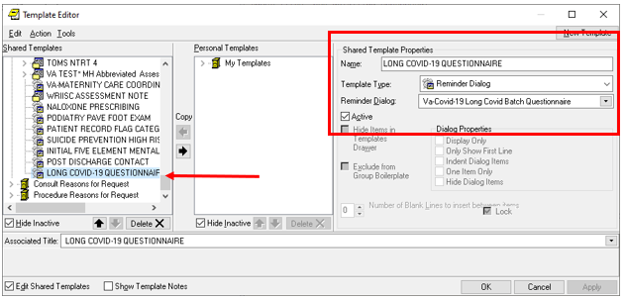

Type in the following information:

Name: **LONG COVID-19 QUESTIONNAIRE**

Template Type: **Reminder Dialog**

Reminder Dialog: **VA-COVID-19 LONG COVID BATCH QUESTIONNAIRE**

Associated Title: **LONG COVID-19 QUESTIONNAIRE**

–– then click Apply.

This note can also be added to your shared template folder, work with your local LONG COVID-19 clinic to find out what their preference is.