

**Update _2_0_412**

Clinical Reminders

VA-PTSD PSYCHOTHERAPY AND MEASUREMENT BASED CARE TRACKING TEMPLATE

Install Guide

**February 2024**

Product Development

Office of Information Technology

Department of Veterans Affairs

Table of Contents

Introduction 1

Install Example 2

Post Installation 5

# Introduction

In 2014, the VHA launched the first EBP psychotherapy template for storing health factors in the larger VHA Clinical Data Warehouse (CDW). As a result of the VHA adopting the VA/DoD Management of Post-Traumatic Stress Disorder Clinical Practice Guideline (PTSD CPG) (2017 and 2023), there has been increased implementation of many recommended treatments. These include Eye Desensitization and Reprocessing (EDMR) and Written Exposure Therapy (WET). This created a documentation and tracking challenge, as the VA has not expanded their template suite to include all the recommended CPG treatments for Post-Traumatic Stress Disorder (PTSD).

This new template allows capture of all recommended PTSD Evidenced Based Therapy and increases ability to track MBC. It also simplifies tracking of PTSD EBPs and MBC.

This template will be added to your shared template folder and can be added to any note.

Sites can also decide to add to an existing local note title if they would like to.

UPDATE_2_0_412 contains 1 Reminder Exchange entry named **UPDATE_2_0_412 VA-PTSD PSYCHOTHERAPY AND MBC TRACKING**

This contains 1 new reminder dialogs.

**The exchange file contains the following components:**

**HEALTH FACTORS**

VA-REMINDER UPDATES [C]

VA-UPDATE_2_0_412

VA-PTSD PSYCHOTHERAPY TREATMENTS [C]

VA-PTSD PSYCHOTHERAPY EPISODE OF CARE LAST SESSION

VA-PTSD PSYCHOTHERAPY EPISODE OF CARE FIRST SESSION

VA-PTSD PYSCHOTHERAPY MBC ACT MODIFY

VA-PTSD PYSCHOTHERAPY MBC ACT REMAIN SAME

VA-PTSD PSYCHOTHERAPY TRACKER GROUP [C]

VA-PTSD PYSCHOTHERAPY MBC ACT

VA-PTSD PYSCHOTHERAPY MBC SHARE

VA-PTSD PSYCHOTHERAPY OTHER TEXT

VA-PTSD PSYCHOTHERAPY OTHER CBCT

VA-PTSD PSYCHOTHERAPY OTHER TREATMENT

VA-PTSD PSYCHOTHERAPY PCT

VA-PTSD PSYCHOTHERAPY WET

VA-PTSD PSYCHOTHERAPY EMDR

VA-PTSD PSYCHOTHERAPY CPT

VA-PTSD PSYCHOTHERAPY PE AND CBT

VA-PTSD PSYCHOTHERAPY PE

**REMINDER TERM**

VA-REMINDER UPDATE_2_0_412

**REMINDER DIALOG**

VA-PTSD PSYCHOTHERAPY AND MBC TRACKING

This update is being distributed as a web host file. The address for the host file is: https://vaww.va.gov/reminders/docs/UPDATE_2_0_412.PRD

The file will be installed using Reminder Exchange, programmer access is not required.

Installation:

=============

This update can be loaded with users on the system. Installation will take less than 5 minutes.

# Install Example

Go to Reminder exchange in Vista.

To Load the exchange file, use LWH. The URL is:

https://REDACTED/UPDATE_2_0_412.PRD

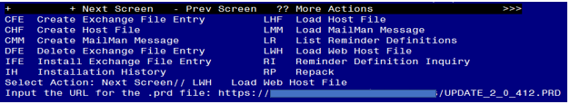

You should receive a message that the file was successfully loaded into your reminder exchange file.

Search and locate exchange file name **UPDATE_2_0_412 VA-PTSD PSYCHOTHERAPY AND MBC TRACKING**

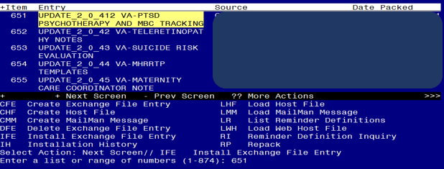

At the **Select Action** prompt, enter **IFE** for Install Exchange File Entry

Enter the number that corresponds with your entry titled **UPDATE_2_0_412 VA-PTSD PSYCHOTHERAPY AND MBC TRACKING**

*(in this example it is entry 651, it will vary by site)* that is dated 01/16/2024.

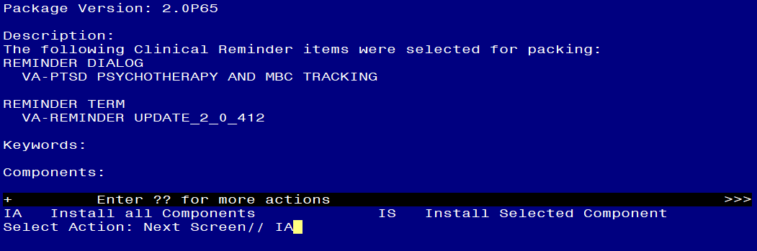

At the **Select Action** prompt, type **IA** for Install all Components and hit enter.

**For all new entries in any category, you will choose I to Install.**

**If you are prompted to overwrite any items, choose S to Skip.**

You will then be prompted to install the dialog component.

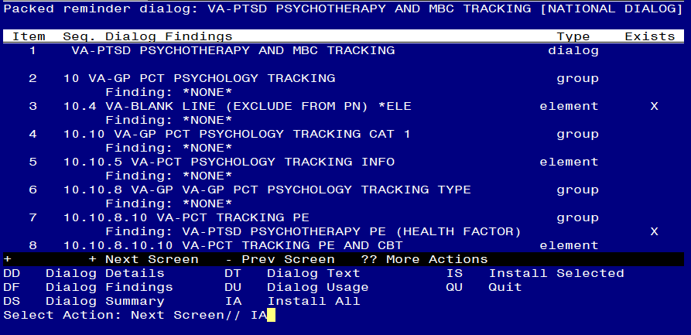

Select IA to install all. This will install the reminder dialog **VA-PTSD PSYCHOTHERAPY AND MBC TRACKING**

Install reminder dialog and all components with no further changes: Y//Y

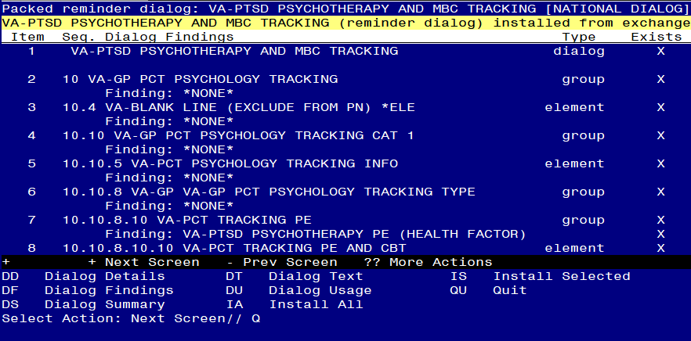

After install, select Q for quit.

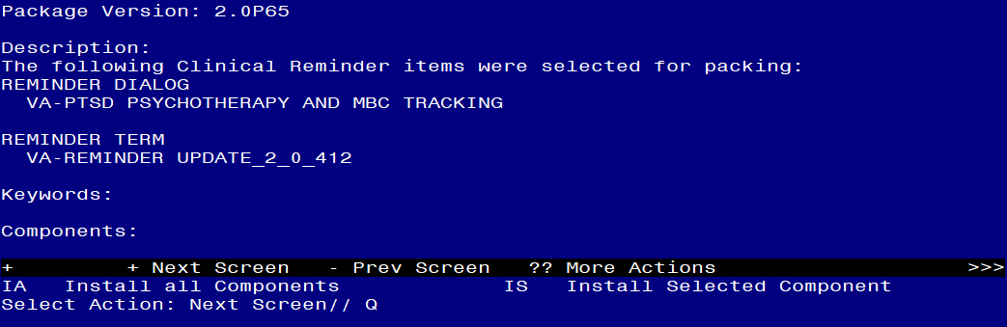

Select Q for quit to exit the install.

Install Complete.

# Post Installation

1. **Make the Dialog template available to be attached to a Personal or Shared template or to be able to attach the dialog to a progress note title. (You can use the LINK feature in this menu for steps 1 & 2 if you choose to)**

Select Reminder Managers Menu <TEST ACCOUNT> Option:

**CP** CPRS Reminder Configuration

CA Add/Edit Reminder Categories

CL CPRS Lookup Categories

CS CPRS Cover Sheet Reminder List

MH Mental Health Dialogs Active

PN Progress Note Headers

RA Reminder GUI Resolution Active

TIU TIU Template Reminder Dialog Parameter

DEVL Evaluate Coversheet List on Dialog Finish

DL Default Outside Location

PT Position Reminder Text at Cursor

LINK Link Reminder Dialog to Template

TEST CPRS Coversheet Time Test

NP New Reminder Parameters

GEC GEC Status Check Active

WH WH Print Now Active

Select CPRS Reminder Configuration <TEST ACCOUNT> Option:

**TIU** TIU Template Reminder Dialog Parameter

Reminder Dialogs allowed as Templates may be set for the following:

1 User USR [choose from NEW PERSON]

3 Service SRV [choose from SERVICE/SECTION]

4 Division DIV [SALT LAKE CITY]

5 System SYS [NATREM.FO-SLC.MED.VA.GOV]

Enter selection: **5** Choose *the appropriate number for your site. Your site may do this by System or other levels. The example below uses SYSTEM level.*

Setting Reminder Dialogs allowed as Templates for System:

NATREM.FO-SLC.MED.VA.GOV

Select Display Sequence:

388 VA-COVID-19 TELEPHONE FOLLOW-UP

389 VA-SRA-CONSULT RESPONSE (D)

*When you type a question mark above, you will see the list of #’s (with dialogs) that are already taken. Choose a number* ***NOT*** *on this list. For this example, 391 is not present so I will use 391.*

Select Display Sequence: **391**

Are you adding 391 as a new Display Sequence? Yes// **YES**

Display Sequence: 391// <Enter> 391

Clinical Reminder Dialog**: VA-PTSD PSYCHOTHERAPY AND MBC TRACKING**

reminder dialog NATIONAL ...OK? Yes// <Enter> (Yes)

**2.** **Add the reminder dialog to your shared template folder in CPRS.**

In CPRS, open the Template Editor, expand Shared Template, select the appropriate folder (if applicable), then click New Template (top right-hand corner).

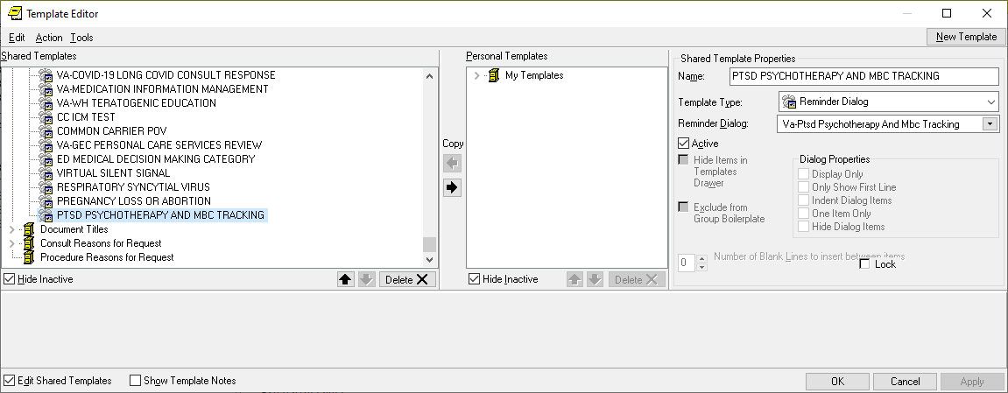

1. Type in the following information:

Name: **PTSD PSYCHOTHERAPY AND MBC TRACKING**

Template Type: **Reminder Dialog**

Reminder Dialog: **VA-PTSD PSYCHOTHERAPY AND MBC TRACKING**

- then click Apply.

** NOTE: Your site can also connect this template to any local note titles that you would like to. Please work with your local Mental Health clinical experts to see if this is something they would like for you to do.