

**Update \_2\_0\_413**

Clinical Reminders

VA-ONCOLOGY CLOSE TO ME TEMPLATES

Install Guide

**February 2024**

Product Development

Office of Information Technology

Department of Veterans Affairs

**Table of Contents**

[Introduction 1](#_Toc150413166)

[Pre-Install 1](#_Toc150413167)

[Install Details 2](#_Toc150413168)

[Install Example 3](#_Toc150413169)

[Post Installation: 10](#_Toc150413170)

# Introduction

VA National Oncology Program (NOP) Close to Me infusion service provides parenteral anti-cancer therapy services at Community Based Outpatient Clinics (CBOCs) to increase access points to care for Veterans. This service seeks to reduce travel time for Veterans, improve VA care continuity, and provide Veteran-centric care. These templates (2 notes and 1 consult) were developed by the National Oncology Program Office in collaboration with an interdisciplinary team of subject matter experts. The consult template will be used by Oncology providers to place a consult order for service request. Two note templates will primarily be used by Close to Me nursing staff to triage consults and administer treatments to patients at the CBOCs. These standardized templates also include health factors to simplify data collection and facilitate continuous process improvement efforts.

For more information regarding the National Oncology Program:

REDACTED

The purpose of the Close to Me reminder dialogs are to standardize care, providing consistency in documentation and facilitating data collection. VHA Directive 1415 requires that all sites use the National Oncology templates therefore all sites must install the templates, however only sites currently participating in the Close to Me infusion program are required to implement them.

The reminder exchange file includes the following reminder dialog templates:

1) VA-ONCOLOGY CLOSE TO ME CONSULT RESULT

2) VA-ONCOLOGY CLOSE TO ME ADDENDUM

The package also includes the following TXML template:

VA-ONC CLOSE TO ME CONSULT REQUEST

**\*\*The Close to Me Consult Addendum template may be placed in your shared templates folder where your Oncology templates reside\*\***

# Pre-Install

These are new templates so there are no pre-install steps.

UPDATE\_2\_0\_413 contains 1 reminder exchange file entry named

UPDATE\_2\_0\_413 VA-ONCOLOGY CLOSE TO ME TEMPLATES

**The exchange file contains the following components:**

HEALTH FACTORS

1 VA-REMINDER UPDATES [C]

2 VA-UPDATE\_2\_0\_413

3 VA-ONC CLOSE TO ME [C]

4 VA-ONC C2ME TREATMENT REACTION

5 VA-ONC C2ME EMERGENCY NOT RELATED TO TREATMENT

6 VA-ONC C2ME MEDS WASTED/NOT USED

7 VA-ONC C2ME ADDENDUM

8 VA-ONCOLOGY CLOSE TO ME [C]

9 VA-ONC C2ME PATIENT SUITABLE FOR CBOC TX NO

10 VA-ONC C2ME DEFER SCHEDULING

11 VA-ONC C2ME REFER PATIENT FOR SCHEDULING CBOC

12 VA-ONC C2ME REFER PATIENT FOR SCHEDULING NO

13 VA-ONC C2ME REVIEW NEXT STEPS/POC YES

14 VA-ONC C2ME REVIEW NEXT STEPS/POC NO

15 VA-ONC C2ME PATIENT CONSENT TX LOCATION NO

16 VA-ONC C2ME PATIENT CONSENT TX LOCATION YES

17 VA-ONC C2ME PATIENT SUITABLE FOR CBOC TX YES

18 VA-ONC C2ME SCHED/AVAIL ALIGN TO CBOC TX PLAN NO

19 VA-ONC C2ME SCHED/AVAIL ALIGN TO CBOC TX PLAN YES

20 VA-ONC C2ME RELIABLE TRANSPORT NO

21 VA-ONC C2ME RELIABLE TRANSPORT YES

22 VA-ONC C2ME TX VA LOC PATIENT PREFERENCE

23 VA-ONC C2ME TX PREF AT VA D/T C2ME SERVICES NA

24 VA-ONC C2ME TX PREF AT VA D/T C2ME SERVICES NO

25 VA-ONC C2ME TX PREF AT VA D/T C2ME SERVICES YES

26 VA-ONC C2ME TX LOC REVIEW NO

27 VA-ONC C2ME TX LOC REVIEW YES

28 VA-ONC C2ME PATIENT INTERVIEW

29 VA-ONC C2ME FIRST DOSE RECEIVED AT VAMC

30 VA-ONC C2ME FIRST DOSE OTHER/REASON

31 VA-ONC C2ME FIRST DOSE AT CBOC/CLINIC

32 VA-ONC C2ME MEETS NEED FOR FIRST DOSE AT VAMC

33 VA-ONC C2ME PATIENT RTN FROM COMM CARE NO

34 VA-ONC C2ME PATIENT RTN FROM COMM CARE YES

35 VA-ONC C2ME PATIENT ON APPROV C2ME TX

36 VA-ONC C2ME CHART REVIEW APPROP YES

37 VA-ONC C2ME CONSULT RESULT

REMINDER TERM

38 VA-REMINDER UPDATE\_2\_0\_413

REMINDER DIALOG

39 VA-ONCOLOGY CLOSE TO ME ADDENDUM

40 VA-ONCOLOGY CLOSE TO ME CONSULT RESULT

# Install Details

This update is being distributed as a web host file. The address for the host file is: https://REDACTED /UPDATE\_2\_0\_413.PRD

The file will be installed using Reminder Exchange, programmer access is not required.

Installation:

=============

This update can be loaded with users on the system. Installation will take less than 15 minutes; the post install will take less than 30 minutes.

# Install Example

Go to Reminder exchange in Vista.

To Load the exchange file, use LWH. The URL is: https://REDACTED/UPDATE\_2\_0\_413.PRD

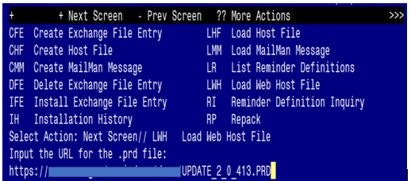

You should receive a message that the file was successfully loaded into your reminder exchange file.

Terminal window screen shot of the message displaying the URL of the file that was successfully loaded.  Part of the URL has been redacted as it is a VA only internal web site URL as shown in the text unless redacted for use outside of the VA.

Search and locate exchange file name UPDATE\_2\_0\_413 VA-ONCOLOGY CLOSE TO ME TEMPLATES

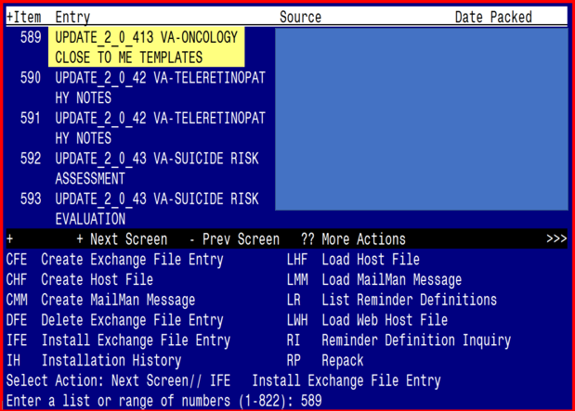

At the **Select Action** prompt, enter **IFE** for Install Exchange File Entry

Enter the number that corresponds with your entry titled UPDATE\_2\_0\_413 VA-ONCOLOGY CLOSE TO ME TEMPLATES

*(in this example it is entry 589, it will vary by site)* that is dated02/01/2024*.*

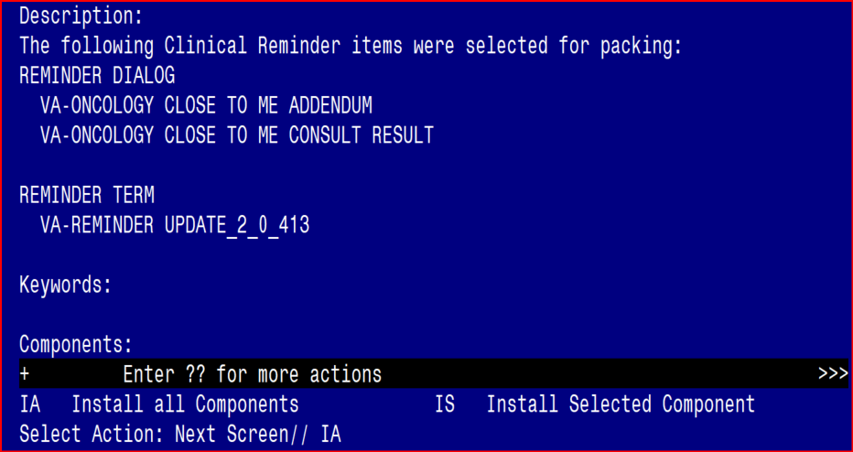

At the **Select Action** prompt, type **IA** for Install all Components and hit enter.

**For all new entries in any category, you will choose I to Install**

You will then be prompted to install the FIRST dialog component.

Regarding The VA_ONCOLOGY CLOSE TO ME RESULT (NATIONAL DIALOG):
Screen shot of the terminal window showing a list of elements, groups and dialogs with the text with IA for "Install All" entered at the "Select Action:" Prompt.  The correct entry is described in the text.

At the **Select Action** prompt, type **IA** to install the dialog: **VA-ONCOLOGY CLOSE TO ME CONSULT RESULT**

Select Action: Next Screen// IA Install All

Install reminder dialog and all components with no further changes: Y// Yes

Regarding The VA_ONCOLOGY CLOSE TO ME RESULT (NATIONAL DIALOG):
Screen shot of the last of the list of elements, groups and dialogs that needed to be installed with a Q for quit entered at the "Select Action:" prompt because they now all exist.  

After completing this dialog install, you will type Q.

You will then be prompted to install the NEXT dialog component.

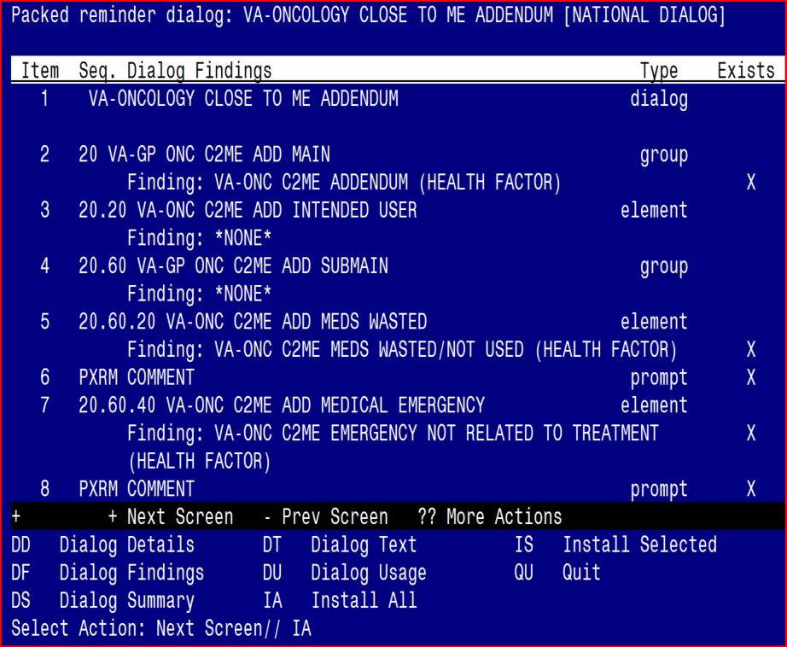

At the **Select Action** prompt, type **IA** to install the dialog: **VA-ONCOLOGY CLOSE TO ME ADDENDUM**

Select Action: Next Screen// IA Install All

Install reminder dialog and all components with no further changes: Y// Yes

Regarding The VA_ONCOLOGY CLOSE TO ME ADDENDUM (NATIONAL DIALOG):
Screen shot of the terminal window showing that after all of the groups, templates, elements, terms, components and dialogs required for this update have been installed, the reminder that was installed with Q entered for quit to finish. The name of the VA employee at the Source line label has been redacted.

After completing this dialog install, you will type Q.

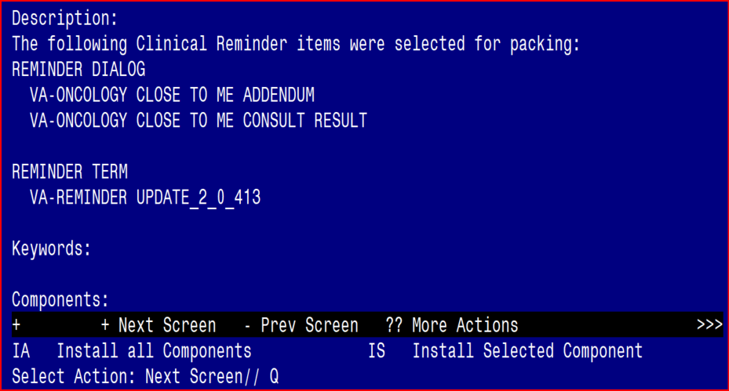

You will then be returned to this screen. At the **Select Action** prompt, type **Q.**

Install complete.

# Post Installation:

**Complete the following (not mandatory to complete if you are not a current or future Close to Me site):**

**Step 1:** Complete the Oncology Close to Me Consult Setup Technical Guide (separate attachment).

**Step 2:** Complete Update\_2\_0\_413 post installation steps below.

# National Oncology Close to Me Consult Result Note

1. **Create Note Titles:**

Document Definitions (Manager) à Create Document Definitions à Next Level à Progress Notes à Next Level à Enter document class where consults are located à Title.

Create the following note title:

**ONCOLOGY CLOSE TO ME CONSULT RESULT** (may leave out “RESULT” if that is not your sites naming convention)

VHA Enterprise Standard Title: **HEMATOLOGY AND ONCOLOGY** **CONSULT**

You can add these to your document class where consults are located.

**NOTE**: You will add this note to your consult document class.

1. **Make the Dialog template available to be attached to a Personal or Shared template and attach the dialog to a progress note title (LINK feature in this menu for steps 2 and 3).**

Select Reminder Managers Menu Option: **CP** CPRS Reminder Configuration

CA Add/Edit Reminder Categories

CL CPRS Lookup Categories

CS CPRS Cover Sheet Reminder List

MH Mental Health Dialogs Active

PN Progress Note Headers

RA Reminder GUI Resolution Active

TIU TIU Template Reminder Dialog Parameter

DEVL Evaluate Coversheet List on Dialog Finish

DL Default Outside Location

PT Position Reminder Text at Cursor

LINK Link Reminder Dialog to Template

TEST CPRS Coversheet Time Test

NP New Reminder Parameters

GEC GEC Status Check Active

WH WH Print Now Active

Select CPRS Reminder Configuration Option: **TIU** TIU Template Reminder Dialog Parameter

Reminder Dialogs allowed as Templates may be set for the following:

1 User USR [choose from NEW PERSON]

3 Service SRV [choose from SERVICE/SECTION]

4 Division DIV [SALT LAKE CITY]

5 System SYS [NATREM.FO-SLC.MED.VA.GOV]

Enter selection: **5** Choose *the appropriate number for your site. Your site may do this by System or other levels. The example below uses SYSTEM level.*

Setting Reminder Dialogs allowed as Templates for System: NATREM.FO-SLC.MED.VA.GOV

Select Display Sequence:

388 VA-COVID-19 TELEPHONE FOLLOW-UP

389 VA-SRA-CONSULT RESPONSE (D)

*When you type a question mark above, you will see the list of #’s (with dialogs) that are already taken. Choose a number* ***NOT*** *on this list. For this example, 391 is not present so I will use 391.*

Select Display Sequence: **391**

Are you adding 391 as a new Display Sequence? Yes// **YES**

Display Sequence: 391// <Enter> 391

Clinical Reminder Dialog: **VA-ONCOLOGY CLOSE TO ME CONSULT RESULT**

reminder dialog NATIONAL

...OK? Yes// <Enter> (Yes)

Select Display Sequence: **392**

Are you adding 392 as a new Display Sequence? Yes// **YES**

Display Sequence: 392// <Enter> 392

Clinical Reminder Dialog: **VA-ONCOLOGY CLOSE TO ME ADDENDUM**

reminder dialog NATIONAL

...OK? Yes// <Enter> (Yes)

1. **Associate the reminder dialogs with the note title in CPRS.**

In CPRS, open the Template Editor, expand Document Titles, select the appropriate folder (if applicable), then click New Template (top right-hand corner).

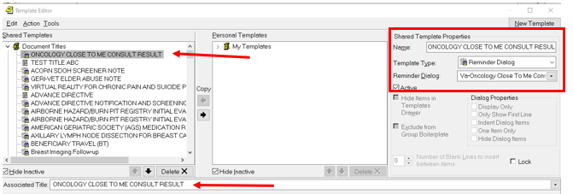

1. Type in the following information:

Name: **ONCOLOGY CLOSE TO ME CONSULT RESULT**

Template Type: **Reminder Dialog**

Reminder Dialog: **VA-ONCOLOGY CLOSE TO ME CONSULT RESULT**

Next, type in the Associated Title name:

**ONCOLOGY CLOSE TO ME CONSULT RESULT** - then click Apply.

1. **Place the Close to Me Addendum reminder dialog into the shared templates folder where you normally place oncology templates**

In Template Editor, expand Shared Templates, select the appropriate folder (if applicable), then click New Template (top right-hand corner).

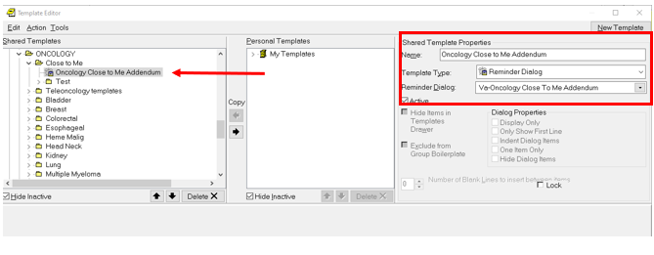

1. Type in the following information:

Name: **Oncology Close to Me Addendum (can be in all caps or mixed case per site preference)**

Template Type: **Reminder Dialog**

Reminder Dialog: **VA-ONCOLOGY CLOSE TO ME ADDENDUM**

then click Apply.

1. **Add Social Work Consult to the reminder dialog.**

Using the VistA menu Reminder Dialog Management (DM) à Reminder Dialogs (DI) à Change View (CV) à Dialog Elements (E) view.

**Locate and edit the reminder dialog element:**

VA-ONC C2ME CON PTI MODE OF TRANSPORT NO

\*\*\*Map your site’s social work consult quick order as the FINDING ITEM\*\*\*

1. If your site does not wish to have the RTC order populate from the template, edit this element and remove the additional finding.

NAME: VA-ONC C2ME CON PTI TX SCHEDULE AT CBOC

FINDING ITEM: VA-ONC C2ME REFER PATIENT FOR SCHEDULING CBOC

Additional findings:

Q SD RTC Finding # 1

Select ADDITIONAL FINDING: `1 SD RTC

Editing Finding Number: 1

ADDITIONAL FINDINGS: SD RTC// @

SURE YOU WANT TO DELETE THE ENTIRE ADDITIONAL FINDINGS? y (Yes)

DIALOG/PROGRESS NOTE TEXT:

