

**Update _2_0_52**

Clinical Reminders

VA-RELATIONSHIP HEALTH AND SAFETY ASSESSMENT NOTE

Install Guide

**March 2020**

Product Development

Office of Information Technology

Department of Veterans Affairs

Table of Contents

Introduction 1

Install Details 5

Install Example 5

Post Installation 8

# Introduction

**Description:**

The Relationship Health and Safety Assessment note template will serve as the recommended national template for the Intimate Partner Violence Coordinator or trained designee to complete the initial, trauma informed, psychosocial assessment of Veterans who screen positive or disclose experience of IPV in all clinics or settings. The use of this template is mandatory.

For questions on this dialog template contact: REDACTED

UPDATE_2_0_52 contains 1 Reminder Exchange entry:

**UPDATE_2_0_52 RELATIONSHIP HEALTH AND SAFETY ASSESSMENT NOTE**

**The exchange file contains the following components:**

**TIU TEMPLATE FIELD**

TEXT NO LIMIT

IPVAP NORMAL LIMITS

IPVAP INSIGHT CHOICES

IPVAP THOUGHT PROCESS CHOICES

IPVAP AFFECT CHOICES

IPVAP MOOD CHOICES

IPVAP BEHAVIOR CHOICES

TEXT (1-30 CHAR)

DATE

**HEALTH FACTORS**

VA-REMINDER UPDATES

VA-UPDATE_2_0_52

DOMESTIC/INTERPERSONAL VIOLENCE SCREEN

VA-IPVAP/A - DOES NOT CONSENT TO DOC

VA-IPVAP/A - CONSENTS TO DOCUMENT

VA-IPVAP/A - OTHER DISPOSITION

VA-IPVAP/A - DECLINED CONSULT

VA-IPVAP/A - DECLINED RESOURCES

VA-IPVAP/A - CONSULT PLACED SAME DAY

VA-IPVAP/A - CONSULT PLACED FUTURE

VA-IPVAP/A - PROVIDED CRISIS NUMBER

VA-IPVAP/A - PROVIDED NDV HOTLINE NUMBER

VA-IPVAP/A - PROVIDED IPVAPC CONTACT

VA-IPVAP/A - IPVAPC NOTIFIED

VA-IPVAP/A - TEAM NOTIFIED

VA-IPVAP/A - REFER INT OTH

VA-IPVAP/A - REFER INT USE

VA-IPVAP/A - REFER INT CHAP

VA-IPVAP/A - REFER INT MED

VA-IPVAP/A - REFER INT MH

VA-IPVAP/A - REFER INT HOMELESS

VA-IPVAP/A - REFER INT

VA-IPVAP/A - REFER EXT OTH

VA-IPVAP/A - REFER EXT THER

VA-IPVAP/A - REFER EXT ADVOCACY

VA-IPVAP/A - REFER EXT FIN

VA-IPVAP/A - REFER EXT LEGAL

VA-IPVAP/A - REFER EXT SHELTER

VA-IPVAP/A - REFER EXT

VA-IPVAP/A - EMERGENT NEEDS

VA-IPVAP/A - REPORT

VA-IPVAP/A - SAFETY PLANNING

VA-IPVAP/A - PRINT RESOURCES PROVIDED

VA-IPVAP/A - PRINT EDUCATION PROVIDED RF

VA-IPVAP/A - PRINT EDUCATION PROVIDED

VA-IPVAP/A - EDUCATION PROVIDED

VA-IPVAP/A - DOES NOT CONSENT TO ASSMT

VA-IPVAP/A - HEALTH NOTED

VA-IPVAP/A - HEALTH TBI

VA-IPVAP/A - HEALTH MST

VA-IPVAP/A - HEALTH SP

VA-IPVAP/A - RA PROG EXTERNAL

VA-IPVAP/A - RA PROG INTERNAL

VA-IPVAP/A - RA SOC INSUFF QUAN

VA-IPVAP/A - RA SOC INSUFF QUAL

VA-IPVAP/A - RA SOC INSUFF PROX

VA-IPVAP/A - RA SOC INSUFF ACC

VA-IPVAP/A - RA SOC INSUFF

VA-IPVAP/A - RA SOC SUFF

VA-IPVAP/A - RA TRANS INSUFF

VA-IPVAP/A - RA TRANS SUFF

VA-IPVAP/A - RA LEGAL HX

VA-IPVAP/A - RA LEGAL CUR

VA-IPVAP/A - RA LIVE CHANGE

VA-IPVAP/A - RA LIVE HOMELESS

VA-IPVAP/A - RA LIVE SHELTER

VA-IPVAP/A - RA LIVE SUPPORT

VA-IPVAP/A - RA LIVE OTH UNSTB

VA-IPVAP/A - RA LIVE OTH STB

VA-IPVAP/A - RA LIVE NAME

VA-IPVAP/A - RA LIVE CHILD

VA-IPVAP/A - RA LIVE PUV

VA-IPVAP/A - RA APPLYING

VA-IPVAP/A - RA SOURCE FAMILY

VA-IPVAP/A - RA SOURCE PARTNER

VA-IPVAP/A - RA SOURCE PUV

VA-IPVAP/A - RA SOURCE SAVE

VA-IPVAP/A - RA SOURCE SUPP

VA-IPVAP/A - RA SOURCE REL NONEMP

VA-IPVAP/A - RA SOURCE INCOME

VA-IPVAP/A - RA FIN CHANGE

VA-IPVAP/A - RA FIN INSUFF

VA-IPVAP/A - RA FIN SUFF

VA-IPVAP/A - RA RECENT UNEMP

VA-IPVAP/A - RA NOT EMP OTH

VA-IPVAP/A - RA NOT EMP IPV

VA-IPVAP/A - RA NOT EMP STU

VA-IPVAP/A - RA NOT EMP DIS

VA-IPVAP/A - RA NOT EMP RET

VA-IPVAP/A - RA NOT EMP

VA-IPVAP/A - RA EMP OCC

VA-IPVAP/A - RA EMP PT

VA-IPVAP/A - RA EMP FT

VA-IPVAP/A - RA EMP

VA-IPVAP/A - RA STU PT

VA-IPVAP/A - RA STU FT

VA-IPVAP/A - RA STU

VA-IPVAP/A - RA ED OTH

VA-IPVAP/A - RA ED DD

VA-IPVAP/A - RA ED MD

VA-IPVAP/A - RA ED BD

VA-IPVAP/A - RA ED AD

VA-IPVAP/A - RA ED HS

VA-IPVAP/A - RA ED LH HS

VA-IPVAP/A - RH PUV HX SERV

VA-IPVAP/A - RH PUV VET

VA-IPVAP/A - RH PUV SERV

VA-IPVAP/A - RH PUV CASUAL

VA-IPVAP/A - RH PUV FORMER

VA-IPVAP/A - RH PUV CURRENT

VA-IPVAP/A - RH SINGLE

VA-IPVAP/A - RH DATING

VA-IPVAP/A - RH NEVER MARRIED

VA-IPVAP/A - RH WIDOWED

VA-IPVAP/A - RH SEPARATED

VA-IPVAP/A - RH DIVORCED

VA-IPVAP/A - RH MARRIED

VA-IPVAP/A - FORM OTH CP

VA-IPVAP/A - FORM OTH PY

VA-IPVAP/A - FORM OTH

VA-IPVAP/A - FORM HAR CP

VA-IPVAP/A - FORM HAR PY

VA-IPVAP/A - FORM HAR

VA-IPVAP/A - FORM TEC CP

VA-IPVAP/A - FORM TEC PY

VA-IPVAP/A - FORM TEC

VA-IPVAP/A - FORM FIN CP

VA-IPVAP/A - FORM FIN PY

VA-IPVAP/A - FORM FIN

VA-IPVAP/A - FORM STA CP

VA-IPVAP/A - FORM STA PY

VA-IPVAP/A - FORM STA

VA-IPVAP/A - FORM THR CP

VA-IPVAP/A - FORM THR PY

VA-IPVAP/A - FORM THR

VA-IPVAP/A - FORM HEA OTH

VA-IPVAP/A - FORM HEA REP

VA-IPVAP/A - FORM HEA MH

VA-IPVAP/A - FORM HEA SU

VA-IPVAP/A - FORM HEA CP

VA-IPVAP/A - FORM HEA PY

VA-IPVAP/A - FORM HEA

VA-IPVAP/A - FORM ISO CP

VA-IPVAP/A - FORM ISO PY

VA-IPVAP/A - FORM ISO

VA-IPVAP/A - FORM VER CP

VA-IPVAP/A - FORM VER PY

VA-IPVAP/A - FORM VER

VA-IPVAP/A - FORM SEX CP

VA-IPVAP/A - FORM SEX PY

VA-IPVAP/A - FORM SEX

VA-IPVAP/A - FORM PHY CP

VA-IPVAP/A - FORM PHY PY

VA-IPVAP/A - FORM PHY

VA-IPVAP/A - INCR DA SCORE

VA-IPVAP/A - INCR NO WEAP

VA-IPVAP/A - INCR YES WEAP

VA-IPVAP/A - INCR NO PREG

VA-IPVAP/A - INCR YES PREG

VA-IPVAP/A - INCR NO CONS

VA-IPVAP/A - INCR YES CONS

VA-IPVAP/A - INCR NO FREQ

VA-IPVAP/A - INCR YES FREQ

VA-IPVAP/A - INCR POS SEC

VA-IPVAP/A - FORM ALL

VA-IPVAP/A - HX IPV

VA-IPVAP/A - REF BY WHO

VA-IPVAP/A - REF BY SCREEN

VA-IPVAP/A - CONSENTS TO ASSMT

VA-IPVAP/A - SCREEN NOT DONE

VA-IPVAP/A - SCREEN NOT DUE

VA-IPVAP/A - SCREEN DONE

VA-IPVAP/A - ND OTHER REASON

VA-IPVAP/A - ND CHILD>2 Y/O PRESENT

VA-IPVAP/A - ND OTHER ADULT PRESENT

VA-IPVAP/A - ASSMT NOT DONE

**REMINDER SPONSOR**

SOCIAL WORK/CASE MANAGEMENT – INTIMATE PARTNER VIOLENCE ASSISTANCE PROGRAM

**REMINDER TERM**

VA-REMINDER UPDATE_2_0_52

**REMINDER DIALOG**

VA-RELATIONSHIP HEALTH AND SAFETY ASSESSMENT

# Install Details

This update is being distributed as a web host file. The address for the host file is: **http://REDACTED /UPDATE_2_0_52.PRD**

The file will be installed using Reminder Exchange, programmer access is not required.

Installation:

=============

This update can be loaded with users on the system. Installation will take less than 30 minutes.

# Install Example

To Load the Web Host File. Navigate to Reminder exchange in Vista

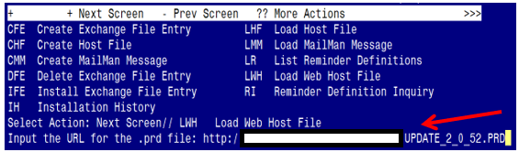

At the **Select Action:** prompt, enter **LWH** for Load Web Host File

At the **Input the url for the .prd file:** prompt, type the following web address:

**http://REDACTED/UPDATE_2_0_52.PRD**

Terminal window screen shot of the message displaying the URL of the file that was successfully loaded.  Part of the URL has been redacted as it is a VA only internal web site URL.

You should see a message at the top of your screen that the file successfully loaded.

Search and locate an entry titled **UPDATE_2_0_52 VA-RELATIONSHIP HEALTH AND SAFETY ASSESSMENT NOTE** in reminder exchange.

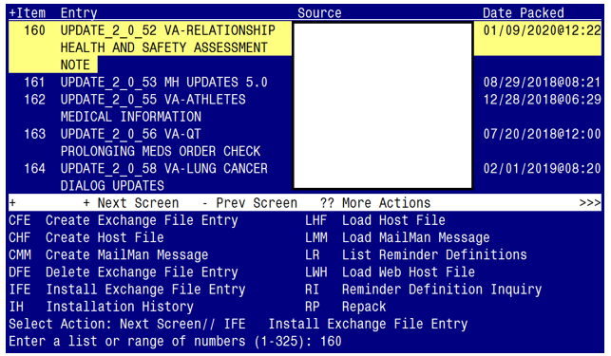

At the **Select Action** prompt, enter **IFE** for Install Exchange File Entry

Enter the number that corresponds with your entry titled **UPDATE_2_0_52 VA-****RELATIONSHIP HEALTH AND SAFETY ASSESSMENT NOTE**

*(in this example it is entry 160 it will vary by site)*

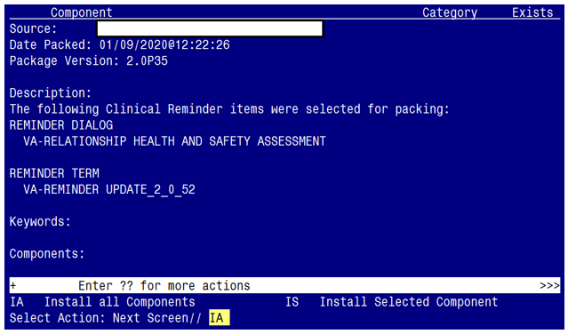

At the **Select Action** prompt, type **IA** for Install all Components and hit enter.

Select Action: Next Screen// IA Install all Components

You will see several prompts, for all new entries you will choose **I to Install**

**You will be promped to install the reminder dialog component:**

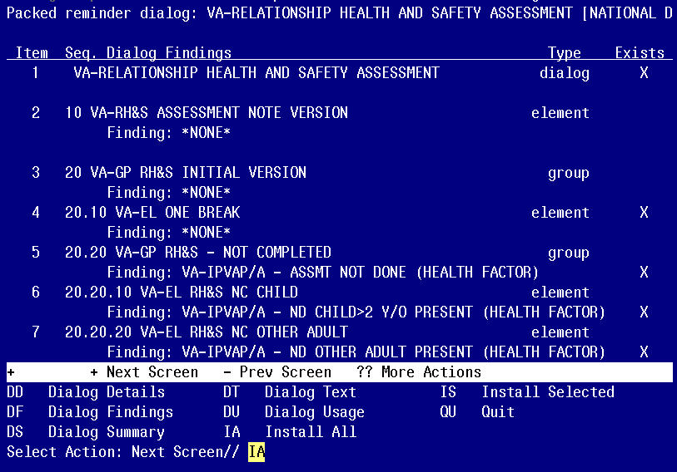

At the **Select Action** prompt, type **IA** to install the dialog –

**VA-RELATIONSHIP HEALTH AND SAFETY ASSESSMENT**

Select Action: Next Screen// IA Install All

Install reminder dialog and all components with no further changes: Y// Yes

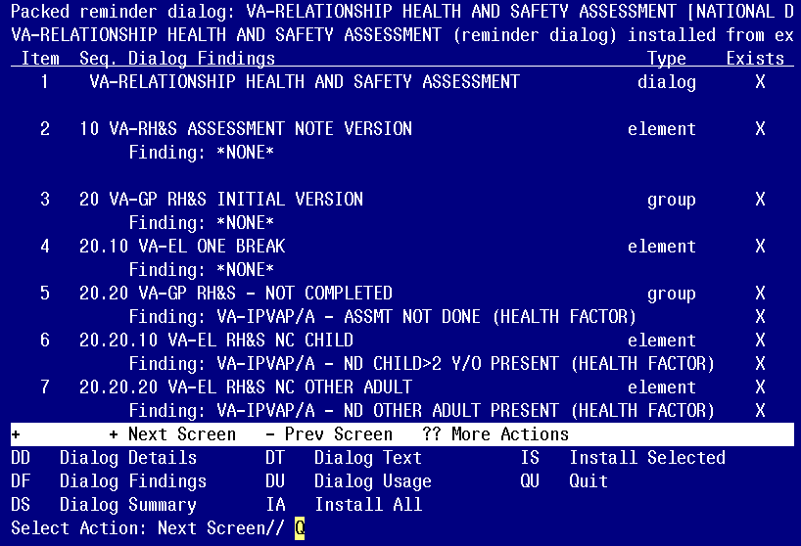

When the dialog has completed installation, you will then be returned to this screen. At the **Select Action** prompt, type **Q.**

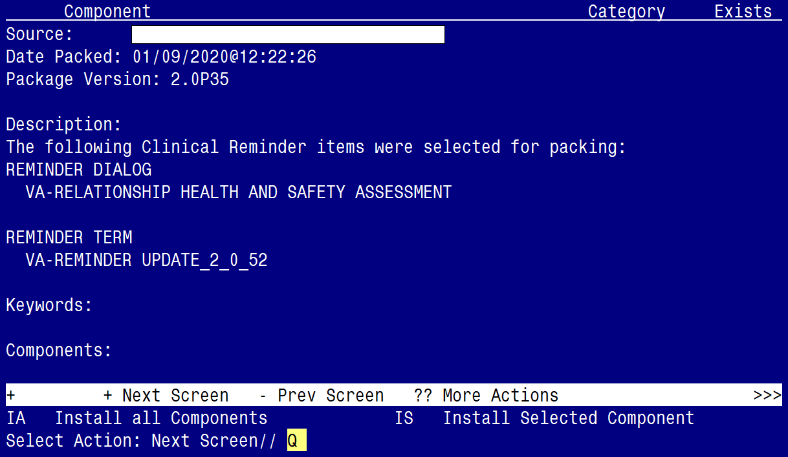

When the dialog has completed installation, you will then be returned to this screen. At the **Select Action** prompt, type **Q.**

Install complete.

# Post Installation

1. **Make the Dialog able to be attached to a Personal/Shared template or to a progress note title.**

From the Reminders Manager Menu:

Select Reminder Managers Menu Option: **CP** CPRS Reminder Configuration

CA Add/Edit Reminder Categories

CL CPRS Lookup Categories

CS CPRS Cover Sheet Reminder List

MH Mental Health Dialogs Active

PN Progress Note Headers

RA Reminder GUI Resolution Active

TIU TIU Template Reminder Dialog Parameter

DL Default Outside Location

PT Position Reminder Text at Cursor

Select CPRS Reminder Configuration Option: **TIU** TIU Template Reminder Dialog Parameter

Reminder Dialogs allowed as Templates may be set for the following:

1 User USR [choose from NEW PERSON]

3 Service SRV [choose from SERVICE/SECTION]

4 Division DIV [choose from INSTITUTION]

5 System SYS [NATREM.FO-SLC.MED.VA.GOV]

Enter selection*:* 5  *Choose the appropriate number for your site. Your site may do this by System or other levels. The example below uses SYSTEM level*

Setting Reminder Dialogs allowed as Templates for System:

Select Display Sequence: **?**

148 VA-VETERANS CHOICE NOTE

149 VA-TBI SCREENING

*When you type a question mark above, you will see the list of #’s (with dialogs) that are already taken. Choose a number* ***NOT*** *on this list. For this example, looking above I see the number 150 is not present, so I will use 150.*

Select Display Sequence: **150**

Are you adding 150 as a new Display Sequence? Yes// **Y** YES

Display Sequence: 150// <Enter> 150

Clinical Reminder Dialog**: VA-RELATIONSHIP HEALTH AND SAFETY ASSESSMENT**

then **<enter>**

OK? Yes// <Enter> (Yes)

1. **Setup of Note title**

The RELATIONSHIP HEALTH AND SAFETY ASSESSMENT NOTE title should be created to be used with this reminder dialog template.

Name: RELATIONSHIP HEALTH AND SAFETY ASSESSMENT NOTE

VHA Enterprise Standard Title: RISK ASSESSMENT SCREENING NOTE

Comprehensive information on Creating Document Definitions can be found beginning   
on page 47 of the [TIU/ASU Implementation Guide](http://www.va.gov/vdl/documents/Clinical/CPRS-Text_Integration_Utility_(TIU)/tiuim.pdf).

1. **Add the reminder dialog template as a stand-alone shared template**

* Open Template Editor
* Click ‘triangle’ to left of Shared Templates to expand
* Select the folder(s) that the reminder dialog template should be located

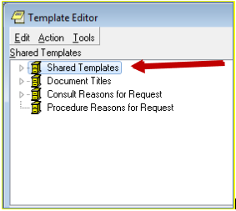

* + Click New Template button
  + Type VA-RELATIONSHIP HEALTH AND SAFETY ASSESSMENT in the Name box
  + Click down arrow and Click on Reminder Dialog in Template Type Box
  + Type VA-RELATIONSHIP HEALTH AND SAFETY ASSESSMENT in Reminder Dialog box
  + Click Apply

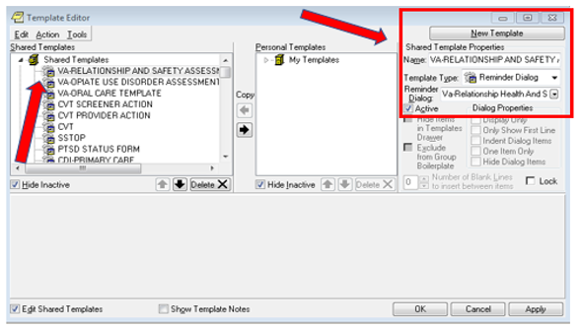

Test the shared template in CPRS to verify that the template opens when selected

1. **Associate the reminder dialog with the note title**

* Open Template Editor
* Click ‘triangle’ to left of Document Titles to expand

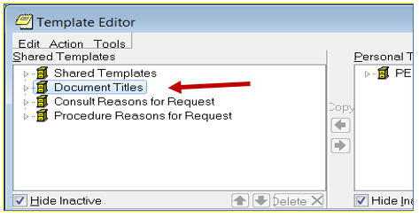

* Click New Template button
* Type VA-RELATIONSHIP HEALTH AND SAFETY ASSESSMENT in the Name box
* Click down arrow and Click on Reminder Dialog in Template Type Box
* Type VA-RELATIONSHIP HEALTH AND SAFETY ASSESSMENT in Reminder Dialog box
* Type RELATIONSHIP HEALTH AND SAFETY ASSESSMENT NOTE in Associated Title Box
* Click Apply

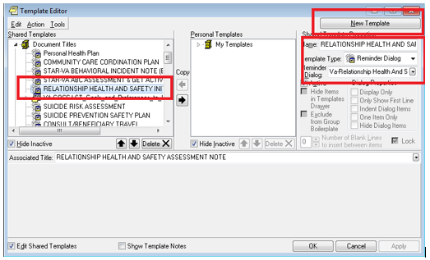

Test the progress note title in CPRS to see new template is attached.

1. **Add consults to two elements**

Element: VA-EL RH&S - NON-EMERGENT CONSULT

FINDING ITEM: Q.<<add consult name here>>

(your site’s consult name would be similar to “Relationship Health and Safety Outpatient”)

Element: VA-EL RH&S - URGENT CONSULT

FINDING ITEM: Q.<<add consult name here>>

(your site’s consult name would be similar to “Relationship Health and Safety E-Consult”)

(refer to the contacts in the introduction above for any questions about these consults)