

**Update _2_0_54**

Clinical Reminders

TERATOGENIC MEDICATIONS UPDATE 4

Install Guide

**July 2018**

Product Development

Office of Information Technology

Department of Veterans Affairs

Table of Contents

Introduction 1

Install Details 1

Installation: 2

Install Example 2

Post-Install Set-up Instructions 7

# Introduction

UPDATE_2_0_54 contains 1 Reminder Exchange entry: **UPDATE_2_0_54 VA-TERATOGENIC MEDICATIONS ORDER CHECKS (Update#4)**

The Teratogenic Medications Order Check Interim Solution was originally released as VistA patch PXRM*2*22 in July 2012. The interim solution is intended to have regular updates for clinical content, primarily to add newly approved medications that have a noted risk during pregnancy and that warrant an order check. This update, UPDATE_2_0_54 represents the fourth such update. This update adds dolutegravir and dolutegravir-containing medications to the ‘Known or Potential Teratogen (EXTREME Risk-to-Benefit Ratio)’ order check in support of the FDA’s announcement and based upon a National PBM Bulletin dated May 31 2018.

# Install Details

This update is being distributed as a web host file. The address for the host file is: **https://REDACTED/UPDATE_2_0_54.PRD**

The following reminder content is included in this UPDATE:

**REMINDER DEFINITION**

VA-TERATOGENIC MEDICATIONS ORDER CHECK

**REMINDER TERM**

VA-WH TUBAL REANASTOMOSIS (TERM)

VA-WH TUBAL LIGATION CODES (TERM)

VA-TERATOGENIC MEDICATIONS ORDER CHECK EXCLUSIONS(TERM)

VA-REMINDER UPDATE_2_0_54

**REMINDER TAXONOMY**

VA-WH TUBAL REANASTOMOSIS (TAXONOMY)

VA-WH TUBAL LIGATION CODES (TAXONOMY)

VA-TERATOGENIC MEDICATIONS ORDER CHECK EXCL (TAXONOMIES)

VA-WH HYSTERECTOMY W/CERVIX REMOVED

**HEALTH FACTORS**

WH PAP SMEAR

WH HYSTERECTOMY W/CERVIX REMOVED

VA-REMINDER UPDATES

VA-UPDATE_2_0_54

**REMINDER SPONSOR**

VHA National Center for Health Promotion and Disease Prevention (NCP) and VHA Office of Women's Health

**REMINDER ORDER CHECK ITEMS GROUP**

VA-TERATOGENIC MEDICATIONS (CAT X) GROUP

**REMINDER ORDER CHECK RULES**

VA-TERATOGENIC MEDICATIONS ORDER CHECK (CAT X)RULE

The file will be installed using Reminder Exchange, programmer access is not required.

# Installation:

This update can be loaded with users on the system. Installation

will take less than five minutes.

# Install Example

To Load the Web Host File. Navigate to Reminder exchange in Vista

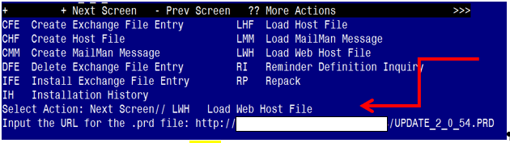

At the **Select Action:** prompt, enter **LWH** for Load Web Host File

At the **Input the url for the .prd file:** prompt, type the following web address:

**https://REDACTED /UPDATE_2_0_54.PRD**

**Terminal window screen shot of the message displaying the URL of the file that was successfully loaded.  Part of the URL has been redacted as it is a VA only internal web site URL.**

You should see a message at the top of your screen that the file successfully loaded.

Navigate to the exchange entry named UPDATE_2_0_54 VA-TERATOGENIC MEDICATIONS ORDER CHECKS(UPDATE #4)

At the **Select Action** prompt, enter **IFE** for Install Exchange File Entry

Enter the number that corresponds with your entry **UPDATE_2_0_54 VA-TERATOGENIC MEDICATIONS ORDER CHECKS(UPDATE #4)**  *(in this example it is entry 371, it will vary by site)*

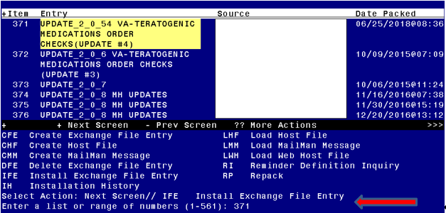

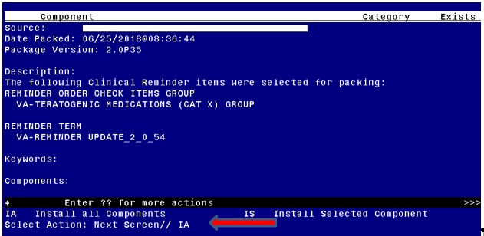

At the **Select Action** prompt, type **IA** for Install all Components and hit enter.

The following is a listing of the prompts you will see when installing the entry

If you are prompted that a component exists but is different, you will use the SKIP action **EXCEPT** for entry:

VA-TERATOGENIC MEDICATIONS (CAT X) GROUP and

This entry will use the UPDATE action

HEALTH FACTORS entry named WH PAP SMEAR already exists and the packed

component is identical, skipping.

HEALTH FACTORS entry named WH HYSTERECTOMY W/CERVIX REMOVED already

exists and the packed component is identical, skipping.

already

HEALTH FACTORS entry VA-REMINDER UPDATES already exists and the packed component is identical, skipping.

HEALTH FACTORS entry VA-UPDATE_2_0_54 is NEW,

what do you want to do?

Select one of the following:

C Create a new entry by copying to a new name

I Install

Q Quit the install

S Skip, do not install this entry

Enter response: I// nstall

REMINDER SPONSOR entry named VHA National Center for Health Promotion

and Disease Prevention (NCP) and VHA Office of Women's Health already

exists and the packed component is identical, skipping.

REMINDER TAXONOMY entry named VA-WH TUBAL REANASTOMOSIS (TAXONOMY) already exists but the packed component is different, what do you

want to do?

Select one of the following:

C Create a new entry by copying to a new name

O Overwrite the current entry

U Update

Q Quit the install

S Skip, do not install this entry

Enter response: O// Skip, do not install this entry

REMINDER TAXONOMY entry named VA-WH TUBAL LIGATION CODES (TAXONOMY)already exists but the packed component is different, what do you

want to do?

Select one of the following:

C Create a new entry by copying to a new name

O Overwrite the current entry

U Update

Q Quit the install

S Skip, do not install this entry

Enter response: O// Skip, do not install this entry

Are you sure you want to overwrite? N// YES

REMINDER TAXONOMY entry named VA-TERATOGENIC MEDICATIONS ORDER CHECK EXCL (TAXONOMIES) already exists but the packed component is

different, what do you want to do?

Select one of the following:

C Create a new entry by copying to a new name

O Overwrite the current entry

U Update

Q Quit the install

S Skip, do not install this entry

Enter response: O// Skip, do not install this entry

Are you sure you want to overwrite? N// YES

REMINDER TAXONOMY entry named VA-WH HYSTERECTOMY W/CERVIX REMOVED

already exists but the packed component is different, what do you

want to do?

Select one of the following:

C Create a new entry by copying to a new name

O Overwrite the current entry

U Update

Q Quit the install

S Skip, do not install this entry

Enter response: O// Skip, do not install this entry

REMINDER TERM entry named VA-WH TUBAL REANASTOMOSIS (TERM) already

exists and the packed component is identical, skipping.

REMINDER TERM entry named VA-WH TUBAL LIGATION CODES (TERM) already

exists and the packed component is identical, skipping.

REMINDER TERM entry named VA-TERATOGENIC MEDICATIONS ORDER CHECK

EXCLUSIONS (TERM) already exists and the packed component is

identical, skipping.

REMINDER TERM entry VA-REMINDER UPDATE_2_0_54 is NEW,

what do you want to do?

Select one of the following:

C Create a new entry by copying to a new name

I Install

Q Quit the install

S Skip, do not install this entry

Enter response: I// nstall

REMINDER DEFINITION entry named VA-TERATOGENIC MEDICATIONS ORDER

CHECK already exists and the packed component is identical, skipping.

REMINDER ORDER CHECK RULES entry named VA-TERATOGENIC MEDICATIONS

ORDER CHECK (CAT X) RULE already exists but the packed component is

different, what do you want to do?

Select one of the following:

C Create a new entry by copying to a new name

O Overwrite the current entry

U Update

Q Quit the install

S Skip, do not install this entry

Enter response: O// Skip, do not install this entry

**REMINDER ORDER CHECK ITEMS GROUP** entry named VA-TERATOGENIC

MEDICATIONS (CAT X) GROUP already exists but the packed component is

different, what do you want to do?

Select one of the following:

C Create a new entry by copying to a new name

O Overwrite the current entry

**U Update**

Q Quit the install

S Skip, do not install this entry

Enter response: O// UPDATE

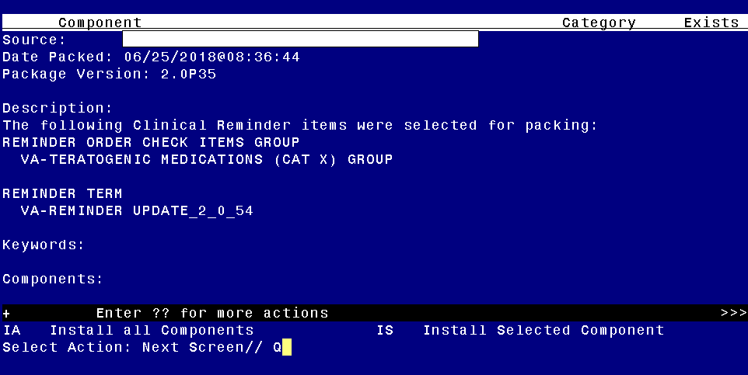

You will then be returned to this screen. At the **Select Action** prompt, type **Q.**

Install Complete

# Post-Install Set-up Instructions

## *Activate the Reminder Order Check Rules*

The installation of CLINICAL REMINDER UPDATE_2_0_54 will require the STATUS of the Reminder Order Check Rule “VA-TERATOGENIC MEDICATIONS ORDER CHECK (CAT X) RULE” be changed to PROD.   Shown below are the steps to make this change if yours does not show that PROD status.

The option represented here is **Add/Edit Reminder Order Check Rule [PXRM ORDER CHECK RULE EDIT].**

Select Reminder Order Check Menu Option: **RE**  Add/Edit Reminder Order Check Rule

Select Reminder Order Check Rule by:  (N/R/T/Q): N// **N**  ORDER CHECK RULE NAME

Select Reminder Order Check Rule: VA-TERATOGENIC MEDICATIONS ORDER CHECK (CAT X) RULE

RULE NAME: **VA-TERATOGENIC MEDICATIONS ORDER CHECK (CAT X) RULE**

DISPLAY NAME: **Known or Potential Teratogen (EXTREME Risk-to-Benefit Ratio)**

STATUS: **PROD**

**^ *change to PROD to activate Production Mode instead of Testing Mode***

CLASS: **NATIONAL**

SPONSOR:

REVIEW DATE:

______________________________________________________________________________

______________________________________________________________________________

I=INACTIVE, P=PRODUCTION, T=TESTING

Enter a command or '^' followed by a caption to jump to a specific field.

*NOTE: If you require further technical assistance, if there are any questions or problems during the installation, please notify your local IT support to log a national help desk ticket or contact the VA Service Desk and have them submit a national ticket to:*

*Category: Enterprise Applications*

*Subcategory: Applications*

*Enterprise Application: VistA - Clinical Reminders*