

**Update_2_0_88**

Clinical Reminders

VA-Opioid Use Disorder Buprenorphine Initiation

Install Guide

**January 2020**

Product Development

Office of Information Technology

Department of Veterans Affairs

Table of Contents

Introduction 1

Install Details 3

Install Example 3

Post Installation 7

# Introduction

The dramatic rise in opioid prescribing has been accompanied by parallel increases in nonmedical opioid use, overdose deaths, opioid use disorders (OUD) and treatment initiations for OUD.  One initiative to address this problem in the Veteran Affairs (VA) healthcare system is the Stepped Care for Opioid Use Disorder (OUD) Train-the-Trainer (SCOUTT) initiative, which aims to improve access to OUD treatment across primary care, pain management, mental health, and other health care settings.  This template is part of the national roll-out of SCOUTT and is designed to guide and support documentation of the initial prescription of buprenorphine for OUD.  It is the second of three templates that will be released: OUD assessment, buprenorphine initiation and buprenorphine follow up.

**UPDATE_2_0_88 contains 1 Reminder Exchange entry:**

UPDATE_2_0_88 VA-MH OUD BUPRENORPHINE INITIATION TEMPLATE

**The exchange file contains the following components:**

**TIU TEMPLATE FIELD**

BLANK SPACE1

VA-MH OUD OTHER NO INDENT

VA-MH SAMHSA TIP 63 URL

VA-MH OUD PROVIDER GUIDE BUPE HOME

VA-MH OUD EXAM PSYCH TEXT

WP-2LINES

VA-MH OUD EXAM DERM TEXT

VA-MH OUD EXAM MSK TEXT

VA-MH OUD EXAM GI TEXT

VA-MH OUD EXAM RESP TEXT

VA-MH OUD EXAM CV TEXT

VA-MH OUD EXAM HEENT TEXT

GEN WORD PROC NARROW

MH OUD STORM REPORT

VA-MH OUD IMED CONSENT BUPE ED

VA-MH OUD MAT

VA-MH OUD HANDOUT BUPE CLINIC

VA-MH OUD HANDOUT BUPE HOME

WP 3/70

WP FREE TEXT

VA-MH FILM/TAB

VA-MH OUD MEDS MAX MG

VA-MH OUD HOURS

VA-MH OUD MED DOSE 1/2 1

VA-MH OUD MED DOSE 1-2

COMMENT 35

COMMENT 15

COMMENT 10

WP 1 LINE

YES/NO

00 EDIT BOX 70X5

WP 2 LINE1

VA-MH ADDITIONAL INFORMATION

GEN TEXT BOX 50

VA-MH DOCUMENT NEXT STEPS

TEXT (1-60 CHAR)

VA-MH OUD OTHER

VA-MH EMPLOYMENT HX2

VA-MH HOUSING SITUATION

VA-MH RELATIONSHIP HX

VA-MH DIAGNOSIS HX

VA-MH OUD SPECIFY TEXT

VA-MH OUD FREQUENCY TEXT3

VA-MH OUD FREQUENCY TEXT1

VA-MH OUD FREQUENCY TEXT2

VA-MH OUD MILD MOD SEVERE

00 EDIT BOX 12

**HEALTH FACTORS**

VA-REMINDER UPDATES

VA-UPDATE_2_0_88

VA-MH OUD TEMPLATES

VA-MH OUD BUPE INITIATION UDAS ORDERED

VA-NALOXONE

VA-PATIENT DECLINED NALOXONE

VA-MH OUD BUPE INITIATION INPATIENT

VA-MH OUD BUPE INITIATION OFFICE EDUCATE

VA-MH OUD BUPE INITIATION OBSERVE

VA-MH OUD BUPE INITIATION HOME EDUCATE

VA-MH OUD BUPE INITIATION HOME

VA-MH OUD BUPE INITIATION TEMPLATE

VA-MH OUD ASSESS TREATMENT ACCEPTED

VA-MH OUD ASSESS TREATMENT OFFERED

VA-MH OUD ASSESS MEETS CRITERIA

VA-MH OUD ASSESS DOES NOT MEET CRITERIA

VA-MH OUD ASSESS DSM 5-2 REDUCE USE

VA-MH OUD ASSESS DSM 5-11 WITHDRAWAL

VA-MH OUD ASSESS DSM 5-10 TOLERANCE

VA-MH OUD ASSESS DSM 5-9 PHYSICAL PROB

VA-MH OUD ASSESS DSM 5-8 HAZARDOUS

VA-MH OUD ASSESS DSM 5-7 ACTIVITIES

VA-MH OUD ASSESS DSM 5-6 SOCIAL PROBLEMS

VA-MH OUD ASSESS DSM 5-5 FAILURE

VA-MH OUD ASSESS DSM 5-4 CRAVING

VA-MH OUD ASSESS DSM 5-3 OBTAIN OPIOIDS

VA-MH OUD ASSESS DSM 5-1 LARGER AMOUNT

**REMINDER SPONSOR**

Mental Health Services

Office of Mental Health Services

**REMINDER TERM**

VA-REMINDER UPDATE_2_0_88

**REMINDER DIALOG**

VA-MH OUD BUPRENORPHINE INITIATION TEMPLATE

**HEALTH SUMMARY TYPE**

VA-BUPRENORPHINE INDUCTION LAB

OB AUDC

**HEALTH SUMMARY OBJECTS**

VA-BUPRENORPHINE INDUCTION LAB REVIEW (TIU)

AUDC (TIU)

**TIU DOCUMENT DEFINITION**

VA-BUPRENORPHINE INITIATION LAB REVIEW (TIU)

AUDIT-C

# Install Details

This update is being distributed as a web host file. The address for the host file is: **http://vista.med.va.gov/reminders/UPDATE_2_0_88.PRD**

The file will be installed using Reminder Exchange, programmer access is not required.

Installation:

=============

This update can be loaded with users on the system. Installation will take less than 20 minutes.

# Install Example

If your site is unable to use LWH functionality, you will use vista mail to install the exchange file. The subject of the email will be UPDATE_2_0_88. You will see a message similar to this one.

Screen shot showing MailManmesage 131677 successfully loaded.  The the message would be similar to this.

To Load the Web Host File. Navigate to Reminder exchange in VistA

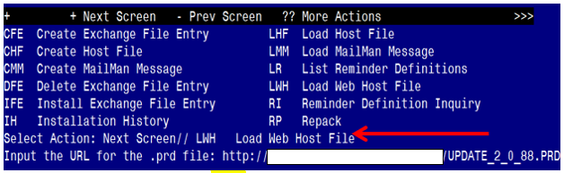

At the **Select Action:** prompt, enter **LWH** for Load Web Host File

At the **Input the url for the .prd file:** prompt, type the following web address:

**http://vista.med.va.gov/reminders/UPDATE_2_0_88.PRD**

You should see a message at the top of your screen that the file successfully loaded.

Search and locate an entry titled **UPDATE_2_0_88 VA-MH OUD BUPRENORPHINE INITIATION TEMPLATE** in reminder exchange

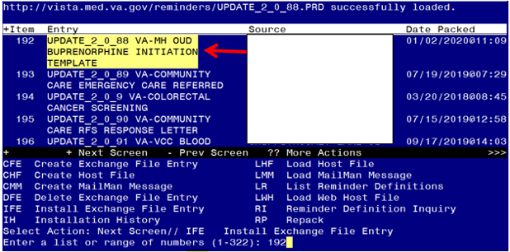

At the **Select Action** prompt, enter **IFE** for Install Exchange File Entry

Enter the number that corresponds with your entry titled **UPDATE_2_0_88 VA-MH OUD BUPRENORPHINE INITIATION TEMPLATE** *(in this example it is entry 192, it will vary by site). Make sure the date of the exchange file is* 01/02/2020@11:09:17

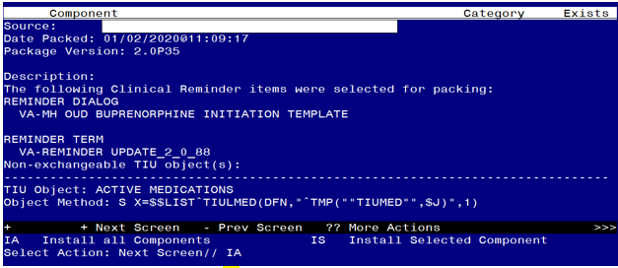

At the **Select Action** prompt, type **IA** for Install all Components and hit enter.

Select Action: Next Screen// IA Install all Components

During the installation, you will see several prompts: *Note that you will Install all new components*

**You will be promped to install the dialog component:**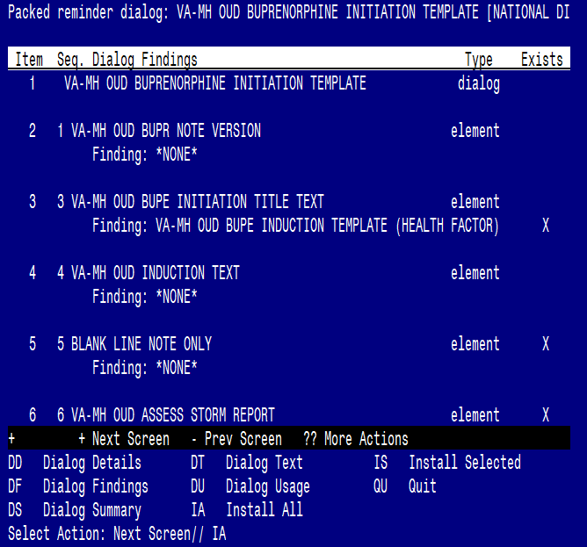

At the **Select Action** prompt, type **IA** to install the dialog – **VA-MH OUD BUPRENORPHINE INITIATION TEMPLATE**

Select Action: Next Screen// IA Install All

Install reminder dialog and all components with no further changes: Y// ES

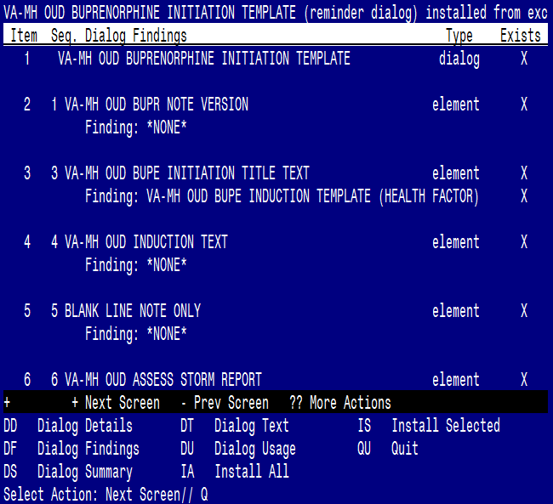

When the dialog has completed installation, you will then be returned to this screen. At the **Select Action** prompt, type **Q.**

You will then be prompted to install the remaining components:

HEALTH SUMMARY TYPE entry VA-BUPRENORPHINE INITIATION LAB is NEW,

what do you want to do?

Select one of the following:

C Create a new entry by copying to a new name

I Install

Q Quit the install

S Skip, do not install this entry

Enter response: I// nstall

HEALTH SUMMARY TYPE entry named OB AUDC already exists but the packed

component is different, what do you want to do?

Select one of the following:

C Create a new entry by copying to a new name

O Overwrite the current entry

U Update

Q Quit the install

S Skip, do not install this entry

Enter response: O// Skip, do not install this entry

HEALTH SUMMARY OBJECTS entry VA-BUPRENORPHINE INDUCTION LAB REVIEW (TIU) is NEW,what do you want to do?

Select one of the following:

C Create a new entry by copying to a new name

I Install

Q Quit the install

S Skip, do not install this entry

Enter response: I// nstall.

TIU DOCUMENT DEFINITION entry VA-BUPRENORPHINE INITIATION LAB REVIEW is NEW,

what do you want to do?

Select one of the following:

C Create a new entry by copying to a new name

I Install

Q Quit the install

S Skip, do not install this entry

Enter response: I// nstall.

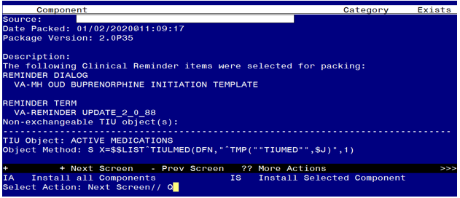

You will be returned to this screen. Type Q to quit.

Install Completed

# Post Installation

1. **Make the Dialog templates available to be attached to a Personal or Shared template or to be able to attach the dialog to a progress note title.**

From the Reminders Manager Menu:

Select Reminder Managers Menu Option: **CP** CPRS Reminder Configuration

CA Add/Edit Reminder Categories

CL CPRS Lookup Categories

CS CPRS Cover Sheet Reminder List

MH Mental Health Dialogs Active

PN Progress Note Headers

RA Reminder GUI Resolution Active

TIU TIU Template Reminder Dialog Parameter

DL Default Outside Location

PT Position Reminder Text at Cursor

Select CPRS Reminder Configuration Option: **TIU** TIU Template Reminder Dialog

Parameter

Reminder Dialogs allowed as Templates may be set for the following:

1 User USR [choose from NEW PERSON]

3 Service SRV [choose from SERVICE/SECTION]

4 Division DIV [choose from INSTITUTION]

5 System SYS [NATREM.FO-SLC.MED.VA.GOV]

Enter selection*:* **5**  *Choose the appropriate number for your site. Your site may do*

*this by System or other levels. The example below uses SYSTEM level*

Setting Reminder Dialogs allowed as Templates for System:

Select Display Sequence: **?**

148 VA-VETERANS CHOICE NOTE

149 VA-TBI SCREENING

151 VACO TRANSPLANT REFERRAL (D)

*When you type a question mark above, you will see the list of #’s (with dialogs) that*

*are already taken. Choose a number* ***NOT*** *on this list. For this example, looking*

*above I see the number 150 is not present, so I will use 150.*

Select Display Sequence: **150**

Are you adding 150 as a new Display Sequence? Yes// **Y** YES

Display Sequence: 150// <Enter>

Clinical Reminder Dialog**: VA-MH OUD BUPRENOPRHINE INITIATION TEMPLATE**<Enter>

OK? Yes// <Enter> (Yes)

1. **Setup of Note title**

The new note title that needs to be created is:

**OPIOID USE DISORDER BUPRENORPHINE INITIATION**

This note title is to be mapped to the following VHA Enterprise Standard Title:**MENTAL HEALTH NOTE**

Comprehensive information on Creating Document Definitions can be found beginning on page 47 of the [TIU/ASU Implementation Guide](http://www.va.gov/vdl/documents/Clinical/CPRS-Text_Integration_Utility_(TIU)/tiuim.pdf)

Your site can also set up the template in your shared template folder.  Staff may access the template either through the note title or the shared template folder.

**3a. Associate the reminder dialog with the note title in CPRS**

To do this, go to Template Editor, then Document Titles, select the appropriate folder (if applicable), and choose New Template (top right-hand corner).

Type in the following information:

Name: **OPIOID USE DISORDER BUPRENORPHINE INITIATION**

Template Type: Reminder Dialog

Reminder Dialog: VA-MH OUD BUPRENORPHINE INITIATION TEMPLATE

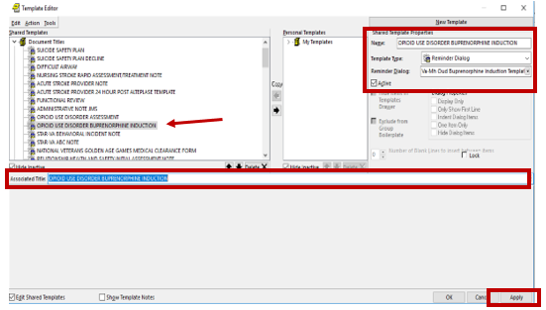

Next, type in the Associated Title, which in this case is OPIOID USE DISORDER BUPRENORPHINE INITIATION and hit Apply.

**3b. Add the dialog to a shared template in CPRS.**

To do this, go to Template Editor, then Shared Templates, select the appropriate folder (if applicable), and choose New Template (top right-hand corner).

Type in the following information:

Name: **OPIOID USE DISORDER** BUPRENORPHINE INITIATION

Template Type: Reminder Dialog

Reminder Dialog: VA-MH OUD BUPRENORPHINE INITIATION TEMPLATE

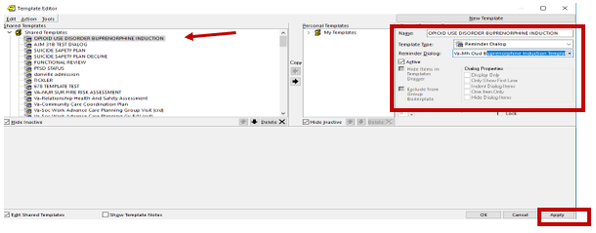

Hit Apply.

1. Add your local PDMP hyperlink txml field

Using the menu Reminder Dialog Management, Reminder Dialogs, change your view to Elements. Search for and edit the following element. VAL-MH OUD PDMP LINK. Insert your local existing txml template field.

If one does not exist, you will need to create a txml template field hyperlink to your state’s PDMP (prescription drug monitoring program) website. Look up your state’s PDMP website [here](http://www.pdmpassist.org/content/state-pdmp-websites?order=field_state_territory_district_value&sort=asc).

1. Add your local DATA OBJECT FOR ACTIVE MEDICATIONS to the following element:

Using the menu Reminder Dialog Management, Reminder Dialogs, change your view to Element. Search for and edit the following group: VAL-MH OUD ACTIVE MEDICATIONS If you prefer to use your local ACTIVE MEDICATIONS object, you can replace it with the current object in this element (i.e. |ACTIVE MEDICATIONS|).

1. Add the local labs to the health summary type VA-BUPRENORPHINE INDUCTION LAB as selection items in the SLT component. CONTACT YOUR LOCAL LAB ADPAC TO FIND OUT WHAT YOUR LOCAL LAB TESTS ARE. These are the lab tests that you should add:

Hepatitis A Ab

Hepatitis B Core Ab

Hepatitis B Surface Ab

Hepatitis C Ab

SGOT

SGPT

HIV Screen (Note, this is a Group so additional local elements for verbal consent can be added)

UDAS (Urine Drug of Abuse Screen) – add lab panel components

1. Using the menu Reminder Dialog Management, Reminder Dialogs, change your view to Group. Search for and edit the following group: VAL-MH OUD BUPE INITIATION ORDER LABS Add appropriate lab orders to the following elements:

VAL-MH OUD BUPE INITIATION ORDER LABS CBC

VAL-MH OUD BUPE INITIATION ORDER LABS BMP

VAL-MH OUD BUPE INITIATION ORDER LABS HEPATITIS A

VAL-MH OUD BUPE INITIATION ORDER LABS HEPATITIS B

VAL-MH OUD BUPE INITIATION ORDER LABS HEPATITIS C

VAL-MH OUD BUPE INITIATION ORDER LABS LFT

VAL-MH OUD BUPE INITIATION ORDER LABS HIV-GP

VAL-MH OUD BUPE INITIATION ORDER LABS UDAS

VAL-MH OUD BUPE INITIATION ORDER LABS HCG (qualitative, urine or blood per your facility preference)

Using the menu Reminder Dialog Management, Reminder Dialogs, change your view to Elements. Search for and edit the following element VAL-MH OUD ASSESS NALOXONE ORDERED . Add your local quick order for NALOXONE. The drug from national drug file is DR.NALOXONE HCL 4MG/SPRAY SOLN   NASAL SPRAY

1. Using the menu Reminder Dialog Management, Reminder Dialogs, change your view to Elements. Search for and edit the following element VAL-MH OUD BUPE INITIATION MEDS 2 MG TABS Add your local quick order for BUPRENORPHINE 2MG/NALOXONE .5 MG TAB
2. Using the menu Reminder Dialog Management, Reminder Dialogs, change your view to Elements. Search for and edit the following element VAL-MH OUD BUPE INITIATION MEDS 8 MG TABS Add your local quick order for BUPRENORPHINE 8MG/NALOXONE 2 MG TAB
3. Using the menu Reminder Dialog Management, Reminder Dialogs, change your view to Elements. Search for and edit the following element VAL-MH OUD BUPE INITIATION MEDS 2 MG FILM Add your local quick order for BUPRENORPHINE

2 MG/NALOXONE .5 MG FILM

1. Using the menu Reminder Dialog Management, Reminder Dialogs, change your view to Elements. Search for and edit the following element VAL-MH OUD BUPE INITIATION MEDS 8 MG FILM Add your local quick order for BUPRENORPHINE

8 MG/NALOXONE 2 MG FILM

1. Using the menu Reminder Dialog Management, Reminder Dialogs, change your view to Elements. Search for and edit the following element VAL-MH OUD BUPE INITIATION MEDS 2 MG TABS DISCHARGE. Add your local quick order for BUPRENORPHINE 2MG/NALOXONE .5 MG TAB
2. Using the menu Reminder Dialog Management, Reminder Dialogs, change your view to Elements. Search for and edit the following VAL-MH OUD BUPE INITIATION MEDS 8 MG TABS DISCHARGE Add your local quick order for BUPRENORPHINE 8MG/NALOXONE 2 MG TAB
3. Using the menu Reminder Dialog Management, Reminder Dialogs, change your view to Elements. Search for and edit the following element VAL-MH OUD BUPE INITIATION MEDS 2 MG FILM DISCHARGE Add your local quick order for BUPRENORPHINE 2 MG/NALOXONE .5 MG FILM
4. Using the menu Reminder Dialog Management, Reminder Dialogs, change your view to Elements. Search for and edit the following element VAL-MH OUD BUPE INITIATION MEDS 8 MG FILM DISCHARGE Add your local quick order for BUPRENORPHINE 8 MG/NALOXONE 2 MG FILM
5. Using the menu Reminder Dialog Management, Reminder Dialogs, change your view to Elements. Search for and edit the following element VAL-MH OUD BUPE INITIATION WITHDRAWAL CLONIDINE Add your local quick order for CLONIDINE O.1 MG
6. Using the menu Reminder Dialog Management, Reminder Dialogs, change your view to Elements. Search for and edit the following element VAL-MH OUD BUPE INITIATION WITHDRAWAL ACETAMINOPHEN. Add your local quick order for ACETAMINOPHEN 500 MG
7. Using the menu Reminder Dialog Management, Reminder Dialogs, change your view to Elements. Search for and edit the following element VAL-MH OUD BUPE INITIATION WITHDRAWAL ONDANSETRON. Add your local quick order for ONDANSETRON 4 MG
8. Using the menu Reminder Dialog Management, Reminder Dialogs, change your view to Elements. Search for and edit the following element VAL-MH OUD BUPE INITIATION WITHDRAWAL LOPERAMIDE. Add your local quick order for LOPERAMIDE 4 MG